19 March 2014

Globalisation and Children’s Diets:
The Case of the Maya of Mexico and Central America

Professor Barry Bogin and Dr Ines Varela-Silva
Loughborough University

With the assistance Dr Hugo Azcorra, Dr Hannah Wilson, Ms Adriana Vázquez-Vázquez, Ms María Luisa Avila, Dr María Teresa Castillo Burguete and Dr Federico Dickinson
Correspondence to: b.a.bogin@lboro.ac.uk

Globalization has many definitions (Al-Rodhan, 2006). An anonymous author of a Wikipedia page writes that, “Globalization is the process of international integration arising from the interchange of world views, products, ideas, and other aspects of culture” (http://en.wikipedia.org/wiki/Globalization). This international integration is the total of "...all those processes by which the peoples of the world are incorporated into a single world society" (Albrow & King, 1990, p. 8). Many anthropologists, including the present authors, doubt that globalization will unify hundreds of cultures and language groups into ‘a single world society.’ More likely, globalization works to unify economic markets via trade, the flow of monetary capital, the movement of human capital via rural-to-urban and international migration, and the targeting of investment toward financial profits. Globalization may or may not result in greater human well-being, health, and happiness (Graham, 2010).
Food globalization integrates the products of multinational corporations with processes of dietary change. This integration influences the biology, social organization, and ideology of people. Globalization is also unlikely to produce a ‘single world society’ of food. The hundreds of human cultures, with their multiplicity of religions, social classes, and ethnicities, often demand that people eat culturally-specific foods. The diversity of physical environments for food production will likely mean that biological species available to eat and the final choices of edible items will reflect local bio-social ecologies. In addition, transport costs may make the price of imported foods beyond the means of the majority of the world’s people, who are of low income.
Archaeological and historical sources do, in fact, support the local nature of food availability, food production methods, and consumption choices (Bogin, 1998; Dufour et al., 2013). Despite this long history, a shift toward global foods may have begun about 300 ago. In his book Sweetness and Power, Sidney Mintz (1985) contends that in the 18th Century European Colonial powers practiced a trade of goods and slaves which marked the beginning of food globalization. The mass transport of the food crops of tea, sugar, tobacco and, to a lesser extent, chocolate and coffee, made these commodities the first mass produced, imported foods, of mass consumption. The production was done, primarily, in the tropical zone colonies and the consumption was principally done achieved in the metro poles of Europe.
Today these same food commodities are part of a globalized trade. The products of tea, sugar, tobacco, chocolate and coffee are found in virtually all regions of the planet that have human inhabitants. These products are grown, manufactured, packaged, transported and sold through networks that are largely controlled by multinational corporations. Consumers purchase these products in containers bearing corporate logos, which aid and promote the instant public identification of the company.
These corporate logos have symbolic meanings to the consumers of the products. Corporations use their economic, social, and political power to shape and enhance meaning to include notions of quality, purity, social good, social status, health, ethnic or religious identity, and more. The globalized soft drink Coca-Cola® is one well-researched example of the meaning imbued in a product and is corporate logo. We focus on Coca-Cola (also referred to as Coke) because the Mexican people are currently the greatest per capita consumers of Coca-Cola of any nationality (see data below). It is claimed that the Mexican State of Yucatan may have the highest Coke consumption of all Mexico (http://www.yucatanliving.com/culture/mexico-sweet-mexico.htm). The Maya people of Yucatan, Mexico have been one of the targets of the Coca-Cola Corporation’s sales campaigns for at least the past 20 years (Leatherman and Goodman, 2005; Verza, 2013). The globalization of Maya diets has not been caused by Coca-Cola alone, but this globally most popular of all carbonated, sugar-sweetened soft drinks is part of the story of the globalization of children’s diets.
The ‘Coca-Colonization’ of the Yucatan
The term ‘Coca-Colonization’ may have first been used by in 1949 by the newspaper L'Humanite (Kuisel, 1991) and then again by the American magazine Time in 1950 to describe the post-World War II sales offensive of the Coca Cola Company in Europe (http://content.time.com/time/magazine/article/0,9171,812138-1,00.html). Since then the term has come to mean both the globalization of this particular beverage and also the process of commodity globalization in general.
Leatherman and Goodman (2005) titled their analysis of diets in four Yucatec Mayan communities ‘Coca-colonization of diets in the Yucatan.’ By this title they mean “…the pervading presence of Coca-Colas ®, Pepsis®, and an assortment of chips, cookies, candies, and other high-sugar, high-fat snack foods, collectively called ‘‘comidas chatarras’’ (junk foods)” (p. 883). According to a study by Yale University's Rudd Center for Food Policy and Obesity, by the year 2011 Mexico became the number one consumer of soft drinks of all nations, with an average per capita consumption is 163 liters per capita (http://latino.foxnews.com/latino/health/2011/09/06/mexico-leads-world-in-consumption-sugary-drinks-study-says/). By comparison the per capita consumption of soft drinks in the United States reaches only 118 liters.
Not surprisingly, Mexico is one of the world leaders for diseases associated with poor diet. According to a United Nations report, 7 out of every 10 Mexican adults are overweight or obese and diabetes is Mexico’s number 1 cause of death, taking some 70,000 lives a year. According to the 2012 Mexican National Survey of Health and Nutrition (Instituto Nacional de Salud Pública, 2013), 34.4 percent of Mexican children ages 5 to 11 years are obese. This is a higher obesity rate than any other country. The comparable figure in the United States is 16.9 percent (http://www.therecord.com/living-story/2618264-mexico-facing-a-diabetes-disaster-as-obesity-levels-soar/).
The Mexican government has recognized the tyranny of liquid calories from soft drinks. In October 2013 the Mexican government enacted an eight percent ‘sugar tax’ on soft drinks. The tax will impact the lower income people the most as they spend proportionately more of total income on food than do higher income people. This economic effect may be justified by data showing that poor parents tend to buy more sugary soft drinks than wealthier parents (Jimenez-Cruz et al., 2010; Han and Powell, 2014). Poor families in Mexico, in the United States, in Europe and elsewhere may feed their children soft drinks and other high sugar snacks because these are cheap, omnipresent, and tasty.
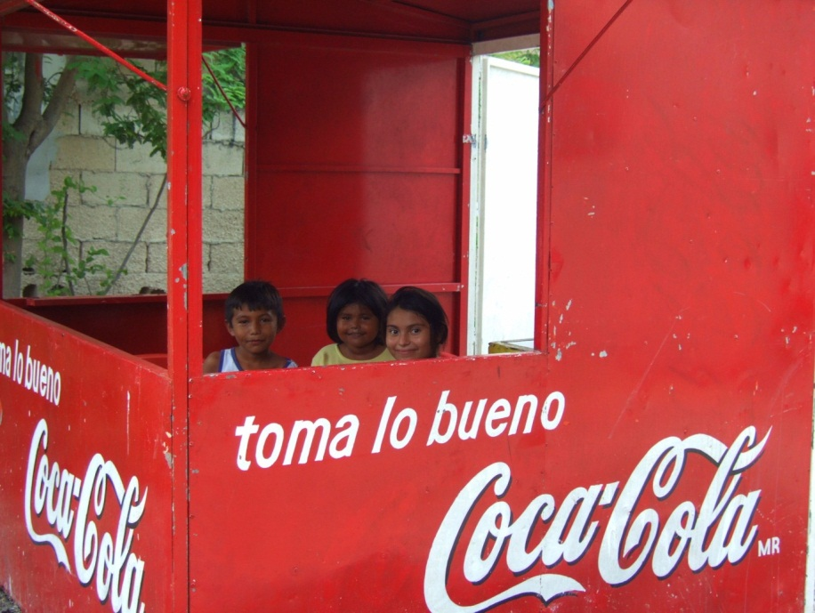
Globalized corporations provide the large and complex infrastructure to support the pervasive presence of snacks and soft drinks. The investment by the beverage giants seems to be working (Figure 1).
Figure 1. The “coca-colonization” of Yucatan. Sugary soft drinks are replacing traditional beverages in the Yucatan Peninsula. Even in the most remote rural areas advertisements invite people to try high sugar, high caloric drinks. Photographer: Inês Varela-Silva. Location: Celestun, Yucatan, Mexico. Date: 2007

Leatherman and Goodman (2005) found that in the Yucatan village of Yalcoba, with about 1500 inhabitants, there are at least 40 ‘sales points’ (small stores called tiendas) for Coca-Cola, Pepsi-Cola, and other sugary soft drinks. In their survey of 75 school-aged children in Yalcoba, Leatherman and Goodman found that reported daily intakes of junk food included about 360 ml (~12 oz.) of soft drinks (mostly Coke or Pepsi), 1.5 packages of chips, cookies, or other snack foods, and about two small candies. The maximum daily intake of junk food reported was about 1.8 liters of soda, seven packages of snack foods, and six candies (ibid).
The Maya of Yucatan
The Yucatan Peninsula is historically a center of the Maya culture. There are an estimated 7-8 million Maya living in Guatemala, the Yucatan Peninsula of southern Mexico, Belize, El Salvador, and western Honduras (Lovell, 2010). This makes the Maya the largest Native American ethnic group. Common features of rural lifestyle, economic activities, kinship and marriage systems, religion, philosophy, and a brutal history of repression since the Conquest of the Americas binds all Maya together into a shared cultural identity. There are, however, 22 or so Maya languages, each associated with a specific Maya group, such as the Yucatec Maya of southern Mexico.
The living Maya are the biological and cultural descendants of the people inhabiting the same culture area prior to European contact in the year 1500 AD. Archaeology of the region indicates that hunter-gatherers and small scale farmers existed in the region for thousands of years. It is not certain which of these groups became the Maya. By about 250 CE a Maya cultural identity was well established and the people were organized in several state-level societies, ruled by priest-kings and an elite class of political-religious leaders. Each Maya state group maintained armies and a workforce of peasants that produced food using a mosaic system of" ... agricultural fields, raised wetland fields, kitchen gardens, terraced hills, and…managed forests" (McNeil et al., 2010). Maya plant and animal husbandry cultivated a diversity of species to provide food; medicinal plants; and wild animals for protein food and honey, firewood, and building materials.
This is how the Spanish and Portuguese Conquistadors encountered the Maya in the Yucatan Peninsula in the year 1500. New infectious diseases introduced by the Conquistadors, such as smallpox, bubonic plague, and measles, spread rapidly among the Maya, and without any biological or social resistance whole villages of Maya were decimated. Between 1519 and 1632 at least eight epidemics spread across Yucatan and Guatemala (Lovell, 2010). It is estimated that 90 percent of the Maya population died between 1500 and1625, totaling about 1.8 million people in Guatemala (Lovell & Lutz, 1996).
In the past 200 years or so, Maya culture has been characterized by subsistence and market-oriented agriculture, small-scale animal holdings (sheep, chickens, a cow, or burro) augmented by craft specialization. An example of Maya women, and a girl, wearing traditional woven and embroidered clothing, and making tortillas, a traditional food, is provided in Figure 2. 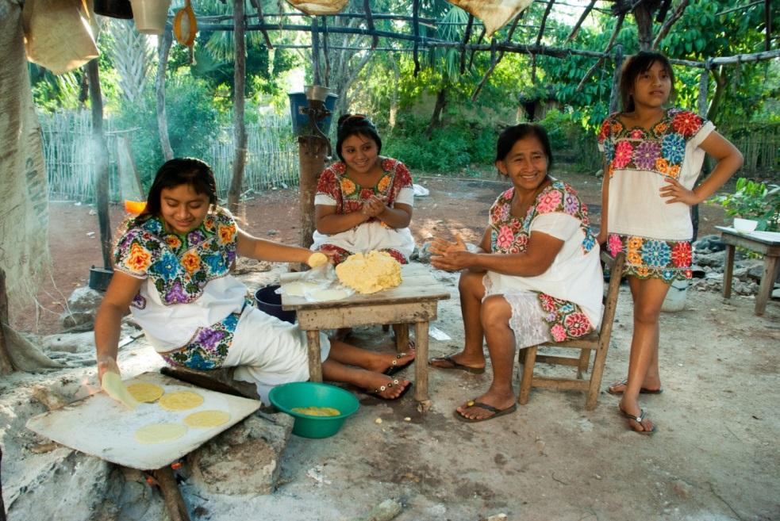
Figure 2. Women and girls make tortillas on the ko ben, a sheet of metal placed on three stones above a wood fire. Dried corn kernals are ground to a flour, mixed with calcium carbonate, and then boiled to a paste-like consistency. The resulting mixture is dough called masa harina (pictured on the table). Small balls of masa harina are hand-patted into disks that are cooked. The tortilla is the most commonly eaten food item of the Maya and of all Mexicans. Photographer: Miguel Cetina. Location: San José Oriente, Yucatan, Mexico. Date: 2011
Other characteristics of traditional Maya culture are social behavior relating to household economy, endogamy (marriage within the community), collective religious practice, use of the Maya calendar, and communication in a Maya language. Some aspects of modern-day traditional Maya culture predate the Conquest; others are postcolonial syncretic blends between various Maya and Spanish social-religious practices. New practices are derived from globalization, such as use of mobile phones, the internet, and drinking Pepsi-Cola and Coca-Cola.
The Maya of Merida
Since the European Conquest, the Maya of Yucatan have experienced, and continue to experience, adverse socioeconomic conditions, including marginalization and poverty (Siniarska and Wolanski, 1999; Bracamonte y Sosa and Lizama Quijano, 2003). During much of the 19th and 20th Centuries the Maya lived in rural areas of the Yucatan and worked in the sisal agroindustry. Sisal (Agave sisalana) production was the primary industry of the region. Sisal fibers were used to make rope and twine, paper, cloth, mattresses, wall coverings, carpets, and other products. Maya sisal workers lived on the sisal plantations, often under terrible conditions. During fieldwork in 1978 an elderly Maya man told one of us (FD) that the sisal workers called the plantation era 'the age of slavery.' There was local resistance and violent protest by the Maya in the 19th Century, but it was the Mexican Revolution of the early 20th Century and the global economic depression of 1929 that destroyed much of the plantation system. Competition from less expensive sisal produced in Brazil and Africa and from other lower cost natural fibers, and then synthetic fiber such as polypropylene, caused the Yucatan sisal industry to collapse in the 1980s. Since the collapse, migrants from rural Maya villages searching for jobs and new opportunities have flooded into the city of Merida (Lizama Quijano, 2012) or toward tourist resorts such as Cancun. According to the Mexican Census, the population of Merida rose from 241,964 inhabitants, in 1970, to 830,732 inhabitants in 2010 (Azcorra et al. under review), and likely more than a million today.
Many of the Maya of Merida live in the southern neighborhoods of the city. This is a low socioeconomic status area and geographically segregated from the central and northern regions by the International Airport, a Federal prison, and a military base. Surveys in the year 2000 found that at least 19% of the residents of this southern region were Maya-speaking people, the highest percentage in the city, though most were fluent in Spanish as well. Other pockets of Maya language speakers were found in some areas of the East and North of Merida (Azcorra et al. under review).
The Nutritional Dual-Burden
In 2005, several of the present authors (BB, IVS, MTCB, FD) met in Merida and began to work together to better understand the biocultural living conditions of Maya families in Merida. This new work was supported by our previous studies with Maya living in rural Yucatan and Guatemala, and Maya migrants to the United States (Wolanski et al., 1993; Bogin et al., 2002; Castillo-Burguete et al., 2008). Our new research focused on the nutritional dual-burden, which may be broadly defined as the coexistence of under-nutrition (mainly stunting) and over-nutrition (overweight and obesity) in the same population/group, the same household/family, or the same person (Varela-Silva et al., 2012).
The Maya are one of the shortest stature, non-Pygmy, populations in the world. Pygmies are short statured due to the lack of specific hormones, their carrier proteins, or cell binding agents, but there are no such known reasons for Maya short stature. The average height of contemporary, rural-living Maya men and women in Mexico and Guatemala is 160 cm and 148 cm, respectively. On a world-wide basis, women tend to average 12 cm less than men from the same population (Bogin and Keep, 1999). Estimates of stature from skeletal remains at Maya archaeological sites indicate that the height of men averaged 166 cm at the start of the Classic Period in 250 AD, a time of relative prosperity for the Maya. Maya men of high social status, indicated by burials within ornate tombs or pyramids, averaged 170 cm in height, and at least one man was 177 cm tall. These high status Maya were about the same height as ‘tall’ African populations, such as the Tutsi of Rwanda and Burundi, measured in the early 20th Century (170 cm), and taller than many Europeans at the end of the 19th Century (Bogin, 2013). By the end of Classic Period, at about 900 AD, Maya societies were suffering from centuries of warfare and environmental change. Maya kingdoms in lowland Guatemala were disbanded, but centers such as Uxmal in the Yucatan peninsula remained vibrant until about 1200 CE. During this period the average stature of Maya men decreased to 163 cm and declined again to its present value after the European Conquest of 1500 AD (Bogin and Keep, 1999).
Maya adults and children measured in the early to mid-20th Century were usually thin, with very low body fat. The combination of short stature and thinness were indications of an inadequate diet. Surveys in rural Guatemala Maya villages in the 1950s-1960s found that total energy intake averaged only 87% of requirement, with less than 15% of energy derived from fat or protein. There were also deficiencies of riboflavin (vitamin B₂), niacin (vitamin B3), and vitamin C (Bermudez et al., 2008; Bogin, 2013). These Maya diets would result in both short stature and thinness, especially as the diets were combined with heavy workloads and recurrent respiratory and gastrointestinal infections. In addition, periodic epidemics of measles reduced nutrients available for body growth (Bogin, 2013).
By the early 21st Century the relationship of weight to height for Maya children and adults changed. Based on a cross-sectional survey conducted in Merida in 2006, we found that Maya mothers remained short, with 69.4% of the 206 women measured below 150 cm. Stunting was detected in 21% of their children, aged 4.0-6.9 years old, and overweight in 33%, with 2.4% both stunted and overweight. Mother's height below 150 cm and the child's birth weight below 3000 grams both were statistically significant predictors of stunting in the child (Varela-Silva et al., 2009). We interpreted this to indicate that there is an intergenerational transmission of poor growth in this Maya sample.
In 2010 we collected additional data from 58 Maya mother-child pairs in Merida. The 31 boys and 27 girls were 6.8-9.9 years old. Based on references for height and weight produced by the Centers for Disease Control, United States, 31% of the children were stunted, 12.1% were overweight, and 15% were obese. Using these same references, 81% of the mothers were stunted (height <150 cm), 91.4% were overweight, with 39.7% of the overweight women classified as obese (Varela-Silva et al., 2012).
In principle it should be virtually impossible for a 7-9 year old child to be simultaneously stunted and overweight. It should be highly unlikely to find so much stunting and obesity, even in different children, within the Maya of Merida. Our findings are not isolated, as similar reports come from several other low socioeconomic status groups in both developing and developed nations (Varela-Silva et al., 2012). Several hypotheses have been proposed to explain the nutritional dual-burden (Frisancho, 2003; Varela-Silva et al., 2007; Said-Mohamed et al., 2012; Wilson et al., 2013). In the following analysis we examine the most basic of these hypotheses – that the diet of the Maya mothers and children participating in our studies is deficient in one or more nutrients essential for skeletal growth, but excessive in total energy.
We employed a food frequency questionnaire (FFQ) to collect data about the diet of a sample of 58 mother-child dyads. The age of studied women was between 22 and 49 years (mean = 34.30 ±6.28 years. The 58 children (boys = 31) were between 6.8 and 9.9 years old (mean = 8.42, ±0.79).
FFQs may be used to identify patterns of consumption of specific foods at the individual and community level. The FFQ methodology may be less accurate than other methods, such as diet diaries, 24-hour recall, and weighed food intakes, especially for determining individual diets. In terms of costs and benefits, FFQs are useful to identify the main food components of the diet of groups of people, and when applied to representative samples an FFQ may provide a general idea about the dietary characteristics of the population (Dary and Imhoff-Kunsch, 2012). The kind and number of foods or products included in the questionnaire depend on the purpose of the study.
Our FFQ included 78 foods, grouped in 7 categories: 1) cereals, breads, and rice; 2) beans, meats and fish; 3) milk and eggs; 4) animal and plant fats (e.g., cooking oil and lard); 5) sugar, honey, and sugar-sweetened soft drinks; 6) local and non-local fruits; and 7) vegetables. We also determined if the food eaten was prepared at home or was commercially processed and packaged.
We visited the families at their homes and applied the FFQ to the mothers to obtain information about their own food consumption during the previous week and that of their son/daughter who participated in the study. We followed a standardized methodology to apply the FFQ (Madrigal Fritsch and Martínez Salgado, 1996) and we are confident that virtually all the food consumed at home by the mother and the child were recorded. We likely missed some foods consumed out of the home, such as soft-drinks and snack foods consumed by children. Not recoding these items will underestimate the weekly frequencies and more conservatively estimate total food intake.
Analysis Procedures
All analyses were done separately for the mothers as a group and then for children as a group. There were no significant differences between the boys and girls in height, weight, or frequencies of foods consumed. For each group, the frequency of consumption of each of the 78 foods was categorized in four levels: 1) no consumption (or less than weekly consumption), 2) low consumption, at 1-2 days/week, 3) medium consumption, at 3-4 days/week, or 4) high consumption, at 5-7 days/week.
Detailed tables of these frequencies have been reported by Azcorra et al. (under review) and are not repeated here. We provide here a summary of these data to show the most common to least common foods eaten. We evaluate the nutritional adequacy of our participants by comparison of the frequencies with findings from Mexican National Health and Nutrition Survey (Encuesta Nacional de Salud y Nutrición) of 2006 (Instituto Nacional de Salud Pública, 2007) and other studies conducted in the state of Yucatan and city of Merida.
The findings from the food frequency questionnaire are that, in general, the Maya mothers and their children eat:
- A high consumption of maize tortillas and locally produced wheat baguettes (called pan francés), a medium consumption of rice, pasta, and sugar-sweetened refined wheat bread (called pan dulce), and low consumption of refined wheat white bread (called pan blanco) or high fiber carbohydrates, such as oats.
- Beans were consumed in low to high amounts, pork and chicken were consumed in medium to low amounts and beef and fish in low to no amounts.
- Milk consumption was reported to be low for the mothers and high to medium for the children, with 84.5% of children and 60.3% of mothers consuming only whole milk.
- Vegetable oils and mayonnaise had high consumption, while lard and margarine had low consumption.
- More than 70% of mothers and 60% of children had high to medium consumption of sugar (sucrose) and sugar-sweetened soft drinks. Honey consumption was low to absent.
- Except for the consumption of bananas and oranges by children, both mothers and children reported very low frequencies of consumption of fruits. The lowest frequencies of consumption were for non-local fruits (apple, pear, grapes and strawberry) which are more expensive than local fruits (banana, watermelon, papaya and orange).
- Vegetable consumption tended to be low to absent. The exceptions were for cucumbers, tomato, and onion which had a medium consumption by both mothers and children. Even so, these vegetables of tend to be used in relatively low quantities, mostly to add flavor to other foods, in the culinary culture of Yucatan.
We analyzed the consumption of soft drinks and packaged ‘junk foods’ (comidas chatarras) in greater detail. The frequencies of soft drink consumption are shown in Table 1. Mothers have, in general a medium to high intake, with these two categories accounting for 70.7% of frequency. The children have a more variable intake, but 53.5% have a medium to high consumption of sugar-sweetened soft drinks. The children’s data are based on the mothers’ reports and do not include soft-drinks consumed out of the home and out of sight of the mother.
Table 1. Consumption of soft drinks by mothers (n=58) and children (n=58)

Consumption | Mothers |  | Children
 | F | % | F | %
No consumption | 2 | 3.4 | 5 | 8.6
Low | 15 | 25.9 | 22 | 37.9
Medium | 16 | 27.6 | 8 | 13.8
High | 25 | 43.1 | 23 | 39.7
Total | 58 | 100 | 58 | 100
F = frequency Low: 1-2 days per week; medium: 3-4 days per week; high: 5-7 days per week

In Table 2 are shown the data for consumption frequency of ‘junk foods.’ These are packaged snack foods such as biscuits (galletas), fried chips or crisps of corn, potato, or wheat (frituras de maiz, papa y trigo), cadies and sweets (dulces), such as caramels and chocolates. Most of these processed, packaged products are purchased from the tiendas (small shops) located in neighbourhoods where our participants reside. Mothers report, generally, no or low consumption of these junk foods. One mother reported that she and her child only ate junk foods on special occasions, such as a birthday. Children, in contrast, are reported to have a low to high consumption of junk foods. About half the children have a medium or high consumption (50.1%). Again, this is based on mothers’ reports and does not include biscuits, chips, or sweets eaten outside the home.

Table 2. Consumption of snack foods by mothers (n=58) and children (n=58)
Consumption | Mothers |  | Children
 | F | % | F | %
No consumption | 15 | 25.9 | 6 | 10.3
Low | 30 | 51.6 | 22 | 37.9
Medium | 7 | 12.2 | 10 | 17.3
High | 5 | 8.6 | 19 | 32.8
Special occasions | 1 | 1.7 | 1 | 1.7
Total | 58 | 100 | 58 | 100
F = frequency; Low: 1-2 days per week; medium: 3-4 days per week; high: 5-7 days per week

We compared and interpreted the results from our FFQ against the Mexican National Health and Nutrition Survey (Encuesta Nacional de Salud y Nutrición) of 2006 (Instituto Nacional de Salud Pública, 2007). The Mexican National Health and Nutrition Survey was a carefully constructed, representative investigation of the Mexican population. In Yucatan, the survey included 6,985 persons living in 1,553 households. A detailed FFQ, including portion sizes of foods eaten, was included. The FFQ included 101 foods and participants were asked for each food item how many times it was eaten in past 7 days, the number of days per-week the item was eaten, the number of times per day, the portion size (later converted to a weight) eaten, and number of portions eaten each day (Rodríguez-Ramírez et al., 2009). This allowed for the estimation of intakes of specific nutrients.
The findings for 5-11 years old children of the lower socioeconomic status (SES) were that total energy intake was only 81% of requirement and that there were inadequate intakes of vitamin A, folates, heme iron, zinc, and calcium (Instituto Nacional de Salud Pública, 2007). These estimates are for the whole of the Yucatan region, both rural areas as well as all of the city of Merida, and for children from all low SES families, not only Maya families. Another FFQ study based on further analysis of the Mexican National Health and Nutrition Survey data of 2006 plus a sample of 126 children from impoverished Yucatan families found nearly identical results (Cuanalo de la Cerda et al., 2014).
The globalized diet of the Maya
The diet of the Maya mothers and children of our sample is typical of diets of low socioeconomic status (SES) groups in urban areas that have experienced the effects of globalization. Compared with rural diets of Maya villagers surveys in the 1950s-1960s (Bonfil Batalla, 2006; Bermudez et al., 2008; Bogin, 2013) our Merida Maya sample has undergone a nutritional transition, with a shift from locally-grown foods high in fiber and low in fats, to the global diet of highly processed foods, high in saturated fat, animal products and sugar, and low in fiber. In the traditional rural villages of the middle 20th Century, Maya health was not very good as evidenced by stunting and thinness. In Merida, with a globalized diet, health problems remain, as evidenced by short stature and obesity.
There are some benefits associated with the nutrition transition. The Mexican National Health and Nutrition Survey of 2012 reports a decline in rates of stunting from 27.9% in 2006 to 15.8% in 2012 for 1-4 year olds residing in urban Yucatan. This decline is explained, in part, by improvements in the health care system. These improvements include attention to preventative medical care. There was also investment to improve access to safe water, sanitary toilets and cement floors in low income family homes. Some of these public health benefits were provided by the Oportunidades (Opportunities) Program. Oportunidades was initiated in1996 as a new program of political policy and practical intervention to prevent and reduce malnutrition (Instituto Nacional de Salud Pública, 2007). Nearly 40% of homes in the state of Yucatan received benefits from Oportunidades.
The Mexican National Health and Nutrition Survey of 2012 Survey also reports that since 2006, rates of overweight/obesity in the same 1-4 year old age group increased from 14.4% to 15.1% (Instituto Nacional de Salud Pública, 2013). Obesity in older age groups increased by greater amounts.
Given this broadly uniform set of findings, we find support for our fundamental hypothesis that the nutritional dual-burden of short stature combined with overweight/obesity is the result of a diet deficient in one or more nutrients essential for skeletal growth, but excessive in total energy.

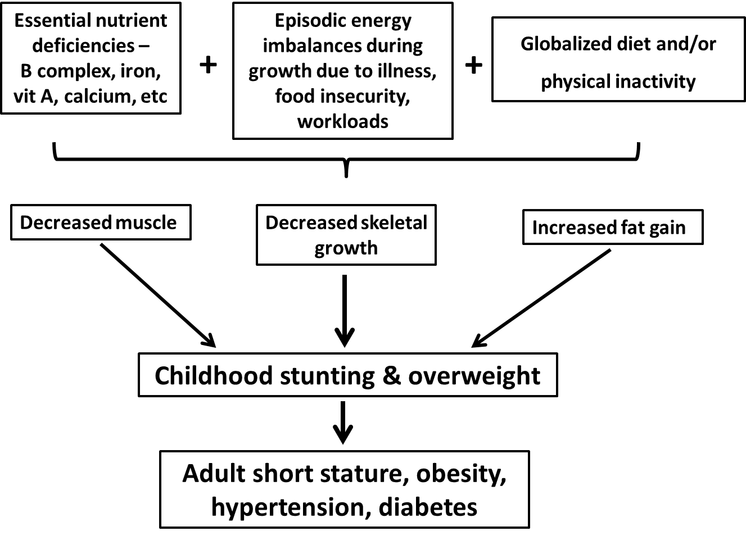
Figure 3. Probable association between essential nutrient deficiencies, energy imbalances, globalized diet, physical inactivity, childhood stunting/short stature and overweight, and the adult phenotype of short stature, obesity, hypertension and diabetes (modified from Sawaya et al., 2009).

We depict in Figure 3 the probable associations between Maya diet, lifestyle, child physical growth, and adult phenotype. All nutritional surveys of the Yucatan region of Mexico, and of its Maya people, find that some essential nutrients are deficient in the diet. The lack of any single essential nutrient (defined as those which must be supplied by the diet for basic metabolism, growth, physical activity, and reproduction) will impair growth. The combination of deficiencies for folate and other B complex vitamins, iron, vitamin A, and calcium will slow skeletal growth and reduce stature. The Maya families participating in our study are of low SES and live under economic and dietary insecurity – the most recent Mexican national survey reports 66.7% of all families in Merida are food insecure (Instituto Nacional de Salud Pública, 2013). Unemployment and under-employment of Maya parents is common and when employed the work is often of a physically demanding nature (e.g., construction). For adults, the episodic nature of wage-earning, diet, and physical activity is known to be associated with an overall poor diet and weight gain from body fat (Eisenmann et al., 2011; Metallinos-Katsaras et al., 2012; Popkin et al., 2012).
We objectively measured the physical activity of 33 of the 58 children in the FFQ sample (17 boys) over a one week period (Wilson et al., 2011, 2013). We found they were highly active, overall, spending an average of 120 min per day in moderate-to-vigorous physical activity (MVPA), which exceeds international recommendations for their age and sex. Stunted children, however, spent significantly less time in MVPA, and five stunted girls did not achieve the minimum level for MVPA of 60 minutes per day. Further analysis found that children with short stature, measured as a continuous variable, and lower fat free mass (meaning, the skeleton, muscle, and organs of the body, but not the fat) have lower total energy expenditure compared to taller children with higher fat free mass. The children had a mean energy expenditure of 1986.5 (SD=332.6) kilocalories per day. This estimate was based on Actiheart reference equations, which were developed based on white British children, so may not be accurate for Mexican-Maya children.
To estimate the energy intake adequacy of the Maya children in our sample we used their mean group values for age, height, weight, and level of physical activity. These values are 8.25 years old, 122 cm, 27 kg, and ‘active’ (defined as sedentary activities plus 1-2 hours per day of additional activities reflecting an intensity of 3.0-4.8 Mets). Based on these values, and using the United States references for energy requirements, the Maya children should consume an average of 1920 kcal per day. This would equal a shortfall of 66.5 kcal per day, based on our estimate of mean energy expenditure of 1986.5 kcal/day.
If these Maya children were deficient in total energy intake they should be under-weight or, at best, normal weight. However, more than 25% are overweight or obese and only 5% are under-weight (Varela-Silva et al., 2012). Obviously, we either overestimated the energy expenditure of the children in our sample, or more likely the children are eating more kilocalories than they expend in basic metabolism and physical activity.
Energy imbalance does not, however, explain the short stature and overweight/obesity of our Maya children and their mothers. An explanation for the nutritional-dual burden of the Maya children may be that their diet is deficient in essential nutrients, but not in fact deficient in total energy. As shown in Figure 3, essential nutrient deficiencies, episodic energy imbalances due to illness and food insecurity, and a globalized diet lead to not only shorter stature, but also decreased muscle mass, the primary determinant of fat free mass. The fat free mass is a major component of total energy expenditure, which may be expressed simply as the sum of basal metabolism plus physical activity. Short stature and decreased muscle mass in Maya children will reduce total energy expenditure and the requirements for total energy intake (Wilson et al., 2012). An 8 year old girl, for example, who is 124 cm tall requires about 150kcal less per day than a girl of the same age who is 131 cm tall. If the short girl consumes the ‘extra’ 150 kcal per day, then she may gain about 1.25 pounds of body fat in 30 days, assuming that 3500kcal = 1.0 pounds of body fat.
An increased risk for elevated body fat for short statured children may be exacerbated by high amounts of sedentary behavior. While we measured physical activity we did not measure sedentary behavior. The British Heart Foundation explains that, “Sedentary behaviour is not defined simply as a lack of physical activity. It is a group of behaviours that occur whilst sitting or lying down and that require very low energy expenditure” (http://www.bhfactive.org.uk/userfiles/Documents/whatissedentarybehaviour.pdf). Reading a book while seated is an example of a sedentary behavior. Exercising while seated, such as using a rowing machine, is physical activity and not sedentary behavior. Maya children may run, play and do other activities to meet the 60 minutes per day requirement for MVPA, but our ethnographic observations, and those of many other fieldworkers since the time of Sol Tax’s studies of highland Maya weavers (Tax, 1953), find that Maya children and adults practice more sedentary behavior than better nourished Mexican and European children and adults. Tax reported that Maya girls learning to weave are able to sit almost motionless for hours at a time while watching an older women weave. During our fieldwork in Guatemala, Mexico and the United States we have observed Maya children sit, almost motionless, while we took measurements on their classmates. Non-Maya children in these same countries are more often moving and playing while waiting to be measured (Bogin and Varela-Silva, fieldnotes). The synergistic effects of smaller stature, lower fat free mass, sedentary behavior, and a globalized diet may work to increase body fat, resulting in the nutritional dual-burden that plagues the Maya communities of Merida and elsewhere (e.g., Smith et al., 2002).
The globalized diet is especially problematic as this diet is high in fat, relative to carbohydrates, and high in sugars, especially from processed foods such as soft drinks and packaged junk foods. Fats are more than twice as energy dense as carbohydrates, but often are nutrient poor. Sugars provide an attractive taste, but few essential nutrients. Based on our ethnographic observations and interviews with the mothers and, occasionally other family members, we understand that the patterns of food consumption reported represent a strategy to adapt to the low purchasing power of the families. Many of the products and foods frequently consumed are sold at low prices in the small stores (tiendas) of the neighborhood. These products satisfy immediate hunger and energy requirements of the family and also satisfy desire for good tasting food and drink. During fieldwork in Yucatan we have been told that when people eat bread (pan francés or pan dulce) and drink a Coke, their stomach becomes full and the sensation of hunger disappear (Federico Dickinson, fieldnotes). Food economists working with low SES populations have shown that the importance of taste is as important, or a bit more important, than the cost and the nutrient density of foods purchased (Drewnowski and Darmon, 2005). “Good taste, high convenience, and the low cost of energy-dense foods, in conjunction with large portions and low satiating power, may be the principal reasons for overeating and weight gain” (ibid, p. 900).
Soft drinks represent one of the most common processed foods in the Maya diet. Based on data collected in November 2013 we found that the difference in price between a liter of still water and a liter of soft drink is $3 Mexican pesos (about $0.25 USA dollars). The still water is cheaper, but people prefer the sweet taste of the soft drinks. The authors visited Maya homes in March and April 2010. In many homes sugar-sweetened soft drinks were visible, either in bottles around the home or being consumed. In one of the homes we saw a stack of 4 or 5 cases of 2-liter Coca-Cola bottles. Each case contained 4 bottles. The father of this home explained that he purchased these cases at Wal-Mart, which is a United States based, global department store and supermarket. The father assured us that these Coca-Colas were for family consumption and not for sale.
The consumption of sugar-sweetened beverages begins in infancy. In our fieldwork we have seen one year old infants given small amounts of Coca-Cola by their mothers. One method used by the mothers is to dip a finger in the Coke and then allow the infant to suck the finger. Another method is to pour Coca-Cola into a baby bottle and allow the infant to drink. One of the present co-authors (MTCB) observed during her fieldwork in Yucatan that mothers may alternate feeding their babies Coca-Cola with a sugar-sweetened orange or apple flavoured soft drink. Some of the mothers explained that they do this because physicians informed them that Coca-Cola is not good for children, but children want to drink it. So, the mothers “negotiate” by giving sometimes the fruit flavoured soft drinks and sometimes the Coca-Cola.
In every home we visited there are items in use that have the Coca-Cola logo, such as plastic table and chairs. One of the primary schools in the neighborhood had a refrigerator painted with the Coca-Cola. We visited this school on a day when the children were presenting dances and songs based on traditional Mexican folktales. There were several vendors both inside the school grounds and just outside selling Coke and Pepsi beverages and packaged snack foods (comidas chatarras). In a few homes we were offered refreshment, which is long-standing custom of hospitality in Yucatan and Chiapas, Mexico. In every instance this was a soft drink such as Coke or another commercial brand drink, such as ‘sparkling apple juice’ – a sugar-sweetened, carbonated apple-flavored beverage.
In the Mexican state of Chiapas, the Coca-Cola and Pepsi-Cola companies have worked successfully to convince people to offer the globalized soft drinks instead of a locally-produced, mildly alcoholic beverage distilled from fermented sugar cane and corn, called pox (pronounded as 'posh', Verza, 2013; Federico Dickinson and María Teresa Castillo Burguete, fieldnotes). Offering people a drink of pox was an important part of traditional religious and social activities. The corporate strategy to replace pox with soft drinks is reinforced by evangelical Christian groups who campaign against traditional religion and drinking alcohol (Eber, 2000; Kovic, 2005; Verza, 2013). The evangelicals are another type of globalization, as these religious groups originate from the United States and other wealthy nations and export their practices and ideologies to the poorer nations. The evangelicals prefer that Coke, Pepsi, or a similar soft drink be offered at social/religious gatherings. Similar pressure from global corporate and religious entities in Merida may be encouraging the shift from locally made beverages to globalized soft drinks.
Conclusion
The globalized diet of the Maya is not an isolated case. Communities around the world are experiencing similar types of nutrition transitions and the associated health consequences. The Maya case is a bit more poignant because following the Conquest and colonization by European powers more than 500 years ago, the Maya suffered under-nutrition, with short stature, thinness, and high infant and child mortality. Today, the Maya face a new mixture of nutritional threats from diets that are supplied by multinational corporations. Many local foods remain part of the Maya diet, such as tortillas, but even these local foods are increasingly globalized. Factory manufactured tortillas, for example, may be made from non-local ingredients, even non-traditional ingredients and may displace local production and sales networks (Lind and Barham, 2004). All societies must come to terms with food globalization. Research is a first step toward a better understanding of the reasons for, and consequences of, food globalization. The next step is to translate research findings into social, economic, and political action to improve child health and well-being. Enabling people to increase local control of their diet is one possible research translation. Almost all of the 58 Maya homes we visited have garden space, but very few grow any food. Promoting the development of home vegetable and fruit gardens may be one effective intervention to improve diet and health.
Acknowledgments
The research reported here is part of The Maya Project http://mayaproject.org.uk. Created in 2012, The Maya Project is a combination of biocultural research, fine arts, and public engagement. The goal is to accurately represent the living Maya people. The Maya Project achieves this goal through the photography, paintings, music, crafts, and writing of Maya artists, as well as non-Maya artists and researchers. The authors thank the Wenner-Gren Foundation (#IRCG-93) and Santander Universities at Loughborough University for funding this research. Janice Tut-Be provided valuable assistance in fieldwork. The cooperation of the Maya mothers and their children, as well as local primary schools in the Maya neighborhoods, is very much appreciated.
References
Albrow M, and King E. 1990. Globalization, Knowledge and Society. London: Sage.
Al-Rodhan NRF. 2006. Definitions of Globalization : A Comprehensive Overview and a Proposed Definition. Geneva.
Azcorra H, Wilson HJ, Bogin B, Varela-Silva MI, Vázquez-Vázquez A, and Dickinson F. Dietetic characteristics of a sample of Mayan dual burden households in Merida, Yucatan, Mexico. Arch. Latinoam. Nutr.
Bermudez OI, Hernandez L, Mazariegos M, and Solomons NW. 2008. Secular trends in food patterns of Guatemalan consumers: new foods for old. Food Nutr. Bull. 29:278–87.
Bogin B, and Keep R. 1999. Eight thousand years of economic and political history in Latin America revealed by anthropometry. Ann. Hum. Biol. 26:333–351.
Bogin B, Smith P, Orden AB, Varela Silva MI, and Loucky J. 2002. Rapid change in height and body proportions of Maya American children. Am. J. Hum. Biol. Off. J. Hum. Biol. Counc. 14:753–761.
Bogin B. 1998. From caveman cuisine to fast food: the evolution of human nutrition. Growth Horm. IGF Res. 8 Suppl B:79–86.
Bogin B. 2013. The Maya in Disneyland: Child Growth as a Marker of Nutritional, Economic, and Political Ecology. In: Dufour DL, Goodman AH, Pelto GH, editors. Nutritional Anthropology: Biocultural Perspectives on Food and Nutrition. Second. Oxford: Oxford University Press. p 231–244.
Bonfil Batalla G. 2006. Diagnóstico sobre el hambre en Sudzal, Yucatán: un ensayo de antropología aplicada. Mexico, D.F.: Centro de Investigaciones y Estudios Superiores en Antropología Social, Universidad Autónoma Metropolitana: Universidad Iberoaméricana.
Bracamonte y Sosa P, and Lizama Quijano J. 2003. Marginalidad indígena: una perspectiva historica de Yucatan. Desacatos 13:83–98.
Castillo-Burguete MT, Viga de Alva MD, and Dickinson F. 2008. Changing the culture of dependency to allow for successful outcomes in participatory research: Fourteen years of experience in Yucatan, Mexico. In: Bradbury H, Reason P, editors. The SAGE Handbook of Action Research. London: SAGE Publications.
Cuanalo de la Cerda HE, Ochoa Estrada E, Tuz Poot FR, and Datta Banik S. 2014. Food intake and nutrition in children 1-4 years of age in Yucatan, Mexico. Ann. Hum. Biol. 41:46–52.
Dary O, and Imhoff-Kunsch B. 2012. Measurement of food consumption to inform food fortification and other nutrition programs: an introduction to methods and their application. Food Nutr. Bull. 33:S141–5.
Drewnowski A, and Darmon N. 2005. Food choices and diet costs: an economic analysis. J. Nutr.:900–904.
Dufour DL, Goodman AH, and Pelto GH. 2013. Nutritional Anthropology,. Second. Oxford.: Oxford University Press.
Eber C. 2000. Women and Alcohol in a Highland Maya Town: Water of Hope, Water of Sorrow. Second. Austin: University of Texas Press.
Eisenmann JC, Gundersen C, Lohman BJ, Garasky S, and Stewart SD. 2011. Is food insecurity related to overweight and obesity in children and adolescents? A summary of studies, 1995-2009. Obes. Rev. 12:e73–83.
Frisancho AR. 2003. Reduced rate of fat oxidation: a metabolic pathway to obesity in the developing nations. Am. J. Hum. Biol. 15:522–32.
Graham C. 2010. Happiness around the World: The Paradox of Happy Peasants and Miserable Millionaires. Oxford: Oxford University Press.
Han E, and Powell LM. 2014. Consumption patterns of sugar-sweetened beverages in the United States. J. Acad. Nutr. Diet. 113:43–53.
Instituto Nacional de Salud Pública. 2007. Encuesta Nacional de Salud y Nutrición 2006. Resultados por entidad federativa, Yucatán. Cuernavaca, México.
Instituto Nacional de Salud Pública. 2013. Encuesta Nacional de Salud y Nutrición 2012. Resultados por entidad federativa, Yucatán. Cuernavaca, México.
Jimenez-Cruz A, Bacardi-Gascon M, Pichardo-Osuna A, Mandujano-Trujillo Z, and Castillo-Ruiz O. 2010. Infant and toddlers’ feeding practices and obesity amongst low-income families in Mexico. Asia Pac. J. Clin. Nutr. 19:316–23.
Kovic C. 2005. Mayan Voices for Human Rights: Displaced Catholics in Highland Chiapas. Austin: University of Texas Press.
Kuisel RF. 1991. Coca-Cola and the Cold War_The French Face Americanization, 1948-1953.pdf. Fr. Hist. Stud. 17:96–116.
Leatherman TL, and Goodman A. 2005. Coca-colonization of diets in the Yucatan. Soc. Sci. Med. 61:833–846.
Lind D, and Barham E. 2004. The social life of the tortilla: Food, cultural politics, and contested commodification. Agric. Human Values 21:47–60.
Lizama Quijano J. 2012. El perfil Maya de la blanca Mérida. Merida, MX.
Lovell GW, and Lutz CH. 1996. “A Dark Obverse”: Maya Survival in Guatemala,: 1520-1994. Geogr. Rev. 86:398–407.
Lovell WG. 2010. A Beauty That Hurts: Life and Death in Guatemala. 2nd editio. Austin: University of Texas Press.
Madrigal Fritsch H, and Martínez Salgado H. 1996. Manual de encuestas de dieta. Mexico, D.F.: Instituto Nacional de Salud Pública.
McNeil CL, Burney D a, and Burney LP. 2010. Evidence disputing deforestation as the cause for the collapse of the ancient Maya polity of Copan, Honduras. Proc. Natl. Acad. Sci. U. S. A. 107:1017–22.
Metallinos-Katsaras E, Must A, and Gorman K. 2012. A longitudinal study of food insecurity on obesity in preschool children. J. Acad. Nutr. Diet. 112:1949–58.
Mintz SW. 1985. Sweetness and Power. New York: Penguin Books.
Popkin BM, Adair LS, and Ng SW. 2012. Global nutrition transition and the pandemic of obesity in developing countries. Nutr. Rev. 70:3–21.
Rodríguez-Ramírez S, Mundo-Rosas V, Jiménez-Aguilar A, and Shamah-Levy T. 2009. Methodology for the analysis of dietary data from the Mexican National Health and Nutrition Survey 2006. Salud Publica Mex. 51 Suppl 4:S523–9.
Said-Mohamed R, Bernard JY, Ndzana A-C, and Pasquet P. 2012. Is overweight in stunted preschool children in Cameroon related to reductions in fat oxidation, resting energy expenditure and physical activity? PLoS One 7:e39007.
Sawaya AL, Martins PA, Baccin Martins VJ, Florêncio TT, Hoffman D, do Carmo P Franco M, and das Neves J. 2009. Malnutrition, long-term health and the effect of nutritional recovery. Nestle Nutr. Workshop Ser. Pediatr. Program. 63:95–108.
Siniarska A, and Wolanski N. 1999. Living Conditions and Growth of Maya Indian and Non-Maya Boys from Yucatan in 1993 in Comparison with Other Studies. Int. J. Anthropol. 14:259–288.
Smith PK, Bogin B, Varela-Silva MI, Orden B, and Loucky J. 2002. Does immigration help or harm childrens health? The Mayan case. Soc. Sci. Q. 83:994–1002.
Tax S. 1953. Penny Capitalism: A Guatemalan Indian Economy. Washington, DC: Smithsonian Institution Press.
Varela-Silva MI, Azcorra H, Dickinson F, Bogin B, and Frisancho a R. 2009. Influence of maternal stature, pregnancy age, and infant birth weight on growth during childhood in Yucatan, Mexico: a test of the intergenerational effects hypothesis. Am. J. Hum. Biol. 21:657–63.
Varela-Silva MI, Dickinson F, Wilson H, Azcorra H, Griffiths PL, and Bogin B. 2012. The nutritional dual-burden in developing countries--how is it assessed and what are the health implications? Coll. Antropol. 36:39–45.
Varela-Silva MI, Frisancho AR, Bogin B, Chatkoff D, Smith PK, Dickinson F, and Winham D. 2007. Behavioral, environmental, metabolic and intergenerational components of early life undernutrition leading to later obesity in developing nations and in minority groups in the U.S.A. Coll. Antropol. 31:39–46.
Verza M. 2013. The “Coca-Colization” of Mexico, the Spark of Obesity. periodismohumano [Internet]. Available from: http://english.periodismohumano.com/2013/03/05/the-coca-colization-of-mexico-the-spark-of-obesity/
Wilson H, Dickinson F, Griffiths P, Bogin B, and Varela-Silva MI. 2011. Logistics of using the Actiheart physical activity monitors in urban Mexico among 7- to 9-year-old children. Am. J. Hum. Biol. 23:426–8.
Wilson HJ, Dickinson F, Griffiths PL, Bogin B, Hobbs M, and Varela-Silva MI. 2013. Maternal short stature does not predict their children’s fatness indicators in a nutritional dual-burden sample of urban Mexican Maya. Am. J. Phys. Anthropol. 00.
Wilson HJ, Dickinson F, Hoffman DJ, Griffiths PL, Bogin B, and Varela-Silva MI. 2012. Fat free mass explains the relationship between stunting and energy expenditure in urban Mexican Maya children. Ann. Hum. Biol. 39:432–9.
Wolanski N, Dickinson F, and Siniarska A. 1993. Biological traits and living conditions of Maya Indian and non Maya girls from Merida, Mexico. Int. J. Anthropol. 8:233–246.

© Professor Barry Bogin and Dr Ines Varela-Silva

