13 June 2016
Rubens and London
Professor Simon Thurley

This afternoon, we are going to enjoy the second in the lunchtime series of Painters in London, and I have got the privilege of talking about Peter Paul Rubens – what an astonishing talent!

He was born into a humble family in 1577, and his genius propelled him to the pinnacle of social, economic and artistic success by the time he died in 1640. This is a man who produced, or at least oversaw, over 3,000 paintings, engravings and woodcuts, ranging from the small title pages of books to vast architectural decorative programmes. He was a scholar who spoke five languages fluently, a connoisseur and a collector with a brilliant eye, a consummate businessman, a tough negotiator, a capable diplomat, a much-loved husband and father, and an all-round charming guy… It makes you sick!

This polymath occupies an important place in the history of painting in London, and as I have already said, he is the second in our series of painters, and I would just like to start with making two neat little links with Hans Holbein the Younger, the subject of our first lecture by Susan Foister.

The first is that, after leaving home and becoming apprentice to a little-known painter in his native Antwerp, Rubens’ earliest surviving work is a group of drawings that he made after Woodcuts by Holbein. Those are Holbein’s Woodcuts, the Dance of Death, and here are Rubens’ absolutely charming drawings, in which you can already see his genius for making figures come alive with those few masterful strokes of a paintbrush.

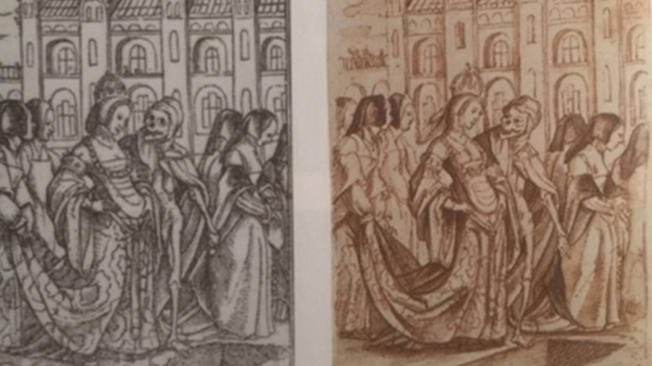

The second connection of course is, as we shall see, that he was to create, at Whitehall Palace, the defining architectural space for the Stuart dynasty, just as Holbein had done, in the same building as the Tudors had lived.
At the age of 23, in 1600, Rubens left Antwerp for Italy, where he spent the next eight years of his life, and when he returned home in 1608, he was already a successful and very well-known painter. Soon after his return, the governors of the southern Netherlands, Archduke Albert and Archduchess Isabella appointed him as their court painter. The clever arrangements that he negotiated with him allowed him to keep his studio in Antwerp and not move in to work at the royal palace in Brussels. What this meant was that, as well as ducal patronage, Rubens could take lots and lots of private commissions.

While small altarpieces and other commissions were admired, what really secured his fame and fortune in this period were his great hunting pieces, large canvasses full of snarling, fighting and dying lions, tigers, leopards, wolves, boars and even hippos and crocodiles. This is the Lion Hunt, painted in 1621, which is now in Munich.

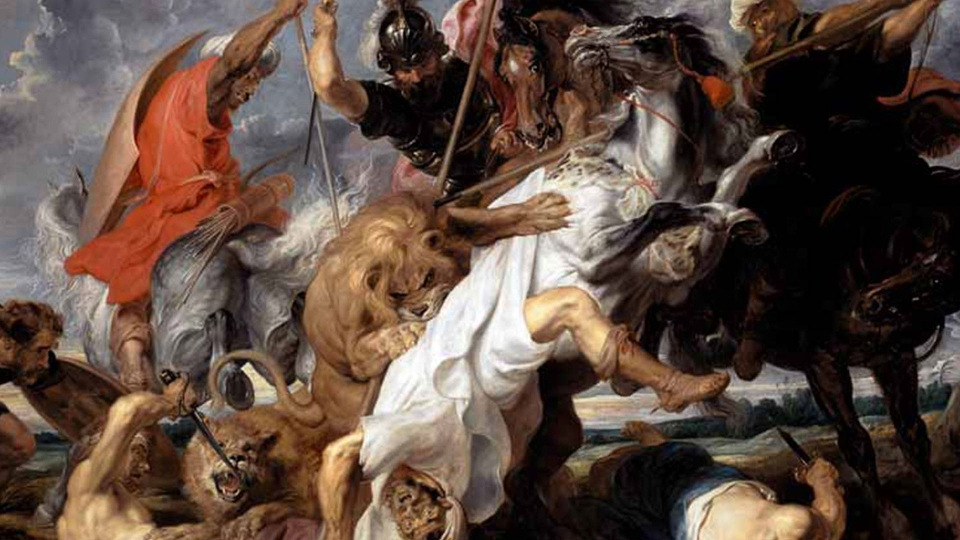

These macho paintings were very attractive to the hunting-obsessed princely and aristocratic patrons with big walls to cover. The only way that Rubens could possibly finish so many enormous canvasses was by relying on a small, but very brilliant, studio of assistants, who specialised in various parts of the background of these great paintings. Rubens would produce an oil sketch of the composition, he would undertake some of the key brushwork, and he would then leave the rest to others to complete.

This technique of using his studio concerned some of his most discerning patrons, who of course wanted paintings solely from the brush of the master himself, and one of those patrons was in fact Charles I, who wanted a painting wholly by the hand of Rubens and he got one, in 1622. This was his first Rubens, this extraordinary self-portrait, entirely from Rubens’ own hand. This does not show Rubens as a painter but one of the great man, as a gentleman, a well-dressed and wealthy connoisseur, in fact a man a bit like Charles I himself.

Well, Rubens’ first large-scale decorative commission was not for a palace, it was for the new Jesuit church in Antwerp, now San Carlo Borromea, a building begun in 1615. This here is a painting by Pieter Neefs showing the church.

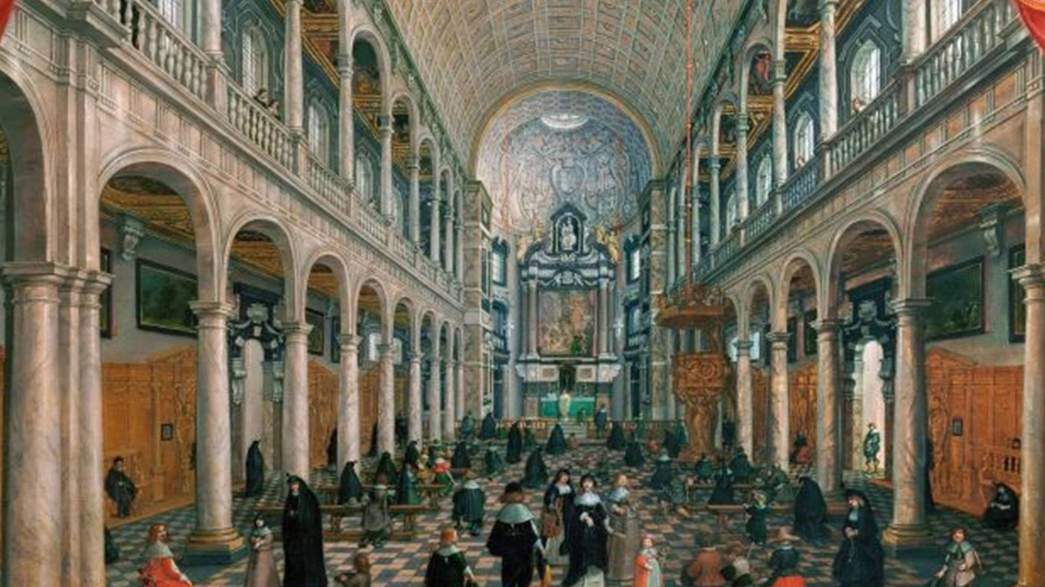

Rubens started work on an incredible 39 paintings that were to be installed in the ceiling of the upper and lower galleries, and what you can see here, here are the galleries, and can you see there, and here, these are the paintings in the ceilings of the galleries there.

What we have to be absolutely clear about is these were not frescos. These are canvasses. They are canvasses set into a timber framework. Painting in fresco, in other words directly onto the plaster, was all very well in Rome, in the Sistine Chapel and elsewhere, but in damp climates, this is quite a risky proposition. So, in Venice, another damp climate, Rubens would have seen the great ceiling of San Sebastiano, painted by Veronese in the mid-1550s, and he would have also seen, as I will show you later, the ceilings of the great rooms in the Doge’s Palace. All these paintings were done in canvas in the painter’s studio and then erected in a timber framework when completed. So, as far as Rubens was concerned, the new Jesuit church, which I have just shown you, and all his other decorative schemes that we will be looking at this afternoon were all painted on canvas.

When the Jesuit church here was completed, Rubens was unquestionably the most successful and the most famous painter in Northern Europe, and he was also now a man with a taste for large-scale decorative work and what he really wanted to do was move on to this church and secure a commission from a great prince of Europe, a secular commission, and on the very day this church was consecrated, he was writing a letter to William Trumbull, the English Ambassador to the Court in Brussels and this is what he wrote: “As for His Majesty,” we are talking about James I here, “and his Royal Highness the Prince of Wales,” the young Charles I, “I shall always be very much pleased to receive the honour of their commands, and regarding the hall in their new palace, I confess that I am, by natural instinct, better suited to execute very large works than small curiosities. Everyone according to his gifts! My talent is such that no understanding, however vast in size or diversified in subject, has ever surpassed my courage.” Obviously, he was a modest man too…

The hall he is talking about is the Banqueting House, built in Whitehall amidst the Tudor Palace of Whitehall, is the Banqueting House – I will talk about it in a few minutes.

But in 1621 when these words were penned, the Banqueting House was not even complete, but this extraordinary man had already laid his claim to decorate it. Well, of course, he need not have worried about getting a spectacular, secular, princely commission because, that very autumn, he received a commission from the Queen Mother of France to decorate her Palace of Luxembourg in Paris.

Marie de’ Medici wanted to decorate the two great long galleries that ran the whole length of her house on each wing. One gallery was to be for her side, which was to be decorated with the scenes of her life, and the gallery on the other side here was devoted to scenes of her late husband, Henry IV.
The work on the Jesuit church had taught Rubens how to organise such an enormous project, and the paintings for Marie de Medici’s side were completed and shipped and installed in the end of 1624, just in time for the marriage celebrations of her daughter, Henrietta Maria with Charles I of England. One of those paintings, the Marriage of Marie de’ Medici by Proxy, the fifth of the great series showing her life is now in the Louvre. During these great festivities for the marriage of Henrietta Maria and Charles I, held at the Luxembourg Palace, Rubens met the Duke of Buckingham. The Duke of Buckingham, of course, was James I’s and Charles I’s favourite, and he had come to Paris to pick up Henrietta Maria and escort her back to England. Buckingham, not wanting to miss a chance, immediately commissioned Rubens not only to paint a portrait of himself but to paint a large allegorical ceiling for his residence in London, York House. The oil sketch for this painting that was completed and put into York House in London. York House is gone – I am going to talk about it later, and the actual painting, catastrophically, was destroyed by fire in 1949. But we have the sketch, and you can see the Duke of Buckingham in apotheosis in the centre of this canvas.

While Rubens was working on the Luxembourg Palace, the peace that had existed across Europe between the Hapsburg territories and basically everybody else, which had been held together by a truce, dissolved into hostility. Now, I am not going to describe in detail all the extremely complex foreign policy issues of the time, even if I was qualified to do it, which I am not, but what we need to know essentially is that across Europe there erupted a period of intense diplomatic activity, as states attempted to re-align themselves, and in this process, Archduchess Isabella, Rubens’ patron, asked Rubens to become her envoy. Painters and connoisseurs had very easy access to the courts of Europe and they were very used to moving smoothly in princely circles. They were also unobtrusive and reliable diplomats, without complex personal agendas. So, for three years, between 1627 and 1630, Rubens’ life was taken up with attempting to smooth the way for international alliances on behalf of the Archduchess, and key to this was her effort to bring about an alliance between England and Spain.

Diplomacy was a transnational language of rituals and protocols. What it allowed was for people to move from court to court and communicate with an agreed framework which everybody understood. Today, in diplomatic protocol, everybody is judged to be equal, but in the 16th and 17th Centuries, this was not the case. You started with the Holy Roman Emperor, who was number one. You then went to France, who was number two, and this is where the problems started because there was not an agreed hierarchy beneath that. The Venetians were very keen that they should be number three, but they did not have a crowned head, and of course, when you come to an Archduchess of a Protectorate, you were really quite low in the pecking order. So, Rubens, quite low in this pecking order, was not an ambassador. He was a diplomatic envoy, preparing the way for an arrival for a full embassy to achieve the Archduchess’ ends.

So, Rubens’ arrival in London and his reception by Charles I on June 5th 1629 was not a formal ambassadorial reception but it was the arrival of someone who was trying to organise an embassy, but it was hugely important, and for many people in England, who hated Catholic Spain, this was an immensely unpopular development. Now, of course, Rubens knew about the English court. He had not only met Buckingham but he had also met English envoys and connoisseurs and merchants and he already believed that Charles I was, and I quote, “the greatest amateur of paintings amongst the princes of the world”, and of course he had met Queen Henrietta Maria at the great Palace of Luxembourg before she had come to England as Queen.

Rubens must have had some reservations about the protestant country that he arrived in, a country that had treated Henrietta Maria’s servants extremely badly – in fact, they had been expelled from England. When he arrived in London and saw the royal houses, his reservations might have been greater. Although Charles I’s palaces contained some remarkable paintings, some wonderful tapestries and a few sculptures, the buildings themselves were essentially erected in the time of Henry VIII. There had been a few modifications under Queen Elizabeth, especially at Greenwich, a few improvements done by James I, principally the new Banqueting House at Whitehall, but the royal building stock in England was nothing like the King of France’s, let alone the Luxembourg Palace of his patroness Marie de’ Medici.

Rubens was put up in London at York House. If you remember, York House was the residence of the Duke of Buckingham, but by this stage, the Duke was dead – he had of course been assassinated - so the house was empty. It was one of the great aristocratic mansions on the Strand, and it is in fact the only one of which anything survives. Here is York Watergate, now beached in the Embankment Gardens.

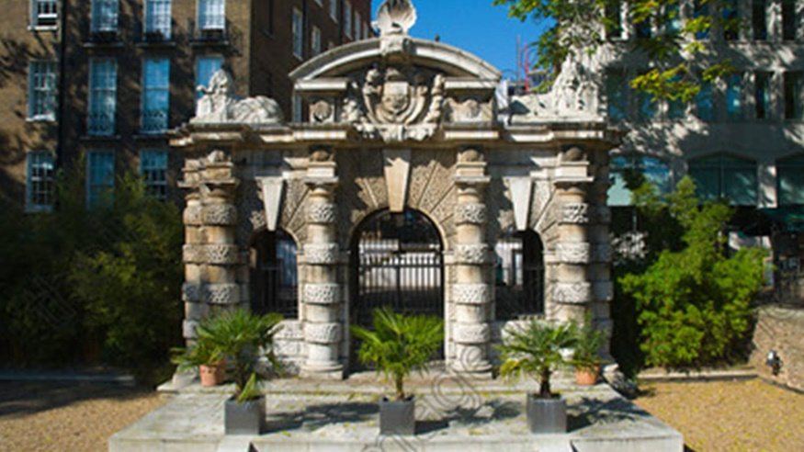

It was probably designed Sir Balthazar Gerbier, the Duke of Buckingham’s architect, art agent and painter, who was in charge of the Duke’s collections at York House. Gerbier had actually met Rubens because he had accompanied Buckingham to the marriage party of Henrietta Maria in Paris, and as keeper of York House, it was his responsibility to welcome Rubens and be his keeper while he stayed in London. So, Rubens is staying at the Duke of Buckingham’s house, still full of all his collections, and here he was able to see, for the first time, the ceiling he had painted in Antwerp that had been shipped to London and installed in Buckingham’s house.

While he was in England, he did not confine himself to London. He travelled around. He saw Windsor, Oatlands, Greenwich, Royal Palaces, but he also went out to Cambridge and to various noblemen’s houses.

Well, on his diplomatic mission, it took Rubens three months to set up an agreement for a full exchange of ambassadors, but he was ordered by the Archduchess to remain in London until the arrival of the Spanish Ambassador himself, which was not in the end to be until January 1630. This was quite frustrating for Rubens. He would very much like to have returned home, and in particular see his young sons, but he suffered an enforced exile, which he made the most of. Luckily, in his extensive baggage train, Rubens brought to London his paints, and he accepted a number of English commissions, including a richly-coloured, three-quarter length painting of Thomas Howard, the Second Earl of Arundel, whose great collection of classical sculpture was accommodated in another one of the great Strand mansions and which Rubens much admired - this painting now in the Isabella Stewart Gardner Museum in Boston.

Another painting which he began was a much more intimate work. It shows the wife and children of Balthazar Gerbier, a painting now in the National Gallery of Art in Washington. It shows Deborah Kip, Gerbier’s wife, and his children. This is probably painted at York House, and with a sort of eye of faith and imagination, you could perhaps imagine that they are looking out over The Thames perhaps in the background.

But there are two paintings that Rubens did in his period of enforced exile in London that really interest me. The first one is one that Rubens presented to Charles I as a goodbye gift – quite some goodbye gift. This is Peace and War, or sometimes known as Minerva protects Pax from Mars. It is in the National Gallery, so you can go and see it, and it is not a very subtle allegory of Rubens’ wish to bring about Anglo-Spanish peace.

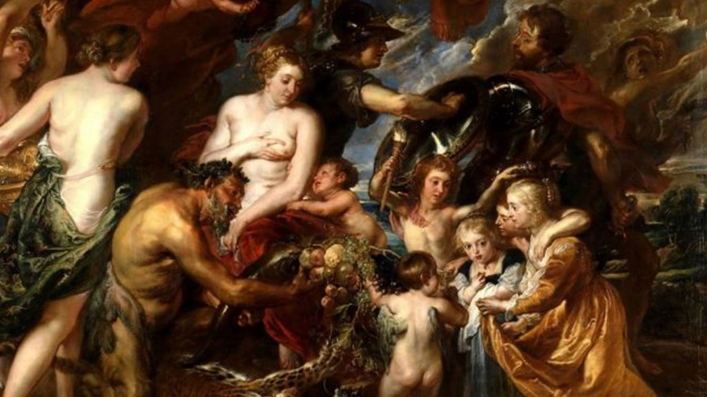

The message is: prosperity will flourish when war is stamped out. So you have Minerva here, who is shoving off Mars, getting him out of the way, to protect Peace, who is being served by Plenty, with all these lovely goodies here. Although this is an allegory, Rubens immortalised three of Gerbier’s children by using them here as models for the painting. In so doing so, I think he very cunningly suggested that the fruits of peace would be passed on to the next generation, and a next generation of course that Charles I would have recognised by face. Well, the King liked this goodbye present very much, and he hung it in one of the principal galleries at Whitehall, where it remained until it was sold off during Oliver Cromwell’s Commonwealth.

But another painting which Rubens did while he was in London is the one that really fascinates me. This now hangs at Windsor Castle, it is in the royal collection, but it was not in fact a present to the King.

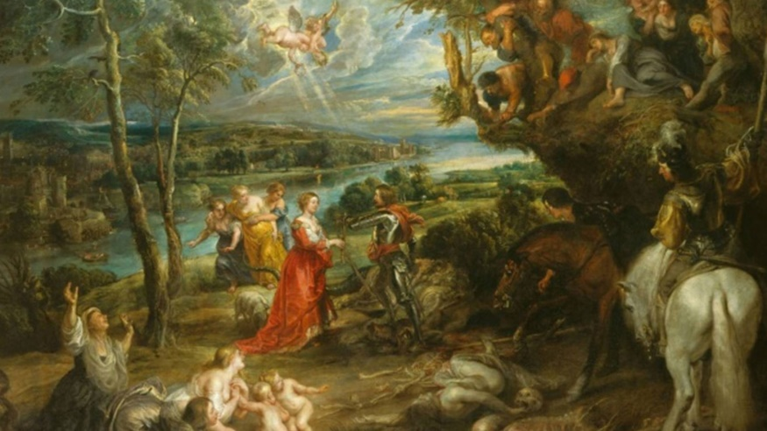

Rather interestingly, this painting was done in London and taken by Rubens back to Antwerp as his own souvenir of London, much better than a t-shirt or anything else that might have been available. It was described in 1630 as one executed by Rubens, and I quote, “in honour of England”, and it was sent home to Flanders, again as a quote, as “a monument to his abode and his employment here”. Well, you can see what the painting is, I think. It is St George and the Dragon, lying down here, in a wonderful landscape. But if we were looking at this painting under a raking light in Windsor Castle, we would see that there are a lot of joins in the canvas, and in fact, the original composition was this bit in the middle, and by the magic of PowerPoint, I can show you what the original one looked like: that was the painting that Rubens actually painted in London. But after Rubens had taken this painting to Antwerp, he was persuaded, in 1634-5, by Charles I’s painting agent and advisor, Endymion Porter, to sell it to Charles I, and it is at this point that it is likely that Porter, or perhaps Rubens, decided to make it a more substantial piece, and that is what happened to it… So, these bits here were all added, and it explains why it is a bit of an odd painting. The central thing here which is going on is all rather small and it only really makes sense when you see what the original painting was like, when of course the central moment was actually quite big. So he adds this mounted standard on one side, carrying a huge furled flag of St George, and then, to balance it up on the lower part here, he has added these incredibly grisly remains of people who have been chewed up and spat out by the dragon, including various people weeping and wailing when they discover that their husbands have been munched.

So what is this painting actually all about? Well, it certainly is not the very obvious and pointed allegory about Rubens’ diplomatic mission that the National Gallery’s Peace and War that I have just shown you actually was. Some people have suggested that St George slays the dragon, who is War, to give the lady and her children the benefits of Peace, but I do not think we have any need really to assume that this painting had anything to do with Rubens’ diplomacy. This, after all, was not designed as a presentation, this was a painting he did for himself as his own souvenir of England, and of course St George is England’s patron saint and Rubens seems to have been genuinely taken by England and its countryside. He wrote home in August 1629, and I quote: “This island seems to me to be a spectacle worthy of the interest of every gentleman, not only for the beauty of the countryside and the charm of the nation but” as he went on to say “also for the great works of art and collections at court.” So, Rubens clearly had an appreciation for the English countryside, and I think what he is painting here is an English idyll, potentially inspired by the view out of the windows at York House. Perhaps we can see the tower of Southwark Cathedral, perhaps we can see the Banqueting House, perhaps we can see Lambeth Palace, all of which would have been visible from the windows of York House.

Now, it has been suggested that these figures here are Charles I and Henrietta Maria. Well, the lady looks absolutely nothing like Henrietta Maria and so I do not think it could ever have meant to be her. However, the figure of St George I think is strikingly like Charles I and I think was almost certainly a portrait of him.

Rubens never formed a particularly intimate bond with Charles. I mean, Charles I did not invite him to live in Whitehall Palace or anything. But the two men did get on and, of course, Charles hugely admired Rubens’ talents and was very flattered to have him at his court. When he left, in January 1630, Rubens had a final audience with the King at the Banqueting House. The painter was knighted. He was presented with a diamond-encrusted sword and various other very valuable goodies. So clearly there was a close relationship there. And it was during this long stay in the English court that Charles I invited Rubens to paint a ceiling for the Banqueting House at Whitehall.

Now, just for a few moments, I need to re-trace our steps and go back into the Elizabethan period when Whitehall received its first Banqueting House. Here, you see a 16th Century plot of Whitehall. Here are the gardens, here is the Holbein Gate, here is the road which runs between Charing Cross and Westminster, the Great Hall, and this location here was the location where Queen Elizabeth built a Banqueting House for the marriage negotiations with various of her suitors.

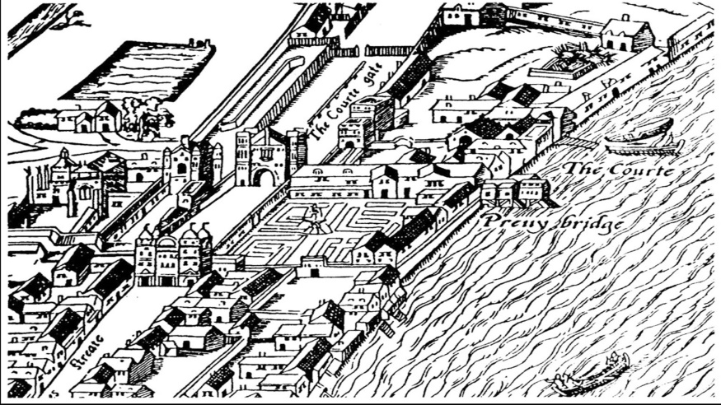

This Banqueting House she built was out of canvas and, although it was completed in 1581, it remained right into James I’s reign. James, of course, wanted to get rid of it, replace it with something better, and he commissioned an architect called Robert Stickles to build him a new Banqueting House. We have no image of it, but we have an engraving by Hans Vredeman de Vries which was the inspiration for the Banqueting House, an Egyptian hall, as described by the Ancient Roman writer. James I was very excited, this major architectural commission, and in 1607, when work on the building was well-advanced, he diverted his progress, summer progress, to call in and look at the work. What he saw completely and utterly horrified him. Stickles’ design might have looked good on paper, but inside, it was a forest of columns, and it made it incredibly difficult to see anything. You could not see the windows. You could not see anybody doing a play or a masque in there. The place was a disaster. And although James I started using it in 1608, he was not a happy man. But luckily, luckily for James I, luckily for Rubens, and luckily for us, a palace cleaner who was not concentrating properly in January 1619 accidentally ignited a pile of rubbish, and instead of doing the sensible thing and calling “Fire!”, they locked the door and ran away, and so this Banqueting House burnt to the ground, and the King’s new architect, Inigo Jones, was commissioned to replace it. Despite having an architect of the calibre of Inigo Jones, the King was very anxious about this commission, he did not want another flop on his hands, and so he created a committee of senior courtiers who would agree the design and would supervise the construction, and so Jones presented his design, got it agreed, and was granted £9,850 to build the new Banqueting House.

Well, of course, Jones was very heavily influenced by buildings he had seen on his travels in Italy, particularly by Andrea Palladio, and his inspiration for the Banqueting House was drawn from Palladio’s reconstructions of Ancient Roman buildings. The design for the building was something quite out of the ordinary for Whitehall, indeed for England as a whole. This was the first complete building to be designed and built modelled on the principles of classical architecture, both inside and out. Jones’ design, in Jones’ own pen, would have been quite startling for most people not used to seeing classical pillars and stone balustrades. You can see here the Tudor Palace of Whitehall either side of it, and a startling stone building squeezed in between the ancient parts. Work, which started on the new structure in 1619, raced ahead, and the shell of the new building was completed by the spring of 1622.

So, what did James get for his money? Well, he essentially got two rooms: a Great Hall on the first floor linked to his Privy Gallery and his private lodgings, and beneath it was an arched brick grotto, covered with shells, with a little fountain, the King had private debauched parties. In fact, when the drains underneath the Banqueting House were excavated in 1961, evidence of these were found in the form of broken wine glasses and broken wine bottles.

The original appearance of the Banqueting Hall is actually very different to what we see today. All the great chambers in Tudor or Stuart palaces were decorated by tapestry, and this new Banqueting House was to be no exception. Originally, the windows were blocked in, and from this rail, great tapestries were hung, so you have got to imagine it looking much more like a Tudor Great Hall: you go in, there are tapestries, there is a balcony above, and there are lights above that.

James was hugely proud of his new Hall, and he was painted sitting in front of it. Here is this wonderful painting by Paul van Somer done in the early-1620s.

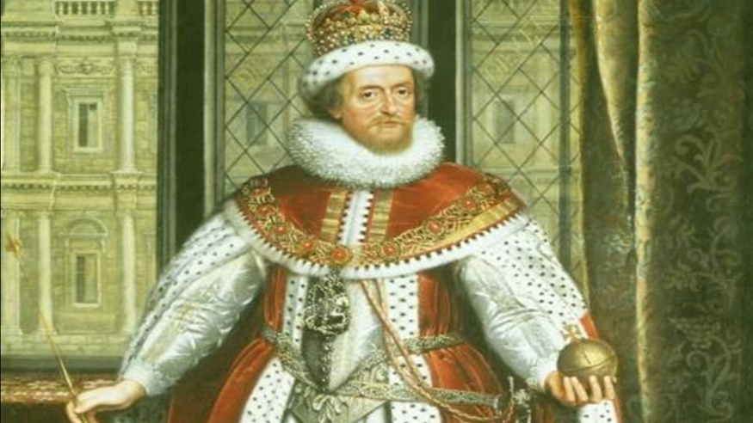

At last, England had a building which could compare with the modern palaces of Europe, a building in which the King could be proud to entertain foreign princes, ratify treaties, receive the Houses of Parliament, create new peers, celebrate the Feast of St George, and most importantly of all, conduct ambassadorial receptions. It was a building created to magnify the greatness of James and his Stuart dynasty, and James comprehensively used it as such. For the short time left to him after the Banqueting House was completed, it became the ceremonial heart of the kingdom. But, in 1625, he died, and left his kingdom, his palace, and his new dynastic memorial, the Banqueting House, to his son and heir, King Charles I.

But James I’s legacy here was an unfinished structure. As we have seen, Rubens pitched to paint the canvasses for the ceiling in 1621. It is likely, but we have no firm evidence, that his offer was accepted as early as 1621, but no progress was made until Rubens came to London on his diplomatic mission in 1629. In London, of course, he met Inigo Jones, and it is certain that the two men discussed in detail the commission. Architecturally, the model for the Banqueting House was a basilica from Ancient Rome, but both for Rubens and Jones, I think the idea for the ceiling came from the Sala del Collegio, the Hall of the College, in the Doge’s Palace in Venice, which both men knew well. This great room was where foreign delegations were received and granted an audience by the college, which was the majesty, composed of the Doge and his six counsellors. The hall was completely redecorated after a fire in 1574, and the gilded ceiling frames contained a series of works by Veronese done between 1578 and 1582. Of course, the important point is that the function of the room is the same as the function of the Banqueting House. So, the two men sat down, they also probably sat down with this committee that had been overseeing the Banqueting House, and at that point, the subject of the ceiling paintings were agreed. It was to be quite a complex scheme, commemorating the memory and achievements of James I. We have, very luckily, an oil sketch, recently acquired by the Tate Gallery, and the sketch is almost certainly the painting that was made by Rubens in 1629 while he was in London, while he was consulting with Jones, and that he showed to Charles I to get his approval. The sketch has elements in it of seven of the nine final panels. It was very quickly done, but it captivates the main style of what was to be achieved, and what went with this sketch was a written scheme setting out exactly what would be shown in the various canvasses.
What I do not want to do this afternoon is over-emphasise the influence of the Renaissance and Baroque Italy on this commission because the Banqueting House was actually firmly rooted in English tradition because there had been a long tradition in England, since the Middle Ages, of the main audience rooms of English Kings being painted with dynastic murals. Henry III’s Painted Chamber in the Palace of Westminster, and of course a 17th Century copy of the great painting by Hans Holbein the Younger which was in the Privy Chamber at Whitehall. This painting, the Whitehall Mural, has the same subject as the ceiling of the Banqueting House. Here you have the father, Henry VII, and his wife, Elizabeth of York, passing down the crown to Henry VIII and his wife Jane Seymour, and then on of course to Edward VI.

The new ceiling at the Banqueting House presented huge challenges to Rubens. The Painted Chamber, the mural in the Privy Chamber, were microscopically small in comparison. Never before had Rubens worked on this scale. The painted area was in total 225 square metres. In fact, these were the biggest ceiling canvasses in Northern Europe. Larger ones could only be found in the Doge’s Palace in Venice. In fact, the three largest of the canvasses, which we are going to talk about in a moment, were too big to be painted in his studio and had to be executed either in the galleries of the Antwerp Exchange or in the Refectory of the Carmelite Monastery. To help cover the huge square meterage, Rubens employed a team of assistants. But what of course he had to contend with was the fact that these canvasses would eventually be viewed from 50 feet below and generally at an angle, and so he had to sort out this perspectival problem, a problem that he had first encountered at the Jesuit church, where he had experimented first with the technique of fore-shortening based on an angle of sight of 45 degrees. When he had cracked these perspectival problems, he painted a complete sketch of the whole ceiling. This was sent from Antwerp to Charles I, and Charles I hung it on the ceiling of his closet in Whitehall Palace, and presumably he had to lie flat on his back on the floor to see the effect of it so he could get far enough away from it.

Well, these canvasses were completed in May 1633, but they lay rolled up in Rubens’ studio for nearly a year before they were re-touched and sent the 160 kilometres to Dunkirk on a wagon and, from there, they crossed the Channel and arrived in London. When the canvasses eventually appeared at Whitehall, they were unrolled on the floor of the Banqueting House. Now, extraordinarily, we have no record of this extraordinary moment, but it is unthinkable to think that Charles I himself was not standing over them as they were unrolled and enthusing about their quality.

There was however a problem. With mounting horror, Inigo Jones and Rubens’ assistants realised that the canvasses did not in fact fit in the holes in the ceiling. This was despite a huge amount of correspondence and careful supervision by both Rubens and the English. The problem was a very simple one. Although feet and inches were both used on both sides of the Channel, the length of a foot differed from country to country. Rubens misunderstood which length of foot Inigo Jones had specified, and so in at least four cases, fairly drastic alterations had to be made to Rubens’ paintings on site to get them to fit. The work of extending and re-painting the canvasses and tacking them into their timber stretchers was finished quickly, and they were finally lifted up into place by early 1636. Before they had arrived, Jones had supervised the re-decoration of the interior. The original plain white scheme was replaced by walls painted in imitation of marble and a ceiling encrusted in gold-leaf. In this way, a building begun for James I as a celebration of his reign was completed by his son as his memorial, and this is how we should read the Banqueting House today: it is a cenotaph for King James. The two rectangular canvasses in the ceiling here celebrated the King’s greatest achievements, and the centre oval represents God’s judgement of his success.

Looking at the ceiling, it is very important to realise that the compartments were carefully designed to be seen from specific viewing points. The canvas over the door for instance is invisible as you enter the room because it is directly above your head, and it is best seen from either the throne itself or when the visitors turned after they had addressed the monarch. It depicts James’ great achievement, the unification of the crowns of England and Scotland! Carrying the combined arms of England and Scotland, flying down to fix it on the back of the throne canopy, under which James is sitting, but James is not much interested in that – he is actually looking at England and Scotland presenting to him a baby, a baby who was actually born while these paintings were being painted. The baby of course was to be Charles II. The greatest achievement – passing on the dynasty…

The central canvas is set so that people entering the Hall would see it first, and this is important because this conveyed the central message of the whole scheme. Essentially, the central painting here encapsulates Charles I’s view of royal rule. In speeches he made in the House of Lords in 1628 and 1629, he made it quite clear that he saw that his authority derived directly from God, and it was to God only who he was responsible for his actions when he died. So, as a consequence, this painting shows James I being carried up to heaven, his earthly crown being removed, his heavenly crown being put on, and he is going up to God to give account of his work as King.

The oval here would not have been seen clearly by the monarch sitting on his throne, and this one, which was directly above his head, would have been completely invisible. In this one, James is shown sitting in a niche, symbolising his role as judge of his people and upholder of the law in Parliament, the keeper of the peace, and this theme of peace actually ran through the whole ceiling actually, in many ways. His imperial crown is being lifted and a triumphal crown is about to be passed on his head by two winged victories that you can see flying rather precariously above his head, and below his feet, James is expelling Mars, the God of War, and the various ghoulish monsters here sort of writhing beneath.

So, unquestionably, this is the most important piece of work that Rubens did in England, but I do not want to end on this because, in Charles I’s reign, there were two other architectural settings for Rubens’ work in London. We have seen one of them, which was the ceiling at York House, but there was also an altarpiece at Somerset House, and it is to this extremely interesting commission that I now want to turn.

We have got to remember that Rubens was a devout Roman Catholic, and he should be seen as one of the leading painters of the Roman Catholic Counter-Reformation, which was led, in the Netherlands, by his patrons, the Archduke Albert and the Archduchess Isabella. A significant part of Rubens’ output and some of his finest work was in fact religious painting. In 1622, the Archduchess Isabella had commissioned Rubens to paint a crucifixion with Mary, St John, and Mary Magdalene to present to the English Secretary of State, George Calvert. George Calvert was a Roman Catholic, and Isabella thought that a gift to such a powerful potential ally would help smooth the way for her future negotiations, and this painting, this crucifixion, was handed over to him in September 1622, and he was apparently delighted with it. But Calvert, who was, as I say, Secretary of State, fell out with the Duke of Buckingham in 1623 and retired to the country. The following year, he and the Duke were reconciled and, as a gesture of friendship and reconciliation, Calvert presented the Duke with his Rubens crucifixion. To be honest, the painting was probably not a very easy one to live with. It was ten-foot-high, it was eight-foot-wide, and as a crucifixion, at a time when Catholics were under intense suspicion, it was a bit of a liability. It seems as if the Duke was not that keen on the painting either and he presented it to the King, who thought that it would be most appropriate for his wife, Henrietta- Maria – pass the parcel. So, we do not know, but we suspect, that the Queen was absolutely thrilled with this gift. Early-17th Century Paris was alight with enthusiasm for Counter-Reformation and the court of Mary de’ Medici, where of course Henrietta Maria had been brought up, was a centre of Counter-Reformation activity, connected to a Carmelite Priory and an Oratory, and of course when Henrietta Maria came to England, she was accompanied by her Oratorian priests and her Capuchin friars, and of course it was her greatest wish that her household would become a Trojan horse to bring Roman Catholicism back to England. So, for her, the acquisition, in this roundabout way, of this huge altarpiece by the leading exponent of Northern European Counter-Reformation religious painting must have been something of a coup.

So, by their marriage treaty, Henrietta Maria was entitled to practise her Roman Catholicism and retain her own Roman Catholic priests. Her house was of course Denmark House or Somerset House. Those of you who have been to my evening lectures will have seen this before. The Strand, the river, the royal lodgings, the little Capuchin friary, the friary of the Capuchin order, entered through this gatehouse that the Queen built. Inside, is a plan of it. Inside the palace, you could get, or the Queen could get, via a special passageway, into an upper pew which would allow her to see the altar and observe services. Inside, it had another one of those great ceilings. A drawing of the ceiling, designed by Inigo Jones, very similar to the Banqueting House, but unfortunately, what we do not have is an image of the altarpiece at the east end of the church. But descriptions of the first mass held there make it certain that it was of a Counter-Reformation type, probably very similar to this print of 1643 by D. A. Pirrets from his book of engravings of altarpieces. This large space here above the tabernacle was the space designed to hold Rubens’ great Crucifixion.

So, what did the Crucifixion look like? Well, we have a number of written descriptions of it, and in fact, Rubens only painted a very small number of crucifixions that had Mary Magdalene and John at the foot of the cross. One of them is in the British Museum, a drawing, showing that composition. It was not the drawing for the altarpiece at Somerset House because I think we know that it was a drawing that was for an engraving. There is another one in Antwerp, here, which is an oil sketch and it is possible that this sketch is very similar or could even be related to the painting that ended up in the friary at Denmark House.

Denmark House Chapel was being completed at exactly the same time as the Chapel of Peterhouse, the college in Cambridge. The Peterhouse Chapel was, in many sense, the Anglican equivalent of the Queen’s Friary Church. The master of the college was Sir Christopher Wren’s uncle, Matthew Wren, a close follower of Archbishop Lord, who shared with Lord a strong belief that churches should reflect the beauty of holiness, and worship in them should be ceremonious. Today, we would describe this as a High Church point of view. These High Church views were regarded by many with suspicion, and by some, with complete horror. This Chapel is an extraordinary building, the most interesting building of its date in England, as far as chapels are concerned. It was richly decorated, and inside, the East Window, there was a stunning glazing scheme by the Flemish glazier, Bernard van Linge, and this design here is a design by Rubens. The painting is known as the Coup de Lance and was painted as an altarpiece for the Recollets Church in Antwerp in 1619-20, but it was engraved and published and it was widely available. At Peterhouse, the Coup de Lance was successfully translated into glass. The composition was expanded to fill all the five lights. If you compare the glass with the design by Rubens, you can see that this figure of Christ and the convicts either side are taken directly from the Rubens design. These windows at Peterhouse were completed in 1632. So, we have two important churches with major images by Rubens completed within a couple of years of each other.

Now, as the reign of Charles I slipped into chaos and eventually into Civil War, one of the key issues was the perceived Roman Catholic sympathy of the Royal Court. These suspicions embraced men like Matthew Wren and Archbishop Laud, but it in particular focused on the presence in the Queen’s household of this Capuchin Friary, full of Counter-Reformation art and architecture. The Civil War was then heralded by a vicious outburst of iconoclasm at many of these places. William Dowsing was a parliamentary zealot who was in charge of the destruction of all monuments of superstition and idolatry in Cambridge, and he records his visit to the Chapel at Peterhouse, and I quote: “We went to Peterhouse, 1643, December 21, with officers and soldiers, and December 20 and 23rd, we pulled down two mighty great angels with wings and diverse other angels and the four evangelists and Peter, with his keys, over the Chapel door, and about a hundred cherubims and angels and diverse superstitious letters in gold.” But Dowsing didn’t get to the windows because the college had taken them down and packed them in boxes before the troops arrived. They were reinstalled at the Restoration, which is why they’re there to be appreciated today.

The situation at Denmark House Chapel however was not as good. Here is the description of what happened there in the words of one of the Capuchin friars who saw it took place, and I am quoting: “One of the parliamentary commissioners, named Clotworthy, entered the Royal Chapel, where he climbed on the high altar and looked at the very valuable gilded picture done by the hand of Rubens. He called for a halberd,” in other words a long pike – “and he struck the first blow on the face of the crucifix with such offensive words it would be horrific to repeat. His second blow was at the Virgin’s face, with more hateful blasphemy, and then, thrusting his halberd under the feet of the crucified Christ, he ripped the painting to bits.” This orgy of destruction then moved to the side altars, to the statues and then into the cemetery outside. The remains of the great altarpiece were taken through the garden to the terrace, over the river, and there, Clotworthy and his men threw the tattered canvas into the waters of the River Thames.

Perhaps we might have expected this orgy of destruction to have engulfed the Banqueting House too. After all, this was the principal throne room of a republic, and the ceiling was a vast celebration of the very dynasty that had been ousted. But strangely, throughout Whitehall, the painted murals remained, in the old Palace of Westminster, then the House of Lords, Henry III’s murals remained. In the Palace Galleries, where the Coronation of Henry VIII was painted, they remain, in the Privy Chamber, the image of Henry VIII stayed, and in the Banqueting House, James I still presided over receptions and debates held by Oliver Cromwell.

So, why did the ceiling survive? Well, I see the execution of Charles I as the 17th Century Brexit. It was internationally unacceptable but it was very popular with some who felt that the monarch had betrayed their beliefs, but the new regime, like England after a potential Brexit, still had to rule. It still required palaces. It still required a Great Hall for the vital business of re-establishing international relations on an entirely different basis. While Roman Catholic images were completely unacceptable, there was no denying that England was once a monarchy, and so, while most of Charles I’s great art collection was sold off to pay the debts of the army, the bits that you couldn’t move were kept as the background for the magnificence of Cromwell’s rule. It is a little strange thought that Oliver Cromwell sat below this celebration of monarchy, but I think that we should see the ceiling in the Banqueting House more as a celebration of power. Charles I and Cromwell, in the end, were both Kings, even if they both did not have the name of King themselves.

© Professor Simon Thurley, 2016

Gresham College
Barnard’s Inn Hall
Holborn
London
EC1N 2HH

