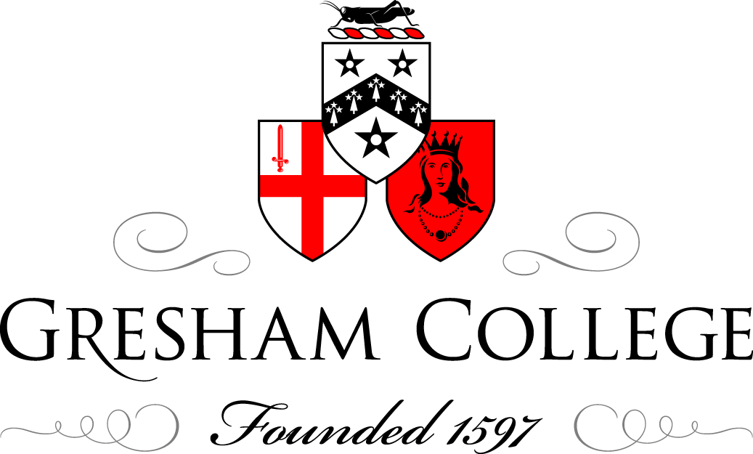

23 May 2013

Britten and the String Quartet:

A Classical Impulse- String Quartet No. 2

Professor Roger Parker

As mentioned at some length in my opening lecture of this series, Benjamin Britten (born a century ago in 1913) began his professional career in the 1930s as a prolific and precocious composer in an eclectic range of genres, indeed in practically every field except opera. In 1939, a few months before war was declared and together with the tenor Peter Pears, he went to the USA for a prolonged visit, perhaps even to emigrate; there he wrote and premiered his String Quartet No. 1, the first of his works in this genre to be granted an opus number, but preceded by many a quartet written during his teenage years. In 1942, in the midst of the Second World War and despite concerns about the safety of making an Atlantic crossing, Britten and Pears returned home. Worries about the journey aside, they did so with wider-reaching trepidation: during the preceding months, with his beleaguered homeland in the grip of a “total war” whose outcome was still far from certain, Britten’s absence had sparked a considerable controversy, one that says much about the mood of those uniquely dark and anxious times.

The most extended airing of this controversy took place in late 1941 in the pages of The Musical Times, an august journal that had been in existence for nearly a century. It was initiated, under the coy title “An English Composer Goes West”, by a certain Pilot-Officer E.R. Lewis, who, although not mentioning Britten by name, penned a letter of complaint about the attention given to a certain young composer who had emigrated to the US; Lewis stated that “the taking of American citizenship by the group to which he belongs invites mockery of the sociological ideals [I suppose he meant socialist ideals] which it formerly proffered at considerable length, and I must protest at the continued description of this musician as a ‘British composer’ when, by his own action, he disclaims that title”. With the battle lines thus drawn, a subsequent lengthy correspondence column did little to resolve matters, still less make the debate any less ill-tempered. Composers such as Gerald Cockshott and E.J. Moeran wrote in Britten’s defence, but they were shouted down by supporters of Lewis, the latter group shored up by heavy-handed editorial interventions that repeatedly reminded readers of the traumas of World War One and the duties of all in the present state of “total war”. Behind it all, of course, were anxieties by the bucket-load, some of them of a remarkably longstanding English pedigree: about Britten’s homosexuality, for example, and—related in most people’s minds—his association with Auden and other left-wingers who had similarly left their country of birth; about England as a place where music had long flourished but where embarrassingly few composers of international standing had emerged; about the status of art more generally and its relationship to masculine duty—as one sabre-rattler put it, “If [Benjamin Britten’s] art is to be worth much, he must be a man before he is an artist, ready to accept the risks, responsibilities and duties of a man”. It cannot have been by chance—again, the Musical Times’s editorial bias is obvious—that one tranche of this correspondence was juxtaposed with a news item about “fire-fighter” Dmitri Shostakovich, heroically finishing his Seventh Symphony in besieged Leningrad and declaring to the world that “the cultural workers of Leningrad are doing their duty like all other Leningrad citizens”.

In this high-charged context, it is small wonder that in the years immediately following Britten’s return, as he set up home with Pears in London and periodically escaped to deepest Suffolk in order to compose, he was careful to foster his rehabilitation as an “English” composer, building bridges wherever possible. Although he registered as a Conscientious Objector, he and Pears on occasions worked hard for CEMA (the Council for the Encouragement of Music and the Arts, an organization that after the war became the Arts Council), often giving concerts in, to put it kindly, less-than-elevated circumstances. What is more, and ultimately much more important, his major compositions in what remained of the war years—among them the Hymn to St. Cecilia, A Ceremony of Carols and the Serenade for Tenor, Horn and Strings—all display a clear commitment to English traditions. In particular they explore new ways of imagining the relationship between English words and English music, a relationship that Britten thought had endured a centuries-long period of decline.

This last circumstance obviously reappears in his most important work to emerge during these years, an opera that was premiered just as the war was coming to an end. As he admitted (and it was a potent sign of the operatic times), for an impecunious young composer trying to make his way in the world, an operatic project was the height of impracticality, and Britten was nothing if not practical. But even before he left the US he had an opera in mind, one based on a poem by Aldeburgh poet George Crabbe and set in a rough, seafaring community; crucially, he had been given a modest grant by the conductor Serge Koussevitsky, one that allowed him the extra time needed to write such a large-scale work. This Crabbe opera became, of course, Peter Grimes, which was premiered in London in June 1945 with Pears in the leading role; it proved so internationally successful that Britten was able to dedicate much of his future energy to opera—to make it, as he said at the time, his “real metier”. He was aware of the strangeness of this decision: the “professional” opera composer, the specialist, had long since disappeared. As Britten wrote to fellow composer Michael Tippett: “I am possibly an anachronism. I am a composer of opera, and that is what I am going to be, throughout”.

Grimes is an important moment in the tortured later-twentieth-century history of opera, but it was also a crucial one in Britten’s composing career and the reception of his music, establishing the backdrop against which future works such as his Second String Quartet would be listened to and assessed. One of the most striking aspects of early Grimes commentary, for example, is an anxious concern about where Britten stood vis-à-vis his musical heritage. Two questions were repeatedly asked. How did he relate to recent mainland European trends? And what about his national roots? With a little help from the composer himself, who was a diffident but canny self-publicist, answers came readily, if inconclusively. The first question, about what we might call his modernist credentials, generated confusion. Everyone could hear that Grimes was tonal—albeit often ambiguously so—and had few leanings towards the atonality or serialism then in European vogue. On the other hand, aspects of the score—not least its six orchestral interludes, its less-than-elevated subject matter and its unconventional, outsider protagonist—were plainly influenced by such advanced pieces as Berg’s Wozzeck. As for the second question, the matter of Englishness, here the position of Grimes was yet again not clear, mostly because there was virtually no native operatic tradition to refer to.

Significantly, Britten himself emphasised the national void preceding him: he declared that part of his task was “to restore to the musical setting of the English language a brilliance, freedom and vitality that have been curiously rare since the death of Purcell”, a statement that was often quoted approvingly by those favouring a modern-day English “Renaissance”. What is more, the harmonic idiom often veers into a modal writing (the sharpened-fourth of the Lydian mode a particular favourite) that—in spite of the Back-to-Purcell proclamations—has reminiscences with recent home-grown composers such as Gustav Holst and Ralph Vaughan Williams.

It was in this post-Grimes context that the Second String Quartet emerged, and there are many resonances with what we might call the “project” of the opera. Commissioned by and dedicated to Mary Behrend, a close friend at this time, and first performed in late 1945, the Second Quartet was one of a clutch of works (The Young Person's Guide to the Orchestra and The Holy Sonnets of John Donne are two others) that again celebrated the work of Henry Purcell. Indeed, the Wigmore Hall concert in which the Second String Quartet received its premiere was a commemoration of the 250th anniversary of Purcell’s death. As the composer wrote in a programme note for the concert: “Purcell was the last important international figure of English music. Ironically, the continent of Europe has been more aware of his greatness than the island which produced him. But that he should be to the English public little more than a name in history books is not altogether strange, for he is the antithesis of the music which has been popular for so long in this country”. Fighting words, one might think; but perhaps they can also be read between the lines. One the one hand, such patriotic celebration of Purcell might seem entirely laudable, and was by no means confined to Britten at this period: when the Royal Opera House opened its doors for operatic business in 1946 (it had been a dance hall during the war), its first fully staged opera was Purcell’s The Fairy Queen. On the other hand, though, we might recall that Britten’s eulogy is accomplished, at least in this verbal form, at the expense of other, more recent native composers, figures such as Holst and Vaughan Williams whose influence would presumably have been much more threatening.

Whatever the case, the composer announced to its dedicatee that this new Quartet was “the greatest advance that I have yet made, & altho’ it is far from perfect, it has given me encouragement to continue on new lines”. Let’s see if we can locate some of the aspects of the work that might betray that bold assessment. The first movement is marked “Allegro calmo senza rigore” (a calm, free Allegro), a tempo designation which is perhaps a gesture to looming classical precedents such as Beethoven, who was also fond of lengthy, evocative bits of Italian at the head of his later works. But what is immediately striking is the evocation of an ancient sound: the long-held pedal notes, and the prominent octave doublings of the winding, improvisatory melody, suggest a church organ that has somehow mutated into a string quartet. Also improvisatory, and also redolent of times (quite possibly Purcellian times) long past, is the fact that the movement is constructed out of severely limited material. Basically, it comprises what might be called a variation on one interval, the interval of a tenth, an open sonority that begins each new melodic idea, and that often underpins those ideas in the form of long-held pedal tones.

When, after this beautiful meandering opening, the music eventually picks up pace and energy, it betrays a strangely brittle form of dynamism, one that in many ways grows out of the stasis that has preceded it, and follows the same obsessive intervallic patterns. The Britten analytical industry has (perhaps inevitably) wanted to stress the sonata-form aspects of the movement. But it’s certainly easier (if less elevating) to hear an essential tension not between tonal areas or contrasting themes but rather between the quartet medium as a single, sonorous, hurdy-gurdy-like instrument on the one hand, and, on the other, as an unruly collection of four instruments constantly threatening to pull away from each other. What is clear, though, is that the hurdy-gurdy finally triumphs. In a beautiful coda, the stasis of the opening with its oh-so-resonant tenths reappears in the upper three instruments, while a cello, pizzicato and instructed to play “like a harp”, sketches some disarmingly simple cadences.

After this complex, challenging play of opposites, the second movement presents a sudden, even brutal contrast. There are clean-cut melodic lines and violent, stabbing chords (the Bernard Herrmann of Alfred Hitchcock’s Psycho might have been listening); but there are also passages in which the entire quartet ensemble seems to be dancing, each part at a slightly different speed. Where, one wonders, is all this nervous energy coming from? Why such agitation? One speculation is that, in contrast to those famous Britten moments (in Peter Grimes and elsewhere) in which nature is so tellingly evoked, here we are confronted with an eerie, scurrying, urban world, in which machine-like gestures fragment any sense of the musical pastoral of the preceding generation of English composers: or, another way of putting this, as if the needle had somehow become stuck on an insubstantial figure from a baroque dance movement, a figure that then gradually gains significance through continual, mechanical repetition. At the end, the machine winds down and we’re done, with multiple question marks hanging in the air.
And so to the third and last movement. It’s called “Chacony”, an overt homage to Purcell, who wrote several such movements, and the crowning glory of the quartet. It takes up more than half the work’s total length and comprises a theme and 21 variations, various sub-grouping of which are separated from each other by elaborate solo cadenzas. Although there are wisps of thematic similarity to earlier ideas in the work, in gestural terms this Chacony is utterly unlike anything that has come before. The stately octave-unison opening is like a study in elongation, as though a single gesture (itself a cadence, an endpoint) has been enlarged under a microscope, again with the quartet as a single, powerfully vibrating instrument. If you want my advice, don’t even try to count off those 21 variations; Britten makes such “structural listening” particularly difficult by fashioning his theme as a nine-bar unit, creating an irregularity that serves continually to upset any sense of orderly progress. Instead, listen on a larger scale to the alternation between solo passages and increasingly complicated ensemble textures; especially to the gradual accumulation of melodic detail in the slow-motion explosion of Baroque ornamentation (turns and trills especially). In listening to such moments, one might again think of late Beethoven, in particular the way his final movements tend to dissolve into airy trills. But, coming as it does so soon after Peter Grimes, it might also be useful to think of the Chacony as operatic, an evocation strongest in a beautiful legato section about two-thirds of the way through (it’s variation 16, in case—against my best advice—you are counting). The instruments are in blissful in parallel thirds and sixths, with shared trills and with the cello busy underneath in chordal pizzicatos.

And finally, most remarkable of all, in so many ways against the grain of the movement, comes a remarkable, hyper-affirmative ending. C major, the home key of the quartet, the open sonorities of which were explored so gently at the start of the first movement, returns here in huge gestures, massive chords pealing forth. It is almost as if, after being so many other things (hurdy-gurdy, organ, single complex vibrating instrument, and so on) the string quartet at the close strives to become a huge, celebratory orchestra. After the equivocation of the first movement, the eerie violence of the second and the stately progress of the Chacony, suddenly, and against the odds, we have arrived! A victory, or perhaps a homecoming, is grandly declared.

As so often with Britten, we can propose decodable musical meanings for this Quartet very much at our peril, or—rather—at risk of a diminishment of the music, which in so many ways defies simple interpretation. To take the most obvious example, does this work has something to say about its period of composition? Is it a postwar parable of sorts? The frequent references to Purcell and—by extension—to a moment in which British musical culture had a figure of international stature, might (as discussed earlier) seem patriotic; and certainly it’s easy to hear the triumphant ending as a celebration, or at least a release, of sorts. All this is surely consonant, and richly so, with England in late 1945. But such stories, in one sense invited by the music’s contrasts and multiple manners, is at the same time made somehow more fragile by the sheer complexity of the musical surface, the ambiguity of its effect. Perhaps it’s time for the words to stop and for the music, at once so haunting and so resistant to being pinned down, to take up the story. Here then, to play for you Britten’s Quartet No. 2, is the Badke Quartet. Please join me in welcoming them: Tamsin Waley-Cohen, first violin; Emma Parker, second violin; Jon Thorne, viola; and Jonathan Byers, cello.

© Professor Roger Parker 2013

