13 April 2011

To Infinity and Beyond

Professor Ian Morison

To Infinity and Beyond - a view of the cosmos.

Modern cosmology arose from Einstein's General Theory of Relativity which is essentially a theory of gravity. As gravity was the only force of infinite range that could act on neutral matter, Einstein realised that the universe as a whole must obey its laws. He was led to believe that the universe was "static", or unchanging with time, and this caused him a real problem as gravity, being an attractive force, would naturally cause stationary objects in space to collapse down to one point. To overcome this he had to introduce a term into his equation that he called the Cosmological Constant, Lambda or Λ. This represents a form of antigravity that has the interesting property that its effects become greater with distance. So, with one force decreasing and the second increasing with distance it was possible to produce a static solution. He later realised that this was an unstable situation, and that a static universe was not possible, calling this "the greatest blunder of his life". He could have predicted that the universe must be either expanding or contracting. However, as we shall see, perhaps he wasn't quite as wrong as he thought.

Big Bang models of the universe

A Russian meteorologist, A.A. Friedmann, solved Einstein's equations to produce a set of models in which the universe expanded from a point, or singularity. These were given the name "Big Bang" models by Fred Hoyle - this was meant to be a disparaging term as Hoyle was an advocate of another theory, the Steady State Theory, to be discussed below, and did not like them! In all of these models, the initially fast rate of expansion is slowed by the attractive gravitational force between the matter of the universe. If the density of matter within the universe exceeded a critical amount, it would be sufficient to cause the expansion to cease and then the universe would collapse down to a "Big Crunch" (these are called closed universes). If the actual density were less than the critical density, the universe would expand for ever (called open universes). In the critical case that is the boundary between the open and closed universes, the rate of expansion would fall to zero after infinite time (called the "flat" or "critical" universe).

A useful analogy is that of firing a rocket from the Earth; if the speed of the rocket is less than 11.186 km per second, the Earth's escape velocity, the rocket will eventually come to a halt and fall back to Earth (equivalent to closed universes), if it equals 11,186 km per second it will just escape the Earth with its speed reducing with time (equivalent to the critical universe), whilst if it exceeds 11.186 km per second it will leave the Earth more quickly (equivalent to open universes).

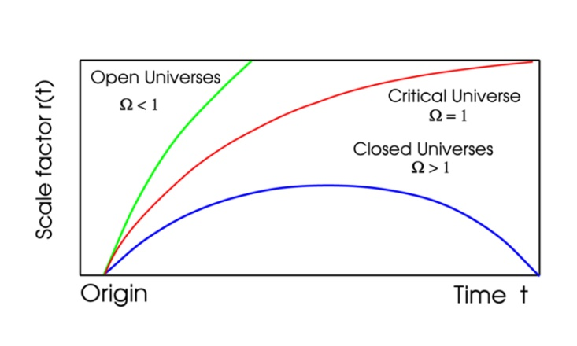

The models are distinguished by a constant, Ω (omega) that is defined as the ratio of the actual density to the critical density. In closed universes Ω is greater than 1, space has positive curvature, the angles within a triangle add up to more than 180 degrees and two initially parallel light rays would converge. In open universes Ω is less than 1, space has negative curvature, the angles within a triangle add up to less than 180 degrees and two initially parallel light rays would diverge. In the critical case, Ω is equal to 1, space is said to be "flat" (the author much prefers the term “Euclidian” rather than flat), the angles within a triangle add up to 180 degrees and two initially parallel light rays will remain parallel. It should be pointed out that this refers to a universe on the very large scale and, in the region of a massive object, such as a star or galaxy, the space becomes positively curved.

The Blueshifts and Redshifts observed in the spectra of galaxies.

As has been described in more detail in the transcript relating to “Hubble’s Heritage”, when the spectra of galaxies were first observed in the early 1900's it was found that their observed spectral lines, such as those of hydrogen and calcium, were shifted from the positions of the lines when observed in the laboratory. In the closest galaxies the lines were shifted toward the blue end of the spectrum, but for galaxies beyond our local group, the lines were shifted towards the red. This effect is called a "redshift" or "blueshift" and the simple explanation attributes this effect to the speed of approach or recession of the galaxy.

Some of the earliest observations of red and blue shifts were made by the American astronomer Vesto Slipher. In 1913 he discovered that the Andromeda galaxy had a blueshift of 300 km/s. This implies that Andromeda and the Milky Way galaxies are approaching each other due to the gravitational attraction between them but not, as might first appear, by 300 km/sec. Our Sun is orbiting the centre of our galaxy at about 220 km/second and taking this into account, the actual approach speed is nearer 100 km/sec. By 1915 Slipher had measured the shifts for 15 galaxies, 11 of which were redshifted. From the measured shifts, and using the Doppler formula given above he was able to calculate the velocities of approach or recession of these galaxies. These data were used by Edwin Hubble in what was perhaps the greatest observational discovery of the last century, and it is perhaps a little unfair that Slipher has not been given more recognition.

The expansion of the universe

In the late 1920's Edwin Hubble, using the 100" Hooker Telescope on Mount Wilson, measured the distances of galaxies in which he could observe a type of very bright variable star called Cepheid Variables which vary in brightness with very regular periods – as described in the “Hubble’s Heritage Transcript”. He combined these measurements with those of their speed of approach or recession (provided by Slipher) of their host galaxies to produce a plot of speed against distance. All, except the closest galaxies, were receding from us and he found that the greater the distance, the greater the apparent speed of recession. From this he derived "Hubble's Law" in which the speed of recession and distance were directly proportional and related by "Hubble's Constant" or H₀. The value that is derived from his original data was ~500 km/sec/Mpc. Such a linear relationship is a direct result of observing a universe that is expanding uniformly, so Hubble had shown that we live within an expanding universe. The use of the word "constant" is perhaps misleading. It would only be a real constant if the universe expanded linearly throughout the whole of its existence. It has not - which is why the subscript is used. H₀ is the current value of Hubble's Constant!

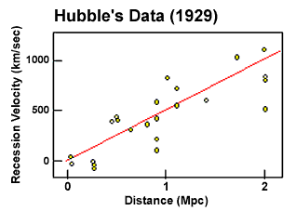

If one makes the simple assumption that the universe has expanded at a uniform rate throughout its existence, then it is possible to backtrack in time until the universe would have had no size - its origin - and hence estimate the age, known as the Hubble Age, of the universe. This is very simply given by 1/H₀ and, using 500 km/sec/Mpc, one derives an age of about 2000 million years:

1/H₀ = 1 Mpc / 500 km/sec
= 3.26 million light years/ 500 km/sec
= 3.26 x 10⁶ x 365 x 24 x 3600 x 3 x 10⁵ sec / 500
= 3.26 x 10⁶ x 3 x 10⁵ years / 500
= 1.96 x 10⁹ years
= ~2 Billion years

In fact, in all the Friedmann models, the real age must be less than this as the universe would have been expanding faster in the past and, in the case of the "flat" universe, the actual age would be 2/3 that of the Hubble Age or ~1,300 million years old.

A problem with age
This result obviously became a problem as the age of the solar system was determined (~4,500 million years) and calculations relating to the evolution of stars made by Hoyle and others indicated that some stars must be much older than that, ~10 to 12 thousand million years old. During the blackouts of World War II, Walter Baade used the 100" telescope to study the stars in the Andromeda Galaxy and discovered that there were, in fact, two types of Cepheid variable. As a result, Hubble's constant reduced to ~250 km/sec/Mpc. There still remained many problems in estimating distances, but gradually the observations have been refined and, as a result, the estimate of Hubble's constant has reduced in value to about 70 km/sec/Mpc. One of the best determinations, 74.2 +/- 3.6 km/sec / Mpc, is that made by a "key project" of the Hubble Space Telescope that observed almost 800 Cepheid variable stars in 19 galaxies out to a distance of 108 million light-years. Observations of gravitational lenses give a totally independent method of determining the Hubble Constant and their best value to date is:
H₀ =71+/-6 km s⁻¹ Mpc⁻¹.

These are in very good agreement so it is unlikely that the true value of Hubble's constant will differ greatly from this. But the Hubble age of ~14,000 Million years that is derived corresponds to the age of a "flat" universe of only ~9,300 million years. From observations of globular clusters - which contain some of the oldest stars in the universe - and of the white dwarf remnants of stars we suspect that the universe must be somewhat older than 12,000 Million years so, if we believe the current value of Hubble's constant, there is still an age problem with the Big Bang models.

NB: This is really important and is rarely ever pointed out. The standard Big Bang models cannot be correct!

The Cosmological Redshift

In the section above, the blueshift and redshift were regarded as being due to the Doppler effect, and this would be perfectly correct when considering the blue shifts shown by the galaxies in the local group. However in the cases of galaxies beyond our local group there is a far better way of thinking about the cause of the redshifts that we see. As Hubble showed, the universe is expanding so that it would have been smaller in the past. In addition it is not right to think of the galaxies (beyond the movements of those in our local group) moving through space but, rather, that they are being carried apart by the expansion of space. A nice analogy is that of baking a currant bun. The dough is packed with currents and then baked. When taken out of the oven the bin will (hopefully) be bigger and thus the currants will be further apart. They will not have moved through the dough, but will have been carried apart by the expansion of the dough.

When a photon was emitted in a distant galaxy corresponding to a specific spectral line, the Universe would have been smaller. In the time it has taken that photon to reach us and the photon has traveled through space, the universe has expanded and this expansion has stretched, by exactly the same ratio, the wavelength of the photon. This increases the wavelength so giving rise to a redshift that we call the "Cosmological Redshift". A simple analogy is that of drawing a sine wave (representing the wavelength of a photon) onto a slightly blown up balloon. If the balloon is then blown up further, the length between the peaks of the sine wave (its wavelength) will increase.

The steady state model of the universe

Because of this "age" problem many astronomers did not give much credence to the Big Bang models and in 1948, Herman Bondi, Thomas Gold and Fred Hoyle, who disliked the idea of an instantaneous origin of the universe, proposed an alternative theory called the "Steady State" theory. All cosmological theories embrace what is called the "cosmological principle" that is, on the large scale at any given time, the view of the universe from any location within it will be the same. (This has been nicely proven by the Hubble Space Telescope in that the two Hubble Deep Fields, one in the northern sky and one in the south, have identical characteristics.) Bondi, Gold and Hoyle extended this principle to give what they called "the perfect cosmological principle" where the words "at any given time" were replaced by "for all time". Their universe was unchanging on the large scale. That did not mean that it was not expanding. At the heart of their theory was the idea that, as the galaxies moved further apart due to the expansion of the universe, new matter, in the form of hydrogen, was created in the space between them which eventually formed new galaxies to keep the observed density of galaxies constant. The universe had no beginning and will have no end and is, as the theory's name implies, in a "steady state". As new matter is continuously being created, it is also called the theory of continuous creation.

Big Bang or Steady State?

In the early 1960's observational tests were made to decide between the two theories. Suppose one could measure the galaxy density close to us - to give the number of galaxies per cubic mega-parsec. As these galaxies are close to us we see them essentially at the present time. If we could then measure the density of galaxies in the far universe, we would be measuring it at some time in the past. In the Steady State model these results should be the same, but in the Big Bang model the density should have been higher in the past. Martin Ryle at Cambridge attempted such measurements by counting radio sources. Though there were problems with his initial data, these results did finally indicate a greater density of radio sources in the past so disproving the Steady State theory. The deathblow to the Steady State theory came in 1963 when radiation, believed to have come from the Big Bang, was discovered.

The Cosmic Microwave Background

It was the American physicist, George Gamow, who first realised that the Big Bang should have resulted in radiation that would still pervade the universe. This radiation is now called the "Cosmic Microwave Background" (CMB). Initially in the form of very high-energy gamma rays, the radiation became less energetic as the universe expanded and cooled so that by a time some 300 to 400 thousand years after the origin the peak of the radiation was in the optical part of the spectrum. Up to that time the typical photon energy was sufficiently high to prevent the formation of hydrogen and helium atoms and thus the universe was composed of hydrogen and helium nuclei and free electrons - so forming a plasma. The electrons would have scattered photons rather as water droplets scatter light in a fog and thus the universe would have been opaque. This close interaction between the matter and radiation in the universe gave rise to two critical consequences: firstly the radiation would have a black body spectrum corresponding to the then temperature of the universe and secondly that the distribution of the nuclei and electrons (normal matter) would have a uniform density except on the very largest scales.

We will return to the second consequence later, but now will continue with the first. As the universe expanded and cooled there finally came a time, ~ 380,000 years after the origin, when the typical photon energy became low enough to allow atoms to form. There were then no free electrons left to scatter radiation so the universe became transparent. This is thus as far back in time as we are able to see. At this time the universe had a temperature of ~3000K. Since that time, the universe has expanded by about 1000 times. The wavelengths of the photons that made up the CMB will also have expanded by 1000 times and so will now be in the far infrared and radio part of the spectrum - but would still have a black body spectrum. The effective black body temperature of this radiation will have fallen by just the same factor and would thus now be ~3K.

The Discovery of the CMB

Radio astronomers Arno Penzias and Robert Wilson serendipitously discovered this background radiation in 1963, but incontrovertible proof as to its origin had to wait until 1992 when the COBE satellite was able to show that the background radiation had the precise black body spectrum that would have been expected. It is worth telling a little of the Nobel Prize winning story of its discovery. Penzias and Wilson had been given use of the telescope and receiver that had been used for the very first passive satellite communication experiments using a large aluminum covered balloon called "Echo". It had been designed to minimise any extraneous noise that might enter the horn shaped telescope and the receiver was one of the best in the world at that time. They tested it thoroughly and found that there was more background noise produced by the system than they expected. They wondered if it might have been caused by pigeons nesting within the horn - being at ~ 290 K they would radiate radio noise - and bought a “Havahart” pigeon trap (now in the Smithsonian Air and Space Museum in Washington) to catch the pigeons. They were taken 40 miles away and released but, as pigeons do, they returned and had to be "removed" by a local pigeon expert. During their time within the horn antenna, the pigeons had covered much of the interior with what, in their letter to the journal Science was called "a white dielectric substance" - we might call it "guano". This was cleaned out as well but having removed both the pigeons and the guano there was no substantial difference. The excess noise remained the same wherever they pointed the telescope - it came equally from all parts of the sky. An astronomer, Bernie Burke, when told of the problem suggested that they contact Robert Dicke at Princeton University. Dicke had independently theorised that the universe should be filled with radiation resulting from the big-bang and was building a horn antenna on top of the Physics department in order to detect it. Learning of Penzias and Wilson's observations, Dicke immediately realised that his group had been "scooped" and told them that the excess noise was not caused within their horn antenna or receiver but that their observations agreed exactly with predictions that the universe would be filled with radiation left over from the Big Bang. Dicke was soon able to confirm their result, and it was perhaps a little unfair that he did not share in the Nobel Prize. The average temperature of the CMB is 2.725K. Thirty years later COBE's measurements were able to show that the CMB had the precise "blackbody spectrum" that would result from the Big Bang scenario. Since then, it has been very difficult to refute the fact that there was a Big Bang.

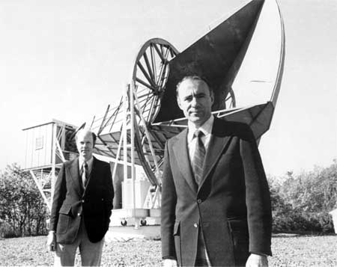
Arno Penzias and Robert Wilson at the Holmdel Antenna

[This story is detailed in the transcript for the lecture “The Afterglow of Creation”]

Inflation

By the 1970's, problems with the standard Big Bang models had arisen. Observations had shown that the universe was very close to being "flat", Ω ~1, and the Big Bang theory gives no particular reason why this should be so. Any curvature that the Universe has close to its origin tends to get enhanced as the Universe ages - a slightly positively curved space become more and more so and vice versa. In fact, had not  Ω been in the range 0.999999999999999 to 1.000000000000001 one second after its origin the Universe could not be as it is now! This is incredibly fine tuning, and there is nothing in the standard Big Bang theory to explain why this should be so. This is called the "flatness" problem.

A second problem is known as the "horizon" problem. The universe appears to have exactly the same properties - specifically the observed temperature of the cosmic microwave background - in opposing directions. The CMB from one direction has taken nearly 14,000 million years to reach us, and the same from the opposing direction. In the standard Big Bang models there has not been sufficient time to allow radiation to travel from one of these regions to the other - they cannot "know" what each other's temperature is, as this information cannot travel faster than the speed of light. So why are they at precisely the same temperature?

These problems were addressed with the idea of "inflation", first proposed by Alan Guth and refined by others. In this scenario the whole of the visible universe would have initially been contained in a volume of order the size of a proton. Some 10⁻³⁵ of a second after the origin this volume of space began to expand exponentially and increased in size by a factor of order 10⁵⁰ - 10⁶⁰ in a time of ~10⁻³² second - to the size of a sphere a metre or more in size. This massive expansion of space would force the geometry of space to become "flat", just as the surface of a balloon appears to become flatter and flatter as it expands. (Hence one would naturally get a "flat" universe.) Inflation would also ensure that the whole of the visible universe would have uniform properties so also addressing the horizon problem. This is a result of the fact that prior to the inflationary period the volume of spacetime that now forms the visible universe was sufficiently small that radiation could easily travel across it and so give it a uniform temperature.

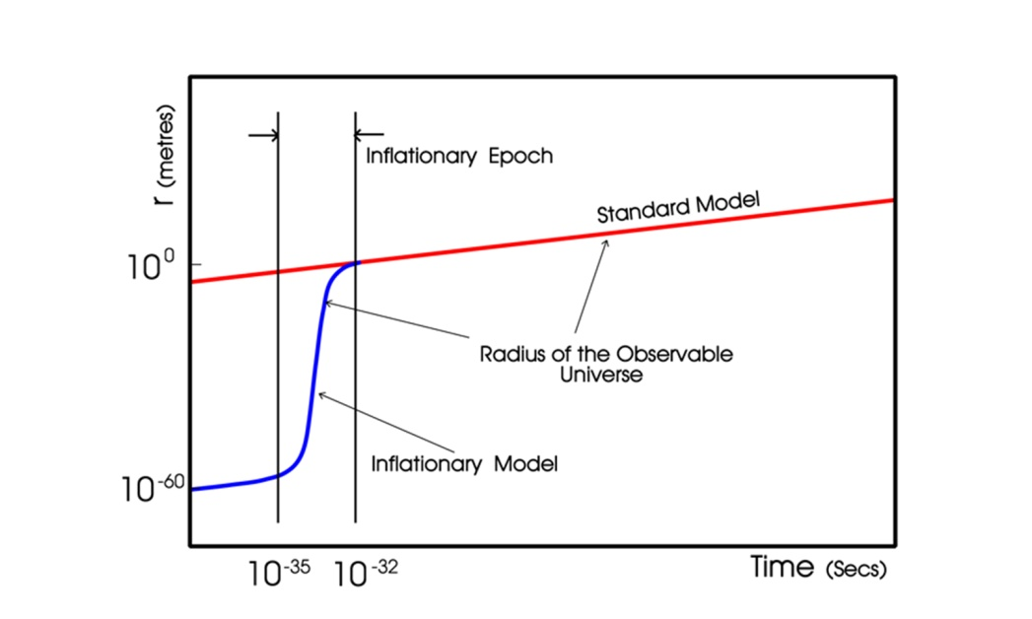
The Big Bang and the formation of the primeval elements

Half of the gravitational potential energy that arose from this inflationary period was converted into kinetic energy from which arose an almost identical number of particles and antiparticles, but with a very small excess of matter particles (~1 part in several billion). All the antiparticles annihilated with their respective particles leaving a relatively small number of particles in a bath of radiation. The bulk of this "baryonic matter" was in the form of quarks that, at about 1 second after the origin, grouped into threes to form protons and neutrons. (Two up quarks and one down quark form a proton, and one up quark and two down quarks a neutron. The up quark has +2/3 charge and the down quark -1/3 charge so the proton has a charge of +1 and the neutron 0 charge.) An almost equal number of protons and neutrons were produced but, as free neutrons are unstable with a half-life of 10.3 minutes, the only ones to remain were those that were incorporated into helium nuclei comprising two protons and two neutrons. So, after a few minutes, the normal (baryonic) matter in the universe was very largely composed of hydrogen nuclei (protons), helium nuclei (alpha particles) and electrons - with one electron for each proton. (We now believe that several times more "dark matter", whose constitution will be discussed below, was also created.)

[A more detailed description is given in the transcript “The Violent Universe”]

The "ripples" in the CMB.

Observations by the COBE spacecraft first showed that the CMB did not have a totally uniform temperature and, since then, observations from the WMAP spacecraft, balloons and high mountain tops have been able to make maps of these so called "ripples" in the CMB - temperature fluctuations in the observed temperature of typically 60 micro Kelvin.
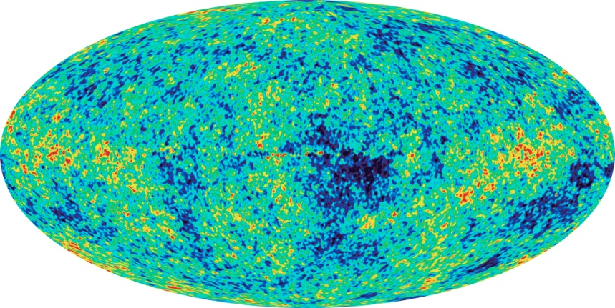

All-sky map of the CMB ripples produced by WMAP in February 2003

Why are these small variations present? To answer this we need to understand a little about "dark matter". Though not yet directly detected, its presence has been inferred from a wide variety of observations which will be discussed in detail later.

As described above, for ~380,000 years following the big bang, the matter and radiation were interacting as the energy of the photons was sufficient to ionize the atoms giving rise to a plasma of nuclei and free electrons. This gives rise to two results:

1) The radiation and matter are in thermal equilibrium and the radiation will thus have a black body spectrum.

2) The plasma of nuclei and electrons will be very homogeneous as the photons act rather like a whisk beating up a mix of ingredients.

It is the second of these that is important to the argument that follows. When the temperature drops to the point that atoms can form the matter can begin to clump under gravity to form stars and galaxies. Simulations have shown that, as the initial gas is so uniformly distributed, it would take perhaps 8 to 10 billion years for regions of the gas to become sufficiently dense for this to happen. But we know that galaxies came into existence around 1 billion years after the Big Bang. Something must have aided the process. We believe that this was non-baryonic dark matter. As this would not have been coupled to the radiation, it could have begun to gravitationally "clump" immediately after the Big Bang. Thus when the normal matter became decoupled from the photons, there were "gravitational wells" in place formed by concentrations of dark matter. The normal matter could then quickly fall into these wells, rapidly increasing its density and thus greatly accelerating the process of galaxy formation.

[Dark matter is covered in detail in the transcript for the lecture “The Invisible Universe”.]

How Dark Matter affects the CMB

The concentrations of dark matter that existed at the time the CMB originated have an observable effect due to the fact that if radiation has to "climb out" of a gravitational potential well it will suffer a type of red shift called the "gravitational red shift". So the photons of the CMB that left regions where the dark matter had clumped would have had longer wavelengths than those that left regions with less dark matter. This causes the effective blackbody temperature of photons coming from denser regions of dark matter to be less than those from sparser regions - thus giving rise to the temperature fluctuations that are observed. As such observations can directly tell us about the universe as it was just 380,000 or so years after its origin it is not surprising that they are so valuable to cosmologists! Not only that; the photons that make up the CMB have traveled across space for billions of years and will thus have been affected by the curvature of space. It is possible to simulate the expected pattern of fluctuations if space were negatively curved, positively curved or flat so that if astronomers could map these fluctuations accurately then it would be possible to measure the curvature of space.

This is no easy matter. The CMB needs to be observed at mm radio wavelengths that are masked by emission from water vapour in the Earth's atmosphere. So experiments have been flown in satellites (COBE and WMAP), balloons (Boomerang and Maxima) or located at high dry sites on Earth such as the Atacama Desert in Chile at a height of 16,000 ft or on the flanks of Mount Teide in Tenerife (the CBI and VSA experiments respectively). Another very good site, where the DASI experiment is located, is at the South Pole where it is so cold that the water vapour is largely frozen out of the atmosphere! The results of these observations of the small temperature fluctuations in the CMB confirm, without exception, that space is flat to within 1-2% : Ω = 1.

The Hidden Universe: Dark Matter and Dark Energy
If, as inflation predicts and observations confirm, space has zero curvature, it is possible to calculate the average density and the total mass/energy content of the visible Universe. If the total mass was M, then it appears that the best estimate of the mass of the visible matter, stars and excited gas, is about 0.01M. 99% of the content of the Universe is invisible! The first question to ask is whether this invisible content is normal (baryonic) matter that just does not emit light - gas, dust, or objects such as brown dwarfs, neutron stars or black holes. These latter objects are called MACHOs (Massive Astronomical Compact Halo Objects) as many would reside in the galactic halos that extend around galaxies.

There are two pieces of evidence that indicate that the total amount of normal matter in the Universe is only ~4% of the total mass/energy content. The first depends on measurements of the relative percentages of hydrogen, helium and lithium and their isotopes that were formed in the big bang. These are very sensitive to the baryon to photon ratio and put an upper limit of baryonic matter at about 4%. The second line of evidence is that if a significant amount of mass were in the form of MACHOs then gravitational micro lensing studies (as have discovered a number of planets) would have detected them. Though we know that, for example, pulsars are found in the galactic halo the total mass of these and other MACHOs cannot explain the missing matter. So we still have to account for ~96% of the total mass/energy content of the Universe! From several lines of observational evidence it is believed that a substantial part of this is in the form of non-baryonic dark matter - usually just called dark matter.

Evidence for Dark Matter

[This is covered in detail in the transcript for the lecture “The Invisible Universe”]

1) Cluster Dynamics

The first evidence of a large amount of unseen matter came from observations made by Fritz Zwicky in the 1930's. He studied the Coma cluster of galaxies, 321 million light years distant, and observed that the outer members of the cluster were moving at far higher speeds than were expected. Suppose a cluster of galaxies were created which were not in motion. Gravity would soon cause them collapse down into a single giant body. If, on the other hand, the galaxies were initially given very high speeds relative one to another, their kinetic energy would enable them to disperse into the Universe and the cluster would disperse, just as a rocket traveling at a sufficiently high speed could escape the gravitational field of the Earth. The fact that we observe a cluster of galaxies many billions of years after it was created implies that that there must be an equilibrium balancing the gravitational pull of the cluster's total mass and the average kinetic energy of its members. This concept is enshrined in what is called the Virial Theorem so that, if the speeds of the cluster members can be found, it is possible to estimate the total mass of the cluster. Zwicky carried out these calculations which showed that the Coma Cluster must contain significantly more mass than could be accounted for by its visible content.

2) Evidence for an unseen component in Spiral Galaxies

In the 1970's a problem related to the dynamics of galaxies came to light. Vera Rubin observed the light from HII regions (ionized clouds of hydrogen such as the Orion Nebula) in a number of spiral galaxies. These HII regions move with the stars and other visible matter in the galaxies but, as they are very bright, are easier to observe than other visible matter. HII regions emit the deep red hydrogen alpha (H-alpha) spectral line. By measuring the Doppler shift in this spectral line, Vera Rubin was able to plot their velocities around the galactic centre as a function of their distance from it. She had expected that clouds that were more distant from the centre of the galaxy (where much of its mass was expected to be concentrated) would rotate at lower speeds - just as the outer planets travel more slowly around the Sun. This is known as Keplerian motion, with the rotational speed decreasing inversely as the square root of the distance from centre. (This is enshrined in Kepler's third law of planetary motion and can be derived from Newton's law of gravity.)

To her great surprise, Rubin found that the rotational speeds of the clouds did not decrease with increasing distance from the galactic centre and, in some cases, even increased somewhat. Not all the mass of the galaxy is located in the centre but the rotational speed would still be expected to decrease with increasing radius beyond the inner regions of the galaxy although the decrease would not be as rapid as if all the mass were located in the centre. To give a concrete example; the rotation speed of our own Sun around the centre of the Milky Way galaxy would be expected to be about 160km/sec. It is, in fact, ~ 220km/sec. The only way these results can be explained is that either the stars in the galaxy are embedded in a large halo of unseen matter - extending well beyond the visible galaxy - or that Newton's law of gravity does not hold true for large distances. The unseen matter whose gravitational effects her observations had discovered is further evidence of "Dark Matter".

How much non-baryonic dark matter is there?

The best fit to current observations corresponds to dark matter making up ~ 23% of the total mass/energy content of the Universe. Other observations support this result. This the leaves two further questions: what is dark matter and what provides the remaining 73% of the total mass/energy content?

What is Dark Matter?

The honest answer is that we do not really know. The standard model of particle physics does not predict its existence and so extensions to the standard theory (which have yet to be proven) have to be used to predict what it might be and suggest how it might be detected. Dark matter can be split into two possible components: Hot Dark Matter would be made up of very light particles moving close to the speed of light (hence hot) whilst Cold Dark Matter (CDM) would comprise relatively massive particles moving more slowly. Simulations that try to model the evolution of structure in the Universe - the distribution of the clusters and super clusters of galaxies - require that most of the dark matter is "cold" but astronomers do believe that there is a small component of hot dark matter in the form of neutrinos. There are vast numbers of neutrinos in the Universe but they were long thought to have no mass. However recent observations imply that they must have some mass but current estimates put this at less than 1 millionth of the mass of the electron. As a result they would only make a small contribution to the total amount of dark matter - agreeing with the simulations.

Axions and WIMPS

One possible candidate for cold dark matter is a light neutral axion whose existence was predicted by the Peccei-Quinn theory in 1977. There would be of order 10 trillion in every cubic centimetre! An extension to the standard model of particle physics called "super symmetry" suggests that WIMPS (Weakly Interacting Massive Particles) might be a major constituent of CDM. A leading candidate is the neutralino - the lightest neutral super symmetric particle. Billions of WIMPS could be passing through us each second! Very occasionally they will interact with the nucleus of an atom making it recoil - rather like the impact of a moving billiard ball with a stationary one. In principle, but with very great difficulty, these interactions can be detected.

Dark Energy

Normal and Dark matter can between them account for some 27% of the total mass energy of the Universe. It appears that the majority, some 73%, must be something else. It appears to be a form of energy latent within space itself that does not cluster and so is totally uniform throughout space. In fact this could be exactly what was invoked by Einstein to make his "static" universe - the cosmological constant or Lambda, Λ. A positive Λ term can be interpreted as a fixed positive energy density that pervades all space and is unchanging with time. Its net effect would be repulsive. There are, however, other options and a range of models are being explored where the energy is time dependent. These are given names such as "quintessence", meaning 5th force. As the total amount of this energy and its repulsive effects are proportional to the volume of space, the effects of dark energy should become more obvious as the Universe ages and its size increases.

In all of the Friedmann models of the Universe, the initial expansion slows with time as gravity reins back the expansion, and the expansion rate would never increase. However if there is a component in the Universe whose effect is repulsive and increasing with the volume of space, the scale size of the Universe will vary in a quite different way with time. Initially, when the volume of the Universe is small, gravity will dominate over dark energy and the initial expansion rate of the Universe will slow - just as in the Friedmann models, but there will come a point when the repulsive effects of the dark energy will equal and then overcome gravity and the Universe will begin to expand at an ever increasing rate. If this is the case, distant galaxies will be further away from us than would have been the case in the Friedmann models.

Evidence for Dark Energy

But, though Cepheid variable stars are some of the brightest stars known, there is a limit to distances that can be measured by using them. Something brighter is required. For a short time, supernovae are the brightest objects in the Universe and there is one variant, called a Type 1a supernova, that is believed to have a uniform peak brightness. It might be useful to consider an analogy. Imagine a ball of plutonium of less than critical mass. If one then gradually added additional plutonium uniformly onto its surface it would, at some point in time, exceed the critical mass and explode. The power of this explosion should be the same each time the experiment is carried out as a sphere of plutonium has a well defined critical mass.

A type 1a supernova occurs in a binary system. The more massive star of the pair will evolve to its final state first and its core may become a white dwarf about the size of the Earth. Later its companion will become a red giant and its size will dramatically increase. Its outer layers may then be attracted onto the surface of the white dwarf whose mass will thus increase. At some critical point, when its mass nears the Chandrasekhar limit of roughly 1.44 times the mass of the Sun, the outer layers will ignite and in the resulting thermonuclear explosion the entire white dwarf star will be consumed. As all such supernovae will explode when they reach the same total mass, it is expected that they will all have similar peak brightnesses (about 5 billion times brighter than the Sun) and should thus make excellent standard candles.

Because type Ia supernovae are so bright, it is possible to see them at very large distances. The brightest Cepheid variable stars can be seen at distances out to about 10-20 Mpc (~32 to 64 million light years). Type Ia supernovae are approximately 14 magnitudes brighter than Cepheid variables, and are thus about a quarter of a million times brighter. They can thus be can be seen about 500 times further away corresponding to a distance of around 1000 Mpc - a significant fraction of the radius of the known Universe. However supernovae are rare with perhaps one each 300 years in a typical spiral galaxy. Observations are now observing thousands of distant galaxies on a regular basis and sophisticated computer programs look for supernovae events. Once initially detected, observations continue to look for the characteristic light curve of a type 1a supernova which results from the radioactive decay of nickel-56; first to cobalt-56 and then to iron-56.

Hubble (and later others) plotted the apparent expansion velocity of galaxies against their distance and produced a linear plot. This plot would not be expected to continue linearly out to very great distances due to changes in the expansion rate of the Universe over time. For the critical (or zero curvature) Universe which the CMB observations imply, the curve would have been expected to fall below the linear line for great distances. Observations of distant type Ia supernovae have recently enabled far greater distances to be measured which, together with the corresponding redshifts, have enabled the Hubble plot to be extended to the point where the plot would no longer be linear. As expected, the plot is no longer linear but, to great surprise, the curve falls above the linear extrapolation, not below. This implies that the expansion of the Universe is speeding up - not slowing down as expected - and is thus evidence that dark energy exists.

The nature of dark energy

Dark energy is known to be very homogeneous, not very dense (about 10⁻²⁹ grams per cc) and appears not to interact through any of the fundamental forces other than gravity. This makes it very hard to detect in the laboratory.

The simplest explanation for dark energy is that a volume of space has some intrinsic, fundamental energy as hypothesized by Einstein with his cosmological constant. Einstein's special theory of relativity relates energy and mass by the relation E = mc² and so this energy will have a gravitational effect. It is often called a vacuum energy because it is the energy density of empty vacuum. In fact, most theories of particle physics predict vacuum fluctuations that would give the vacuum exactly this sort of energy. One can perhaps get some feeling of why a pure vacuum can contain energy by realizing that it is not actually empty! Heisenberg's Uncertainty Principle allows particles to continuously come into existence and (quickly) go out of existence again. A pure vacuum is seething with these virtual particles!

According then to Heisenberg's Uncertainty Principle there is an uncertainty in the amount of energy that can exist. Because of the equivalence between matter and energy, these small energy fluctuations can produce particles of matter (a particle and its anti-particle must be produced simultaneously) which come into existence for a short time and then disappear. A number of experiments have been able to detect this vacuum energy. One of these is the Casimir experiment in which, in principle, two metal plates are placed very close together in a vacuum. In practice it is easier to use one plate and one plate which is part of a sphere of very large radius. One way to think of this is that the virtual particles have associated wavelengths - the wave particle duality. Virtual particles whose wavelengths are longer than the separation of the plates cannot exist between them so there are more virtual particles on their outer sides and this imbalance gives the effect of an attractive force between the plates.

An interesting analogy is when two ships sail alongside each other to transfer stores or fuel in the open sea in conditions with little wind but a significant swell. Between them, only waves whose wavelength is smaller than the separation of the hulls can exist but on the outside all wavelengths can be present. This inequality gives rise to a force that tends to push the two ships apart, thus requiring that the ships actively steer away from each other.

The cosmological constant is the simplest solution to the problem of cosmic acceleration with just one number successfully explaining a variety of observations and has become an essential feature in the current standard model of cosmology. Called the Lambda-CDM (or Λ-CDM) model, as it incorporates both cold dark matter and the cosmological constant, it can be used to predict the future of the Universe.

The makeup of the Universe

The observations of the CMB, type Ia supernovae, Hubble's Constant and the distribution of galaxies in space all now give a consistent model of the universe. It appears that normal matter accounts for just ~4%, dark matter ~23% with the remaining ~73% of the total mass energy content of the universe being in the form of dark energy. Over the next few years, as the CMB observations are refined, we will have pretty accurate values for these percentages. The figure shows how we believe that the scale size of the universe has changed with time in the past and how it will expand ever faster in the future. You will see that the actual age of the universe is similar to the Hubble Age (linear expansion zero) with a value now believed to be 13.75 thousand million years.

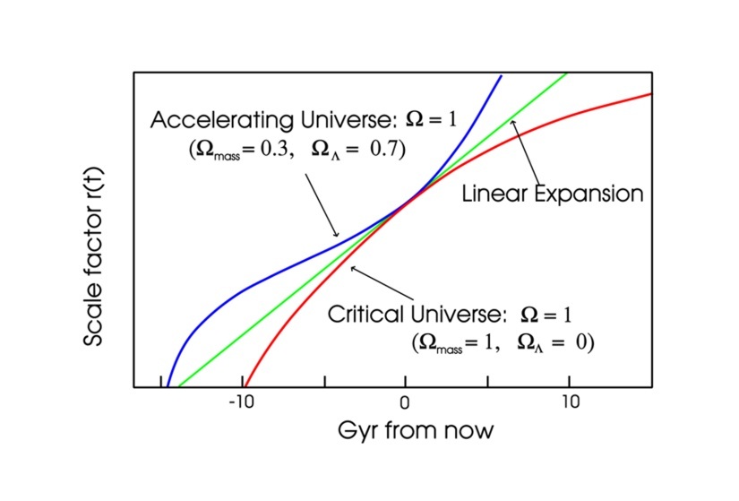
A plot showing the scale size of the universe with time.
A Universe fit for intelligent life

The very fact that you are reading this transcript tells us that our universe has just the right properties for intelligent life to have evolved. But why should this be so? As eloquently described in a book "Just Six Numbers" by Emeritus Gresham Professor Martin Rees, there are a number of parameters that have a major influence on how universes can evolve and how stars produce elements that are needed for life. Two of these have been already been covered in this transcript; the constants Omega,  Ω,and Lambda, Λ, If Ω had been higher the Universe would have rapidly collapsed without allowing life a chance to evolve, if it had been smaller galaxies and stars would not have formed. In addition, if Λ, which is surprisingly small, had been larger it would have prevented stars and galaxies forming.

You have also read in this chapter how the galaxies formed as a result of fluctuations in the density of the primeval universe - the so called "ripples" that are observed in the Cosmic Microwave Background. The parameter that defines the amplitude of the ripples has a value of ~ 10⁻⁵. If this parameter were smaller the condensations of dark matter that took place soon after the Big Bang (and were crucial to the formation of the galaxies) would have been both smaller and more spread out resulting in rather diffuse galaxy structures in which star formation would be very inefficient and planetary systems could not have formed. If the parameter had been less than 10⁻⁶, galaxies would not have formed at all!  But if this parameter were greater than 10⁻⁵ the scale of the "ripples" would be greater and giant structures, far greater in scale than galaxies, would form and then collapse into super-massive black holes - a violent universe with no place for life!

One parameter of our universe is so well known that it is barely given a moment's thought - the number of spatial dimensions, 3. But if this were either 2 (no complex structures) or 4 (forces fall as the inverse cube and atoms could not form), life could not exist.

Einstein's famous equation, E = m c², relates that amount of energy that can be extracted from a given amount of mass, so the value of c is obviously fundamentally important. In practice only a small part of the energy bound up in matter can be released, as in the conversion of hydrogen to helium. This process releases 0.7% of the mass of the four protons that form helium - a percentage closely linked to the strength of the strong nuclear force. This parameter, 0.007, has been called "nuclear efficiency". However if this value were too small, say 0.006, the sequence of reactions that build up helium could not take place. In the first of these reactions, two protons form a deuterium nucleus but, given a value of 0.006 for the nuclear efficiency, deuterium would be unstable so preventing the further reactions that give rise to helium - stars would be inert. On the other hand, if this parameter were 0.008, meaning that nuclear forces were stronger relative to electrostatic forces - the electrostatic repulsion of two protons would be overcome and they could bind together so no hydrogen would have remained to fuel the stars. A critical reaction in the evolution of stars is the formation of carbon in the triple alpha process. As described earlier, Fred Hoyle played a key role in the understanding of this reaction and pointed out that even a change of a few percent from the observed value of 0.007 would have severe consequences on the amount of carbon that would be formed in stars - with obvious consequences for life as we understand it.

A "Multiverse"

So how can it be that all the parameters described above are finely tuned so that we can exist? There are two possible reasons. The first is that our universe was "designed" by its creator specifically so that it could contain intelligent beings, a view taken by some scientist-theologians. A second view is that there are many universes each with different properties, the term "multiverse" has been applied to this view. We have no knowledge of what lies in the cosmos beyond the horizon of "our" visible universe. Different regions could have different properties; these regions could be regarded a different universes within the overall cosmos. Our part of the cosmos is, like baby bear's porridge, just right.

String Theory: another approach to a "Multiverse"

Theoretical physicists have a fundamental problem. Einstein's General Theory of Relativity that relates to "gravity" is a classical theory, whereas the other forces are described by quantum mechanics. A "theory of everything" has yet to be found that can bring together all the fundamental forces. One approach that is being actively pursued is that of "String Theory". The early string theories envisioned a universe of ten dimensions, not four, making up a 10-dimensional space-time. The additional six beyond our three of space and one of time are compacted down into tiny regions of space of order 10⁻³⁵ m in size and called strings. These are the fundamental building blocks of matter. Different "particles" and their properties, depend on the way these strings are vibrating - rather like the way a string of a violin can be excited into different modes of vibration to give harmonically related sounds. As these strings move they warp the space-time surrounding them in precisely the way predicted by general relativity. So string theory unifies the quantum theory of particles and general relativity.

In recent years five string theories have been developed each with differing properties. In one there can be open strings (a strand with two ends) as well as closed strings where the ends meet to form a ring. The remaining four only have closed rings. More recently Ed Witten and Paul Townsend have produced an 11 dimensional "M-Theory" which bring together the five competing string theories into a coherent whole. This 11th dimension (and it not impossible that there could be more) gives a further way of thinking about a multiverse.

We can think of a simple analogy: take a sliced loaf and separate each slice by, say, one centimeter. On each of these slices add some ants. The ants could survive, at least for a while, eating the bread of what is effectively a 2 dimensional universe. To them the existence of other colonies of ants on adjacent slices would be unobservable. But we can see that all of these exist within a cosmos that actually has a third dimension.

In just the same way, rather than being individual regions of one large spatially linked cosmos, it could be that other "universes" exist in their own space-time - hidden from ours within a further dimension.

Beyond our Imagination

In the description of this talk (written March 2010) I ended with: “……or even that our Universe could just be one small part of a Multiverse that extends beyond our imagination!”
I was implying that the totality of the cosmos and the laws that govern its existence might well be beyond the ability of our human minds to grasp.
(Certainly mine!)

I was interested to read comments made by Lord Rees later last summer:

- Some of the greatest mysteries of the universe may never be resolved because they are beyond human comprehension, according to Lord Rees, president of the Royal Society and Astronomer Royal – and past Gresham Professor of Astronomy.

- Rees suggests that the inherent intellectual limitations of humanity mean we may never resolve questions such as the existence of parallel universes, the cause of the big bang, or the nature of our own consciousness.

- He even compares humanity to fish, which swim through the oceans without any idea of the properties of the water in which they spend their lives.

- “A ‘true’ fundamental theory of the universe may exist but could be just be too hard for human brains to grasp.”

Perhaps I am not alone!

The Future of the universe

The accelerating expansion of the universe that is now accepted has a very interesting consequence. It used to be thought that with a slowing rate of expansion, as the universe became older we would see an increasing number of galaxies (as the distance we could see becomes greater). In a universe whose expansion is accelerating the exact opposite will be true - yes, we will be able to see farther out into space, but there will be increasingly less and less for us to see as the expansion carries galaxies beyond our horizon.

On the large scale, the space between the galaxy clusters will be expanding - carrying them ever faster apart - but it is believed that clusters like our own local group will remain gravitationally bound and, in fact, its members will merge into one single galaxy largely made up from our own Milky Way galaxy and the Andromeda galaxy. If one looks forwards in time to ~100 billion years, any observers in existence within this "galaxy" would see a totally empty Universe! The expansion of space will have carried all other galaxy beyond our horizon - the edge of the visible Universe.

It would be virtually impossible for such observers to learn about the evolution of the Universe for a number of reasons including the fact that the peak of the energy spectrum of the Cosmic Microwave Background (CMB) will have red shifted down to ~ 1m and would be virtually impossible to detect!

From theoretical studies of stellar evolution and how the relative abundances of the elements change with time, (for example, the amount of hydrogen is reducing and that of helium increasing as a result of nucleosynthesis in stars) it might well be possible to estimate the age of the galaxy, but it would be not be possible to infer that its origin involved a Big Bang. It would be tough being an astronomer!

We happen to live at the only time in the history of the Universe when the magnitude of dark energy and dark matter are comparable and also when the CMB is easily observable; so enabling us to infer the existence of dark energy and the way in which the Universe had evolved since the Big Bang and are able to postulate its future runaway expansion.

Any observers present when the Universe was young would not have been able to infer the presence of dark energy as, at that time, it would have had virtually no effect on the expansion rate. Those in the far future will not be able to tell that they live in an expanding Universe at all, and not be able to infer the existence of dark energy either! As the longest lived stars come to the end of their lives, the evidence that lies at the heart of out current understanding of the origin and evolution of the Universe will have disappeared.

Now is about the best time in the life of the universe to unravel its mysteries.

It is a great time to have been your Gresham Professor of Astronomy!

©Professor Ian Morison, Gresham College 2011

