

1 December 2014

An Update on the Universe

Professor Ian Morison

Predictions of a “Hot” Big Bang and hence the presence of radiation within the Universe

Two American scientists, George Gamow and Richard Dicke independently predicted that very high temperatures must have existed at the time of the Big Bang − both for somewhat the wrong reasons. Gamov wanted the temperature to be very high so that all the elements found in nature could be synthesized in the early stages of the Universe. We now know that apart from nitrogen (in the CNO process) the elements are created during the latter stages in the life of stars and, in the case of massive stars, during the end of their life in a supernova explosion.

The other prediction was made by Richard Dicke, a physicist at Princton University. He, like Fred Hoyle, did not like the idea of a singular start to the Universe (what was there before?) and came up with the idea of the oscillating Universe in which the Universe expands up to a maximum size and then collapses again to a singularity (called the Big Crunch) of the maximum density possible before expanding again. Since Gamow’s failure to explain the formation of the elements heavier than Helium, Hoyle and others had showed how the heavier elements had been formed in stars. Thus to start afresh with a new expanding universe, all the heavier elements had to be destroyed. Dicke realized that extreme heat − temperatures of at least a billion degrees − would do the job nicely as the heavy elements would crash together and split up into their constituent protons, neutrons and electrons.

An undeniable consequence of both these predictions is that such a hot phase in the life of the early Universe would have been filled with very high energy photons, initially in the form of gamma rays. As the Universe has expanded the radiation has become less energetic and would now be in the far infra red and very short wave radio parts of the spectrum. But this means that if one could place a thermometer in the space between the galaxies it would not read absolute zero but a value of a few degrees above absolute zero. This radiation is now normally called the “Cosmic Microwave Background” radiation (CMB) but has had alternate names such as the Relict Radiation and the name of this chapter − “The Afterglow of Creation”.

In 1948, Gamow produced an important paper with his student Ralph Alpher, which was published as "The Origin of Chemical Elements". [Gamow had the name of Hans Bethe listed as one of the authors on the article even though he had played no part in its preparation. The paper became known as the Alpher-Bethe-Gamow paper to make a pun on the first three letters of the Greek alphabet, alpha, beta and gamma!]

The paper showed how the present levels of hydrogen and helium in the universe (which are thought to make up ~98% of all matter) could be largely explained by reactions that occurred during the "Big Bang". This lent theoretical support to the Big Bang theory, although it did not explain the presence of elements heavier than helium. In this paper, no estimate of the strength of the present day residual CMB was made but shortly afterwards his students Ralph Alpher and Robert Herman predicted that the afterglow of the big bang would have cooled down after billions of years, and would now fill the universe with a radiation whose effective temperature was five degrees above absolute zero. The names of Alpher and Herman have been largely ignored since then which is somewhat unfair. Their prediction was essentially forgotten about for twenty years and even they thought, incorrectly, that the technology available then would be unable to detect such weak radiation.

Ironically, the effective temperature of the universe had been measured by this time − but by a chemist and so this did not become common knowledge for many years after. CN is a radical which can exist in space caused by the photo dissociation of HCN in dense molecular clouds. It was first discovered in 1941 by A. McKellar using a Coude spectrograph mounted on the 100-inch Hooker telescope on Mt. Wilson. CN has some excited rotational vibration levels and McKellar observed one that corresponded to an effective temperature of 2.3 degrees above absolute zero. This implied that the CN lay in a bath of radiation at this effective temperature − the first observation of the CMB!

Richard Dicke had been a pioneer in the field of radio astronomy and realized this radiation, now largely in the microwave part of the spectrum, should be able to be detected and recruited two young physicists, David Wilkinson and Peter Roll, to build a horn receiver and detector to look for what they called “the Primeval Fireball”. They began work in the spring of 1964.

The Serendipitous Discovery of the Cosmic Microwave background

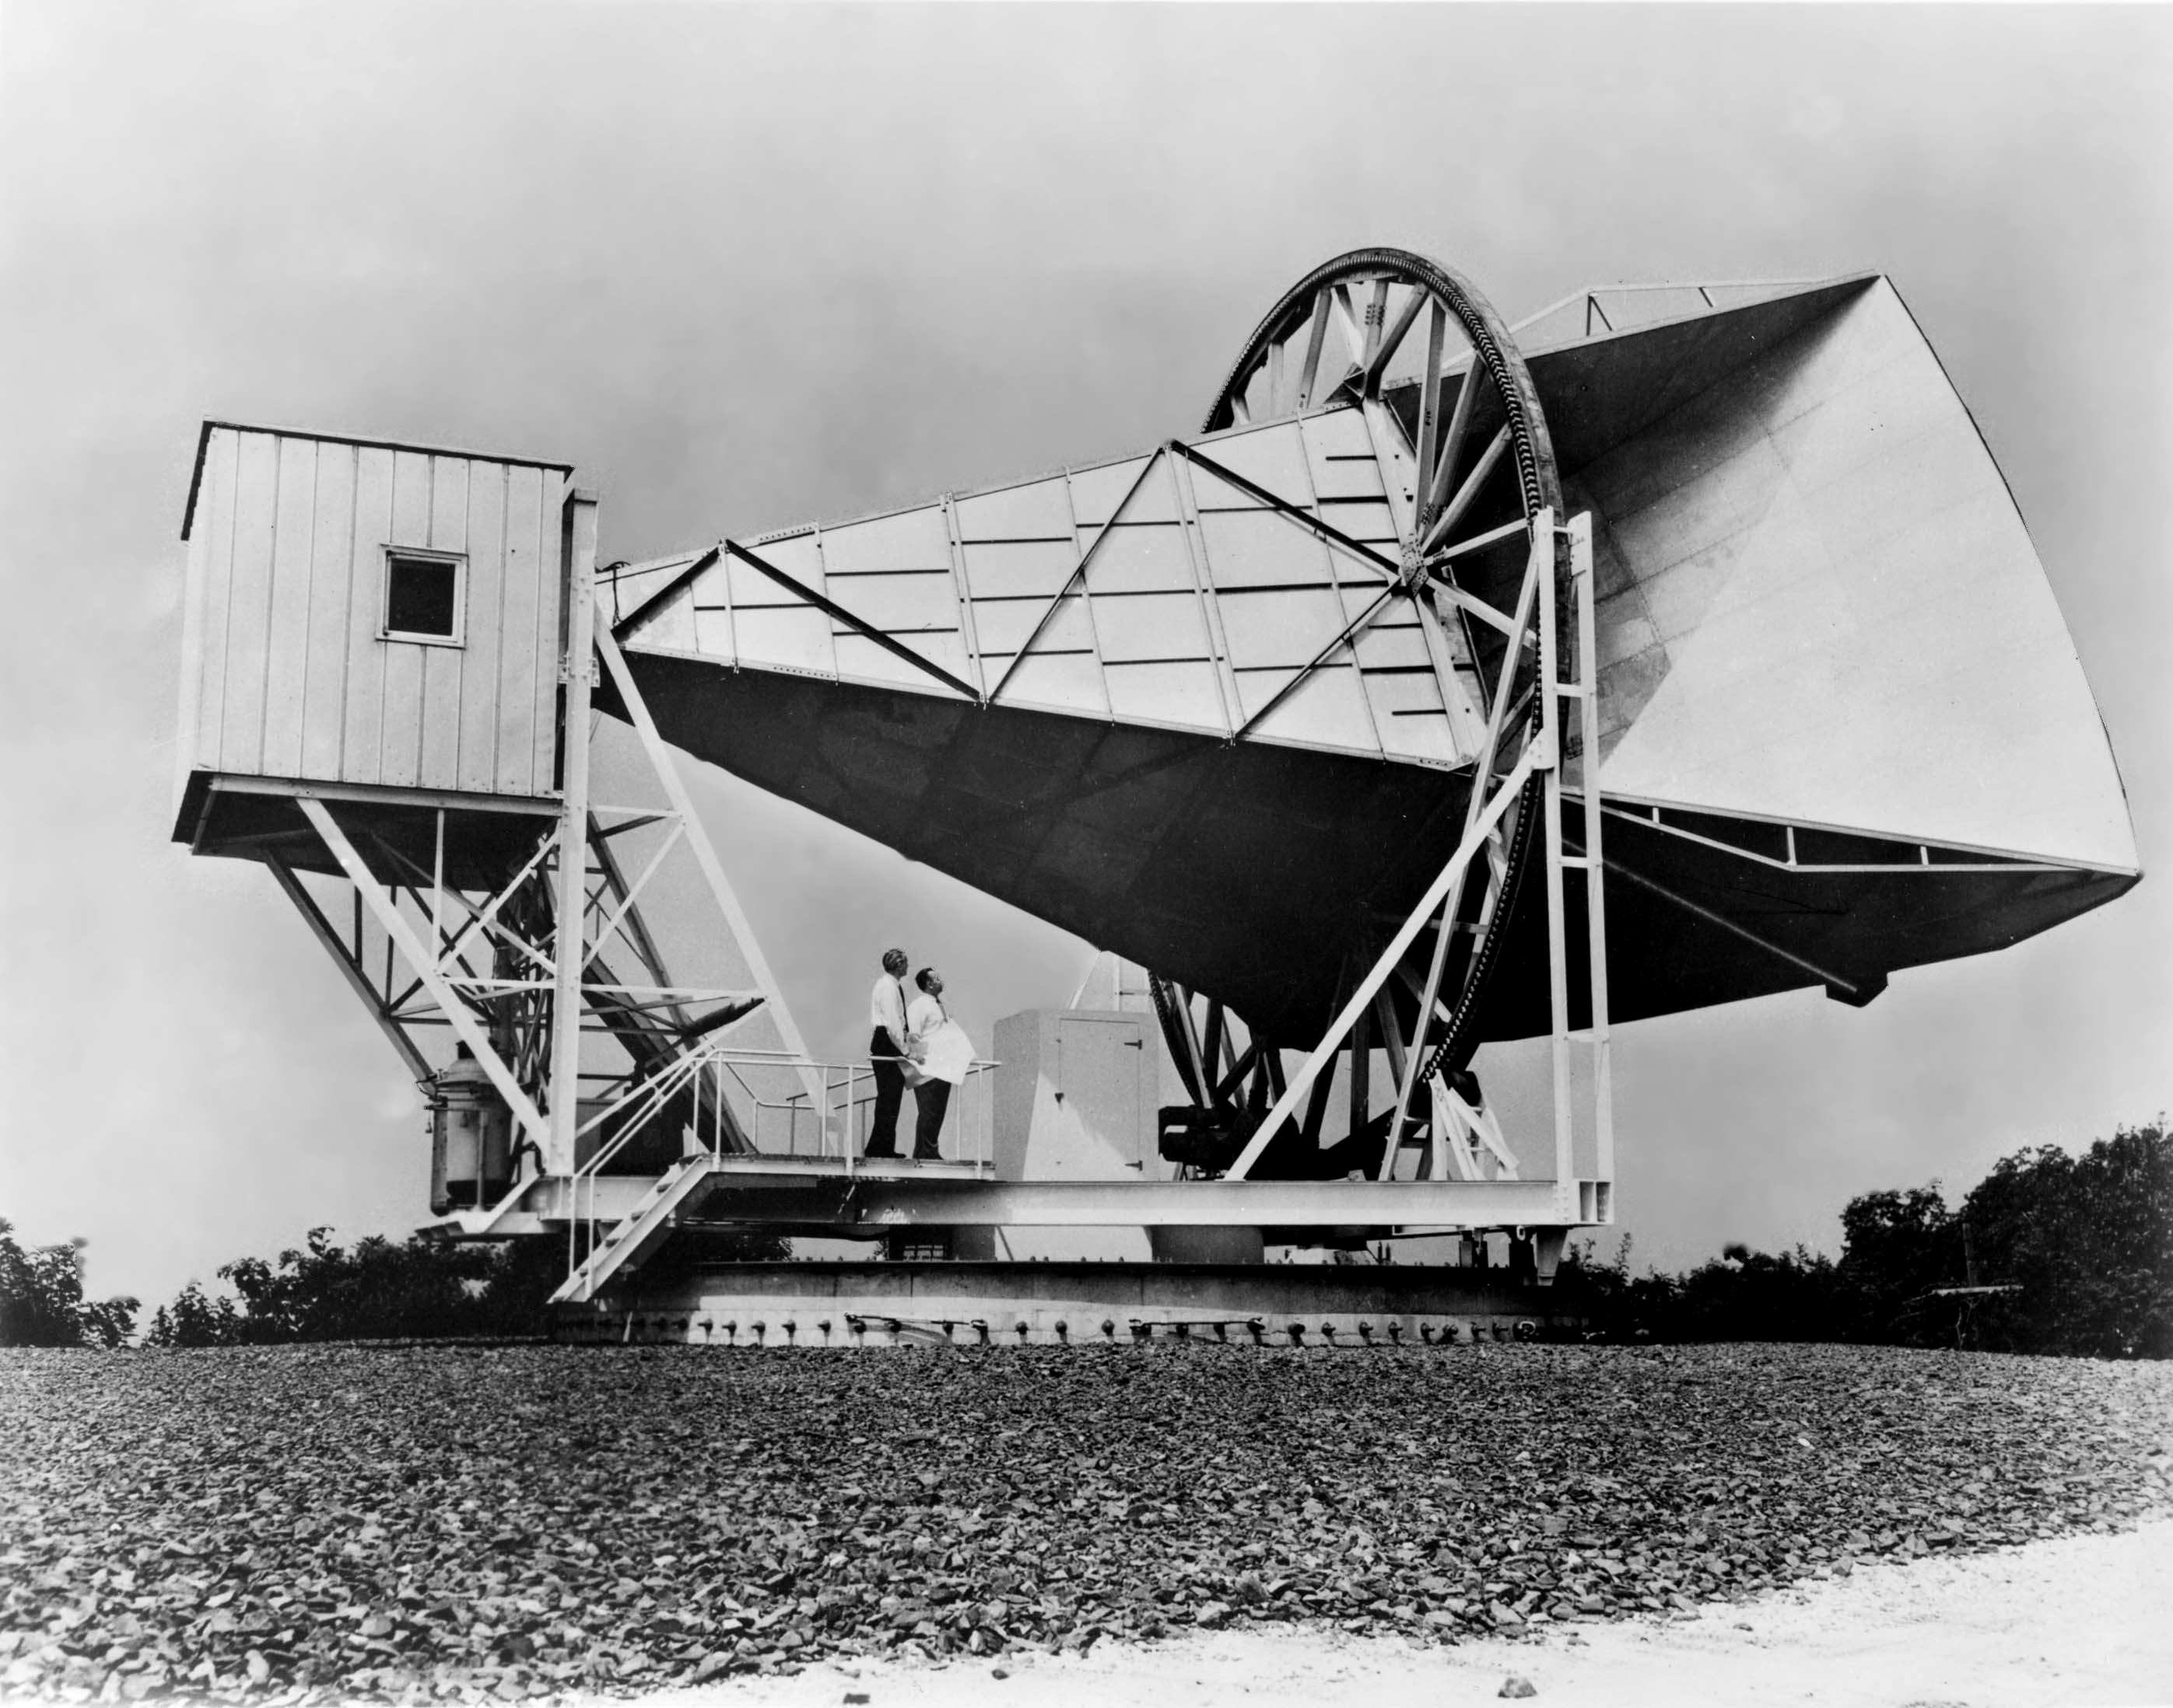
Arno Penzias and Robert Wilson at the Holmdale antenna with which they discovered the Cosmic Microwave Background.

Our story now moves to the Bell Telephone Laboratories where two radio astronomers, Arno Penzias and Robert Wilson had been given use of the telescope (Figure 22.1) and receiver that had been used for the very first passive satellite communication experiments using a large aluminum covered balloon called "Echo". It had been designed to minimise any extraneous noise that might enter the horn shaped telescope and the receiver was one of the best in the world at that time. They tested it thoroughly and found that there was more background noise produced by the system than they expected. They wondered if it might have been caused by pigeons nesting within the horn − being at ~290 K they would radiate radio noise − and bought a “Haveaheart” pigeon trap (now in the Smithsonian Air and Space Museum in Washington) to catch the pigeons. They used the internal mail system to send them 40 miles away to the Bell Telephone Whippany site where they were released but, as pigeons do, they returned and had to be "removed" by a local pigeon expert. During their time within the horn antenna, the pigeons had covered much of the interior with what, in their letter to the journal “Science” was called "a white dielectric substance" − we might call it "guano". This was cleaned out as well but having removed both the pigeons and the guano there was no substantial difference. The excess noise remained the same wherever they pointed the telescope − it came equally from all parts of the sky.

Another radio astronomer, Bernie Burke, when told of the problem suggested that they contact Robert Dicke at Princeton University. As described above, Dicke had independently theorised that the universe should be filled with radiation resulting from the big-bang and his students were building a horn antenna on top of the Physics department in order to detect it. Learning of the observations made by Penzias and Wilson, Dicke immediately realised that his group had been "scooped" and told them that the excess noise was not caused within their horn antenna or receiver but that their observations agreed exactly with predictions that the universe would be filled with radiation left over from the Big Bang. Dicke was soon able to confirm their result, and it was perhaps a little unfair that he did not share in the Nobel Prize that was awarded to Penzias and Wilson.

The cause of the Cosmic Microwave Background – as we now believe

We believe that the universe began in a burst of inflation that expanded a volume of space smaller than a proton by a factor of perhaps 10⁶⁰ up to the size of order a metre in diameter in a time of less than 10⁻²³ second. This released a massive amount of energy. Half of the gravitational potential energy that arose from this inflationary period was converted into kinetic energy from which arose an almost identical number of particles and antiparticles, but with a very small excess of matter particles (~1 part in several billion). All the antiparticles annihilated with their respective particles giving rise to a bath of radiation (the CMB) within which remained a residual number of particles.

The free electrons interacted with scattered the light – rather as water droplets scatter light − and so, as in a fog, the Universe was opaque. As the universe expanded and cooled there finally came a time, ~380,000 years after the origin, when the typical photon energy became low enough to allow atoms to form. There were then no free electrons left to scatter radiation so the universe became transparent. This is thus as far back in time as we are able to see. At this time the universe had a temperature of ~3,000 degrees Kelvin. As the radiation and matter were then in thermal equilibrium, the radiation would have a very well defined power spectrum − known as the black body spectrum − with a peak of energy in the yellow part of the visible spectrum. Since that time, the universe has expanded by about 1,000 times. The wavelengths of the photons that made up the CMB will also have expanded by 1,000 times and so will now be in the far infrared and short wavelength radio part of the spectrum − but would still have a black body spectrum. The effective black body temperature of this radiation will have fallen by just the same factor and would thus now be ~3 degrees Kelvin.

This prediction agrees well with the average temperature, now measured, of the CMB of 2.725 degrees Kelvin. However it was not until 1992, nearly thirty years later, that measurements made by the COBE spacecraft were able to show that the CMB had the precise "blackbody spectrum" that would result from the Big Bang scenario. Since then, it has been very difficult to refute the fact that there was a “hot” Big Bang.

The Cosmic Background Explorer (COBE)

The Cosmic Background Explorer (COBE) was a satellite whose goals were to investigate the cosmic microwave background radiation of the universe. COBE was originally planned to be launched on a Space Shuttle mission STS-82-B in 1988 from Vandenberg Air Force Base, but the Challenger explosion delayed this plan and eventually, having redesigned it to drastically reduce its weight, COBE was placed into sun-synchronous orbit on November 18, 1989 aboard a Delta rocket.

Its first significant result was not long in coming, using the “Far-InfraRed Absolute Spectrophotometer, FIRAS” − a spectrophotometer used to measure the spectrum of the CMB – and with just 9 minutes worth of data COBE was able to plot a spectrum (Figure 22.2) where the error bars on the data points lay within the theoretical Black Body Curve that should have been seen if the CMB really was the radiation from a time when the radiation and matter were in thermal equilibrium.

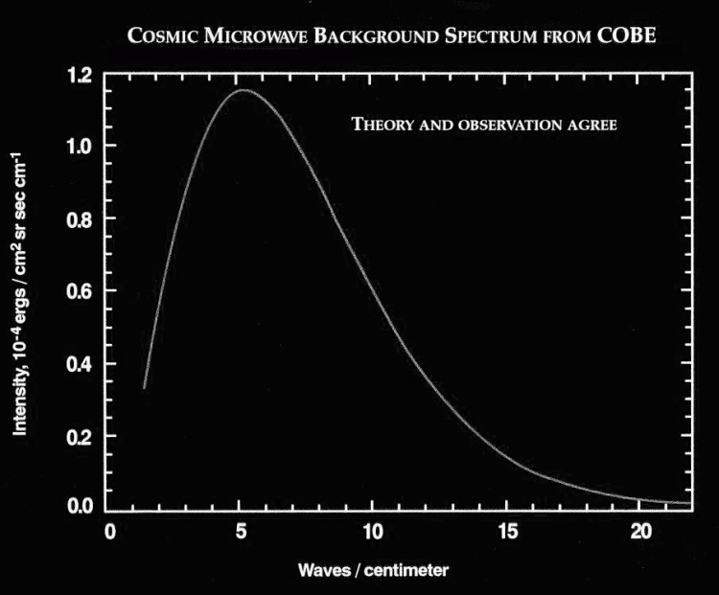
The spectrum of the CMB measured by the COBE spacecraft.

The second significant result came from the Differential Microwave Radiometer DMR a microwave instrument that would map variations (or anisotropies) in the CMB. The ground based results, with their limited accuracy, showed a uniform CMB temperature, but COBE’s greater sensitivity soon showed that the temperature was not constant across the sky; it was slightly hotter in the direction of the constellation Leo in the sky, and slightly cooler in the opposite direction towards Aquarius. The hottest region is +3.5 millikelvin above the average and the coolest -3.5 millikelvin below the average.

Such an observation was predicted due to the fact that our Solar system is moving through space orbiting the centre of our Galaxy and so our motion would mean that photons arriving from the direction of motion are boosted in energy − and hence appear “hotter” whilst those from behind lose energy and thus appear cooler (the Doppler effect). But, to everyone’s surprise, the direction of motion determined from these observations was not aligned with the orbital motion of the Solar System around the Galaxy, but was in nearly the opposite direction. This means that our Galaxy and the whole local group of galaxies are moving with a speed of more than two million miles per hour (600 km/sec or ~1/500 the speed of light) with respect to the Universe at large. What could cause this? It appears to be a result of the clustering and super clustering of galaxies in our local (within 100 million light years) neighborhood so that there is a net gravitational pull towards the direction of Leo.

Incidentally, the COBE DMR observations clearly show changes in the observed velocity of 30 kilometers per second − a 5% effect − due to the motion of the Earth around the Sun − good evidence that Galileo was right!

The cause of the Fluctuations in the CMB

Why are these small variations present? To answer this we need to understand a little about "dark matter" as fully discussed in Chapter 21. Though not yet directly detected, its presence has been inferred from a wide variety of observations.

As described above, for ~380,000 years following the big bang, the matter and radiation were interacting as the energy of the photons was sufficient to ionize the atoms giving rise to a plasma of nuclei and free electrons. This gives rise to two results:

1: The radiation and matter are in thermal equilibrium and the radiation will thus have a black body spectrum as was proven by the COBE observations.

2: The plasma of nuclei and electrons will be very homogeneous as the photons act rather like a whisk beating up a mix of ingredients.

It is worth repeating an argument from the last chapter on dark matter relating to the second of these points. When the temperature drops to the point that atoms can form the matter can begin to clump under gravity to form stars and galaxies. Simulations have shown that, as the initial gas is so uniformly distributed, it would take perhaps 8 to 10 billion years for regions of the gas to become sufficiently dense for this to happen. But we know that galaxies came into existence around 1 billion years after the Big Bang. Something must have aided the process. We believe that this was non-baryonic dark matter. As this would not have been coupled to the radiation, it could have begun to gravitationally "clump" immediately after the Big Bang. Thus when the normal matter became decoupled from the photons, there were "gravitational wells" in place formed by concentrations of dark matter. The normal matter could then quickly fall into these wells, rapidly increasing its density and thus greatly accelerating the process of galaxy formation.

The concentrations of dark matter that existed at the time the CMB originated have an observable effect due to the fact that if radiation has to "climb out" of a gravitational potential well it will suffer a type of red shift called the "gravitational red shift". So the photons of the CMB that left regions where the dark matter had clumped would have had longer wavelengths than those that left regions with less dark matter. This causes the effective blackbody temperature of photons coming from denser regions of dark matter to be less than those from sparser regions − thus giving rise to the temperature fluctuations that are observed. As such observations can directly tell us about the universe as it was just 380,000 or so years after its origin it is not surprising that they are so valuable to cosmologists!

WMAP and Planck

Observations by the COBE spacecraft first showed that the CMB did not have a totally uniform temperature and, since then, observations from the WMAP and Planck spacecrafts, balloons and high mountain tops have been able to make maps of these so called "ripples" in the CMB − temperature fluctuations in the observed temperature of typically 60 micro Kelvin.

The Wilkinson Microwave Anisotropy Probe (WMAP) was originally known as the Microwave Anisotropy Probe (MAP) but was renamed after the death of one of the pioneers of CMB observations, Dave Wilkinson, who sadly died of cancer whilst its data was being analysed. The WMAP spacecraft was launched on 30 June 2001 and flew to the Sun-Earth “L2 Lagrangian point”, arriving there on 1 October 2001. This lies at a distance of 1.5 million km from the Earth directly away from the Sun. In general, as one moves further away from the Sun, a planet (or space probe) will orbit more slowly, but if it lies on the Sun-Earth line the additional gravitational pull from the Earth will add to that from the Sun and the satellite will orbit more rapidly. So, at just the right distance, a satellite can be made to orbit the Sun in one Earth year and so move round the Sun in consort to the Earth. This position is called L2. Here, as the spacecraft is observing the half of the sky away from the Sun it can produce a map of the sky in 6 months. WMAP completed its first all sky survey in April 2002.

The fundamental problem in producing an all sky map is the contamination of foreground emission from our own galaxy and other, more distant radio sources. To overcome this, WMAP observed in five frequencies which allow these to be determined and subtracted from the map. Synchrotron radiation, from electrons spiraling round the magnetic field of the galaxy, dominates the low frequencies whilst emissions from dust dominate the higher frequencies. These emissions contribute different amounts to the five frequencies, thus permitting their identification and subtraction leaving a map without any evidence of the fact that it was made within our galaxy! (I actually find this quite amazing.)

The 3-year WMAP data alone showed that the universe must contain dark matter and that the age of the universe is 13.7 billion years old. The 5-year data included new evidence for the cosmic neutrino background, showed that it took over half a billion years for the first stars to re-ionize the universe, and provided new constraints on cosmic inflation.

At a time ~400,000 years after the Big Bang, WMAP showed that 10% of the universe was made up of neutrinos, 12% of atoms, 15% of photons and 63% dark matter. The contribution of dark energy at the time was negligible.

The seven-year WMAP data were released on 26 January 2010. According to this data the Universe is 13.75 ±0.11 billion years old and confirmed some asymmetries in the data that will be discussed below. The WMAP spacecraft continued to take data in perfect working order until September 2010. Figure 22.3 shows the fluctuations as observed by WMAP of the CMB. (Colour versions can be found by searching for “WMAP CMB map”.)

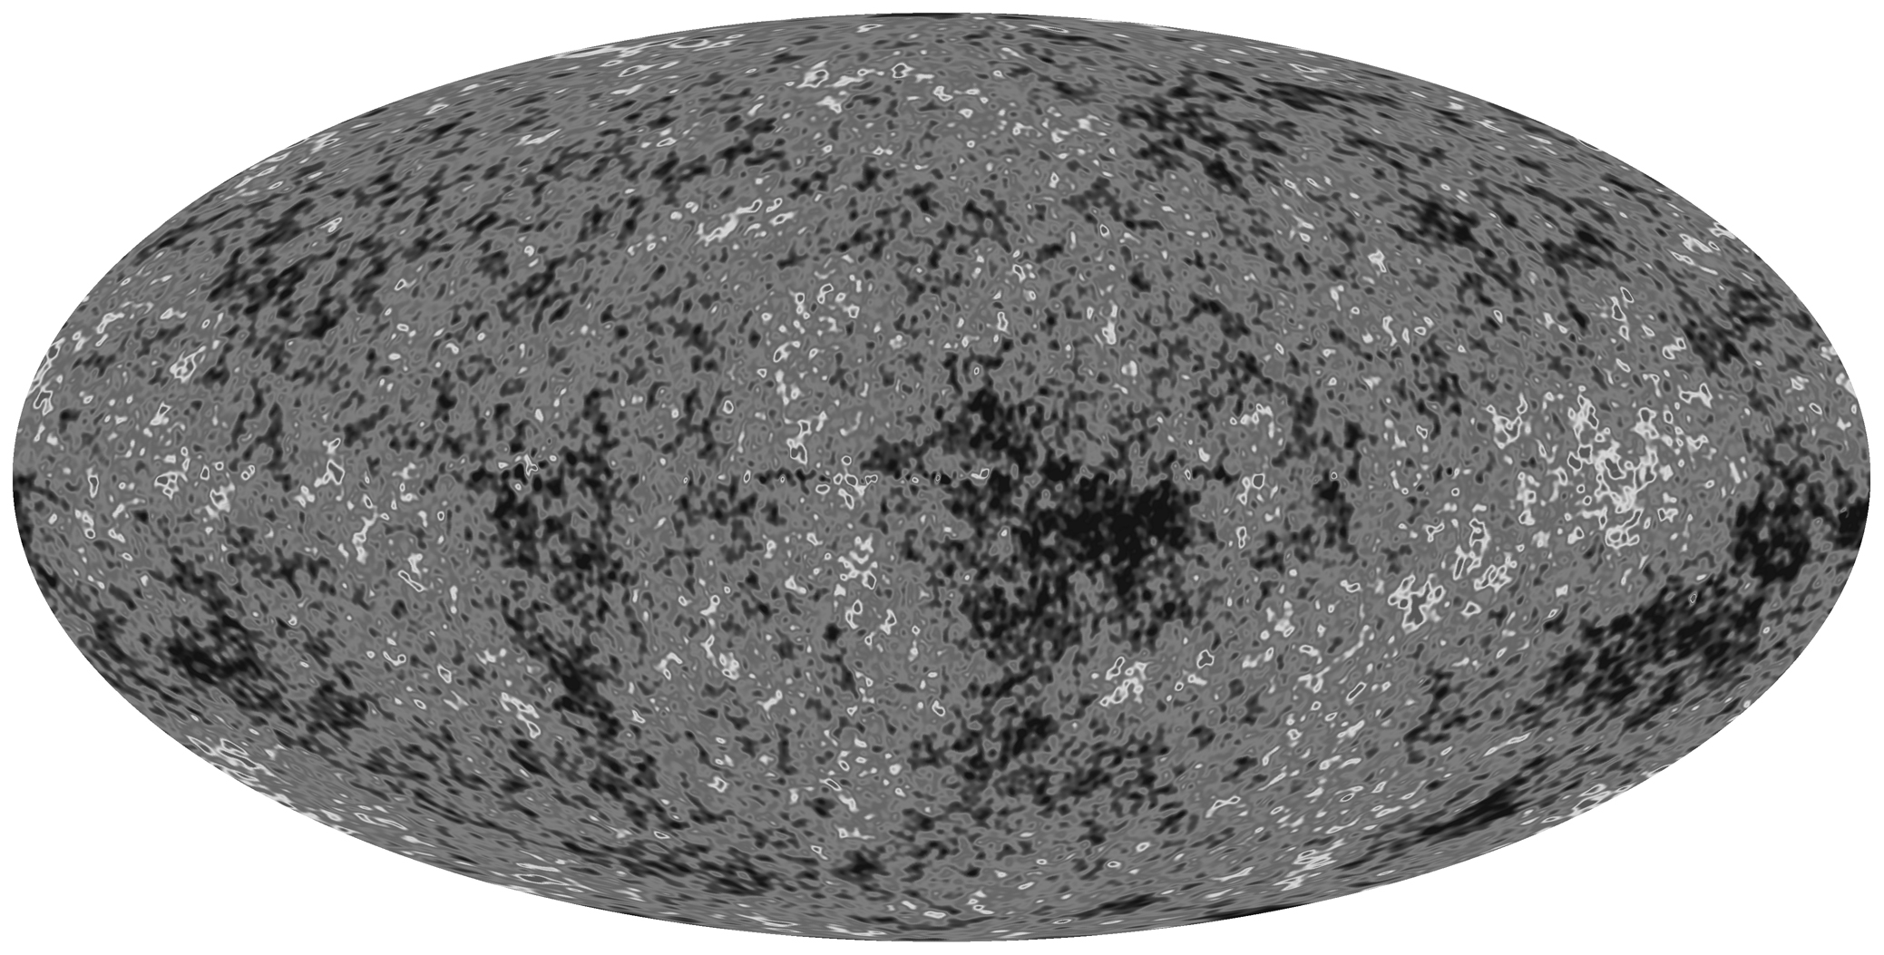

All-sky map of the CMB ripples produced by WMAP in 2008.

The Planck Mission

Planck is a space observatory built by the European Space Agency to complement and improved upon observations made by NASA’s Wilkinson Microwave Anisotropy Probe of the cosmic microwave background. Planck was launched into orbit on the 14th May 2009 and flown to the same L2 region as WMAP where it was injected into its final “figure of 8” orbit on July 3rd by which time the high frequency receivers systems has reached the operational temperature of just 1/10 a degree above absolute zero. It had the ability to make observations at smaller angular scales than WMAP and has significantly higher sensitivity. In addition, it made observations at 9 wavelengths rather than the 5 made by WMAP which should help remove the “foreground” contamination of the CMB data. Two of the receiver systems were designed and built at the Jodrell Bank Observatory and are the most sensitive receivers ever made at their operating wavelengths.

Though the main objective of the mission is to observe the total intensity and polarization of the primordial CMB, it will create a catalogue of galaxy clusters using the Sunyaev-Zel'dovich effect and observe the effects of gravitational lensing on the CMB. In order to remove the effects of the Milky Way from the raw images it will make detailed observations of the local interstellar medium, the galactic synchrotron emission and magnetic field.

Planck started its first All-Sky Survey on 13th August 2009 followed by the second on the 14th February 2010 with 100% sky coverage achieved by mid-June 2010. The first all sky maps of the CMB were published in the spring of 2013. [Note: The Plank CMB map is so detailed that it is very difficult to reproduce in monochrome. Colour versions can be easily found by searching for “Planck CMB map”]

The Planck Results

What have the observations of the CMB told us about the universe?

1: The curvature of space and hence the density of the universe.

The photons that make up the CMB have traveled across space for billions of years and will thus have been affected by the curvature of space. This curvature is a function of the amount of matter (and energy) in space and hence its density. If the density is higher than some critical amount, the space will be positively curved (like, in 2 dimensions, on the surface of a sphere). If the density is critical, Euclidian geometry holds true and is said to be “flat”. If the density is less than this the space will be negatively curved (like, in 2 dimensions, on the surface of a saddle).

Theory tells us the expected angular scale of the fluctuations of the CMB. If we observed it through flat space then we would see exactly this angular scale. If, however, we observed it thought positively curved space − which acts rather like a convex lens − we would observe a larger pattern than predicted, and if we observed it thought negatively curved space − which acts rather like a concave lens − we would observe a smaller pattern than predicted. It is possible to simulate the expected pattern of fluctuations if space were negatively curved, positively curved or flat and these can be compared with observations.

Looking at the “blobs” in the Planck data it appears that there is a significant amount of structure seen on scale sizes of order one degree and this is born out by the position of the first peak in the Planck Angular Scale Plot shown in Figure 22.5.
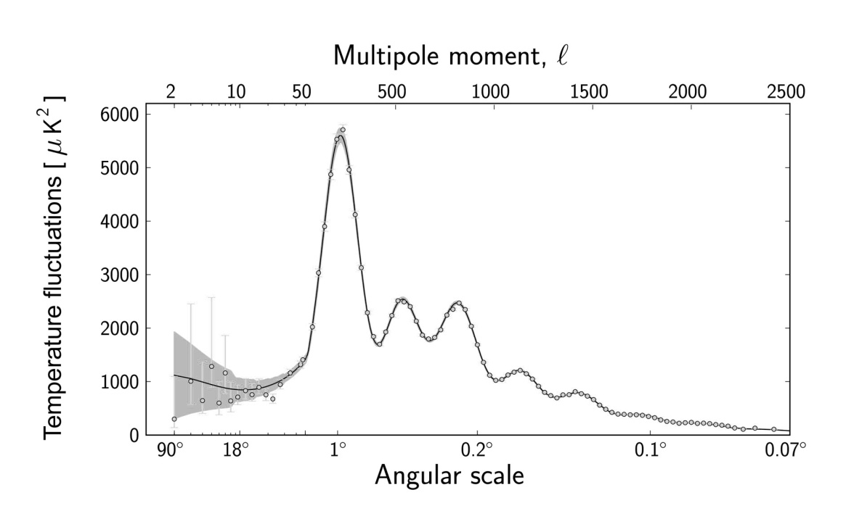
The power in the CMB fluctuations as a function of angular scale derived from the Planck data. Imag: ESA and the Planck Collaboration.

In fact the peak in the plot is at ~0.8 degrees, which is exactly what we would expect if space were “flat” and the WMAP and Planck results show that space is “flat” to an accuracy of 1%. This important result this leads to value of the density of the universe which is 9.9 x 10⁻³⁰ g/cm³, which is equivalent to only 5.9 protons per cubic meter. This is in terms of mass, but we now know that the major part is in the form of energy.

2: The relative amounts of the various components in the universe

In the sections below, the values provided by analysis of the Planck data are given first as these are perhaps expected to be more accurate than those given by WMAP and other experiments. But these are also given in brackets after each result and I find it a little surprising that the values have changed so significantly.

Normal matter 4.9 % (4.5%): This implies that ~95 % of the energy density in the universe is in a form that has never been directly detected in the laboratory!

Dark Matter 26.8% (22.7%): The major part of which is “Cold Dark Matter” (CDM; cold = relatively slow moving particles). Dark matter is likely to be composed of one or more species of sub-atomic particles that interact very weakly with ordinary matter. As we have seen, dark matter plays a very important part in the formation of the galaxies and has significant gravitational effects. Particle physicists have many plausible candidates and experiments are perhaps on the verge of their detection as described the previous chapter. This 27% includes a small proportion of “Hot Dark Matter” (HDM; hot = light particle particles such as neutrinos moving at speeds close to that of light). Neutrinos do make a small contribution to the dark matter total but too great a component of HDM would have prevented the early clumping of gas in the universe, delaying the emergence of the first stars and galaxies. However, WMAP and Planck do see evidence that a sea of cosmic neutrinos does exist in the numbers that are expected from other lines of reasoning.

Dark Energy 68.3% (72.8%): In the 1990's, observations of supernova were used to trace the expansion history of the universe showing that the expansion appeared to be speeding up, rather than slowing down. If 68% of the energy density in the universe is in the form of dark energy, which has a gravitationally repulsive effect, it is just the right amount to explain both the flatness of the universe and the observed accelerated expansion.

3: The Time and Redshift of Reionization

The “Reionization Redshift” relates to the time when the first stars formed and the ultraviolet light produced by them able to split electrons off hydrogen atoms giving ionized Hydrogen. It is termed reionization as when the universe was hot – up to about 380,000 years after the origin of the universe, the hydrogen had been previously ionized. At that time, when the atoms formed and cooled, the universe entered the so called “Dark Ages” which lasted until the universe was again filled with light from the first stars. WMAP showed that this began at a time starting just 400 million years after the Big band and lasted for ~500 million years.

4: The age of the Universe

The data from Planck give an age of 13.8 billion years, slightly greater than the WMAP result of 13.75 billion years. By combining the Planck data with that of WMAP and other experimental values such as that obtained from gravitational lensing, gives a best fit to the age of 13.79 billion years.

5: Hubble’s constant

Plank gave a value for Hubble’s constant of 67 and, in combination with other data, provides values that extend up to ~68 +/- 1. This is in reasonable agreement, but having greater precision, with the final result from the Hubble Space Telescope Key project of ~72. I am pleasantly pleased that this result agrees very well with that obtained from observations of the Double Quasar discovered by astronomers at Jodrell Bank Observatory in the early 1980’s which gave a value of 67 +/-13. At the time most other results were either significantly higher or lower and it is good to know that our result (admittedly with large error bars) was very close to the currently accepted value.

Planck’s Legacy

On the 19th October 2013, the instruments and cooling systems on the Planck Spacecraft were switched off marking the end of the scientific part of the Planck mission after spending more than four years mapping the cosmic microwave background. A day later a piece of software was uploaded to prevent the systems ever being switched on so that the transmitter that had sent the spacecraft’s data back to Earth could never cause interference to future space probes. Prior to this, the spacecraft had been maneuvered out of the L2 position and will spend eternity silently orbiting the Sun.

But vast amounts of data still needed to be analysed and the numerous maps and catalogues will provide a legacy for both today’s and future generations of cosmologists. The peaks and troughs in the CMB spectrum contain highly detailed information about the basic cosmological parameters that have been detailed above. WMAP established the basic details, but Planck not only confirmed this picture but was able to make it far more precise.

Inflation and Gravitational Waves

One prediction of the theories relating to the Big Bang origin of the Universe and the inflation that vastly increased its size, is that the tiny quantum fluctuations present prior to the inflationary phase would have become far greater in extent and would have launched gravitational waves traveling through space. As these waves distorted space as they passed through, they would have had the effect of slightly polarizing the light so giving rise to a “curling” pattern in the polarized orientation of light in the ancient Universe. If this is true, then this imprint should still be visible in the microwave radiation that makes up the cosmic microwave background.

As the amount of polarization is very small its detection is exceedingly difficult but finally, in March 2014, the scientists using an experiment called BICEP2 located at the South Pole (where it is so cold that water vapour is frozen out of the atmosphere and microwave radiation can pass through un-attenuated) announced that they had detected the predicted curling pattern of polarization in the cosmic microwave radiation.

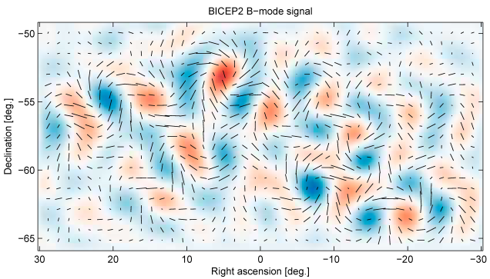
Possible evidence of Gravitational Waves in the early Universe

If this result were to be confirmed then it is proof of an inflationary phase in the early Universe, gives a further indirect detection of gravitational waves and, perhaps most importantly, that gravity has to be quantised. However, after these results were announced other groups suggested that the effect of dust in our galaxy – which can produce very similar polarisation results − may have been underestimated. And in June 2014, when the results of BICEP2 were formally published, the group indicated that they were less confident of their result. Data from the Planck spacecraft released since their initial announcement had indicated that, in general, the polarisation effects of nearby dust were greater than had been assumed, though the Planck data relating to the area of sky specifically observed by BICEP2 was yet to be published – this being due later that year. In their published paper in Physics Research Letters the group states: "[Our] models are not sufficiently constrained by external public data to exclude the possibility of dust emission bright enough to explain the entire excess signal." The results from the Planck spacecraft, one of whose objectives was to measure the polarisation present in the CMB, were thus awaited eagerly so that the BICEP2 results could be confirmed or, perhaps, shown to have been over optimistic.

The Invisible Universe: Dark Matter and Dark Energy

Perhaps the most amazing aspect of our Universe is that we only see about 1% (in the form of stars and bright nebulae) of its total mass and energy. A further 4% of its mass is in the form of dust and gas but this leaves about 95% to be accounted for. A major element of this is, we believe, in the form of “dark matter”. It has been given this name as it does not interact with light and so is invisible but, due to the fact that it does have mass, it does exert a gravitational attraction on normal matter and this is how we have evidence for its existence.

The first question to ask is whether this invisible content is normal (baryonic) matter that just does not emit light such as gas, dust, or objects such as brown dwarfs, neutron stars or black holes. These latter objects are called MACHOs (Massive Astronomical Compact Halo Objects) as many would reside in the galactic halos that extend around galaxies.

There are two pieces of evidence that indicate that the total amount of normal matter in the Universe is only ~4% of the total mass/energy content. The first depends on measurements of the relative percentages of hydrogen, helium and lithium and their isotopes that were formed in the big bang. These put an upper limit of normal (baryonic) matter at about 4-5%. The second line of evidence is that if a significant amount of mass were in the form of MACHOs then gravitational micro lensing studies (as have discovered a number of planets and described in Chapter 12) would have detected them. Though we know that, for example, pulsars are found in the galactic halo the total mass of these and other MACHOs cannot explain the missing matter. So we still have to account for ~96% of the total mass/energy content of the Universe. From several lines of observational evidence it is believed that a substantial part of this is in the form of non-baryonic dark matter − usually just called dark matter.

Dark Matter in Galaxy Clusters

The first evidence of a large amount of unseen matter came from observations made by Fritz Zwicky in the 1930's. Zwicky was a Swiss astronomer who spent much of his life working at the Mt.Palomar Observatory and became a professor of astronomy at the California Institute of Technology. He made many important contributions to astronomy as when, for example, in 1934 he and Walter Baade coined the term "supernova" and hypothesized that they were the transition of normal stars into neutron stars, and were the origin of cosmic rays. In 1937, he predicted the existence of Gravitational lenses as have been discussed in Chapter 16 − Proving Einstein Right. Their existence was discovered in a survey made at the Jodrell Bank Observatory just five years after his death in 1974. Had he been alive when this discovery was made I believe that he would have been a very strong contender for a Noble Prize.

A somewhat acerbic character, throughout much of his later life he felt that his work was underappreciated and was famous for some insults aimed at his colleagues such as when he was prevented from using the 200-inch Hale Telescope when he is quoted as fuming “Those spherical bastards threw me off the 200 goddam-inch telescope! Made up a special rule. No observing after the age of 70! Grrrr, them I could crush!” He expanded on the quote by saying “A spherical bastard was a bastard any way you looked at it”.

Zwicky was instrumental in obtaining a Schmidt Camera for the Mt. Palomar Observatory. These are photographic instruments, discussed in Chapter 9, capable of imaging wide fields and are superb survey instruments. Having personally carried the 18-inch diameter correcting lens from Germany that had been figured by the designer of this type of telescope, Bernard Schmidt, he used it to study the Coma cluster of galaxies, 321 million light years distant. He observed that the outer members of the cluster were moving at far higher speeds than were expected. He was able to measure their velocities by using the shift in the spectral lines of the galaxy.

When the spectra of galaxies were first observed in the early 1900's it was found that their observed spectral lines, such as those of hydrogen and calcium, were shifted from the positions of the lines when observed in the laboratory. In the closest galaxies, the lines were shifted toward the blue end of the spectrum, but for galaxies beyond our local group, the lines were shifted towards the red. This effect is called a blueshift or redshift and the simple explanation attributes this effect to the speed of approach or recession of the galaxy, similar to the falling pitch of a receding train whistle, which we know of as the Doppler effect.

Suppose a cluster of galaxies were created none of which were in motion. Gravity would quickly cause them collapse down into a single giant body. If, on the other hand, the galaxies were initially given very high speeds relative one to another, their kinetic energy would enable them to disperse into the Universe and the cluster would disperse, just as a rocket traveling at a sufficiently high speed could escape the gravitational field of the Earth. The fact that we observe a cluster of galaxies many billions of years after it was created implies that that there must be an equilibrium balance between the gravitational pull of the cluster's total mass and the average kinetic energy of its members. This concept is enshrined in what is called the Virial Theorem, so that if the speeds of the cluster members can be found, it is possible to estimate the total mass of the cluster. Zwicky carried out these calculations and showed that the Coma Cluster must contain significantly more mass than could be accounted for by its visible content.

Dark Matter in Spiral Galaxies

In the 1970's a problem related to the dynamics of galaxies came to light. Vera Rubin observed the light from HII regions (ionized clouds of hydrogen such as the Orion Nebula) in a number of spiral galaxies. These HII regions move with the stars and other visible matter in the galaxies but, as they are very bright, are easier to observe than other visible matter. HII regions emit the deep red hydrogen alpha (H-alpha) spectral line. By measuring the Doppler shift in this spectral line, Rubin was able to plot their velocities around the galactic centre as a function of their distance from it. She had expected that clouds that were more distant from the centre of the galaxy (where much of its mass was expected to be concentrated) would rotate at lower speeds − just as the outer planets travel more slowly around the Sun. This is known as Keplerian motion, with the rotational speed decreasing inversely as the square root of the distance from centre. (This is enshrined in Kepler's third law of planetary motion and can be derived from Newton's law of gravity.)

To her great surprise, Rubin found that the rotational speeds of the clouds did not decrease with increasing distance from the galactic centre and, in some cases, even increased somewhat (Figure 21.1). Not all the mass of the galaxy is located in the centre but the rotational speed would still be expected to decrease with increasing radius beyond the inner regions of the galaxy although the decrease would not be as rapid as if all the mass were located in the centre. To give a concrete example; the rotation speed of our own Sun around the centre of the Milky Way galaxy would be expected to be about 160 km/sec. It is, in fact, ~220 km/sec. The only way these results can be explained is that either the stars in the galaxy are embedded in a large halo of unseen matter − extending well beyond the visible galaxy − or that Newton's law of gravity does not hold true for large distances. The unseen matter whose gravitational effects her observations had discovered is further evidence for the existence of dark matter.

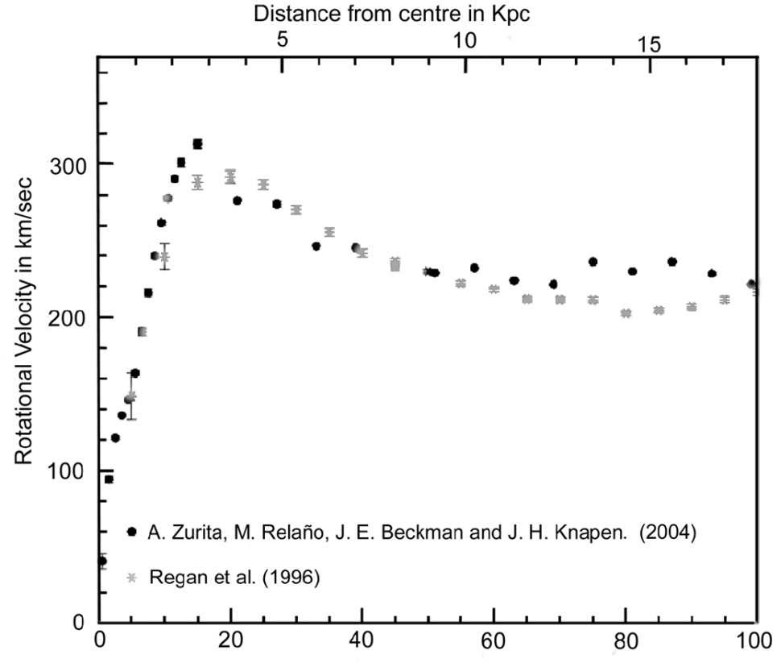

The Galactic Rotation Curve for the galaxy NGC 1530.

The early Universe and the formation of galaxies

As described above, the American physicist, George Gamow, first realised that the Big Bang should have resulted in radiation that would still pervade the universe. This radiation is now called the Cosmic Microwave Background (CMB) and is the subject of the next chapter − “The Afterglow of Creation”. Initially in the form of very high-energy gamma rays, the radiation became less energetic as the universe expanded and cooled, so that by a time some 300 to 400 thousand years after the origin the peak of the radiation was in the optical part of the spectrum.

Up to that time the typical photon energy was sufficiently high to prevent the formation of hydrogen and helium atoms and thus the universe was composed of hydrogen and helium nuclei and free electrons − so forming a “plasma”. The electrons would have scattered photons rather as water droplets scatter light in a fog and thus the universe would have been opaque. This close interaction between the matter and radiation in the universe gives rise to a critical consequence: the distribution of the nuclei and electrons (normal matter) would have a uniform density except on the very largest scales as the photons acted rather like a whisk beating up a mix of ingredients.

This fact is important to the argument that follows. When the temperature drops to the point that atoms can form, the matter can begin to clump under gravity to form stars and galaxies. Simulations have shown that, as the initial gas is so uniformly distributed, it would take perhaps 8 to 10 billion years for regions of the gas to become sufficiently dense for this to happen. But we know that galaxies came into existence around 1 billion years after the Big Bang. Something must have aided the process. We believe that this was due to dark matter. As indicated above, dark matter would not have been affected by the radiation so could have begun to gravitationally "clump" soon after the Big Bang. Thus when the normal matter became decoupled from the photons, there were "gravitational wells" in place formed by concentrations of dark matter. The normal matter could then quickly fall into these wells, rapidly increasing its density and thus greatly accelerating the process of galaxy formation.

How much non-baryonic dark matter is there?

There are several ways of estimating the amount of dark matter. One of the most direct is based on the detailed analysis of the fluctuations in the Cosmic Microwave Background. The percentage of dark matter has an observable effect, and the best fit to current observations corresponds to dark matter making up ~27% of the total mass/energy content of the Universe. Other observations support this result. Only ~5% is made up of normal matter leaving two further questions: what is dark matter and what provides the remaining ~68% of the total mass/energy content?

What is Dark Matter?

The honest answer is that we do not really know. The standard model of particle physics does not predict its existence and so extensions to the standard theory (which have yet to be proven) have to be used to predict what it might be and suggest how it might be detected.

Dark matter can be split into two possible components: Hot Dark Matter would be made up of very light particles moving close to the speed of light (hence hot) whilst Cold Dark Matter (CDM) would comprise relatively massive particles moving more slowly. Simulations that try to model the evolution of structure in the Universe − the distribution of the clusters and super clusters of galaxies − require that most of the dark matter is "cold" but astronomers do believe that there is a small component of hot dark matter in the form of neutrinos. There are vast numbers of neutrinos in the Universe but they were long thought to have no mass. However, recent observations attempting to solve the solar neutrino problem discussed in Chapter 2, show that neutrinos can oscillate between three types; electron, tau and muon. This implies that they must have some mass but current estimates put this at less than 1 millionth of the mass of the electron. As a result they would only make a small contribution to the total amount of dark matter − agreeing with the simulations.

A further confirmation of the fact that hot dark matter is not dominant is that, if it were, the small scale fluctuations that we see in the WMAP data would have been “smoothed” out and the observed CMB structure as described in Chapter 22, “The Afterglow of Creation”, would show far less detailed structure.

Axions

One possible candidate for cold dark matter is a light neutral axion whose existence was predicted by the Peccei-Quinn theory in 1977. There would be of order 10 trillion in every cubic centimeter. If axions exist, they could theoretically change into photons (and vice versa) in the presence of a strong magnetic field. One possible test would be to attempt to pass light through a wall. A beam of light is passed through a magnetic field cavity adjacent to a light barrier. A photon might rarely convert into an axion which could easily pass through the wall where it would pass through a second cavity where (again with an incredibly low probability) it might convert back into a photon.

Another experiment at Lawrence Livermore Laboratory is searching for microwave photons within a tuned cavity that might result from an axion decay whilst, in Italy, polarised light is being passed back and forth millions of times through a 5 tesla field. If axions exist, photons could interact with the field and become axions; causing a very small anomalous rotation of the plane of polarization. The most recent results do indicate the existence of axions with a mass of ~3 times that of the electron, but this has to be confirmed and there may well be other causes for the observed effect on the light.

WIMPS

An extension to the standard model of particle physics called "super symmetry" suggests that WIMPS (Weakly Interacting Massive Particles) might be a major constituent of CDM. A leading candidate is the neutralino − the lightest neutral super symmetric particle. Billions of WIMPS could be passing through us each second and there are a number of ways by which their existence might be detected either directly or indirectly. The latter will be covered first.

Indirect Detection Experiments

Indirect detection experiments search for the products of WIMP annihilation or decay. If WIMPs are their own antiparticle then two WIMPs could annihilate to produce gamma rays or particle-antiparticle pairs and, if they are unstable, WIMPs could decay into particles of normal matter. The results of these processes could be detected through an excess of gamma rays, antiprotons or positrons emanating from regions where it is expected dark matter might be concentrated such as the centre of our galaxy. However other processes, as yet not fully understood, can give rise to these decay products so the detection of such a signal is not conclusive evidence for dark matter.

The Fermi Gamma-ray Space Telescope is searching for gamma rays from dark matter annihilation and decay. It was reported in April 2012 that an analysis of data from its Large Area Telescope instrument has produced strong evidence of a 130 GeV line in the gamma radiation coming from the center of the Milky Way and that WIMP annihilation seemed to be the most probable explanation.

An instrument package called PAMELA was flown on a Russian Earth orbiting satellite. On November 5th 2008, it was reported that it had detected an excess of high energy positrons observed coming from the centre of our galaxy. This excess could be the result of an interaction between two dark matter particles and so, as the authors of the Nature paper say, “may constitute the first indirect evidence of dark-matter particle annihilations”. There would be expected to be a major concentration of dark matter towards the centre of the galaxy, although they add that there could yet be other explanations, such as the presence of a nearby pulsar.

The International Space Station is carrying an instrument called the Alpha Magnetic Spectrometer which is designed to directly measure the fraction of cosmic rays which are positrons. The first results, published in April 2013, indicated an excess of high-energy cosmic rays which could potentially be due to the annihilation of dark matter.

As WIMPs pass through the Sun or Earth, they may scatter off atoms and lose energy giving rise to an accumulation at their centers so increasing the chance that two will collide and annihilate. This could produce a flux of high-energy neutrinos originating from the center of the Sun or Earth. If such a signal were found, its detection of would constitute a powerful indirect proof of WIMP dark matter and is being searched for by high-energy neutrino telescopes such as AMANDA, IceCube and ANTARES.

Direct Detection Experiments

Very occasionally, it is thought that a WIMP will interact with the nucleus of an atom making it recoil − rather like the impact of a moving billiard ball with a stationary one. In principle, but with very great difficulty, these interactions could be detected.

Though a million WIMPS might pass through every square cm of the Earth each second, they will very rarely interact with a nucleus of a heavy atom. It is estimated that within a 10 kilogram detector only one interaction might occur, on average, each day. To make matters worse we are being bombarded with cosmic rays which, being made of normal matter, interact very easily. Any WIMP interactions would be totally swamped! One way to greatly reduce the number of cosmic rays entering a detector is to locate it deep underground − such as at the bottom of the Boulby Potash Mine in north Yorkshire, UK, at a depth of 1,100 m. At this depth, the rock layers will have stopped all but one in a million cosmic rays. In contrast, only about three in a billion WIMPs would have interacted with nuclei in the rock above the detector.

To make matters worse, natural radioactivity in the rocks surrounding the experimental apparatus increases the "noise" which can mask the WIMP interactions, so the detectors are surrounded by radiation shields of high purity lead, copper wax or polythene and may be immersed within a tank of water. The chosen detectors may also emit alpha or beta particles so care must be taken over the materials from which they are made. Photomultiplier tubes (to detect scintillation) cause a particular problem and "light guides" are used to transfer the light from the crystal, such as sodium iodide, in which the interaction takes place to the shielded photomultiplier tube.

There are two main techniques used by current experiments to detect WIMP interactions. One aims to detect the heat produced when a particle hits an atom in a crystal absorber such as germanium. Cryogenic detectors, operating at temperatures below 100mK, used to detect such events. The second technique use a tank of liquid such as xenon or argon surrounded by photo detectors to detect the flash of light produced when a particle interacts in the liquid. Importantly, both of these techniques are capable of distinguishing between the events produced when background particles scatter of electrons and those when dark matter particles scatter off nuclei.

Possible Success?

One possible way to show the presence of WIMP interactions in the presence of those caused by local radioactivity is due to the fact that, in June, the motion of the Earth around the Sun (29.6 km/sec) is in the same direction as that of the Sun in its orbit around the galactic centre (232 km/sec). So the Earth would sweep up more WIMPS than in December when the motions are opposed. The difference is ~7%, so one might expect to detect more WIMPs in June than in December. As the number of interactions from local radioactivity should remain constant, this gives a possible means of making a detection. In the DArk MAtter (DAMA) experiment at the Gran Sasso National laboratory, 1,400 m underground in Italy, observations have been made of scintillations within 100 kg of pure sodium iodide crystals. The results of 7 annual cycles have given what is regarded as a possible detection but, again, there may be other explanations.

In 2011, researchers using the CRESST (Cryogenic Rare Event Search with Superconducting Thermometers) experiment in Italy which is also located in the Gran Sasso National laboratory presented evidence of 67 collisions occurring in detector crystals from sub-atomic particles and calculated that there is a less than 1 in 10,000 chance that all were caused by known sources of interference or contamination. The detectors used in CRESST have an advantage, in that three types of nuclei − calcium, tungsten and oxygen − are bonded together in calcium tungstate. Each of these nuclei has a different mass so that, if for example, the recoil comes from a tungsten nucleus − the heaviest of the three − it implies that the WIMP itself is heavy.
Their results suggested that many of these collisions were caused by WIMPs, and/or other unknown particles.

The LUX experiment

The hopes outlined above have been somewhat dashed by the first results, published in October 2013 from the LUX (Large Underground Xenon) experiment located in the Davis Laboratory of the Sanford Underground Research Facility (SURF) located deep in the Homestake Mine in South Dakota. This laboratory is where, as described in Chapter 2, Ray Davis discovered the solar neutrino problem and is at a depth of 1,500 m so that the flux of cosmic rays is reduced by a factor of a million compared to the surface.

In the hope of capturing WIMP interactions, LUX employs a target 368 kilograms of liquefied ultra-pure xenon, cooled to -100 °C, at the heart of a 70,000 gallon tank of water to provide additional shielding. Xenon is a scintillator which produces light proportional to the amount of energy released in any particle interactions within it. The light is then detected by an array of light detectors (photomultiplier tubes) sensitive to a single photon.

Because the xenon is very pure, it produces very little intrinsic background radiation itself and, as it is three times as dense as water, it prevents the majority of radiation originating from outside the detector from reaching its center. This produces a “very quiet region” in the middle of the target volume where to search for dark matter interactions.

Particle interactions inside the LUX detector produce both photons and electrons. The photons, moving at the speed of light in Xenon (~0.64c), are immediately detected by the photomultiplier tubes. This photon signal is called S1. By analyzing the photons detected by the array of 61 photodetectors above and below the xenon target the x-y position of the interaction within the target can be found. An electric field that pervades the liquid xenon causes the electrons to drift upwards (at about 1 km per second) towards the liquid surface. When they reach the surface and enter the gas above, they produce photons (the S2 signal) by electroluminescence exactly as light is produced in neon signs. The lower down in the xenon tank the interaction takes place, the longer it will take for the electrons to drift up to the surface and hence the greater the difference in time between the S1 and S2 signals, so allowing the depth (the z-coordinate) at which the interaction occurred to be found. Thus LUX can determine at which point within the target interactions happen.

There is a fundamental problem of distinguishing any WIMP detections from the numerous interactions caused by the remaining neutrons that have penetrated the shielding surrounding the xenon target. Neutrons have a very high chance of interacting with several Xenon nuclei as they lose their kinetic energy and so produce multiple events within a short time frame. On the other hand, any WIMPS passing through the target that do interact will have an almost non-existent chance of interacting a second time so will produce only a single event. (Of course, since WIMPs are so weakly interacting, most will pass through the detector unnoticed.) In this way LUX is able to distinguish any WIMP interactions that might occur. Less easy to distinguish from WIMP interactions are those resulting from electron interactions which will also only produce a single event. However these electron recoil events do have a recognized signature so can be separated out.

The First Results

The first results from LUX, based on the first 85 day observing run, were reported at the end of October, 2013. In this time, LUX produced 160 single events that passed the data analysis selection criteria, all of which were consistent with the electron recoil background and so it is not thought that any WIMPs had been detected. This is the most sensitive dark matter direct detection result yet made and rules out the hints of positive detections made by other experiments. For example, a far smaller ultra-cold silicon detector had produced three possible WIMP detections but, if these were real, LUX’s far larger detector should have detected more than 1,600 events − one every 80 minutes − but none were detected.

What of the future?

LUX will be undertaking longer runs to hopefully track down these enigmatic objects but, waiting in the wings is a far larger detector called LUX-ZEPLIN (LZ). The ZEPLIN group whose experiments were conducted in the Boulby Mine in North Yorkshire, UK, pioneered many of the techniques now in use in LUX and, following their final experiment with ZEPLIN-III in 2012, joined in the LUX collaboration so LZ will is based the techniques developed for both the LUX and ZEPLIN experiments, hence the name. It will, however, incorporate further capabilities beyond those already demonstrated in the LUX and ZEPLIN experiments. Compared to the 0.49 m diameter of LUX, LZ will be 1.2 m across and will contain ~21 times as much Xenon so greatly increasing its sensitivity. A principle advance in LZ will be the fact that the Xenon tank will be surrounded by a clear-acrylic tank filled with a liquid scintillator which will substantially enhance the ability to eliminate events caused by background particles. If LUX does not make the first detection of dark matter particles, then there is every hope that LZ will.

However, dark matter particles may be unlike anything in the standard particle models, and if so “passive” detectors such as LUX may never detect them. But there is another approach which is, in effect, an “active” detector where a very high energy accelerator such as the Large Hadron Collider is used to create WIMPS and identify them from their decay products.

How much Normal and Dark Matter is there and what else must there be?

Normal and Dark matter can between them account for some 32% of the total mass-energy of the universe. It appears that the majority, some 68%, must be something else. It is thought to be a form of energy − we call Dark Energy − latent within and totally uniform in space. In fact this could be exactly what was invoked by Einstein to make his "static" universe − the cosmological constant or Lambda (Λ) term. A positive Λ term can be interpreted as a fixed positive energy density that pervades all space and is unchanging with time. Its net effect would be repulsive.

********************

[Part of my life now is writing articles for Astronomy Now. This was the first in a series called ‘Astrophotography for Beginners’]

Imaging Star Trails

When asked by the editor of Astronomy Now to write an article for beginners to show how to make a star trails image I had some initial trepidation as I had never taken one − so this was my first attempt! In the days of film, this used to be a relatively easy project. In the classic example, one simply pointed the camera at the Pole Star and took a single long exposure. With digital cameras, things are not quite so simple due to the ‘dark current’ produced in the sensor which greatly increases the noise level in very long exposure images. Thus the long exposure required to show star trails has to be made up of many short (~30 seconds) exposures and then these must be combined to give the final image. This used to be a complex process but, happily, a wonderful program written by Marcus Enzweiler and called StarStaX has become available to freely download and this takes away all the hard work. It may be downloaded from the Softpedia.com website – just search for ‘StarStax Softpedia’.

First one has to find a suitable location. If one looks on the web, those that stand out have interesting foregrounds: in one, the lamp housing of a lighthouse covers the Pole Star, in another, an attractive church lies in the foreground. To take the classic view of stars trailing around the North Celestial Pole one also needs an unobstructed view towards the north. I have often taken astronomy groups to a parking place on the south side of a mere near my home in Cheshire. This is about as dark a location as one can easily find in east Cheshire and has an open view to the north. I hoped that the lake would provide an interesting foreground but knew that there would be significant light pollution towards the North as one is looking over Manchester. I went there on a still evening with a transparent sky overhead (so reducing the effects of light pollution) equipped with a sturdy tripod on which to mount my Nikon D7000 camera and Sigma 10 – 20 mm lens. Wide angle lenses tend to give the most impressive views.

By the lakeside and alongside a convenient bench I set up the camera pointing towards the Pole Star and set the lens to 10 mm (15 mm equivalent focal length) at its full aperture of f4.5. I sat beside the camera, wearing several layers of clothing and beneath a duvet cover (the air temperature was 4 Celsius as I arrived and dropped to 0 Celsius as time went by) and manually took 30 second exposures at ISO 800: stored as JPEGS to minimise the post processing. The low ambient temperature will have helped to reduce the sensor’s dark current so the individual images were relatively noise free. It is important that the ‘long exposure noise reduction’ function is switched off as, if not, the sky will only be imaged for half the time giving gaps in the trails. Every so often I checked the image displayed on the rear screen for signs of dewing. Cassiopeia was directly above and, when fully dark adapted, I could faintly make out the band of the Milky Way arching overhead. The imaging session ended after 50 minutes as the camera lens, perhaps not surprisingly, dewed up!

At home, the images were downloaded into a folder and StarStaX opened up. The image processing was amazingly simple: first the 100 JPEG images were selected and dropped in to the image box and then the ‘Gap Filling’ blending mode was selected in the preferences box which was opened by clicking the ‘gear wheel’ icon at the top right of the screen. This mode fills in any gaps in the trails caused by the short breaks between exposures. The ‘start processing’ icon (fourth from the left at the top left of the screen) was clicked and, as the program ran, the star trails gradually became apparent, taking a few minutes to build up the complete picture. I was really pleased with the way it looked as I had been worried that 50 minutes total exposure would not be enough to show the trails well.
As I had seen in the camera rear screen display of individual images, the sky was an orange–red colour due to the light pollution from the Manchester area. The effect was not too unpleasant but more prominent than I wanted. I simply loaded the image into a photo processing program such as Adobe Photoshop, opened the Levels box, selected the red level slider (rather than the overall RGB slider) and moved the black point over to the right so reducing the amount of red in the image. To avoid the railings in front of my camera I had not included the lake when capturing the star trails but took a single 30 second exposure over the railings to capture it. The star trails and lake images were then merged together.

Though getting rather cold, sitting still under a dark and cloudless sky for nearly an hour was actually a rewarding experience and I felt that the resultant image had made it very worthwhile.



Star Trails over Reedsmere in Cheshire

© Professor Ian Morison, 2014

