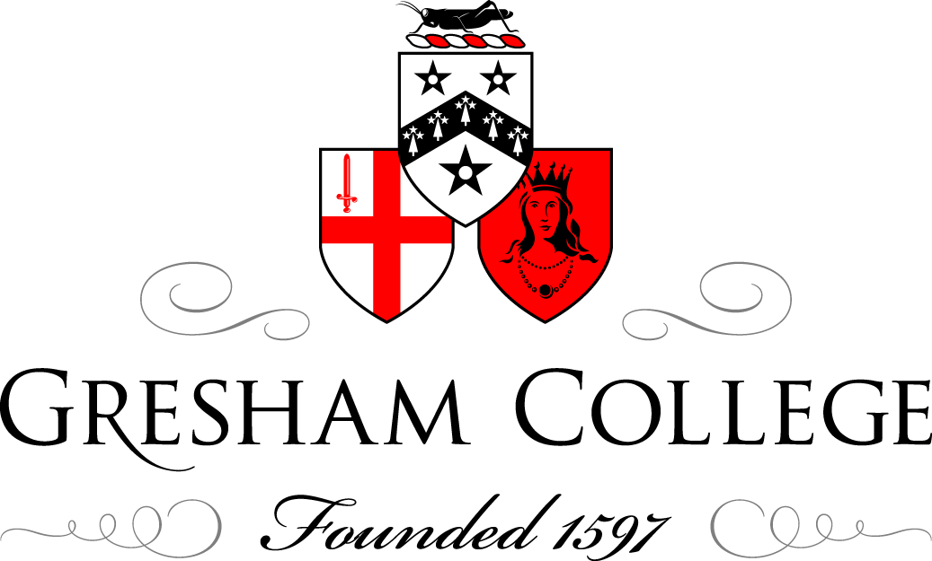

02 July 2014

The History of the Bowler Hat

Timothy Long

The bowler hat was created by London’s oldest milliner, James Lock of Lock & Co., in the 1840s as a form of protective headwear. The original design was commissioned by British soldier and politician William Coke (pronounced ‘cook’) who ordered the hat to protect the heads of his gamekeeper’s who tended to his Norfolk farm. Previous to this, Mr Coke’s gamekeepers had worn top hats, which were often knocked off by low-hanging branches and subsequently damaged. This new style was made extra stiff and was shaped close to the head.
One story suggests that when Mr Coke first saw the hat he had ordered, he took it outside and jumped on it a few times. Happy with the results, he placed his order paying twelve shillings for it. Due to Mr Coke’s involvement with the creation of this style, the bowler hat was often first referred to as a ‘coke’ hat. The name ‘bowler’ is said to have been the last name of the two men hired by Lock & Co to design the hat. The hat eventually went on to be called a billycock, blocker, Christie, derby and a wide variety of other names. There have also been others who claim to have been the originators of the bowler hat.
Throughout the mid-19th century, the bowler hat occupied the status of work-wear for London labourers, until it was adopted by Edward VII, who made it fashionable. Throughout the 20th century, the hat’s popularity grew until it almost entirely lost its association with the working class and became synonymous with civil servants and bankers. By the 1980s, however, the hat fell out of general fashion and was seen only during the most formal occasions or within specific industries, such as in the work dress of the officers of the Queen’s Guard.
While a full comeback is unlikely, The Daily Telegraph reported in 2011 that the retailer, Austin Reed, had stocked the hats for the first time in nearly fifteen years.
Definition:
‘A stiff felt hat with a low round crown and a narrow brim. The prototype was made for the London firm of Lock & Co. by the felt makers Bowler for a client William Coke in the 1840s, hence the names by which it is known. See also Billycock, Blocker, Christie, Derby.’
How it is made:
The hat is made through a process called ‘blocking’ in which felt (usually wool) is stretched over a ‘block’, or form, with the aid of heat, moisture and physical strength of the milliner. Once the material is stretched over the form, it is held in place with pins and strings and allowed to cool and dry. At this stage, the block is carefully removed from the interior of the hat, which is trimmed to the desired finished product. While a variety of animal hair is used for wool felt, many bowler hats of lesser quality are made with a polyester fibre.
Scientific analysis:
While analysing the collection of bowler hats in the archive of the Museum of London, numerous hats were found, dating from c. 1870 to today and manufactured by a variety of milliners, including Lock & Co. While most of the collection of bowlers is made of black wool felt, one stands out, as it was made with light grey felt. Unfortunately, when the hat was donated to the Museum of London in the 1960s, no information was given as to the object’s provenance. Due to this, the hat is simply catalogued as ‘bowler’. Upon further inspection, however, the hat’s colour appears to be one of a few unique qualities about the hat. For example, the two metal grommets punctured into each side of the hat suggest that the original wearer was intending to do physical activity and to sweat and, therefore, needed ventilation around the head. Additionally, the cord hanging from the centre back of the hat is typically associated with riding horses. And finally, the most compelling of all clues is a light ‘dusting’ of white material over the entire brim.
Using a microscope, this dusting of material was analysed and identified as feathers. Could it be that this hat, simply catalogued as a ‘bowler hat’ is actually closely connected to game keeping?
Key figures in the history of the bowler hat are Sherlock Holmes and Dr. Watson. While the deerstalker hat is perhaps more closely associate with Holmes, he and Watson were often described and represented in illustrations wearing bowler hats. As the original Sherlock stories were written in late Victorian England, when the bowler hat was worn by most modern English gentlemen, it comes as no surprise that Holmes and Watson were often seen in this hat.
Following its incredible popularity throughout the 19th and 20th centuries, the bowler hat enters an interesting chapter in its history following the end of World War II. By this point, the bowler hat, like so many other items of clothing, is subverted for a new audience by the emerging youth movements of the day. Bob Dylan refers to the bowler hat on his 1965 Bringing it all Back Home album and in 1971, the movie A Clockwork Orange features its main character, Alex DeLarge and his droogs wearing bowlers.
Perhaps the most surprising element to the history of the bowler hat is its adoption as a traditional part of women’s clothing among the Quechua and Aymara people of South America.
This London-made hat is charged with a variety of connotations and meanings, which make it one of the most iconic and dynamic fashion items created over the last 200 years.
© Timothy Long July 2014

References Swinnerton, Jo (2005). The History of Britain Companion. Robson.
"Bowler hat makes a comeback". The Daily Telegraph (London). Retrieved 1 July 2014
Ginsburg, M (1990) The Hat: Trends and Traditions. London: Barrons Educational Series Inc

