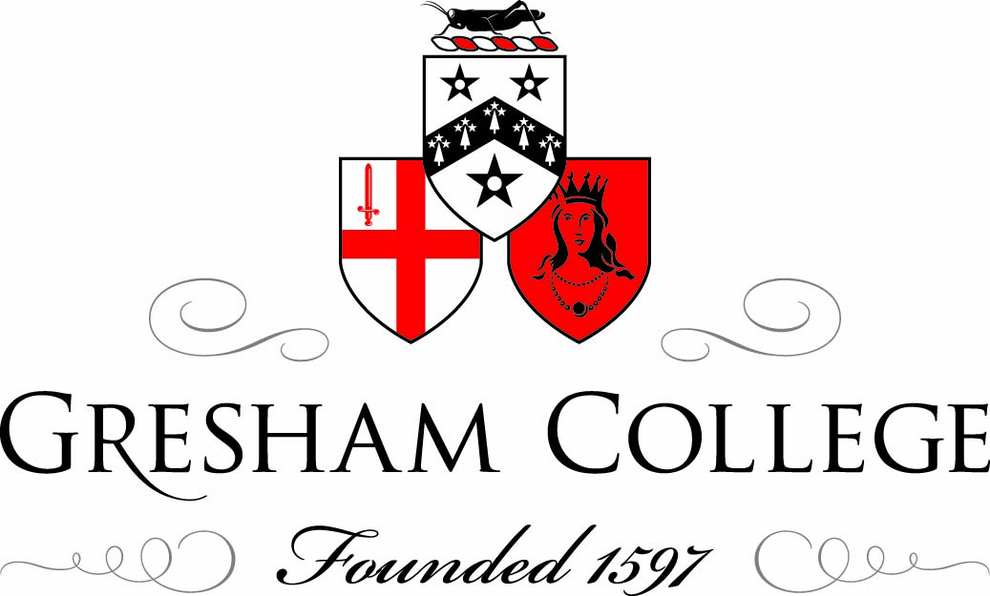

4 July 2012

Resetting the Human Compass:
The Use and Value of the Arts

Sir Andrew Motion

Speaking in its inaugural year, 1962, the Lord Mayor said of the City of London Festival that it existed to “promote beautiful things”. In this lecture, celebrating fifty years of the Festival, Sir Andrew Motion considers the uses of beautiful things, as well as their value – not always, he argues, the same thing.
We are living at a time in which great economic changes have done ‘great damage to many things that we hold dear, and have laid great burdens on the lives of millions.’ However, these same changes ‘also present us with a great opportunity’, the opportunity to ‘reset our compass as human beings’. In this lecture, Motion reflects on ‘the ways in which the arts might themselves set the direction of that compass’.

Personal Development
Motion was born in 1952, part of the ‘baby-boomer’ generation that felt itself ‘living on the sharp edge of a paradox’. His upbringing was not particularly or overtly ‘cultural’, and he identifies a disparity between the life he was born into and the life he leads now. So, what happened?

He describes the major formative influences on his artistic mind and career. Foremost among these is Peter Way, an A Level English teacher who introduced the young poet to the works of Hardy, Milton, Wordsworth, Clare, Keats, Tennyson, Auden, Larkin and Heaney.

‘Peter Way gave me my life; my best friend was my mentor; and the library was my oxygen tent... They had begun to produce in me a feeling that the arts were a peculiar mixture of refuge and vantage point, and were therefore essential to my health and happiness.’

Motion reflects on his attitude towards the arts upon leaving university:

‘Essentially, I believed, and I still believe, that the value of the arts depends on a series of paradoxes... To elaborate a little, they make the familiar strange, they remind us of what we already know, they help us ‘to enjoy and endure’, in Samuel Johnson’s words, by challenging and even shocking us, as well as by more straightforwardly consoling us. And in the midst of all these things, they create what I think is the most important paradox of all: at the same time as they deepen our sense of ourselves, and thereby authorise, extend, confirm and affirm us as individuals, they also allow us to see the world through eyes other than our own and to stand in other people’s shoes. In this respect, they encourage a fundamentally liberal and democratic instinct. It’s this, more than anything, that makes them a vital part of the existence we all share.’

How do we Measure the Arts?
Motion considers how the arts have benefitted in recent years. Between 1997 and 2007, ‘the arts had a 70% increase in funding, and as a result of this, all kinds of old institutions were revitalised – the Tate Modern, the South Bank - and a lot of vivacious new ones emerged – the Sage at Gateshead, the Lowry Centre’. New investment led to ‘a new valuing of the arts as a part of our national life’ – one of the great ‘undersung’ achievements of the New Labour era. ‘By the time of the last Election in 2010, there were two million people working in the creative sector, according to the DCMS, and these two million were contributing £60 million a year to the economy, a contribution that during New Labour’s years in office had grown at twice the rate of the economy as a whole – a fantastic story.’
But what of the problems and the negative issues that have emerged in our recent cultural history? Motion expresses a wariness of ‘instrumentalist’ approaches to the arts:

‘What kind of defence can be made for the research interest that produces no quick material return? What kind of justification can be made for university courses that have no particular use, even if they have a great value? What are the implications of the widespread re-branding of our universities and of our cultural industries as just that, as industries? What can be done about the way philanthropists, where they can be found at all, tend to support success stories, not risky ventures and are inclined to concentrate their money on the metropolis? What do we think about the ways in which institutions place an increasingly heavy emphasis on the commercialisation of intellectual life instead of cherishing universal knowledge and making what Matthew Arnold called ‘the disinterested endeavour to learn and propagate the best that has been known and thought in the world’?’

‘Most commentators, when they speak about the cuts, begin by insisting that the arts should share the country’s collective pain. I have to say, I have very divided feelings about this. A part of me thinks that because the arts are a part of life, they must share the same fate as everything else in life; another part of me wants to daydream and wonder why the arts, which give so much in terms of human value, and which have such an efficient micro-economy within the macro-economy, cannot be ringfenced in the same way that foreign aid and national health are supposed to be ringfenced. Why can’t we take a leaf out of Amartya Sen’s book and start thinking about how to rank the nations of the world in terms of their cultural worth, not just their economic and/or their military power? Why can’t we insist that our national reputation should no longer depend on the way we privilege bankers or go to war? Why can’t we say that, instead, we want our reputation to rest on the way we care about the good quality of our citizens’ lives and affirm that the arts and the humanities are the bedrock of that good quality? The realist in me knows that such a transformation in national image is unlikely, though I refuse to say impossible.’

Nevertheless, this realist imagination can, Motion argues, envision real opportunities for pragmatic change. He demands greater articulation of our country’s cultural values, but bemoans the fact that very often, such demands are simply met with silence from the authorities.

‘And on the few occasions this silence is broken, what do we hear then? News about very severe cuts to the Arts Council; news that the Museums, Libraries and Archives Council, which I used to be the chairman of, has been scrapped; news that the visionary Liz Forgan will not have her post renewed as the chair of the Arts Council; news that the culture of philanthropy the DCMS is supposed to be encouraging has shown precious little signs of coming into existence - in fact, the amount of private money coming into the arts since the initiative was announced has tanked.’

Poetic Examples
In the final part of his lecture, Motion reads and comments on three short poems, offering ‘a physical reality to ideas that would seem diminished if presented in merely abstract terms.’

In Alice Oswald’s sonnet ‘Wedding’, Motion argues that ‘the rush and change of the poem is its own point. It makes us think, first and foremost, about transformations, about the changes that love creates, and the changes that art creates, as it takes hold of familiar experience, illuminates it and passes it back to us as something deeper and refreshed.’
He describes Seamus Heaney’s ‘Postscript’ as a poem that ‘earths’ itself in a particular place and moment, while simultaneously asserting that ‘such moments, are ‘neither here nor there’’:

‘This very familiar phrase confronts the most abiding, tormenting problem that we have to acknowledge as human beings: in expressing ourselves, we put ourselves outside ourselves, because words can never be the same as feelings, however successfully they strive to capture them.’

Finally, Motion discusses one of his favourite poems: Wordsworth’s ‘She Dwelt among the Untrodden Ways’. He shares an anecdote of a student initially resistant and indifferent to the poem, but for whom it came to acquire profound meaning and significance following a personal tragedy.

Conclusion
‘For my own part, let me say this: the arts, and the humanities associated with them, provide us with the paradoxes that we depend on for the realisation and fulfilment of ourselves as human beings – nothing less. They stretch us, while reminding us of our shortcomings and our fallings short. They give us intense and durable pleasures, while, at the same time, testing and provoking us. They are the means by which we learn to live more deeply as individuals, but they are also the echo chambers in which we begin to understand what it means to live in history. They pay attention to events, but they make their own narrative of those events, and sometimes establish themselves at an interesting distance in order to understand them more deeply. They teach us about ourselves, while they allow us to forget ourselves, and, just as fulfillingly, to identify with others. They affirm the value of oblique truths, as well as the usefulness of direct utterance. They honour familiar life, while transfiguring it, and they give us the clearest possible view of what lies beyond our powers of seeing and of saying. They help us to continue living well because they keep death in view. Are these self-evident truths? I would say so. But this doesn’t mean we are excused from cherishing and broadcasting them. In fact, at times like these, we need to do so more urgently than ever. The true wealth of ourselves, and of our society, depends on it.

© Sir Andrew Motion 2012

