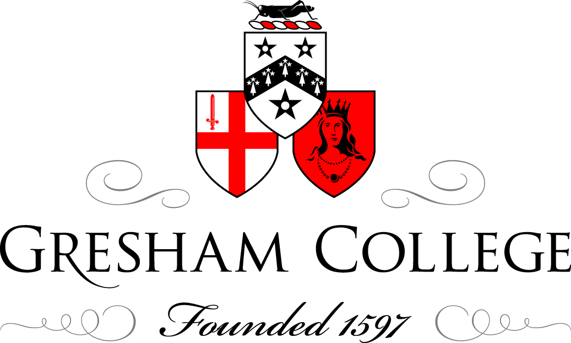

9 October 2013

Modern art – Enemy or Friend of Religious Art?

The Rt Rev. Lord Harries

The Challenge

The advent of modernism presented a huge challenge to artists who wanted to relate to Christian images. David Jones talked about “The Break”. By this, Jones meant two things. First, the dominant cultural and religious ideology that had unified Europe for more than a 1000 years no longer existed. All that was left were fragmentary individual visions. Secondly, the world is now dominated by technology, so that the arts seem to be marginalised. They are of no obvious use in such a society, and their previous role as signs no longer has any widespread public resonance. Their work was “idiosyncratic and personal in expression and experimental in technique, intimate and private rather than public and corporate.”

Anthony Blunt, discussing Jacob Epstein’s Ecce Homo, thought the break occurred much earlier. He pointed out that in a society where religion is a natural part of life, religious art emerges with equal naturalness. But since the Enlightenment religion has not been woven into the texture of our culture, and artists who wish to convey a religious vision will almost invariably produce a work which is private, out of step with the dominant culture and idiosyncratic, a good example being William Blake (1757-1827). In the nineteenth century, an attempt was made to solve this problem by the revival of a medieval style, as with the Gothic Revival, or the early Italian one, as in the case of the Pre-Raphaelites. But Blunt did not think these attempts really met the challenge of the modern world, and were in fact an artifice for avoiding it. But whenever the break occurred “The great difficulty which has faced religious artists in Europe for about a century is that our natural tradition for expressing religious feeling is utterly used up and dead.”
Christian art was once part of what the distinguished art critic, the late Peter Fuller, once called a “symbolic order”. This consisted of shared narratives and recognised images through which the deeper meaning of life could be explored. This has gone.

In addition there remained the much older challenge: how to indicate the transcendent through the mundane?

Sources of renewal

Various sources of renewal have contributed to the revival of vibrant art on Christian themes.

The art of other, often earlier cultures

Jacob Epstein was much influenced by African sculpture in his carving. He was vilified for this work, but it produced masterpieces like Ecce Homo now standing in the ruins of the bombed Coventry Cathedral.
So too was Leon Underwood, described as the Father of modern sculpture and the teacher of Henry Moore. We see this in his Madonna and child in St George’s Cathedral, Capetown.

Twentieth century suffering

Many twentieth century artists were acutely conscious of the terrible suffering of that century and reflected this in their work. For example Otto Dix in Ecce Homo II. So too was Graham Sutherland, as we see in his crucfixion which he did for St Matthew’s, Northampton.

For two years he was to paint thorns with passion and intensity, a theme he was to return to sporadically for many years after. They were for him an image of cruelty and they came to stand for the head of the crucified. It was in 1946 that he began in earnest on the crucifixion scene itself, inspired to do so by the photos of the terribly emaciated bodies of people released from Belsen .They reminded him of the body of Christ on the cross painted by Grunewald for the Isenheim Altarpiece and his own image became a symbol of the endless cruelty of human beings to one another. Whilst motivated by the effects of twentieth century cruelty, and tempted to produce a less naturalistic work, he made a conscious decision to produce a painting “immediately intelligible and within the tradition.”

Rouault was acutely conscious of human suffering, both the misery of the poor area he was born into and the devastation caused by World War I. This is reflected not only his ordinary portraits but in his images of Jesus, for example Jesus mocked by soldiers. He gave one of his paintings the title “Jesus will be in agony until the end of the world.”

Medieval Glass

This was another big influence. Roualt trained first as a glass maker, and this is clearly reflected in his paintings.
John Piper wrote in Stained Glass: Art or Anti-Art? that most stained glass produced over the previous 500 years had not been art at all, just a poor attempt to reproduce in glass what painters do on canvas. But what the Romanesque stained glass artists produced provided a fresh source of inspiration for modern artists. What was important about their work was not the scenes themselves, but the total effect.

As he wrote:
We are still fairly new and fervent converts to Romanesque. The brightness and the primary colour contrasts; the geometrical arrangements of not completely geometrical forms, within bold, black glazing bars; the absence of desire in the makers to achieve any formal recession in drawing or colour-these have provided a sympathetic appeal to the eyes of many in our two thirds of the twentieth century.

John Piper produced the superb baptistery window for Coventry Cathedral and innumerable windows for churches such as the Benjamin Britten memorial window at Aldeburgh.

Abstract style

The modern stress on abstract art was an important source of renewal for religious art, as we see it in the work of Piper himself, Ceri Richards, (The deposition in St Mary’s, Swansea) Anthony Caro, ( The deposition in Christs College, Cambridge and Allision Watts ( Still in Old St Paul’s, Edinburgh) amongst many others. Ceri Richards wrote:
“I was profoundly interested in the religious subject…I approach these subjects with great care and circumspection, for I cannot decide casually to just “do” a religious subject.”

Describing the two versions of Deposition as presenting an image of “almost unbearable sadness” with a “timeless modernity” Mel Gooding writes:
The dead Christ is laid on a white sheet amidst the mud and debris of a public place. In the Swansea painting, in which the lateral cruciform of the composition is clearly explicit, scraps of litter are incorporated into the paint, and the carpenter, whose job it is to have made the cross and to have removed the nails, and who poignantly reminds of the working profession of Jesus himself, is represented by his work bag, whilst someone out of the picture to the left shows concern by clasping hands in a way that prefigures a million prayers.

On Alison Watt:
“A presence at once given and denied” are words that Robert Pogue Harrison used of the Vietnam War Memorial in Washington DC. Richard Holloway finds them particularly apt for the Warrior’s Chapel in Old St Paul’s, Edinburgh where Alison Watt’s painting hangs.

He describes how Alison Watt went into the chapel and was moved by its special atmosphere to paint still in response. He writes of the painting:
It suggests the presence of a huge absence, the brimming over of a vast emptiness. It glimmers against the grey sorrow of the stone, but does not attempt to subdue it. And the Warriors’ Chapel looks as if it has been waiting for it from the beginning.

Intense personal vision

The work of some artists has been shaped less by movements of style than an intense personsoal vision. Stanley Spencer was one. He wrote:
When I lived in Cookham I was disturbed by a feeling of everything being meaningless. Quite suddenly I became aware that everything was full of special meaning, and this made everything holy. The instinct of Moses to take his shoes off when he saw the burning bush was very similar to my feelings. I saw many burning bushes in Cookham. I observed the sacred quality in the most unexpected quarters.
The Tate Gallery originally mistitled this picture “Christ Bearing his Cross” which intensely irritated Stanley Spencer. As he said, the false title implied:
A sense of suffering which was not my intention. I particularly wished to convey the relationship between the carpenters behind him carrying the ladders and Christ in front carrying the cross. Each doing their job of work and doing it just like workmen . . . Christ was not doing a job or his job, but the job.

Again, when Stanley Spencer’s dealer thought of cataloguing the painting as “Christ Carrying His Cross” Stanley was furious. The cross was for him universal. We all have to carry the cross. Again, he said:
Love is the essential power in the creation of art and love is not a talent. Love reveals and more accurately describes the nature and meaning of things than any mere lecture on technique can do. And it establishes once and for all time the final and perfect identity of every created thing.
The strangeness of his style arises out of the way he saw life, as a vision of felt love. As he wrote “Distortion arises from the effort to see something in a way that will enable him to love it.”

Spencer’s “Christ in the wilderness” series is superb, especially his Christ and the Scorpion.
Chagall was inspired by the possibilities of stained glass but he also had a vision arising out of the Jewish mysticism of his childhood in Vitebsk. Leaving Vitebsk, he wrote:

I roamed the streets, I searched, I prayed. “God, Thou who hidest in the clouds, or behind the cobbler’s house, lay bare my soul, the aching soul of a stammering boy, show me my way. I do not want to be like all the others; I want to see a new world.” In answer the town seems to snap like the strings of a violin, and all the inhabitants begin walking above the earth, leaving their usual places. Familiar figures install themselves on the roofs and settle down there. All the colours spill out, dissolve into wine, and liquor gushes out of my canvases.

Sometimes he combined Christian and Jewish imagery, as in White Crucifixion in the Museum of Modern Art in Chicago and his superb windows in Tudely, Kent.

Having the courage of a child’s vision

Cecil Collins, more of a Platonist that a Christian, sought to have a child’s vision, so did Albert Herbert (see for example, Elijah being fed by the Raven) who wrote:
“I used to creep down to the etching room in the basement of St Martin’s and work at these little prints, literary, illustrative, with bits of theology hiding behind childish jokes; all the opposite of what my modernist colleagues were teaching on the top floor.” Eventually he learnt to draw again by looking at children’s drawings and this led him to “drawing what I felt and knew rather than what it looked like.”

Nature and colour

For others it was nature that gave them religious, as well as artistic inspiration.
Earlier in life Norman Adams had experienced a moment of revelation when looking at a butterfly. He realised that the beauty of the butterfly existed just for its own sake, and it gave him an abiding sense that whatever else might be seen in a picture, beauty needed to be part of it. His denied that his paintings were abstract. He saw them in terms of the human journey, that journey with its joy and suffering being conveyed through forms of colour. He needed nature to inspire him but what it inspired was this search for form through colour. However, these forms were not for their own sake. “Subject has always been most important” he wrote, “I cannot start a painting until I am driven by an almost moralistic idea. Of course the idea-subject-and form must match perfectly-becoming a homogeneous root.” “The thorough integration of the forces of the medium-pigment, texture, light, colour-and the forces of nature-emotion, drama, the joy and the sorrow and to find precise equivalents in the former for aspects of the latter has been a major task.”
Adams produced the remarkable Stations of the Cross, Station 10 for St Mary’s Roman Catholic Church, Mulberry Street, Manchester, and his wonderful Golden Crucifixion in which the butterflies offer some hint of resurrection

Modernity, the tradition and the conemporary world

Roger Wager, a contemporary artist is at once a painstaking tradional artist, and a surrealist wanting to suggest something else going on the in the scene. Like T.S. Eliot, he draws on tradition in a way that heightens the sense of the modern.
Wagner is also an accomplished poet, and sometimes he has written a poem to go with a painting, as he has for Walking on Water III with its scriptural quotation at the head.

‘Lord if it is you’ Peter replied
‘tell me to come to you on the water.’
‘Come’ he said. ( Matthew 6,27)

To step out of ourselves on to that sea
Forsaking every safety that we know
Becoming for one moment wholly free
That in that moment endless trust may grow.
To step into that love which calls us out
From all evasions of one central choice
Besieged by winds of fear and waves of doubt
Yet summoned by that everlasting voice.
To walk on water in astonished joy
Towards those outstretched arms which draw us near,
Then caught by winds which threaten to destroy
We sink into the waters of our fear.
Yet underneath all fears and false alarms
Are sinking, held, by everlasting arms.

His latest work is a stained glass window in St Mary’s, Iffley.

In his interesting lecture “Thinking theologically about modern art: marching to an antique drum?” Wagner discusses how he was faced with the daunting challenge of producing work to match that of Piper and which was fully contemporary. Drawing inspiration from T.S. Eliot, both in his essays and poetry, Wagner concluded by saying “When I came to make the Iffley window I felt no hesitation in quoting from Palmer, from medieval painting, from Rouault or from wherever I liked.” So it was that both visual echoes of artists of the past, from Palmer, and some of the images from his previous paintings come together in a creative whole: the sheep he saw on Dartmoor, the great trees he loves to paint, the river of God discussed above, and the twelfth century mosaic tree of life he saw in San Clemente in Rome are all integrated into an overall vision.

Overall modernism has been a friend to religious art

First, an emphasis on art being a work in its own right, and not simply a representation of something else, on form not content, as stressed by Roger Fry and Clive Bell in the phrase “significan form, helped liberate religious art from literalism and historicism.
Second, the emphasis on the abstract element helped this liberation, at the same time as hinting at “something more” going on in the scence.
It is notable that both Icons, and Romanesque art, whose value was re-affirmed in the twentieth century share some of the characterists of modernism.

The Response of Laura Moffatt, Director of Art and Chritianity Enquiry (ACE)

In considering how to respond to Richard’s question of whether today’s art can still be deemed to be a friend of religion, I think one of the many issues facing us is that of the context in which a new work of art is made. I do not just mean the physical context of a place of worship but the wider social, demographic, cultural contexts. I think it drives us to ask what religious life is and how it is played out; more specifically what church is and can be.
I think that in asking those important questions we find that art, in particular what we might term contemporary art, is extremely adaptable and offers exceptional means of translating, augmenting and encapsulating our answers.
To illustrate this I want to show you two works which are both over ten years old now but I think they are exemplary of a contemporary attitude and ability in artists. Co-incidentally, they were also joint winners of ACE’s award for art in a religious context in 2007.
This is Rose Finn-Kelcey’s temporary work Angel, which was a work made specifically for the church of St Paul Bow Common in 2004. It was commissioned by Art in Sacred Places, and the area around Tower Hamlets has significant deprivation; it has a large Bangladeshi community; and, ironically, almost literally sits in the shadow of Canary Wharf.
The church itself houses mosaics by Charles Luytens showing Angels of the heavenly host alongside the four elements of Creation. It is also widely held as a benchmark piece of post-war British church architecture and as such a bastion of good taste!
I should explain the text across the centre which is old technology now but it is an emoticon – a zero, colon, dash and close bracket – which if you flip it up 90 degrees gives you the face of a smiling angel.
In making a work like this, Finn-Kelcey, in a mode that is a little like method acting, would submerse herself in a community, in a context. I happen to know, she is still a keen contributor to the church’s weekly jumble sales!
The work that results appeals across different faiths, ethnicities and ages, it is capable of referencing art history and popular culture. At the same time it is simply saying ‘look at me’, ‘look at this church, something special happens here’. If you like, it is a contemporary para-phrasing of the biblical text that runs around the porch: ‘This is none other but the House of God; This is the gate of heaven.’
While some might be critical of the work’s evasion of any biblical interpretation or Christology, I think it is very brave and poignant piece of art that does not shy away from Christianity, but re-imagines its place in multi-cultural east London.
The second piece which I think demonstrates its adaptability to context is this altar, set within the Chapel of St Anselm in Canterbury Cathedral. It is by Stephen Cox, whose methods are clearly more traditional than Finn-Kelcey’s. But the work is equally driven by the inter-relatedness of different contextual influences.
In brief, the altar was commissioned by the people of Aosta in Italy, the birthplace of Anselm and the place from which the stone for the altar was quarried.
Of course, this work sits well aesthetically in the environment but it also exploits the conceptual strength of materials: the stone is allowed to speak, in a way that magnifies the incarnation of Christ, his death and resurrection. It is something that will testify, for many years to come, to the eloquence of materials, space, history and relationship, brought together in one fluent presence.
Lastly, I want to say that, far from being the enemy of contemporary religious life, art could in fact, play a really vital role in its evolution. It will not be a re-hash of the old church-as-patron story – that time has long gone. But if treated as a symbiotic relationship, artist and church – together with many others involved in the commissioning process – artist and church will be able to offer many rich ways into the Christian narrative.

This dialogue was in connection with the launch of The Image of Christ in Modern Art, (Ashgate) which was based on the Gresham Lectures given by Richard Harries. It is available as a paperback for £19.99

© The Rt. Rev Lord Harries, 2013

David Jones, “Religion and the Muses”, (1941), in Epoch and artist, Faber 2008, p.98.
The article was printed in The Spectator on March 15th , 1935
ibid p.127
John Piper, p.23
Quoted by Mel Gooding, Ceri Richards, Cameron and Hollis, 2002, p.130
Gooding, p.131
Richard Holloway, Leaving Alexandria, Canongate, 2012, p.196
Sermons by artists, Golden Cockerel Press, 1939, p.50
Archives of Arthur Tooth and Sons, in the Tate as 8917. The painting was about to be hung at the Venice Bienalle. Kenneth Pople, p.91
Sermons by artists, Golden Cockrell Press, 1934,p.51 The whole sermon is a powerful hymn to love.
Sermons by Artists, Golden Cockerel Press, 1934,p.52
Adams, p.23
Norman Adams, p.85
Available on the Gresham College website

