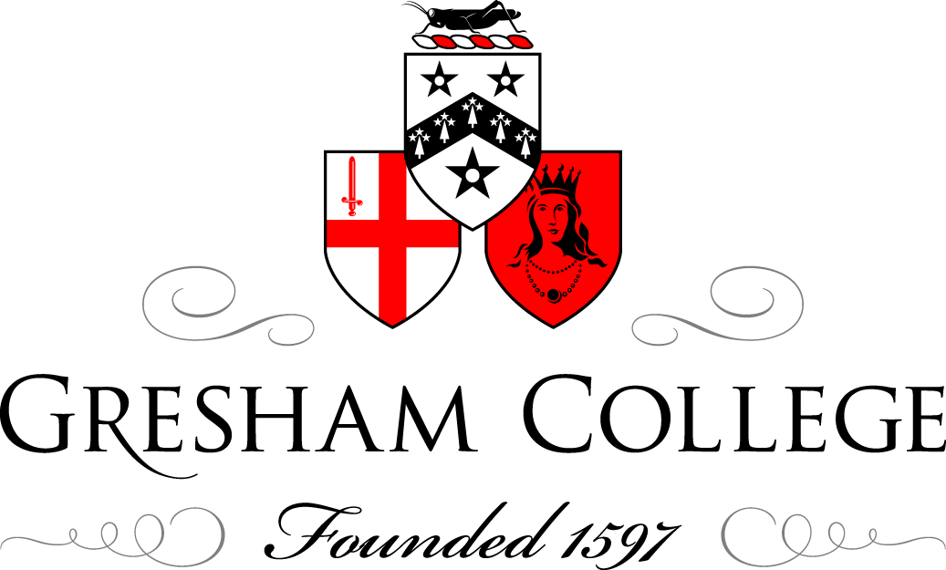

10 November 2010

Made in America:
Christian Fundamentalism

Dr John A Dick

Noam Chomsky: “We must bear in mind that the U.S. is a very fundamentalist society, perhaps more than any other society in the world – even more fundamentalist than Saudi Arabia or the Taliban. That's very surprising.”
Overview:
(1) Introduction
(2) Five-stage evolution of fundamentalism in the United States
(3) Features common to all fundamentalisms
(4) What one does about fundamentalism

INTRODUCTION:

In 1980 the greatly respected American historian, George Marsden published Fundamentalism and American Culture, a history of the first decades of American fundamentalism. The book quickly rose to prominence, provoking new studies of American fundamentalism and contributing to a renewal of interest in American religious history.
The book’s timing was fortunate, for it was published as a resurgent fundamentalism was becoming active in politics and society.
The term “fundamentalism” was first applied in the 1920’s to Protestant movements in the United States that interpreted the Bible in an extreme and literal sense. In the United States, the term “fundamentalism” was first extended to other religious traditions around the time of the Iranian Revolution in 1978-79.
In general all fundamentalist movements arise when traditional societies are forced to face a kind of social disintegration of their way of life, a loss of personal and group meaning and the introduction of new customs that lead to a loss of personal and group orientation.
Regardless of the religious tradition to which they belong, all fundamentalists follow certain patterns:
• Religious ideology is the basis for their personal and communal identity.
• They insist upon one statement of truth that is inerrant, revealed and unchangeable
• They see themselves as part of a cosmic struggle between good and evil.
• They seize on historical moments and reinterpret them in the light of this cosmic struggle.
• They demonize their opposition.
• They are selective in what parts of the religious tradition and heritage they will stress.

Fundamentalist Christianity is defined by Marsden as "militantly anti-modernist Protestant evangelicalism." Marsden explains that fundamentalists were evangelical Christians who in the 20th century "militantly opposed both modernism in theology and the cultural changes that modernism endorsed. Militant opposition to modernism was what most clearly set off fundamentalism."

Although we have not usually thought of Roman Catholics as fundamentalists, the term can certainly be applied to a number of Roman Catholic movements and/or organizations….. And a certainly large number of today’s American Roman Catholic bishops are starting to resemble fundamentalists more and more……

(1) THE FIVE-STAGE EVOLUTION OF FUNDAMENTALISM IN THE UNITED STATES

Fundamentalism in the United States has so far gone through five stages, while maintaining an essential continuity of spirit, belief, and method.

A. FIRST STAGE – 1920s

The earliest phase of fundamentalism in the USA involved articulating what was fundamental to Christianity and initiating an urgent battle to expel the enemies of orthodox Protestantism from the ranks of the churches.

American Christian fundamentalism, therefore, was a reaction by late nineteenth and early twentieth-century evangelical Christians against modernizations in American society, such as industrialization, Darwin’s theory of evolution, and changes in popular mores.
Fundamentalists resented modernization because it clashed with their worldview and their literal interpretations of the Bible and of Christian doctrine. Within the American denominations, fundamentalists fought modernists about the Bible as an historical document, biblical inspiration, and the biblical explanation for the creation of the world.

Fundamentalists also launched a campaign to safeguard “authentic Christian values” in American society, most notably through laws prohibiting the teaching of evolution in public schools.

The term "fundamentalist" was perhaps first used in 1920 by Curtis Lee Laws in the Baptist Watchman - Examiner, but it seemed to spring up everywhere in the early 1920s as an obvious way to identify someone who believed and actively defended the “fundamentals of the faith.”

Throughout the 1920s, fundamentalists waged battles in the large northern church denominations in a struggle for what they perceived as true Christianity at war against a new non-Christian religion that had crept into the churches. In his book Christianity and Liberalism (1923), George Gresham Machen (Presbyterian minister and professor of New Testament studies at Princeton Theological Seminary) called the new naturalistic religion "liberalism," but later followed the more popular fashion of calling it "modernism."

Church struggles occurred in the Methodist Episcopal Church, the Protestant Episcopal Church, and even in the Southern Presbyterian Church, but the grand battles were fought in the Northern Presbyterian and Northern Baptist denominations. Machen was the undisputed leader among Presbyterians. Baptists created the National Federation of the Fundamentalists of the Northern Baptists (1921), the Fundamentalist Fellowship (1921), and the Baptist Bible Union (1923) to lead the fight. The battles focused on instruction in seminaries and the formation of missionaries. In many ways, however, the real strongholds of the fundamentalists were the Southern Baptists and the growing number of new independent churches spreading across the American South and Midwest.
In politics fundamentalists opposed the teaching of Darwinian evolution in public schools, leading up to the famous Scopes trial (1925) in Dayton, Tennessee. William Jennings Bryan, a Presbyterian layman and three times candidate for the American presidency, was the acknowledged leader of the anti-evolution battle.

The Scopes Trial, informally known as the “Scopes Monkey Trial,” was an American legal case in 1925 in which an American high school biology teacher John Scopes was accused of violating a law in the State of Tennessee which made it unlawful to teach evolution. John Scopes was found guilty, but the verdict was overturned on a technicality and he was never brought back to trial. The trial drew intense national publicity, as national reporters flocked to the small town of Dayton, to cover the big-name lawyers representing each side. William Jennings Bryan, three time presidential candidate for the Democrats, argued for the prosecution, while Clarence Darrow, the famed defense attorney, spoke for Scopes.

The trial revealed a growing chasm in American Christianity and two ways of finding truth, one "biblical" and one "scientific." Liberals saw the trial as underlining a growing division in the United States: a division between educated, tolerant Christians and narrow-minded, obscurantist Christians.

In contemporary America, the spirit of the Scopes Trial is alive and well in the Intelligent Design movement, promoted and greatly funded by the Discovery Institute in Seattle, Washington. The Discovery Institute is the driving force behind the movement and the Institute directs its campaigns through its Center for Science and Culture division with guidance from its public relations firm Creative Response Concepts.

The Discovery Institute seeks to promote intelligent design while discrediting evolutionary biology, which the Institute terms "Darwinism.” The Institute strongly asserts that teaching evolution leads to eugenics and Nazism. Intelligent design, a form of creationism, on the other hand, safeguards the belief that certain features of the universe and of living things are best explained by supernatural intervention -- by an intelligent cause -- not an undirected process such as natural selection.

B. SECOND STAGE: LATE 1920s to EARLY 1940s

By the late 1920s, it seemed that militant fundamentalists had failed to expel the “modernists” from American Protestant Christianity and had lost the battle against evolutionism.
Orthodox Protestants, who still numerically dominated all the denominations, now began to struggle among themselves. During the Depression of the 1930s the term "fundamentalist" gradually shifted meaning as it came to apply to only one party among those who believed the traditional fundamentals of the faith. Meanwhile, neo-orthodoxy associated with Karl Barth's critique of liberalism found strong adherents in America.
During this period the distinctive theological point made by the fundamentalists was that they represented true Christianity based on a literal interpretation of the Bible, and that de facto this truth ought to be expressed organizationally and clearly distinct from any association with “liberals and modernists.” Fundamentalists also identified themselves with what they believed was a pure personal morality and a pure American culture. Thus, the term "fundamentalist" came to refer largely to orthodox Protestants outside the large Northern denominations, whether in the newly established church denominations, in the Southern churches, or in the many independent churches across the United States.

C. THIRD STAGE: FROM 1940s to 1970s

In the 1940s, especially after the Second World War, fundamentalists divided gradually into two camps. There were those who continued to use the term “fundamentalist” to refer to themselves and to equate it with “true Bible-believing-Christianity.” There were others who came to regard the term as undesirable, with a connotation of being divisive, intolerant, anti -intellectual, and not at all unconcerned with social problems. This second group wished to regain fellowship with those orthodox Protestants who still constituted the vast majority of clergy and people in the large Northern churches: Presbyterians, Baptists, Methodists, and Episcopalians. They began to call themselves "evangelicals" and to equate that term with true Christianity. In 1948 a few began, to call themselves “neo-evangelicals.”

The term "fundamentalist" was carried into the 1950s by a vast number of Southern and independent churches. It was proudly used by such schools as Bob Jones University, the Moody Bible Institute, and the Dallas Theological Seminary, and by hundreds of evangelists and radio preachers. The International Council of Christian Churches (1948) sought to give the term worldwide currency in opposition to the World Council of Churches, which by that time was considered far too liberal.

The term "fundamentalist" therefore took on special meaning in contrast to evangelicals or neo-evangelicals.

Nevertheless, fundamentalists and evangelicals in the 1950s and 1960s shared much. Both adhered to “traditional” literal interpretations of Scripture and Christian doctrine; Both promoted evangelism, revivals, missions, and a personal morality that strongly opposed smoking, drinking alcoholic beverages, the theater, motion pictures, and card playing. Both identified “American values” with “Christian values.” Both believed in creating organizational networks that separated themselves from the rest of (decadent) society.
Fundamentalists, however, believed they differed from evangelicals and neo-evangelicals by being more faithful to “Bible-believing-Christianity” and more militant against atheistic communism. They tended to oppose the popular evangelist Billy Graham, not to read Christianity Today, which was considered far too liberal. Instead they favored their own evangelists, their own radio preachers, newspapers, and schools. Fundamentalists still tended to differ greatly among themselves and they found it difficult to achieve widespread fundamentalist cooperation across the country.

D. FOURTH STAGE: LATE 1970s and 1980s

By the late 1970s and in particular by the 1980 U.S. presidential campaign of Ronald Reagan, American fundamentalists entered a new phase.
American fundamentalists became nationally prominent as offering an answer for what many regarded as a major social, economic, moral, and religious crisis in America. They identified a new and more pervasive enemy, secular humanism, which they believed was responsible for eroding churches, schools, universities, the government, and above all families. They fought all enemies which they considered to be subversive supporters of secular humanism, evolutionism, political and theological liberalism, loose personal morality, sexual perversion, socialism, communism, and any lessening of the absolute, literal and inerrant authority of the Bible. They called Americans to return to the “fundamentals of the faith” and to the “fundamental moral values of America.”
A new generation of television and print fundamentalists, notably Jerry Falwell, Tim La Haye, Hal Lindsey, and Pat Robertson, led the newly energized American fundamentalist movement.
The base for this new fundamentalism was Baptist and Southern, but it reached into all denominations across North and South. The new fundamentalists benefited from three decades of post-World War II fundamentalist and evangelical expansion through evangelism, publishing, church extension, and radio ministry.
And the new fundamentalists tended to blur the distinction between fundamentalist and evangelical.

Statistically, the new fundamentalists could claim that perhaps one fourth of the American population was fundamentalist - evangelical. However, not all fundamentalists accepted these new leaders, considering them to be neo-fundamentalists.

The fundamentalists of the early 1980s were in many ways very different from their predecessors, but they maintained important elements common to fundamentalists from the 1920s through the early 1980s. They were certain that they possessed “true knowledge” of the “fundamentals of the faith” and that they therefore represented “true Christianity” based on the authority of a literally interpreted Bible.
The new fundamentalists believed it was their duty to carry on the great battle of history: the battle of God against Satan, of light against darkness, and to fight against all enemies who undermined Christianity and therefore undermined America.

Faced with this titanic struggle the new fundamentalists were inclined to consider other Christians, who were not fundamentalists, as either “unfaithful to Christ” or “not genuinely Christian.” They called for a return to an inerrant and infallible Bible, to the traditional statement of the doctrines, and to a traditional morality which they believed once prevailed in America. To do all this, they created a vast number of separate organizations and ministries to propagate fundamentalist belief and practice.

As fundamentalists became even more active politically, we began to refer to them as the Christian Right.

E. FIFTH STAGE: TODAY – FUNDAMENTALIST CHRISTIAN RIGHT

Today the terms Christian Right and Religious Right are often used interchangeably, although the terms are not synonymous. Religious Right can refer to any religiously motivated conservative movement, whether specific to one religion or shared across religious lines. The term Christian Right is used by people from a wide range of conservative political and religious viewpoints. Some 15% of the electorate in the United States tell pollsters that they align themselves with the Christian Right, which serves as an important voting bloc within the U.S. Republican Party. In presidential elections that put George W. Bush in the White House for eight years, conservative American Catholics joined the Christian Right to insure a Bush victory.

Certainly one can credit this fundamentalist Christian political activism to people like Jerry Falwell, and other well-known fundamentalist clergy, who began urging American Christians to become involved in politics in the 1970s.

Beginning with Rob Grant's “American Christian Cause” in 1974, the Christian Voice throughout the 1970s and Falwell's Moral Majority in the 1980s, the Christian Right began to have a major impact on American politics.
By the late 1990s, the Christian Right was influencing elections and policy with groups like the Christian Coalition and the Family Research Council helping the U.S. Republican Party to gain control of the White House, both houses of Congress, and a more conservative Supreme Court by the mid-1990s.
The power of the Christian Right cannot be overestimated in the most recent mid-term elections that have brought a strong voice of opposition to the Democratic party and policies of President Barack Obama.
In recent years, Christian right groups have appeared in other countries such as Canada and the Philippines. However, the Christian right remains an idiosyncratic phenomenon most commonly associated with the United States.

(2)A SUMLMARY OF FEATURES COMMON TO ALL FUNDAMENTALISM

Fundamentalism is fundamentally flawed because it takes one element of the truth and proclaims it as the WHOLE TRUTH. Religious fundamentalists place such a high priority on doctrinal conformity and obedience to doctrinaire spokespersons that they sacrifice values basic to the great religious traditions: love, compassion, forgiveness, tolerance and caring. In their overwhelming seriousness about religion, fundamentalists do not hesitate to intervene in political and social process to ensure that society is forced to conform to the values and behaviors the fundamentalist worldview requires. Fundamentalists are their own justification.

Fundamentalism appeals for a variety of reasons:

•For people who feel unimportant or insignificant, fundamentalism says you are important because you are God’s "special messenger.”

•For people who are fearful, fundamentalism says “you can’t be saved without us…join and be saved.”

•For the confused, fundamentalism says one doesn’t have to think about doctrine nor even be educated in it. Just believe.

•Fundamentalism makes the fundamentalist feel good about himself or her. It is self-stroking.

•Fundamentalism justifies hatred of one group of people for another, because it believes that God hates those who do not conform to the fundamentalist’s worldview.

•Fundamentalism appeals to people burdened by guilt and shame because it exempts them from responsibility for situations or actions that cause guilt and shame. Fundamentalism says…if you are one of us, you are OK.

•Fundamentalism excuses people from honest self-examination; and it justifies their prejudices, zealotry, intolerance and hatefulness.

(3) WHAT DOES ONE DO ABOUT FUNDAMENTALISM?

•The best way to confront ignorance is through real education that emphasizes critical, analytical thinking skills.

•Real education teaches students the importance of gathering evidence and then proceeding to conclusions. Fundamentalists work in opposite fashion.

•We need to establish channels for dialogue and institutions that promote multi-cultural knowledge and understanding.

•We in West need to practice a genuine humility that enables us to see the rest of the world and the rest of the world’s needs.

•We need to translate our vision-gained-from-humility into concrete and achievable actions and strategies.

© Dr John A Dick, 2010

