

11 February 2015

Is Human Evolution Over?

Professor Steve Jones

What I want to explore is: what can we say, if anything, about the future of the species to which many of us claim to belong, Homo sapiens, given what we know about the evolutionary processes that caused that species to evolve?

Well, the notion of change in the future is really more or less universal. You can see it again and again, many of which are just models of decline, but some are more optimistic, and maybe the man who was most optimistic was Thomas More here, who wrote a book called “Utopia”, which means “the real place”, “a good place”, and he had – there is a map of Utopia, which looks to me a bit like the Isle of Wight, which is not to me heaven on earth in particular, but that is another story – lots of yachts, as we can see there… His utopia is interesting. It is a beautifully written book. It was written in 1516, and what happens is that, in his utopia, society changes. Chamber-pots are made of gold because gold is a useful and easy, malleable metal. People who commit crimes are sent to hospital because there must be something wrong with them. People who become ill are put in prison because they have not looked after themselves. These are all radical new ideas, but what is interesting is that this is a utopia of social and intellectual change.

But, about a hundred years ago, or a bit more, as you will see in a moment, that notion of the future altered almost completely, and now basically all our utopias are utopias of physical change, of evolution.

So, here is one, a nice utopian inhabitant. I think that is from “Star Trek”. I never really know as I have never seen “Star Trek”, but what we have got in something like “Star Trek”, and many other bits of science fiction – and I do not read science fiction generally because it is all the same. Science fiction is always the same, whatever it is. You get these strange blobby mutant creatures, biologically changed creatures from outer space, or even here on Earth at some indeterminate time in the future, but in fact – so they have change biologically, they have these interesting brow ridges and gigantic ears, a bit like the Duke of Edinburgh, and they have changed biologically, but if you look at the plots, the stories of these new utopias, modern utopias, they are all exactly the same as what we live in today, the rather dystopian world in which we live. There are tribes, there are gangs, there are wars, there are weapons, there is a love interest, there are quarrels, and all this kind of stuff. So actually, people have changed, but society has not, and that is a really big shift in the way perhaps that we see the future.

I think we can trace that back to the first modern work of science fiction in English, which is written by H.G. Wells. That is the H.G. Wells who was a student at Imperial College, so it is obvious why he thought that everything was going to hell in a hand-cart. But he is photographed here in about 1906 I think, in the Zoology Museum at University College London, which is where I work, in the Grant Museum, which I recommend to you all – it is a remarkable place, and it is full of old fossils. I take my lunch in the senior common-room which is even fuller of old fossils. And there he is, standing there, leaning on a gorilla, with a human skull in his hand. He was very, very interested in the biological future, and he wrote really a magnificent book, which is, and I am sure you have all read it, which is “The Time Machine”.

“The Time Machine” is the first modern piece of science fiction in English. Jules Verne had written “A Journey to the Moon” and so on, but that is in French so it does not count. “The Time Machine” is really rather a good book, and of course, you all know the plot of “The Time Machine”. It turns on somebody who invents a kind of bicycle, upon which he can leap and cycle off into the future. This is rather unlikely…there is the rather unlikely apparatus, and he is zizzing off into the future. He starts off and he zooms off into the future and lights and darks begin to blur into one, and he stops at several thousand years in the future and he gets off his time machine, and he finds himself in somewhere that, at first sight, looks a bit like I suppose Hampstead, okay? It is full of charming, kindly people, many of them vegetarians, who live in delightful post-Georgian houses, polite and loving to their partners, and they are called the Eloi. This seems, at first sight, an ideal future, so he is very happy about the future and he thinks, well, maybe I will settle in this Hampstead of the future, but the Eloi, it soon becomes clear, have a terrible secret, which they are very reluctant to divulge, which is actually there exists another race of people called the Morlocks. The Morlocks would find themselves today much more at home where I live, which is in Camden Town rather than Hampstead, and if you go down to Camden Town Tube Station on a Saturday night, you would find yourself entirely surrounded by Morlocks, these terrible thuggish people who go around terrifying others and fighting and vomiting and that kind of stuff. What he has modelled is that the human species has split into two, there has been an evolution into a charming and delightful form, and into an evil and thuggish form, and of course, because he was an excellent novelist, there is a twist in the tale, which is that the rulers are these terrible Morlocks who only come out at night and roam the streets, and the Eloi are their sheep and cattle – they are there domestic animals, which they slaughter and eat for dinner.

Now, that is a good story, but in fact it has a clear tie with a lot of biological thinking at that time – and I always show this slide – much of which descends from this chap, Francis Galton. Galton was convinced that the future was dark, because he was sure, from his very dubious researches, that people of low quality, however you might want to define that, were having more children than people of high quality, and so, indeed, the human race might indeed split into geniuses, and he wrote a book called “Hereditary Genius”, a group in which of course he included himself, and complete idiots, and he was very concerned about this. This theme is still around – you only have to listen to our recent Education Secretary to hear that that is true. You know, “Speaking as a man who passed the 11+, I obviously see myself as a genius” and the 11+ actually was set up kind of on that assumption too, that there was a pool of hidden talent which was not being recognised and we had to nurture these supposed geniuses to make sure they do not just get wiped out by the idiots. It does not seem to have done all that much good.

Galton was quite blatant in his views that something had to be done, and this is, indeed, where Wells got his idea from, as did many other people of that time – George Bernard Shaw being one, Marie Stopes being another one – and all of them were convinced eugenicists. They were convinced it was their duty to ensure the biological future of the human race by making sure that people of good quality reproduced and people of poor quality did not, and that led to all kinds of disasters, as of course we know. One of the classic disasters, which Galton was very much – he wrote a hair-raising paper in Nature, which is called “Africa for the Chinese”, and what he wants is all the Africans to disappear, because they are useless, and the Chinese actually to fill it instead.

This is an interesting diagram. It is not very politically correct. It shows his supposed ability of different human races, and it is ludicrous, but it is an interesting diagram historically, because it is the first ever use of what we call a histogram, a graphic display of some data, or data-ish data. You can see, as we put the various groups on the scale of nature, the Scala Naturae, the Ancient Greeks were the smartest of all. That is okay because they are extinct so that does not matter. And then we get to the English, which, understandably, are, of the living groups, are the best, and then we have the Asians, and the familiar, dismal races we still face sometimes today, the Africans, and below them are the Australians, with a considerable overlaps with dogs, etc. I once showed this slide in Sydney and it did not go down at all well! I have to say, of course, there is absolutely no truth in that diagram, but it shows the kind of mind-set which was so very common to the time, and it is a mind-set which is an evolutionary mind-set. It comes from Darwin, and Darwin himself, give him his due, being a genius, he did not believe in this at all. He said, “Never say higher or lower.” He did not see any direction to evolution, either for humans or any other creature.

But what I am going to try and do in this talk is to describe to you, and I am sure you do not need the detailed description, what Darwin’s Theory of Evolution actually is, what its raw material is, and ask the question: can we make any predictions about the future of evolution from what we know has gone on in the recent, and perhaps even the distant, past? My thesis is – and I hope you will agree with it, at least in part – that, at least in the sense which many people, or most people, think of evolution, as some kind of progressive business, of “things can only get better”, at least in that sense, in my view, evolution is probably pretty much, for the time being, and in the developed world, over, and I hope I can persuade you of that during the course of this lecture.

So, let us remind ourselves about Darwinism, and it is very simple. Darwin described evolution in three words: descent with modification. We can rephrase that in three even shorter words: genetics plus time. It turns on differences, inherited differences, and they come from errors, we now know, although Darwin did not, that are called mutations. Mutations happen all the time, as we will see in a moment.

Darwin’s descent with modification has a very clever add-on which is called natural selection, inherited differences in the ability to copy genes. If you have inherited a mutation, a genetic variant, that makes it more likely that you will survive, find a mate and reproduce, then that copy of the gene will get more common because other people who do not have it do not do as well as you do. Okay, that is the other familial agreement.

The third one, which is perhaps a bit less familiar, is random change, evolution by accident, and in fact it was that which really struck Darwin when he went round the world on HMS Beagle. The first line of “The Origin of Species” is: “When acting as naturalist upon HMS Beagle, I noticed some peculiarities in the distribution of the animals and plants of South America.” The peculiarity was that, on the Galapagos, there were fewer species of plants and animals than there were on the mainland, and that, he thought, had happened by accident – only a few had actually got there.

So, that is the Darwinian agenda, and I want to explore each one of them: variation, which comes from mutation, natural selection, and isolation and random change. What is going to happen to them?

Well, let us talk, first of all, about mutation. There is a perhaps rather less distinguished piece of science fiction, where we have Bron Fane, whoever the hell he was, has written a book called ‘Rodent Mutation’, where there are x-rays and giant mutant rats running around, striking fear into the hearts of the citizens, and fair enough, x-rays and so on certainly do cause mutations, and so do chemicals and things of that kind. That is certainly true. But in the 1940s, the very pre-history of genetics in fact, there was a strong feeling that we were actually going to suffer a great increase in the mutation rate by virtue of radiation in particular – to a degree, chemicals, but mainly radiation.

And that led to perhaps the most cynical scientific experiment ever carried out, which were the atom bombs on Hiroshima and Nagasaki. Now, there were military reasons behind that, but they were certainly seen as scientific experience because there was a team of physicists waiting to go into the cities as soon as the Japanese had surrendered, and also a team of geneticists. The geneticists were strongly of the opinion that they would actually find a huge number of new mutations in the offspring of those who survived the bomb.

Well, the physicists got in, and they were astonished by the degree of damage. This is a picture of the Hiroshima bomb actually going off, and within a few minutes, what had been a thriving city looked like this…

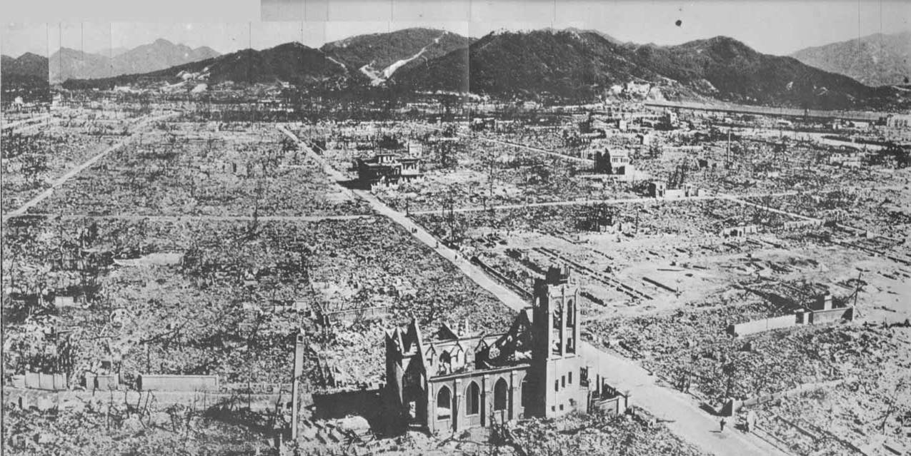
I have actually been there and it is rather a distressing place to go, that is for sure. Many thousands of people were killed at once. Many more thousands of people died slowly and in agony over the next few weeks because they had radiation sickness. The DNA in their body cells had been destroyed by the radiation from the bomb and so they could no longer pump water in and out and they died awful deaths as a result.

But the geneticists - you can see, there is a woman who has been burned by the flash and will certainly die of radiation sickness.

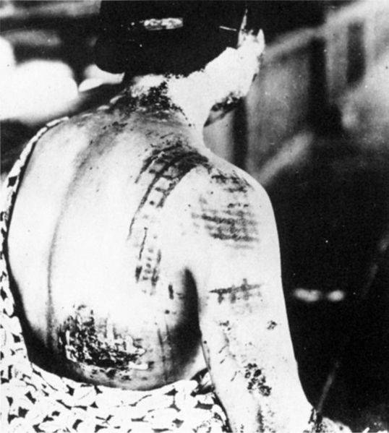

The geneticists were sent in with the expectation that they would look at all the children of people who were irradiated and compare them to those who had been outside the city at the time of the bomb. This was called, initially, the ABCC, Atomic Bomb Control Commission, and it found itself in this railway carriage which was parked outside, parked in the ruins of Hiroshima.

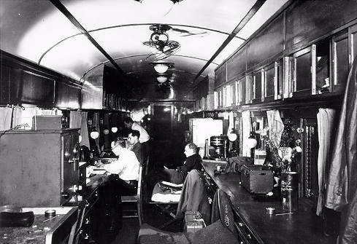

Well, I am not going to go on at great length about it. They went on for nearly 50 years – they gave up in 1995 actually. In retrospect, forgetting the ethical issues, which of course are very real, in retrospect, their task was hopeless because, in 1945 when they went in, we did not know anything about genetics at all. We did not know what the human chromosome number was. We did not know how to look at genetic radiation in proteins. DNA was known to be the genetic material, but what we did not know was the double helix. So, we were totally ignorant, and it is not surprising that they really got very little out of it.

However, towards the end of the process, they began to get some rather more sophisticated techniques, where they could look at a sample of blood proteins from the children whose parents had been in the bomb and had survived, and other children whose parents had been outside the city and survived. It was a huge task – they looked at hundreds of thousands or millions of protein changes, and in fact, they found a total of 28 of them, when you compare the children to the parents. Now, annoying thought – I should not say “annoyingly”, perhaps reassuringly, what actually happened was that there was no effect they could find of the bombs at all. Of the 28, about 14 were in the offspring of people who had been radiated and 14 or so were in the offspring of people who had not been irradiated.

So, so far, so bad, but they did find one quite unexpected effect, that actually, 26 of the 28 new mutations were in the father rather than the mother. That is something that we now know and understand quite well, which is that males are the agents of many, many mutations. It is particularly true with older males. Here is a picture of one of them – that is actually me, 40 years ago, collecting fruit-flies in the California Desert. People tell me I have changed a bit since then… I still have the moustache in an envelope somewhere in case I should need it. That is the process of aging, and the process of aging is a biological phenomenon – it comes, at least in part, from damage to DNA, damage to your own DNA, which often manifests itself in things, rather unfortunate things like this, which is the rate of colon cancer in relation to age, and colon cancer, like many cancers, or all cancers, is a genetic disease of body cells. So, you can see that your body cells decay and degenerate with age, and that is because they have divided and divided and divided and dived as you get older and older, and more and more mistakes are made.

However, it is worse that because of the different ways in which sperm and egg are made. Now, women make all their eggs before they are born and they go through this process of what is called meiosis, of producing half the dose of DNA, before they themselves are born, quite a long time before they are born actually, and then they are just frozen at that moment, until they reach maturity and then these eggs are released at intervals throughout their reproductive life. So, in fact, every egg that a woman passes on is separated by only about five or six cell divisions from the egg that made her. However old she is, her eggs were all made at the same time, before birth.

Men are not like that. We never rest. Even when we are giving lectures at Gresham College, we make large numbers of sperm, and every time that we make a sperm, there is a chance of an error in cell division. The figures are quite startling. If you look at the number of divisions between a 20 year old father, the number of cell divisions between the sperm that made him and the sperm that he passes on, because it is divide, divide, divide, there has been about 20 cell divisions, or 25 cell divisions for that rather young father. If you look, on the other hand, for a 28 year old father, there will have been something like 200 cell divisions, and from a 60 year old father, there will have been 800 to 1,000 cell divisions, from the sperm that made him to the sperm that he passes on, and every one of those involves the chance of a mutation.

Indeed, there are plenty of conditions where you look at the father’s age, and you can see the father’s age along the horizontal axis there, for achondroplasia, for example - and that is the picture of somebody with short arms and legs, Maribarbola he was, Velasco’s painting – and a striking fit between the incidence of this new mutation and the age of the father. It is worth pointing out that nearly all children with achrondroplasia are born as new mutations to older fathers. And the effect is not small – it is a multiplication of something like 15 or 20 times, compared to a young father, and that is much, much more than any radiation dose. Any radiation dose that would push the mutation rate up by 15 times would be instantly lethal.

So, this is quite an important thing and it is not just – these are all skeletal mutations and nervous system mutations, and they all show the same effect, but even mutations and errors which lead to schizophrenia, which of course is a mental disorder, again, the effect is really quite striking. It goes up by about five times in fathers over 50 compared to those under 25. So the effect is big.

If you are worried about the mutation rate in the future, you do not have to worry about chemicals in the water or radiation in the x-ray machine, you have to worry about how many older fathers are there, okay? And what is surprising, and counter-intuitive, is actually, in the developed world now, there are fewer older fathers than there might have been a century or more ago, and that is because – that seems odd because we are all used to the idea that, perhaps in Dickensian times or earlier, fathers started getting down to their paternal duties when they were 16 or so, which they probably did because the chances of staying alive were not all that great, so it was important to “gather yea rosebuds while yea may” as it were, and that is true, but now, we do not do that. Perhaps kids do start having sex at that time but they use contraception, so that there is a delay so that the average age of a father in Britain is now 28 rather than 16, so you might think, oh blimey, well, that is more older fathers, but actually the shape of this curve is that it gets steeper and steeper and steeper with age, so it is really old fathers that matter, and the number of really old fathers has definitely gone down.

Here, we have got fertility with age, the number of children, or fertility rate, which is basically the number of children, in France, which is a fairly developed country, in Pakistan, which is rather less developed but still fairly affluent, and Cameroon, which is actually now getting quite affluent, but when this thing was made, 10 years ago, it was not so. Actually, what you can see is that the crucial group, fathers of over 40, are much more common in places like Pakistan and Cameroon than they are in places like France, because what we do in the developed world now is we start early and we stop early. We have fewer children and we squeeze them into a narrow window. So, if anything, the mutation rate, far from going up, as many people claim to believe, is, if anything going down. So that is mutation…

Let us move on to the next part of the Darwin story, which is natural selection. Now, I always show these slides for natural selection, so if you have heard them before, just fall into a quiet slumber. Many people think that natural selection is somehow a complicated and baffling process, but it is not, it is childishly simple – inherited differences in the chances of reproduction. As I often say, it is design without a designer. It can make incredibly complicated objects with no forethought at all. One of the standard idiot comments by Creationists is, “Look at the eye: how could that extraordinary organ have evolved without somebody up there, God, designing it all and making sure it all fits together?” but you do not need to do that because you can generate the most astonishingly complex organs with very, very simple systems.

I often think of natural selection as a factory, a factory for making almost impossible things, and strangely enough, that was my first experience of natural selection. I left school to train to become an engineer, rather foolishly, or a fitter rather than an engineer, and I went to work in Unilever’s, Lever Brothers’ Soap Factory, on Liverpool’s left bank, in the Wirral Peninsula, under the port sunlight, and I worked in what was known as the detergent shed, and the way you make detergent, then and now, you take an enormous vat, not quite as big as this room but pretty big, filled with a boiling chemical liquid, and you push the liquid through a nozzle, which comes screaming out with a tremendous noise, which is one of the reasons I am deaf, it comes screaming out and breaks into a powder, which falls, and you collect it, and the vapour, which you fan round and condense and use again. In my day, the nozzle looked like this, about this big, a simple constriction, and it did not work very well. It made grains of different sizes, it got blocked, and most important, it wore out very quickly, and these things, which are made of stainless steel, were very expensive.

So, the factory owners across the world hired intelligent designers, mathematicians, to try and make it better, without much success, because the mathematics of a phased transition, as it is known, shifting from a liquid into a powder plus a vapour is not easy to understand. So, almost without realising it, these engineers, moved to a precise analogy of the Darwinian mechanism of inherited differences in reproduction. What they did was to take these nozzles, copy them, mutate them, take one copy and change it slightly, make it longer or shorter, different place for the constriction, a longer or shorter constriction, scratches on the inside, and maybe one of the 10 copies they made did better, so they took that one, melted the other nine down, and they took that one and they made 10 more copies, changed at random once again, mutated once again, and they went through that process again and again, and as they went through that process, something fairly remarkable began to happen: you began to evolve an almost impossible nozzle through this process of natural selection. After only 45 generations, we ended up with this extraordinary thing, which works probably a hundred times better than what went before. Nobody designed that. Nobody knows why it works better. Nobody needs to know why it works better. It just works better. That is evolution by natural selection. This approach is now widely used by engineers, by computer scientists – it is a standard approach in many aspects of technology.

So, as I say, what evidence is there that this might have happened in humans? Well, there is quite a lot, and there is one classic case, which you may know about so I will go through it fairly quickly, which turns on the undoubted difference in appearance of humans across the world. It is worth remembering what a collection of arrivistes we all are, nearly all of us are. We evolved, emerged in Africa – nearly all of human history was in Africa, and we did not get into Europe in any numbers until about 80,000 years ago - we did not get into Northern European, permanently, until about 12,000 years ago, we did not get into the Americas until about 20,000 years ago. So, you know, we are a recent creature, and of course, moving out of Africa lead to a totally different series of environmental challenges.

If you map that out, one of the well-known challenges of course is in skin colour, and that is the skin colour map across the world, and we know a lot about the genetics of it. Rather surprisingly, you can find one of the genes involved in fish, in zebrafish. It was found in a thing called the golden zebrafish. Zebrafish are widely used in biology because you can see them as they develop – they are transparent. The zebrafish is so-called because it has got these black stripes which are filled with a pigment called melanin. The golden one, in the middle there, as you can see, has the stripes but they are not filled with black pigment, so they are more useful to do biology on. If you look below that, you can see the grains of melanin in the wild type and the absence thereof in the mutant fish.

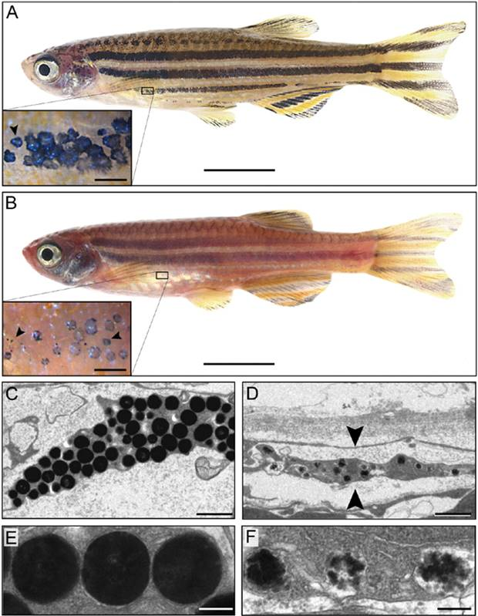

Once you have got the gene in fish, you can look for it in humans – it would take you a second. You just type the sequence in. You type it into a database, and it will say whether you have got (a) that gene, and (b) that mutant in humans. The answer is, yes, you do, and the distribution of the mutant is actually rather interesting. Let us just look at the Old World first, Europe and Africa. Here are Africans, and nearly all Africans have got the blue segment here, which is the version that can make melanin. Nearly all Europeans have got the yellow segment, which is the version which cannot make melanin. So, sometime, on the journey into Europe, there was a mutation, which, for some reason, was advantageous.

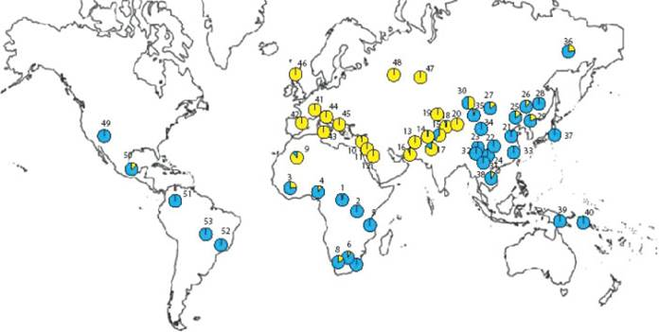

There is a spin on that story because, if we look over in China and Japan, and at Native Americans, who are generally speaking quite light-coloured, they do not have much melanin in their skin, but they have done it in a different way. They have still got the African form of the mutation, the blue one, but they have had a break in a second part of the melanin factory so that they fail to make melanin for a different reason.

So, why is it so advantageous? Why does natural selection pick that up? Well, it is to do, as you may well know, with vitamin balance. If you do not have enough vitamin D, you are in big trouble. Vitamin D, which is in oily fish and liver and stuff like that, is unusual among vitamins because you can make it yourself, in sunlight, in your own skin, and if you do not have it, you have all kinds of problems – you famously have rickets, soft, bendy bones. If you were to go from here to Bunhill Fields, the cemetery just up the road there, and dig up the many thousands of children’s bones who are there, probably, from the eighteenth century, probably 60% or 70% of them would have had rickets and that would have been one reason they would have died, because there was smoke in the air, they were cold, they were wearing thick clothes, there was not the habit of going into the sun, people bricked up their windows because of the Window Tax, so rickets was really a real scourge.

It is still a problem. Here is what actually happens if you do not have enough vitamin D.

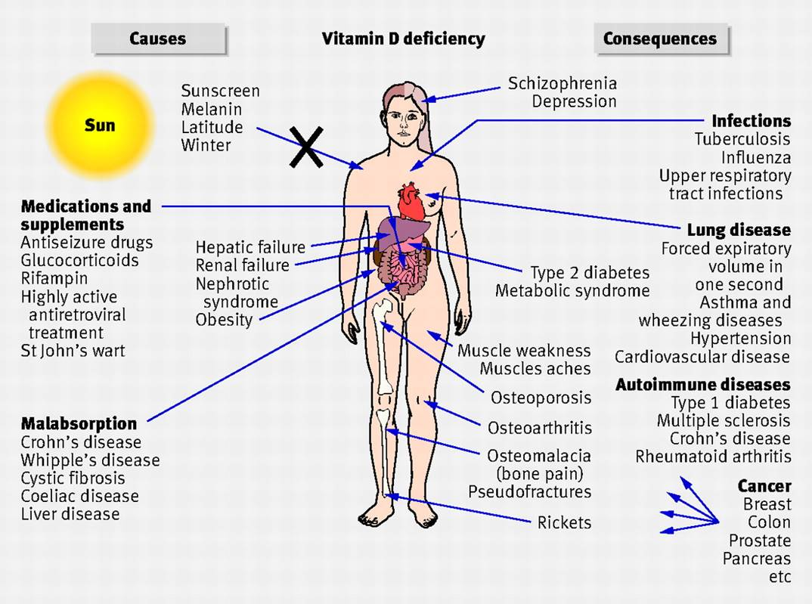

All kinds of things go wrong – osteoporosis, muscle weakness, heart problems, schizophrenia and depression. It is a big, big issue. And, in fact, in some parts of the world, Glasgow most of all, there is a claim that there is a genuine shortage of vitamin D among the population, simply because they maybe have light skins but they do not have much sunlight.

The effect is quite striking.

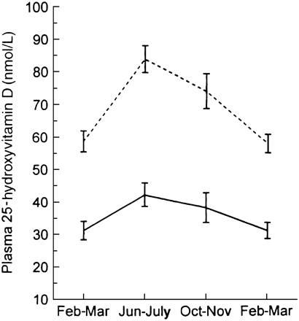

Shown above is the amount of vitamin D in European-Americans (the dotted line) and African-Americans (the solid line) and you can see, for both groups, both the light-coloured and the dark-coloured groups, the incidence goes up of vitamin D in the summer but it goes down in the winter. In fact, African-Americans, on the average, only just manage to make enough vitamin D. In fact, in Britain, the group who is most at risk, and it is a real problem, are immigrants – not necessarily immigrants, but Asian-Britons, women, who tend to wear long, all-encompassing clothing, do not go outside very much, would never dream of sunbathing, and also have a rather small amount of vitamin D in their diet, so it is a real issue. So, any error or change which led to the ability to make vitamin D, in other words losing your black pigment and becoming light in colour, would be very, very rapidly favoured, and it was favoured very quickly.

That leaves one question, perhaps the most important question in today’s biology, which is: what is the point of this mutant here? (Image of Boris Johnson shown). Here, God preserve us, is possibly our future Prime Minister, God help us, and here is his classically active and interested pose here, and he is a blond, and he is a real blond, he is a blond-blond, let us be sure, he is not a peroxide blond, and that is the real question: what the hell is the point of blonds? Why do we have blonds? It is an extension of the white skin story because blonds, historically, were only found in North West Europe. That is the only place they ever got to be common, and if you were to go to Scandinavia, something like 80% of the genes would be for blond hair. Now, why is that?

It turns on an extension of the argument I have just been giving you, which is actually that farming did not get up there until about 4.000 years or less ago. The farmers had a lousy diet. They had porridge, basically, just like Scotland today, and so they were really in desperate need of vitamin D. The reason that farming got up there, the reason you could grow crops up in the North West of Europe and not at the same latitude in the centre has to do with the Gulf Stream. If you draw a line through Birmingham – and I know many people have been tempted to do just that – what you find is, north of that line, in Central Europe, you cannot grow crops, seeds, of the kind that the ancient farmers grow, but in Western Europe, you can, and that is because of our friend the Gulf Stream that gives us an artificially warm climate in the spring, and grains need a warm spring in order to germinate. So, these people suffered a big problem: they had the ability to grow grains, but it rained all the time in the spring. It was not sunny, there was no sun at all, there was no vitamin D in their diet, they could not get it in sunlight, so they became Boris’s. So, that is the original of blonds, and I am glad I got that straight for you. But it is a classic example of natural selection at work, and it has happened in the last few thousand years, and I could multiple examples of that, but I do not need to, just to show you. Let me just give you one, which is perhaps less familiar…

This is the evolution of the ability to drink milk as an adult. When you think about, it is very odd that many humans, almost everybody in this room, I am sure, would automatically – we do not do it anymore, but I used to have a glass of milk when I was an adult, with no problems at all. But for the great majority of the world’s population – Chinese, Japanese, Native Australians, Native South Africans – you give them a pint of milk and they do not like it at all. They get diarrhoea, they are bloated, they burp, and that makes sense because, in nature, adults do not get milk. They get milk from their mothers, but when they grow up, that stops. But, about 4,000 years ago, we began to get the origin of cattle that gave milk, and I think you can see that the incidence of the ability to drink milk, which is actually quite striking changes over Europe, from about 90% in Scotland all the way down to about 40% in the South of Spain, over a short distance, fits exactly with the emergence of cattle and milk-drinking, and this group here, in Nigeria and around, a group called the Fulani, who independently took up milk-drinking from cattle, and they do have that ability.

It is a powerful process. So, the question then arises, what is going to happen to it in the future?

Well, again, it is very hard to be sure, but it seems pretty clear that it has lost much of its power. As I said, natural selection turns on inherited differences in reproduction, and natural selection is a bit like the driving test: it has got two papers. It has got a theory paper, which you have to pass, and then you have got a really difficult practical. I passed the theory paper, because I am still alive, rather surprisingly, so the first part is survival – if you are going to reproduce, you have to stay alive. That does, generally speaking, help, I find. But I have failed the second paper because I have no children. So, you have to look at variation to measure the strength of natural selection, variation in survival, together with variation in the number of children that people have, and if we look at those two, we see some dramatic changes over the last few centuries.

Let us talk first about variation in survival. This is a slide that I show my first-year students on their first day at UCL, just to cheer them up.

Of every million born, how many made it to 21 years old?
1601 – 347,827
1701 – 498,791
1801 – 582,317
1901 – 738,245
2001 – 989,926

I say these are the patterns of life and death in England and Wales over the last 400 years, and in Shakespeare’s time, only one in three made it to be 21, Darwin’s time, or a bit before, about no more than one in two, and now, 99% do. Of course, we have – in the early days, we died from external enemies, things like cholera, tuberculosis, cold, starvation, violence, all of which have been magically banished from this fair land, needless to say. We still have to die in the end, and now we die of things like diabetes and heart disease, which have a genetic component, but that is a slightly different issue. So, everything has changed. Now, that is in England, which is, of course, the high point of world civilisation, but in fact, if you look at the patterns of mortality, apart from Africa, all – these are Asia, South America, India, and so on – there has been a remarkable convergence across the world in mortality patterns from the 1950s to 2005, and then they have got even closer now, so that, even in places like India, which, in the 1950s, the mean age of death was 40, it is now 70 and rapidly approaching 75. Now, that is all a good thing, but what that tells us is that it removes some of the fuel of natural selection, which is differences in ability to stay alive, some of which, no doubt, were influenced by genes. That is the convergence of world life expectancy. So, that part of the natural selection exam has become much easier: we all stay alive long enough to reproduce. The question is: how many of us actually get round to it and reproduce? That too is a rather surprising result…

Here’s a picture of a family on holiday in Sweden in the 1960s.

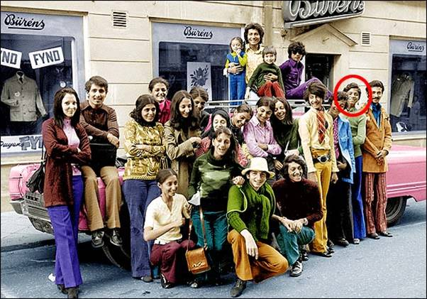

The gentleman, who is shown in this circle, you may recognise – he is no longer with us. That is Osama bin Laden. Osama bin Laden was the son of a chap called Mohammed bin Laden, who was very rich, and Mohammed bin Laden, being a philoprogenitive kind of guy, had 22 wives and 53 children, and in the year of Osama’s birth, he had six children, and everybody in that picture is Osama’s brother, sister, half-brother or half-sister, so that Mohammed bin Laden had a huge number of offspring. Osama had a good few too but did not live up to his father. Now, that is fine for Mohammed bin Laden, but he had 22 wives. That means that 21 poor sods did not have any wives at all. So, there was a huge variation in male reproductive success, and we can see evidence of that in the past. From historical records and from inferences, from buildings and that kind of stuff, we can work out the range of reproductive success in hunter-gatherers, people who are herders, and people who become farmers, and then, indeed, become rich and powerful rulers, and what we find is that, as society gets more unequal, some males, in black, do extraordinarily well, and regularly might have, among the Incas, some of them might have had 350 children, whereas, in hunter-gatherer societies, everybody has about the same number of children.

In some ways of course, we have all become hunter-gatherers again. We go to Sainsbury’s, or Waitrose, and we hunt and we gather on the shelves and we get what we need. It takes an hour a day, or less if you can be bothered to get Ocado to deliver it. So, we are living a hunter-gatherer life, and in fact, what that has done is to greatly reduce the variation in reproductive success, particularly in males rather than females. But if you look at the genes across Europe, and across the world, you will see some striking examples of successful men.

This is Genghis Khan, and Genghis Khan had, like all men, a particular Y chromosome, and Genghis Khan was famous, or notorious, for his sexual proclivities and he had hundreds, literally hundreds of mistresses, and hundreds, possibly even thousands, of children. His sons did just the same because they were powerful Khans too, and in fact, if you draw out the map of that what’s called star cluster, this group of Y chromosomes, which almost certainly descend from Genghis Khan, with a few mutations, if we draw out a map of that variant, you can see that, all across the Mongol Empire, there were lots and lots of them.

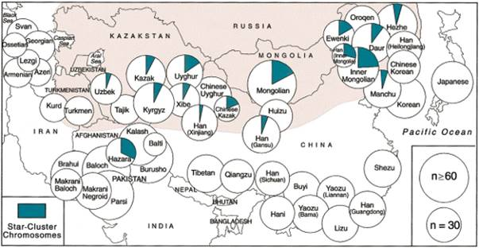

There are probably a hundred million or more men in the world today who carry Genghis Khan’s Y chromosome. And it is kind of interesting, if you take the Hazara, who are not in the area shown here as his Empire, but do believe themselves to be descendants of Genghis, they are dead right – they have Genghis’s Y chromosome. And once again, if Genghis Khan was fertilising every woman in the landscape, lots of men were not doing it, so there was lots of variation in male mating success, and in fact, rather less variation in female mating success.

That too has gone away. We have the same kind of convergence, that everybody has roughly the same number of children. Here is fertility in Europe from 1880 to 2000, and certainly, the average number of children has got less, that is for sure, but what is more interesting is the variation has got less too. So, in fact, everybody now in Western European, male and female, has about two children, 2.1 in England, 1.6 in Italy, so soon no more Italians, but, you know, we have lost that part of the fuel of selection too.

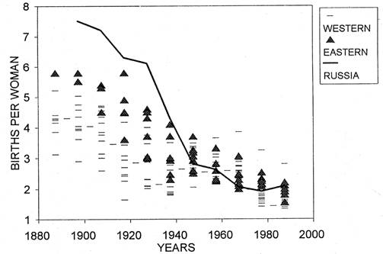

And what we can do, we can actually put those figures together, and we can say, well, let us correct for the disappearance of differences in survival and for differences in fertility, and we can work out a figure that is called the opportunity for natural selection – how much raw material is there, in terms of differential reproductive success, for selection to work on, and it has changed, and very, very quickly.

Here are the figures for The Gambia in 1955.

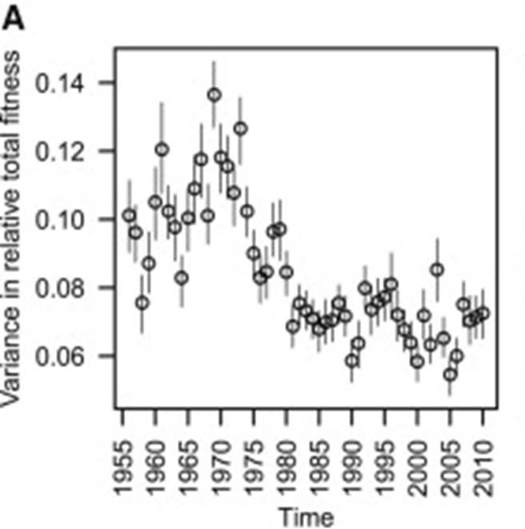

They went up a bit as The Gambia became more affluent, but as The Gambia, which I have been to, which is a very civilised kind of country with a good educational system, as that happened, very quickly, really within 25 years or 30 years, the opportunity for selection, the total variation in reproductive success just plummeted to half what it had been in 25 years, and over longer periods, it has done much, much more than that. In India, for example, if you compare middle class Indians with hill tribes, people who still live the kind of life which the early farmers had, the natural selection, the raw material, it has lost nine-tenths of its power. So, you have got less mutations and less natural selection.

Let me move to the final part of the equation, which is evolution at random, which is perhaps a little bit less familiar, but - this is a diagram I show to my students.

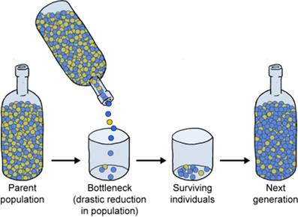

Let us imagine we have got a bottle full of equal numbers of green and blue beads, and we pour 10 of them into a cup, and by chance, purely by chance, we get seven blue ones and three green ones. Then they all reproduce until we have got back to the thousand or so or the hundred or so we had in the bottle originally, and in the next generation, we have got 70 blue ones and 30 green ones. So, simply by virtue of going through a bottleneck of a small number of people, we have had a dramatic change in the genes, and if that happens generation after generation after generation, you very quickly get this phenomenon which is known as genetic drift.

These are diagrams, various generations, repeating that experiment again and again, with different sized samples – very small samples of 20, samples of 200, samples of 2,000 – and you can see, in small populations, you get a very rapid divergence, slower in medium-sized, and very slow indeed in big populations.

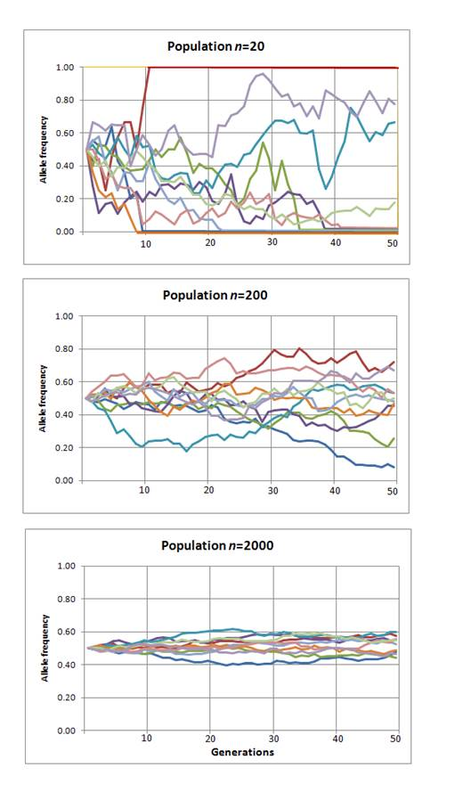

In fact, of course, humans have always been rare. What we can do - one of the most boring bits of research I have ever read has put all the mammals on a line, and this gentleman, who actually is a friend of mine so I should not be rude about him, he found, to his astonishment, that there are more mice in the world than there are elephants. Well, big deal, I hear you say, but if you put everything on the line, from the little voles, which are the smallest, to the elephants, which are the biggest, and everything sits there – farm animals do not count, it has to be wild animals. They all sit on this line, an uncannily straight line, with one exception, which are Homo sapiens. We are 10,000 times more common than we ought to be in terms of our body size. That comes from the population explosion which happened with farming. Every one of you, on the way to this talk, saw more people than the average human being who was a hunter-gatherer would have seen in his or her lifetimes. So, we are used to thinking that we are a very abundant species, but in fact, historically we were not. And we can see plenty of places where this random change in populations has had a big effect, most of all, of course, on isolated populations in the middle of nowhere.

Here is a famous one. The Island of Pingelap. Oliver Sacks wrote a really good book called “The Island of the Colorblind”. Pingelap has got a uniquely high frequency of an otherwise very, very rare gene. It is called achromatopsia, which is basically, first of all, you are colour-blind, and secondly, and much worse, you cannot see in bright light, so if you go out in daylight, you are almost blind with achromatopsia. It is genetic; it is a genetic phenomenon, and something like 60% of the population, probably half as many cases that are known in the world have got this problem. So, it is called the island of the colour-blind because everybody has learned to cope with this and they all live happily together. But if you look at the pedigrees, it turns out that every one of those individuals has indeed descended from one man, who was one of the only three survivors of the gigantic typhoon which wiped the island clean in about 1750. One man and two women were left. He must have carried that gene, hidden away, and it has got very common – purely an accident. So, in small populations, it is a very powerful force.

But it is also quite powerful in bigger populations too, particularly in populations where there are very different levels of success in having sex and reproduction by men and by women. We have seen some of these extraordinary figures, like Genghis Khan, but even in the modern world, there are quite big differences from place to place. In Finland – we all know what Finland’s like – women are actually more variable in their sexual success than men are. In Norway, it is one. In the US, it is 1.2 – men are a bit more variable. In Britain, I think it is about 1.1. But then we go into tribes in South America and in Africa, and you do get much more variation among men than in women.

That has two interesting effects. First of all, it means that the population of male genes, Y chromosomes, is smaller than the population of the non-male version, X chromosomes, and that is because, if males do not have any children, they may as well be dead – they have failed the test of natural selection. That tells us – now, this is rather an overcomplicated slide, so I’ll try and talk your way through.

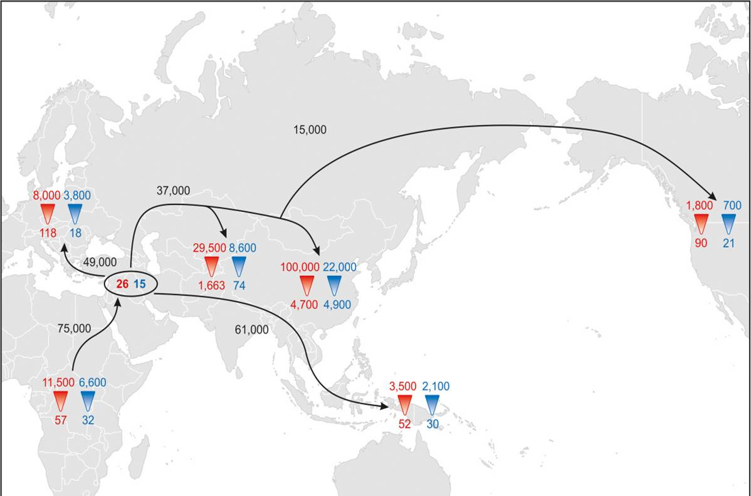

What we could do is look at the amount of variation in the male chromosomes, and the female chromosomes, across the world, and try to work out how big the bottlenecks were, which we certainly went through as we left Africa to other places.

Now, this is really quite a complicated slide and I should try and make a copy myself which is simpler, but what we have got is the estimate of the bottleneck size of the people, women in red and men in blue. We have an estimate of the smallest bottleneck and of the overall bottleneck over the whole of history, but just look at the smallest bottleneck at the bottom. The whole of the population of Africa descends from 57 women and 32 men. A small number of those got out to this central bit here – 26 women and 15 men. India, an enormous population explosion, but huge sexual inequality, just a few men with children, 29,500 women, and 1,600 men, and then, over in the New World, if you crossed from Siberia, the founding population was 90 women and 21 men.

So, it is a big, big difference, and that tells us something rather interesting, rather as an aside, in the biblical tale of Adam and Eve. Now, these guys, they originated that first and least original of all sin of having sex, and they certainly existed in some sense – there was an Adam and there was an Eve – but we can be completely sure they never met, because the population size of the Adams, the males, was much less than the population size of the Eves, the females. So, we could draw a little diagram of that, and here we have a population of one, two, three, four, five, six, seven, eight, nine, ten males, which, each generation, only two or three males reproduce, and they are the black lines, and the thin lines are male lines that come to an end, and we will see in one, two, three, four generations, we can get back to Adam.

Now, let us do Eve. In Eves, where there are ten, each generation, more reproduce, three or four reproduce, and in that case, we have to go back one, two, three, four, five, six, seven, eight, nine, ten generations to get to Eve. In fact, Adam, the universal ancestor of the human race, probably lived like 80,000 years ago, so he was human. Eve was not human, Eve probably – not a modern human. She probably lived about 150,000 years ago, and she was a homo erectus. Well, be that as it may, but it shows the subtlety of population bottlenecks – they have quite a big, big, em, map, big, big effect.

In fact, if we draw a map of the amount of genetic variation in human populations across the globe, as we moved out from Africa into the southern tip of South America and the distant islands of the Pacific, you can see the overall amount of variation goes down, so that, in somewhere like the southern tip of South America, we have only got a little bit more than half the variation in Africa, and in Europe, we are intermediate.

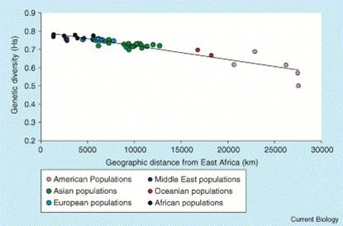

That just shows, once again, the power of bottlenecks, and that too has actually changed quite strikingly because history has always been made in bed, but now the beds are actually getting much closer. Once we stayed close to where we were born and populations could build their own identity, and in fact, people had a very small choice of who they could mate with, and if you had one very dominant male and lots of females, then basically perhaps only that male would have children. But now of course we have the most important invention of all to an evolutionary biologist, which is the bicycle. You no longer have to marry the boy or the girl next-door. You can get on your bicycle, or your 747, and come to UCL or wherever you like, and have a much bigger choice of partners, so the inequality in male mating success evens out and the population size gets much bigger. The effects of a bottleneck get much less. And as populations begin to blend, the population size gets bigger and bigger.

The classic case has to do with one group, who are very interested in their own evolution, who are African-Americans. African-Americans, understandably, feel that their past was stolen from them, and they are very curious to know how much are they African and how much are they European in ancestry. There’s this rather dubious company, 23 and Me, who I have rather mixed feelings about, but they will do something that is called ancestor painting. They will take your set of chromosomes and, for a couple of hundred dollars, they will tell you how many of your chromosomes come from Africa – and this is one woman, quite a lot of her chromosomes come from Africa – how many come from Europe, that is the black sections, how many come from Asia… Now, Asia seems odd, but of course Native Americans are basically Asia. And you see, this is quite an add-mixed population, so that there has been effectively quite a large population size there, because both Europeans and African slaves were mating. Of course it was the European men that took advantage of the African women. But that effect is there, and of course the effect is much, much more real today.

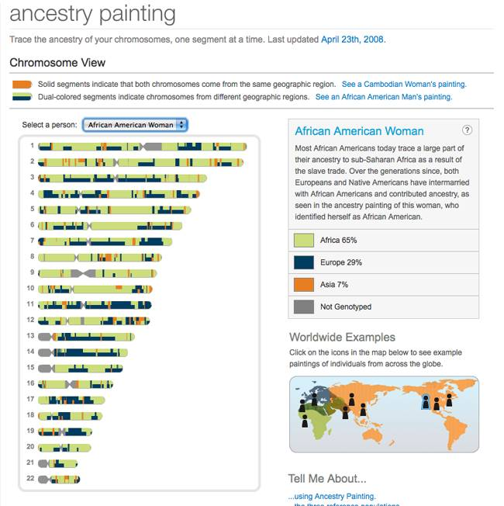

In London, which is probably the most sexually open city in the world, if you take a teenager in London, walking through the streets, one of whose parents is an Afro-Caribbean, for half of them, the other parent will be white. So, there we have got almost a complete blending of two groups, and there, in effect, we have got a much bigger population of people who are mating and much less chance of these random bottlenecks through small groups with only a few people succeeding in mating. You can put figures on that, to some degree, by asking yourself a simple question: how far apart was your birthplace from that of your partner compared – and, in my case, my wife was born in New York, Manhattan, and I was born in West Wales, so that was about 3,000 miles apart – compared to the distance apart where your parents were born, and where your mother’s mother was born and your mother’s father was born. My parents were born three miles apart in West Wales. I was once lecturing this to students, and one arrogant little sod shouted from the back, “And it shows!” I did not work out who it was…

And of course, that effect has now become absolutely immense. These are the flights from Heathrow. I should have put Ryanair, where the effect is even bigger of course. You can now find a partner from across the globe. So, effectively, the whole population of the globe, it is not quite one random mating population, but it is rapidly getting that way, so no more bottlenecks.

You can see it, and I have shown this before here, by looking at surnames, which are localised. Here were the Joneses in 1881

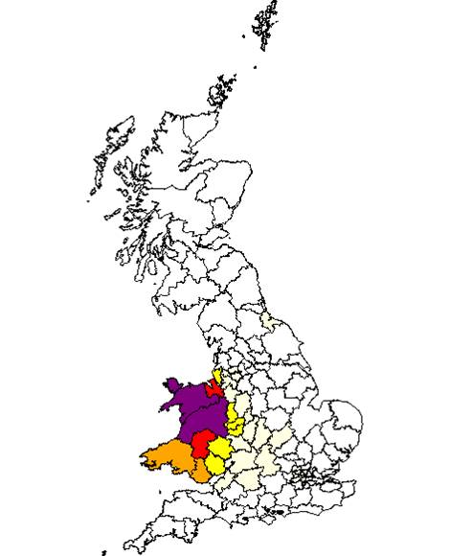

and by 1998, we have moved out, carrying our genes with us, and as you see, we have reached into England.

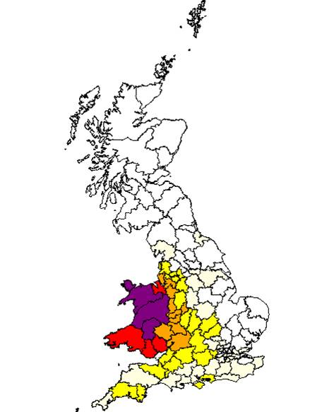

You have to make 1% to get onto this map, although we have not in fact made it either to Oxford or Cambridge, but I do not care about that.

So, that is what is happening. We are moving into an era of unprecedented openness and large population size, so really, all I can summarise this whole tale is that evolution has lost its power: there are fewer mutations, there is much less natural selection, and there is effectively no population bottlenecks, so the Darwin machine has come, in some senses, to a stop. So, if you are worried about what utopia is going to look like, you should not worry because you are living in it now. So, I will stop there.

Thank you!
© Professor Steve Jones, 2015

