

13 April 2012

Debussy: Text and Ideas Symposium
‘Time-full’ Interiors: Debussy, Fête galante,
and the Salon of Marguerite de Saint-Marceaux

Emma Adlard

Claude Debussy, L’Isle joyeuse (Paris: Durand, 1904), bars 67-98.
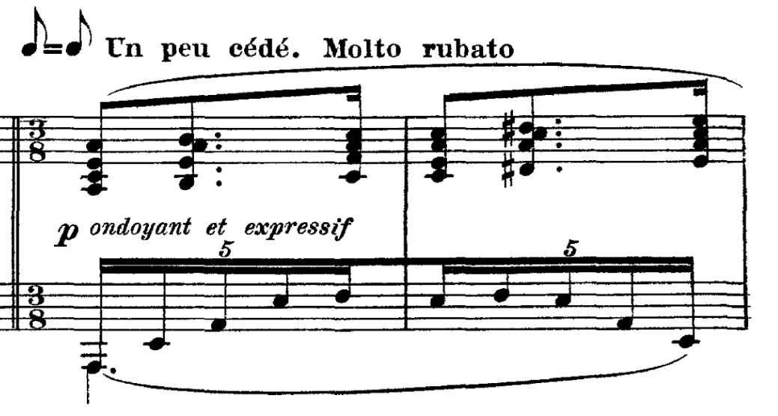

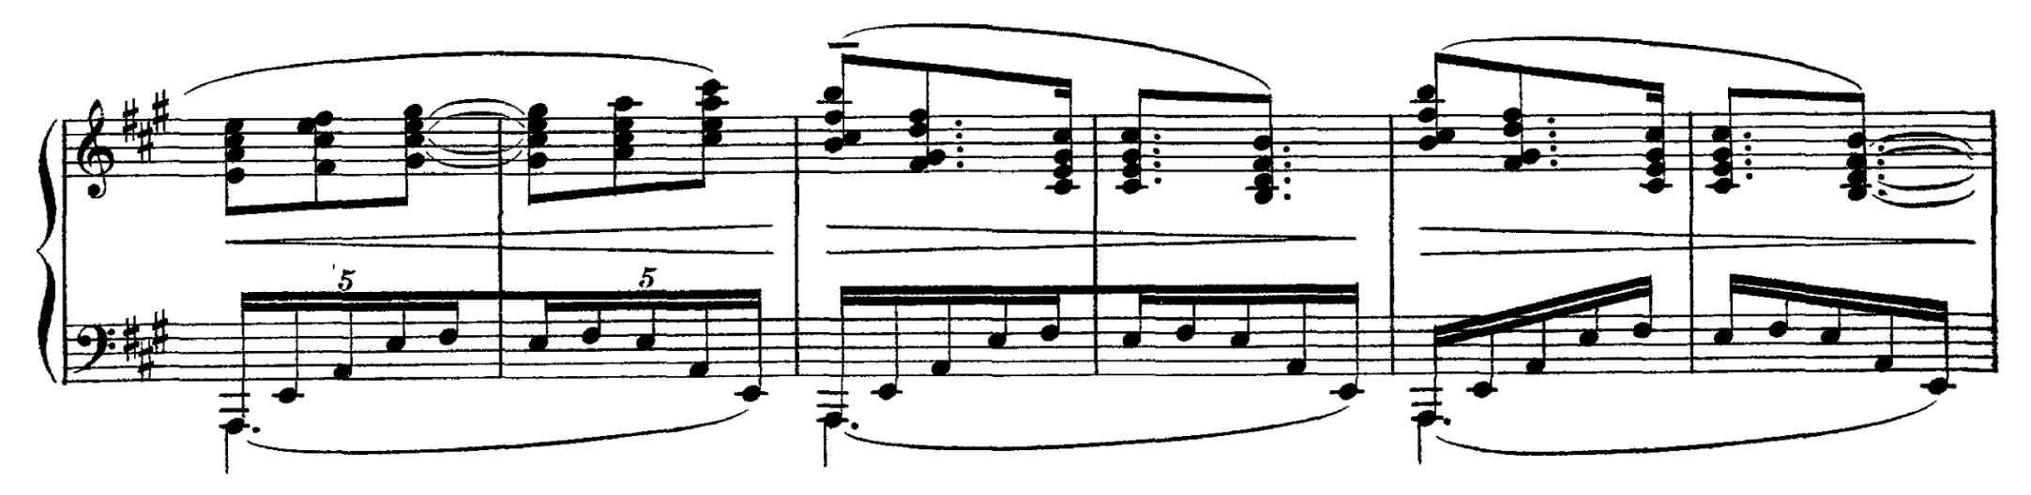
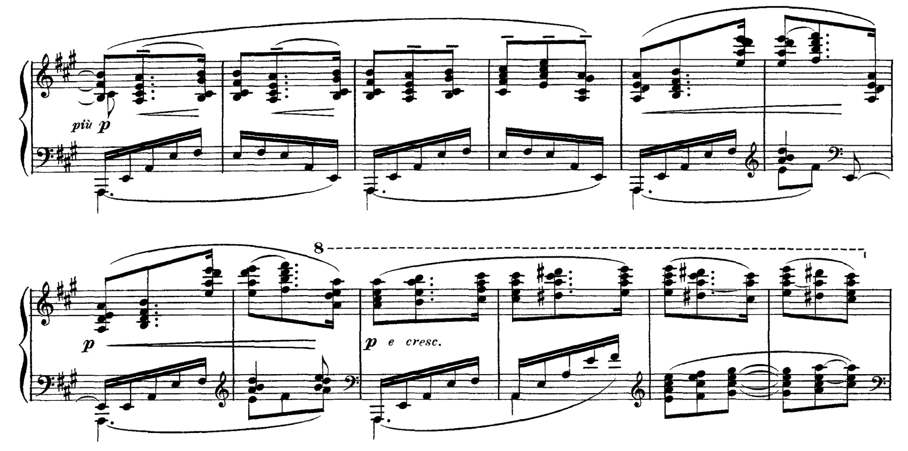
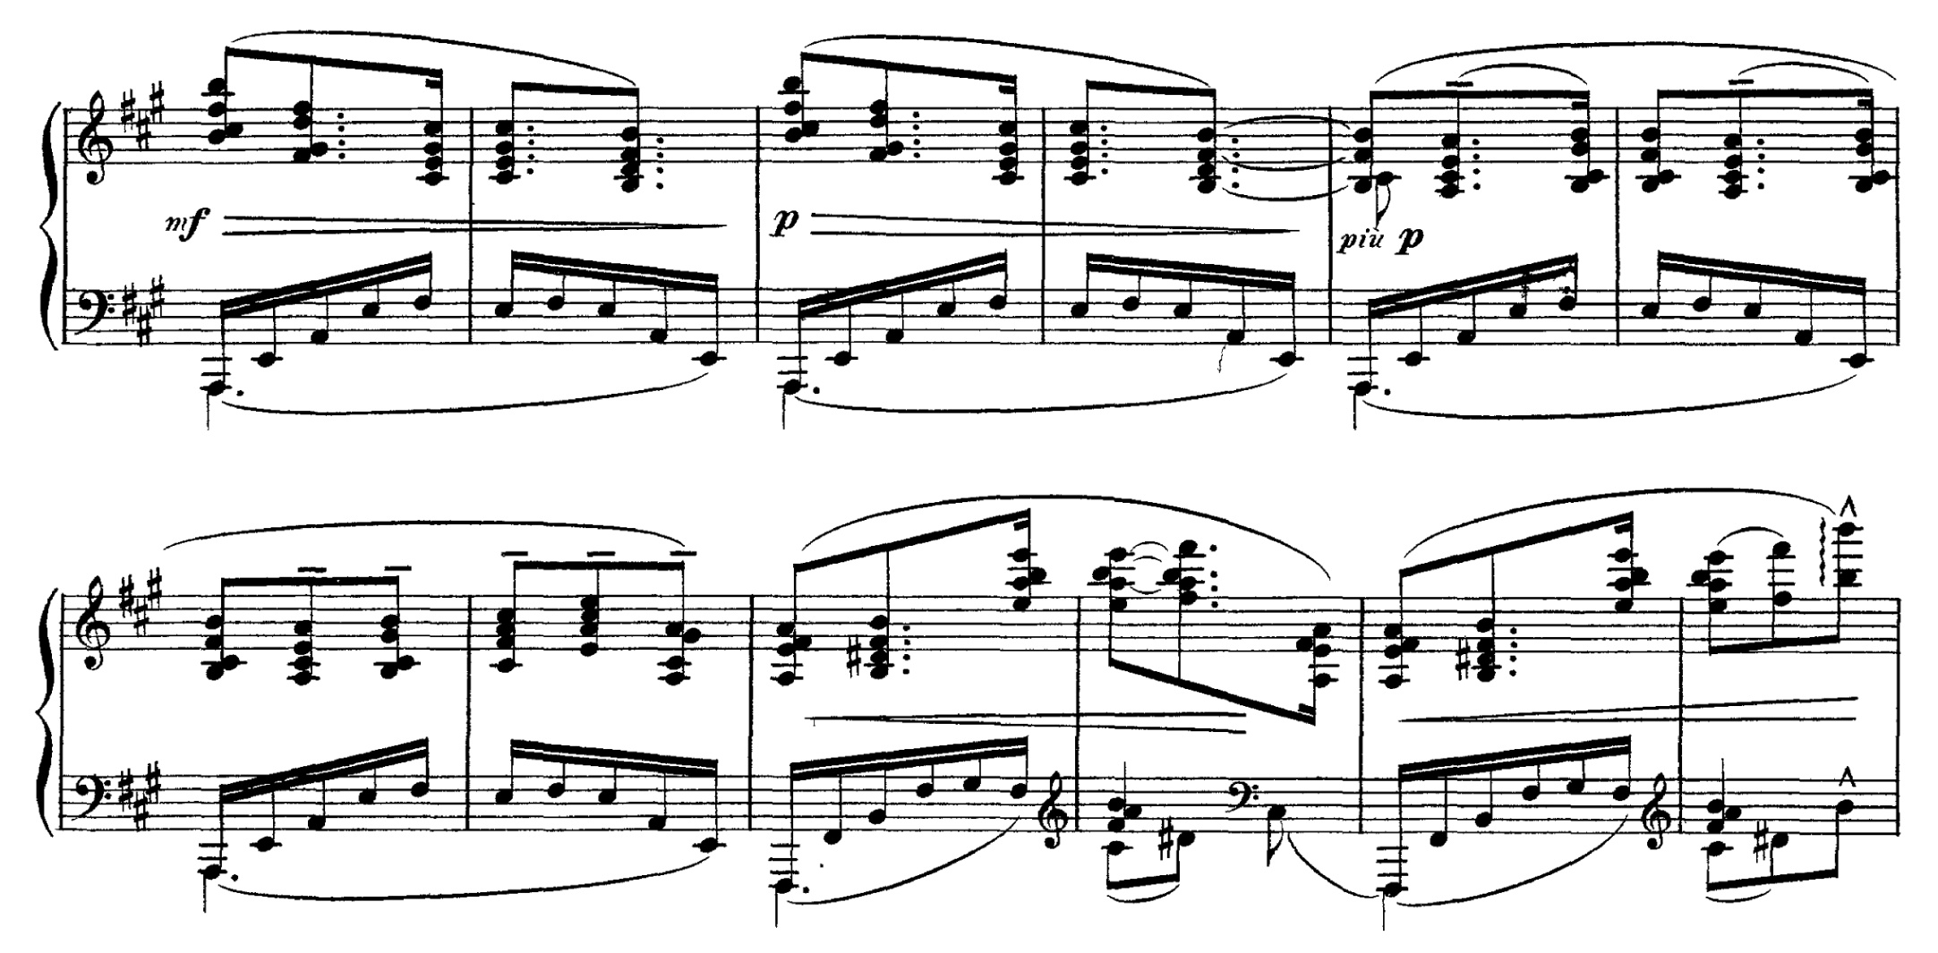

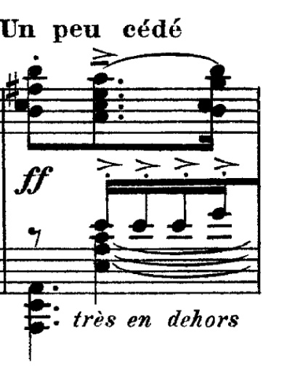
Debussy, L’Isle joyeuse, bars 220-43.

