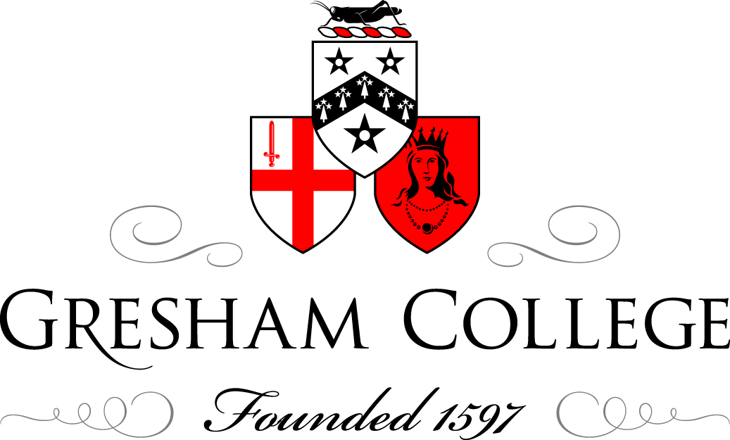

14 January 2015

The City and the Charter

The Medieval Context And William Marshal

Lord Judge

Eight hundred years ago this month, indeed almost 800 years ago to this very day, what we nowadays would describe as peace talks collapsed. The talks were organised and planned and took place at the Temple, then described as the New Temple, the home of the Knights Templar, one of the most influential and powerful orders in Christendom. It was also a place of holy sanctuary, some ten minutes ride on horseback from where we stand today, but 200 or years or so before this ancient Guildhall was built. Assembled there were the anointed king, John, and his rebellious barons who had already formed the conjuratio, or sworn association to seek relief for their grievances against the king, and a further group of barons, those who were faithful to their oaths of fealty, but none of whom had any great affection for the king himself, together with Stephen Langton, the Archbishop of Canterbury and the heavyweight members of the Church. At this Epiphany meeting the rebel barons presented their king with their terms. From his point of view they were outrageous. He had a ready made excuse to bring the discussions to an end. The rebel barons had come to the Temple carrying arms, and had not shown “proper respect”, the excuse of the yobbo down the ages, which is with us still. But the Church got what it wanted, a second charter, guaranteeing its independence, which in effect repeated the charter granted earlier at Temple a couple of months earlier in November 1214. Those charters became Clause 1 of Magna Carta, although the rebel barons had not been seeking any particular status or consideration for the Church.

And that, quite apart from the prospect of the horrors of civil war, highlights a very distinctive feature of the times in which our predecessors lived, which is difficult for us to grasp. Unlike our secular age, medieval men, and woman, were troubled about the destiny of their immortal souls.

In 1215 it was not that long since Thomas a Becket had been murdered on the steps to the altar of Canterbury Cathedral. Just ten years earlier, John had refused to accept Langton as the Archbishop. England was placed under papal interdict, and in January 1209 John was excommunicated, and although neither the interdict nor his excommunication served to change his conduct, by January 1213 the Pope, Innocent III, had pronounced sentence of deposition on him and, again using a phrase with which we are sadly familiar, had authorised the King of France, Philip Augustus, to wage Holy War against him. More bothered by the impact of the papal order on the exercise of his power on earth than he had been by the potential consequences to his own immortal soul, John submitted to the Pope in May 1213, and accepted the Pope not only as his spiritual lord, but as his feudal lord. The kingdom was surrendered, and John became the vassal of the Pope. The Euro sceptics of the day would have rent their garments and when later the Pope directed the rebel barons how they were to pay taxes, they would no doubt have donned sackcloth and ashes.

The Pope, Innocent III, was never someone to knowingly undersell himself. He was generous enough to acknowledge that he was lower in status than God. But he asserted and sought to enforce the assertion, that he was above all men, including reigning monarchs. Philip Augustus the King of France would have been only too pleased to rub John’s nose yet further in the mud following his great victory over John’s allies in France at the Battle of Bouvines in July 1214. The prize would be the throne of England for his son Louis.

This is a rarely remembered, perhaps never really taught aspect of the history of the times. It was not long, as civil war became inevitable, that the rebel barons offered the throne of England to Louis of France if he would bring troops to England to assist them in the civil war. The barons who forced the king to seal Magna Carta were traitors. And so, I regret to say, standing in the Guildhall, was the City of London. Now desperate for support, in May John gave the City its Charter, and its own Lord Mayor. It was a bribe. He hoped that by giving the City the Charter for free, that he had refused to give earlier save on payment of a very substantial sum of money, the City would side with him. It did not. The City saw the reality. The king’s position was becoming steadily weaker. When French soldiers, no fewer than 7000 of them, eventually landed in England, quite unopposed, and greeted warmly by the rebel barons, the City was later to open its gates to them. We are still in contact with the consequences of the grant of the Charter to the City, exemplified each year as the new Lord Mayor of London is presented to the Lord Chief Justice to take the ancient oaths of office. Perhaps we can thank King John for something.

That is the context. A civil war is about to and indeed has broken out. Men assemble on a field by the River Thames, known as running mead or Runnymede. They are armed and ready to fight. The rebel barons have their articles, literally their terms written out ready for discussion. The discussions begin on the 15th June 1215. The deal is done by the 19th June. And copies of the Charter are distributed throughout the country. We still have four of the originals, and the Lincoln copy of the Charter actually says “Linconia” on the back, no doubt taken back to Lincoln by the bishop who was present at Runnymede.

Contrary to popular belief, the king never signed the Charter. He simply sealed it. It was not called Magna Carta or the Great Charter. It was just one more charter in an age of charters. As a legal document it was forced out of the king under duress. It was unenforceable in law, and the king had no intention of abiding by it. The Pope, in his capacity as John’s feudal lord, with England as his fiefdom, immediately annulled it. It was “utterly repudiated” and the king was forbidden by the Pope “to presume to observe it”.

In the medieval context, the significant moment is found in Clause 61 when, the anointed king, answerable on his death to God for the way he had reigned and his fidelity to his coronation oath to offer justice and good government acknowledged that if he failed in these respects while still alive, he was answerable to a group of men, chosen by the rebel barons, for any non-compliance with the charter. On the continent John was derided for becoming subject to “over kings”. Nevertheless from it derived the principle identified by Justice Bracton in the early 13th century, acknowledging that the king was above all other individuals, but that he was subject to the law. To God, of course, but, crucially for the development of all our constitutional principles, subject to the law.

In all this story, notice the singular feature which was never drawn to our attention when we learned our history at school. These events were consequent on actions or inaction by large numbers of people, each with his own personal characteristic, strength and weaknesses. Each reacting to an unfolding situation, sometimes predictably, sometimes not. Not all the rebel barons were equally committed to the rebellion, and not all the supporters of the king felt the same depth of allegiance to him. Llewellyn of Wales would have been unlikely to want to compromise with the king who had ordered the execution of fourteen sons of the Welsh nobility which he held as hostage against the good behaviour of the Welsh. And William Marshal himself, to whom I shall come, had been declared a traitor by King John in about 1205, and effectively banished from court, only as John’s situation became increasingly hazardous, summoned back to assist him.

If there is a hero of this event it is the virtually unknown William Marshal, Earl of Pembroke. Having summoned him to return to England to assist him, John regarded Marshal as his key envoy in the discussions and negotiations. Importantly, he was seen as the only civilian (as opposed to clerical) guarantor of John’s good faith. So close was he to the centre of the discussions, that some historians suggested that he, together with Langton, was one of the joint authors of the terms of the first charter (notice the deliberate use of the word “first”). That is regarded as improbable, but gives an indication of how close to the heart of the discussions he was. And, as the June 1215 Charter itself makes clear, he was the first of the “illustrious” magnates from the baronial class to be named. When the charter was annulled and civil war broke out, Marshal, acknowledged to be one of the foremost campaigners of the age, supported the king. But with the French invasion the outcome was uncertain.

Then, again as I remind us, history is determined by what a recent Prime Minister described as “events”. It is not my wish, even 800 years later, to trumpet with joy at the death of historical figures, but in July 1216 Innocent III died, and was succeeded by a pope of a different hue, and then in October 1216 John himself died at Newark.

The death of a medieval king without an heir old enough to succeed him would be catastrophic for the line. We all know what happened to the Princes in the Tower. John’s heir was a boy, Henry, some 9 years old. When Marshal heard of John’s death, he was at Gloucester, and immediately summoned the loyal barons to Gloucester Abbey where the boy king was anointed. Gloucester Abbey, let it be noticed, because Westminster Abbey itself was under the control of French forces.

Marshal was appointed as Regent, Rector Nostra et Regine Nostri, a new title and office. In effect he had become Regent or Protector and the Ruler of the Country. As Dan Jones, in his recent book, The Plantagenets, The Kings who made England underlines:

“All those in the Abbey’s vast crowd must have realised that this was a dreadful way to start a reign … it was not just to the solemn 9 year old Henry’s advantage that (Marshal’s) attitude prevailed among a few good men in England. The future of the dynasty depended on it”.

Marshal’s first step was to resuscitate John’s 1215 Charter, notwithstanding its repudiation by John and annulment by the Pope. In late 1216 he issued it under his personal seal, together with that of the Papal Legate. It was not identical, and included a number of revisions. Its purpose was an attempt at reconciliation with the rebels, offering in its final clause the possibility of a resolution of outstanding issues when fuller counsel would be possible to achieve what was best for the common good. It was issued from a position of great military weakness. And it proved unacceptable to the barons, and presumably to Louis of France. And so the civil war continued.

In 1217, the French army was divided, and a substantial proportion took part in the siege at Lincoln Castle. Marshal, was no longer young. He was at the age of judicial retirement, 70 years or so. He took his forces up to Lincoln, and there set about raising the siege. When the opportunity presented itself, leading his troops personally, he set off into battle. His enthusiasm for the fight was so undiminished that he forgot to wear a helmet. Just as well his squire reminded him to do so. After the battle his helmet was dented in more than one place. But after hand to hand fighting the battle ended in a great victory. Forty six rebel barons were captured. Although the French invasion continued for a while, Louis was defeated shortly afterwards in a sea battle off Sandwich. During the peace negotiations which followed, Marshal, working with the Papal Legate, accepted that the liberties demanded by the rebel barons should be restored. And in November 1217 another charter was reissued, again without being in quite the same language as the two previous charters, but understood to be part of the same sequence. The difference this time was that the charter sealed by Marshal did not reflect the military pressure which forced John to seal the 1215 charter, nor the military weakness of the royal situation, which led Marshal to issue and seal the 1216 charter, but now issued in the full amplitude of triumph in battle. In short, the defeat of the rebel barons would still culminate in a charter. It was not, in modern language, a Truth and Reconciliation process, but it showed a magnanimity and statesmanship which brought an end to foreign invasion, civil war, and established the Boy King on the throne. The magnanimity was not properly recognised by the boy when he became an adult, and Marshal was criticised for the generosity of the peace terms he accepted. Perhaps that is why his name has been obliterated from public memory. Henry III later paid the price: Simon de Montfort. Marshal died two years later, and given a state funeral where Stephen Langton described him as “the greatest knight that ever lived”.

By 1225 when the king was old enough to assume power, the charter was reissued under his own seal. The deal was very simple. Unless you give us our charter you cannot have the taxation you are seeking. This is not the occasion, and there is no time to address how “no taxation without representation” became the foundation for our parliamentary system, but even the ultimate development of Parliament can be attributed to the way in which Marshal governed during his years as Regent, a process by which one of the most distinguished of modern historians describes as “proto-parliamentary”. However all that may be, I firmly believe that without William Marshal, what we now call Magna Carta, would have been no more than a medieval document commanding very little attention from any but the most distinguished, specialist historians, or perhaps an effort by an especially geeky young man or woman to acquire a PhD.

If you want to pay your respects to William Marshal and his achievement, you can visit the Temple Church, the Mother Church of the common law Marshal joined the Order of Knights Templar a few days before his death. One of the treasures of that church is his monumental effigy.

© Lord Judge, 2015

