16 February 2016
Germs, Genes and Genesis: The History of Infectious Disease
Professor Steve Jones

My subject today is infectious disease, and, as all science writers know, it is impossible to speak on a scientific subject without mentioning Alice in Wonderland.

So I would like to recall the famous race where they all run like mad and don’t seem to be moving. Alice asks the Red Queen what’s going on, and she says that, in her country, if she runs, she ends up in a different place. The Queen responds, “Here, you see, it takes all the running you can do to keep in the same place.” That has now entered the scientific literature as what is known as “the Red Queen Hypothesis.” It was formulated by a colleague of mine when I was at the University of Chicago in the late-1960s, a man named Leigh Van Valen. He pointed out that the traditional idea of evolution can be summarised as something that goes onwards and upwards, with everything always getting better, until you end up with human beings. That really was not a fair representation of what evolution is about because an awful lot of evolution involves conflict between different living creatures – between predators and their prey, between plants and their pollinators, or between males and females of any species – as each one tries to take advantage of the other; males and females more than most of course, males more than most, and the other one retaliates in order to avoid that attempt to take too much, and so you’ve got this endless race. They are evolving constantly, but basically they are not going anywhere. So it is the Darwinian equivalent, maybe, of dancing round a handbag; where you stay roughly where you are although you are doing a lot of moving about.

Perhaps the classic example of this comes from medicine, and it is worth remembering how optimistic doctors once were. There was a book published in the 1960s, the age of optimism, “The Evolution and Eradication of Infectious Diseases”. This book, which was rather a classic in its day – I remember reading it when I was a student – blithely asserted that all infectious diseases would be eradicated by the year 2000. As you may have noticed, that hasn’t happened. Certainly, there has been quite a lot of success in that regard. I can illustrate that with a simple experiment I carried out with this audience once before. If you look to the person to your left and the person to your right, I can say, with a certain amount of confidence that two of the three of you will die for reasons connected to the genes you carry. I don’t know which two, but most of the conditions that kill us off nowadays, things like cancer, heart disease, diabetes, early onset Alzheimer’s disease, have a strong inherited component. I say this to my students and they look bored, but of course, when you’re 18, you know you’re immortal. But then I say, “Cheer up, because if I’d been giving this lecture in Shakespeare’s time, two out of three of you would be dead already!” and that’s true.

Of every million born, how many made it to 21 years old?

- 1601 347 827
- 1701 498 791
- 1801 582 317
- 1901 738 245
- 2001 989 926

These are the patterns of life and death in London in Shakespeare’s time, 1601. Only one baby in three made it to be 21. Just before Darwin was born, 1801, just about one in two did, and in 2001, 99% of them made it to be 21. That of course, is because what kills us off has changed. Long before Shakespeare’s time and for quite a time afterwards, what killed us off were external matters, things like cold, starvation, violence, and most of all, of course, disease. Last year was the anniversary of the Great Plague, and this year the anniversary of the Great Fire of London. The bills of mortality, which were collected in those days, show an extraordinary spike in death during the summer of 1665.

Something worth remembering about these plagues is that it is not just animals and humans that are affected, but plants too, which can kill of vast numbers of people. The famous Potato Blight in Ireland in the 1850s was due to a fungus which attacked the potatoes. Every Irish person ate 14 pounds of potatoes every day; that was their major staple food. Once a week, they might have a little cheese. Potatoes are a fantastic plant – they contain more vitamin C than a lemon, are full of fibre and are cheap. During the 1850s Blight, all the plants died and the population of Ireland collapsed. More than a million people died, and more than a further million emigrated. The population of Ireland has not yet succeeded in growing back to what it was before this episode.

I think we are right to suggest that we have had considerable success in controlling many diseases. Smallpox, of course, has effectively gone. There are plenty of others, however, waiting in the wings. Recently the Observer printed an article entitled, “Zika Forest: birthplace of the virus that has spread fear across the world”. This was in reference to the Zika virus, which may, or may not, cause microcephaly in children. An additional article read, “Phony peach: the disease that threatens to devastate Britain’s trees and plants”. This discussed Xylella fastidiosa, which is attacking all kinds of different species of plant.

The World Health Organisation disease site, which is kept very much up-to-date, shows that there have been 50 new outbreaks of disease since 1st January 2016. These include examples such as Zika virus, Guillaine-Barré syndrome - an autoimmune syndrome caused by infection, MERS - a virus which causes breathing difficulties in the Middle East, Lassa fever, microcephaly in Brazil and avian flu in China. There are many more plant outbreaks listed for the same period of time.

I want to talk about where these conditions come from and how genes reveal their history and perhaps their future.

If you look at the great sweep of human history, there have already been three eras.
They can be called the Age of Disaster, which is the vast majority of human history; the Age of Disease, which began with the origin of farming and the Age of Decay within which we are living today. The Age of Disaster, which accounts for 99.9% of human history, was characterised as being hunter-gatherer. During this Age, people died of starvation, accidents, violence and the cold temperatures. As far as we can see, there wasn’t much infectious disease. The Age of Disease then commenced with the establishment of agriculture. We now live, at least for the time being and at least for the Western world, in an era when most people die of decay, although we could be back to disease fairly soon.

The moment when the Age of Disease was actually inaugurated is mentioned very specifically in the Book of Genesis. Adam and Eve committed the first of all sins when Eve ate the fruit of the tree of knowledge. God found out about this so he threw him out, and as he said,

“In the sweat of thy face shalt thou eat bread…the Lord God sent him forth from the Garden of Eden to till the ground…”

In that moment, and it could even be a memory of the event, was that humans stopped being hunter-gatherers, living in a Garden of Eden with plenty of readily-available food, to being farmers, where they had to dig the soil and plant potatoes in order to stay alive. Rather incidentally, of course, we ourselves have returned to being hunter-gatherers. We can go to Waitrose - we don’t have to grow our own stuff. We tend to forget that farming, however, in the old days, was a tremendously laborious and time-consuming pastime. Peasant farmers nowadays have only half as much leisure time, almost none in fact, compared to the very few hunter-gatherer societies that exist today.

As a result of their least original sin, Adam and Eve had two children, Cain and Abel. Cain killed Abel, and Abel was sent out to the Land of Nod, East of Eden. Cain set barriers to fields – he was the first farmer and the first landowner. That is when the era of disease actually began.

This is clear if we look at where the origin of farming actually was, and it is more than a coincidence perhaps that the Land of Nod is exactly where agriculture began. First of all, primitive wheat crop plants, and then, very quickly, the domestication of various animals.

This was immediately accompanied by an enormous increase in human numbers, which too has a resonance in Genesis. This is when Abraham agrees to kill his first-born. God says to him,

“That in blessing I will bless thee, and in multiplying, I will multiply thy seed as the stars of heaven and as the sand which is upon the seashore”.

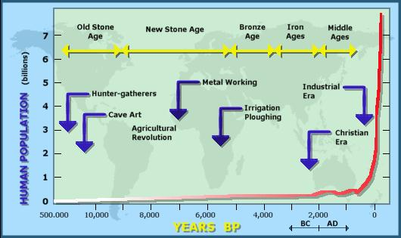

This is the human population size over the last half-million years or so, shown on a non-linear scale. Populations really began to expand after the origin of farming, even more so at the beginning of the Christian era, and of course still continuing to grow.

The world’s first city or the world’s first assemblage of buildings was found about 10 000BC, again in the Land of Nod, in what was then Assyria. It is an extraordinary place, called Gobekli Tepe. It could be as much as 10,000 years old, which is several thousand years older than the Great Pyramid, much older than Stonehenge, and it is extraordinarily sophisticated. There were a number of circular church-like structures and all kinds of monuments. There really must have been vast numbers of people and the archaeologists found literally hundreds of thousands of animal bones, which were eaten by these people. It seems to have been similar to Chartres Cathedral: people came to this place of worship from all over the Middle East, stayed there for a while and then went back to their farms. There was an explosion of agriculture, but in fact, this also marked the beginning of an explosion of disease.

We can see a microcosm of that when we look at the population patterns in Western Europe as farming arrived. There has been a lot of argument recently in human genetics about how farming arrived and whether people came in a big wave, in small numbers, if we were all really hunter-gatherers who never moved, or whether we came from various places. It is all a bit of a mess.

But it is clear, however it happened, that farming arrived in Europe not all that long ago, probably about 4,000 years ago in Western Europe. The dotted line here shows the general pattern of population growth in these different places, in Ireland, in Scotland, in Sussex, in Paris, in the Languedoc and so on. It is very striking, however, when farming arrives, which is the blue arrow you can see in each of these graphs, that it is immediately or almost immediately followed by a population explosion. Red means that the rate of growth is greater than the trend line - the average rate of growth over the whole period. But, if you look, for example, at Scotland, there’s an explosion in numbers, followed really quite soon - within a few hundred years, by a collapse, and that is remarkably consistent. It is consistent in all these places, and we do not know why that is, but it is by no means impossible that it marks the first epidemics and the spread of the first disease.

In order to get an epidemic, you need two things: firstly a big enough population so that the disease organism can move from individual to individual – that is why hunter-gatherers were so relatively healthy, because they did not have big populations. Everybody, on their way to this meeting, saw more people than a typical human being, by whom I mean a hunter-gatherer, would have seen in his or her whole lifetime. They lived in small groups which did not interact, so they did not have epidemics. That changed with the beginning of farming as you had groups which these organisms could race through. Secondly, what also changed at about that time, as we saw in Gobekli Tepe and elsewhere, is that people began to move. Before that, people had not moved very much. Then they began to move, and that is a fatal combination. In addition to this, people began to come into much closer contact with animals, both wild and domestic, which, it turns out, brought great numbers of infectious diseases with them.

Now, there are many diseases in the Bible. The Old Testament was not a comfortable place to live, that’s for sure. Here’s just a few of them: there’s Jehoram, whose bowels fell out; Job, who shrivelled up; Jesus cured a boy who was a lunatic who fell into the fire, or the water, as the case may be; and Deuteronomy had somebody being smitten with consumption and with fever, inflammation and with burning; a woman with an issue of blood. The one of which there is most discussion is in Leviticus. Leviticus was written – people argue about it, but it was written about the period said to be about three and half, four thousand BC, when Babylon was the biggest city in the world. Babylon was the first big city, and it is obsessed with cleanliness, as you may remember. When you read your Bible this morning, you may have opened it at Leviticus, and it is particularly obsessed with leprosy and how to diagnose leprosy and f you identify leprosy, then the person involved is thrown out of the society and sent outside the camp - a sort of primitive healthcare measure maybe. Well, we don’t really know what many of those diseases are – what shrivelled Job up, we’re not quite sure, and we’re by no means certain why Jehoram’s bowels fell out – but we do know that, a bit later than that, certainly in early Christian times, there was a great deal of leprosy there.

A place called Haceldama ‘The Field of Blood’, which is just outside Jerusalem, was bought with the 30 pieces of silver that Judas received from the Romans for betraying Jesus. Judas then, so legend has it, consumed by guilt, then hanged himself on The Field of Blood, and it was bought by the priests initially as a burial ground for non-Jews, although later used for Jews as well. It still exists and I have been to it – an oddly sinister-looking place. About five or six years ago, people began to look at some of the remains, which are still there in the burial niches, and one grave niche, like most of them, had been carefully sealed up with plaster. It was opened up and some bones were taken, and in fact the agent of leprosy, mycobacterium, as it is called, was actually present there. So, there was certainly leprosy present in that era.

There’s leprosy itself, mild and severe cases of the disease, now called Hansen’s disease. The agent was discovered by a Norwegian biologist called Hansen. It leads to extreme disfigurement. The terror which people had of it, and they certainly did – I mean, if you read stories of these leprosariums and the like, these lazarettes as they were called, the terror which people had of it was actually quite unreasonable because it is not particularly infectious and it usually takes an extremely long time to show its effects, but these effects can be very startling and unpleasant. It is unlike many diseases because we have evidence of it long before the origin of farming, so it got into humans well before farming began, and unlike many diseases, we don’t know where it came from. We don’t know whether it came from a creature from outside or how it arrived, but that’s exceptional because, for most of them, we do know that indeed there are transfers between animals and ourselves. Ironically, in the case of leprosy, we know of one case of transfer between ourselves and animals, but it is a two-way street, because in North America, armadillos catch leprosy, but they catch it from humans, and of course there was no leprosy in the Americas before the Europeans arrived. The armadillos had been there a lot longer than that. Some of those in Texas who like to shoot and cook armadillos have caught leprosy as a result. So, it is a two-way street, but for leprosy, we don’t know.

But many of them, we do know. We now know that there are many, many cases of the movement of diseases between different animal species, great numbers of them in fact. Some of them are between wildlife and domestic animals, and that’s a real issue with things like BSE. Many of the diseases in animals come from their wild relatives.
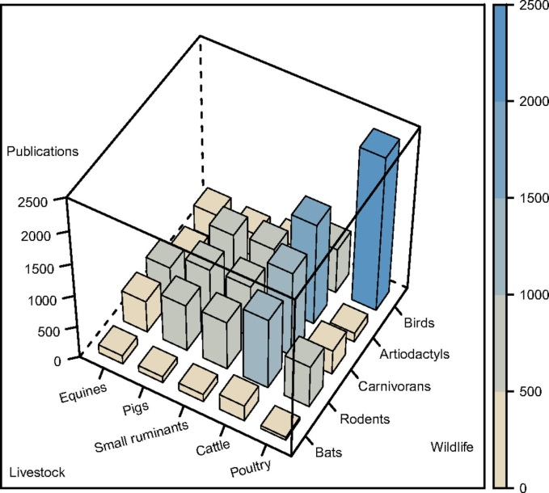

The effects are really quite striking. This is rather a complicated graph, but I’ll talk you through it. What we’ve got on the right-hand side are the wild animals, the creatures; the birds, the cloven-hooved creatures; the carnivores, the rodents and the bats, and what we’ve got on the left-hand bottom are the animals, the chicken, the cattle, the sheep, the pigs and the horses, which receive it. Let’s take the birds. Birds certainly give diseases to poultry, to chickens, but they also give diseases to cattle, to sheep, to pigs, and to horses. One of the worst agents, one of the worst of the animals responsible are bats, and they carry some very, very nasty diseases, particularly viruses. Things like the Ebola virus in humans probably came from bats. In Sydney, as you probably know, there are fruit-bats that live in the botanic gardens, and they can fly 3,000 kilometres in their lives, from Malaysia, carrying disease viruses with them. We estimate that at least 60% of all human diseases have come in that way: they have been transferred from one species to another, except that we are the species to which the disease agent has been transferred.

Now, you can see a kind of series of stages. There are some conditions in which the disease is in an animal. In a dog, in this case, it is rabies. It is in an animal, and it is transmitted to humans, and if you’re bitten by a rabid dog, it is not a good idea, as I think you probably know. Dogs, very strangely, we’ve discovered in the last few months really, were domesticated far, far earlier than any other animal because there are remains of dog bones around human settlements in China from 33,000 years ago. They got to the Middle East by the origin of farming and into Europe about 10,000 years ago - dogs have been around for a long time. Dogs carry a virus, rabies - an RNA-based virus, which is really very dangerous of course, and if you are bitten by a virus, you may well die. It is treatable now, but before Pasteur and his marvellous work, you would almost certainly have died. But you would not pass the virus on to somebody else – if you bit them, they would not be infected.

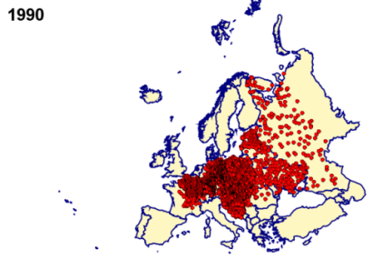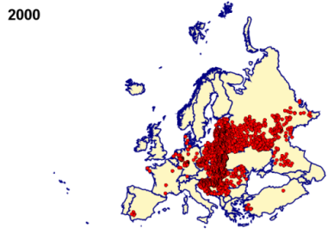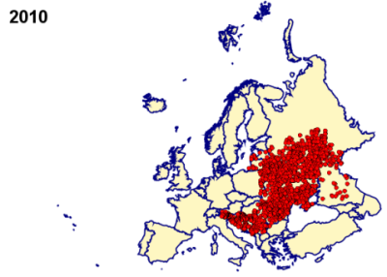

The disease, incidentally, is still around. Here, we’ve got the patterns of infection, mainly of wild foxes, in 1990 to 2010. There were still plenty of cases in Europe, none in Britain as it was eliminated a long time ago, but you can see it is still around, although it is very slowly being driven back. So that is stage one: dog to man, never man to man.

In cats, which have also been around for a long time, we have the same thing. You may have heard of a cat virus called toxoplasma, which actually changes the behaviour of those who are infected by it. Mice are normally terrified of the smell of cats - they can smell cats and they run away. If they have toxoplasma infection, which they catch from the cats’ urine, they find the aroma of a cat irresistible and they rush up to it, squeaking excitedly, and are then eaten. The cat is manipulating their behaviour. It turns out that many human cat-owners have the same condition. They have toxoplasma in their brain and, although I’m not sure they go rushing up to tigers saying “Hello, hello!” and stroking them, but they do to cats, and more importantly, they have much more risk-seeking behaviour. If you look at road accident victims, they are considerably more likely to have toxoplasma in the brain than people who haven’t had road accidents. So, that too is a case of movement of a disease from an animal to a human, but no further in the human chain.

The next step is a disease in which it goes from animal to man but it cannot sustain a long epidemic, and the famous case of that – and there have been several of them – is swine-flu and its relatives. The most recent epidemic in the 1990s started off with a mixture of three kinds of virus. On the farms in China, bird-flu, either in chickens or more often ducks, and human-flu each infected the local pigs on peasant farms, where they mixed up their genes to give a pig the flu, swine-flu as it is called. That got into humans, the pig-flu interacted with an existing human flu virus to give swine-flu, which could be passed on from human to human and really cause quite severe symptoms. The target population, however, quite quickly build up enough immunity in the population as a whole that it really could not continue for more than one season, and that is why flu viruses tend to shuffle from season to season, sometimes being very severe, sometimes not.

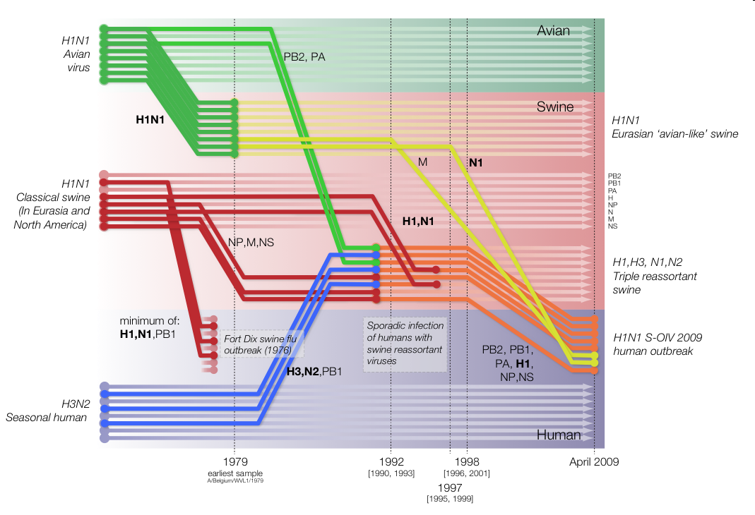

There are new invasions from different places, and you can actually track the history through their genes. On the graph you can see the H1N1, which is the swine-flu virus. That has got some bird genes in it, some pig genes and human genes, and they are all coming together and mixing together. The 1918 flu epidemic was far more serious than this, killing more people than were killed in the whole of the First World War. Frozen corpses have been dug up in Alaska of people who died of the disease. They’ve looked at the virus and interestingly enough, it is quite different. It is just a bird virus. There is no evidence that it is a mixture of different viruses that have come together. So, what we thought of as being the same disease, is in fact a different disease. That is actually quite common as you look more carefully at particular infections. They turn out to be considerably more complex than one actually thought.

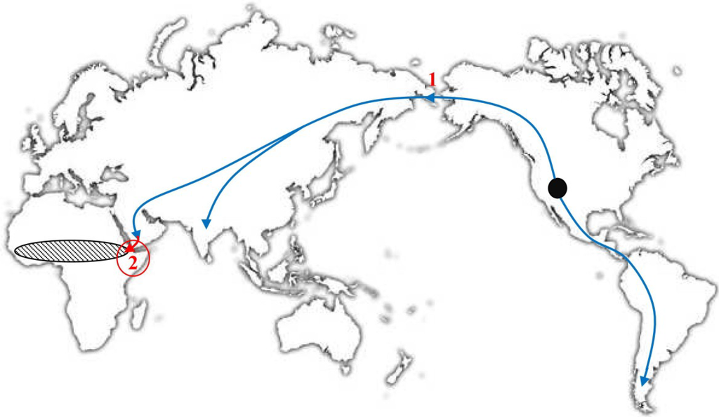

The next step is human to human, where we can actually see what the vector might have been. Camels were the bringers of smallpox. Here we’ve got a diagram that shows the origin of the camelids, which were a New World creature, but they got into the Old World across the Bering land-bridge, tens of millions of years ago, and got to Asia by about two million years ago. From Asia, they were domesticated, went to the Middle East, and got into Africa. In Africa, they overlapped with a particular species of gerbil, called the naked sole gerbil which is the only reservoir of cultivated pox virus in wild populations. You can draw an evolutionary tree of the viruses. In red, we’ve got the human virus, variola virus. There is also the sole virus, and the camel virus. So, almost certainly, it got from the gerbil into the camels. The camels then were moved back into the Middle East by the farmers, and they got smallpox from there. These are many other pox viruses, none of which seem to have got into the human population. And then, finally, you get something like the diseases of Leviticus, where we don’t know what the originator was and it goes from human to human and we don’t know where it came from. But some people say that 60%, perhaps even 100%, of all our infectious diseases, in some way, came from the animal world, so there’s been an awful lot of movement, and what we can do is use them to track patterns of change.

The classic case of how we can do that is the evolution of the epidemic of the 20th Century, and perhaps the 21st Century too, which is of course, HIV.

HIV is a global problem. It is due to an RNA virus, which is small and infects humans. It is not particularly infected but gets into white cells, T Cells, and basically hijacks their machinery. There are often no symptoms for months, years, or even decades, because what the virus does is persuade the white cells to copy the copies of the virus, and the white cell then dies and bursts, and gets out. More get copied, and slowly, your immune system, which is partly based on these white cells, is driven down until it is not functional anymore. You suddenly fall prey to all kinds of infections and lung diseases and Kaposi’s sarcoma, and then you’ve got AIDS. There is a big gap, however, between the infection, the first burst of virus multiplication, and the appearance of HIV itself. HIV is, of course, a huge issue. In some places in Russia, 70% of the population have got HIV, mainly through drug abuse. In the US, the population at risk is still very much men who have sex with men. But overwhelmingly, the world centre of HIV is in Africa, where two-thirds of all the people in the world with HIV live.

I once spent a year in the southern tip of Africa, in the early-1970s, teaching at the University of Botswana. Botswana actually has the highest incidence of HIV in the world. At its peak, more than one in three people in Botswana were infected with HIV. Of course, the disease was scarcely known then. It had just been noticed in the United States in 1971, but it certainly was not in the public consciousness at all, either in Europe or the States or, for that matter, in Africa. I enjoyed my time there. It was then very small. Gaborone, the capital, has become much bigger now and has become a tourist destination, but it was unusual among African countries in that it was rich. It had diamond mines. The diamond mines weren’t owned by people who stole them from the Africans; they were owned by the Government. They were run by de Beers, but de Beers paid a huge sum to the Government for that. It was peaceful and it was a single tribe, a very nice place.

It was actually very Christian because Scottish missionaries had gone there in the 19th Century and persuaded the people of Botswana that they would never sell drink to the natives. Queen Victoria was so impressed by this, as she was right to be impressed, that it was never a British colony, it was a British protectorate instead.

Christianity is still there, and I had a rather odd interaction with one student. I had been talking about human evolution and the immense age of the human species and hominids two million years ago. I asked one of the students at the end and I remember his name, Small Boy Electric, “Well, look, I know that I’m telling you all this stuff, but I know that you believe, quite passionately, because the Bible says so, that we arrived on Earth on October 4th 4004BC, on a Thursday, by divine intervention, with Adam and Eve.” He said, “Oh, yes Sir, yes Sir, it is very simple – you evolved, we were created.”

But it saddens me to give you that anecdote because it is more than likely that Small Boy and half the people in his class are now dead because of HIV. As I say, I was there in the 1970s.
Age (years)

Age (years)
Population (thousands)

The pale blue is what the age pyramid of men and women would be in 2020. There’d be lots and lots of young people. There’d be quite a lot of middle-aged people, and then there would be fewer and fewer old people. That is what it would be if there were no HIV.

However, what HIV did was to remove a whole cohort of young people. All these people died. The dark blue is the actual age pyramid, and among that cohort are people of the age of my students and their successors. It is a real major issue, there’s no question at all about that.

Let’s talk a little bit about how HIV works. It has a number of surprising attributes, many of which are revealed by looking at its genetics, and indeed at the genetics of those it attacks.
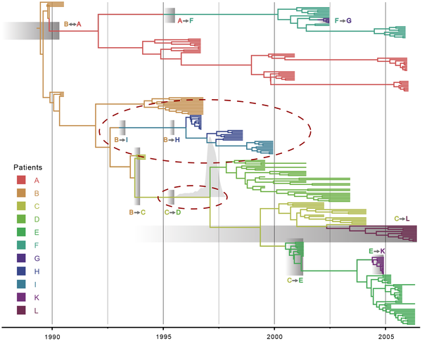

The evolution in HIV within particular patients can be seen. In this graph we’ve got time at the bottom, from 1990 to 2008. This is the history of an epidemic. We know who infected whom. They are all joined by lines, and there are a series of infections of one person after another, and what you find is, very surprisingly, that usually an infection only involves the transmission of one HIV particle, just one, out of the billions which are present in the bloodstream. If it is transmitted by sexual intercourse, which is most commonly the case in Africa, very few particles actually get into the semen. Even if they get into the female genital tract, only very few or none actually get through that due to its strong protective effect. This may well have evolved to stop the transmission of this kind of disease. So it is not a particularly infectious disease, but when one particle gets through, you can see an enormous amount of evolution within each patient so that everybody with HIV is themselves a laboratory of Darwinism – evolution is actually taking place. As there are 37 million people worldwide with the condition, there is a huge amount of evolution going on. We can use the genes and the history, to track its spread across the world.

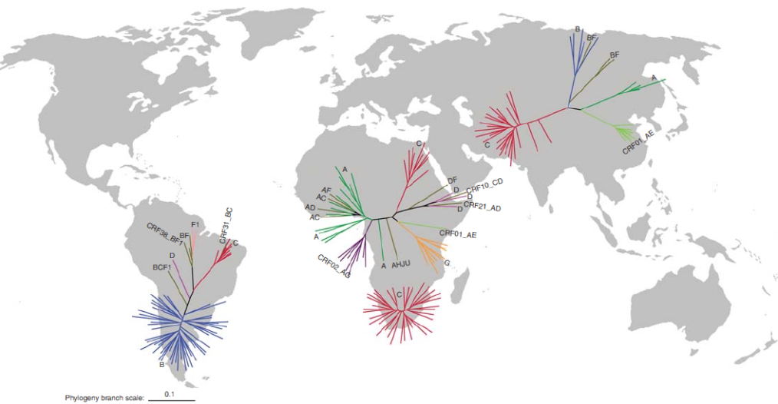

It almost certainly started in West Africa, probably in Cameroon more than likely. As far as we can see, it spread first from the Congo Basin to Haiti, with some evidence showing that it had got to Haiti by the 1960s. From Haiti, it got to the United States, and then it whizzed all over the world like that. You can see many other changes which have actually taken place. On the map, the three groups of lines are the pedigree. The one on the top-right is Russia and the Middle East; the one in the middle is around the Congo; the one at the bottom, just below the one in the middle, is South Africa; and the one at the bottom-left is the New World. The different colours actually represent different variant forms, genetic forms of the actual virus, and it is quite striking how different, different places are. For example, South Africa, where everything is red, is quite different, quite distinct, in its HIV history than the Congo, so presumably only a few viruses got in there, perhaps not all that long ago, and spread quickly. South America, where almost everything is blue, is again quite different from almost everywhere else, and once again, it is probably a tiny bottleneck of one or two infected people who brought that virus with them before it actually spread.

Now, you can see, also, that many more alarming things are happening. Something that is beginning to happen, rather alarmingly, is that what 10 years ago was a series of almost independently changing, almost ‘species of viruses’, (variants A, B, C, and D and so on, where you either had A or B or C or D, and you could see the accumulation of change within each of those lineages), what’s happened in the last 10 or 15 years is that actually the viruses themselves have taken up sex.

In the days when it was transmitted mainly by sexual intercourse, between humans, very few people would be infected by more than one attack of the virus, but now that it is transmitted widely by drug abuse, by needle-sharing, there you are very likely to be infected by more than one variant, and there you’re beginning to see what we saw with the H1N1 flu-virus. The different viruses in somebody’s bloodstream that might carry two or three different, separate infections of HIV, are beginning to swap and exchange genes. They are called recombinant viruses. They are scrambled up. And that is very alarming because what it means is the various resistances to drugs which exist in different parts of the world can now get together and be put together as combinations of viruses which are resistant to a whole slew of drugs at once, and you may or may not be glad to learn that London is the world capital of that process. And we have a big group at University College London, UCL, which studies this issue. We have a very large group that works on HIV and viral disease. And that is because London, of course, attracts people from all across the world, and Britain has always been a sexually very open society, so there is plenty of opportunity for viruses to scramble up.

However, there are other aspects of the virus which are probably a bit more positive. The virus is a microcosm of evolution. Charles Darwin himself never imagined for a moment that he would ever see evolution in action. He saw evolution as being something like astronomy, which is where you took a telescope and you looked into the heavens and you tried to work out what had happened in the distant past. He never imagined for a second that there would be a time when people would walk on the Moon or send probes to Jupiter. That was out of the question. And evolution used to be like that, but in fact, the AIDS epidemic, and many other diseases, are evolution in microcosm – we actually see it happening. And with AIDS, HIV, we see not just the bottlenecks, which are important, as Darwin noted when he talked about the animals and the plants on the Galapagos, but Darwin’s process of natural selection. Natural selection is inherited differences in the chances of reproducing. As I often say, natural selection is a factory for making almost impossible things, a series of successful mistakes that build on themselves until you get an extraordinary being like the AIDS virus. So, that is natural selection, and you can see it absolutely hard at work in ourselves and in the viruses too.

This is the HIV’s lifecycle. It gets into the bloodstream, begins to find white cells, and attaches itself to a kind of attachment point on the surface of the white cell. It then injects its RNA into the body of the cell. It is a bit like the Space Shuttle going up to the Space Station, attaching itself to the tube, with human DNA being squeezed through the tube and into the Space Shuttle. This does exactly the same. One of the attachment points, or the main attachment point, has a rather unromantic name, CCR5, chemokine receptor 5. We don’t need to bother with the details of it, but that’s where it attaches itself. It squeezes in its RNA, the RNA hijacks the DNA to force it to make more RNA, and in time, the white cell dies.
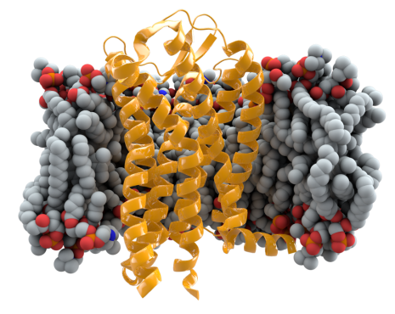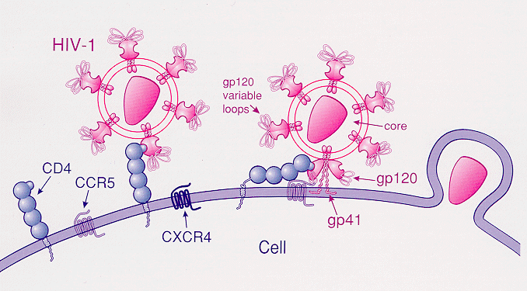

It does this all over Africa, and in many other places, and nobody is resistant to it. Very surprisingly, in parts of the world which have already seen HIV in the near-past, we have a variant. There is a CCR5 receptor, shown in a sort of muddy yellowish-brown there, sitting inside the cell membrane, which is kind of grey, and just to the right of it, you can see the virus particles attaching themselves to the receptor. Something like one person in four, has a deletion in their CCR5 receptor, a kind of genetic change, a mutation, which involves taking out a length of DNA. It is inherited, passed down the generations, and in fact it has got 34 DNA letters that have been taken out of that CCR5 receptor. Quite surprisingly, that is common in North-West Europe. Its deletion is common and goes up to about 20% in places like some of the Scandinavian countries. There will be somewhat more people with one copy than just 20%. 20% of the genes, at most, are CCR5-deleted.

Well, why is it there? It certainly isn’t there because of HIV, because HIV has only been in Europe for the last 30 or 40 years. People have speculated why that is. Deletion may have given protection against plague or against smallpox, we don’t really know, and maybe that is why it has got that strange distribution. However, it also gives considerable protection against HIV.

This is the progression from infection to the appearance of symptoms of AIDS, and these are people – the dotted line, unlike the solid line, this dotted line is the proportion of people who stay AIDS-free, so 2, 4, 6, 8, 10 years, and after. Half the people who carry a copy of this protective variant are still HIV-free after 6 years. The people that do not have the protective variant show HIV signs after 6 or 7 years. The ones that do have it take on average 12 years for half the people to show signs of the infection. And in fact, even after 16 years, something like a quarter of the people still show no signs of that infection. So, this is really quite a strong protective variant, and in time, no doubt, it will become commoner as the AIDS epidemic continues.

This is not the only protective variant. There are several of them. The ones shown here are in the immune system, and what we’ve got are three possible types. The proportion of people in a population where many of them have two copies of the letter C is shown in dark red at the bottom there, many more of them stay alive than in populations which have only a small proportion with two copies of the letter C. That too is protective, and there are probably many, many more of these things.

Something the virus has done, in consort with other diseases, is to push human evolution really quite rapidly. We don’t know why CCR5 never emerged in Africa – it is just not there. There’s a little bit in Morocco. But it is probably quite simple: the mutation never happened. If the mutation had happened, it would have spread, but it didn’t happen, so the Africans are paying the price.

Bizarrely, there also seems to be lots of evolution of the virus itself in the process of spread. If you’re infected by HIV, you have what seems like a rather severe case of flu. You feel ill, sweaty, often have a bit of a rash, you feel shaky, and that is the HIV virus really going wild. It is beginning to take over your immune system. Then it settles down and the flu goes away, and most people who are infected in fact never go to a doctor because it doesn’t last for very long, but the virus is still there, ticking away. But you find enormous differences in what is called the viral load in people before they begin to show symptoms.

Patient 1, here, has got vast numbers of viruses, even though he has not got any symptoms; Patient 2 has got far fewer, and Patient 1 is going to get ill well before Patient 2. The figures are quite spectacular. Some people have 10⁶, that is a million viral particles per mil, whereas others have 10², which is a hundred. There is, therefore, a 10,000 times difference among different people in the viral load which they actually have while they remain healthy. Now why is that? You could say that maybe it is because some people are genetically resistant to the virus and some people are not. But it is more than that because what you can do, and it is something which has been done quite extensively, is to say, here we have somebody who is infected, where did he or she get it from? Let us say it is a woman and she’s been infected. You find the partner, who infected her, and maybe she passed it on during childbirth and breast- feeding her children, as unfortunately happens so often. Something you find is that although the male responsible and the woman are not genetically similar, they have rather similar loads of the virus particles. So, it is the virus particle which, for some reason, is developing enormously in numbers in some individuals and not in others. We don’t quite know why that is.

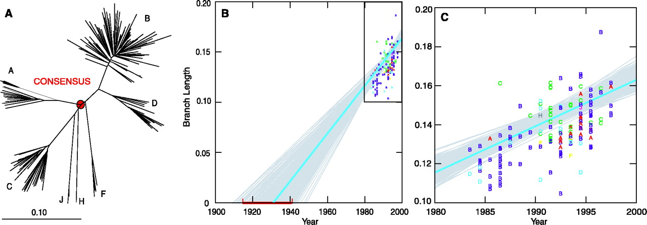

Let’s talk now about where AIDS came from and, maybe, what we can do about it. What we know full well, is that AIDS is an African disease, and people began to realise what HIV was in the 1960s and by the early-1980s, it was possible to read off the genetic message in HIV. In A, we’ve got a tree of relatedness of the African HIVs in about 1980, or a bit later. It is just a family tree based on genes, in the same way as we could make a family tree of ourselves based on genes. In B, in the top right-hand square, we’ve got dots. Those dots represent annual readings of the HIV map over the 20 years from 1980 to 2000. Rather surprisingly, I have not been able to find it going up to 2016. What you can do is draw a line and say, given it has changed this much in 20 years, how long will it take us to get back to zero? The answer is that it lands somewhere between 1920 and 1940, and that is the section in the box. That seems naïve, but that is the consensus sequence.

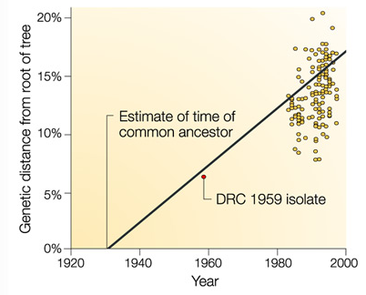
The best evidence, without question, for evolution, is fossils. It seems too hard believe that one could ever get the fossil of a virus, but that has actually happened. A few years ago, a rather daring American biologist went to the Democratic Republic of Congo, and he went to the hospital in Kinshasa. He began to look at specimens in the pathology laboratory from people who had died long before, in the hope, perhaps, of finding evidence of HIV well before the main epidemic had commenced. He looked at hundreds of specimens, and he only found one, but he did find one, from 1959, from a young African, who had died of a then unknown disease. He took out that 1959 sample, he read off its RNA, he put it on that line which we’ve just drawn and it sits almost exactly on the line. In fact you can see that is how long the branches of the trees were in 1959, and by the year 2000, they had grown that much more. So, we can track the origin of the virus in humans.

The virus came from somewhere, it came from other primates. It is a classic case of a zoonosis, a disease that comes from another animal. I took a picture in Sierra Leone, many years ago, in a butcher’s shop, where there were lots of monkeys scattered about, bush-meat. It is a chimp virus, and you can read the chimpanzee genome.

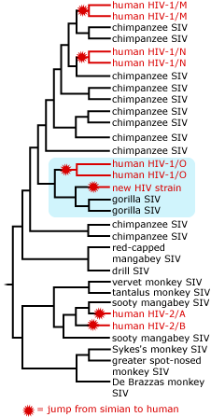

The human HIV virus is in red here. The chimpanzee SIV is a simian immunodeficiency virus. There is also a new HIV human strain, which has only just been discovered, that is close to gorillas. There is also something called a sooty mangabey which is close to another strain of HIV. So, it got into us from other primates, and what you actually see is that the chimpanzee immune system has become grossly simplified compared to ours. That may represent the past spread, the sweep of strong natural selection, which only the people who had variants like those with the CCR5 deletion survived, and so only the protective variants lived on in the modern population. Thus, chimpanzees too paid an enormous price in death and mortality, perhaps 5,000 years ago, when it first emerged with them.

We can actually track down a bit more accurately where this chimpanzee virus was found, and it turns out that the most common form of the HIV virus, M and N, are both close to chimpanzee viruses that come from Cameroon and Gabon, and that’s almost certainly where it came from. It almost certainly has been around for a long time. The most probably explanation is that hunters came back infected with the virus, they infected their partners, other people in the village became infected, and probably everybody died, but nobody moved. They were hunter-gatherers. They weren’t moving around like people at Gobekli Tepe in Turkey. In the 19th Century, however, with the dreadful imperialist rule of the Belgians in Congo, cities began to grow, slavery really took hold, and people began to move, in large numbers, to places like Kinshasa. The population rocketed up and the epidemic got underway.

Therefore, clearly, that is how it got going and that is how it got to spread across the world, and we’ve uncovered that using genetics. It is a classic case of a zoonotic disease.

This is all very interesting, and in many ways, all very tragic. However, there have been some positive moves.

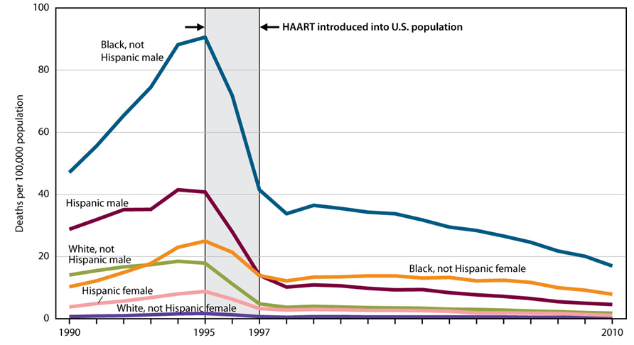
This is high activity anti-retroviral therapy, which I won’t bore you with the details, where they’ve got a parcel of drugs which really works remarkably well, and the new ones work even better on people infected with HIV. In the new ones, there is no sign of the evolution of resistance yet, although it will certainly come, and you can see a complete collapse in the amount of HIV infection from 1997 in these ethnic groups – blacks, whites and Hispanics.

That has had an effect in Africa. If one looks at the patterns of life and death, from 1960 to 2010, in the various southern African countries, you can see life expectancy in Botswana dropped from the 1980s from 65 to something like 50, but it is on the way back up again. Now, that isn’t to say that the AIDS story is over, because it is not. The number of people affected is going up and not down, but we are having some success.

If you’re cheerful about AIDS, however, and I’ll end my talk on this cheery note, there are plenty of other conditions waiting in the wings. They are called emerging diseases. There are some of them, neglected, emerging and re-emerging tropical diseases, such as dengue, which have really come back with a bang. Dengue is called break-bone fever. You get an immune response on a second bite by a mosquito which can literally break your bones as the anguish is so much and as you tense your muscles. Leprosy, we thought we had driven out, but it is coming back in some places. Chagas Disease, a disease Darwin may have caught and which is carried by a kissing bug, forces a parasite into your bloodstream. There are other diseases which are all either coming back or poised to come back, such as schistosomiasis, carried by snails, and we can see where these diseases could re-emerge or appear.

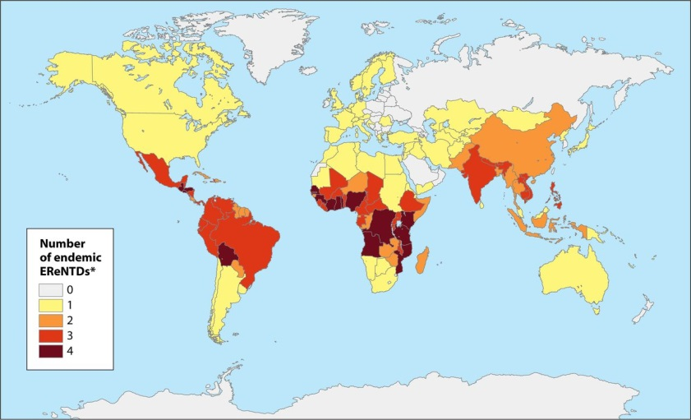

This is the global intensity of five of the major ones – Dengue, Rabies, Cysticercosis, Chagas disease, and Trypanosomiasis. It does not take much observation to see that the centre of that is of course Africa.

So, what is going to happen in the future to these diseases? I have to say that the demographic patterns and the patterns of human movement are such that I think we face the real potential of a catastrophe.

First of all, let’s look at the patterns of global fertility. The world capital of fertility is, needless to say, Africa. The mean family size for sub-Saharan Africa is 5. The mean family size for Britain is just over 2, 2.01. The mean family size for Italy is 1.3. In Africa, it is huge and there is no sign of it getting any smaller. Places like India and China very quickly reduced their family sizes, in China with some pressure from the Government, but in India, through social pressure more than anything else. Africa, this has not happened, and that is going to have a dramatic effect on the patterns of distribution of Africans and of African genes, and indeed, of African diseases.

We can see a striking shift over time. In 1492, genes for white skin colour suddenly began to expand in number across the world because white-skinned people, Europeans, travelled to the New World. They travelled all over the world taking their DNA, their genes, with them. Now, that process is being reversed. In 1950, there were about twice as many whites as black Africans in the world, but now the figures are about equal, and in 2050, there will be more than twice as many blacks as whites because of differential population growth.

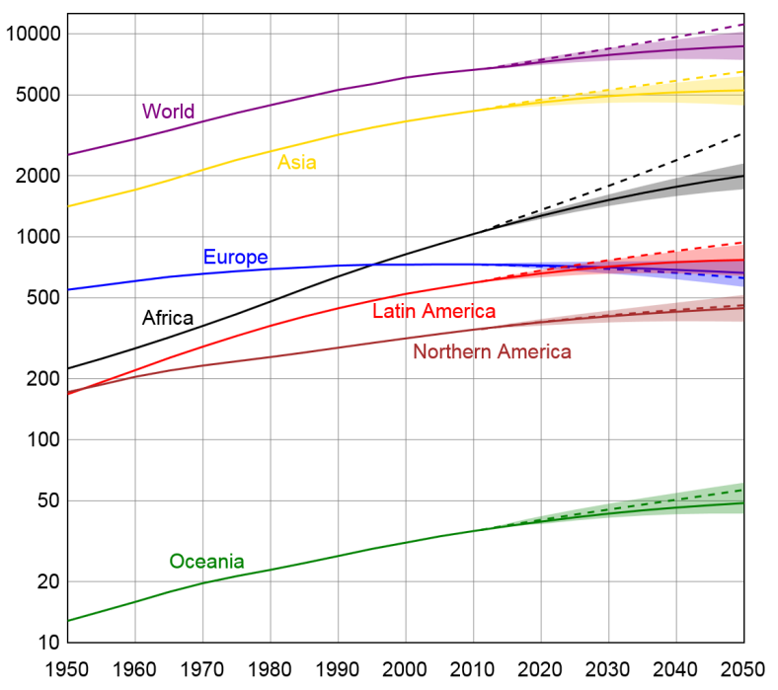

These are the estimated population numbers across the world, shown in a logarithmic scale, so it is a rapidly expanding scale, from 1950 to 2050. Europe is flat or declining; Northern America is pretty flat; Asia is reasonably flat and Africa is rocketing up. These are the maximum estimates, from the United Nations. So, if we have, as we probably will by 2050, 9 billion people, 3 billion of them will be Africans and they will be one-third of the world’s population. Exactly as happened at the origin of agriculture, when we had the same kind of population explosion, they will move. They have no choice but to move. We can of course see that happening now, on a very small scale. They will not move at the rate that the farmers did, who took several thousand years to get from the Middle East into Western Europe, they will move quickly. They will move, in fact, by all the modern modes of transport we have. They may even manage to get onto an aeroplane.
I’ll end up with completing that quotation from Alice in Wonderland about the future:

“My dear, here we must run as fast as we can, just to stay in place. And if you wish to go anywhere, you must run twice as fast as that.”

When it comes to disease, we’re now running twice as fast as that, and I think I can summarise my talk by saying this is a very interesting time to be an epidemiologist…

© Professor Steve Jones, 2016

Gresham College
Barnard’s Inn Hall
Holborn
London
EC1N 2HH
www.gresham.ac.uk

