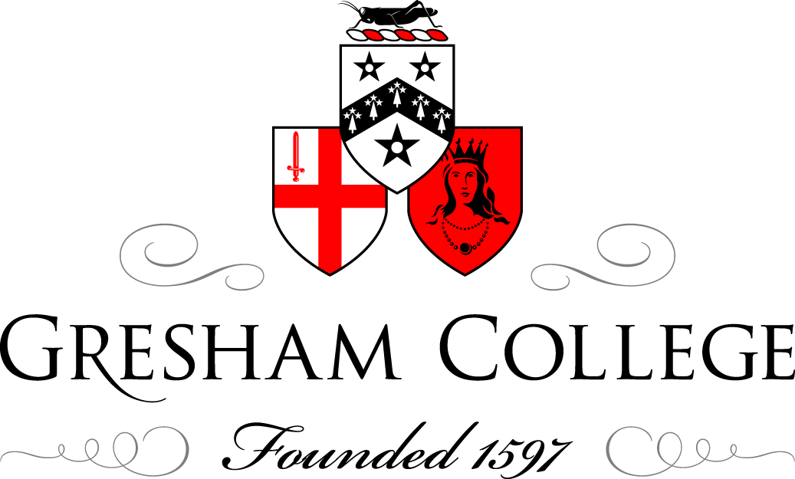

18 April 2013

Music and Conflict Resolution

Ian Ritchie

I am talking today about music and conflict resolution. Although there is considerable evidence available concerning the power of music and its effective application to the damaging human consequences of conflict, much less has been spoken or written about its potential role in resolving conflict or addressing its causes. Without redressing the balance completely, I hope to provide one or two pointers in the wider context of music and its longstanding relationship with conflict.

There are a number of ideas that are worth exploring – separate subjects as well as variations upon the same – and I propose to say something about the power of music and to define some of the different facets of its relationship with conflict. I hope that this will provide an overture of ideas: the full symphony has yet to be written. In fact, we have only begun to scratch the surface of what is to be learned about the effects of music upon human emotions, behaviour and well-being, both mental and physical.

I have chosen the following themes and variations: conflict resolution at the heart of musical expression itself; the use of music to avert conflict, to resolve conflict, to heal the trauma caused by conflict and to rebuild broken communities, not just damaged minds; and finally music’s response to the experience of conflict, for example inspired by war, which incidentally can be part of the healing process or ‘resolution’ achieved through the creative process. With the importance of ‘resolution’ uppermost in my mind, I have avoided the subject of music’s use throughout history as propaganda in support of conflict and as a weapon on the battlefield itself.

By way of introduction, I should explain how I came to be involved in this whole area of discussion. In the first place my whole professional life has involved making and working with music, and over time I have gained a deepening awareness of the nature and power of music itself. But then, around 20 years ago, I was drawn into the events and consequences of the war in the Balkans, especially in Bosnia-Herzegovina. Some of you will remember the extraordinary courage of the cellist in Sarajevo, Vedran Smailović, who night after night donned his tails and played in the city’s main marketplace, at the site of the murderous mortar attack by the Serbian forces; it was freezing as well as dangerous but he survived, albeit with frostbite which damaged his cello playing. I knew some of the composers who wrote music specially for him and one in particular, Nigel Osborne, who was renting my flat in Edinburgh at the time: he visited Sarajevo in the midst of the siege and arranged to get the cellist out; he finally succeeded in bringing Vedran to Scotland where my flat became his home for a while! At the end of the war I spent time in Mostar with Nigel Osborne setting up the Pavarotti Music Centre and its unique Music Therapy clinic for children suffering trauma as a result of the conflict: it was also a music school, recording studio, performance space and a centre for musical outreach into the schools and communities throughout the region; I also set up a cross-community orchestra, the Mostar Sinfonietta, which comprised not only Muslims and Catholics from the two parts of the divided city but also musicians of all standards and from all the confessions of this one-time mixed and integrated society.

Conflict resolution has lived at the heart of musical expression. It is generally true to say that every artist is on a quest for beauty, though the 20th century threw up some exceptions to this rule. In music, beauty stems from the creation of dissonance and its resolution into harmony, the struggle being required to create the conditions necessary for the greater expressive impact. This seems to offer a parallel with human nature itself which appears to require contradiction and disagreement en route to achieving the clarity of consensus and agreement – or, worse still, needs conflict to be waged in order properly to comprehend the peace that might ensue. It is therefore unsurprising that music, a basic human impulse which predates even any form of speech in an individual’s development, is a potentially powerful medium in the area of conflict and a tool for its resolution. The nature of music can be described as an interdependent triangular relationship between inventing, performing and listening – three cornerstones of a creative triangle. There are illustrations which I can give of conflict being averted, resolved and its traumatic consequences repaired through all three modes of musical engagement: simply listening, performing with a voice or an instrument, or creating either in pure musical terms or harnessed to other forms of expression, such as words in the making of song.

There is one very public and increasingly widespread example of music being used to avert conflict: I am sure that many of you, like me, will have emerged from a London underground station or entered a shopping centre to the sound of classical music being played through loudspeakers. The purpose of these installations is to discourage the build-up of restless individuals, to break-up the congregation of rowdy gangs and to prevent anti-social behaviour. As a music lover, one is bound to feel slightly queasy at the thought of this instrumental function of a much-loved art form as a kind of subliminal wallpaper as opposed to food for the soul; and it is ironic that something beautiful should be deliberately off-putting rather than encouraging for people. But it has the desired effect. The potential of music to wind people up and foment conflict is well known and has been the bread and butter of military musicians for thousands of years – raising morale on the part of both attacker and defender, inspiring teamwork but also individual and collective aggression. It follows that the exact opposite can also be achieved, with music that can inspire peace and dissolve aggression. There is considerable potential for the Armed Forces to engage in this approach as part of the role of the very many military musicians deployed in the theatres of war and not merely on the parade grounds. The role of army bandsmen in relation to medical care has existed for centuries and now goes well beyond the stretcher-bearing duties of the musicians, as was the case in both the World Wars for example, to embrace working in field hospitals alongside the doctors. And now there are even graduates with formal music therapy qualifications who have started to enter the Army as serving musicians. This is an optimistic sign of music being applied potentially more systematically as a cure to the trauma of military engagement, even though it does not yet foretell the possibility of music as prevention – and we must remember that prevention is better than cure, as the saying goes.

Although music and the resolution of conflict is the declared subject of my short talk, this is perhaps the most elusive aspect of music’s role in this context. There is no doubt that it can have a calming influence. Neuroscientists – and I am not equipped or prepared to speak with any pretence of expertise in this area – have demonstrated the actual patterns of brain activity in response to different kinds of music that can induce different emotional responses. Indeed the physics and the chemistry induced by music within the human brain are becoming increasingly the subject of expert treatise and actual treatment in the fields of neuroscience, psychiatry and the growing profession of music therapy. But these applications of music have tended to prove their cases in the aftermath of conflict rather than in the midst, addressing the traumatic effects or social damage within communities that have been divided through conflict. One illustration that I shall give, one of a number of examples that I experienced during my many visits to Bosnia in the aftermath of the Balkan conflict, when I was engaged with the composer Nigel Osborne to set up and build a Music Therapy clinic in Mostar specifically to treat war-damaged children, is a social and political one. After we had built and opened the Pavarotti Music Centre, complete with its Music Therapy clinic, a number of us continued to volunteer in delivering music projects for the children of Mostar as well as for the adults and for the specific goal of healing the society as well as the individual: this meant bringing people together from across the very strong divide between East Mostar and West Mostar – essentially the Moslem Bosniaks and the Catholic Croats who made up (and still comprise) the most substantial proportions of the city’s population; at the conclusion of a major songwriting and choral singing project involving children from both halves of the city, we presented a concert in the courtyard of the Music Centre to which the two Mayors of Mostar were invited to attend (officially there was only one Mayor and a deputy Mayor for the municipality, but the community division required the artifice of recognising two mayors to support the separate education systems and civic governance of the place); the Mayors sat at the opposite ends of the front row, surrounded by their respective weighty officials, but during the course of the evening they increasingly recognised their people, their families and their heritage in the faces, songs and behaviour of the children performing in front of them – by the end of the evening the two Mayors were sitting together and speaking animatedly for the first time since hostilities had ended. Although the Serbo-Croat language is shared and spoken by the divided parties, it provided no medium for real understanding: it was the music that achieved that.

I can offer countless examples of music as a means of healing trauma caused by conflict, and the work in Bosnia is just one of these. Colleagues of mine in various NGOs or working as individuals have found themselves working effectively as artists applying their gifts in ways that are therapeutic – in ex-Yugoslavia, the Caucasus, the Middle East and parts of Africa, for example, that have been torn apart by war – but the medically accredited clinical discipline of Music Therapy, now functioning all over the world, has been applied systematically to trauma in rather more isolated conflict situations. Apart from the Bosnian example, another centre for this work has been Northern Ireland both during and in the aftermath of the troubles there. From these and other sources have emerged conferences, publications and studies which have already been shared internationally and continue to show the way in which music can actually heal post-traumatic stress disorders. This approach has massive untapped potential in relation to the Armed Forces, particularly as they return from the Afghanistan and Iraq theatres of war with many suffering from diagnosed post-traumatic stress disorders which, in earlier generations, were described as shell shock and consigned traumatised soldiers to forbidding asylums around the country. In recent years there has been substantial work undertaken – in Northern Ireland once again – among civilians and the widespread incidence of trauma that people have experienced. This has shown not only the individual benefits from this being treated, using Music Therapy as a powerful means, but also the collective consequences upon the wider community. In short, the proposition now is that sustainable peace can be achieved far more readily through addressing and healing trauma within individuals, families, and their wider circles.

I have already alluded to how music can rebuild broken or divided communities and not just repair individually damaged minds. During my time spent in Bosnia over the years, one particular model which I helped to develop and support was that of the Mostar Sinfonietta, which drew together once more the small number of musicians who remained in the city by the time the conflict was over. This was not as straightforward as it sounds, because of the divided nature of the city: once upon a time this held a happily united and intermarried mixture of people of all confessions and national backgrounds, but 15 years ago it was (and to some extent still is today) a place of ghettos and political divisions, principally between the Moslem and Catholic communities. The small mixed-ability ensemble of musicians symbolised a unity that could be achieved through a shared purpose and a common language – a harmonious resolution to the dissonant conflict which went before. Daniel Barenboim, through his West Eastern Divan Orchestra made up mainly of young Israeli and Palestinian musicians, achieved a worldwide profile for this way of working together. Less visibly, another organisation I am involved in, Musicians without Borders, has for several years been running a Rock School in Mitrovića, a town in Kosovo which has remained resolutely divided between its Albanian and Serbian citizens on opposite sides of the river running through. The only way to bring the young people together was to take them on summer courses to Skopje in neighbouring Macedonia where they happily made music together, whilst back in Kosovo their School existed in two separate buildings on either bank of the river. Soon they started to walk across the bridge and begin the process of their families and communities getting to know each other once again. Closer to home, Musicians without Borders, through its UK office in Manchester, has brought together refugees and asylum seekers, not only from different areas of conflict around the world but also those remaining separated in spite of coming from the same country: the effective medium for this has been music, leading to the creation of an inspiring multinational ensemble, Beating Wing Orchestra, and project involving victims of torture called Stone Flowers.

As I approach the conclusion of my words, it would be remiss of me not to refer to the huge amount of music and, indeed, of poetry which through song has become music that has been inspired by or created in response to conflict. Perhaps more than in any other time of war, some remarkable soldier-composers emerged during the First World War, such as Butterworth, Gurney, Ravel and Vaughan Williams, alongside poets, painters and other famous artists. Even music created by those who avoided taking part in wars, such as Second World War pacifists like Benjamin Britten or Samuel Barber, or composers who were too old to fight like Richard Strauss, responded to the pity of war in a way which could offer resolution, or a musical pathway to peace, at least in their own minds and routinely affecting those of the performers and the audiences of such music. This summer I shall be presenting an experiment, hopefully a first which will be much imitated in the future, by commissioning special arrangements of some of this music, created by those involved in and influenced by conflict, so that it can be performed by military band. In this instance, it will be the Band of the Royal Artillery who are of course trained and deployed in making music for ceremonial occasions and raising public morale: indeed, on the morning of their concert which happens to be on Armed Forces Day, 29th June, they will have changed the guard at Buckingham Palace; that evening, however, they will be performing a new and totally different repertory that includes the reflective and profoundly moving songs which Ivor Gurney wrote while in the trenches on the Somme. This concert concludes the Worlds in Collision conference which the City of London Festival is presenting in partnership with The Musical Brain.

In conclusion, I should tell you a little bit about this conference that looks at Music and the Trauma of War. We are putting it on in the Mansion House, symbolising the very heart of our capital City and bringing together musicians, music therapists, arts practitioners, psychologists, psychiatrists, neuroscientists, historians and soldiers to share their knowledge and experience. The first day looks at the application of music to the trauma of war and the second at the response of music to the experience of conflict, ending with the unusual concert. This event will hopefully offer some continuity – at least one of the potential directions forward – from this important seminar in which it has been a privilege to have the chance to participate and say a few words. As I said at the start and have done little to disprove in my words which followed, we are only now scratching the surface of a huge subject and just beginning to understand the extent of music’s usefulness and its power to make a difference to individual lives and to humanity as a whole.

© Ian Ritchie 2013

