19 October 2015
“The Instruments of Darkness Tell Us Truths”
Ritual Protection Marks and Witchcraft
at Knole, Kent
James Wright

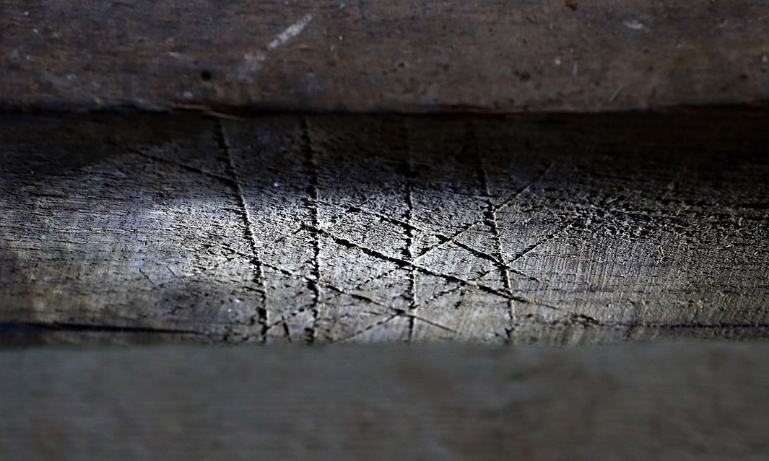

Introduction

The recording of the fabric below the floors in 38 rooms at Knole, near Sevenoaks, Kent was commissioned by the National Trust during opening up works undertaken as part of the major programme of restoration and repair. The fieldwork was undertaken between November 2013 and February 2014.

Knole is one of England’s greatest historic houses and has been home to servants of the Crown for centuries. Dating of the floor framing was possible in parts of the building by association with timber roof structures of known date from dendrochronology. Thus it can be stated that all of the floors recorded on the second floor of the building including the South Barracks, King’s Tower, Retainer’s Gallery and East Range date to the remodelling of the house under Thomas Sackville in 1605-08.

Analysis of the relationships between the rooms of the South Range has led to the theory that it was remodelled as a royal suite by Thomas Sackville. The King’s Tower acted as a royal bedchamber complete with closet and lobby with direct access to a rooms long gallery. Servants were able to access the lower status on the second floor via the Second Painted Stair which gave admission to the Retainer’s Gallery which acted as a long gallery for Household staff. In turn the South Barracks provided direct communication to the Upper King’s Store which was originally intended as a bedchamber with closet and lobby for a high status retainer.

Detailed analysis of timbers in the Spangled Bedroom, Cartoon Gallery, Outer Wicket Tower, King’s Bedchamber and Upper King’s Store yielded a number of apotropaic symbols. Thirteen symbols were identified carved onto a tie beam in the King’s Store. The beam is 5.33m in length, orientated east-west and is located 2.37m to the south of the north elevation. The beam was laid during the programme of remodelling at Knole under Thomas Sackville between 1605-08. The King's Tower is essentially a medieval structure with significant alterations to the windows, floors, chimneys and layout by Sackville (Oxford 2007, 30-31). Dendrochronology of the floor beam and roof beam directly above gave a felling date of the winter of 1605-06 (Bridge 2010; Tyers 2014). The fact that the beam was laid whilst the oak was still green - and therefore malleable - indicates that it must have been placed in its current location during the spring or summer building season of 1606. The dating is seen as significant as few apotropaic symbols have ever been dated before and they were carved in reaction to the aftermath of the Powder Treason of November 1605.

Description of the apotropaic symbols in the King's Store

The apotropaic symbols are carved on the north face of the beam, and on the east and west faces of the joists which are jointed into the north face of the beam. In total there are 10 apotropaic marks (Fig 1 - Fig 5), although it is anticipated that there were originally 13 with 3 having been obscured or removed by the introduction of a steel strap-work at the west end of the beam to support the rotten timber. Additionally 2 others were recorded upon the eastern jamb of the fire surround within the same room (Fig 7).

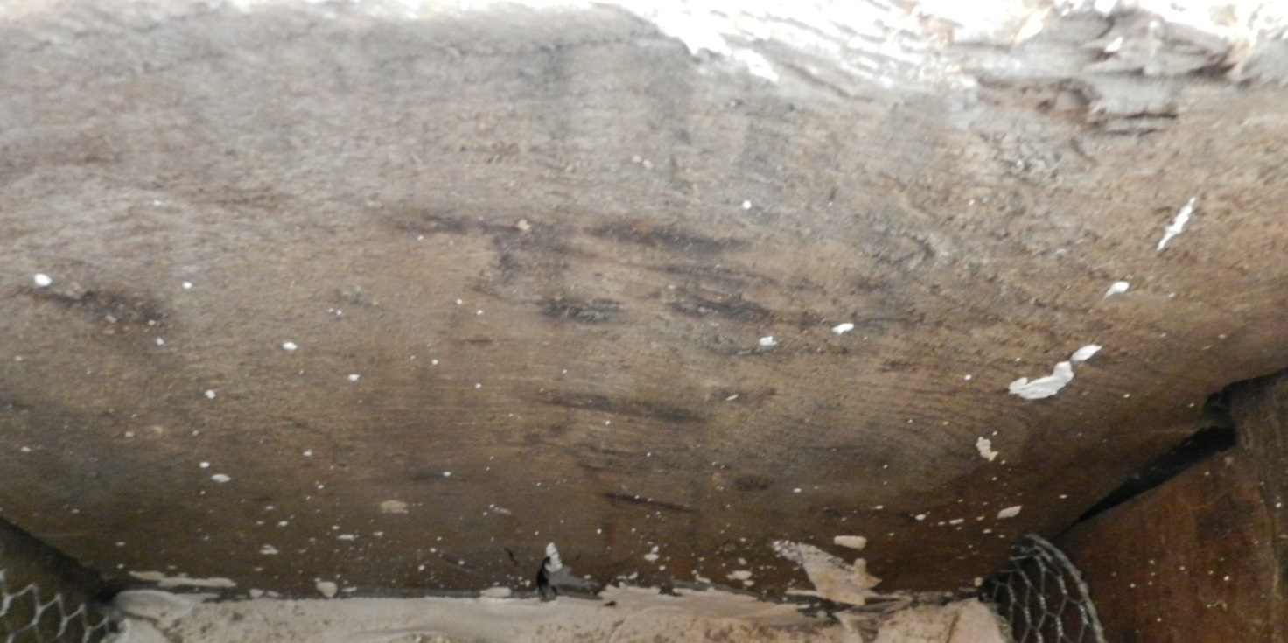
Fig 1 Scorch marks on the north face of the beam, looking south. These marks are the most easterly of the assemblage.
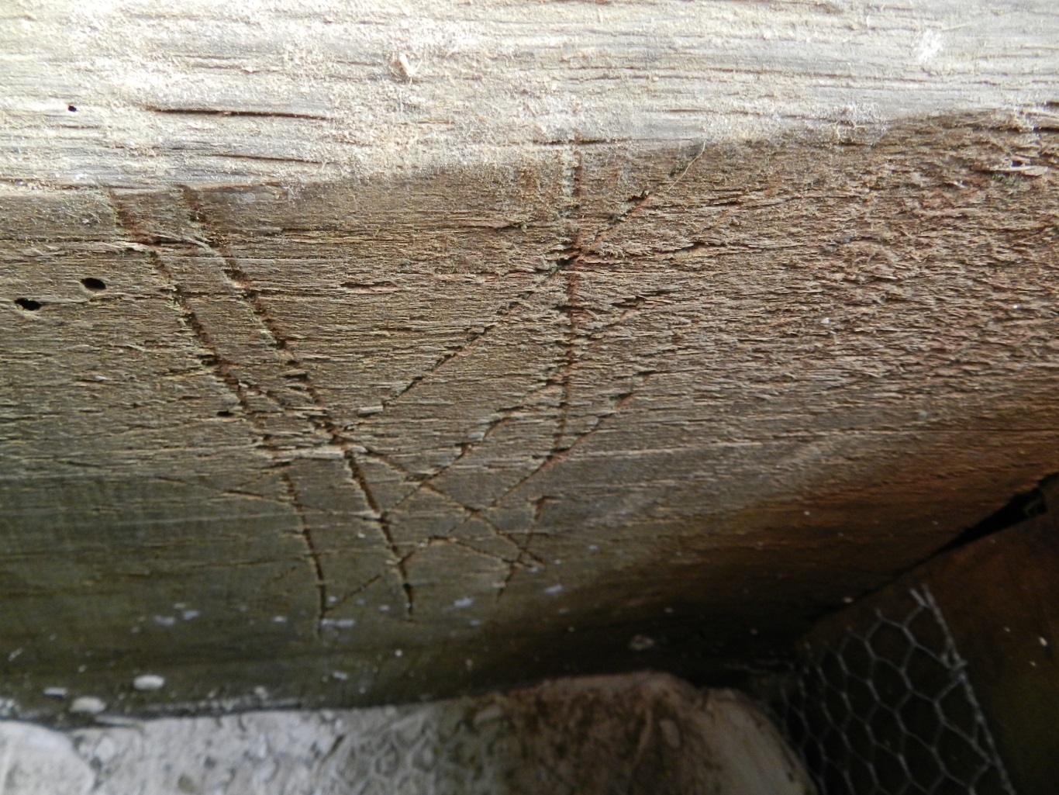
Fig 2 Apotropaic symbol on the beam, looking south
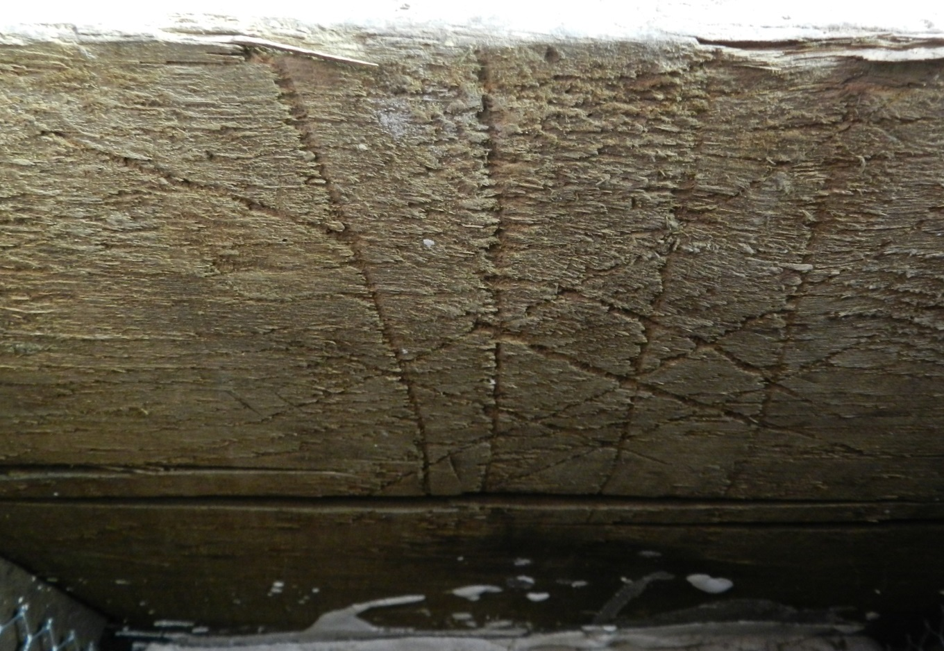
Fig 3 Apotropaic symbol on the beam, looking south
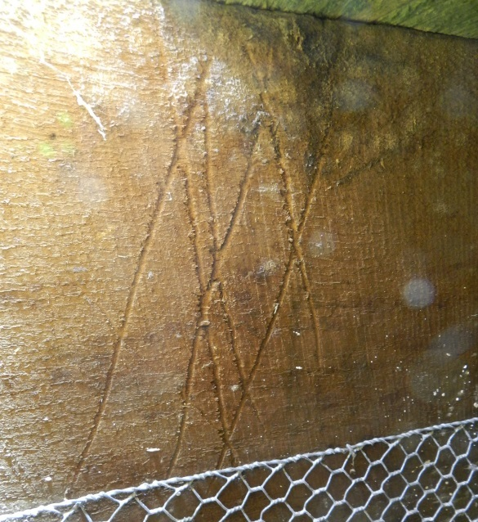 A B 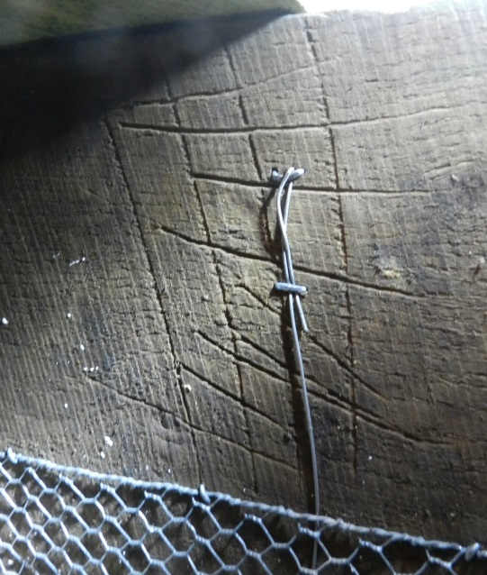

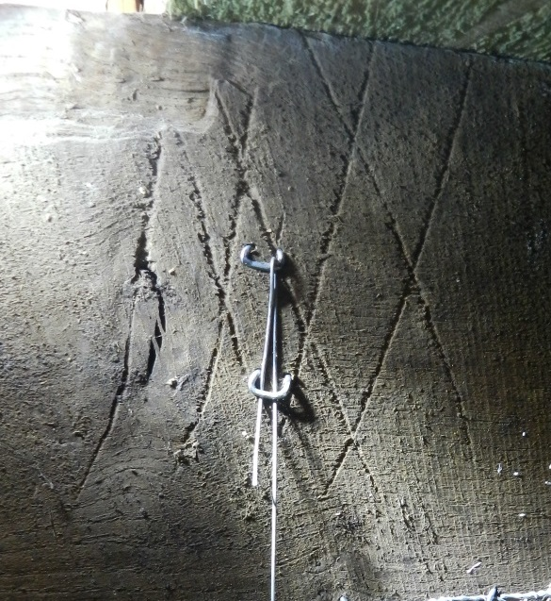 C D 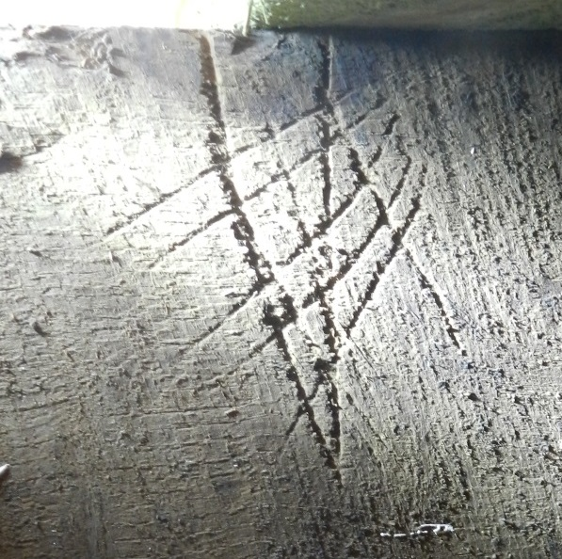

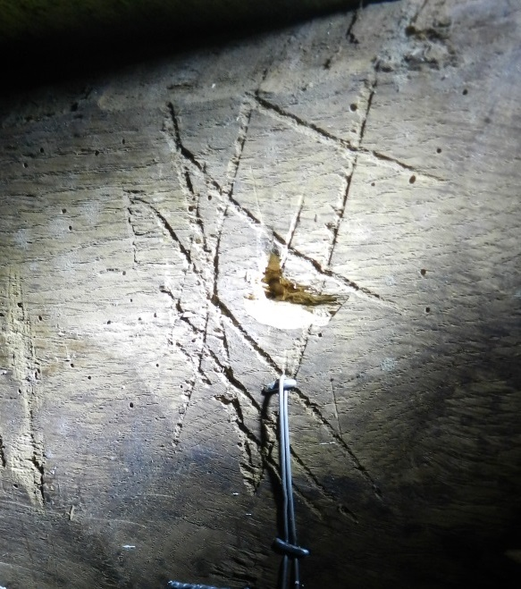 E F 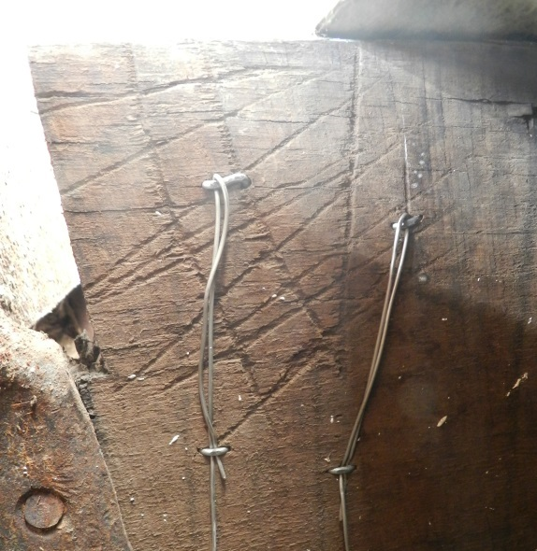
Fig 4 Apotropaic symbols carved on the beam and joists in the King’s Tower
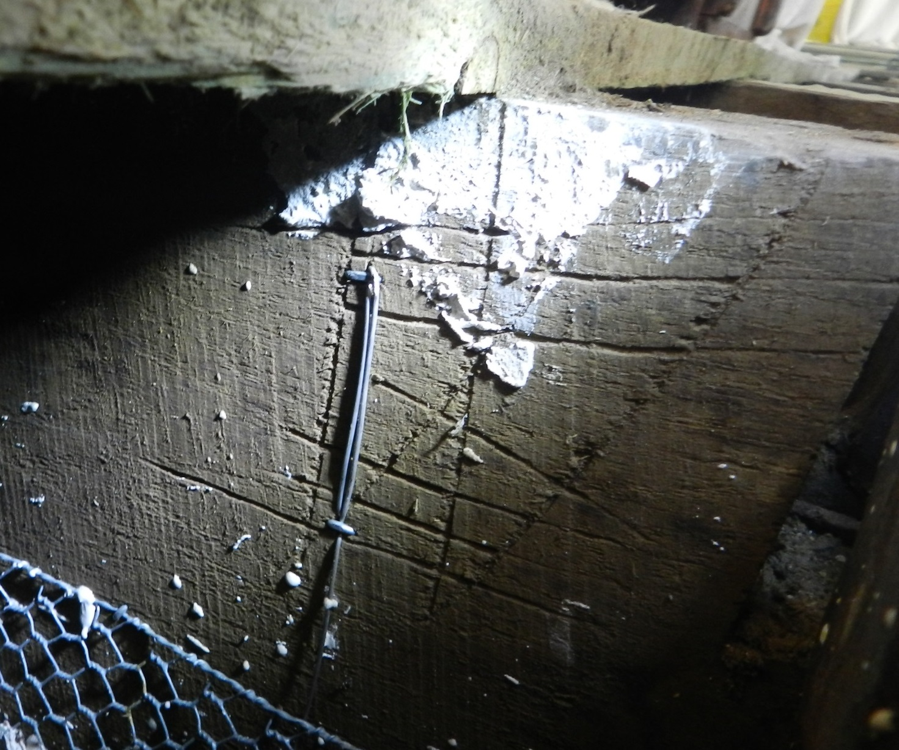
Fig 5 Apotropaic symbol on a joist which is jointed into the beam, looking east. This mark is the most westerly of the assemblage.

A Roman numerical system of carpenter's marks was found on both the north and south face of the beam as well as the related joists. The carpenter's marks were observed in alternating bays between the joists and number I, II, III, IV, V, VI and VII with the sequence running east to west (Fig 6).

The apotropaic marks consist of scorch marks, interlocking V-shapes, regular chequerboard designs and irregular meshes. They are found only on the north face of the beam or the joists which are jointed into this face and are located in the alternating bays between the carpenter's marks. No apotropaic marks are found in the bay between carpenter's marks I and II however in the bay after II a number of horizontal scorch marks were observed. Subsequently every single bay without carpenter's marks features chequerboard, interlocking V-shapes and mesh apotropaic marks on the beam and associated joists.

The apotropaic symbols, in common with the carpenter's marks, were carved using a race knife during the construction process. It is clear from their locations that there is simply not the room to carve them in situ. Equally illuminating is the fact that the scorch marks which were applied with a candle or taper are horizontal to the timber and not perpendicular indicating that the beam was standing upright in the framing yard when the marks were administered (Fig 1). Therefore it is possible to be certain that all of the apotropaic marks in the King's Store were added by the carpenters in a planned system prior to construction on site. It seems equally probable that their addition was authorised by the Thomas Sackville’s master carpenter who has recently been identified as Matthew Banks (Town 2010, 162-4)
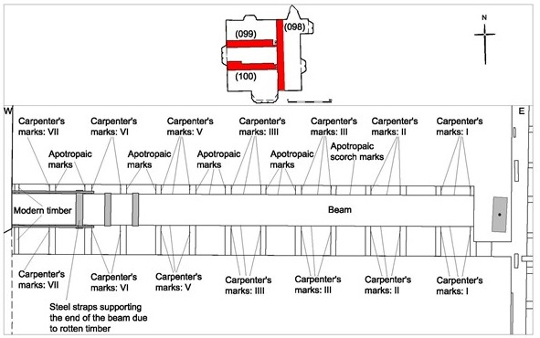
Fig 6 Annotated plan view of the beam with apotropaic symbols

Apotropaic marks are also to be found carved onto the stone jamb of the early 17th century fire surround in the north elevation of the King's Store. A “W” shaped mark which is actually two overlapping “V” shapes was found to be in association with a partially obscured chevron design (Fig 7). The fire surround has been painted (during the 20th century) with a very light blue paint which has partially flaked off to reveal the two apotropaic marks. It seems possible that further apotropaic marks and other graffiti inscriptions may exist below the paintwork. The scorch marks on the beam were located immediately adjacent to the eastern jamb of the fire surround; with the other symbols located west of the scorch marks. It appears that the apotropaic marks in the King's Store directly relate to the presence of the fireplace.
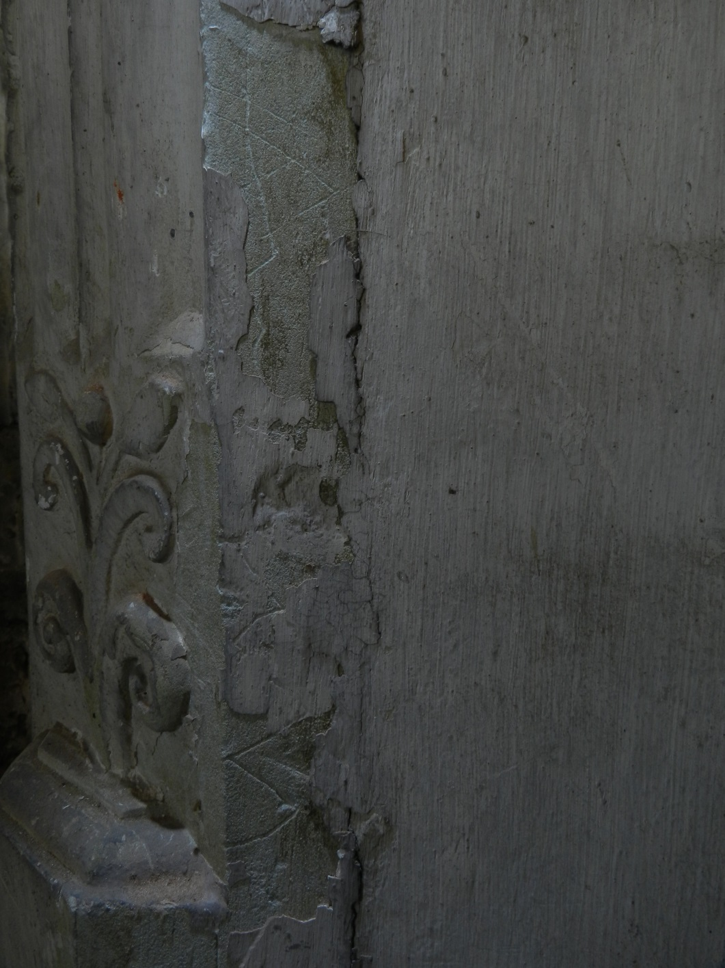
Fig 7 Double V-shape and chevron apotropaic symbols on the east jamb of the fireplace, looking north

Other apotropaic symbols at Knole

Other apotropaic marks have been identified at Knole during the enabling works archaeological survey. Scorch marks were found on a floor joist directly opposite the eastern jamb of the late 17th century fire surround in the King's Bedroom (Fig 8). A mesh similar to those in the King's Store was observed in the Spangled Bedroom. A chequerboard was found in the Outer Wicket. Several compass drawn circles were identified on the end of a beam below the southern bay window in the Cartoon Gallery. Additional to the survey apotropaic marks have also been observed in the Great Hall in the form of Marian symbols (see below) on the timber fire surround and panelling immediately to the south, as well as a mesh on the soffit of the stone door arch leading into the Great Stair. A butterfly mark is on the door-latch of the Screen’s Passage. Two double-V marks are on the western jamb of the northern door of the Loggia. A compass drawn daisy wheel, which is a very ancient protective symbol of eternity appropriated by Christianity as a reference to the Holy Trinity, was found on the lead flashing of a stone plinth on the south elevation of Stable Court along with several meshes and at least three Jacob's Ladders. Knole therefore has an extensive assemblage of apotropaic marks throughout the building which further survey will almost certainly add to.
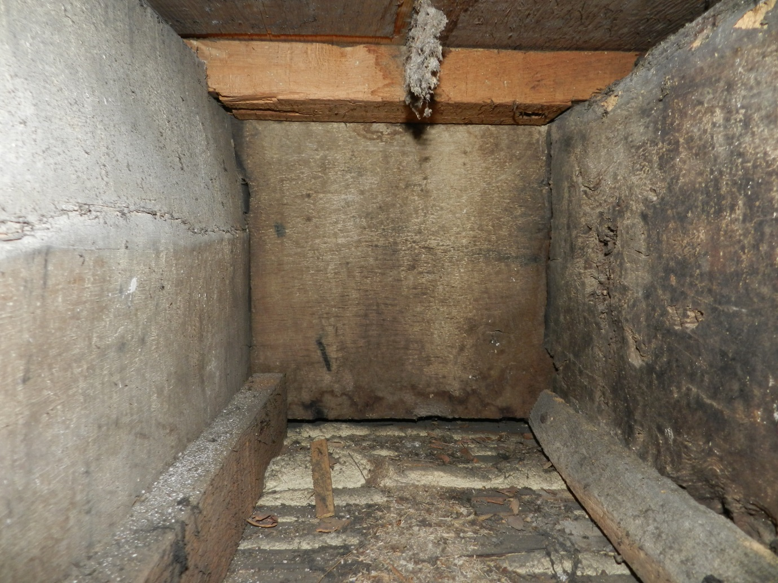

Fig 8 Scorch marks on a beam beneath the King’s Bedchamber which is directly opposite the east jamb of the fireplace

Context of apotropaic symbols

The study of apotropaic symbols is still an emerging one and is an incredibly specialised subject which has been dominated by Timothy Easton, with very detailed surveys of specific regions carried out latterly by Matthew Champion. Much of what follows in section 1.4 is develops on themes inspired by their work.

The word apotropaic comes from the Greek apətrəpeɪɪk meaning “to turn away” and has been used to identify symbols, objects, carvings and talismans which have traditionally been associated with warding off evil. Given that such beliefs are folk traditions it is rare for any documentary texts to refer to their use or purpose. However the Middle English poem Sir Gawain and the Green Knight contains an explicit reference to a pentagram design upon the eponymous hero's shield which was intended to ward off external evil:
It is a sign that Solomon once set on a time
to betoken Troth, as it is entitled to do;
for it is a figure that in it five points holdeth,
and each line overlaps and is linked with another,
and every way is endless; and the English, I hear,
everywhere name it the Endless Knot.
… So there
the pentangle painted new
he on shield and coat did wear
(Tolkien 1979, 8th ed., 30)
The poet then goes on to illustrate the symbolism of the five pointed design with reference to the five wounds of Christ, the Five Joys of free-giving, friendliness, chastity, chivalry and piety. The anonymous author of the poem lived in the West Midlands and set the text down c 1400 indicating that the belief in the protective power of the endless line created by the pentagram was current in medieval England.

Ultimately the belief in the protective charm of the pentagram comes from Biblical apocrypha based on the Jewish text Tractate Gittin from the Babylonian Talmud in which Solomon is given a seal ring which had the power to repel demons. Arabic sources later developed this legend to depict the ring as a six pointed star, whereas in Western traditions it is a five pointed star which Mephistopheles says prevents him from entering a threshold in the Faust legend (Funk & Wagnells 1906). The early modern period playwright Robert Greene included a reference to the power of the pentagram in his c 1588 – c 1592 play Friar Bacon and Friar Bungay:
The great arch-ruler, potentate of hell
Trembles when Bacon bids him or his fiends
Bow to the force of his pentageron
(Wills 1995, 184)
The chequerboard and mesh designs observed in the King's Store and elsewhere at Knole are analogous to the apotropaic pentagram; and in fact some of the designs are possibly diluted versions of the five pointed design (Fig 2). Effectively the carvings were created to act as demon traps in an attempt to ward off devils, evil spirits and witches (Champion 2015, 45-52).

Whilst the power of the pentagram was demonstrably current in medieval and early modern England, apotropaic symbols in the context of domestic buildings seem to have a slightly later date. They first begin to appear during the early 16th century and remain an almost constant presence right the way through to the early 18th century, and may survive into the 19th and early 20th centuries on rural agricultural buildings (Easton 1999, 22-4). It is possible that the sense of spiritual neuroses and fear created by the rejection of Catholicism during the Reformation may have led to the proliferation of a folk tradition which sought to offer protection in a world that no longer sanctioned official religious cults based on appealing to saints through relics for protection.

The double-V design carved onto the jamb of the fire surround in the King’s Store (Fig 7) and the interlocking V-shapes on the beam and joists (Fig 4 A and C) is a Marian symbol invoking the protection of Mary the Mother of God and stands for ‘Virgo Virginum’ (Easton 1999, 24). It is curious that such a symbol should have gathered such popularity during the post-Reformation given that the cult of worship surrounding Mary was no longer officially sanctioned. An anonymous German illustration made c 1600 entitled ‘Hort an new schrecklich abenthewr Von den vnholden vngehewr’ (Listen to new terrifying adventures of the sinful monsters) shows a double-V apotropaic symbol on the left hand side of a fireplace lintel (Fig 9). Notably the symbol has been crossed out and therefore nullified. Consequently the chimney is providing a means of access for witches (see below) who are no longer deterred by the presence of the symbol.

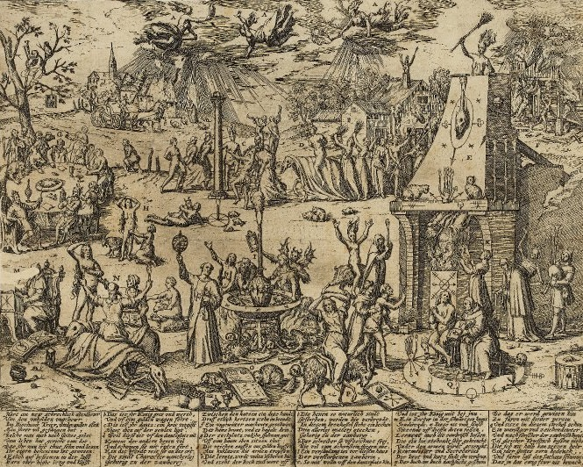
Fig 9 Hort an new schrecklich abenthewr Von den vnholden vngehewr by an anonymous German artist c 1600 which has an apotropaic symbol illustrated on the fireplace lintel. Picture Source: Trustees of the British Museum, 1880,0710.1582

The third form of apotropaic symbols in the King's Store are the scorch marks (Fig 1) which have been made by directly burning the timber with a candle or taper. Examples of such phenomena have been identified at nineteen different properties in Suffolk by Timothy Easton and the over-riding pattern is that they are applied in high status bedrooms as a protection for the occupants against witchcraft during periods of sleep (Easton 2011, 57, 60). The links between demonic possession during sleep have been made extensively and there was even a belief that the devil would steal semen from dying or sleeping men to use during intercourse with witches (Wills 1995, 39). The scorch marks may also be a form of sympathetic magic using fire to fight the fires of hell.

Easton has noted that apotropaic marks can be found in clusters within domestic buildings concentrating around windows, doors and fireplaces (Easton 1999, 24) - essentially areas of the building which are exposed to external openings. A passage from the Daemonologie published by James VI of Scotland in 1597 (later James I of England) is often quoted to explain this phenomena:

But the third way of their comming to their conuentions, is, that where in I think them deluded: for some of them sayeth, that being transformed in the likenesse of a little beast or foule, they will come and pearce through whatsoeuer house or Church, though all ordinarie passages be closed, by whatsoeuer open, the aire may enter in at. (James Rx. 1597)

The location of the apotropaic symbols in the King's Store are directly associated with the fireplace. Double-V symbols invoking protection from the Virgin Mary are carved onto the east jamb of the fireplace, directly opposite this on the floor beam is a series of scorch marks and to the west are an intensive cluster of demon-trap meshes and Marian symbols. Effectively this created a protective magical force-field of apotropaic symbols closing off the flow of air down the chimney and into the bedroom. The belief that sleeping people were particularly vulnerable to possession goes some way to explaining this concentration of apotropaic symbols within the King's Store especially when it is considered that the bed in this room lay parallel to the beam (see below) which lay between it and the source of danger – the fireplace. This relationship of bed, apotropaic marks and fireplace has also been potentially observed in part in both the King's Bedchamber and Spangled Bedroom.

Function of the King's Tower

It is not possible to discuss the original medieval form and function of the tower, however Thomas Sackville's remodelling of 1605-08 led to its development as part of a suite for royal accommodation (Sackville-West 1998, 21). The acquisition of Knole in 1604 by the socially-aspirational Sackville, who had recently been appointed Lord Treasurer, was in part an attempt to attract the patronage of the newly crowned James I. Sackville seems to have been concerned by the the new monarch’s favouritism towards Lord Burghley's palace at Theobald's Court near Enfield. His purchase of Knole coupled with the frenetic pace of rebuilding which has been described as by ‘an old man in a hurry’ (Girouard 2009, n.98, 121) - as Sackville was an elderly and sick man by 1605 and very aware of his own mortality - is indicative that he was trying to attract the court to his own property before it was too late (Town 2010, 113-8).

The first floor of the King's Tower acted as a potential royal bedchamber (James I never did actually visit Knole) for the monarch, which was approached up a short flight of stairs from a lobby flanked by a large window to the east and a wardrobe to the west. Later in the 18th century the window was blocked by a niche in the bay window of the Cartoon Gallery (Karim, Sorapure & Wright 2014) at which point a small room which may have functioned as a close-stool was created. Within the King’s Bedchamber a fireplace was inserted into the north elevation in the early 17th century to match the surviving one at second floor level; however this was then replaced by a late 17th century bolection fireplace (Fig 10). A great bay window pierces the south elevation and there are large covered windows in the east and west elevations. The state bed, dating to the late 17th century, stands in front of the western window.
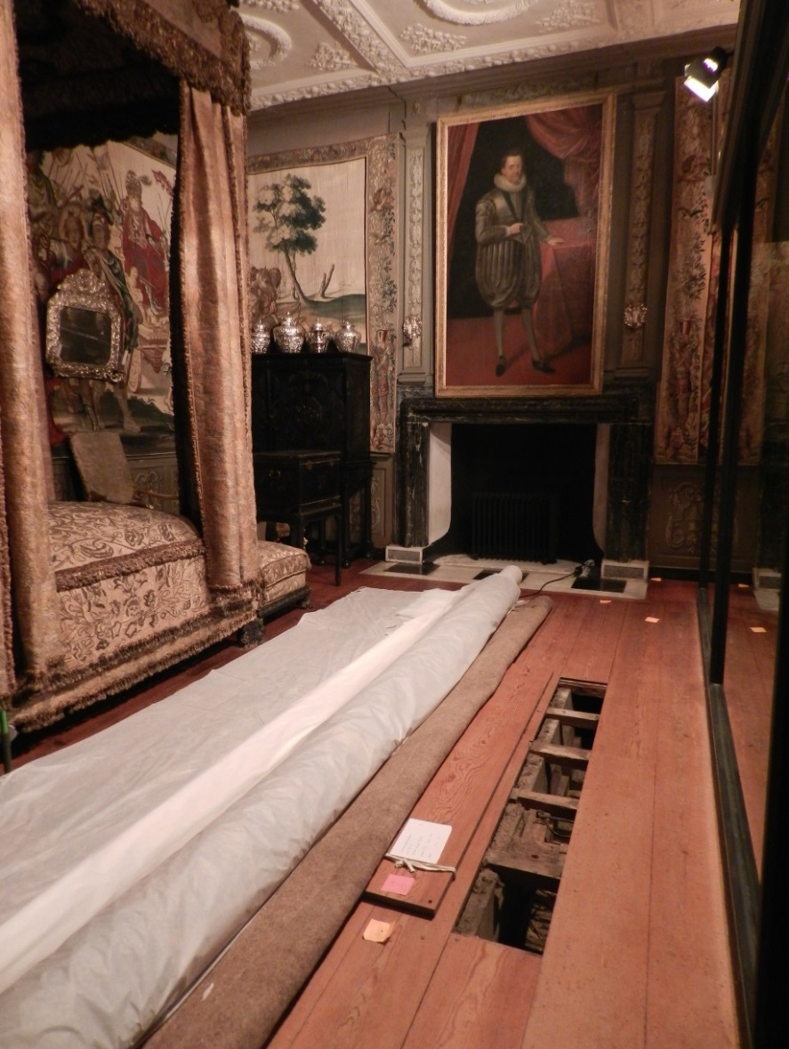
Fig 10 The King’s Bedchamber, looking north. Note the enabling works floor intervention in the foreground within which scorch marks were observed directly opposite the eastern (right hand) jamb of the fire surround in the background

Above the King's Bedroom is the King's Store which was intended as the bedchamber of a high status royal retainer. Whereas the lobby, close-stool and wardrobe were external to the tower structure at first floor; at second floor level the tower is approached by a short passage from the South Barracks and the ancillary rooms are contained within the tower. Within the King's Store wall scars and empty mortice holes in the floor beams indicate that from the passage there was a small lobby lit to the east by a bay window, directly ahead (to the south) was a wardrobe and to the west was a door leading into the bedchamber. The chamber has a large bay window to the south with another window to the west. The fireplace was inserted during Sackville's early 17th century remodelling and is within the north elevation (Fig 11). The Curator at Knole has stated that the weight of evidence from similar high status spaces including the King's Bedroom below suggests that originally a bed would have stood against the west elevation opposite the door (Emma Slocombe, pers. comm.)

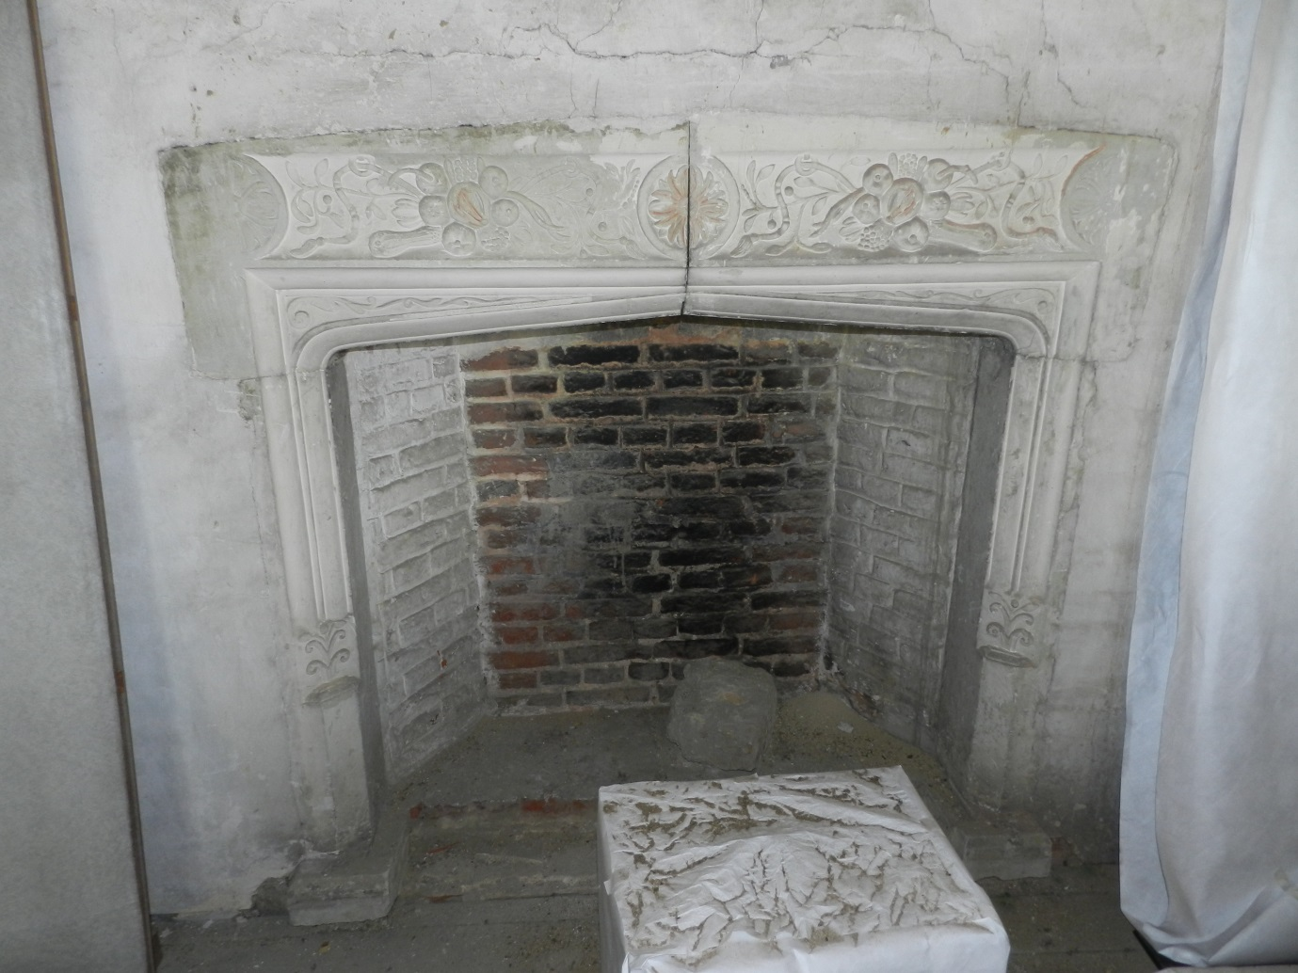
Fig 11 The fireplace in the north elevation of the King’s Store, looking north

At first floor level the King’s Bedchamber was accessed from the Cartoon Gallery (Fig 12) which functioned as a high status long gallery within the South Range. Puzzlingly the first floor and second floor of the King's Tower do not seem to have had direct communication during the post-medieval period. Consequently the high status royal retainer lodging on the second floor room communicated with the royal apartment via the South Barracks, Retainer's Gallery (Fig 13), Second Painted Stair and Cartoon Gallery (Fig 12). The low status appearance of the South Barracks - with its internal lead drainage system and plain lath and plaster ceiling - points to the fact that this could never have been a high status area (Fig 14). It must therefore have acted as a communication corridor between the second floor of the King's Tower and the much more high status Retainer's Gallery which acted as another long gallery only this time at second floor level.
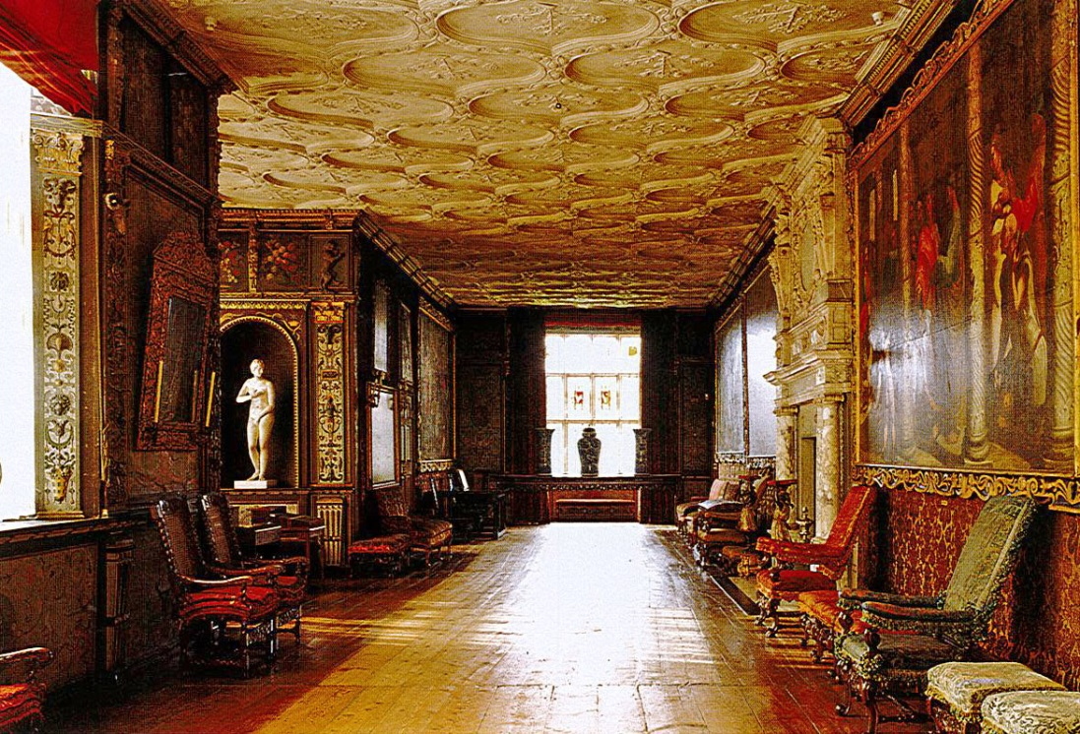
Fig 12 The Cartoon Gallery, looking west

Since the mid-16th century the incorporation of a long gallery became a necessary symbol of status in architectural design, partly brought on by a revolution in glazing technology which allowed for the production of much larger windows. Their purpose was entirely recreational which according to the 17th century commentator Roger North had 'no other use but pastime and leisure'. North goes on to articulate that the first floor was the ideal location for the long gallery as 'higher than the first floor it must not be, for such are garrets, as I have often seen, are useless, because none will purchase the use of them with paines of mounting' (Morris 2003, 229-232). Consequently the Cartoon Gallery with its extremely high status serpentine ceiling ribs by Richard Dungan and wall paintings by Paul Isaacson must be seen as the premiere gallery at Knole; with the Retainer's Gallery at second floor with plainer geometrical intersecting ribs as distinctly lower status.

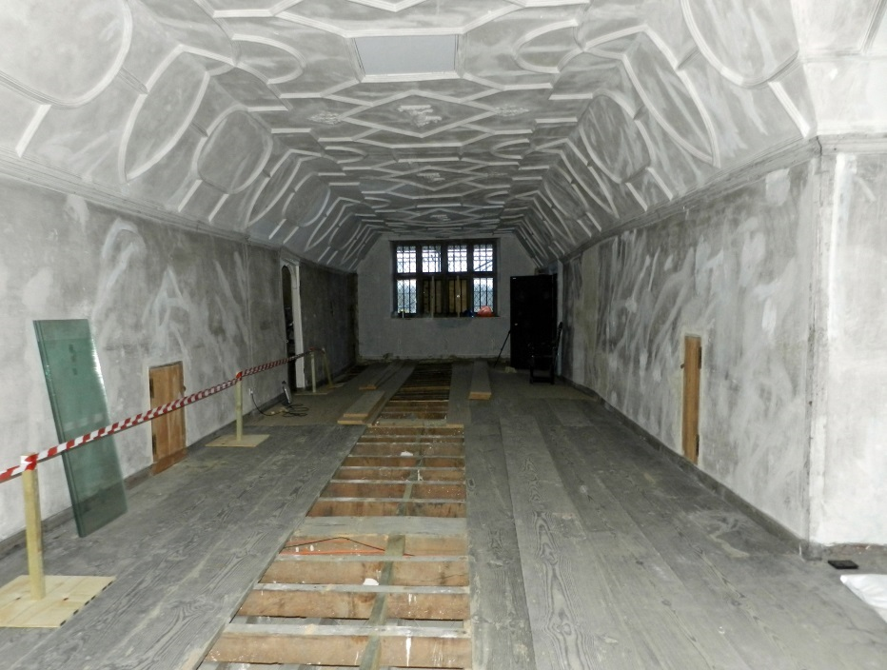
Fig 13 The Retainer’s Gallery, looking south towards the doors to the Second Painted Stair (left) and South Barracks (right)

The conclusion to be drawn here is that the Retainer's Gallery provided a space for household members whereas the Cartoon Gallery was used by only the very highest status occupants of Knole. The South Barracks therefore acted as a corridor of communication which led from the lodging of a significant royal retainer in the King's Store via the Retainer’s Gallery, Second Painted Stair, Cartoon Gallery and ultimately into the King's Bedchamber where the monarch resided.

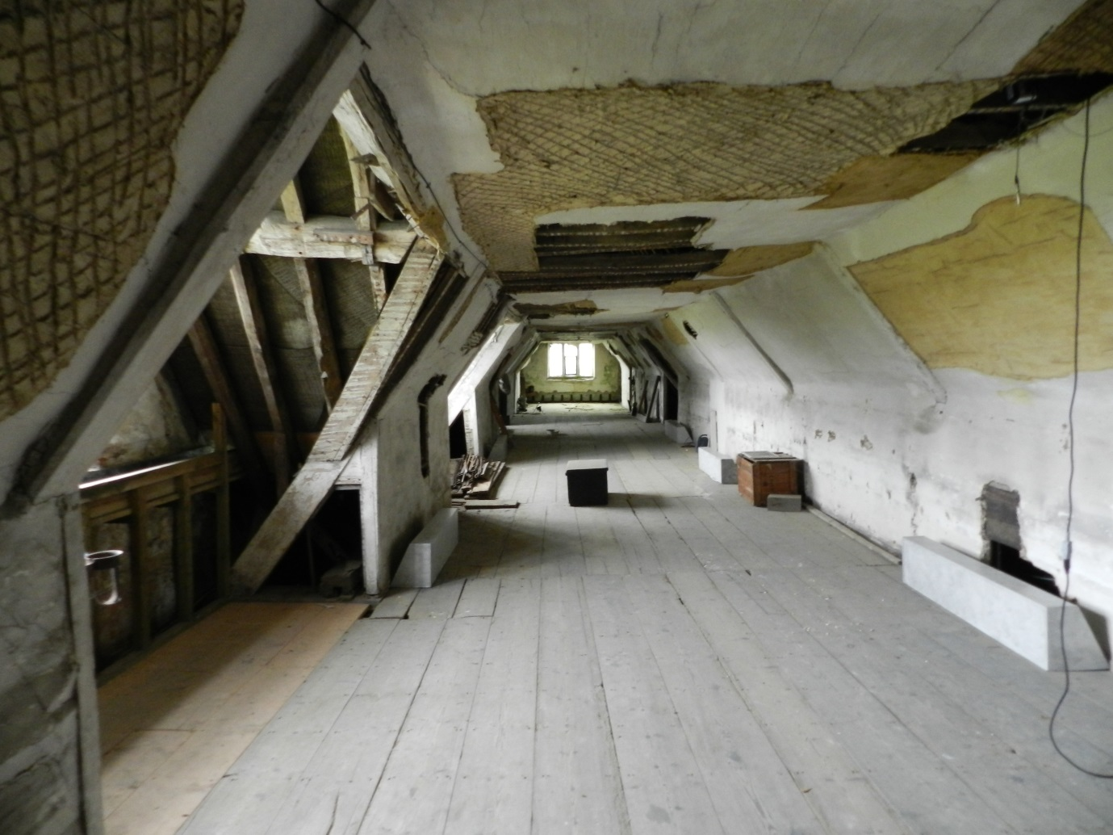
Fig 14 The South Barracks, looking west towards the passageway into the King’s Store

James I, witchcraft and the Gunpowder Plot

It has been demonstrated above that a series of apotropaic symbols were incorporated by the carpenters in the 1606 remodelling of the King's Tower and that this building was intended to be a royal suite of apartments designed for use by James I. James is known to have been a very scholarly monarch, yet also had a deep and fervent interest in the occult brought about by a devoutly religious belief. During the 16th and 17th centuries there was not the conflict between academia and superstition that we might see in these two views of the world. The people of early modern England were fundamentally different in character and experience to ourselves (Shapiro 2010, 306). This was a time when cunning folk, who dabbled on the fringes of both academic study and the occult, such as Simon Foreman and John Dee were consulted by the middle and upper classes on subjects as diverse as astronomy, herbalism, alchemy, philosophy, mathematics and especially astrology. Science and magic were not necessarily distinguishable.

James' interest in witchcraft developed as a result of the North Berwick trials of 1590 during which it emerged (under extreme torture) that one Agnes Sampson had attempted to drown the Scottish king and his new bride Anne of Denmark as they sailed back to Scotland during a storm conjured up by a coven of witches who had reputedly Christened a cat during a Black Mass. James was so appalled at the reports that he eventually produced a book of dialogues which investigated the practice and measures of protection against witchcraft entitled Daemonologie which was published in 1597 and reprinted (Fig 15) following his English coronation in 1603 (Fraser 1974, 45-8). James then enshrined protective measures against witchcraft in law in 1604 when he decreed it to be a capital offence to summon spirits for the purpose of injuring people (Sharpe 2001, pp. 15-16). Despite this James maintained a balanced opinion on the subject and actually helped to expose several fraudulent claims of witchcraft suggesting a very complex picture of the monarch's belief (ibid, p. 28).

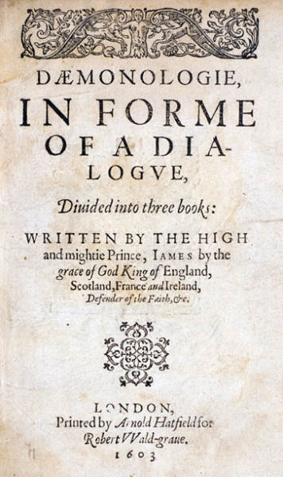
Fig 15 Title page of the second edition of Daemonologie by James I published in 1603

Regardless of James' own specific attitudes, the belief in witchcraft was certainly widespread through the population of early modern England. Radical social changes including a doubling of the population in the century between 1530-1630, a lack of food, a drop in wages and the expansion of the gap between rich and poor created enormous socio-economic tension which found a partial outlet in the tendency for slightly richer members of society to attempt to settle old scores through identifying witchcraft amongst their poorer neighbours within the community (Sharpe 2001, 34-38). Whether or not the accusers genuinely believed that the accused had actually perpetrated witchcraft is irrelevant – the fear was instilled within society and the perceived protection afforded by apotropaic symbols became a widespread, if unreported, phenomena.

A state of hypertension was created by the discovery of the Gunpowder Plot in 1605. Whilst controversy still rages as to whether or not the mine beneath Parliament was really there, and whether or not the plot was a government conspiracy to further discredit Catholics, the debate is immaterial for the social and political consequences. The fallout of the plot led to widespread fear and hysteria amongst all levels of English society. Given that the beam in the King's Store can be confidently dated as being laid during the spring or summer of 1606 the dense cluster of apotropaic marks carved onto it must be seen in the light of the national reaction to the Gunpowder Plot.

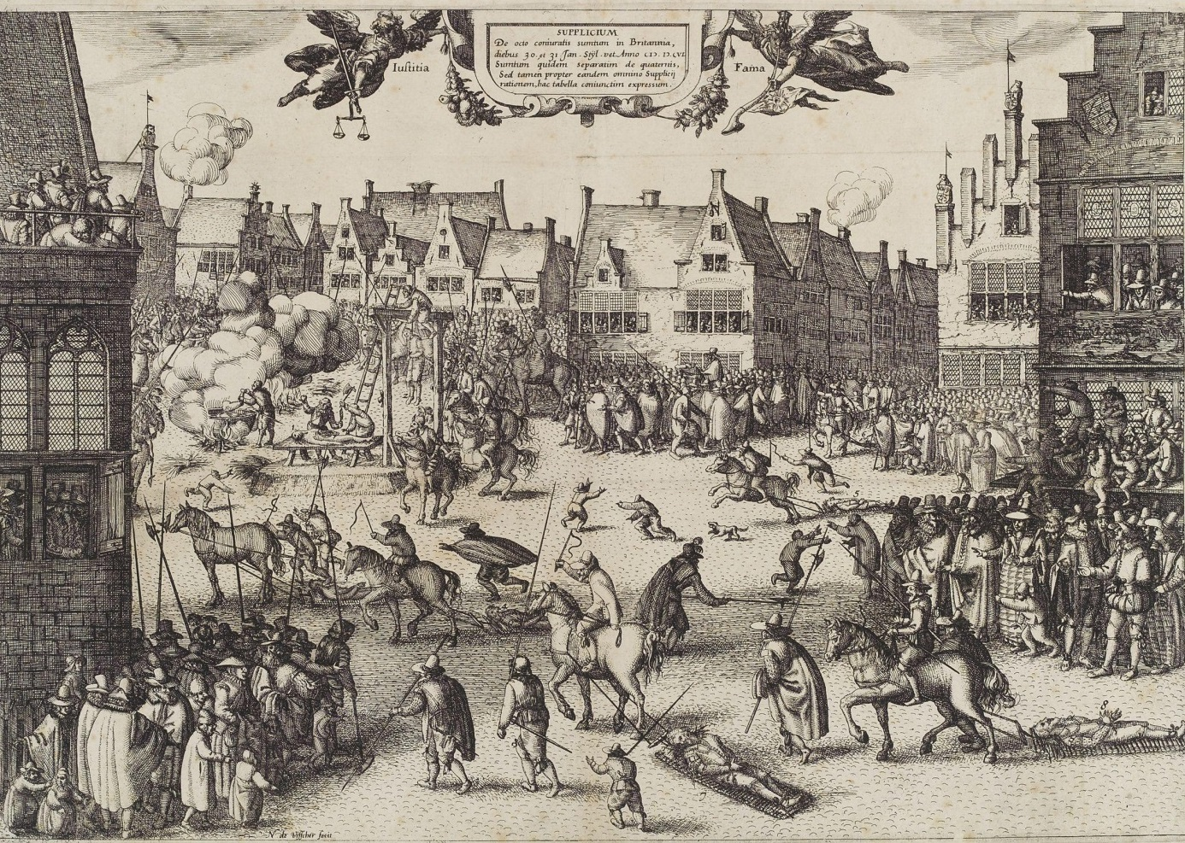
Fig 16 The execution of Guido Fawkes on 31st January 1606 as depicted by Claes Visscher

The perceived use of witchcraft in plots against James seems to have been a common factor and the Gunpowder Plot was no exception. The 1590 North Berwick trials have already been discussed; in 1593 a rebellion led to accusations of witchcraft against the Earl of Bothwell and magic formulas were found on the body of the assassin in the 1600 Gowrie Plot (Wills 1995, 42). It is therefore not surprising that accusations of witchcraft surrounded the Gunpowder Plot. A typical reaction of the period was by the physician Francis Herring who stated in Popish Pietie that the Gunpowder Plot was 'that monstrous birth of the Roman harlot... the quintessence of Satan's policy, the furthest reach and stain of human malice and cruelty'. Rumours even spread in early 1606 that James had been murdered at Okingham with a poisoned knife thus furthering the national sense of fear of plots against the king (Fraser 1996, 151).

James himself controlled the official reaction and propaganda following the plot which involved a rendition of his own personal interpretation of events to Parliament, public sermons by leading churchmen, the trials of the surviving plotters (Fig 16) and later the Jesuit priest Father Garnet - who was accused of masterminding the conspiracy, published accounts and statements of those involved, censorship of literature and plays and several tracts denouncing Catholicism (Wills 1995, 16-18). An Oath of Allegiance was demanded of all English subjects in June 1606 (Fraser 1996, 154). Meanwhile official anniversary sermons given on the orders of James himself became increasingly more specific that the plot had been directed by Satan himself (ibid, 150-55).

In the wake of the event a number of plays were staged both publically and at court which made allusions to themes relating to the Gunpowder Plot such as the apocalyptic destruction of a kingdom, undermining, plots and equivocation. These included John Marston's Sophonisba, Thomas Dekker's The Whore of Babylon, Barnabe Barnes' The Devil's Charter and most famously William Shakespeare's Macbeth. The latter was penned and acted by James' own company of players The King's Men (Wills 1995, 9). The idea of equivocation as a system of syntax to avoid the sin of outright lying under interrogation was adopted by Jesuit priests and appears as a repeated refrain by the Porter in Macbeth - a character that is notionally the porter to the gates of Hell (Fig 17). Perverting language through equivocation was seen at the time as a mortal sin which was equated with 'the potency of abused language in magic and witchcraft' (ibid, 95). It is therefore easy to see how a nation was whipped up to a frenzy of fear and hatred for witchcraft through a deliberate use of official and unofficial channels by a government bent on survival in the aftermath of a Catholic threat with a perceived demonic origin.

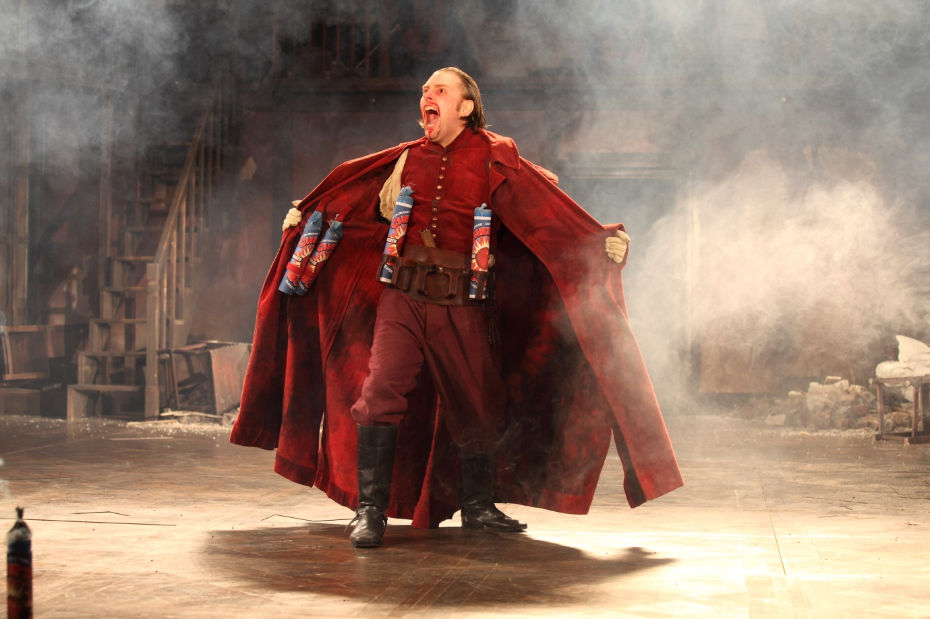
Fig 17 The interpretation of the Porter by Jamie Beamish in the 2011 production of Macbeth by the Royal Shakespeare Company made the demonic nature of the character explicit and linked to the origins of the play in the Gunpowder Plot through the use of explosives onstage (Photo Credit: Ellie Kurttz © RSC)

Conclusions

The level of apotropaic protection afforded to the second floor of the King's Tower at Knole should therefore be seen against the background of a massive groundswell of propaganda against Catholics and - by extension - witches. Thomas Sackville, himself a confidant of James, was in the process of constructing a progress house with the specific intention of attracting a royal visit at precisely the time of the Gunpowder Plot. The beam with such a dense concentration of apotropaic symbols is known from dendrochronology to have been laid in the immediate aftermath of the plot, a time that was rife with widespread propaganda against witchcraft by a monarch who believed in the real danger posed by demonic forces to his person. There is tantalising evidence in the form of scorch marks adjacent to the jamb of the fireplace at first floor level in the King’s Bedchamber intended for royal usage and it seems highly likely that another dense concentration of symbols similar to that in the King’s Store awaits discovery in this space.

It is not being suggested that either King James or Thomas Sackville were deliberately party to the decision to carve the symbols in the King's Tower. It is far more likely that the marks were made by the team of craftsmen under their foreman Matthew Banks. It has been demonstrated by Easton and Champion that apotropaic symbols were widespread in their use in domestic buildings by 1606 and had been so for almost a century based on an existing set of beliefs harking back to at least the medieval period. The introduction of such symbols was probably as natural to the carpenter as it was to mark up timbers with their systems of Roman numerals intended to aid framing. However, the particularly dense concentration within a tower being remodelled as a royal suite by a high status government official intent on attracting James to Knole at a time of enormous anti-witchcraft propaganda must have left a clear impression upon the craftsmen who seem to have risen to the challenge of protecting their king from the perceived demonic forces unleashed by the Gunpowder Plot.

Bibliography

Bridge, M., 2010, The tree-ring dating of timbers from Knole, Sevenoaks, Kent
Champion, M., 2015, Medieval Graffiti – The Lost Voices of England’s Churches
Easton, T., 1999, 'Ritual marks on historic timber' in Wealden Downland Open Air Museum Magazine Spring 1999
Easton, T., 2011, 'Candle Powers' in Cornerstone Vol. 32 No. 4
Fraser, A., 1996, 2nd edition 2002, The Gunpowder Plot – Terror and Faith in 1605 - Part Two
Fraser, A., 1974, 2nd edition 1977, King James VI of Scotland and I of England
Funk & Wagnells, 1906, Jewish Encyclopedia
James Rx., 1597, Daemonologie – In the form of a dialogue divided into three books
MOLA, 2013, Knole House: The East Range façade and roofs: Interpretative historic building survey unpublished report for NT (Authors: Sorapure, D, & Wright, J)
MOLA, 2014, Knole House – Roofs above the Kitchen Range and South Range: Interpretative historic building survey, unpublished report for NT (Authors: Karim, A, Sorapure, D, & Wright, J)
Morris, M., 2003, 2nd edition 2013, Castle – A History of the Buildings that Shaped Medieval Britain
Sackville-West, R., 1998 12th edition 2013, Knole
Shapiro, J., 2010, Contested Will
Sharpe, J., 2001, Witchcraft in early modern England
Town, E., 2010, A house ‘re-edified’ – Thomas Sackville and the transformation of Knole 1605-1608. Unpublished PhD University of Sussex
Tolkien, J.R.R., 1979 8th edition 1987, Sir Gawain and the Green Knight, Pearl and Sir Orfeo
Tyers, I., 2014, The tree-ring analysis of timbers from a building: Knole, Sevenoaks, Kent
Wills, G., 1995, Witches & Jesuits – Shakespeare's Macbeth
LOSullivan@hamiltonmayday.co.ukLOSullivan@hamiltonmayday.co.uk

© James Wright October, 2015

Gresham College
Barnard’s Inn Hall
Holborn
London
EC1N 2HH
www.gresham.ac.uk

