

19 June 2014

More Means Better:
50 Years of Higher Education

Professor Sir Roderick Floud FBA
Provost of Gresham College

It is now about 50 years since British higher education began to expand. This has transformed our universities and our society. In my final lecture as Provost of Gresham, I’m going to talk about the nature and consequences of that expansion, but particularly about the ways in which British universities still need to change if they are to thrive for the next 50 years.

What are my qualifications for talking about this subject? First, I have lived through it – it is 50 years since I graduated from Oxford and started my doctorate in economic history. Second, I have been fortunate to work in some of the best universities in the world. I have helped to shape policies on higher education in Britain and Europe and been elected by fellow Vice-Chancellors to lead them. I have been able to teach and do research in an academic subject, economic history, which I still find fascinating. I spent 31 years at two institutions, Birkbeck College and London Metropolitan University, which have made an enormous contribution to the higher education of adults and members of black and minority ethnic groups who would otherwise have been denied such opportunity. I’ve ended my career at a unique institution which I admire. In other words, I’ve been very lucky. It has not always been easy or enjoyable but there has certainly never been a dull moment.

British higher education, like much else, began to change in the 1960s. The report in 1963 of the Robbins Committee, a Royal Commission into the future of Higher Education, produced the first six new – plateglass – universities. Meanwhile Antony Crosland as Secretary of State for Education created the parallel polytechnic system.

In response came the cri de coeur by the English novelist, Kingsley Amis, that “more will mean worse”. He argued forcefully that expanding the number of students would reduce their quality. A university education had always been, and should remain, restricted to a very small intellectual elite; only very few – such as the tiny proportion of the population who then went to university, were clever enough to benefit from it.

Amis was certainly not the first and was not to be the last to say this, although he probably phrased it most memorably. Since his time, similar arguments have been used to oppose the increased number of women in universities, the increased number of part-time students, the growth of academic research and the transformation of polytechnics into universities. We have been told that graduate salaries will fall, that more and more graduates will be unemployed, that students would be better off not going to university and should be doing apprenticeships or having children. Most recently, the doomsayers have focussed on high levels of student debt.

So what has actually happened and what is likely to happen next?

To put it simply, we have had more of everything. We have certainly had more than anyone foresaw– even Kingsley Amis in his worst dreams. Most of the expansion has not been – at least in the western developed countries – the result of conscious policy; instead, the supply of graduates seems roughly to have kept place with the demand for them. As economies have grown and particularly as they have become more and more orientated towards services and less towards making or growing things, universities have grown with and within them.

The much derided target supposedly set by the 1997 Labour Government, of 50% of the age-group going to university, was actually a prediction by that famously radical body, the Confederation of British Industries, of the likely demand for graduates in the 21st century. That prediction seems to be coming true, as demand for graduates continues to match supply and the graduate premium – the greater income that graduates receive compared to non-graduates with the same qualifications – is maintained. As the economy emerges from recession, more and more graduates will be recruited.

Now let me look at what “more of everything” has meant.

“Throughout our Report we have assumed as an axiom that courses of higher education should be available for all those who are qualified by ability and attainment to pursue them and who wish to do so.” – Robbins Report 1963

This famous statement from the Robbins report firmly stated the case for expanding British universities. There were, Robbins realised, more people “qualified by ability and attainment” than the universities of the early 1960s were providing places for. Rejecting the possibility of expanding existing universities sufficiently, he opted for six new ones. His predictions came true, the places were filled and, during the 1980s and 1990s there were successive waves of expansion in the university and polytechnic systems.

After I left Oxford and taught at UCL and Cambridge from 1965 to 1975, I benefitted from this expansion – it was very easy to get a university job. But it was only when I got to Birkbeck that I fully realised what Robbins had meant; there I found hundreds of students who were “qualified by ability and attainment” and immensely hard-working, but whom the old system had failed. As a result, we had wasted their potential. The same would have been true, without that expansion in student numbers, of the children of illiterate Bangladeshi migrants whom we were able to attract to study at London Guildhall University.

What are the numbers?

Students in tertiary education, Great Britain, 1900 - 2011
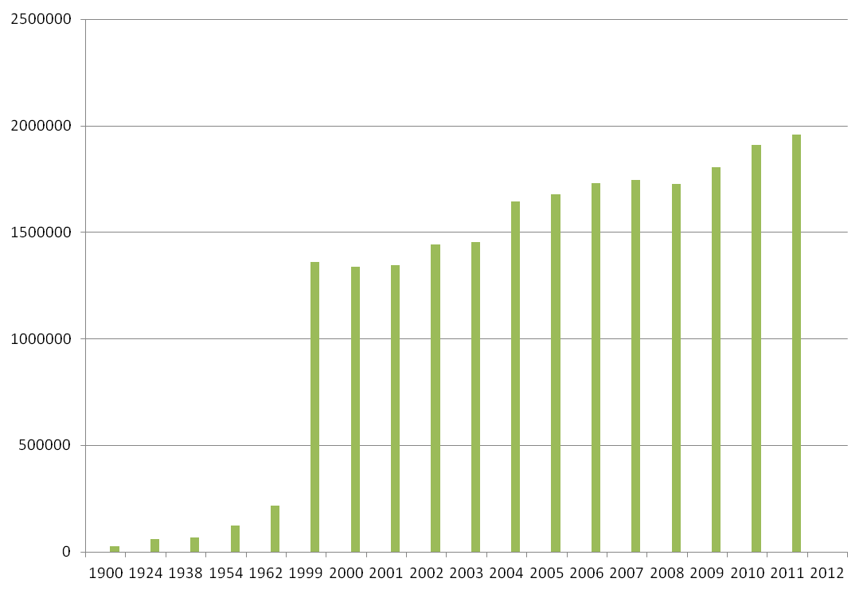
Source: 1900-1962 Robbins Report; 1999-2011 UNESCO

They are quite difficult to find and this graph therefore has a gap in it between 1962 and 1999. There were 216,000 students in Britain in 1963, when Robbins reported. By 1999 there were well over 1 million and today there are nearly 2 million. Despite the dire warnings of Kingsley Amis, the quality of degrees was maintained and graduates from the expanding system found jobs. The economic argument for expansion, important to Robbins, was amply justified.

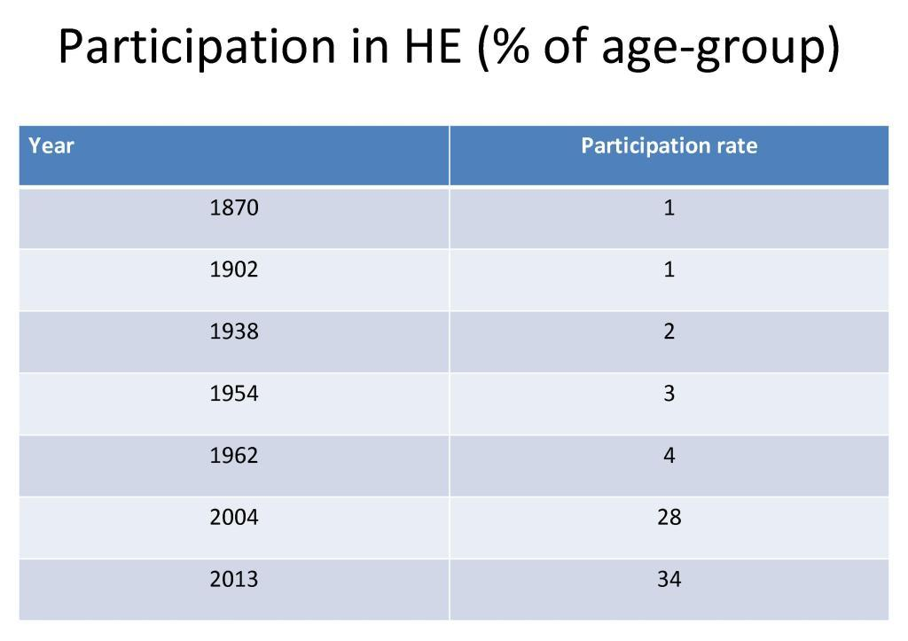

As this table shows, the result has been that a greater and greater proportion of people attend university. I was one of only 4% of my age-group; a young person starting university today will be one of about 35% of hers.

However, the growth in student numbers has not been a triumph for egalitarian social policies or “widening participation” as it is now known. It is still almost as difficult for someone from the working classes – though that is a much smaller proportion of the population than it was - to get to university as it was in the 1960s. What the growth has been is a triumph for women, but principally middle-class women.

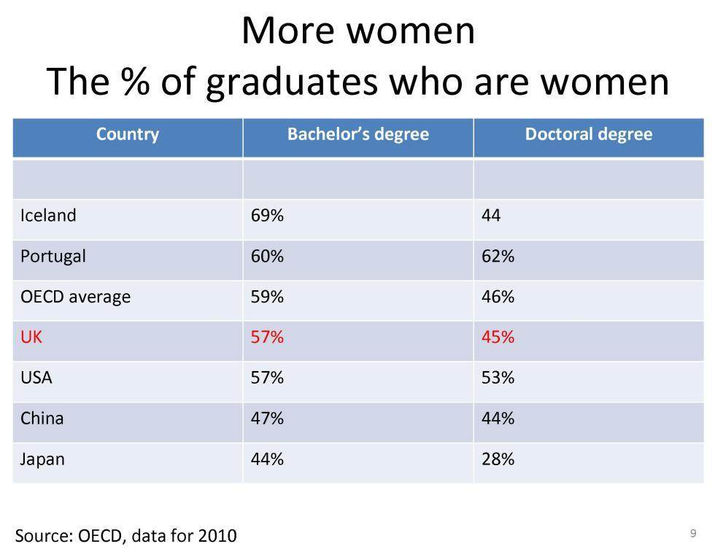

In Britain and almost everywhere in developed countries now, women either surpass or equal men among graduates; the only exceptions are Korea, China, Turkey and Japan. There are even more women students than men in Saudi Arabia. The UK is close to but still below the average for developed countries.

This is a startling and very rapid change; in less than four decades, several millenia of discrimination against women have been entirely reversed. Men are now in a minority. Graduate professions long seen as male dominated, such as medicine, the law and even the church are increasingly dominated by women, although not yet in senior positions. But girls are doing better at school, they have higher career aspirations then men and they are reaping their rewards, although salaries still shamefully lag behind.

None of this was, anywhere, planned. Universities did not deliberately seek to recruit more women. Indeed, many of them sought to stem the tide. In the mid-1960s, it ranked as a triumph that women were occasionally allowed to dine in my Oxford college hall and that they could become members of the Oxford Union.

I joined a Cambridge college as a Fellow in 1969 at the start of six years of fierce debate about the admission of women as undergraduates. “More will mean worse” was mild by comparison. We were told that to admit women would be like admitting cats to a dogs’ home. We were assured presumably on the basis of a spiritualist séance that the founder of the College, Sir Walter Mildmay, a contemporary of Thomas Gresham, would not have approved. We were told that the college could not afford to fit full-length mirrors in every bedroom, apparently an absolute requirement for women students. We were told that there was a danger – a danger – that women applicants to read English would be cleverer than the men and would therefore have to be admitted.

Meanwhile those women who did succeed, against all the odds, were patronised and their achievements depreciated. This was the response to the award of the Nobel Prize to Dorothy Hodgkin.



[Let me acknowledge, at this point, the help of Bahram Bekhradnia and the Higher Education Policy Institute, who have allowed me to use some of their graphs.]

However, the tide could not be stemmed. Women from ethnic minority communities have helped it along, as in general they have been more successful at school and university than men from those communities. Now, as this graph shows, women take part far more than men in English higher education; the position is the same in the rest of the UK

It has become a commonplace of educational discussion that the real problem in all countries lies with white working-class males, whose traditional occupations have disappeared but who have not been attracted sufficiently into higher education, to gain the skills that they need today.

I have been criticised for describing all this as “the triumph of women.” Of course there is much more to do; women are still discouraged from careers in research, there are far too few female professors or vice-chancellors and, outside academe, too few women in politics, among judges or at the top of FTSE 100 companies. But I am unrepentant – the change since the 1960s has been remarkable.

More women has been a European, indeed a worldwide, phenomenon. Not so the growth of part-time students, which has been a particularly British phenomenon, symbolised by that great success story, the Open University. In truth, Britain pioneered the concept of part-time study in the nineteenth century, in places such as the Mechanics’ Institutes and, later, Birkbeck College and the technical colleges which became Polytechnics in the 1960s. We exported part-time study to the United States, but not to Europe. Even today, only Ireland, the Netherlands and Spain apart from Britain have significant numbers of part-time students.

But Britain led the field until, recently, government funding policies led to a sharp drop in part-time students. This is much to be regretted and ought to be reversed. Places like Birkbeck and most of the former Polytechnics have done a tremendous job in increasing the skills of the population through part-time study. This function is not sufficiently recognised; it tends to take second-place to the appeal of part-time study in giving second chances. Both are important but it is, frankly, stupid of the government to discourage people from seeking to improve and widen their skills.

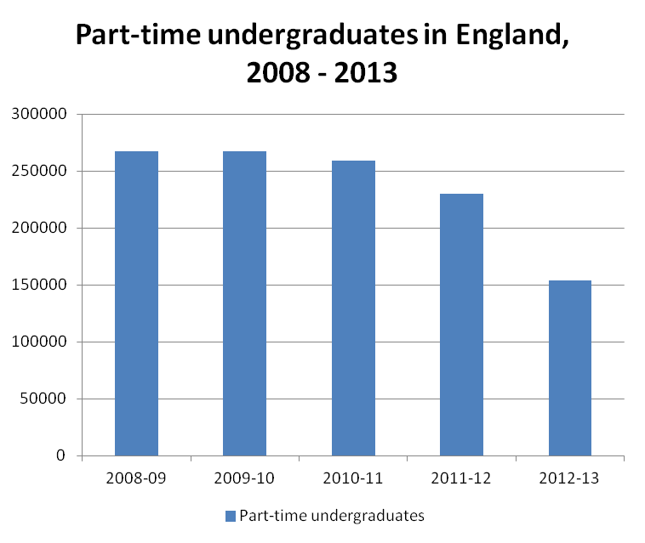
Source: Derived from HEFCE 2013, ‘Trends in young participation in higher education’

More students mean more teachers and, since the main qualification for becoming a university teacher is to be a good researcher, more teachers means more research. In addition, governments around the world have become convinced that economic growth depends on innovation and that innovation depends on research; even in bad times, therefore, they have protected academic research from the worst of the cuts. Gordon Brown, for example, boosted spending on university research and George Osborne, Vince Cable and David Willetts have done the same.

The result, throughout the world, has been an explosion of academic journals and of the number of articles that they publish, both in print and increasingly as online publications. Keeping track of them all has become an industry in itself, abounding with league tables and citation indices as academics strive to get their results published in the best peer-reviewed journals. Britain seems to be very good at all this.

Britain still doesn’t spend as much on research as do many other countries, either from public or private funds, but the results are spectacular.

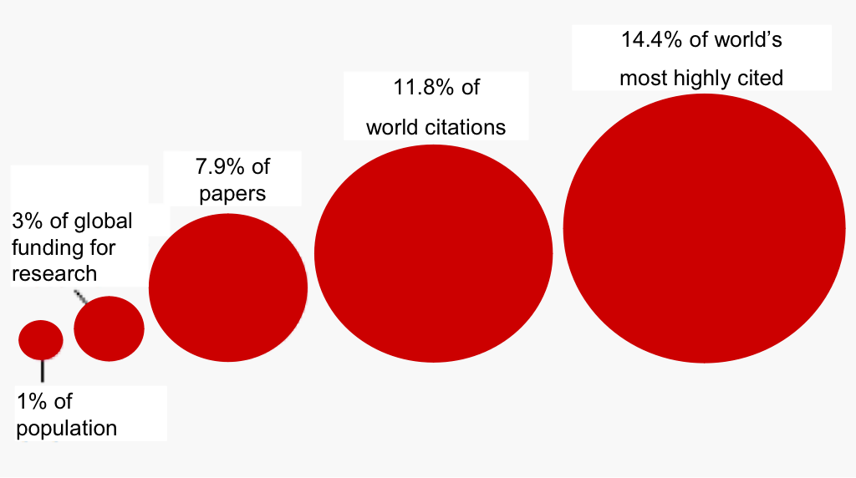

Now for two successes which most of you will not have heard of, the European Higher Education and Research Areas.

In the last 15 years we have achieved a common structure of undergraduate and postgraduate degrees across the whole of Europe, stretching indeed from Reykjavik to Vladivostock and the Arctic Circle to the Mediterranean and the Caspian Seas. It has produced some unlikely bedfellows: I remember being at a meeting of the Bologna Process, as it is called, when we admitted Russia and the Holy See to membership. Although one shouldn’t say it too loudly, the model that all these countries have adopted is the British one, with much shorter undergraduate degrees than many of them were used to, followed by masters and PhDs. On top of this, millions of students have experienced higher education in countries other than their own through the EU’s Erasmus programme, which allows them to study for a term or year in a different university.

We also have a European research area, across the EU and many associated countries, which funds good research projects and the movement of good researchers between countries. EU research programmes and cooperation between national research funding agencies mobilise the best researchers wherever they are to be found. They make it possible for researchers to meet and discuss their ideas and to take part in joint programmes of research to tackle really significant problems in such areas as transport, medicine, climate change and Britain does particularly well from this funding, reflecting its strength in research, and gets out of it far more than we put in. The Vice-Chancellor of Cambridge recently estimated that universities like his receive 15-20% of their funding for research from the EU. It could all be put at risk – so far as Britain is concerned – by the Eurosceptics, as similar Eurosceptics in Switzerland have just demonstrated.

Finally, this graph says it all.

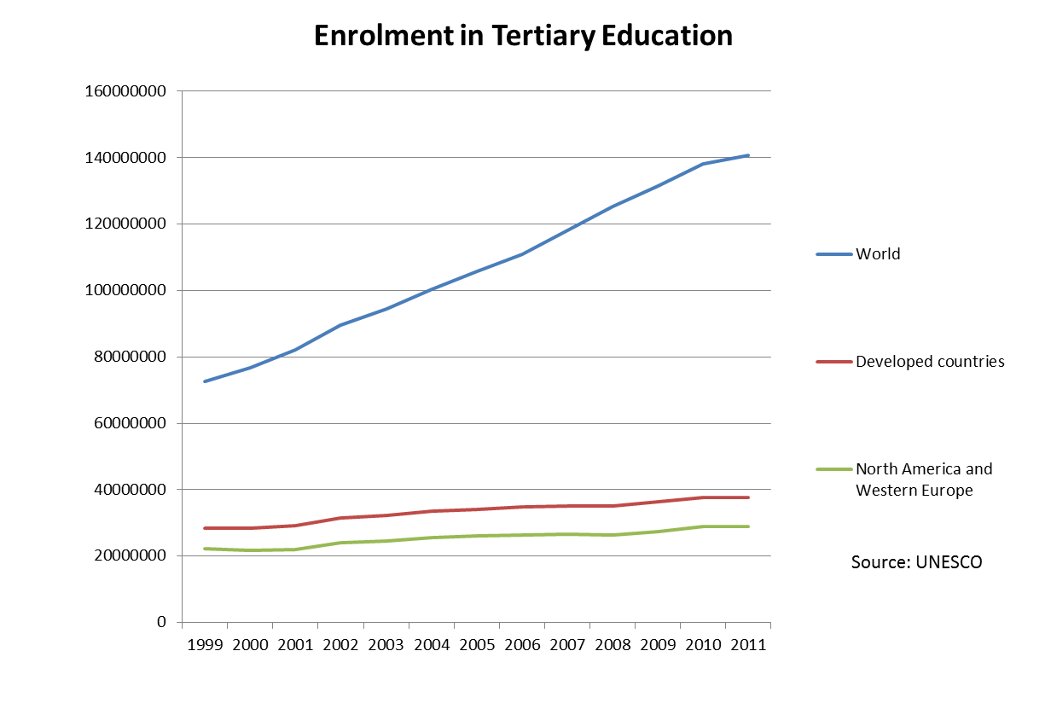

We think that our expansion in student numbers has been rapid; some continue to think it has been too rapid. But look further afield. Growth in Europe and North America, indeed in the developed countries as a whole, has recently been puny compared to growth in the rest of the world, where governments – think of China and India – see universities and their graduates as the key to economic growth.

There are now twice as many people enrolled in tertiary education in countries outside the developed world as there are within it and the disparity is growing. Along with it goes more research and development in those countries and more innovations as their workforces become more highly skilled. Countries like Britain have traded for decades on having a more highly-skilled workforce, but that advantage is rapidly diminishing.

This is the moment that we have chosen actively to discourage the international students who, for decades, have kept British universities solvent while they study here. Until recently, they returned to their own countries to speak highly of British higher education. Now, by contrast, they feel unwelcome; they are unwelcome to a government which is desperate to cut immigration by any means.

Most people don’t realise, I think, that students – if they intend to stay longer than a year - are a major part of the numbers for net immigration which grab the headlines. Few of those international students want to stay in this country after they graduate so they are not “taking jobs from hard-working British people” as the UKIP and Conservative rhetoric goes. It is extraordinary that the government persists in counting students as immigrants and therefore as its prime target for cutting immigration.

Let us devoutly hope that they fail. If they were to succeed, they would probably destroy a significant number of British universities.

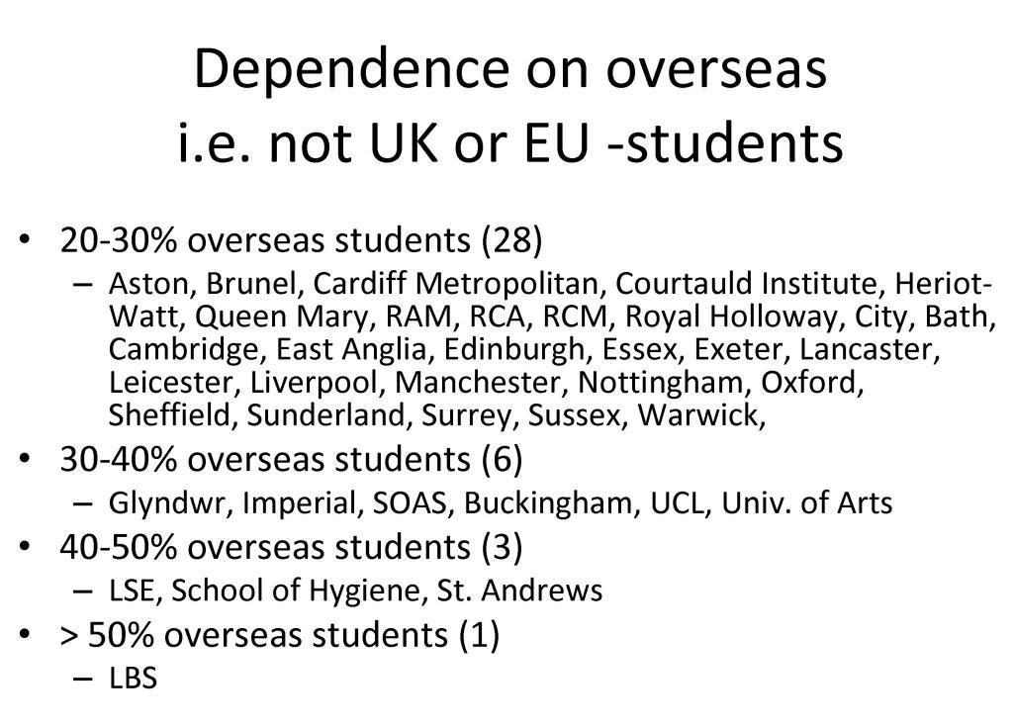

Vice-chancellors don’t like to say this, but I can. This slide shows how many British universities there are, including some of the most successful and prestigious, who could not do without their income from overseas students. Take that away and you will jeopardise the universities which educate many of our children and grandchildren. The only way for them to survive would be to put up their fees to much more than the current level of £9000.

The policy is, frankly, mad.

British higher education has, over the past 50 years, been a great success. More has unambiguously meant better. Without the expansion of British universities, we would not have ended discrimination against women, we would not have allowed millions of our fellow-citizens to fulfil their potential through full- and part-time study, we would not have achieved our place as the leading country in Europe for research across the whole spectrum of the sciences, humanities and social sciences.

The dire consequences which Kingsley Amis foresaw, but which Robbins immediately refuted, have not come to pass. Of course, we need to continue to worry about the quality of teaching and learning, but British university courses are now far better designed and far more professionally taught than when I began my career.

There are a whole range of other benefits from the growth of universities. Graduates are happier, less prone to crime, more likely to take part in social, cultural and charitable activities in the community than are non-graduates. They are even less likely to be obese. Graduate unemployment has risen less rapidly than general unemployment and is falling more rapidly. It is good to be a graduate and good that we have so many of them.

The Future

Now, what about the future? I have one major prediction, which is that expansion will continue. I’ll explain why in a moment.

But I am also concerned about the future. We have a messy, muddled non-system of higher education. Policies are not coherent, not thought-out. We need to think again, as Robbins did fifty years ago, about the whole future of British universities and about the ways in which they could work better for themselves and for future generations of students. So, for the rest of this lecture, I will discuss areas where the current state of British higher education could be improved.

Inevitable, I am going to be critical, probably provocative. So I want to make it clear that I greatly admire the people who run Britain’s universities and the academics and administrators who work in them. In my experience, they love their jobs because they can make a difference to our society, either by increasing our knowledge through research or by teaching succeeding generations of students; university employment is not well-paid by the standards of many other jobs which demand high-level qualifications, but those who do these jobs know that they are worthwhile. They also enjoy them. In the 19th century, clergymen had the highest life expectancy of any occupation; today it is academics. That probably says something.

To return to the future, I confidently predict that expansion will continue and that the results will continue to be good. Why do I say this?

First, because we still have – compared to many other countries – relatively few people going to university.

Britain is not at the top of a league table of university attendance, as some politicians seem to think. Instead, as this graph shows, we are in the middle among developed countries and cannot afford to slip further down. We are already far behind comparable countries like Australia, the United States and many other European countries and there are many other countries yapping at our heels. A service economy like ours, rather than a country with lots of agriculture, natural resources or manufacturing, needs more and more trained graduates.

The second reason why I predict that expansion will continue is because the imposition of the highest fees in the world for a publicly funded system has hardly dented the demand for university places – with the significant and worrying exception of part-time places. So strong has been the demand that the Chancellor, George Osborne, recently astonished the university world by lifting the cap on undergraduate numbers and allowing universities to recruit as many as they wish, with their fees continuing to be covered by loans from the state. Few of us think that the sums add up, but the new policy is a signal that the government thinks people will continue to want to come to university.

Meanwhile, demand to do Masters degrees and doctorates continues to be strong and could be even stronger if we didn’t discourage overseas students.

However, all is not well. The successes that I have described were achieved with very little conscious planning, with a funding system that is so complex that it defies description – as I found when trying to explain it to the Governors of my university – and with entrenched privilege which has changed little since the 1960s.

If you doubt this, remember that it was Michael Gove who pointed out recently that there are more Etonians at Oxbridge than young people who received free school meals. There are more black and minority ethnic students at London Metropolitan University than in the whole of the Russell Group of elite universities.

There are many other problems – the Public Accounts Committee has serious doubts that the current system of student fee support is sustainable and it is clear that, if anyone in Government believed that it would save money, they will be wrong. Meanwhile the Government, as I have just said, is hell-bent on destroying the success in recruiting international students which benefits the UK economy by several billion pounds each year. We have universities which are supposedly autonomous but actually entirely dependent on public money, universities which are supposed to compete but cannot raise their fees. It is not only the fee system but the whole system that deserves the term “omnishambles”.

In fact, there really isn’t a system, as Robbins realised. That is still true – there are still no guiding principles or agreed objectives for the spending of huge sums of public money. Some of the greatest universities in the world now share that funding with private institutions which allegedly exist largely to milk the student loan system.

You might defend this as the result of organic development and free competition (although actually competition is totally constrained) and necessary for the preservation of academic freedom. But Robbins disposed of this 50 years ago. As his report also pointed out, academic freedom is the right of individuals to express opinions which may be unpopular, it is not a justification for the existence of any particular institution.

What should be done about it? There is an argument, bolstered by the successes which I have just described, to let things muddle along. After all, my alma mater, the University of Oxford, has stayed one of the best universities in the world despite a governance system which breaks most of the rules in the book.

But I think higher education is now too important to our economy and society to do this. We need to take a look at the system as a whole, not just odd bits of it like the fees for undergraduates. What we really need, fifty years on, is another Robbins Commission which can, as Robbins tried to do, design a system fit for this century. However, Royal Commissions are out of favour and it has been left to private bodies such as the Institute for Public Policy Research, to fill the gap. Their committee, chaired by Professor Nigel Thrift, reported last year. It made 23 major recommendations, most of which I agree with.

But the recommendations are about improving the position that English universities are in today. The committee didn’t go back to first principles or try, as Robbins did 50 years ago, to design a system. I think we need to do that.

We need to think seriously about how many universities we have, about what they do and about how we pay for the teaching and research that they do. I believe that we have too many universities, that they are trying to do too many different things and that the way in which we fund their research is fundamentally flawed. Many others have said the same about the funding for teaching, so I’m going to ignore that topic, but I will argue that the idea that universities can provide for either their teaching or their research through fund-raising from alumni or philanthropy is a chimaera.

First, too many universities, each trying to do too many things. No-one seems to know how many there are worldwide, but there are probably about 1500-2000 in Europe. All of them can award doctoral degrees, in contrast to the United States, where only a small proportion can do so.

In Britain there are 134 members of Universities UK, while London Higher, which represents the wider category of higher education institutions in London, has 40 members within the M25. There are many other HE instititutions in London, including branch campuses of many universities from the rest of England and from Scotland. This is too many, both in Britain as a whole and within London. Each institution, from the largest university to the smallest conservatoire or higher education college, has a Board of Governors, a Vice-Chancellor or Principal, a Finance department, an HR department, registry, admissions office, fundraising office and so on. The overhead is too great.

So my first proposal is to cut the number of universities in Britain by at least one-third if not one-half.

We don’t need two or more universities in each of our major cities, glowering at each other and competing to attract the attentions of businesses and local authorities. Why do Leeds, or Sheffield, or Oxford, or several other cities picked at random, need two Vice-Chancellors, two Registrars, two groups of Governors? Is it really necessary to have two universities outside Brighton, separated only by a main road?

In London, the situation is even more bizarre, with Colleges which are all nominally part of the University of London all competing to remain independent from each other and recoiling at any suggestion that they might join forces with parvenus such as London Met, Westminster or Kingston. We have conservatoires and art colleges which could perfectly well be faculties of a larger university.

Experience suggests that universities will not make such radical changes for themselves; Vice-chancellors and Boards of Governors fiercely defend their separate existences. The Higher Education Funding Council has remained supine in the face of the evidence that all this is unnecessary and inefficient. The Welsh government has stepped in to reduce the number of universities in Wales; maybe the next English government will have to do the same.

At the same time, universities are simply trying to do too many things at once.

They are trying to be hoteliers, conference organisers, caterers, sporting promoters, careers advisors, pastoral counsellors; they run great estates, house research institutes, provide theatres and concert halls, sell souvenirs and t-shirts, act as property developers, invest on the stock market. They set up overseas subsidiaries, finance start-up companies, develop science parks, maintain some of the most beautiful buildings in Britain, run some of our greatest museums, art galleries and libraries.

They even run buses.

All this is a hangover from a time when universities were detached from the world, living in a rural cocoon and teaching 18 year olds fresh out of boarding school. Maybe then universities needed to do everything. Now most universities are in the middle of big cities and do not need to do all these things. It is even odder that many of their activities still follow the academic cycle of term and vacation that was established in the Middle Ages. Despite conferences, many lecture theatres – expensive real estate - lie empty for large parts of the year.

There is duplication and waste in academic as well as administrative affairs. In an age when every student can download a lecture onto a tablet or smartphone, it does not make sense for lectures on, for example, first-year economics or English or biology to be given at several different universities in the same city at roughly the same time. Nor does it make sense for lectures to be repeated in successive years, often with only minor changes.

Freeing lecturers from the need to do all this, by sharing the tasks between them, would leave more time for real interaction with students in seminars and classes rather than the false interaction provided by sitting in a large lecture audience. This might enhance student satisfaction, which is wilting under the combined impact of high tuition fees and the increasing lack of willingness of the research “stars” among academic staff to undertake undergraduate teaching.

However, the tyranny of “not invented here” is as prevalent in academe as in other walks of life. If duplication is to be reduced, it will have to be through cooperation between the lecturers involved. This, in my experience, will come only through merging their academic departments, another argument for reducing the number of universities.

One could go further. There is a strong argument for specialisation, in the form of universities which concentrate entirely on postgraduate education. They could make better use of the best researchers who are already, in many places, concentrating on Masters and PhD students and leaving the undergraduates to junior staff or teaching assistants, many of them now on zero-hours contracts.

The Robbins Commission, 50 years ago, discussed whether Oxford and Cambridge should become all-graduate institutions. They rejected the idea, arguing that it would be too great a change to the character of Oxbridge and that, in any case, at that time only 18% of their students were postgraduates. Now the proportion is much larger, as it is at the other great research-led universities such as LSE, Imperial and UCL, together with some of the best specialist universities such as the Institute of Education and the School of Hygiene. Turning Oxbridge into all-graduate institutions has been discussed sotto voce in common rooms for years and it is probably time for there to be a proper and open debate about it again.

If we were to organise the university system so that many academics explicitly concentrated on research and postgraduate teaching, we would need to modify the way in which research, and the research universities, is funded. But reform is badly needed anyway. To put it bluntly, a good bit of the current system is an expensive charade. Let me explain.

This slide describes the four most important sources of money for university research. Europe, as I said earlier, is increasingly significant. Charities are very important, particularly in medical research. Private industry funds less, proportionately, than in countries like the United States but is still significant in areas of applied science and engineering. But every year the first source, the state, provides more than £4.5 billion. It comes in two parts so that the system is known as “dual support”. Two-thirds, about £3 billion each year, is allocated to research projects, mainly through competitions organised by the research councils which now cover every academic field. The grants which result pay for the direct costs of the research and the universities also receive payments for their overhead expenditure on buildings, equipment and the salary of the vice-chancellor. One-third, about £1.5 billion each year, is paid in block grants to universities. I want to focus on the process for doing this.

In the 1980s, under the impact of Thatcherite funding cuts, Britain pioneered the assessment of university research. Since then, the books and articles of academic staff have been scrutinised, by panels of their peers, every five or six years and, by an increasingly elaborated and always time-consuming process, their academic departments have been assigned a grade. This grade is then translated into funding from the Higher Education Funding Council for the succeeding period. As I said, about £1.5 billion per year is distributed by these means so the results of each assessment determine how upwards of %6 billion is spent.

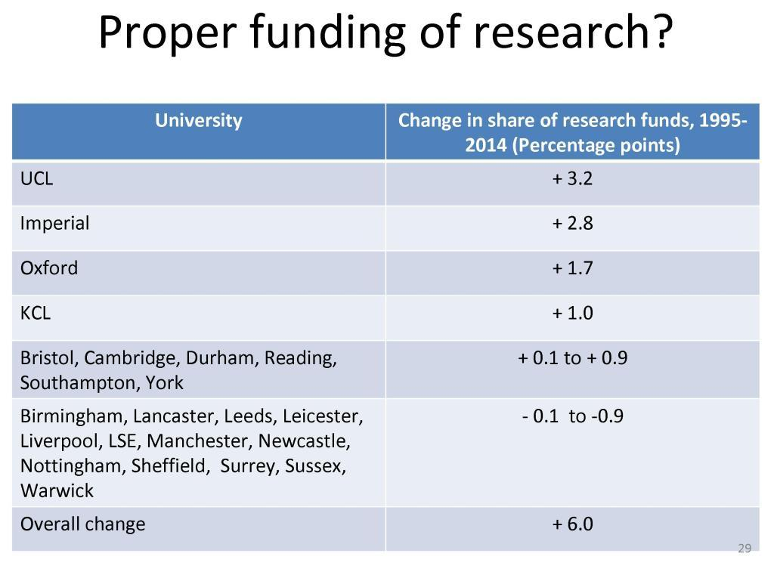

I have no objection at all to the principle of research assessment; it is entirely right that public money should be properly spent and be seen to be spent on the best of academic research. But the practice of research assessment is a different matter. Each assessment costs between £20 million and £100 million pounds, depending on whose estimates one accepts. That may not seem very much if one is distributing over £6 billion between each successive assessment, but it is still an enormous waste of money, for the simple reason that it does not lead and has never led to any significant change in funding for most research universities.

To demonstrate this, let’s look at the funding which goes to the top 24 research universities; together, this was 70% of the cake in 1995 and is over 75% today. Both this government and the last have pursued, without much evidence that it is beneficial, a policy of concentrating the funds.

Oxford, Cambridge, Imperial and UCL still get much the same proportion of the cake as they did twenty or thirty years ago. In fact, over the 19 years between 1995 and 2014 only three universities – Imperial, Oxford and UCL – out of those top 24 research universities changed their share of the cake by more than 1 percentage point and that was because the system was tweaked to reward the most highly graded. It would be cheaper simply to give them the money in perpetuity rather than to waste time and money on what has essentially become an extremely expensive way of constructing a league table which hardly changes. Another reason for this stability in funding is that the grade given by the assessment has to be multiplied by the average cost of research in each subject; how is that calculated? Surprise, surprise, by what it has cost in the past.

However, giving the top universities the same money forever is probably a step too far for government or the funding council, even if that is essentially what has happened. So I have a better solution. Although the assessment of research by the Higher Education Funding Council gets all the attention, it actually accounts for only one-third of public funding for research in our universities; the other two-thirds is distributed by the research councils on the basis of project proposals and plans. They reward good ideas rather than past achievement, which seems a proper thing to do, and they demand, of course, that academics and universities report on what they have done and account fully for the money they have received.

So my solution is to take all the money and distribute it through the research councils. The current system is beloved of Russell Group vice-chancellors, who can distribute, as they wish, the sums that their universities receive. Actually, although they complain about it, a lot of academics love it too; they are intensely competitive people and love league-tables, particularly if they are the people sitting in judgment on the research of their friends.

But it is an expensive charade. It should be replaced by a properly competitive system, using the mechanisms which the research councils already have. There is one further reason for doing this – we are always being told how we should be more like the United States – well, that world leader in research allocates its funds through research councils and has no equivalent of our research assessment system.

My fourth prescription for a healthy higher education sector is to forget about fund-raising in the sense of soliciting donations from rich people.

The pressure to raise funds from alumni and rich donors came from a series of misunderstandings of American universities. People who should have known, or been told, better, like Gordon Brown, thought that fund-raising for a tiny proportion of American universities – principally those in the Ivy League – could be translated into sizeable donations not only to Oxbridge – the closest analogue – but to the general run of UK universities.

This ignored the fact that most US universities in the state system did not, and do not, receive much of such funding, except occasionally to fund a football stadium; it ignored also the fact that, as one distinguished American university President put it to me, “fund raising for universities in America is a branch of the tax avoidance industry”. It depends on tax advantages which – fortunately – do not exist in Britain; finally, it ignored the fact that donations to most British universities were at such a low level that extraordinary increases would be needed to make any difference at all to university finances.

Now, twenty or thirty years since pressure to fund-raise began, and after large sums of money have been invested in “development” – always mistrust an activity that dare’s not speak its name – while government has spent large amounts in matching fundind and, of course, in tax relief for the donors, the results have been frankly pitiful, except for donations to a very select group of universities. About 80% of all the funds raised now go to Russell Group universities and, of those, 50% are to Oxbridge; Oxbridge secures 100 times as much in new donations as all the fifteen Million+ universities, principally the former polytechnics. No one seems to know how many of the donations have been for academic purposes, rather than to providing ever-more luxurious accommodation for undergraduates to underpin the vacation conference trade. Vice-chancellors are proud of what they have achieved – I confess to having been delighted at raising £4.5 million for the Women’s Library at London Guildhall University – but most will admit that many of the donations have not been for their top academic priorities and that virtually none of the donations have supported teaching and learning rather than bricks and mortar.

Despite all this, the juggernaut has rolled on. Vice-chancellors and heads of Oxbridge Colleges are now expected to be supplicants for gifts rather than academic leaders or university managers. We now have the bizarre spectacle of the Higher Education Funding Council setting universities a target of raising £2 billion per annum to substitute for cuts in public funding. The fund-raisers are rubbing their hands; we have 1500 fund-raising staff in universities at the moment but will need, they say, to double that number to meet this target and we will of course need to raise their salaries to recruit that number. That would mean that we had more fund-raisers than academic staff in architecture and planning or in agriculture and veterinary science; the “development” workforce would be one-third of the number of academic staff in the whole of the humanities. This is sheer madness.

Universities are not, except in the strict legal sense of the world, charities; as I’ve shown earlier, they are increasingly multi-faceted businesses. It is absurd that they should be expected, by the state and its agencies, to rely on donations which attract charitable tax relief. They should be funded to do the job which the state wants them to do.

We will be told that the state cannot afford to fund universities. Well, then I have a solution which should appeal to a government which professes to believe in the free market and private sector disciplines. Forget about fund-raising and allow universities to charge a fair price for the services that they provide. This was the solution advocated by Lord Browne in his review of student fees, but which the government refused to accept.

What is that price? Well, we can look at other countries:-

As this graph shows, Britain is getting its higher education on the cheap.

Public investment in HE as percentage of GDP
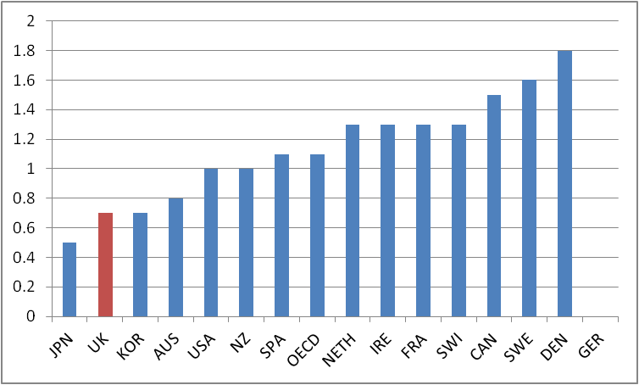

Private investment in HE as percentage of GDP
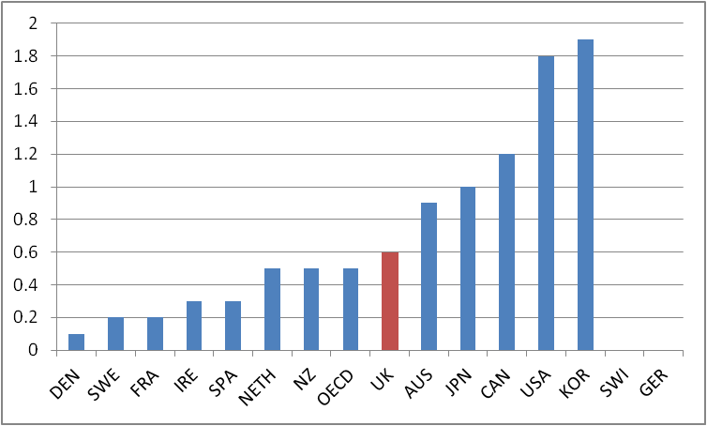
Source: OECD 2013, ‘Education at a Glance’

The government should trust the evidence that shows that investing in higher education is one of the best investments that the state and individuals can make. British higher education – if allowed to recruit the overseas students who want to come here – is one of our most successful export industries. Britain already spends less than many other comparable countries on higher education. It is adding insult to injury to tell us that the state will not support this success story and that we should spend our time going cap-in-hand to hedge fund millionaires to fund such vital and efficient public services.

I’m delighted that I’ve spent my working life – and a good bit of my private life – in British universities. It has been exciting and challenging. I’ve lived through a great expansion of the university system and I believe that all the evidence shows that expansion has been successful in a whole range of different ways. Those, like UKIP, who seek to turn back the clock and reduce the number of graduates are just showing their ignorance.

But I also feel frustrated, as I retire at the end of July from my last job in British higher education. The system could, I believe, be much better. It could be a system and, for that reason, I think we need a new Robbins report, a new Royal Commission to think for the next 50 years. Meanwhile, we could do much more with what we’ve got. We can avoid wasting money on too many universities. We can get more for our money by specialising, by avoiding duplication and by dispensing with vanity projects such as our current research assessment methods. We can stop spending money on chimaera such as alumni funding for state funded universities and, above all, we can recognise that British higher education deserves, and can justify, much greater funding than our blinkered politicians seem ready to give it.

I hope, for the sake of my grandchildren, that the next 50 years of British higher education will be at least as successful as the last 50 years. More has meant better and even more will mean even better. Kingsley Amis was wrong.

© Professor Sir Roderick Floud FBA, 2014

