27 September 2016
Proving Einstein Right!
Professor Ian Morison

This lecture will try to give you a feel of Einstein’s ‘Theory of General Relativity’ and show how, over the last 90 years, it has stood up to all the observational tests that have been made.

Einstein's Special Theory of Relativity postulates that nothing can travel through space faster than the speed of light, 3 x 10⁵ km s⁻¹. (The word ‘through’ has been highlighted as the expansion of space can carry matter apart faster than the speed of light.) Perhaps a rather far-fetched thought experiment will help to make it clear that, if this is the case, Newton's Law of Gravity cannot be totally correct. Suppose that the Sun could suddenly cease to exist. Under Newton’s theory of gravity, the Earth would instantly fly off at a tangent. Einstein realised that this could not be the case. Not only would we not be aware of the demise of the Sun for 8.31 minutes – the time light takes to travel from the Sun to the Earth – the Earth must continue to feel the gravitational effects of the Sun for just the same time, and would only fly off at a tangent at the moment we ceased to see the Sun. This assumes, of course, that whatever carries the information about the gravitational field of the Sun will also propagate at the speed of light. So something has to propagate through space to carry the information about a change in gravity field. Einstein thus postulated the existence of gravitational waves that would carry such information. As we will see later, the existence of such gravitational waves has been shown indirectly and now directly observed.

In 1915, Einstein published his ‘General Theory of Relativity’ often called ‘General Relativity’ which is essentially a theory of gravity. Objects in our Universe exist in a four dimensional space-time continuum which combines the three co-ordinates of space with a fourth co-ordinate, time. For simplicity, in what follows, the term ‘space’ will be used. In the absence of mass, Einstein's theory predicts that space is ‘flat’. This is a rather unfortunate term as it seems to imply a 2 dimensional plane surface. In fact, it simply means that light will travel in straight lines, so two initially parallel beams of light remain parallel. In ‘flat’ space a triangle in any orientation will have inscribed angles that add up to 180 degrees. Euclidian Geometry holds true! (Personally, I would like to start a movement to stop calling space ‘flat’ and use the terms ‘Euclidian’ or ‘zero curvature’ space instead!)

If a mass is now introduced into flat space it makes the space positively curved so that two initially parallel beams of light will converge and the inscribed angles of triangles will add up to more than 180 degrees. A simple, two dimensional, analogy is a flat stretched sheet of rubber. Ball bearings rolled across it will travel in straight lines. If a heavy ball is now placed on the rubber sheet, it will cause a depression and should a ball bearing come close, it will follow a curved path. In just the same way, the space around our Sun is positively curved and the Earth is simply following its natural path through this curved space − there is no force acting on it.

Imagine a spherical world where the inhabitants believe totally (but incorrectly) that the surface is flat. In the region near their north pole the icy surface is virtually frictionless. The inhabitants use a hovercraft like transport so that, once moving, the craft experience no frictional forces. Two craft, 10 km apart, and at identical distance from the pole, set off at the same time and at the same speed heading due north on parallel paths across the ice. As they believe that the surface is flat, they will expect to remain this distance apart as they travel across the ice. They will thus be somewhat surprised (and possibly hurt) when they collide at the North Pole! In order to maintain their belief that the surface of their world is flat they could postulate a force, that they might call ‘gravity’, to explain why their craft were drawn together. In the same way, we postulate the force of gravity to explain what we observe in the (incorrect) belief that three dimensional space is flat in the vicinity of mass, not curved.

Gravity is a force that we "invent" to explain what we observe happening (such as the planets going around the Sun) in the belief that space is flat when it is, in fact, positively curved.

The first ‘test’ of Einstein's theory was its application to the orbit of Mercury. As Kepler's first law of planetary motion tells us, the orbit of Mercury should be an ellipse with the Sun at one focus. The point of closest approach, called its perihelion, would remain fixed in space if the Sun was a sphere and there were no other planets. However the oblateness of the Sun and perturbations caused by the other planets cause the orbit to ‘precess’ − think of the patterns produce by a ‘spirograph’. Accurate observations showed that the observed value of this precession, 5599.7 arc seconds per century, disagreed with that calculated from Newton's theory by 43.0 arc seconds per century. The application of Einstein's theory provided a correction term of 42.98+/- 0.04 arc seconds - exactly that required to remove the anomaly!

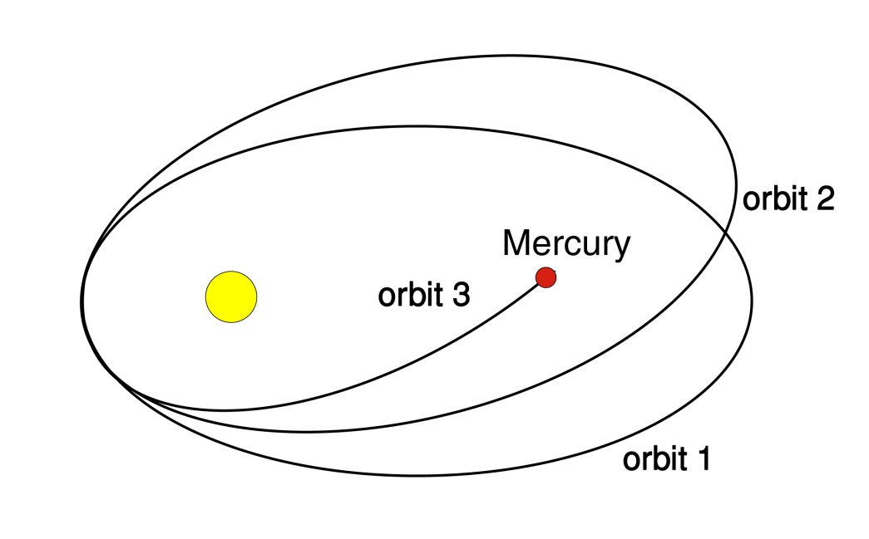

It was realised that Einstein’s theory could be tested by observing the positions of stars when observed close to the Sun. Einstein’s theory predicted that the positions of the nearest stars would be shifted by just 1.75 arc seconds − close to the limitations in measurement accuracy due the atmosphere. (It should be noted that Newton also predicted, for different reasons, that light waves should be bent when passing the Sun, but the effect due to the distortion of space-time in Einstein’s theory is twice that predicted by Newton’s theory.)

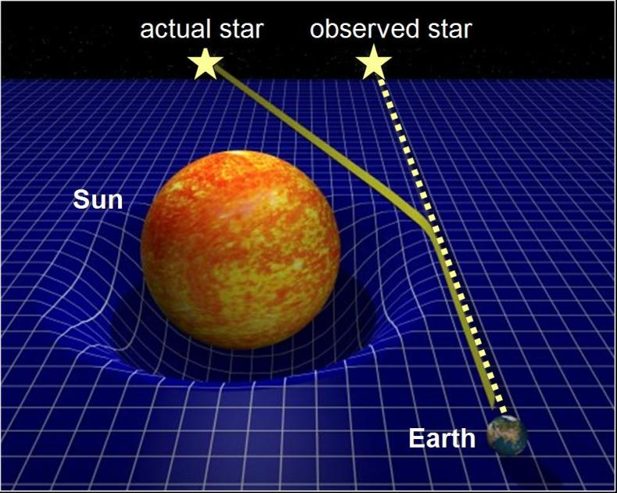

We cannot usually measure the positions of stars close to the Sun except during a total eclipse of the Sun and thus the eclipses of 1919 and 1922 which followed the publication of Einstein's theory played a significant role in the history of science. In essence the plan was simple. Prior to a solar eclipse, take images of the sky where the Sun would be during totality. Take the same images during totality − the only time when stars can be seen close to the Sun’s position − and compare the positions of the stars.

Sir Arthur Eddington led the British eclipse expedition to the Atlantic Island of Principe, whilst a second set of observations were made from Sobral in Brazil. Fortuitously, at the time of the eclipse, the Sun lay in front of the Hyades star cluster, so giving a rich field of stars to make measurements from − comparing individual star positions made during the eclipse with earlier observations of the cluster. The telescopes used thus had to be portable and this limited their accuracy. The control images obviously had to be taken at night when it would have been colder than during the day time. Even disregarding these problems, the experiment was not easy. The anticipated deflection of 1.6 arc seconds has to be compared with the typical size of a stellar image as observed from the ground (due to atmospheric turbulence) of 1 to 2 arc seconds.

The data from the observations were not quite as conclusive as was implied at the time. The telescope at Principe was used to take 16 plates, but partial cloud reduced their quality. Two usable plates from the telescope on Principe, though of a poor quality, suggested a mean deflection of 1.62″. Two telescopes were used at Sobral where conditions were superb; sadly however the focus of the main instrument shifted, probably due to temperature changes, and the stellar images were not clear. They were thus difficult to measure and produced a result of ~0.93 arc seconds. A smaller 10 cm instrument did, however, produce 8 clear photographic plates and these showed a mean deviation of 1.98 +/- 0.12 arc seconds. If all the data had been included, the results would have been inconclusive, but Eddington, with some justification, discounted the results obtained from the larger Sobral telescope and gave extra weight to the results from Principe (which he had personally recorded). On November 6th that year the Astronomer Royal and the President of the Royal Society declared the evidence was decisively in favour of Einstein's theory. However there were many scientists who, at the time, felt there were good reasons to doubt whether the observations had been able to accurately test the theory.

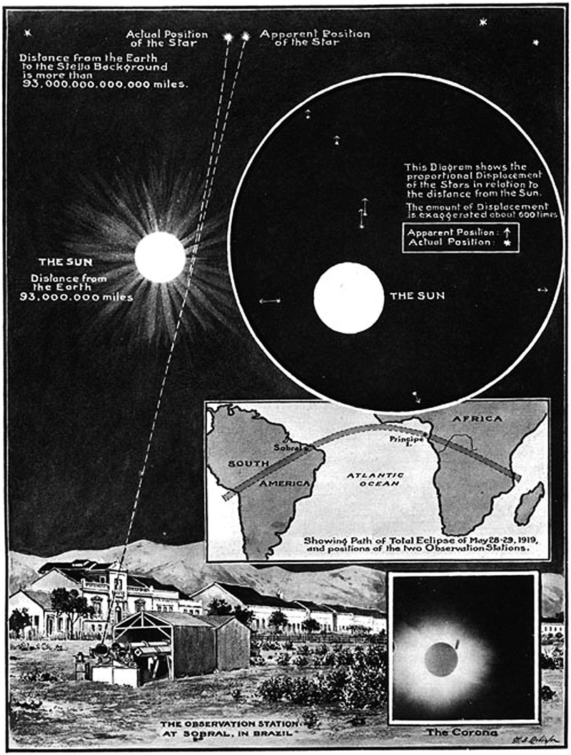

A more positive test of the theory came from observations made by William Campbell's team from the Lick Observatory who observed the 1922 eclipse from Australia. They determined a stellar displacement of 1.72 +/- 0.11 arc seconds. Campbell had believed that Einstein’s theories were wrong, but when his experiment proved exactly the opposite, he immediately admitted his error and thereafter supported relativity. (One tends to believe an experiment when the results do not agree with the expectations of the observer!)

If the Sun's mass can produce a small shift in the position of a distant object, so also should the mass of a galaxy. Occasionally, a galaxy will be close to the line of sight of a more distant object. The mass of the galaxy distorts the space around it forming a ‘gravitational lens’. Depending on the relative positions, this lens can form multiple images of the distant object or even spread its light or radio emission into an arc or ring − called an Einstein ring. In 1977, observations by the Lovell Telescope at Jodrell Bank discovered two quasars whose positions were close (~6 arc seconds) to that of a foreground galaxy. Quasars are very distant bright radio sources that appear like stars on photographic plates - hence their full name ‘quasi-stellar-object’ which means ‘looking like a star’. Now called the ‘Double Quasar’, it was soon realised that we were observing two images of the same object. But there is a subtle difference. The path length through space between us and the quasar is longer for one of the images by a distance of 417 light days. We thus, simultaneously, see it at two times in its existence − separated by 417 days! Time and space do interact showing why space-time is implicit in Einstein' theory.

[One might wonder how the time difference has been measured. Quasars are giant galaxies which, at their heart have a ‘supermassive black hole’. Stellar material falling in towards the black hole provide the energy source of the quasar, and as the rate at which material is consumed varies so does the energy output of the quasar. The effect is that the brightness varies with time. Suppose the image whose light has travelled least is seen to increase rapidly by 10%. Then we would see the image whose light travels further increasing by the same amount some time later determined by the difference in path length. By comparing the brightness curves of the two images, a ‘match’ was found when the time difference was 417 days.]

These observations enabled the value of Hubble’s Constant − the rate of expansion of the Universe – to be estimated giving a value of ~68 km/sec per megaparsec. At the time measurements made by optical telescopes gave widely varying values ranging from 50 to 100 km/sec per megaparsec. The latest values range from just under 68 to 71 km/sec per megaparsec. Jodrell Bank Observatory got it right three decades earlier!

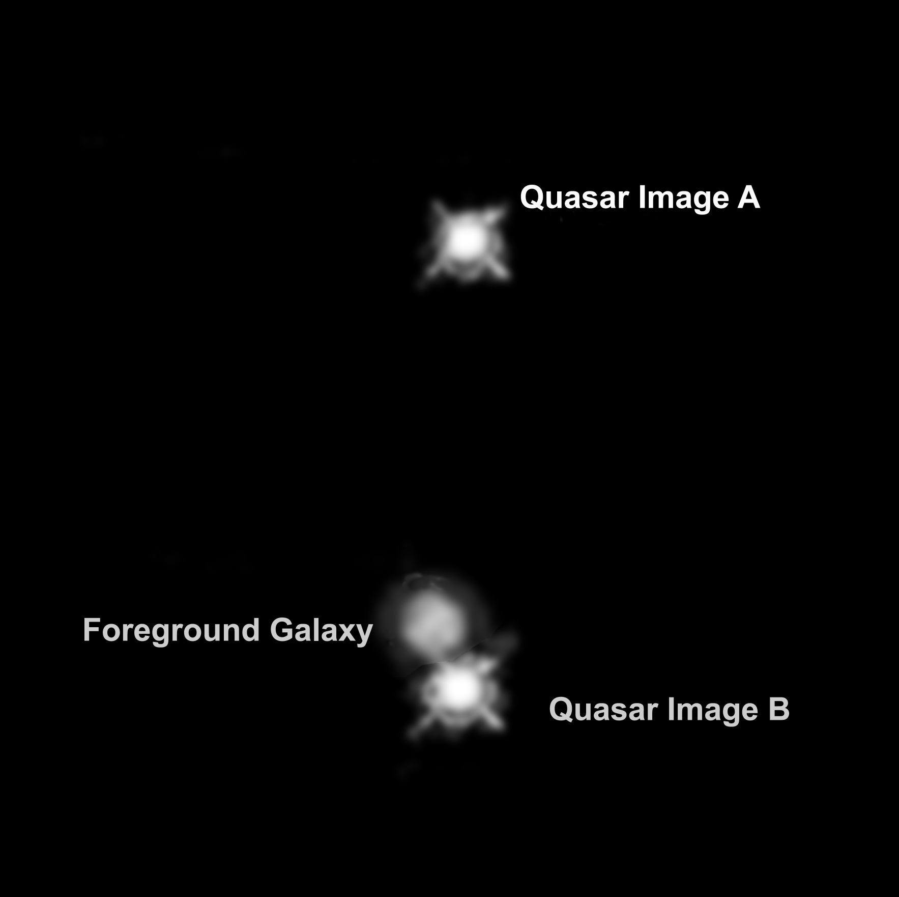

In the 1960’s Irwin A. Shapiro realised that there was another, and potentially far more accurate, way of testing Einstein’s theory. Shapiro was a pioneer of radar astronomy and realised that the time that a radar pulse would take to travel to and from a planet would be affected if the pulse passed close to the Sun. In the accompanying diagram, (a) shows the direct path that a radar pulse would take to and from Mars if we could imagine that the Sun was not present and that, as a consequence, space was flat. Path (b) on the diagram shows that, due the curvature of space a radar pulse sent along this precise path would curve away to the left and not reach Mars. The pulse that would reach Mars, shown as path (c), has to take a path slightly to the right of its true position so the curvature of space near the Sun would deflect it towards Mars. The echo would follow exactly the same path in reverse. As the pulse has had to follow a longer route to Mars and back it will obviously take longer than if the Sun was not present. The radar pulse will thus be delayed. The ‘Shapiro Delay’, as it is called, can reach up to 200 microseconds and provided an excellent test of Einstein’s theory.

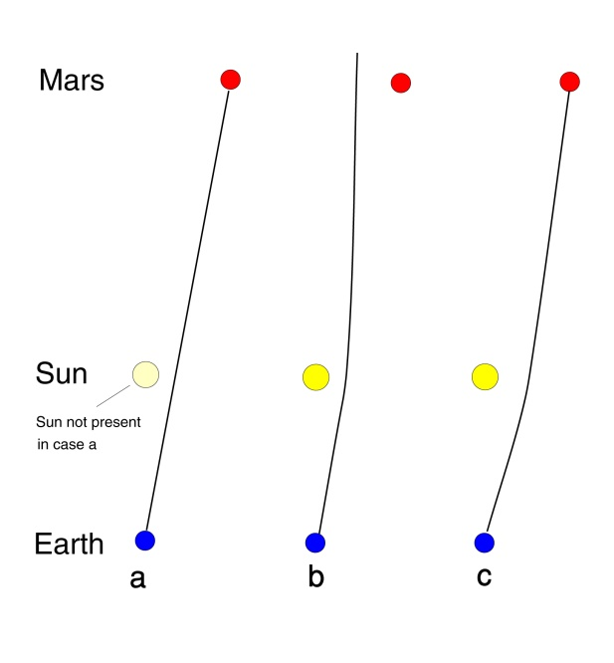
Further tests, of even higher accuracy, using the Shapiro delay have been made by monitoring the signals from spacecraft as the path of the signals passed close to the Sun. In 1979, the Shapiro delay was measured to an accuracy of one part in a thousand using observations of signals transmitted by the Viking spacecraft on Mars. More recently, observations made by Italian scientists using data from NASA's Cassini spacecraft, whilst en route to Saturn in 2002, confirmed Einstein's theory of general relativity with a precision 50 times greater than previous measurements. At that time the spacecraft and Earth were on opposite sides of the Sun separated by a distance of more than 1 billion kilometres (approximately 621 million miles). They precisely measured the change in the round-trip travel time of the radio signal as it travelled close to the Sun. A signal was transmitted from the Deep Space Network station in Goldstone California which travelled to the spacecraft on the far side of the Sun and there triggered a transmission which returned back to Goldstone. New techniques enabled the effects of the solar atmosphere on the signal to be eliminated so giving a very precise round trip travel time. The Cassini experiment confirmed Einstein's theory to an accuracy of 20 parts per million.

Though not specifically a ‘test’ of Einstein's theories, the Global Positioning Satellite network (GPS) is beautiful illustration to show that, if Einstein's two theories are not taken into account, then the GPS system could not function. GPS essentially works by the transmission of highly accurate timing signals from a constellation of satellites orbiting the Earth. By ‘knowing’ where the satellites are when they transmit their time signals, a receiver on the ground can calculate the distances from each observed satellite and hence where on the surface of the Earth it must be. The timing signals are derived from hydrogen maser atomic clocks carried in each satellite. They orbit the Earth at a height of ~20,200 km while moving at a speed of ~14,000 km per second. Both these statements are significant. Einstein's special theory of relativity shows that a moving clock, when observed from a body at rest, will appear to run slow. The result is that, if the hydrogen maser is set to give precise timing signals on the ground, it will appear to run slow when in orbit by 7 microseconds per day. One might thus set the clock to run fast on the ground so that, when in orbit, it runs at the correct rate.

But this would ignore Einstein's general theory of relativity. At a height of 20,200 km, the value of the acceleration due to gravity, g, is reduced by a quarter as compared to that measured on the Earth's surface. Clocks run faster in weaker gravitational fields and this effect would make the clocks run fast by 33 microseconds per day. In order to run at the correct rate in orbit the clocks have to be made to run slow by ~28 microseconds per day when calibrated on the ground!

The next major advance in testing Einstein’s theory came with the discovery, by Russell Taylor and Joseph Hulse in 1974, of the first ‘binary pulsar’. As observations of pulsars are key to what follows a brief resume of their origin and properties is in order. In the latter phases of their life, nuclear fusion in the cores of massive stars builds up the elements to iron, the element with the most stable nucleus. When the core has converted all its mass into iron, nuclear fusion stops and gravity makes the core collapse. The vast majority of the protons fuse with electrons to give neutrons and finally, when the core is about 20 km in diameter, ‘neutron degeneracy pressure’ halts further collapse. Not surprisingly, the resulting object is called a neutron star. The density is incredibly high − one cubic centimetre would weigh about 10 time greater that Mount Everest − and it has a very powerful magnetic field, perhaps 600 trillion times stronger than that of the Earth. The progenitor star will have been rotating relatively slowly, as will its core. As the core collapses down, conservation of angular momentum causes the rotation speed of the core to greatly increase, rotating initially perhaps 60 times per second.

The magnetic field axis of the neutron star will usually be inclined to its rotation axis. This rotating field accelerates particles which give rise to beams of radio emission, in some cases with light and x-ray emission as well. The two beams, from above the north and south magnetic poles, sweep around the sky rather like that from a lighthouse. Should one or, rarely, both of these beams sweep across the Earth’s position in space radio telescopes will pick up a short pulse of energy. These radiating neutron stars thus rapidly gained the name ‘pulsar’. The first was discovered by Jocelyn Bell in 1967. The radiation of energy away from the pulsar takes energy out of the system and thus their rotation will gradually slow down. But, as you can imagine, the rotational energy in a 1.4 solar mass object spinning at a typical rate of 10 rotations per second is enormous, so the slow down rates is very slow and thus pulsars make exceedingly good clocks – comparable to atomic clocks on Earth. In fact, when the first pulsar was discovered, it was not initially thought that a natural phenomenon could give rise to such accurately timed pulses and it was suspected that perhaps it was a signal from an alien race. Its first, unofficial, name was LGM1 – Little Green Men one!
It is the fact that pulsars are such accurate clocks that have made them such valuable tools with which to test Einstein’s theory. In the ‘binary pulsar’ system discovered by Taylor and Hulse, a 1.4 solar mass pulsar is orbiting a companion star of equal mass. It thus comprises two co-rotating stellar mass objects. General Relativity predicts that such a system will radiate gravitational waves – ripples in space-time that propagate out through the Universe at the speed of light. Though gravitational wave detectors are now in operation across the globe, this gravitational radiation is far too weak to be directly detected. But there is a consequent effect that can be detected. As the binary system is losing energy as the result of its gravitational radiation, the two stars should gradually spiral in towards each other. The fact that one of these objects is a pulsar allows us to very precisely determine the orbital parameters of the system. Precise observations over the 40 years since it was first discovered, shown in the diagram show how the two bodies are slowly spiralling in towards each other, exactly agreeing with Einstein’s predictions! Taylor and Hulse received the Nobel Prize for Physics in 1993 for this outstanding work.

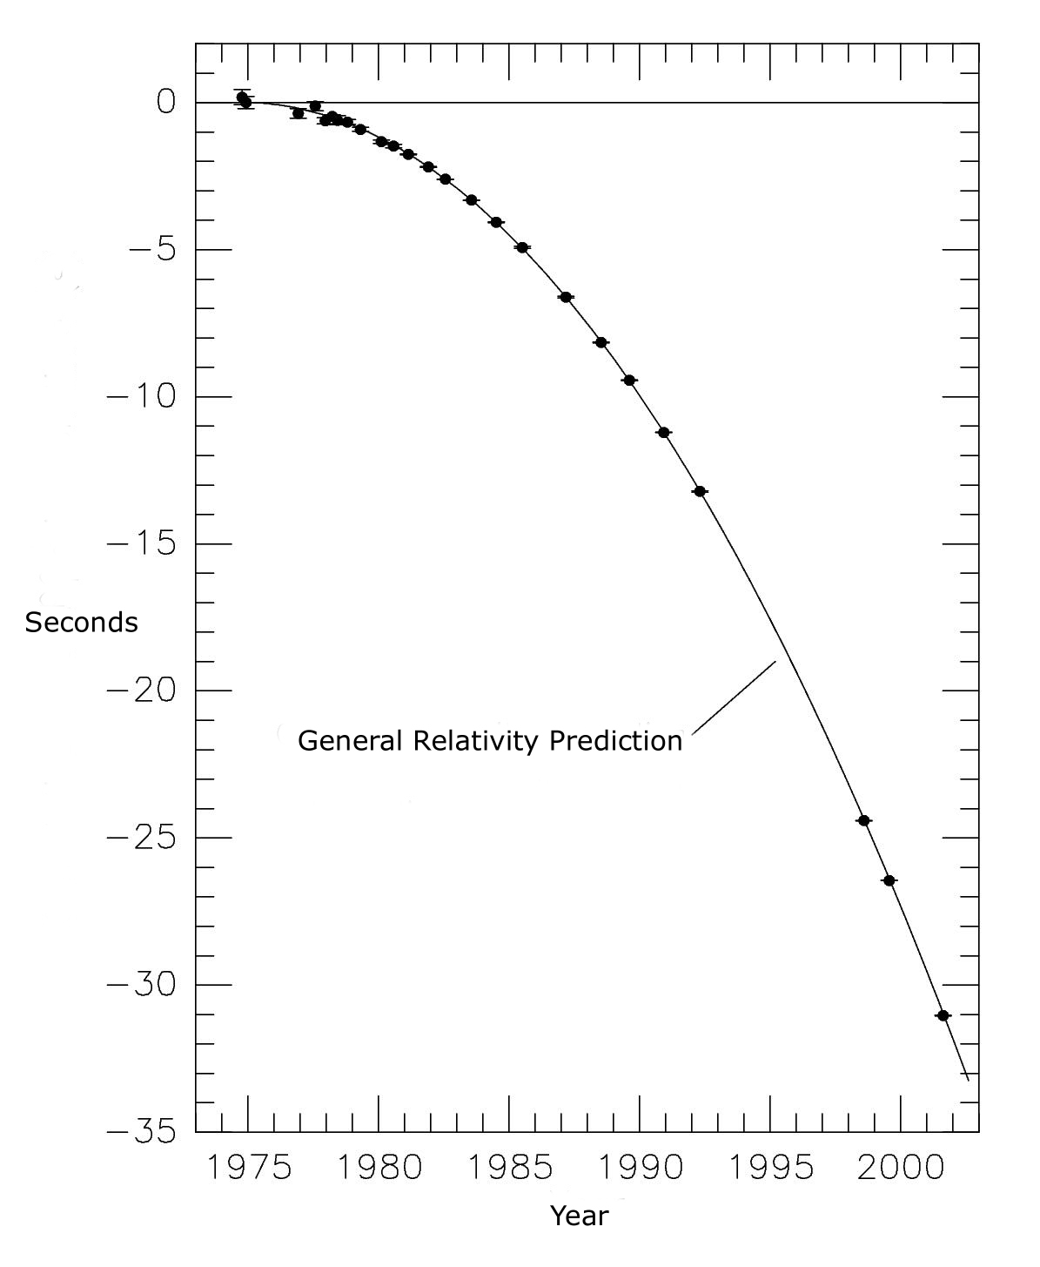

It is another pulsar system, this time where both objects in the system are pulsars, and called the ‘Double Pulsar’, that has produced some of the most stringent test of General Relativity to date. It was discovered in a survey carried out at the Parkes Telescope in Australia using receivers and data acquisition equipment built at the University of Manchester’s Jodrell Bank Observatory. In analysis of the resulting data using a super-computer at Jodrell Bank the double pulsar was discovered in 2003. It comprises two pulsars of masses 1.25 and 1.34 solar masses spinning with rotation rates of 2.8 seconds and 23 milliseconds respectively. They orbit each other every 2.4 hours with an orbital major axis just less than the diameter of the Sun. The neutron stars are moving at speeds of 0.01% that of light and it is thus a system in which the effects of general relativity are more apparent than any other known system. At this moment in time, General Relativity predicts that the two neutron stars should be spiralling in towards each other at a rate of 7mm per day. Observations made across the world since then, including those using the Lovell Telescope at Jodrell Bank, have shown this to be exactly as predicted.

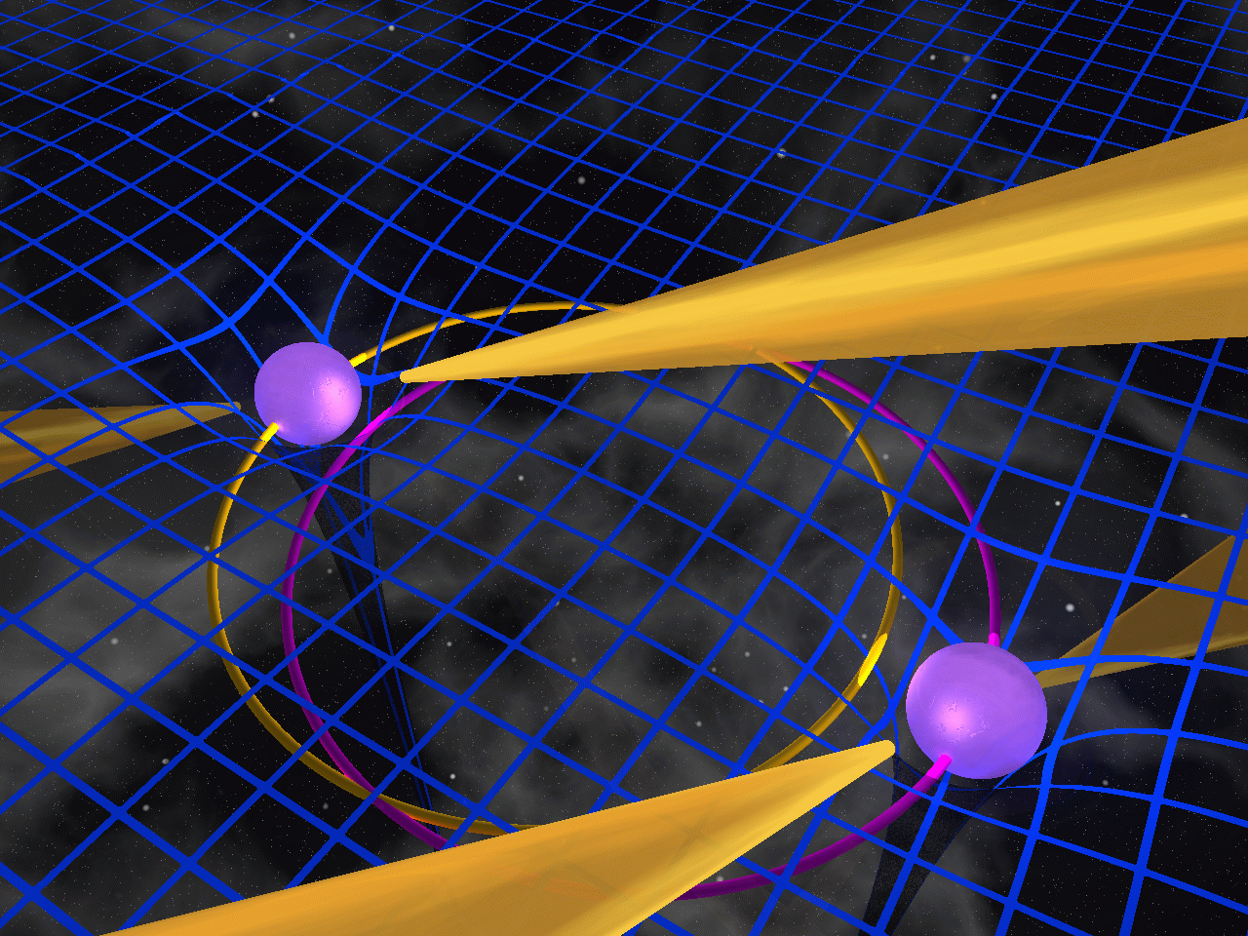

In fact, five predictions of General Relativity can be tested in this unique system. The one that has provided the highest precision within this system is a measurement of the Shapiro delay. By great good fortune, the orbital plane of the two pulsars is almost edge on to us. Thus, when one of the two pulsars is furthest away from us its pulses have to pass close to the nearer one on their way to our radio telescopes. They will thus have to travel a longer path through the curved space surrounding the nearer one and suffer a delay that is close to 92 microseconds. The timing measurements agree with theory to an accuracy of 0.05%. Einstein must be at least 99.95% right!

As the two neutron stars at gradually getting closer, at some point in the future they will coalesce to form what may well be a black hole. As they finally merge into one there what I can only call a gravitational wave ‘tsunami’ is produced. The predicted strength of the gravitational wave produced by such mergers is such that, before long, it is expected that they will be detected by gravitational wave detectors on Earth.

The way that they could detect such a gravitational wave can perhaps be understood by a ‘possible’ way to detect a tsunami wave crossing an ocean. Suppose, in a ‘thought experiment’, two boats are spaced one kilometre apart and an accurate laser system measures the distance between them. Should a tsunami wave first reach one of them. The boat will carry out a circular motion as the wave passes beneath thus making a small momentary change in the two boats separation which will be detected by the laser system. Some time later the wave will reach the second boat and the separation will again show a deviation. Note, however, that a tsunami wave which, coming side-on and reaching both boats simultaneously would not be detected as the boats motion would be at right angles to the distance being measured. To overcome this one might well have three boats to make a right angle triangle and so waves reaching the boats from any angle could be detected.

This is exactly similar to the gravitational wave detectors such as ‘LIGO’ − the Laser Interferometer Gravitational Wave Observatories − in North America. LIGO uses a device called a laser interferometer, which measures the time it takes light to travel between suspended mirrors to very high precision using laser light. Two mirrors, 4 kilometres apart, form one ‘arm’ of the interferometer, and two further mirrors make a second arm perpendicular to the first forming an L shape. Laser light enters the system at the corner of the L and a beam splitter divides the light between the arms. The laser light reflects back and forth between the mirrors repeatedly before it returns to the beam splitter. Any deviations in the path lengths, as would be caused by the passing of a gravitational wave, can be measured with extreme precision − movements as small as one thousandth the diameter of a proton can be measured! To achieve this, the mirrors and the light paths between them are housed in one of the world's largest vacuum systems, with a volume of nearly 300,000 cubic feet, evacuated to a pressure of only one-trillionth of an atmosphere. High-precision, vibration-isolation systems are needed to shield the suspended mirrors must from natural vibrations such as those produced by earth tremors.

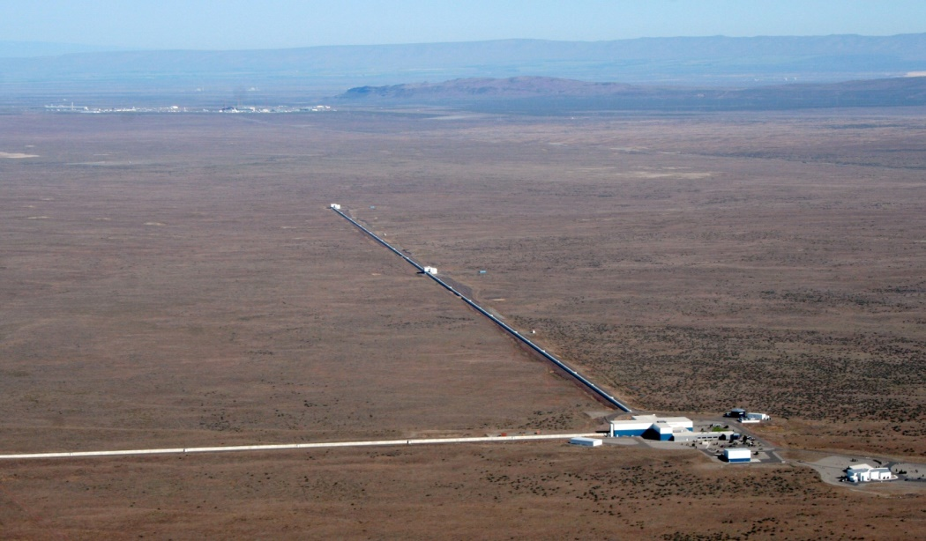
LIGO, Hanford, Oregon

Currently, there are two LIGO locations, one located at Hanford in Oregon and a second at Livingston in Louisiana − a separation of 9 milliseconds in light travel time. In the initial ‘LIGO’ observations, no gravitational wave events were detected. They then came off-line and their sensitivity was greatly enhanced to produce ‘Advanced LIGO’. The two observatories came back on-line and started observations in September 2016.

In what will almost certainly be one of the most important discoveries of this century, both sites detected a gravitational wave on the 14th September. The ‘chirp’ waveforms, increasing in frequency as two massive black holes spiralled in towards each other, appeared identical at the two sites but were separated in time by 9 milliseconds, Livingston first. Not only does this provide superb corroboration of the truth of the signals, but also that the gravitational wave must have arrived from the south with the most probable location of the event being in the direction of the south celestial pole.

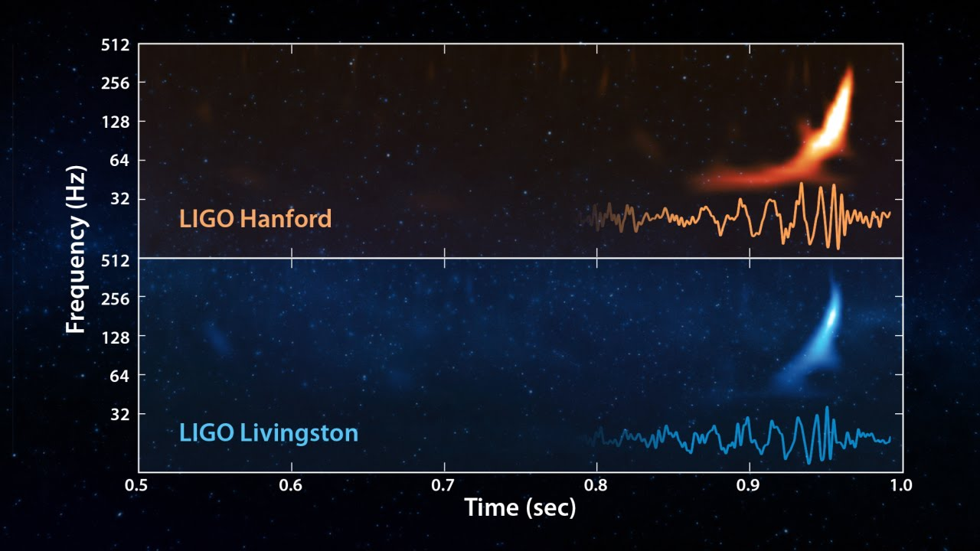

From the precise shape and amplitude of the two waveforms, it was possible to deduce (in a way I find quite amazing) that the two detectors had observed the merger of two black holes of 29 and 36 solar masses to produce a single black hole of mass 62 solar masses. You will spot that 3 solar masses has been ‘lost’. It is this mass that has been converted into the gravitational wave that was observed − the most energetic event that has ever been witnessed from Earth! From the amplitude and hence energy in the wave measured on Earth by Advanced LIGO, it was possible to deduce that the event happened at a distance of 1.3 Billion light years (+/- 500 Billion light years).

A candidate, but unconfirmed, event was observed on October 12th but then a confirmed event (GW151226), the merger of 14 and 8 solar mass black holes, was observed on December 26th, thought to be at a distance of ~1.4 billion light years. LIGO was able to observe 27 orbits over one second (as opposed to 2/10ths of a second for GW150914, the first detection). The observations agree perfectly with General Relativity and showed that one Black Hole is spinning. As in operation in its first observing run Advanced LIGO would be expected to see ~1 event every two months. Following its first observing run, improvements to the system (such as increasing the laser power) will, over time, increase its sensitivity by a factor of two so enabling black hole mergers to be detected at greater distances and should also allow the merging of two neutron stars into a black hole to be observed.

Further gravitational wave detectors are to come into operation: VIRGO and GEO600 in Europe, KAGRA in Japan and a further Advanced LIGO detector in India. When an event can be detected by several detectors, the time differences will allow far greater precision as to its direction so perhaps enabling optical telescopes to observe the galaxy system in which it occurred.

A detector with ‘arms’ of length 5 million km, called e-LISA, is planned to be located in space and this year the ‘LISA Pathfinder’ satellite has proven many of the techniques that are needed.

A new era in the study of our Universe has begun!

However, though we are now showing the Einstein's theory holds true to high precision, this cannot be the whole story.

One of the most perplexing problems in theoretical physics at the present time is the attempt to harmonize the theory of general relativity, which describes gravitation and applies to the large-scale structure of the universe (including stars, planets, galaxies), with quantum mechanics, which describes the fundamental forces acting at the atomic scale of matter. It is commonly thought that quantum mechanics and general relativity are irreconcilable, but general relativity can be linked to massless particles called gravitons. There is no proof of their existence, but quantized theories of matter necessitate their existence and they would act as ‘messenger particles’ carrying information about changes in mass distribution in the same way that the other fundamental forces have messenger particles − for example photons are the messengers of the electromagnetic force and gluons are the messengers of the strong force (which keeps groups of three quarks bound together to form protons and neutrons).

The graviton is an essential element of much modern theoretical physics and one major effort of the Large Hadron Collider, the world's largest particle accelerator and collider, is to provide evidence for their existence though it will not be able to detect them as such.

One problem is that the force of gravity is ~10³⁹ times weaker than the other electrical forces that control the universe. One idea is that is that gravity may in fact have an intrinsic strength similar to that of the other forces, but appears weaker because it operates in a higher-dimensional space. This provided a link with string theories where there may, in fact, be 11 dimensions in all. Six of these are tightly curled and form the fundamental particles − called strings. The way in which these vibrate defines the type of particle. Four further dimensions are those of space and time which thus leaves one further dimension. Some think that gravitons can ‘leak out’ into this hidden dimension so that gravity appears to be far weaker than it actually is.

We have a lot to learn!

© Professor Ian Morison, 2016

