# 

# 

16 November 2016

**The Prevention of Cancer**

Professor Christopher Whitty

When Gresham College was founded, cancer was rare and even more rarely diagnosed. Bills of Mortality published shortly after the College started show less than 1% of deaths were ascribed to cancer. As other causes of death, initially infectious ones and more recently cardiovascular deaths have retreated the relative importance of cancer has steadily grown. Whilst cancer was considered rare in the 1600s, risk factors for cancer we recognise today were hotly disputed at the time of this college started. The first Gresham Professor of Physic, Matthew Gwinne got his MD in part on the question of whether frequent use of tobacco was beneficial. He subsequently debated it in front of King James VI & I who famously described tobacco as “A custome lothsome to the eye, hatefull to the Nose, harmefull to the braine, dangerous to the Lungs”. Dr Gwinne went on to become commissioner for inspecting tobacco.

Overall mortality from cancers is a combination of how common they are (incidence; new cases a year) and survival (how likely you are to die if you get the cancer). In the last lecture on treatment of cancer we discussed how survival has steadily been improving for most, but not all cancers. Some treatments are also becoming less unpleasant, but prevention of cancer will always be better than cure. In this lecture we will consider how to reduce the incidence of cancer. Cancer Research UK (CRUK) estimate that 42% of cancers in this country are preventable and in some countries the proportion of preventable cancers would be even higher. For some of cancers, including some of the least treatable ones, prevention is relatively straightforward. For others prevention requires lifestyle modifications people may not wish to make. For most cancers however the single biggest risk factor is age, which cannot be modified. If, therefore we do not prevent cancer, the incidence of many cancers will rise inexorably in all countries with ageing populations.

**Where science and politics interact. What is the role of the state?**

Cancer prevention is not just about science. In all political traditions the debate about the responsibility of the state compared to the individual is one of the central questions of politics. There is a long and proud tradition arguing that state should interfere in the lives of individuals as little as possible. This is true on both the left and the right of the political spectrum although the arguments are couched differently, and there are clear trends over time and between generations. This presents a challenge to cancer prevention along with other areas of public health. In the UK some sections of the press try to ensure the voice of this tradition is heard, others make use of it in a way which is wildly inconsistent, personally unpleasant and intellectually incoherent, largely consisting of screaming headlines about nanny state in one section of the paper whilst calling for bans in others. The question of what the public thinks are the relative roles of the state, the medical profession and individual is however a very important one and should be taken seriously, and sometimes those of us working in public health do not give it enough thought.

Sensible people who are sceptical of the desirability or necessity of the state intervening in the lives of citizens for public health tend to be prepared to consider it reasonable if one or more conditions are met. Generalising a more complex picture these include: that the evidence is strong; the degree of damage substantial and the interventions have an effect; where infections are involved so protecting one protects all; protecting the vulnerable and in particular children; were it is cost-effective; when it protects the working age population. They tend to be more sceptical when: it removes rights; it removes pleasures; it exposes citizens to the law; it is a barrier to trade; it expands government; they often have a general, and sensible, caution about unintended consequences. State or medical intervention is not however all or nothing. There is a ladder of interventions starting with informing, moving through engagement with industry, nudge taxes, heavy taxation and on to banning things completely. Different interventions for different cancers will reasonably have different levels of public support.

**Preventing cancers driven by infections.**

An area which is widely publicly accepted is preventing infections which will go on to cause cancers. Several cancers are driven in in part or largely by infections. Examples include cervical cancer from human papilloma virus, hepatoma liver cancer from hepatitis B and C, stomach cancer from *H. pylori* bacteria, and several cancers including lymphomas and Kaposi’s sarcoma made possible by HIV.

In the UK probably the most important systematic attempt to prevent cancer by preventing infection is HPV (human papilloma virus- wart virus) vaccination in children before they are sexually active. Up to 70% cervical cancer is currently caused by two viruses, HPV 16 and 18. Since vaccines against them are over 95% protective, and there is very high school vaccine coverage, even without other interventions over the next decades cervical cancer rates in the UK will roughly halve. New vaccines are likely to extend coverage to the HPV types which cause the majority of the remaining cancers. In the intervening period it is possible to detect abnormal cells which are not yet cancerous using smear (PAP) tests, and tests for the viruses themselves. This led to a steady decline in cervical cancer in the UK even before vaccination was introduced.

Although cervical cancer is a significant problem in all countries it is especially common in developing countries and in particular in southern Africa. Introducing HPV vaccination worldwide would have a substantial public health benefit for women everywhere. Even more widespread is hepatoma (hepatocellular carcinoma of the liver) secondary to hepatitis B infection. It is a rare cause of liver cancer in the UK but a very common one in East Asia and West Africa. Introducing Hepatitis B vaccination a birth in Taiwan led to a substantial reduction in hepatoma and is likely that as it is rolled out elsewhere in Asia and Africa it will lead to major falls in this common disease.

Cervical cancer and hepatoma secondary to Hepatitis B are examples where a vaccine before infection can abort a potential route to cancer. In the case of *H. pylori*, a relatively bacteria of the stomach, there is no vaccine but it can be treated. *H. pylori* is associated with the commonest form of stomach cancer, as well as the relatively rare lymphoma MALTomas of the stomach. There is now good indirect evidence that treating *H. pylori* before cancer begins stops the subsequent cancer occurring in most cases. In the UK *H. pylori* infection is often treated to prevent peptic ulcer disease. It is likely that the significant reduction that has been seen in stomach cancer is at least in part due to treatment of *H. pylori* with antibiotics on a widespread scale. In areas the world such as China where stomach cancer is more common the impact of this on reducing cancer may well be substantial, although there are other causes of stomach cancer so it will not be completely eliminated.

**Occupational cancers**

Preventing occupational cancers commands widespread support. Some cancers which are occupational in origin have now disappeared such as Potts scrotal cancer which was almost exclusive to chimney sweeps. In the UK around 4% of cancers are occupational in origin. Not all can be prevented but some can and the most important example is mesothelioma. Almost all cases are caused by occupational exposure to asbestos. The UK, which currently has one of the highest rates of mesothelioma incidence in the world, arguably was slow to recognise the threat asbestos caused. Asbestos was heavily regulated from the 1980s and banned at the end of the 1990s but because of the delay between exposure and cancer the peak of mesothelioma has only just been reached and it will take many years before it has substantially declined.

Figure 1. Observed and projected mesothelioma rates, UK.

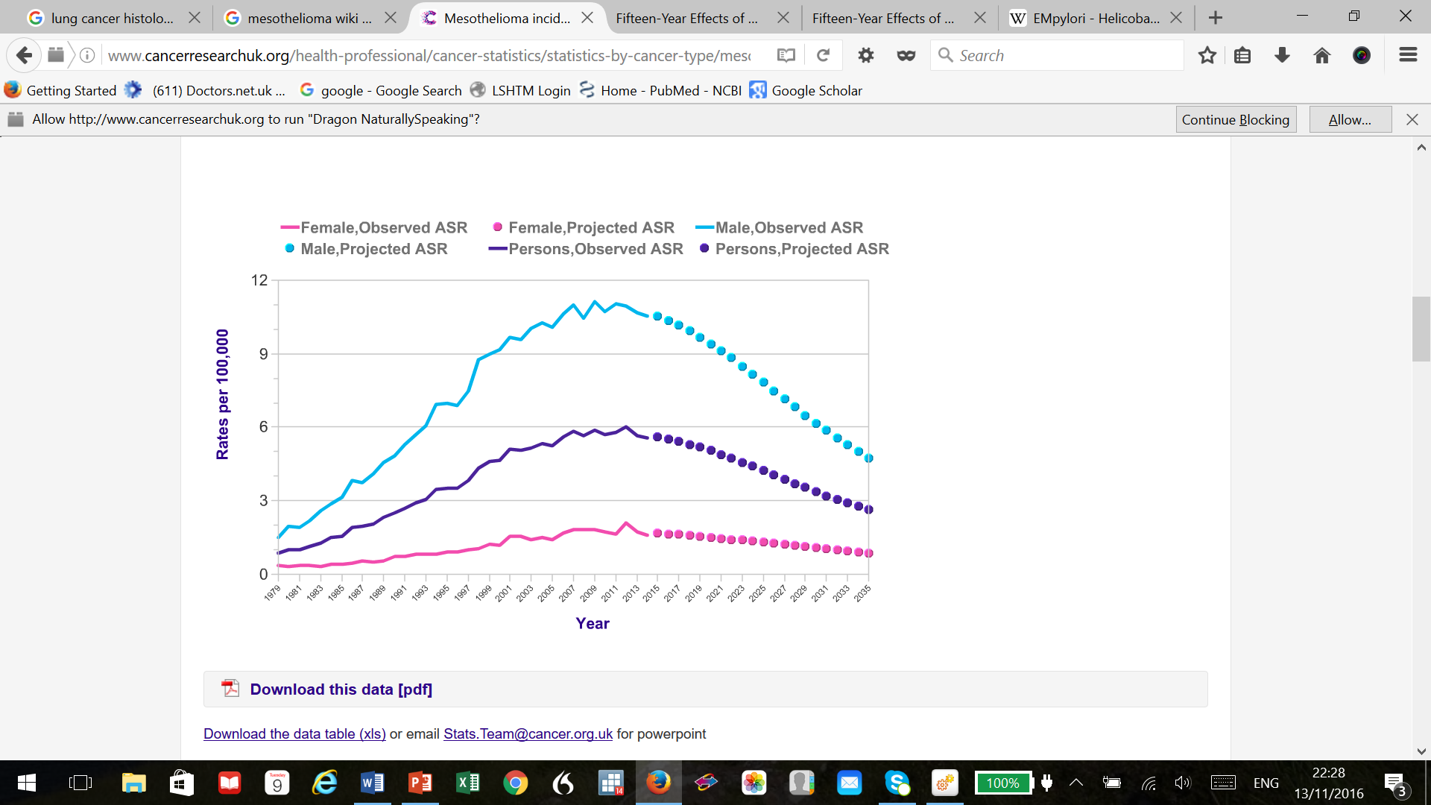

**Genetic screening and prophylactic measures**

Genetic screening for the small group of people with substantially increased risk of cancer offers the chance to head off that cancer. It is likely that this area of public health will expand over the next 20 years. Identifying genetic predisposition to cancer is only useful if the link is strong enough to act, and there is a treatment available. Having genes such as BRCA1, BRCA2 or TP53 are examples where there is. Currently surgical interventions such as double mastectomy in very high risk women are major interventions only justified by substantially increased risk. Long-term prophylaxis with drugs is however a realistic possibility in at least some cancers; an example is tamoxifen or raloxifene which NICE recommends for some women with very high risk of breast cancer. Taking drugs to prevent cancer may in time and in some people become similar to taking statins to prevent cardiac disease in those with high cholesterol. The trade-off is between reducing the risk, and the side effects, inconvenience and cost of the drugs. The more precisely the risk can be assessed, and the safer the drugs, the more likely this will become a major part of cancer prevention in the future.

**Smoking: the front line in the fight against cancer**

The impact that smoking has on increasing the risk of cancer is difficult to exaggerate. Around 28% of all cancers in the UK are smoking-related, and for lung cancers which are some of the least curable, most unpleasant and most common cancers in the UK four out of five cases will be caused by smoking. It also contributes to mouth, pharynx, tongue, lip, oesophagus, larynx, nose, bowel, cervix, liver, ovary, kidney and bladder cancer. The evidence that smoking caused lung cancer was clear by the end of the 1950s, coming from observational, case-control and cohort studies, and accepted by the end of the 1960s (except by a few tobacco companies which made a policy of trying to extend the period over which this was seen as a ‘scientific controversy’). The impact of smoking on cancer is dose-related with more smoking leading to higher risk. On the positive side stopping smoking reduces the risk of cancer, over time very substantially.

Figure 2. Smoking rates in men and women, and lung cancer rates, UK.

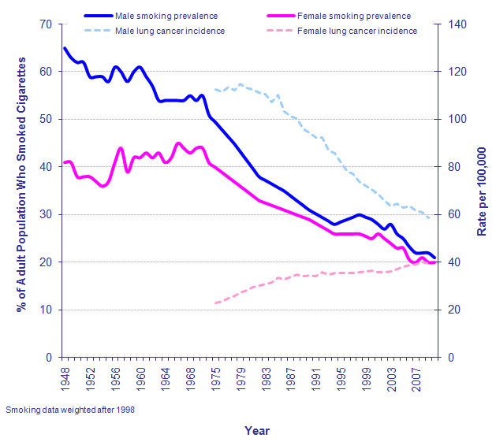

Smoking is an area where when considering the ladder of intervention by the state on reducing cancer in individuals the justification for more state action seems clearest. Scientific evidence is overwhelming, the disease is common, fatal and extremely unpleasant with limited long-term treatment, smokers are suffering from an addiction which makes it very difficult for them to control their habit, stopping smoking occurring virtually eliminates the risk for most people, and stopping smokers smoking significantly reduces the risk. Smokers pose a risk to anyone who inhales their smoke, their children and above all themselves. In a theoretical world where smoking did not occur cancer rates in UK would be much lower than they are today.

**Alcohol, obesity, diet**

Alcohol is a major risk factor for some relatively rare cancers including oesophagus and mouth cancer, and a minor but not trivial risk factor for some major ones in particular breast cancer and colon cancer. Like smoking the risk is incremental. Estimating alcohol use in itself is often quite difficult since alcohol intake varies over the life course, over the week and recall of alcohol intake is often inaccurate. There is however reasonably strong evidence supporting the link of alcohol and cancers. Like smoking the risk of alcohol is incremental; for example for breast cancer the risk from light drinking (a small glass of wine a day or less) is extremely small, whilst for heavier drinking that would still be considered social drinking (for example 3 large glasses of wine a day) risk is much higher. Cancer is not the only health risk of heavy drinking, but it is an important one.

The composition of diet has a significant impact on the risk of cancer, and in particular colon cancer and stomach cancer. Most people are aware a diet high in fibre vegetables and fruits is associated with a lower risk of cancer, and conversely one high in red meats and processed meats is associated with higher risks. These associations are undoubtedly there in observational studies of various types. Teasing apart which components of this diet are the most important has proved surprisingly difficult, but current estimates suggest a healthy balanced diet would in theory reduce cancer risks particularly of the colon and rectum by up to 9%.

Obesity is one of the greatest worries because unlike smoking rates are going up steadily in the UK and most other developed, and increasingly developing, countries. Reducing obesity rates is a difficult policy challenge. Obesity is however easier to measure than dietary factors or indeed alcohol making detecting associations easier. Meta analyses of pooled data suggest significant, although not dramatic, associations with colon cancer (especially in men) and endometrial cancer and postmenopausal breast cancer amongst others in women. There is a negative association with cancers which are largely caused by smoking, probably because smoking is associated with lower weight, but not enough to offset the major cancer disadvantages of smoking. Overall current estimates are that around 5% of cancers are associated causally with obesity, and smoking rates decrease and obesity increase this proportion is set to go up. Obesity of course has other, non-cancer related health risks.

**Conclusion**

This talk has not considered every risk factor for cancer. For example everyone now is aware that too much exposure to sunlight increases the risk of malignant melanoma and other skin cancers. It has however discussed most of the major risk factors which are preventable for cancers. Overwhelmingly the most important is smoking, and reducing that will lead to significant reductions in cancer in the future. Some cancers can be largely or completely prevented by preventing infections (cervical cancer) and stopping occupational exposures (mesothelioma). These are widely accepted to be the appropriate role of the state. There are some cancers such as prostate cancer for which no modifiable risk factors have yet been identified. For what are sometimes termed lifestyle risks such as smoking, heavy alcohol use and obesity the public reasonably expects strong evidence and a strong association if state measures are proposed. Informing people of risks, whatever some parts of the press may say, is always appropriate if based on best current science. For some, in particular smoking, moving a lot further up the ladder of state intervention is widely accepted. The overall message of this talk however is that a substantial proportion of cancers are preventable, and some of them are easily preventable. Within the lifetime of this audience several important cancers will decrease very substantially as a result of actions we are taking now.

© Professor Christopher Whitty, 2016

Gresham College

Barnard’s Inn Hall

Holborn

London

EC1N 2HH

[www.gresham.ac.uk](http://www.gresham.ac.uk)