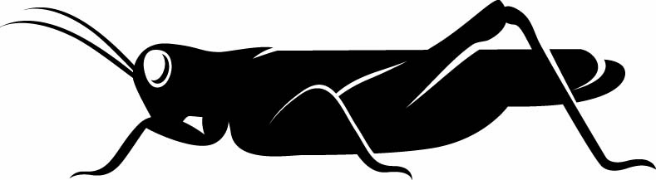
31 January 2017
Cheats, Liars and Fornicators:
The Hidden Face of Mother Nature
Professor Steve Jones

It is a strange thing, the truth about beauty. People are interested in beauty, and obviously, it is a very important thing, and wonderful things have been written about it, and wonderful paintings have been made based on beauty, but what is beauty? In some senses: “Beauty is truth, truth beauty, that is all ye know on earth and all ye need to know” – that of course is Keats, “Ode on a Grecian Urn”, and it is a very beautiful line, but in fact it probably is not true. But one very common use of beauty is to see the handiwork of God in the works of nature, and you can see that again and again – there are dozens and dozens of websites – nature declares God’s glory in a universal language, and the fact that something is beautiful somehow defines the fact that there must be a very beautiful divine being arranging matters so that should be so. Nature declares God looks glory but that is actually very misleading, at least to biologists, because to biologists, beneath every beauty lurks a beast. It may well be hidden away, but now and again, it will show its ugly side, and that is what I want to explore in this talk.

Nobody can deny that much of nature is very beautiful, and nobody can deny that the theory of evolution is very beautiful.

This is the famous last paragraph of ‘The Origin of Species’:

“From so simple a beginning, endless forms most beautiful and most wonderful have been and are being evolved.”

That is the last line of ‘The Origin of Species’, the only time in ‘The Origin’ actually that the word “evolve” appears, and the word “evolution” does not appear at all. I have no problem at all with Charles Darwin, agreeing that many of the works of nature, physical and biological, are indeed beautiful, and you can see that when you look around you, the beauties of nature, the beauties of flowers for example, the beauties of butterflies, the beauties of birds, and even the beauties of our fellow primates. But all those beauties are, in some way, either screams of sexual frustration, which many of them are, silent screams of passion in an attempt to attract a mate, they are screams of rage in an attempt to fight off predators, or they are screams of dishonesty when you pretend that you are dangerous or attractive when in fact you are not. So, nature is basically lying to you when it says that it is beautiful. It is a phenomenon of evolution.

I have to tell you, with some pride, that the last word has now been written on Darwin and on evolution, and I have to tell you with further pride that that last word was written by me, a book published last week, which is actually the ‘Ladybird Book of Evolution’, which summarises the whole of Darwin’s argument, the 170,000 words of ‘The Origin of Species’ in 5,200 words – that is a mastery piece of editing and the pictures are nice too. It has not sold nearly as many copies as Prince Charles’ book on global warming, which I can kind of understand, but I am most miffed to find that it is sold even fewer copies than the third one in the series, which is the ‘Ladybird Book of Quantum Mechanics” – my God!

Darwin knew that a real disproof of his theory would emerge if he ever found a creature that was acting solely for the benefit of another species. He says that, more or less, bluntly: if he finds a creature that lives only to help another species, that could not have evolved. Evolution is fundamentally a selfish phenomenon, hence the famous “selfish gene”. Well, he has no reason to worry because, in spite of many claims that it is true, it has never actually been found to be true at all. Under peace, there is always conflict, and under what seems stability and beauty is often a secret…a quiet war which means that the whole system is poised on the edge of collapse.

We can illustrate that with a very famous and familiar analogy, which is the Red Queen hypothesis, which has been much-used in biology and I’m sure you are familiar with it, and it comes of course from ‘Alice in Wonderland’. ‘Alice in Wonderland’ is an extraordinary book. It is an extraordinary book not only because it is a wonderful classic of English literature, but also contains within itself many, many scientific themes, in mathematics more than anything else, because the Reverend Charles Dodgson was a mathematician, and many of its hallucinatory moments, such as Alice growing or getting smaller or neck stretching, reflected the fact that Lewis Carroll had migraine, very severely, and often saw things stretching or disappearing, or a big blob appearing in front of his eyes – the Cheshire Cat, in other words, where only the smile was left. But that is neither here nor there!

The Caucus Race, where they go round in circles, and then Alice runs as hard as she can and she runs like mad and she is astonished to find that she stays in the same place. That has been used again and again by biologists to illustrate what is called co-evolution, the interaction between two species as as they try to take advantage of each other, and often invest a lot in taking that advantage, but in the end, they end up in the same place, in a stable kind of equilibrium, even in spite of having invested vast quantities of effort in trying to fool and take advantage of their partner.

Darwin was very well-aware of the problem. It is worth remembering that Darwin wrote 19 books altogether, some of which are practically unreadable. There are four books on fossil barnacles. I do not particularly recommend them. But the book after ‘The Origin of Species’, just three years after ‘The Origin’, actually summarised this particular issue of a co-evolutionary race, with two combatting partners, often generating the most beautiful objects very precisely, and this was Darwin’s 1862 book – ‘The Origin’ was 1859 – on the various contrivances by which British and foreign orchids are fertilised by insects. That was a classic of Darwinian writing because he solved yet another problem in a book, and then he went and resolved human evolution, he was an extraordinary genius. But Darwin was interested in orchids, for many reasons, particularly because they are exquisitely adapted, or so it seems, to their pollinators. Orchids are of course plants. Many of them are simultaneously male and female. Darwin already knew about sexual selection – the peacock’s tail, and so on. He knew that there was a battle among males in order to defeat the male opposition and to attract the females, and a battle among females to choose the best, highest quality male. He saw that when he talked, for example, about the peacock’s tail.

That is also true in plants, except in plants a third party is involved because what a plant needs, from a plant’s point of view, a bee is a flying penis and that is what it does. It comes flying in, for its own selfish reasons, to get a reward from the plant, and as it does, if it gets its reward, it picks up the pollen, and delivers pollen at the same time, and moves genes between plants. Now, from the plant’s point of view, what we need to have is a pollinator, which is busy, hungry and faithful, in other words, it is always at work, it does not get much of a reward, and it only comes with the same kind of plant every time. But from the pollinator’s point of view, things are quite different: it wants to be lazy, bloated, and promiscuous – that is what it really wants to do. It wants to have a good time, basically, and flit from flower to flower, of different species, getting a big reward each time, and not having to do too much work. Now, we have got this classic tension between the two, and you can see that better than anything else probably in orchids. The contrivances by which orchids are fertilised are as varied, and almost as perfect, as any of the most beautiful adaptations in the animal kingdom, and Darwin was certainly right, and he talks enormously about the details of how they do it.

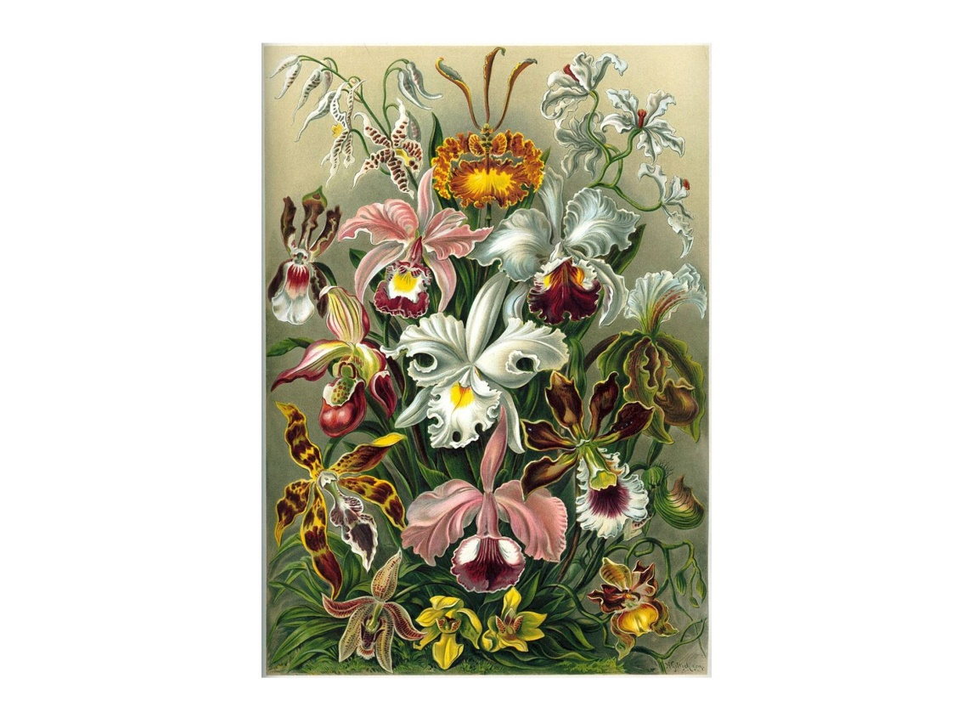

Here is a Victorian illustration of some orchids, and I think you will agree, they are the most astonishing, complicated, and beautiful flowers, and they are very, very expensive, and very hard to grow. A bunch of orchids is an expensive gift to your potential mate, so in some senses, they play a part in our own reproductive lives as well. They get their name – their Latin name is the orchidaceae, and actually, “orchidaceae” is the same root as “orchidectomy”, and they are named after their roots, which look exactly like testicles, which actually, given their own sex lives, is actually rather appropriate. We will see later there is a close tie between this battle between the two partners and the evolution of sex itself.

Darwin saw that they were an example of sexual selection. The selection was on the botanical equivalent of the peacock’s tail, as I have already said. There are thousands and thousands of flowering plants, thousands and thousands of different pollinators – insects, kangaroos do it in Australia, bats do it quite frequently, even giraffes do it to some African acacia trees, moving pollen around. So, it is a busy business, there is no question, and this, as I said, there is a divergence in interest between the two parties. So, as a result, what seems like cooperation, pollinator and plant, is full of discord. The bunch of flowers is an advertisement, a statement of a high quality product, from the insect’s point of view, but like many advertisements, it overstates what it is going to offer, as we will see.

Darwin saw this precise convergence and cooperation, between different species of plant and their pollinators, which was sometimes extraordinarily precise. Somebody once sent him, from Madagascar, a particular flower called Angraecum, which has a nectary a foot long, and he speculated that there must be in Madagascar a moth – and these things are pollinated by moths – which had a tongue a foot long. Well, there is Darwin’s orchid, and if you want to see Darwin’s orchid, if you go to Down House in Kent, they are growing in the greenhouse there. In I think it was 1992, finally, the moth was discovered, and that is the pollinator. That is one of the very rare predictions you could make that has ever been made in Biology and found to be correct. And there is a race: there is a constant tendency by the plant to increase the length of its nectary; and this challenges the moth even further, and then the moth has to match that by increasing the length of its tongue until perhaps it gets to the physical limit and you end up with this very precise type.

However, if you make a family tree of orchids, using DNA, which you can do, make a phylogeny as we say, look at the all the orchids and see who is related to what, make a pattern of kinship of the orchids, and that has been extensively done in all plants, including orchids, and you do the same for the moths or for bees, it turns out they are not the same. So, it turns out that what looks like stability is not. These moths have shifted, over evolutionary time, from one species of plant to another. It does not happen very often, which is why we do not often see it, but it really does happen.

But Darwin realised that there was plenty of opportunity for cheating in this system, and he was baffled to find that some orchids did not give a reward, and he could not understand that at all. These were in Southern England, these orchids, and he just could not understand that, and he called this, “this gigantic imposture”. He could not see how that evolved. He was so obsessed by this – how could this evolve? He spent a long time dissecting the orchids and grinding them up and seeing if the plant was eating a bit of orchid or eating the pollen – no, there was nothing there. What he did not realise is how dishonest these things could be because these were what we call mimics. These are orchids that do not give a reward, and yet look sufficiently attractive and like plants that do give a reward to bring pollinators in, at no cost to themselves.

There are many of them. For example, here are three of them:
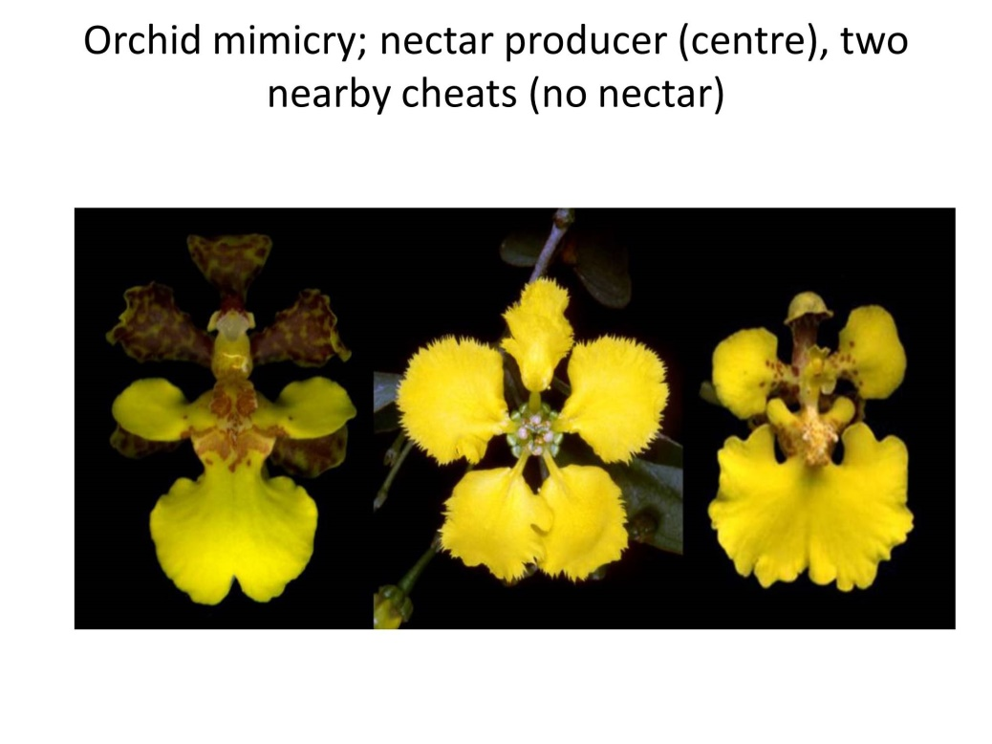

The central species is a real nectar-giver. The ones on either side are cheats. They look remarkably like the central one, and you tend to find that the mimics tend to grow scattered among their hosts, because if the frauds all grow together, then the insects very quickly learn that these things are frauds, so in other words, these plants, a bit like fraudsters in the City of London, tend to attach themselves to different groups of companies, or in this case, rewarding orchids. In fact, about a third of all wild orchids act in this way, so there is plenty of underhand stuff going on. They are manipulating the behaviour of their pollinators, and that, it turns out, is something which is very common in nature, that one party changes the behaviour of the other party for its own advantage, and of course mimicry of this kind is common in animals too.

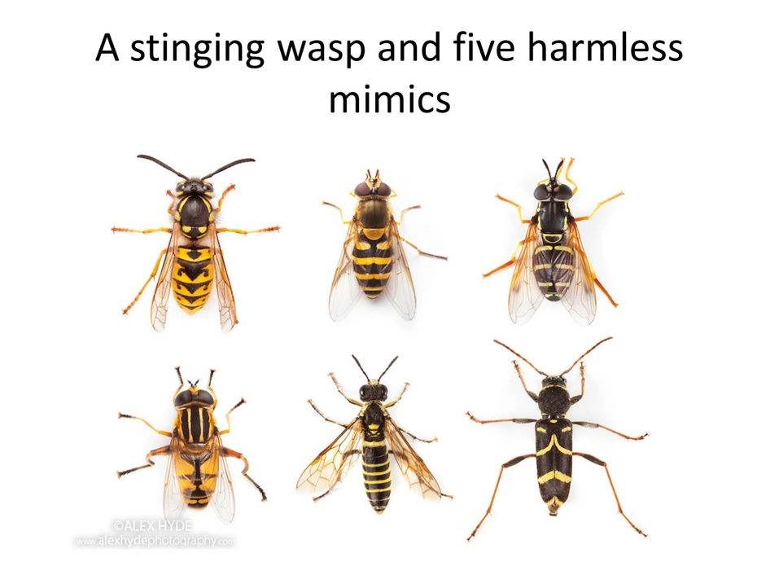

There is a very familiar case, the stinging wasp, and five harmless mimics, some of them are flies. One of them, on the bottom right, is actually a beetle. But if you are flying along, as a bird, and you have been stung by a wasp, you are going to avoid them all. But of course, that is an indirect kind of parasitism because, if there are too many mimics, then the birds come flying along and they might learn to associate these bright patterns with things which are tasty rather than things which are dangerous, so that the dangerous ones get attracted more often. So, this is a kind of parasitism with an indirect kind of parasitism, and there are lots and lots of examples of it.

Here is a very bizarre one. It is a Peruvian bird who is nestling, when it is little and small and tiny, and they are often attacked by predators, other birds that come in and pick off the nestlings. It actually mimics a toxic caterpillar. It is only just been discovered a few weeks ago. They have done experiments to show that it actually does, it works. So, I have never seen a bird that actually mimics a caterpillar before, but these are everywhere, and there are some famous examples of them.

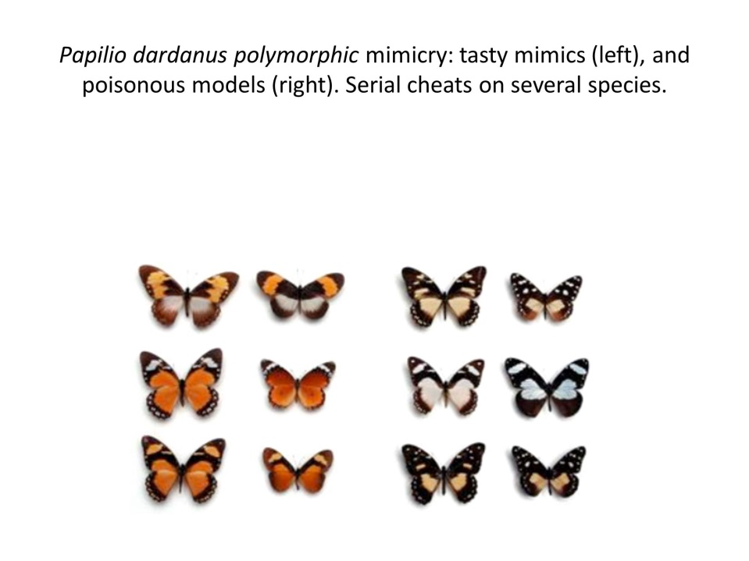

If you have travelled in Africa, I once did some work on these things. This is a butterfly that is called Papilio dardanus, and if you look at those butterflies, if you look at the ones on the right, at the three – there are two groups of six. On the left-hand group, there are some brownish ones on the right, and on the right-hand group, there are some blackish ones on the right. Every one of the smaller individuals is a different species of butterfly. They are totally distinct from each other. They are in different genera, they are not related, they do not mate with each other, and they look different. The other six, the ones on the left, the slightly larger ones, are all the same species of butterfly, Papilio dardanus, which have evolved to mimic different species of the poisonous ones, and of course therefore they are forcing the poisonous ones to pay a price. When the poisonous ones are very abundant and the mimics are rare, then mimicry is perfect; when the mimics are very abundant and the poisonous ones are rare; then mimicry breaks down. So, it is a dynamic thing.

I had a friend of mine, years ago, who wanted to know how poisonous these butterflies were. He had seen them in Africa. The birds will eat the model and immediately throw up. So, he decided to eat one and he thought he had better check with the medics first, and it turned out the amount of poison in these models – they are called cardiac glycosides and they are actually got from plants - is enough to kill five people if you eat one of them, so I do not recommend it. Next time you are in Africa and you feel like eating a butterfly, make sure it is a mimic rather than a model.

It is an interesting and fascinating thing, and, once again, it is a matter of the mimic manipulating the behaviour of the predators, behavioural change. There are some examples of what we call aggressive mimicry too.

Cuckoos are a well-known example of mimicry. Actually, cuckoos themselves - and there are many cuckoo-like birds across the world, the familiar British cuckoo, but also plenty in Africa, a totally different group in the Americas – they actually themselves are mimics. They look like predators. They look like hawks, sparrow-hawks or other kinds of hawks. They are not. They generally eat insects. But what they do is they terrorise small birds, because they look like hawks, the small birds then leave their nests, and of course then the real parasitism comes in when the cuckoo zooms in and throws out at least one of the eggs of the host species and dumps its own egg. I do not know if you have ever seen the bits of film which are occasionally shown on television. They come in, throw out an egg, and dump their own egg within two or three seconds – it is quite a remarkable piece of behaviour. Of course, what happens then is that it lays its egg in another species’ nest and we get, just like the butterflies, races of cuckoos that specialise on different models.

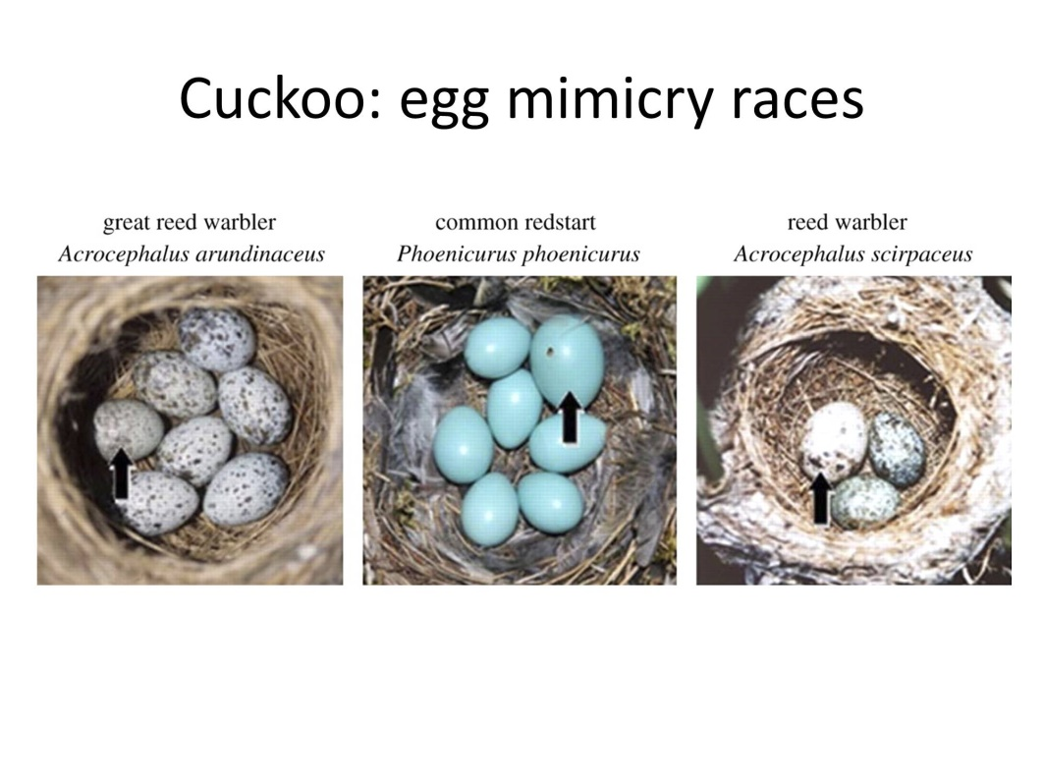

Here we have a reed warbler and the black arrows are the cuckoo’s eggs, and you can see how perfectly they match the eggs of their targets. They are always slightly larger, but the birds do not seem to notice that, and of course what happens is that the cuckoo’s egg grows more quickly and hatches earlier than the other ones, and then we have the hatch, the cuckoo chick, which has got a little back-pack on its back, in which it can grab the other eggs, or even the other chicks of the native species, and throw them out, and then it grows to be this enormous cuckoo in the next, which the poor parent sees as a bunch of its own offspring. It does that because, if you take the song of a particular model bird, a reed warbler in this case, and you record it, you can say it just goes cheep-cheep, something like that – I am not very good at doing read warblers – but if you do the whole brood of reed warblers, six or seven of them at once, you get this constant cheeping. If you then get the cuckoo chick, it makes the same noise as a whole brood of reed warblers, and the poor old parent thinks it is not one big bird but six of its own small birds and so it feeds it. That is what we call a super-stimulus. That is an exaggerated form of a particular thing, and again, it is a battle between the two. The stimulus is it is a dishonest advertisement.

There is an arms race here. Some species of bird can identify cuckoo’s eggs and throw them out, always, so they do not get parasitized very much. Others do it sometimes, but not always, and others cannot do it at all. So, clearly, this is a dynamic process, like all the others.

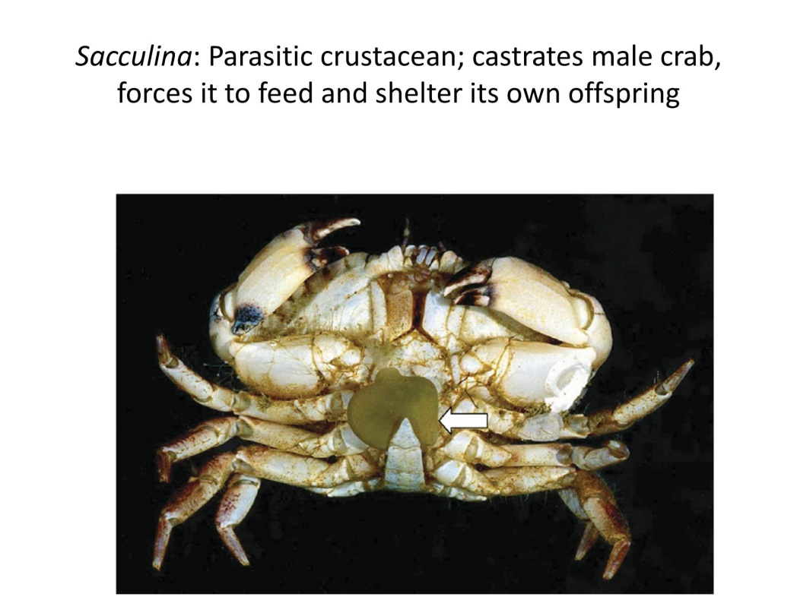

There is a very strange and rather telling example of altering the behaviour of a host, which is this creature here. We are moving towards the fornicators now. This is a crustacean, a thing like a small barnacle or crab, which its Latin name is sacculina. What sacculina is, it is a parasite on other crabs, and my God does it change its host’s behaviour. That thing with an arrow is actually called the externa. It is part of the sacculina. The sacculina itself does not look anything like a crab or a barnacle – it has not got a shell. But what actually happens is that a female sacculina gets onto a male crab, bores its way into it, gets in there and starts growing through the whole tissue mass of the crab until really it has taken up a large part of the crab’s body, and it leaves a bit of its own body, in fact its own egg mass, outside the crab’s body, in exactly the same way as a female crab would put her own egg mass when she lays eggs, but then a male sacculina comes along, fertilises the female parasite, and together they feminise the male. They castrate it. They switch on hormones that cause the male crab to become female so that is hard luck on the male crab. It even does female mating dances, which is perhaps rather embarrassing for the male crab But as the process goes on, the sacculina, the parasite, releases its own eggs into the water, and female crabs, when they release their own eggs, have a rather interesting piece of behaviour: they release them one at a time and then they wave them off in the water, they wave them off to give them a chance, a better chance of staying alive, rather than have one small mass of crab larvae. Well, the sacculina does that, and the crab, the parasitized crab, does that very complicated piece of behaviour, but what it is doing is taking its parasite’s larvae and waving them off, so its entire brain has really been taken over by the existence of this parasite.
So, do we have anything similar in our own parasitic history? The answer is yes.

It is a parasite called a toxoplasma, it is a single-cell parasite, and it is a very common behaviour pattern among parasites to have more than one host. Some of them have whole chains of hosts. But this one has got, effectively, two hosts: it has got a mammal, a cat in this case, which is its primary host, where it has sex and produces its own offspring, which are then excreted by the cat; and it has got a secondary host, which, generally speaking, is a mouse.

Mice live in a world of smell. Anybody who has ever kept mice or been into a mouse laboratory will know immediately that mice live in a world of smell because they stink! But they have a very, very sophisticated apparatus for identifying their kin, animals from different populations, predators, and if a mouse smells cat urine, it will immediately think, “Good God, I am not staying around here!”, and it will run away as fast as it can, unless, that is, it has been infected by this toxoplasma, which gets into the mouse brain and persuades the mouse that the most delicious perfume in the world is in fact the smell of cat urine. So, what it does, it sniffs this urine and says, “Oh, that is a marvellous perfume!” and it rushes up the stream of urine until it finds the cat and is eaten by the cat.

But the problem is that humans themselves, sometimes often, get infected by this particular parasite. They do not really play a part in its chain, but incidentally, they get infected. About one person in three in the UK has been infected at one time or another – more than that in France, which I find oddly comforting. Now, usually, there are no obvious symptoms, although there are certain conditions, called toxoplasmosis, which is dangerous for pregnant women or people with deficit immune systems, but most people are not aware that they have been infected. However, there has been a lot of controversy about this, but I think the recent literature makes it really quite clear, that what happens is, when it gets in you have got a cyst of the toxoplasma in a mouse brain. It is also in human brains, when it gets in, and there is a very strong fit between symptoms of mental disorder, such as schizophrenia, depression and suicide, and the presence of toxoplasma in the brain. So, it is doing something to the human personality, and the effect is statistical but I think is strong.

There is an even more startling statistic, which has been put around quite extensively. It has to do with motor accidents. There is a recent paper, quite a large survey that was carried out in Prague, which took people who had been in car crashes, they had crashed their cars, a large group of them, compared to another control group of people who drove and had not crashed their cars, and there was an incidence of toxoplasma of almost three times higher in those who had crashed their cars into other cars or stationary objects, compared to those who did not have toxoplasma. So, just as in the mouse, this pushes you towards high-risk behaviour. So, there you have got the manipulation of human behaviour too by a particular cheat and parasite.

The big, high-impact question in Biology, which has not been answered, is: what is the point of males? Why do we bother with sex? Sex is incredibly expensive, in many senses, biologically, socially, in terms of embarrassment, and males are basically parasites on females. To put it crudely, what they do is they persuade the females to copy their male genes with either no input, apart from a few sperm, or rather little input in terms of childcare and that kind of stuff. So, why are males so damned persistent? Where do they come from and why do they persist? It is actually a sub-set of this story about the interaction, as in pollinators and orchids, the interaction between two parties with different interests, and indeed, sex, many people argue, originated with parasitism itself.

There are plenty of cases where you can grow plants and animals without males. A classic case when it comes to crop plants is the banana, which, in spite of its interesting shape, is in fact entirely asexual and all female, and in fact, all the bananas you see, in all the shops in the Europe, belong to the same clone – it is called the Cavendish clone – and in fact, I can tell you, eat your bananas while you can because the Cavendish clone is rapidly going extinct because they are all being attacked by various tropical diseases and they are all the same and it is a risky tactic.

The most striking case of co-evolution between parasite and host that we know, which is also associated with the origin of sex, has to do with the potato. We tend to forget how novel a crop the potato is. The potato is a New World plant. Its host races are many in the Andes and it kept huge populations of South Americans alive. It is an extraordinarily nourishing plant. You can live perfectly well just on potatoes, and perhaps a little bit of milk as well. It has got more Vitamin C in a big spud than in a lemon. So, it is the ideal plant and people grew it. It was not at all popular in Europe. It came across in the 16th Century to Spain, together with the gold of the Andes, but the Church did not like it because it is not mentioned in the Bible and it grows rather dangerously close to the Devil because it grows underground, so it was used as a medicine. There is a very strange line in Falstaff’s ‘Merry Wives of Windsor’, when Falstaff, who quite wrongly believes he has persuaded two women to share his bed, and he comes out with a line that has long baffled Shakespearian scholars. He looks up at the sky and he says, “Let the sky rain potatoes!” Many learned articles have been written about what he means, but in fact potatoes were thought to be an aphrodisiac in those days, hard though it is to believe. I have to say, I have eaten plenty of chips, with no apparent result! But they transformed the European economy, from the French Revolution onwards - the French Revolution was actually quite important in bringing potatoes in - and they particularly of course transformed the Irish economy, until, in 1848, or a bit before, what was called the potato blight appeared.

By that time, the poor, the Catholic, side of Ireland was really addicted to the potato. A family of eight could live on an acre of land, which is not very much, and on only potatoes and a single cow – they would stay healthy on that boring but adequate diet. So, the population of Ireland exploded, as you can see, from 1500 onwards, and when the potatoes came in, in about 1780, and you can see a rocketing up of the Irish population. But then came the potato blight. Nobody knew what this was. It seemed to be something which had come out of nowhere, but in fact, what it is was a single clone – it is called phytophthora infestans, the invading plant-killer. In South America, it is there, it had a huge effect. The population of Ireland crashed. It still has not got back to the level which it was at the time of the potato blight, and if you go to Ireland of course, as you will be well aware, in many parts of Ireland, there are deserted villages as a result of this enormous disaster. Actually, it is a classic of the interaction between parasite and host because, in Ireland, and across much of Europe, only one clone of potatoes was being grown, just like the bananas today. They were all genetically identical to each other, probably billions of potatoes. In Ireland, they were called the “lumpers” because they were big, lumpy potatoes, very productive and that was fine, until you got a parasite that could actually mimic the defences, the internal defence of the potato against infection. So, what the potato is basically doing is saying to other parasites “You cannot get into me – I have got a immune system that you cannot circumvent”, but once you get a parasite, as you inevitably will, in which a genetic change, or perhaps from somewhere else, has got a new form of virulence gene, then it is going to get in there and it is going to kill everything, and that is exactly what happened in the potato blight.

Of course, the potato in South America is a sexual plant. It has flowers, they pollinate each other, and there are many, many varieties. In Europe, it was not. In Europe, people just used to take seed potatoes, as they called them, cut them up, and just plant the lumps, and then they would grow another copy of what was there before. So, if you go to South America, you find these native varieties of potatoes, and there are hundreds of them, literally hundreds of them, and each one looks different, they taste different. Some of the South American native peoples still use them, much less than they used to, but now there is a potato bank, in Lima, in Peru, where they grow these things because, within these lines, there are genes which give resistance to different forms of this infestive parasite.

Every year now, or every couple of years, what happens is that the potatoes in Europe are – it is a place in Holland, appropriately enough, in Wageningen, in the agricultural university, which, every year, about this time of year or a bit later, scans the potatoes of Europe, and there are billions of potatoes in Europe, billions more in India and China, which are now the biggest growers of potatoes in the world, and asks what resistance, what susceptibility genes are present in this year’s crop, genes that make them liable to attack by these mimics, these fungus-like things, and adds new ones to protect the potato every year.

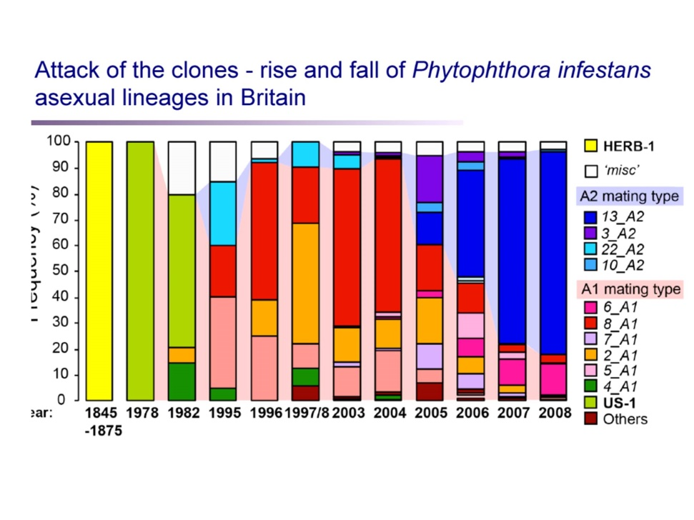

Here, we have got a rather complicated diagram, but what you can see is that, in 1845, there was only one form of the parasite in Europe, and that was the time – that lasted until 1875, and there was just one form of the parasite which could attack the one form of the potato. That lasted, more or less, until 1978. There would be one form of the parasite that would be replaced, after a couple of years, by another form, and another form, and you could – when it was done professionally, all they did was change the form in all the potatoes of Europe once a year, and that was fine, seemed to work, until 1977. In 1977, sex raised its ugly head because, in 1976, you may remember, there was a very, very dry year, which meant that the potato crop across Europe largely failed, and so what European importers did was to bring in American potatoes from a source which they had not used before, and that was Mexico. Mexico grows lots of potatoes. For reasons which are simply not understood, the phytophthora, the infestive parasite, is sexual in Mexico and not in the Andes, so what happened was, without them realising it, before 1978, they had had an asexual parasite and an asexual host, and in the 1978, they brought in sex and in fact, sex first appeared in Scandinavia, appropriately enough, where they brought in all the potatoes from Mexico, and that began to roar through the parasite population. That made evolution move much, much faster because, once you have got sex, you are doing what we call re-combining – you are getting new mixtures of genes every generation.

It is like playing poker. If you always get three aces and a king in your hand, you are going to win nearly every time against somebody who shuffles their hand every time, but one time, they are going to get four aces and then you are going to lose. With sex, you do that – you are constantly shuffling the cards. And once that had happened, you can see the rate at which the shuffling of the potato clones greatly increased. In 2008, there was a very, very powerful attack, which they had to move lots and lots of the blue section, resistances, in order to fight it, but now, this is very carefully controlled. But it is still poised on the edge. It is still poised on the edge, very much, of another potato blight.

In fact, sex and disease and parasitism are closely related. It is often suggested that they might be so closely related that this kind of parasitism, this kind of cheating, was at the origin of sex itself. I am now going to tell you a tragic story, from my point of view.

Thamesmead was built in the 1970s, on a swamp, and it is not the world’s most charming place. Thamesmead is built on an interesting swamp because it was one of the anchorage points, in the 19th Century, of ships going up the Thames. They would drop anchor in the Thames, just off Thamesmead, before they went up to the docks, St Katherine in order to be unloaded, and in 1878, a ship came from New Zealand, and it came back empty from New Zealand, having taken some stuff to New Zealand. It had a lot of ballast, big stones from New Zealand in its hold, and so they threw this ballast into the Thames, and on it was a little snail. It is called Potamopyrgus jenkinsi – actually, it has changed its name and it is Potamopyrgus antipodarum now. It got in there, and if you go to any freshwater in Europe, and brackish waters too, you will find billions of these snails. In a good place, you can put in a net, dig them out, and you will get 150, 200, in a net – they are everywhere. They have come from New Zealand and they just spread across all the rivers and lakes of Europe, without doing much harm that we can see, but we do not know much about river and lake biology.

Years ago, myself and some colleagues did a bit of rather primitive molecular biology on them, in 1984. They were always sold as being clones. They are all female. There are no males. We found one male, with a penis in the moat of Harlech Castle in North Wales. That is the only one we ever found, whether it was a mutant, I do not know, but all the others were female. So, we thought, well, let us look at the genetics of this. So, we ground these guys up and we discovered there were three clones – A, B, and C, we called them – and in brackish places, there were three, and in not very brackish places, two lived together, and in freshwater, there was only one. So, we published that paper in that high-profile journal, the Journal of Molluscan Studies – it did not seem to have changed my career very much! On the other hand, I have published numbers of papers in both Nature and Science, and they have not changed my career either! And we thought no more about it and we were incredibly stupid! I just look back and gasp because somebody else, I think quite independently, to be frank, had the obvious idea of going to New Zealand where these things come from and ask what goes on there, and it turned out that this guy, Curtis Lively, discovered that there is an absolutely diagrammatic fit between parasitism and sex.

Now, this snail lives in scenic New Zealand. New Zealand is a very, very beautiful place indeed. These animals live in lakes and in rivers, mostly in lakes, and they live either in high icy lakes or they live in lowland lakes with lots of ducks on them. There are also lots of parasites, as there often are in lakes, things called trematodes, and it is an absolutely linear fit between the presence of parasites and the presence of males. If you go to a high and icy lake, where it is too cold for the parasites to complete their lifecycle within a year, then there are no males.

It is quite a simple lifecycle. The ducks eat the snails, they poo out the eggs, which then infect the snails, so it is straightforward. But there is a striking fit between the proportion that are parasitized, effectively zero in a very high lake, and the proportion of males. There is the proportion of males in the population, up to 40%, that are parasitized, an absolutely linear fit between the two. So, the more parasites, the more males. With parasites, you have got this evolutionary race going on, so you need this expensive luxury known as males who will shuffle the cards for the females, we are kind of the croupiers of the biological world and we do the card-shuffling and keep up with the parasites. It is even true on a much smaller scale, because if you go to a deep lake, down below, it turns out that the males only exist in the shallow water, as far down as the ducks can dive. Below the level at which the ducks can dive, there are no males because the ducks do not eat the snails and you do not need any males. So, that is a beautiful example of the evolution of sex under the pressure of cheats and liars, of parasites, but once you have got the evolution of sex, once you have got the fornicators, everything speeds up, and you get all these phenomena appear within particular species – exaggerated signals, changes of behaviour, taking advantage of the other partner.

You tend to think, if you watch David Attenborough films, one tended to think that if you saw red deer fighting on the Isle of Rum, big, hairy, red deer, bashing each other like mad, one male would win, and one assumed that the other male would not have any sexual success, and you particularly assumed that the males who did not even bother to take part in the fight would have no sexual success. Well, we were completely wrong because, with the advent of DNA probes and paternity testing, it became clear that there was another strategy. There was the fighting strategy, but there was something which is – the technical name is the SFC, and I explain to my students I have to use technical language in this field, it is called the “sneaky fucker strategy”. The “sneaky fucker strategy” brings great joy to my heart because it means, even if you go to the library all the time, if you sit quietly and watch these big hairy fools making a spectacle of themselves and fighting, then you can sneak in, mate, and sneak out again, and that turns out to be quite a successful approach.

There is a very recent paper about “sneaky fuckering”. These are shore birds called ruffs and they are remarkable, of course now rare, unfortunately, in Britain, but I have seen them once. There are two forms of male, or there were thought to be two forms of male: there is one which has got a big black ruff and they live on the seashore, and one which has more of a white ruff. They fight over females and they have quite vicious fights, and you have got this kind of uneasy equilibrium between them. Generally, the black males win in the fights, but they are so exhausted by having won they think, oh God, and the white one then rushes in and does a bit of SFC-ing, and so it is quite stable. But just last year, it was discovered that there is a third form of male. The third sex, as you might call it, is a male that looks exactly like a female. You cannot tell them apart without dissecting them. What happens is that this female mimic just saunters into this fighting arena, saunters up to the female, winks at the female, mates with the female and flies away again, and it is a perfectly successful strategy. So, that is an extraordinary case of mimicry and cheating, where you actually cheat by taking up a sexual identity of something else.

The other thing which happens, which is a parallel to the world of cheating outside, we have seen a bit of these super-stimuli, these enormous cuckoos. You get just the same in sexual behaviour. You get, for example, what we call receiver bias. For some reason that we do not understand, when it comes to choosing a mate, females prefer to have an animal with enormous horns or bright colours which show the male’s ability, allegedly, and show the excellence of the male’s genes, but why do they like big horns or bright colours, and why do they not like peacock’s tails? Are there things arbitrary? We do not really know, but there do seem to be some in-built tendencies among both males and females to go for super-stimuli.

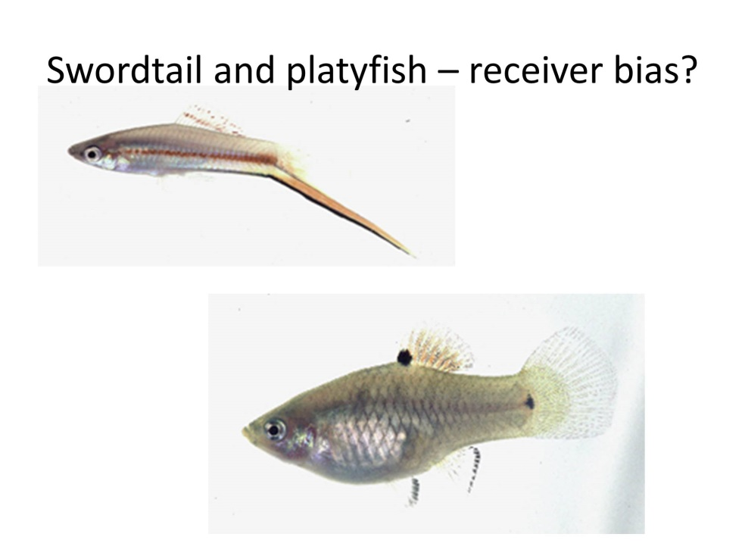

This is an interesting example, two species of fish, closely related. They can hybridise in the lab, and they are actually widely used in cancer research, freshwater fish. One is called the swordtail, for an obvious reason – the males have got an enormous tail. The other is called the platie-fish, which is a close relative, but the males do not have an enormous tail. Understandably, if you take the swordtail and you give the females a choice of going to a male with or without a sword, you cut off the sword of the male, then the females will always go for the male with the sword. That is fine – I mean, it is going for the big, healthy-looking one, right? But the thing which is much more bizarre, on the right there, this is the bottom right square, that is when you do the experiment with a platie-fish, which does not have a sword. If you attach a sword to a male platie-fish, the female thinks, whoopee, and goes straight for that fish. So, somehow, that super-stimuli is embedded, that stimulus is embedded in the female’s brain. Where it comes from, we do not know.

There is a notorious example of the same thing happening in males, where they are attracted to particularly attractive females showing their quality. These are a thing called Australian jewel beetles. The Australian jewel beetle, it is a big beetle, common in Australia. Both males and females are brown, but the female is very, very shiny, and the males fight over who gets the shiniest female. Now, of course, in Australia, with the coming of the white man, there was a great change in the ecosystem, largely because they threw away their beer bottles and here we have a stubbie, an empty beer bottle, which is brown in Australia, they throw them away – if you drive down a highway in Australia, you will see beer bottles on the side of the road everywhere, and most of them have got six males trying to copulate with it because they think this is a super-attractive female! My God, so alcohol does work after all! So, that, again, is a strange spin on the sex and fornication story.

Let me just end up by talking a little bit about sexuality in primates, and I genuinely think it is a big mistake, it is stupid to draw parallels between modern society and other animals. We have stepped outside the imperatives of evolution, but we can make some guesses about what life might have been in the past. There is no question at all that there is a lot of sexual selection among our relatives, in gorillas and chimps, and it is of two different kinds: there is what we call pre-copulatory sexual selection, and post-copulatory. Pre-copulatory sexual selection is the kind which red deer do: they fight like mad, and the strong animal wins, and that is true in the gorilla – in the fights, they win. Gorillas have got embarrassingly small testicles because they do not have to flood out the sperm of a predecessor because they have beaten the potential predecessor into a pulp before and monopolised all the females.

But chimpanzees are not like that. Chimpanzees certainly fight over females, but the difference in size between males and females is much less, and sometimes the one male wins, sometimes the next male wins. So, they put a lot of effort into their testes, as you can see here, and generate vast quantities of sperm, which then, hopefully, will flood out any sperm from a previous male by post-copulatory sexual selection.

So, where do we fit in all that? Well, when it comes to testes, the news is not that good, and it is pretty clear that when you look at the differences between males and females, if there has been any sexual selection in human history, it has been much milder than in chimps and gorillas. The difference in height of men and women, it is there, but it is small. There is not a huge investment in large testes so it may have been there.

There is a very strange spin which suggests that something quite dramatic happened in human evolution because, if we look at the penises of all our relatives, the penises of all other primates have got spines on them, and the spines are there and they are quite large spines, and they are there to hold the female in place after copulation, in the hope that the sperm of the successful male will succeed in doing the job. Humans are the only primate that does not have spines on its penis, which may or may not be good news.

If you look at swimming speeds in sperm, chimps’ sperm are like Olympic swimmers – they go like mad; gorillas’ sperm are very slow swimmers because it is not sperm competition – it is fighting that does the job; and humans are a little bit faster than gorillas, a lot less fast than chimps, so maybe a hint that something was going on.

Now, that does not tell us much about the modern world. It is clearly the case that we no longer live in the kind of world where some males have huge amounts of sexual success which means that other men do not but we can look back at the history of sex in humans by comparing the distribution of genes on the male chromosome, the Y-chromosome, across the world, compared to the distribution of genes that go through both males and females, and you get some interesting patterns.

What you can do is you can make a family tree based on DNA of the relatedness of different kinds of Y-chromosome. In this room, we will have lots of different Y-chromosomes, most of which will be fairly different from each other. There will be lots of different kinds in this room, more than likely. But, in one part of the world, vast numbers of males, in fact, tens or scores or hundreds of millions of men share an identical Y-chromosome. That is that star cluster, as it is called, with a few minor variants that may have arisen by mutation. You may well know this story, but this almost certainly marks the Y-chromosome of Genghis Khan. Genghis Khan, who set up the Mongol Empire, and Kublai Khan and all his male descendants, they were famous for being, to put it bluntly, mass rapists, so their Y-chromosomes became extremely abundant, and the footprint of his Y-chromosome is still there.

Interestingly enough, if you do the same thing in Europe, you get the same pattern. What we have got here is the relative numbers of different kinds of Y-chromosome across Europe and you will see, if you look at the vertical axis, that is the number of Y-chromosomes of a particular identity, a kind of male surname, and the figures go – it is a logarithmic scale, one, 10, 100, 500, 1000, and very few Y-chromosomes, even in Europe, are very, very abundant, and if you go to the right there, and we do not go far enough to the right, but you will find lots and lots of Y-chromosomes are very rare. So that, even in Europe, in historical times – there were some males that had massive sexual success, or considerable sexual success, and many other males who had no or very little sexual success. So, we can see the same history in our own continent, as in Europe, as in Asia.

So, I think the take-home lesson is that cheats, liars and fornicators are everywhere. What are we going to do about it? Let me complete the quote from ‘Alice in Wonderland’. Now, here, you see, it takes all the running you can do to keep in the same place, and if you wish to go anywhere, you must run twice as fast.

©Professor Alec Ryrie, 2017

Gresham College
Barnard’s Inn Hall
Holborn
London
EC1N 2HH
www.gresham.ac.uk

