15 February 2017
From Test-Tube to YouTube
Professor Sir Martyn Poliakoff

The lecture is in three parts, the first one is to ask why do scientists participate, why do they decide to communicate to the public; then, I am going to talk about my own experience; and then, finally, I will try and use my own experience to draw a few more general conclusions, which you may or may not agree with, and I hope we can discuss.

Science lectures often have demonstrations, and so the question comes up: what makes a good demonstration? The first thing is that it should be quite a clear and striking effect. I feel probably there should be an element of surprise, and it should also make quite a relevant scientific point, and also, most importantly of all, the audience has to feel that something might go seriously wrong, or hope that it will do. This place really is not set up to do chemistry demonstrations, so I would do what is more perhaps an engineering demonstration, with a £20 note. What you can do, watch carefully, is you can demonstrate that this note is really quite strong. You can pull very hard and it will not break. However, if you make a small nick, and I will not have you to verify, but I have made a small tear in it and then if you pull, it easily breaks into two. Now, before you get frightened, you can sellotape them back together and still spend them so I haven’t thrown away money!

But what this demonstrates is a point about how things fail mechanically, and usually, if the metal on your car breaks, it is because there is a small crack, and when it is stressed, the fracture starts with a crack and propagates, and if I was giving a full chemistry lecture, I would then explain to you that, if you add niobium, element 41, to steel, and steel has, as in your car, is made up of grains which have grain boundaries. If you add a small amount of niobium, it does not dissolve in the steel and it accumulates in these cracks and stops the crack propagating. So, if you put 200 grams of niobium in the steel in your car, you can use 100 kilos less of steel and still have a car of the same strength. 100 kilos is the size of quite a hefty passenger, and so you can think, in the lifetime of the car, that saves a lot of petrol.

I should also say that this demonstration is one that soon we will not be able to do because all our bank notes are going to be plastic. However, it turns out we now only have the one plastic note. You can actually do some quite interesting experiments with plastic bank notes. If you cool a plastic bank note with liquid nitrogen to minus 196 centigrade, and then thump it with a hammer, it breaks. By the way, it is not illegal to tear up bank notes. It may be stupid. But it is illegal to paint moustaches and glasses on Her Majesty, but you can see, she is okay.

What is perhaps most striking of all is that if you treat a new bank note with concentrated acid, you end up with this totally transparent piece of plastic, which is quite fun but there is no way you will pass this off as a bank note.

We therefore come to the question: why do scientists participate in science communication? And they have quite strong pressures to do so, which can be summed up with this phrase, “duty to communicate with the public”, which comes from a report by the Wolfendale Committee that was published just over 20 years ago, but now there are really quite strong pressures. The Council for Science and Technology, which is chaired by the Prime Minister, has supported this, the Research Councils, and the other funders of research tell researchers that they should be communicating with the public, there are pressures from the universities because they want their employees to satisfy the funders, and then, and this is an important point, there is a need to recruit students because, by and large, people who teach in universities need lots of students to come to their university, otherwise their salaries will not be justified. So, these are the pressures on the scientists.

But the really big question is: why do scientists actually participate? Now, because I do not know the answer to this question, if you do not know the answer to a question, the first thing you do is to ask your children. Very fortunately, in this case, my daughter, Ellen, has published the paper, “What factors predict scientists’ intention to participate in public engagement of science activities?” Ellen is a psychologist at the University of Manchester, so you can have a real scientific analysis of the problem, and what is I think interesting is that time constraints do not seem to be very important. People do not worry whether they have enough time to do it or not. Obviously, there must be some constraint, but not very much. They also do not seem to worry very much about shortage of funding or the fact that they may not get huge career recognition. They will not get as much recognition if they communicate science as if they make some world-shattering discovery.

So, what are the things that do influence them? One of the things is that, if they have done it already, they are much more likely to do it again. You might say that is quite obvious, but on the other hand, people who have done something can be put off it for life. They taste Coca-Cola once and they do not want to drink it again. So, it is important whether they think it is a worthwhile activity and it is important that they think they have the skills to do it. It is also, there is a certain level of peer pressure that it is important that they think that their colleagues are doing it as well. So, this is the theory. Let us now perhaps apply it in practice.

Why did I start in public engagement? In 1974, I was working on the area called photo-chemistry, that is chemical reactions produced by light, and I was at the University of Newcastle-upon-Tyne.

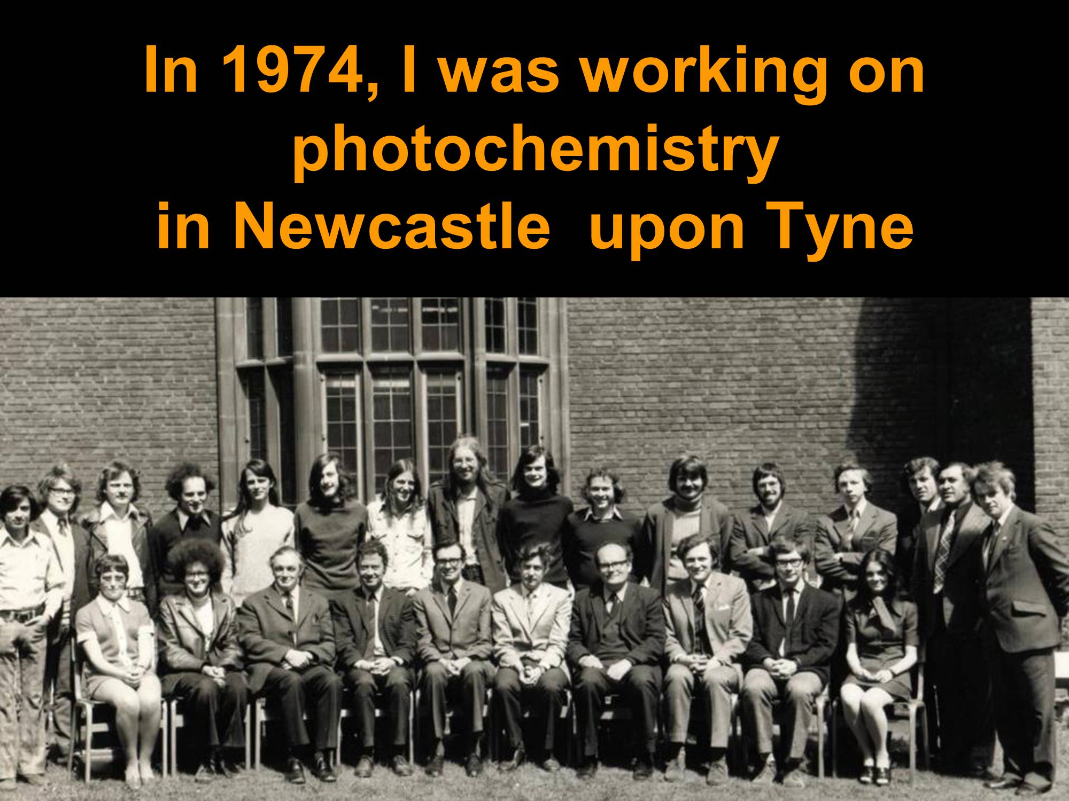

This is the assembled staff in my department. In case you cannot spot me, this is me, and you can see my hair was quite similar to what it is now but a different colour. The reason I started was rather prosaic, that my sister, who is more than nine years younger than me, asked me to give her a lecture at a school in London, so I came down from Newcastle with a big box full of chemicals, something that would not now be allowed, especially on the train, as I think I came down with them, and I gave a talk about photo-chemistry which was called “The Lighter Side of Chemistry” because it was chemistry with light. So that was before I had started doing much teaching, and then after that, I became a lecturer and started teaching Chemistry. Here is a little video to explain about that.

[Video plays]

Well, I do quite a lot of teaching to the first-year students and I use [?] toys to demonstrate them. It looks like a molecular model but it’s actually called a wiggly-giggly. [Inaudible]…and what’s good is that I have to…I demonstrate [the seeds], that if you rotate this through 120 degrees, it looks just the same, but what’s nice is, as you rotate it, it makes a noise, and this really quite excites the students. This one, I was using this morning, and this one [is shaped like this]. This, well, this morning, we were using this for a molecule that had three fluorine atoms here and two hydrogen atoms at the top, which [really is] this shape, and having something like this makes it fun for the students and they can enjoy it, and I’m showing them how to monitor [?] like this and so on. So, this is a new one I’ve just bought, and I’m not quite sure yet what I’m going to do. You can see, it’s square, if you look at it that way, and…but I’ve got six months or so before my lectures start, so I can start thinking what’s the best way to get this in, but it’s quite fun.

So, as my career developed, I became interested in an area that is called green chemistry. This is cleaner approaches to making chemicals and materials, and the idea of the research is that you do something in the lab and then transfer it into industry, and the particular area that I was interested in, and I am still interested in, is trying to replace the solvents that you use to dissolve chemicals to do chemical processes. These quite often are things that are environmentally not very acceptable, and so we were working with so-called super-critical fluids, and we still work with them, which are potentially very much cleaner, and the super-critical fluid is a highly compressed gas, carbon dioxide, or steam, which is compressed until it is nearly as dense as a liquid and it can be used as solvent for chemical reactions.

Let me explain what a super-critical fluid is. You have to imagine this is a real experiment but I am going to show you on video. Imagine a small vessel that has a liquid with a gas above it, and the vessel is sealed so nothing can get in or out. So, if you heat it, the liquid begins to boil, and material goes from the liquid phase to the gas phase, but because the gas cannot get out, it gets denser and denser, and the liquid expands so it gets less dense, and eventually, the density becomes the same, so you have a highly compressed gas, the super-critical fluid, and when you cool it down, it separates again in a storm, which I think is really very beautiful. I keep this apparatus in my office, and I use it to demonstrate to people who might be interested in doing research in our research group, and if they look at it and say “Wow!” I know that they are suitable; if they look bored, I suggest they should go and work with Professor X or Y but not with me.

If you live in London, the Royal Society Summer Exhibition, which takes place every year in the first week of July, is a really terrific exhibition. It is the only science exhibition in our country where you can talk to the researchers who have actually done the research.

In 2004, we got funding from the Engineering & Physical Sciences Research Council, which funded a post which we called Public Awareness Scientist, and Dr Samantha Tang joined first of all our research group and now our School of Chemistry to help the academics explain their research to the public, and so we could do much more ambitious things.

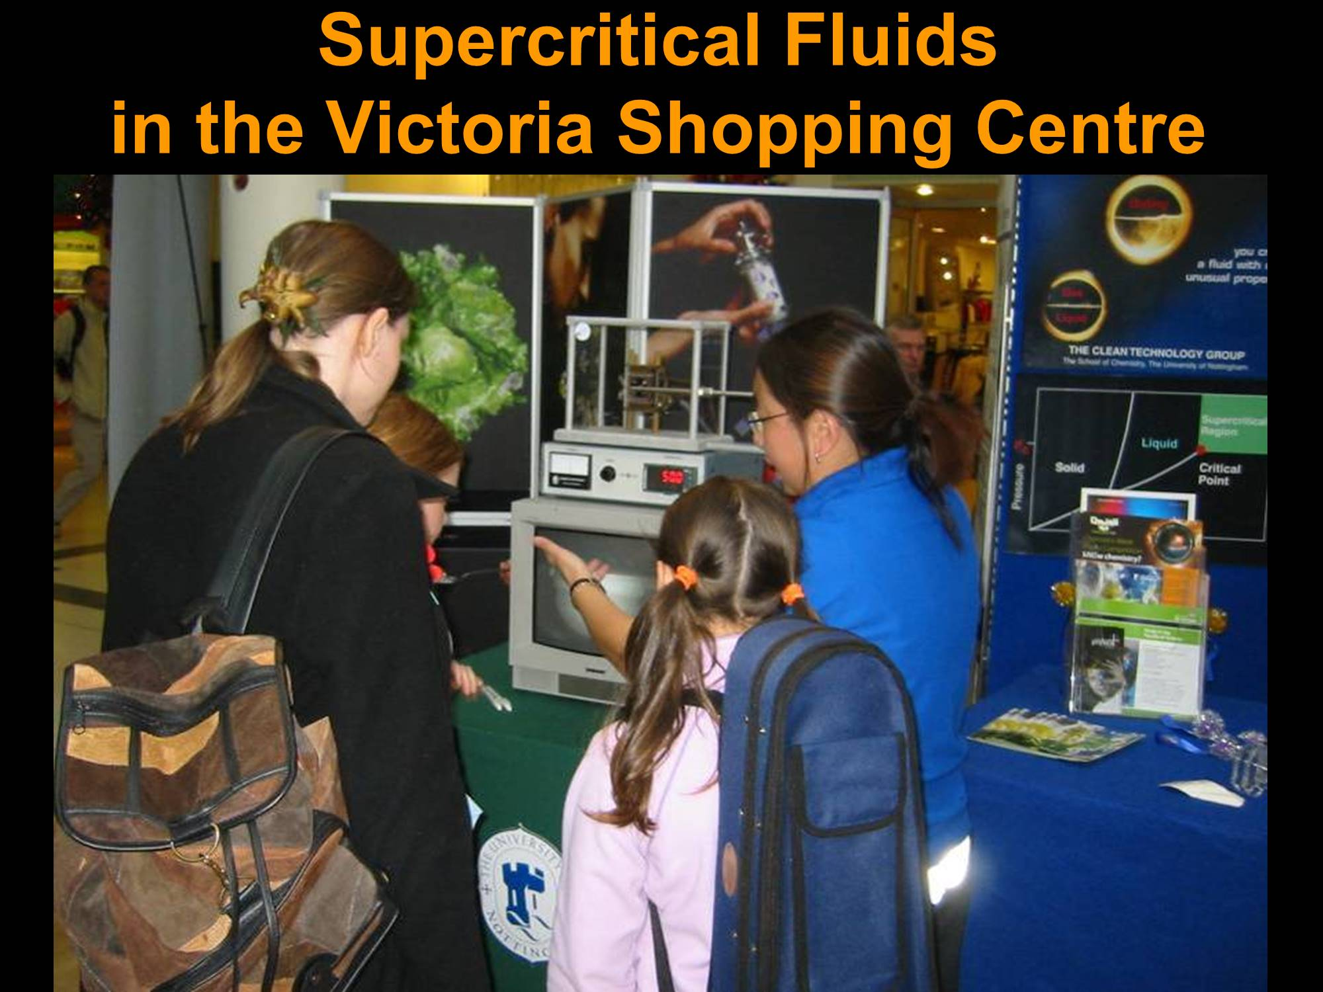

I am at the University of Nottingham, and this is the Victoria Shopping Centre, which is the big shopping centre in the centre of Nottingham. Here, you can see Sam Tang describing essentially the same experiment you saw on video to this young girl, explaining what super-critical fluid is. This was in 2005, and then, three years later, my University started a YouTube channel, called Test-Tube, and I was asked to describe this experiment on the YouTube video.

I became really very friendly with Brady Haran, the video journalist who made the video. A few weeks after this super-critical video was made, Brady came to me and said he had had a really interesting idea: he wanted to make a video about each of the 118 elements on the Periodic Table. I told him he was mad, and the reason I told him he was mad is that it is easy to make a video about sodium or hydrogen – they explode. You can make it visually exciting. But what do you do about an element like element 117, which, at that time, in 2008, not a single atom of this element had ever been synthesized or seen – how can you make a video about an element that does not exist? We had quite a bit of toing and froing, but eventually, he persuaded me it was worth trying, so we made the website, with the Periodic Table. This element 117 here. And the idea is that you click on any of these elements and you get a video about it. So, you if you click on hydrogen, you get a video about hydrogen, with the predictable explosion. Let me just show you a trailer we made to show the sort of things we had on this video, on this website…

[Video/audio plays]

So, this sample, it’s a very, very interesting sample – it’s arsenic. This is [?] of liquid nitrogen and you can see that the nitrogen is evaporating from the top. That’s brilliant! The “per” stands for [?] rate and the “S”, [“sil”], stands for silicate. One of my colleagues who used to work with it described it as evil. The phosphorous is oxidised in the air to generate a nice “P” for phosphorous. Because it has a coating of oxide on the surface… Now, it’s packed in argon because argon is very, very inert – it doesn’t react with anything. Ever since this, I get quite excited. I can see lots and lots of lines in the blue and the green region, and these are all specific to the individual atoms. This one just has more data than you could possibly want. You can see the different grain sizes. And you can imagine the Periodic Table a bit like a family photograph. Ooh-hoo, and there she blows!

In order to make this, I had to find some money, and it was near the end of the financial year, so the money had to be spent very quickly. We began to do the first filming on June 9th 2008 and it was finished on July 17th 2008, so that is five weeks, and we made 120 videos – that is one for each of the 118 elements and the trailer you just saw and an introduction. The total running time was four hours, seven minutes, which, to put in context, is the length of two blockbuster movies or three arty French movies, so it is quite a lot.
We started getting comments on our videos – people posted them on YouTube. This was one of the early ones: “Awesome vid – wish I had found them before I did my GCSE exam.” Now, the interesting thing about this is you cannot tell whether this is a 16-year-old who has just blown his Chemistry exam or a 40-year-old who is regretting a misspent youth. Then there is this one: “I love your videos. Just watching these videos, I have learnt more than a full term at college.” Then this one is a bit more serious: “Videos like these is what makes me interested in school and better improving myself – thank you.”

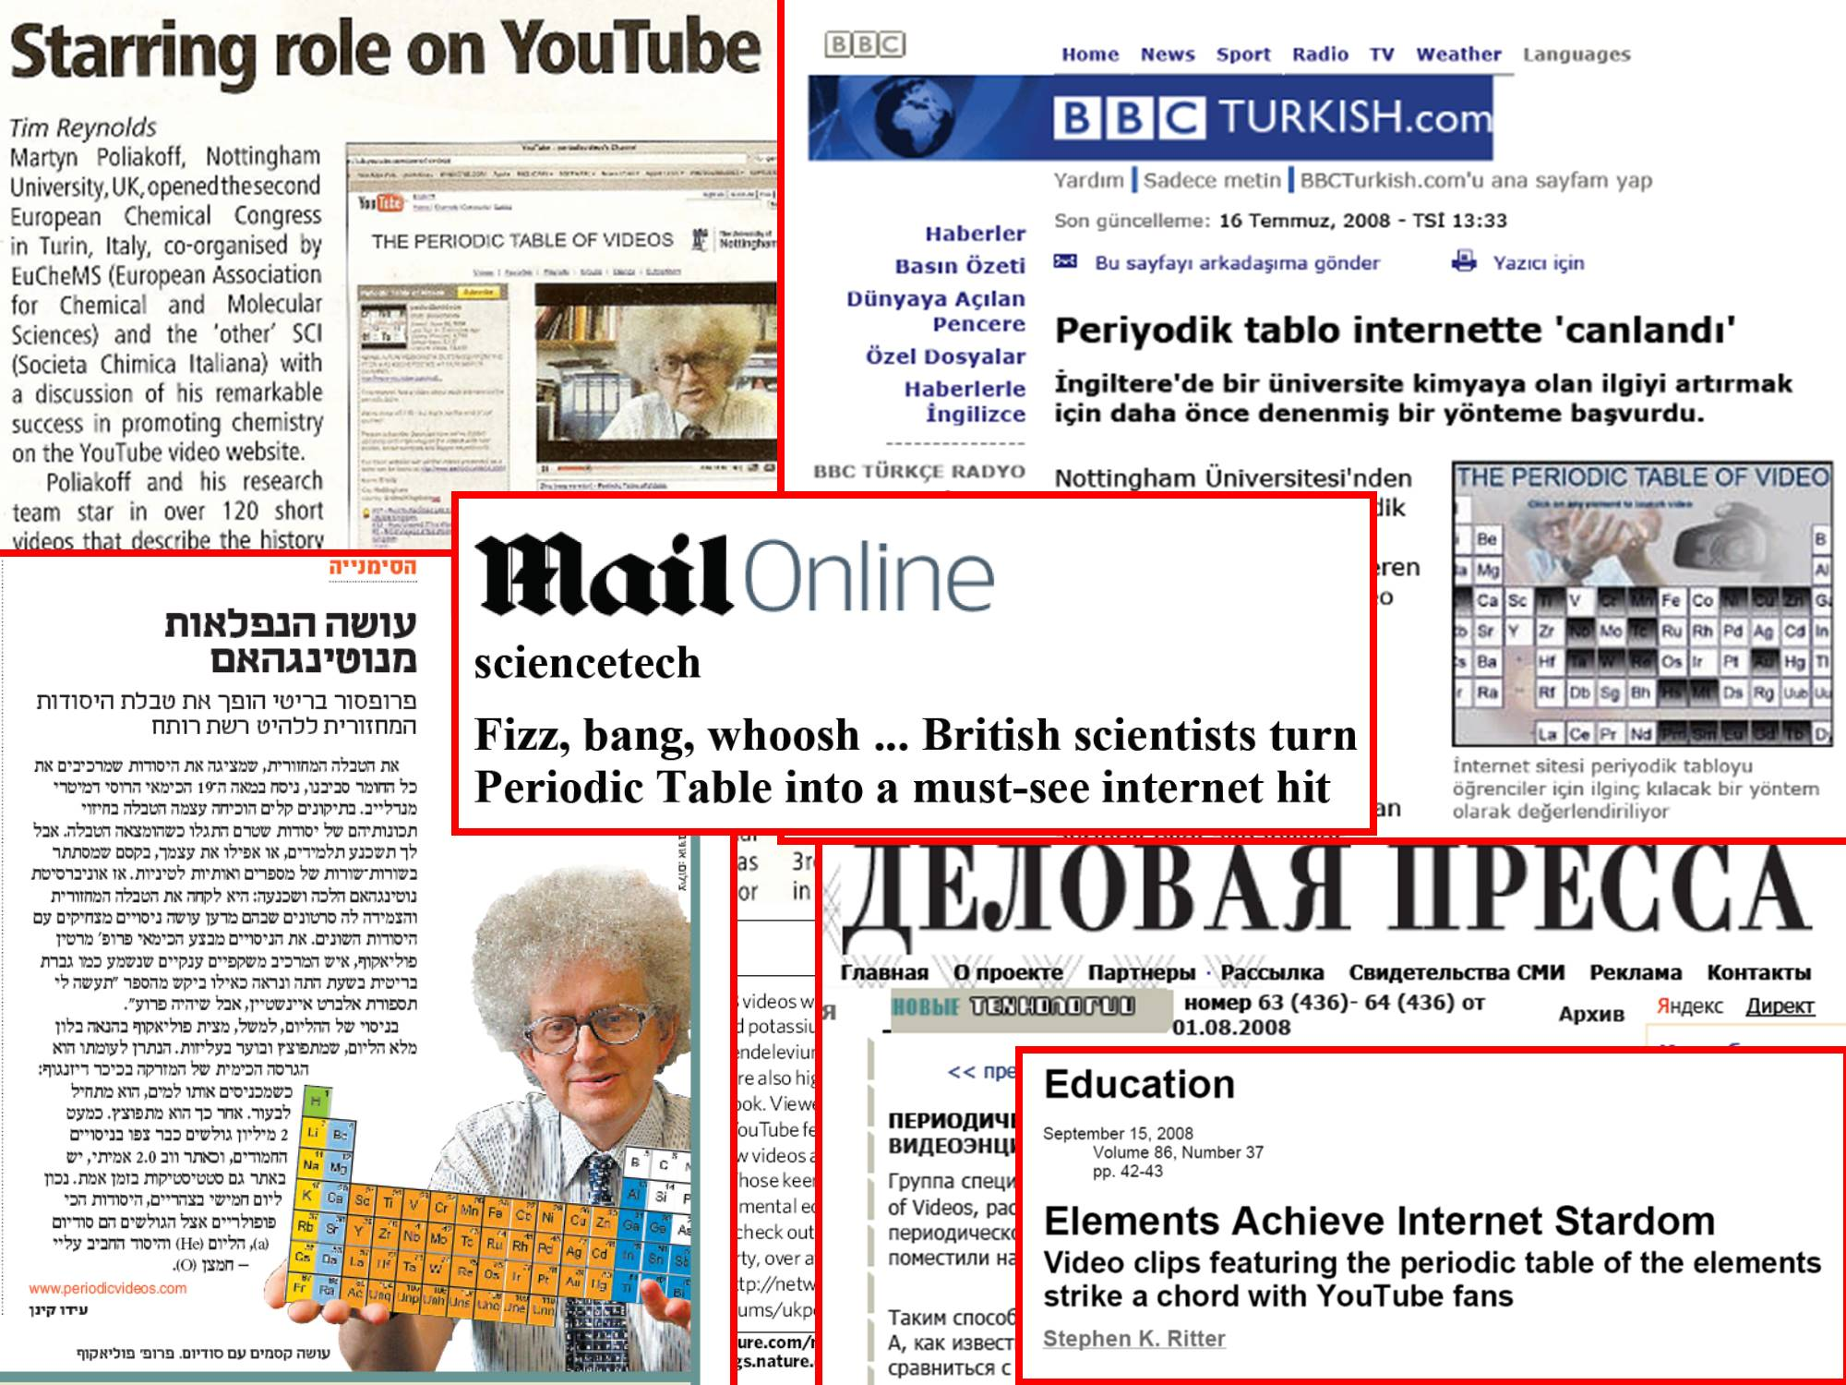

You probably know that the summer is the time when newspapers have nothing to write about, so these videos got a surprisingly large amount of press coverage. This is in Chemical & Engineering News, which is a major American chemistry journal. This is a Russian business magazine. I did not realise that the BBC had a Turkish service, but you can see, this is in Turkish. And this was from an Israeli magazine, I had this translated, and apparently, the key sentence says: “Looks as if he went into a barber’s and said “Give me an Einstein but make it wild”!” So, there was a lot of interest in this.

But we also had a lot of comments which said something like this one: “I do not care what they do as long as they keep making videos.” So, we were suddenly in the situation where we had started what we thought was a nice quick project for the summer, and found it had become an ongoing activity. We had to start making more videos. I do not know if you remember, but 2008 was the year of the Olympic Games, so it was fairly obvious to make a video about gold, silver and bronze. Bronze is not an element, it is an alloy of copper and something else, and that had 40,000 views in two months, so we were quite excited. Then, the Large Hadron Collider started leaking helium, so we made the video, which had nearly 70,000 views in two weeks; and then, the Nobel Prize in 2008, we made the video and it got nearly 40,000 views. Then we started making all sorts of other videos. Our most successful video is putting a McDonald’s cheeseburger, in concentrated hydrochloric acid, and this had five million hits in 21 days, and has got up now to more than 17 million views, so this is more than voted for Brexit!

Then we went to the Bank of England, to the gold bullion vault and we had two million hits in 15 days. It is quite exciting, looks exactly like the duty-free in an airport, except what would normally be Toblerone bars are really gold, and we made a video. Candles at Halloween, that was watched by nearly quarter of a million people in three days; and then, for Chinese New Year, we had tea chemistry.

So, the number of YouTube subscribers has, on the 13th, which was Monday, at 13 minutes to nine, was 893,904 subscribers, and this number is considerably more than the UK royal family, Chelsea Football Club, and Dr Who have on their respective YouTube channels.

We started travelling. So, this is me in the control room of the Heavy Ion Research Centre in Darmstadt, where they synthesised element 111, which, in my view, has the worst name on the Periodic Table, at least for speakers of English, because Roentgenium is very difficult to pronounce. Roentgen was the scientist who discovered x-rays.

Then we bought a high-speed camera, so we could video exploding balloons with hydrogen and other things at high-speed. Very interestingly, if you put a match to a hydrogen balloon, it goes bang. If you fill the balloon with hydrogen and oxygen, it is quite different: the balloon lights up like a light-bulb when you put the match, and also, interestingly, you can see, it forms two blobs, with the match in the middle. This is one of our innovations. At Nottingham, it is called the match on the stick, which is what it says it is.

And then, for example, we included things at the University. We had new teaching labs in 2015, and we found a photograph of students in a lab in 1935, and we got some of our present students, to try and replicate this while explaining the difference between the labs. One of the obvious differences is that there are women here, which there were not in the lab in 1935.

Then we started making videos about molecules. We went to various places to make videos about molecules. Any ideas which molecule this was about?

This is actually about the ozone layer and how chlorofluorocarbons, aerosol propellants, were threatening the ozone layer.

We have also done videos on our research. We still do photo-chemistry and we recently, about 18 months ago, published a paper on making this molecule, which is called Artemisinin, which is quite a powerful anti-malarial drug, and we got a lot of interesting comments from viewers about this. These are the actual crystals of Artemisinin.

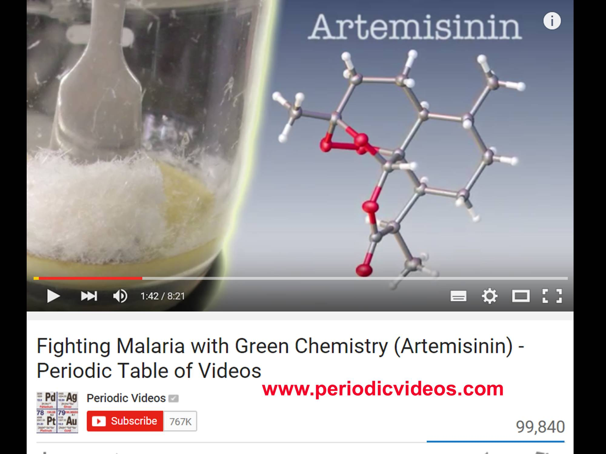

We have also been working with the Ed Ted website to make what we have called the Periodic Table of Lessons. It is another Periodic Table, and you can click on any of the elements and you get a lesson about that element, which is quite useful for school teachers. So, the pupils watch the video, and then there are questions that they can answer. But what makes this quite exciting for school teachers is that, if they register on the site, they can then tailor the questions to their particular class – they do not even have to be in English, they can adapt it, so you could have different questions for GCSE students and A Level students,

Our colleagues at Nottingham in the Physics Department have started a sister channel on physics, called 60 Symbols. There is not a Periodic Table in Physics, so they invented one, which was inspired by - those of you who use Microsoft Word will know that, if you try and insert a symbol, a thing comes up full of symbols, so this is the physicists’ view of symbols. This has been very successful, and also, our colleagues in Computing have started another channel called ComputerPhile. They have not tried to make a Periodic Table of computers. I have done a small number of videos for the 60 Symbols; I have done one video for ComputerPhile because I had a toy called the Smack-A-Mac, which is a soft cuddly Macintosh computer and I made the video about this. The idea was those computers were not very reliable, so when they crashed, you could throw this Smack-A-Mac across the room and relieve your frustrations.

So, this comes out to the question which you have to ask about all scientific communication: are you making any impact? This is not terribly easy to judge, and Brady, my video collaborator, and I wrote a paper in the journal, Nature Chemistry trying to discuss how you might assess impact. The first thing you can look at is the number of views on the video, and the number of views, if you think about it, is probably not a very good measure because you cannot distinguish between, on the one hand, a teacher showing a video to a whole class of children, which might be 30 or, in some countries, even 50 children, so you have that on one hand; the other hand, you have somebody who is drunk and feeling sad, who sits in his garret watching the same video over and over again, and such people exist. Early on, we had an email which said: “I’m in New York, I am drunk, I have just watched all your videos twice!”

The next thing is you can look at the number of subscribers and you can compare this with other channels. So, you can say we’ve got more than the royal family.

But you can, for your own channel, look at the rate at which people unsubscribe – they decide that, having taken out a subscription, which just means they get alerts when a new video is posted, that they decide it is not for them, and for us, the number of people who unsubscribe is about 10%. But you cannot tell how many unsubscribe from other channels, so it is not a very good comparison.

We came up, eventually, with the idea that, although it is not very rigorous, in some ways, what is most indicative is actually to look at the comments that we get, in emails and letters and also on YouTube, from viewers. So, this is quite recent ones – that is 13 days ago. It is an email I got: “My name is Mike Campbell and I am writing to thank you from Halifax, Canada. My elder son, Euan, has developed a great interest in science, so I found your app and let him explore. He loves it, has learnt so much, and really seeks to understand the chemistry. He watches your videos over and over, really enjoys them, and truly learns from them.” I get emails like this not every day but several times a week.

My favourite email ever, which came from the States, said: “I never took Chemistry in school but I have enormously enjoyed these videos. I work in the high school in the US. I’m a janitor.” “I will give your website to the Science Department. I am sure it will be used in their classes.” I feel that if we are getting janitors in schools telling the school teachers how to teach Science, this is quite something.

Now, if you believe that you have discovered a new element or synthesised a new element, in the old days, you just said “Chaps, I have discovered Columbium” or whatever and you just plucked a name out of the air. Nowadays, you have to put your evidence to a committee. So, I got this comment, as an email, which said: “Prof Poliakoff, I just watched your video on the new elements 114 and 116 and found it exceptionally well done, accurate and insightful – what a delight.” This is from Paul J. Karol, who is the Chair of the Joint Committee of the International Union of Pure & Applied Chemistry and Pure & Applied Physics, who decides whether the new element has really been synthesised or not, so this was really quite encouraging.

You can do an analysis of the comments on YouTube with what is called a wordle. You take a mass of text and it picks out the top 100 words, and the more frequent they are, the bigger the word. So, you can see, there’s “like” and “video”, and “love” is quite big, if I can find it. “Chemistry” is quite big here, and, somewhat surprisingly, “hair” is quite big there. So, it is generally very positive.

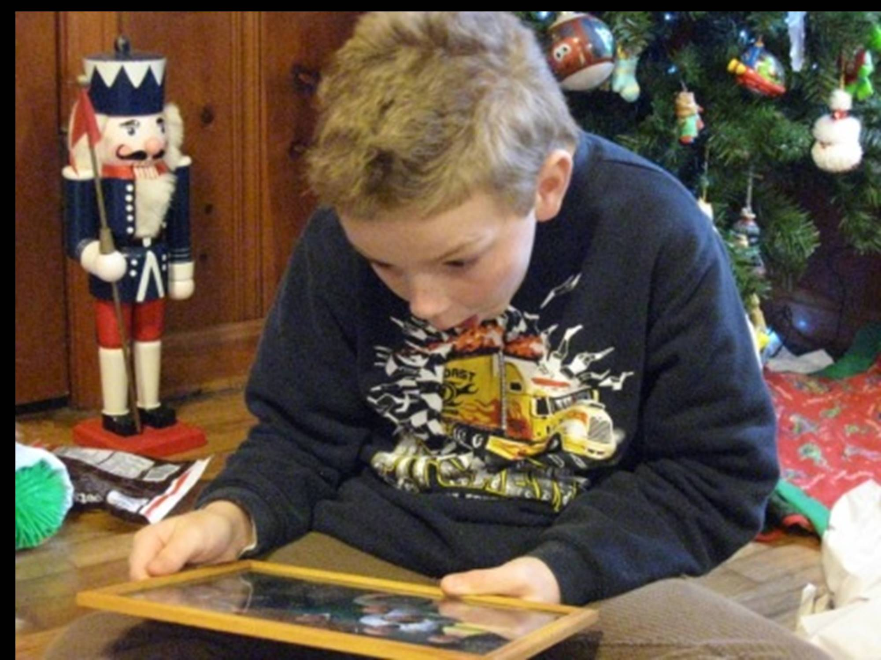

This is one of our fans. He is somewhat older than this now, called Eddie, and his mother wrote to us and said that she was unemployed in Arkansas, and Eddie was a huge fan, and would we send a photo for a Christmas present. So, this is the photo we got back of Eddie about to open his Christmas present, and here he is, having got the Christmas present. Our feeling was that, unless the mother was really sadistic, she could not have faked this picture, so he really was enjoying it.

This is by far our most faithful fan, who is a school teacher on the southernmost island of Japan and I met him exactly a year ago in Tokyo, and he brought this extraordinary coat for me, which I now have in Nottingham, which has the Periodic Table on it.

Let me just try and summarise some general points about public engagement. I think that the really important things about public engagement are, first of all, the scientist has to be enthusiastic. If the scientist is not enthusiastic about what is being done, how can one expect that the public will be enthusiastic? I think, also, the scientist has to enjoy things because, if you do not enjoy them, then why should other people think it’s interesting? But most importantly, you have to be honest, and one of the problems with some of these science programmes you see on television, they are rigged. They pretend that something is exploding, but they have actually put quite a substantial charge of gunpowder to make it more exciting. So, if your experiment does not work, you should be honest about it.

There is always a question: should you be demonstrating science live, in a lecture, or should you be doing it online? Obviously, the great thing about doing it live is that you can interact with the audience.

If you think about online, you are completely remote from the audience. You can perhaps respond to the odd comment on the YouTube video, but even with a huge number of viewers, you may only get a few hundred comments. People often find it hard to believe. They think, particularly now when you have all these films with CGI, if you see something on screen, you can never tell whether it is really genuine. You have to be responsible if you are doing things online. You are constrained by safety in the live lecture theatre, but you must not just say, “Look, you can blow things up like this” because people might start doing them in their back gardens. You have a huge reach. There have been many occasions in the last few years where, in one night, while I have been asleep, more people have watched a YouTube video in which I am talking than everybody I have ever lectured to in my entire life, live, so you have a big reach.

The next thing is that when people make videos, they often feel they should have very serious educational objectives - you have the equivalent of lesson plans. In our videos, none of them have we had a script, and our aim is to, if they are of use to teachers, it is just to help teachers to do their job, not to teach a specific topic, and anyway, the syllabus is so different, say in Sri Lanka from Canada or England, that you could not possibly cover all the syllabuses, but really want to get the message to say that science is worthwhile and even more fun than you think.

We were really quite pleased because New Scientist had a blog on 4th January this year which was on science communication, and the leading picture was a still from one of our videos. But what was really nice, it had a caption saying “Some of the best science communication is being done on online videos, periodic videos” which obviously quite excited us.

© Professor Sir Martyn Poliakoff, 2017

Gresham College
Barnard’s Inn Hall
Holborn
London
EC1N 2HH
www.gresham.ac.uk

