25 April 2017
Energetic Mathematics
Professor Christopher Budd OBE

Introduction

When asked what is the most important invention ever made by humankind, apart from my own personal favourite of calculus (which strangely never gets many votes), one invention that always figures very highly is fire. It was fire that first allowed us to release energy in meaningful amounts. This could then be used for cooking, heating, lighting and the manufacture of new materials such as metals. Since then our whole civilisation has both relied on, and has been defined by, the need to obtain energy. Some of this has come from natural sources such as the wind, the sun directly, or from flowing water. Until recently the bulk of the rest of our energy came from burning wood (or peat) and then fossil fuels such as coal, oil or gas. The industrial revolution was triggered by the discovery that through the use of the transition of water into steam, the heat energy released by this process could be turned into mechanical energy and this could be used to power the great machines of the industrial age including lathes, mills, pumps, lifts and, of course, locomotives. During the 19th Century, the work of Michael Faraday at the Royal Institution in London (where I am now the Professor of Mathematics) led to the discovery that this mechanical energy, when coupled to a generator, could lead to electrical energy. Through the work of many others, most notably Edison and Tesla, we then saw a revolution at the end of the 19th Century and the start of the 20th with the widespread adoption of electricity as the primary means of both transmitting and using energy. Now electricity is generated through a wide variety of mechanisms including wind, solar, hydropower, fossil fuels, and now also including nuclear power, tidal power, wave power, hot rocks and bio-fuels. Of these fossil fuels account for about 80% of our energy production, hydropower, wood nuclear for just under 20% and the remaining 2.5% by renewable sources. Most of the world uses electricity (although about 1 Billion people have no access to electrical power). The huge advantages electrical energy has over mechanical (and most other forms of) energy is that it can be transmitted over huge distances with almost no loss, and it can be (relatively) easily controlled. This has led it to be widely adopted as the primary source of the world’s energy.

The annual consumption of electricity in the UK is about 360 TWh (predicted to rise to 730 TWh in 2050), and the peak demand is around 70 GW, depending upon the time of day and the day of the week. This electrical power is supplied over a complex network starting, usually, with power being generated at a power station. This is then transmitted over a high voltage network, before being reduced in voltage and distributed to commercial, industrial and residential consumers. Maths is vital in ensuring that the lights always stay on as the planners of the grid need to solve a large number of nonlinear differential-algebraic equations, described on a complex network (with 30 million nodes representing different households, industries and other users of electricity), to work out how much electricity can be generated, distributed and stored. However this is not easy as electricity must be consumed as soon as it is purchased, it cannot be stored in large quantities and the user has a very low tolerance to interruptions in the supply. These challenges are going to increase significantly in the future with a greater emphasis on low Carbon generation, a much more distributed supply network (with a significant increase in lower power generation from renewable sources such as solar and wind often at a domestic level), the increase in the use of electric vehicles, an increase in local electricity storage, and the advent of the SMART Grid [4] in which users both have much greater control over their energy demands and also supply much more information to the Grid. For the future planning of the National Grid this raises important questions. For example how should we expand our power system and what will happen 5, 10 or even 20 years from now (remember that it takes a long time to build a power station, and it will be in use for a long time). Furthermore, where should the generating plants be constructed, for both economic and also environmental reasons. In addition, what will be the configuration of the transmission lines, what voltage will they be using and will we see a change from alternating current to high voltage direct current in the future?

In this talk I will explain how the grid system works and the maths behind it. I will explain how power cuts can happen (with the example of the US NE coast blackout) and will show how maths can prevent this in the future. I will then look at the challenges and opportunities presented by renewable energy, the SMART grid and electrical vehicles. There are many challenges for the future supply of energy in as clean a form as possible, and mathematics gives us a vital tool in addressing them.

- Where does electricity come from and where does it go to?

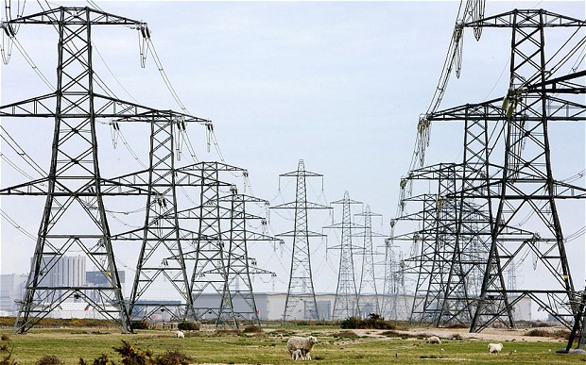
Electricity is mainly generated in large power stations at a very high voltage. In the UK there are around 180 of these. A typical large power station (coal fired or nuclear) can generate around 2MW of electrical power. This is similar to the power production of a typical large hydro electrical plant, but the Three Gorges hydroelectric plant in China produces a staggering 22 GW. A large wind farm (such as the offshore wind farm at Thanet) generates about 300 MW or power. In contrast, a domestic solar cell system would produce around 1 kW. Once produced the electricity is transmitted (in the National Grid in the UK) as three-phase AC (using the method invented by Tesla) at high voltage, with the highest voltage being Extra High Voltage (EHV) of 400kV, over a national network of power cables, typically hung from pylons. It is then sold onto the regional companies where its voltage is successively reduced, by transformers in sub-stations, to the High Voltage (HV) of 11 kV and then down to the domestic supply Low Voltage (LV) of 415V. At all times and places it is at a constant frequency of 50 Hz.
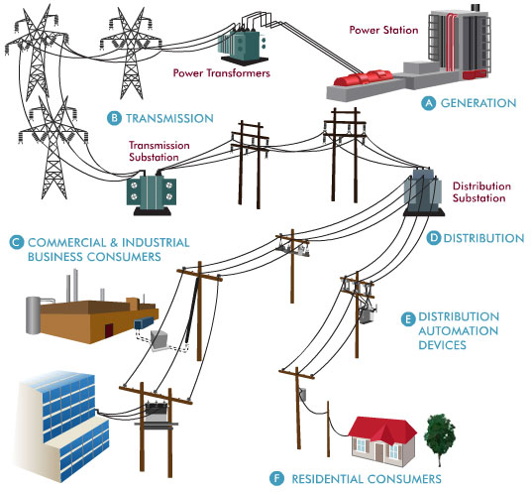

Producing electricity securely, safely, reliably and cheaply, has many challenges. Electricity is difficult to store in large quantities, so it usually has to be used as soon as it is generated. We also have a very low tolerance to any interruption in the electricity supply. Other challenges arise from the extreme interconnectedness of the electricity network, which means that a problem in part of the network quickly becomes a problem for the whole network. Most of the time the process of transmitting electricity proceeds smoothly. However, there are times when the users place a very large demand upon the network. An example of this is an international football match when lots of people will not only turn on their TV sets to watch the match, but will also turn on their kettles at half time, or just after the match finishes. In the figure below we can see the demands on the UK supply by some notable football matches in some recent years. Top of the list was the famous World Cup semi final of England against West Germany, which went to penalties, but was ultimately lost by England [6]. This match is famous for two things. Firstly, Paul Gascoigne’s tears when he received a booking.. And secondly for nearly shutting down the UK electricity supply network. Indeed the total change in the demand for electricity during the match was 2.8 GW, which was 11% of the total power delivered by the network and amounted to about 2 Million kettles.

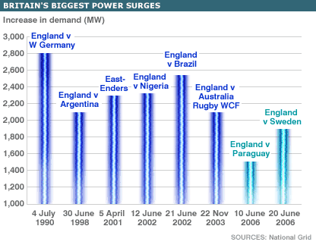

It is the mark of a good electricity supply network that this does not happen, and that the lights always stay on, regardless of the demands placed on the network! Technically this means delivering a secure supply electricity at a near constant voltage and frequency, at all points of the country, regardless of the amount of power demanded from it. Indeed the UK National Grid is very carefully controlled to make sure that the electricity supply remains stable, and the lights have (so far) always stayed on. In the next section we will see why, and the role that maths plays in keeping the lights on.

- The complex story of how electricity is transmitted and distributed.

The modern electricity supply network relies on the invention of alternating current (AC) by Nikolas Tesla. In AC the current and the voltage vary sinusoidally with time as seen below

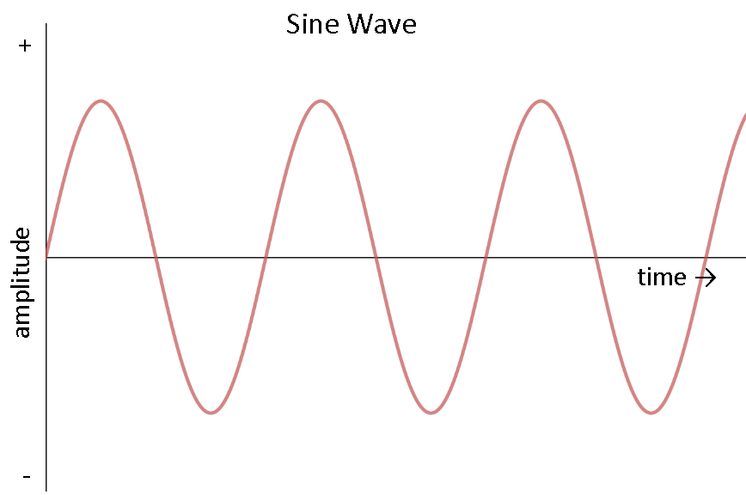

Thus the Voltage V(t) and the current I(t) have the form

$V\left(t\right)=|V| cos(ωt + φ_{1}), I\left(t\right)=|I| cos⁡(ωt + φ_{2})$

where $ω$ is the frequency of 5o Hz and $φ_{1}$ and $φ_{2}$ are the phases of each (which I will return to later), and |V| and |I| are the amplitudes of each.

The reason that AC was originally adopted was that it is relatively easy to transform from a high AC voltage to a low one, and vice-versa, by using a transformer. This can be done with a small loss of energy. A high voltage can then be transmitted at a low current, meaning that the power loss on transmission (which is proportional to the square of the current) is then low. Thus AC could be transmitted over large distances at high voltage with little loss of energy. Only when it is needed to supply a domestic h0usehold is it necessary to transform the electricity down to a lower voltage. In the battle between AC and direct current (DC) in which the voltage stays constant, which was waged at the start of the 20th Century between Tesla and Edison, the advantages of AC so greatly outweighed those of DC, leading to its widespread introduction. (It is worth saying that recent advances in power supply design mean that it is possible, by using controlled switching devices called buck convertors, to transform a high DC voltage to a low one with minimal energy loss. This has led to a comeback of high voltage DC or HVDC, and this is now being used for the power cable link between England and France.)

To represent an AC voltage, electrical engineers make extensive use of complex numbers. The imaginary number i satisfies the equation

$$i^{2}=-1$$

which was originally thought to have no solution. Imaginary numbers were introduced by mathematicians in the 18th century to make sense of this equation, and were originally thought to be highly abstract mathematical objects of no possible use. However they lie at the heart of power engineering. The reason for this is Euler’s famous identity

$$e^{iθ}=\cos\left(θ\right)+ i\sin\left(θ\right).$$

We first met this wonderful identity in the lecture on Maths in the Movies where it was used to describe how objects in space were rotated. In this lecture we will see instead how it relates to power engineering. The reason in this case is that it allows us an easy way of describing alternating current, along with its frequency and phase. So we would simply describe an alternating voltage, as described above, as the real part of the function

$$V\left(t\right)=|V| e^{i(ωt+ φ_{1})}$$

with a similar expression for the current. A convenient way to express this is as

$$V\left(t\right)=\left|V\right| e^{iφ_{1}} e^{iωt}$$

and we call the expression $V=|V| e^{iφ_{1}}$ the complex voltage. This single complex number contains two pieces of information, namely the amplitude, and the phase, of the voltage. There is a similar expression for the complex current. Using this we can now describe how a power network works and how we can use maths to make sure that it operates well.

An example of a small power network, is given below. In this network we have supplies of electrical power from a power stations, many households which are supplied by power from the network, and junctions called buses. Each bus will be at a particular voltage. Between the buses there are connections. These can be the high voltage cables that we see proudly marching across the countryside. The cables carry current between the buses, which is kept low by having a high voltage. Low current leads to much smaller power losses, which is why high voltages are used.
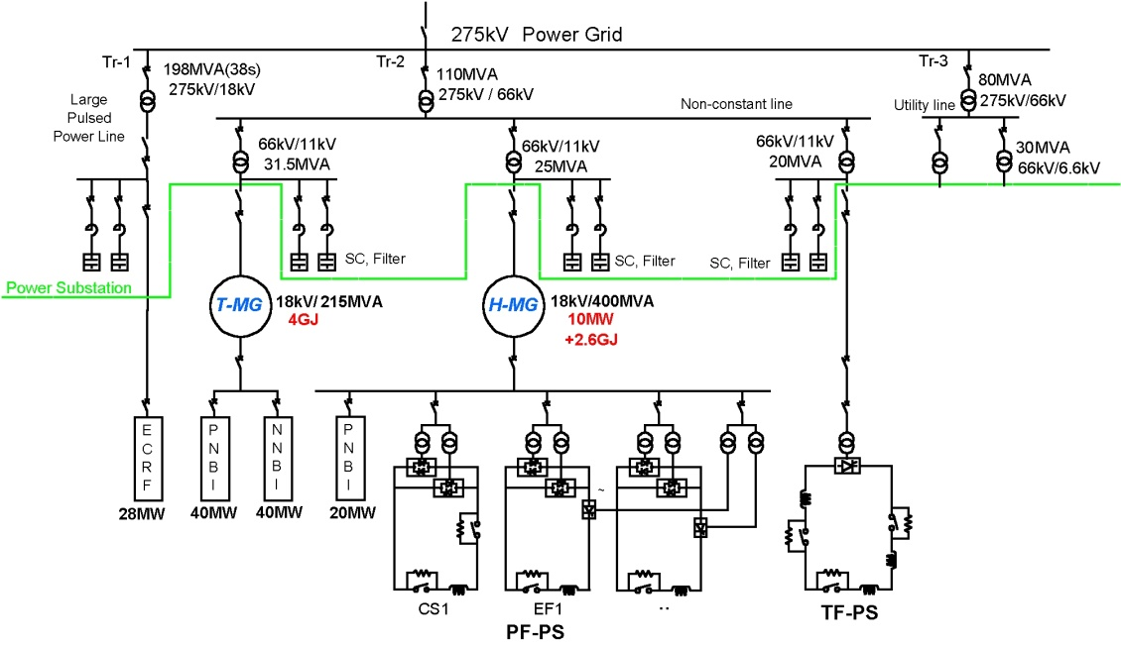

In a typical network there are many buses, which can be power stations, factories, transformers, switches, points where the network changes, and households. In principle there can be one bus for every household, so up to 30 million buses. This immediately gives you some idea of the scale and the complexity of the electricity supply network. At each bus the network needs to supply a certain amount of power. How much this is depends upon the usage and load imposed on the network. We calculate this as follows. Each bus is numbered by an index j=1,2,3, .. N and will have a (complex) voltage $V_{j}$. This bus will in turn be connected to many other buses in the network. Typically a (complex) current $I_{j,k}$ will flow between the buses labled j and k in the network. The power S of this current flow is given by

${ S}_{j,k}=V_{j} I_{j,k}^{*}$ (1)

where $I_{j,k}^{*}$ is the complex conjugate of the complex current. The total power at the jth bus is then given by
$S_{j}=∑_{k=1}^{N} S_{j,k}$ (2)

This power is in turn a complex number and we write $S_{j}= P_{j}+i Q_{j}$. Here $P_{j}$ is called the real power, which is the power which does work, such as heating your home. In contrast $Q_{j}$ is called the reactive power. The real power averaged over a complete cycle of the AC waveform results in net transfer of energy in one direction. The reactive power is that portion of power due to stored energy, which returns to the source in each cycle. Electrical engineers take apparent power into account when designing and operating power systems, because although the current associated with reactive power does no work at the load, it still must be supplied by the power source. Failure to provide for the supply of sufficient reactive power in electrical grids can lead to lowered voltage levels and under certain operating conditions to the complete collapse of the network and a power blackout, as we shall see in the next section.

If the voltage difference between two buses is $V_{k}$ -$V_{j}$ then the current $I_{j,k}$ flowing between them is given by Ohm’s law. In particular there is (another) complex quantity called the conductance $σ_{j,k}$ so that

$I_{j,k}= σ_{j,k} (V_{k}-V_{j})$ (3)

(In high voltage cables the conductance is usually close to being a purely imaginary number. This is because these cables are designed to have a very low resistance, but usually have some inductance.)

We can now combine the three equations (1),(2) and (3) and we find that the total power supplied to the jth bus is given by the expression

$S_{j}= ∑_{k=1}^{N} V_{j} σ_{j,k}^{*} (V_{k}^{*}-V_{j}^{*})$ (4)

Now, when designing and controlling a power supply network, we know the values of the real and reactive power that needs to be supplied to each bus. The voltages at each bus then satisfy the equation

${ ∑}_{k=1}^{N} V_{j} σ_{j,k}^{*} \left(V_{k}^{*}-V_{j}^{*}\right)= P_{j}+i{ Q}_{j}$ (5)

The important equation (5) allows us to work out the voltages at each bus which are needed to supply the desired amount of real and reactive power. Take a look at it. It is nothing other than a large collection of quadratic equations for the voltages. We can understand the complex behaviour of the grid by looking at the complex solutions of quadratic equations. It is worth noting that an attempt was made a few years ago to stop the teaching of quadratic equations at school on the grounds that they were totally useless and would frighten the students as illustrated below. More details of this debate are given in [1]. However, we need to solve quadratic equations if we want to keep the lights on!

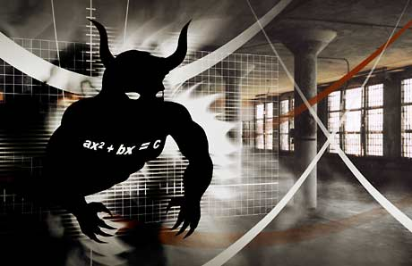

- Power cuts, bifurcations and tipping points

Usually, thanks to careful planning by the National Grid, and other energy companies, the lights do usually stay on. Sadly, however, this doesn't always happen. On August 14th, 2003 a catastrophe hit the North East coast of America [5]. During a storm, an overgrown tree hit a power cable. The safety mechanisms cut in leading to a local shut down of the power supply to the part of the network closest to the affected cable. Unfortunately, there was a software error in the control room, which meant that the shut down spread and spread. As a result the whole of the North East of America and large parts of Canada were plunged into darkness. In the figure below you can see a satellite image of the North East of America, with the ringed black area showing the black out. The resulting blackout lasted for about two days, and affected an estimated ten million people in Ontario and 45 million people in eight US states. The event contributed to at least 11 deaths and cost an estimated $6 billion.

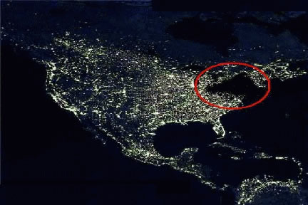

So, could this happen again? One of the main reasons for a power failure is a phenomenon called a Voltage Drop and this is directly related to properties of the solutions of a quadratic equation. Usually a quadratic equation is written as

$ax^{2}+bx+c=0$

and we want to find the solution x. When we meet the equation at school we are told that it may have one, two or no real solutions. These are given by the famous formula

$x=\frac{-b±\sqrt{b^{2}-4ac}}{2a}$

This formula says that the quadratic equation has two real solutions if $b^{2}>4ac$ and no real solutions if $b^{2}<4ac$. To illustrate this we will look at an equation for which a = 1, b = -2. The two solutions are then given by

$x=1±\sqrt{1-c.}$

There are two solutions if $c<1$ and no solutions if $c>1$. A graph of the two solutions is given below, with the special point c = 1, x = 1 highlighted.

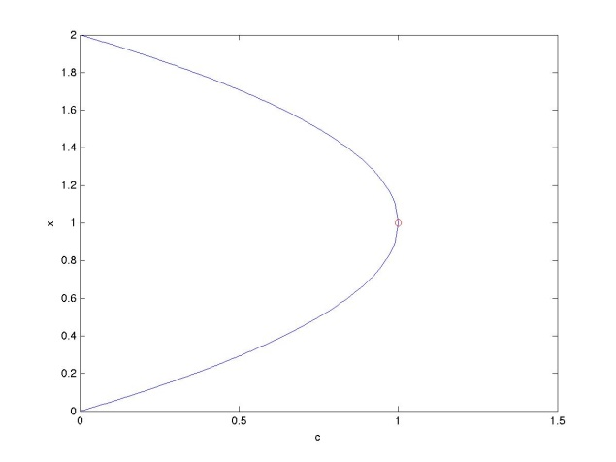

This point is very important as it marks the boundary between when the quadratic equation has two solutions and none. It has various names including a fold point, a saddle-node bifurcation and, most provocatively a tipping point. Tipping points are common, and they are important in many scientific fields, including (as we will see in a future Gresham lecture) climate science. They are also of huge importance in power supply networks. To see this we show below the voltage in a network when it has to supply a reactive power Q. The three curves correspond on the left to a network with fewer power stations on and thus less available power, and on the right to one with more power stations on and thus more available power. Each of these curves has a very similar shape to that of the solution of the quadratic equation illustrated above, complete with a tipping point. This is of course no coincidence as each such curve is given by solving several quadratic equations instead of just one. These curves are given the ‘technical name’ of nose curves for reasons which should be obvious.
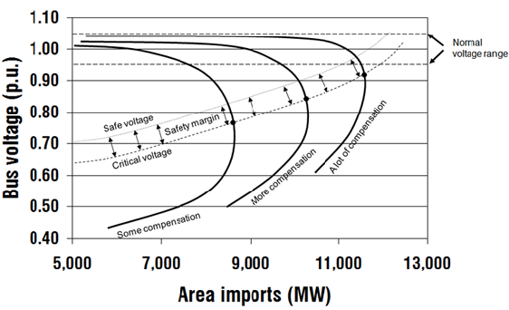

Each nose curve has, as we might expect, two solutions for a given value of Q before the tipping point. The upper part of the curve represents a stable solution in the normal voltage range, which is where we want to operate the power grid. However as the reactive load Q increases a worrying sequence of events occurs. Firstly the supplied voltage starts to drop, and then we get to the tipping there is no solution at all. What happens at this point is that the grid goes into a very unstable state during which the voltage collapses and all of the lights go out. It is fair to say that, due to good planning and management by the National Grid Company, the UK has never experienced a widespread voltage collapse. However, it has occurred in both Italy and Sweden as well as in the NE USA, and all because a quadratic equation didn’t have a solution. There are other causes of power cuts, for example on 13th March 1989 the particles emitted from a large solar flare so overwhelmed the safety systems of the Quebec power system that a power cut resulted. Quebec also suffered later on from a power cut caused by an ice storm. We will return in a future lecture to the effects of climate change on our energy supplies, but before then let’s look at some other challenges.

- The future of energy and its control.

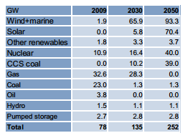
One of the biggest challenges faced by the energy industry is the transition to a low Carbon technology and a move away from a reliance on fossil fuels (and possibly from nuclear fuels as well). Essentially this means a transition to renewable forms of energy such as wind energy, solar power and other forms of power production such as wave and tidal power. The table below from a report published by the (then) Department Of Energy and Climate Change (DECC) in 2010 [2] shows some possible predictions of future energy production. Note the high level of wind and solar and also CCS Coal (Carbon Capture and Storage burning of coal).

Whilst the renewable sources have significant benefits in the reduction of Carbon Dioxide production, they present a big challenge to the grid. In particular they are an intermittent source of energy, and the amount of energy available from them will always be uncertain. In particular both wind and solar energy are dependent in the short term upon the weather, and in the long term by (amongst other factors) the effects of climate change. This predicted change in the way energy is supplied is combined with a projected significant increase in electricity use, particularly for transport, as we move away from internal combustion engines to electrical vehicles. To meet both the supply and demand problems we will increasingly rely on a diversity of different sources of energy production with (possibly) the majority produced by renewables, but with back up supplies (probably from fossil fuels combined with nuclear energy) and significant redundancy in the network needed to maintain the security of the system. All of this places much greater demands on the control and supply of electricity in an optimum cheap and safe way, and this requires careful mathematics. In part this will be achieved by encouraging the users of electricity to be ‘smarter’ in their use, with SMART meters giving constant reports on electricity usage by individual households. However this does in turn lead to additional mathematical problems. At the moment the EHV (Extra High Voltage) supply network is modelled in computers by solving the quadratic equations above for several thousands of points, in which the electricity demands of a whole town (and indeed the HV (High voltage) and LV (low voltage) components of the grid) may be modelled as a single point. This is done to allow the calculations to be performed in a reasonable time, so that the behaviour of the network can be predicted over the short time-scales needed to control it, and it is accurate enough in the context of large amounts of electricity being supplied by a small number of big power stations. However, the increased complexity and volatility of the supply (with, for example, many individual households supplying an intermittent amount of electricity to the grid through solar panels on their roof) means that this approach is no longer accurate and electricity supply companies are finding it harder to predict the demands on the grid. There is consequently now a move to develop simulators, which model every single household. This means solving (for the UK) over 30 Million coupled quadratic equations every five minutes. Remember, that school children were being warned about the health effects of just solving one such equation! Mathematically solving this very large system quickly is a very challenging task, even for a super computer, and developing effective methods to do it is the subject of on-going research.

One reason solving this large system is so hard is related to the changing nature of the electricity supply. As I described above, we now have a multitude of different suppliers of electricity, all of which has to be added into the National Grid. Some of this, for example solar energy, or energy stored in batteries, is generated as DC rather than AC. This needs to be converted to AC at the right voltage and, crucially, at the right frequency and phase, to patch into the Grid. This is achieved using devices called power inverters, which use phase locked loops to synchronise the generated supply to the mains. This introduces additional dynamics into the grid, with the possibility of additional instabilities and lack of security of the supply. To study this we augment the quadratic equations above with additional differential equations and study these using the mathematical theory of dynamical systems [3]. It is known that under some circumstances dynamical systems can have chaotic solutions. It is an intriguing, and disturbing, question as to whether the grid could behave chaotically under certain conditions [3].

- The answer is blowing in the wind

Perhaps the most promising (new) source of renewable energy at the moment is wind power, as can be seen from its dominance in the table above. A large off-shore wind farm can produce large quantities of electrical power, in the order of 500 MW, and wind power can in principle, be available all day and night, most days of the year. Mathematics is used in a number of ways to make wind power more effective. A set of turbines from the Thanet off-shore wind-farm is illustrated below.
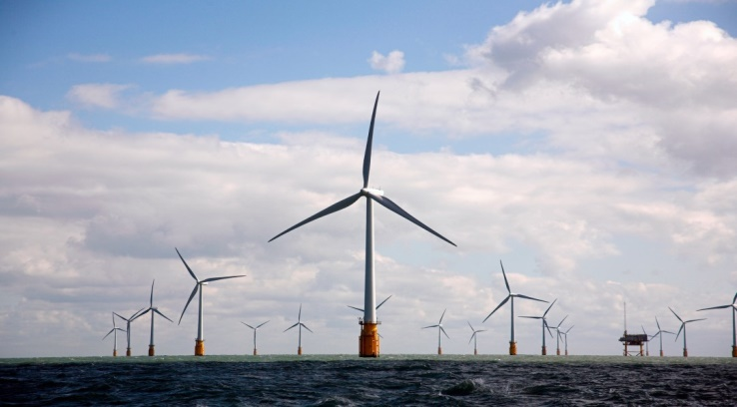

These turbines are in a very harsh environment. As well as the forces from the wind, which are required to turn the blades of the turbine, the turbines also have to cope with the force of the sea. In particular, as well as responding to the ‘average’ sea and wind conditions needed to produce electricity, they also have to deal with extreme conditions, including the intense ‘100 year storms’ which may well occur in the lifetime of the wind farm. This requires careful calculation, both to construct strong enough structures able to deal with the forces involved, and also to predict the nature of the 100 year storms. The latter requires the use of the mathematical/statistical theory of extreme events, and we will return to this in a later lecture.

Large wind farms are built off-shore in part because that is where the strongest and most consistent wind is to be found. On-shore wind-farms have to be very carefully sited to receive anything like the same amount of reliable wind. Unfortunately some of the best locations for these farms, from the point of view of producing energy, are also some of our most beautiful and/or environmentally sensitive areas. Building a large wind-farm there would be at best highly controversial and counterproductive. It follows that it is essential to maximise the potential of those wind-farms which can be built on on-shore sites. An important part of this is ensuring that the electricity they supply is best matched to the demands of the grid. This involves the seemingly impossible task of accurately predicting the wind speed at the precise location of the wind-farm. As an example of this challenge, here is a plot of the seemingly very erratic wind speed given hourly at a single location over a period of two years [7].

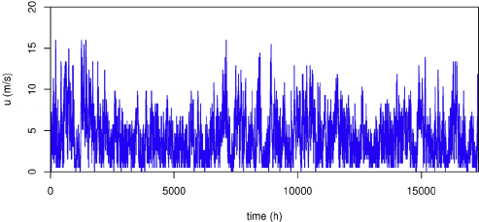

In a future lecture I will talk about the mathematics behind weather forecasting in which the wind is predicted about 5 days ahead on a grid with a resolution of about 1.5 km. Unfortunately for a wind-farm this prediction is unlikely to be accurate enough for their specific location. However, mathematical help is at hand. What the wind-farm and power company managers often need to know is not what the wind will be doing at their location tomorrow, but instead what it will be doing in the next few hours. This is a question that can be tackled by using the statistical and machine learning methods that I described in my lecture on Big Data. These methods take the wind data at the location gathered over a period of several months, and then train statistical models on it (for example by using principle component analysis [7]). (It is relatively easy to gather this data as the wind speed can be measured directly at the site of the turbines. In fact it must be measured accurately there to ensure that the turbines operate safely). These statistical models are highly effective in making short term predictions of the wind local to the site of the wind-farm. In fact over the next four hours they will typically out-perform a more traditional weather forecast (in much the same way that the most accurate way to tell what the weather at your house is right now is simply to look out of the window). However, if you want to know the weather tomorrow then a traditional forecast is more accurate. It is the continued use of mathematics in this way which is helping to make wind power a viable source of mass energy in the future.

- Conclusions

Energy matters to all of us, and the challenge of supplying enough energy in a clean and safe way, is one of the greatest challenges faced by humanity. Energy supply networks are already highly sophisticated, and will get more so as the way in which we use and supply electricity is changing rapidly. To deliver a secure supply well into the future will require equally sophisticated mathematics. However, the bottom line is, that to keep the lights on we all need to be able to solve (lots of) quadratic equations [1].

- References

[1] C. Budd and C. Sangwin, 101 Uses of a quadratic equation, (2004), Plus Maths magazine
https://plus.maths.org/content/101-uses-quadratic-equation

[2] F. Li, Demand side response, conflict between supply and network driven optimisation, Poyry, University of Bath report to DECC, November 2010

[3] C. Budd and J. Wilson, Bogdanov-Takens bifurcation points and Silnikov homoclinicity in a simple power-system model of voltage collapse, IEEE Transactions on Circuits and Systems I: Fundamental Theory and Applications, 49, (2002), 575-590
[4] For details of the SMART Grid see https://en.wikipedia.org/wiki/Smart_grid
[5] The NE US blackout is described in the website https://en.wikipedia.org/wiki/Northeast_blackout_of_2003

[6] The World Cup semi-final match close run for the National Grid, is described in the article http://news.bbc.co.uk/1/hi/uk/5059904.stm

[7] C. Skittides and W-G Fruh, Wind forecasting using principle component analysis, https://www.researchgate.net/publication/261759110_Wind_forecasting_using_Principal_Component_Analysis

© Chris Budd, March 2017

A kilo Watt Hour (KWh) is the amount of energy required to supply a kilo Watt (the rough power consumption of a typical household) for one hour. 1 KWh = 3.6 M Joules. Your electricity bill will usually be given in kilo Watt hours. A TWh is one Tera Watt hour, which is one billion kilo Watt hours.
In power engineering the convention is usual to use j to represent an imaginary number to avoid confusion with current denoted by i. However in mathematics it is conventional to reverse the situation and to use i for the imaginary number and j for current. It is pointless to argue which is better (or worse), but it is a shame that this separation exists between mathematics and engineering. Without making any judgment one way or the other as to which is best, I will use the mathematical convention in this talk, as it is being given by the Gresham Professor of Geometry. However, I’m instantly happy to switch my allegiance when I’m working with power engineers. Indeed, not so long ago, I was one myself.

