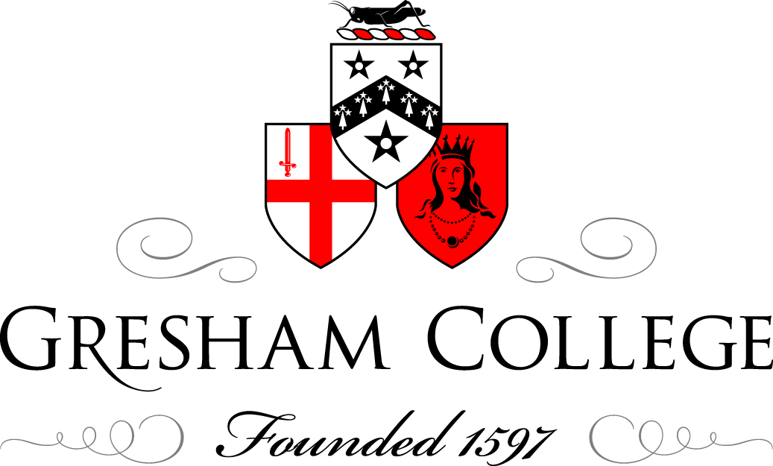

21 March 2014

North Korea’s Unspeakable Crimes Against Humanity:
Revealed

Professor Geoffrey Nice QC

Welcome to Gresham College, an establishment that has provided public lectures on many topics, free, for over 400 years, free not just of the need to pay any money, but free of any political or other interest – independent, and that is why this is a particularly appropriate venue for this important report to be presented, for although I have no doubt the two commissioners to whom I will refer in just a minute, and the report itself, would wish to have great political impact and effect, they and the report are quite independent and without political masters. Thus, Gresham College presents this event for you and on video for a wider, perhaps much, much wider audience.

First, we will see a film, lasting about fourteen minutes, produced by Human Rights Watch, and indeed, it may be appropriate for us to move seats for the duration of that, and then we will hear from Justice Michael Kirby, the Chair of the Commission, and it may be, in the questions and answers thereafter, from Sonja Biserko from Serbia, who was one of the three Commissioners, the third being the Special Rapporteur who is engaged on other business elsewhere.

I desire, in this audience, only to say a couple of things before we watch the film. Commissions of Inquiry by United Nations organisations are not easy to get started, and for this reason, because, although they may often land up dusty and on a shelf, they may also lead to activity, serious activity, because they cannot be overlooked and, accordingly, the international politicians are not necessarily that keen on having Commissions of Inquiry.

Before this Commission was started, many people, including South Koreans who have travelled to Geneva, to The Hague, and here for today, putting in a great amount of work, including many other people, like Human Rights Watch, represented by Brad Adams here, Ben Rogers from Christian Solidarity Worldwide, Lord David Alton, one of the country’s great experts on North Korea, did a great deal, in hope, but with no expectation that a Commission would ever be established. But, eventually, by whatever process, it was, and then good fortune struck, for the UN, in what some would think as a surprising rush of good sense to the head, appointed as its Commissioners Michael Kirby from Australia, Sonja Biserko from Serbia, and the Special Rapporteur, with unequalled knowledge, the three of them being fearless, independent, and being determined by the report was prepared and presented that it should avoid the dusty shelf and lead to action.

Michael will explain what was done, I suspect, to make the report itself irresistible, by the use of public testimony and in its writing construction and the form in which you can find it now, immensely valuable to the public, who do have power to bring pressure on people, and it may well be we will discover upon whom the pressure should be put.

Enough from me. We will now watch the 14-minute film from Human Rights Watch, and I will then call on Justice Michael Kirby to address you, following which we will have a discussion.

[Film plays]

© Professor Geoffrey Nice QC, 2014

