

Metamorphoses – The Terrible Beauty of Change
City of London Festival 2009

13:00 to 14:00, Monday, 22 June 2009
Gresham College
Barnard’s Inn Hall, Holborn, London EC1N 2HH

A Fusion Of Benjamin Britten’s “Six Metamorphoses After Ovid (Op. 49)”
With
Commercial Musings On Sustainability
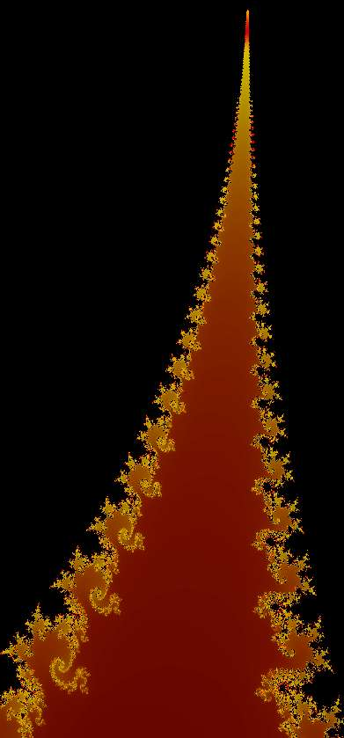

People change the planet in beautiful and terrifying ways, from high art to base waste. Never before have we had such power to transform our planet and ourselves. Never before have we so risked losing everything. Robust economies and environments are essential to mankind’s future. This performance combines music inspired by Ovid’s works with selections from modern political and economic thinking in order to envision how society might metamorphose towards sustainable commerce with nature.

John Harle – Saxophonist & Speaker
Michael Mainelli – Mercers’ School Memorial Professor of Commerce
William Joseph – Graphics

Inspired by Ian Ritchie, Director, City of London Festival

Open – Changes

- Pan – Despair to Hope – Nature & Mankind
Pan, who played upon the reed pipe which was Syrinx his beloved.
Pan (1:48), graphic – Strings, a fractal

- Phaethon – Rise and Fall – Mankind’s Power
Phaethon, who rode upon the chariot of the sun for one day and was hurled into the river Padus by a thunderbolt.
Phaethon (1:29), graphic - Sun Spot sequence from Hubble telescope

- Niobe – Pride before Loss – Caution & Trust
Niobe, who, lamenting the death of her fourteen children, was turned into a mountain.
Niobe (2:26), graphic - Volcano, a fractal

- Bacchus –Destruction after Excess – Internalising Externalities
Bacchus, at whose feasts is heard the noise of gaggling women’s tattling tongues and shouting out of boys.
Bacchus (1:53), graphic – Feuerwerk, a fractal

- Narcissus – Inclusive or Exclusive – Feed-forward To Community
Narcissus, who fell in love with his own image and became a flower.
Narcissus (3:04), graphic - Face2Face, a fractal

- Arethusa – The Needs of the Many - Population
Arethusa, who, flying from the love of Alpheus the river god, was turned into a fountain.
Arethusa (2:49), graphic – Havasu canyon, Arizona USA

Close – Sustainable Commerce & The Long Finance
Transformation, graphic

Publius Ovidius Naso

Publius Ovidius Naso, “Ovid”, (20 March 43 BC – AD 17 or 18) was a Roman poet who wrote about love, seduction, and mythological transformation. He is considered a master of the elegiac couplet, and is traditionally ranked alongside Virgil and Horace as one of the three canonic poets of Latin literature. His poetry, much imitated during Late Antiquity and the Middle Ages, decisively influenced European art and literature. The Metamorphoses is a narrative poem in fifteen books, based on Greek mythology, that describes the creation and history of the world. Completed in 8 AD, it remains one of the most popular works of mythology.

Benjamin Britten

Edward Benjamin Britten, Baron Britten OM CH (22 November 1913 – 4 December 1976) was an English composer, conductor, violist and pianist. Britten was born in Lowestoft, Suffolk, the son of a dentist and a talented amateur musician. He was educated at Old Buckenham Hall School in Suffolk and Gresham's School, Holt. Britten was a prolific juvenile composer; some 800 works and fragments precede his early published works. His first compositions to attract wide attention, however, were the Sinfonietta Op. 1, "A Hymn to the Virgin" (1930) and a set of choral variations, “A Boy was Born”, written in 1934 for the BBC Singers. In 1951 Britten composed six little pieces for solo oboe, to be performed by Joy Boughton (daughter of the composer Rutland Boughton) during the Aldeburgh Festival, “Six Metamorphoses After Ovid (Op. 49)”.

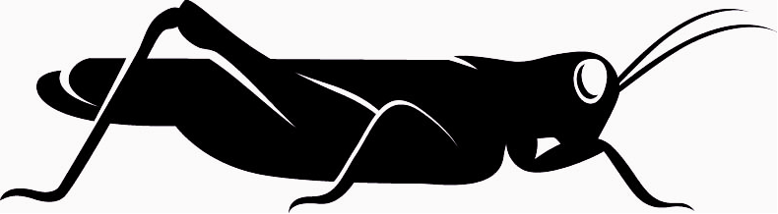
Opening Graphic
John Conway’s Game of Life
Life is played on a grid of square cells like a chess board but extending infinitely in every direction. A cell can be live (filled by a grasshopper) or dead (empty). Each cell in the grid has eight neighbours. What happens in the next generation depends on the number of live neighbours:
- dead cell with exactly three live neighbours becomes live (birth).
- live cell with two or three live neighbours stays alive (survival).
- cell with more than three neighbours dies of overcrowding.
- cell with less than two neighbours dies of loneliness.
[with help from David Ellerman’s website]

Sources
- BRITTEN, Benjamin, Six Metamorphoses After Ovid, Boosey & Hawkes (1952) [see also Britten: Six Metamorphoses After Ovid: Anatomy Of A Masterpiece, Opus 49 (1951) – Study CD, Tracks 1-6, Metamorphoses – George Caird [13:29] British Broadcasting Corporation, Oboe Classics, 2007].
- HUGHES, Ted, Tales From Ovid, Faber & Faber (1997).
- NASO, Publius Ovidius, Metamorphoses, (circa 8)
- Latin - http://www.thelatinlibrary.com/ovid.html
- English – Edited and translated by Sir Samuel Garth, John Dryden, Alexander Pope, Joseph Addison, William Congreve and other eminent hands (1717) -http://classics.mit.edu/Ovid/metam.mb.txt, http://classics.mit.edu/Ovid/metam.html
- English - Translated by David Raeburn, Penguin (2004).
- Commerce lectures 2005-2009 - http://www.gresham.ac.uk/eventsresults.asp?PageId=4&frmSubject=2&frmPeriod=past
- Engravings by Johannes Baur,from Ovidii Metamorphosis, oder Verwandelungs Bücher (1703).
- Fractals created in ChaosPro

