

Gresham Lecture, Wednesday 23 February 2011
Hubble’s Heritage
Professor Ian Morison
The Astronomer
Edwin Hubble, the son of Virginia and John Hubble, was born at Marshfield, Missouri, USA, on 20th November, 1889. His early interest in astronomy was indicated by the fact that, when just 12 years of age, his article about the planet Mars was published in a local paper! The family moved to Wheaton, Illinois, where his father, an insurance executive, had an office. Edwin went to Wheaton High School where, not only did he do well at his academic studies but also excelled at athletics and football. (He held the Illinois High School high jump record for some time.) Following his graduation from Wheaton, he was awarded a scholarship to the University of Chicago, where he studied physics, astronomy and mathematics.
Hubble arrived at the University during the fall of 1906 and, with his height of 6ft 1inch and fine physique, soon became a star of the gymnasium, track and sports field. In his third year he played in 6 out the 12 games that brought Chicago the national universities title. He graduated in March 1910 having been vice president of his class.
He gained a prestigious Rhodes scholarship to study law at Queen's College, Oxford partly as a result of the letter of commendation given him by Physics Nobel laureate-to-be Robert Millikan who recommended him as “a man of magnificent physique, admirable scholarship, and worthy and lovable character.” Surprisingly, he chose to study Law and Spanish - it seems at his father’s insistence – but he would often visit the university observatory and learnt about the new field of celestial photography from its director, Herbert Hall Turner.
During his time at Oxford, it seems that Edwin picked up some affectations and, on his return, surprised his sisters with his attire. Their athletic brother was “dressed in a cape, knickers, and sported a walking stick. A signet ring graced his little finger, and he was wearing a wristwatch he had won for high jumping”. (I should point out that in America “knickers” are full breeches gathered and banded just below the knee!)
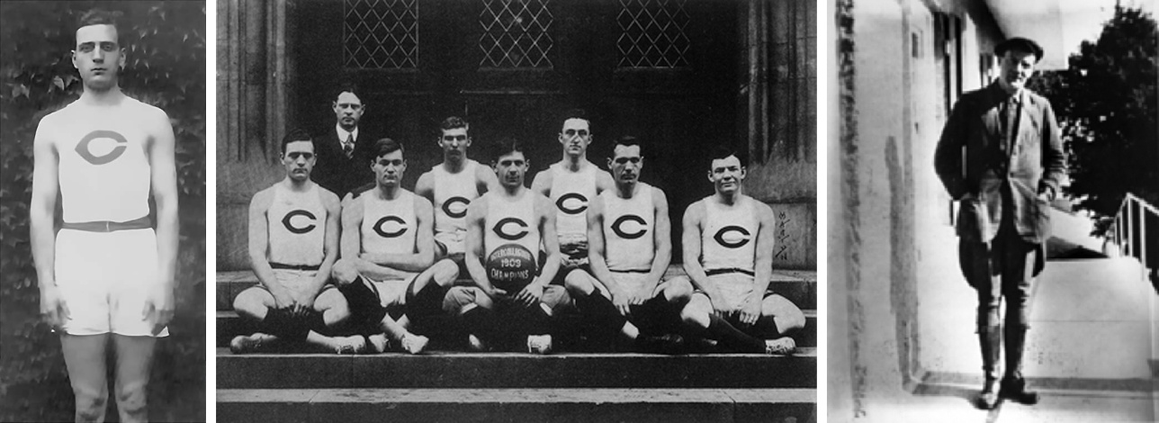
Hubble as an athlete, champion football player (at left) and on his return from Oxford
Back in America, he first taught physics and mathematics at the New Albany High School in New Albany, Indiana and then, having passed the bar examination in 1913, became an attorney at Louisville, Kentucky. It is not at all obvious that Hubble actually practiced to any great extent (if at all) and, by 1914, had tired of the Law and, in August of that year, decided to return to the University of Chicago to study for a PhD in Astronomy. Chicago was no place for an observatory, so the university had built its observatory on the north shore of Wisconsin's Lake Geneva, seventy-five miles to the north-west of Chicago. Here with money pledged by Charles Tyson Yerkes, the Chicago streetcar magnate, they had built the world’s largest refracting telescope with an aperture of 40 inches.
However, Hubble was using the observatory’s 24 inch reflector to photograph areas of the sky to study what were then known as “white nebulae”. (Now known as galaxies.) One object soon took his attention: he was amazed to find that one of his target objects, known as NGC 2261, was changing significantly on relatively short time scales. He described it as “the finest example of a cometary nebula in the northern skies”. His maiden discovery was published in the Astrophysical Journal where he cautiously stated "No attempt is here made to explain the phenomenon of illumination, the nebula must be very near." [This is now known as Hubble's Variable Nebula which changes its appearance noticeably in just a few weeks. It is a reflection nebula made of gas and fine dust fanning out from the star R Monocerotis (R Mon). About one light-year across, it lies about 2500 light-years away in the constellation Monoceros. It is thought that dense knots of opaque dust pass close to R Mon and cast moving shadows onto the reflecting dust forming the nebula.]
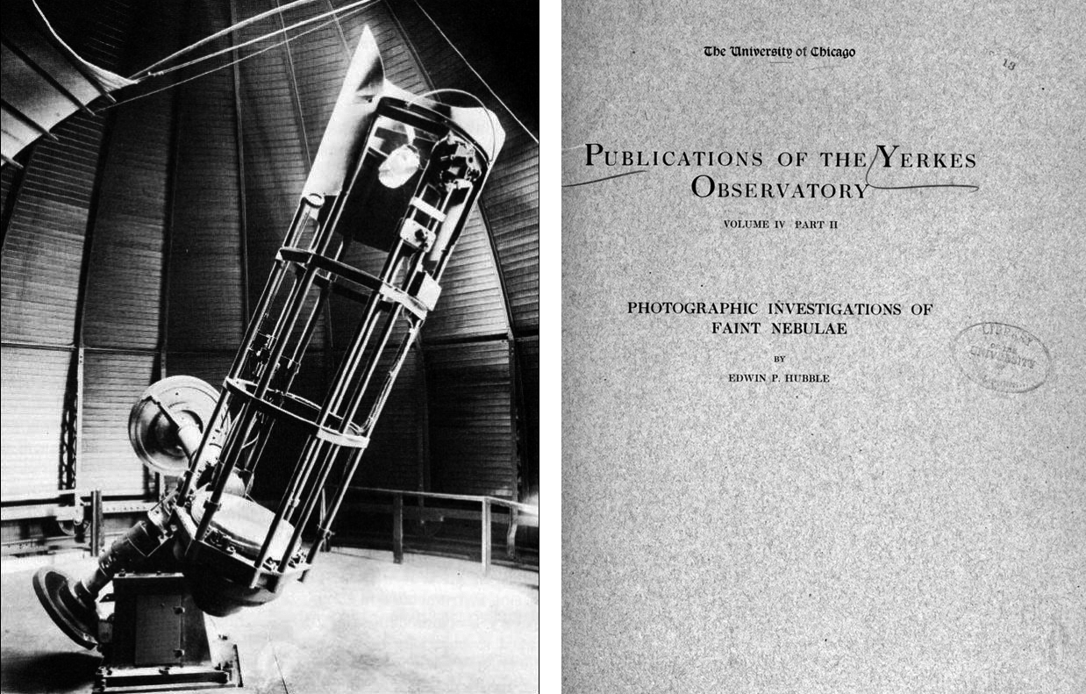
The 24 inch telescope at Yerkes Observatory which Hubble used to image and study faint nebulae.
By the time his thesis was completed some 17,000 nebula had been catalogued by other astronomers. In his thesis he wrote “Extremely little is known of the nature of the nebulae and no significant classification [system] has yet been suggested; not even a precise definition has been formulated. At least some of the great diffuse nebulosities, associated as they are with stars visible to the naked eye, seemed to lie within the stellar system. (Our Milky Way galaxy) So, too, do the planetaries, massive gaseous clouds at even greater distances from the Sun. Yet others, most particularly the giant spirals which display no visible motion, apparently lie outside our system.” Though his thesis was somewhat shaky on technical grounds and rather confused in its theoretical interpretations, it laid the basis of the great discoveries that he was to make in the next ten years.
While finishing work for his doctorate early in 1917, Hubble was invited by George Ellery Hale to join the staff of the Mount Wilson Observatory, in Pasadena, California. However, after sitting up all night to finish his Ph.D. thesis and taking the oral examination the next morning, Hubble enlisted in the infantry and telegraphed Hale, "Regret cannot accept your invitation. Am off to the war." Hubble was commissioned a captain, later rising to the rank of major, and was sent to France where he served as a field and line officer. He returned to the United States in the summer of 1919, and went immediately to join Hale at the Mount Wilson Observatory where the 100” Hooker telescope had been completed some two years earlier. He remained on the staff of the observatory throughout his life apart from a further spell in the US Army during the second world war when he was chief of ballistics and director of the Supersonic Wind Tunnels at the Aberdeen Proving Ground in Maryland. For his work there he received the Legion of Merit award.
Before we can discuss what was, perhaps, the greatest discovery of the last century, we need to learn about two highly significant sets of observations. The first were made by by Henrietta Leavitt whilst working at the Harvard College Observatory where she became head of the photographic photometry department. Her group studied images of stars to determine their magnitude using a photographic measurement system developed by Miss Leavitt that covered a 17 magnitude brightness range. Many of the plates measured by Leavitt were taken at Harvard Observatory's southern station in Arequipa, Peru from which the Magellanic Clouds could be observed and she spent much time searching the plates taken there of them for variable stars. She discovered many variable stars within them including 25 Cepheid variable stars. These stars are amongst some of the brightest; between 1000 and 100,000 times that of our Sun and are named after the star Delta Cepheus which was discovered to be variable by the British astronomer John Goodricke in 1784. These stars pulsate regularly, rising rapidly to a peak brightness and then falling more slowly. As they are very bright they can be seen at great distances. Leavitt determined the periods of 25 Cepheid variables in the Small Magellanic Cloud (SMC) and in 1912 announced what has since become known as the Period-Luminosity relation. She stated: "A straight line can be readily drawn among each of the two series of points corresponding to maxima and minima (of the brightness's of Cepheid variables), thus showing that there is a simple relation between the brightness of the variable and their periods." As the SMC was at some considerable distance from Earth and was relatively small, Leavitt also realized that: "as the variables are probably nearly the same distance from the Earth, their periods are apparently associated with their actual emission of light, as determined by their mass, density, and surface brightness."

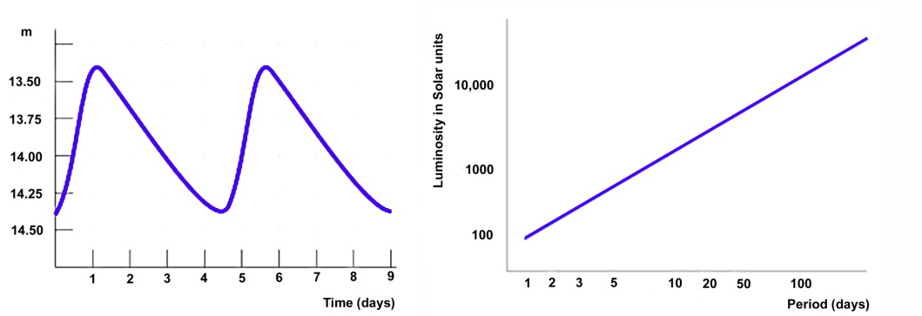
A Cepheid variable Light Curve and period -luminosity relation.
The relationship between a Cepheid variable's luminosity and period is quite precise; a three-day period Cepheid corresponds to a luminosity of about 800 times the Sun whilst a thirty-day period Cepheid is 10,000 times as bright as the Sun. So that if, for example, we might measure the period of a Cepheid variable in a distant galaxy and observe that it is 10,000 times fainter than a Cepheid variable having the same period, in the Large Magellanic Cloud (LMC). We can then deduce that, from the inverse square law, it would be 100 times further away than the LMC, that is 100 x 51.2 Kpc giving a distance of 5,100 Kpc (16,600,000 light years). Cepheid stars are thus the ideal standard candle to measure the distance of clusters and external galaxies. (As we do not the precise location of the Cepheid variable within the cluster or galaxy there will be a small uncertainty but this error is typically small enough to be irrelevant.)
There had long been arguments as to whether the “White Nebulae” were within or beyond out own Milky Way galaxy. In 1912 Vesto Slipher at the Lowell Observatory published his observations of the spectral lines in M31, the Great Nebula in Andromeda, and found that they showed a shift towards the blue. Assuming that this was due to the Doppler shift this indicated that Andromeda was moving towards us at a speed of 300 km/sec – greater than any previously observed. Slipher wrote: "The magnitude of this velocity, which is the greatest hitherto observed, raises the question whether the velocity-like displacement might not be due to some other cause (than the Doppler shift), but I believe we have at present no other interpretation for it." Three years later he reported on the spectral shifts in the lines of a further 14 galaxies, all but three of which were receding from us at high speeds. This was perhaps an indication that these objects were not part of our own galaxy as the measured Doppler shifts of known objects within our galaxy were far less.
But an opposing view was promoted by Harlow Shapely who had used Cepheid variables to measure the size of the galaxy and the place of our Sun within it. As a result, he was a highly respected astronomer so many accepted his word that the nebulae were nearby. His key point was that novae were observed in these objects and, if they were at great distances they would have to be imaginably bright. [They were, they were supernovae!]
What was really needed was the measurement of the distance to one of these “White Nebulae”. Hubble knew that if he could locate a Cepheid variable in one and measure the period of its oscillation, he could compare its brightness with one of similar period that had been observed in the SMC. If, say, it appeared 100 times fainter, he would know that it would lie at a distance 10 times further away than the SMC whose distance was known. The Andromeda Nebula was the obvious target and finally, on an image taken on the 9th October 1923, he found one and was thus able to calculate that Andromeda lay at a distance of 860,000 light years - well beyond the extent of our own galaxy, then thought to be about 300,000 years in diameter. [You will note that these values are about three times smaller than those currently accepted. There are two main types of Cepheid variable and those observed in Andromeda were several times brighter than those observed by Henrietta Leavitt in the SMC. This reduces the calculated distance.]
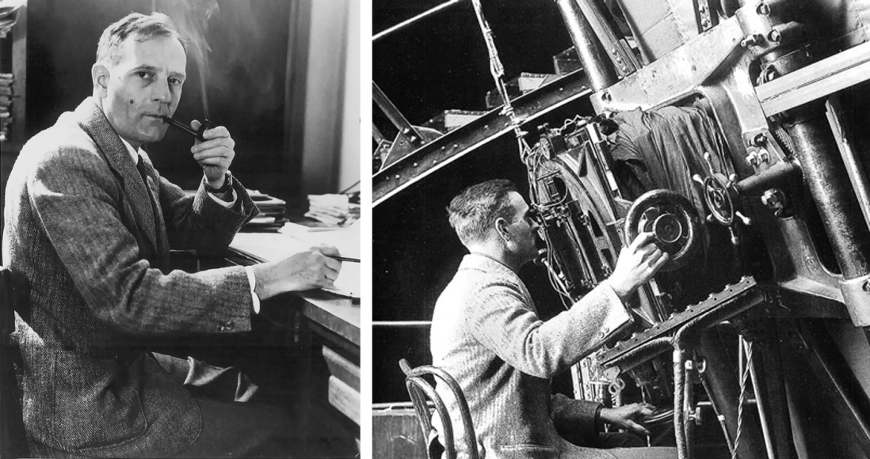
Edwin Hubble at his desk and at the focus of the Hooker 100 inch telescope at Mount Wilson Observatory which he used to measure the distances to the “White Nebulae”.
His discovery, announced on December 30th 1924 profoundly changed our understanding of the Universe. Hubble then went on to measure the distances to the galaxies whose redshifts had been measured by Vesto Slipher and combined his distance measurements with Slipher’s velocity measurements to make what was perhaps the single most important discovery of the last century.
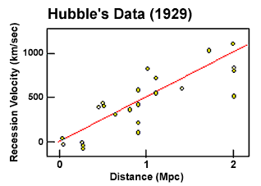
Hubble found that the more distance galaxies had greater velocities of recession and (roughly in the original data) the greater the distance the greater the velocity. This has become known as Hubble’s Law: the velocity of recession being proportional to the distance. Why was this so important? Imagine the very simple one dimensional universe shown below. Initially the three components are 10 miles apart as shown in the above plot. Let this universe expand uniformly by a factor of two in one hour. As seen from the left hand component, the middle components will have appeared to have moved 10 miles in one hour whilst the right hand component will have appeared to move 20 miles - the apparent recession velocity is proportional to the distance.
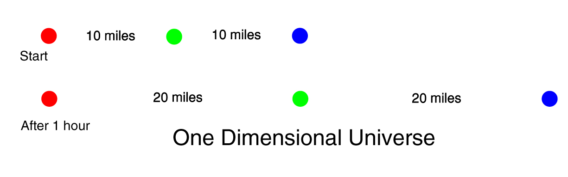
The speed of recession and distance were directly proportional and related by "Hubble's Constant" or H₀. The value that is derived from his original data was ~500 km/sec/Mpc. The use of the word "constant" is perhaps misleading. It would only be a real constant if the universe expanded linearly throughout the whole of its existence. It has not - which is why the subscript is used. H₀ is the current value of Hubble's Constant!
If one makes the simple assumption that the universe has expanded at a uniform rate throughout its existence, then it is possible to backtrack in time until the universe would have had no size - its origin - and hence estimate the age, known as the Hubble Age, of the universe. This is very simply given by 1/H₀ and, using 500 km/sec/Mpc, one derives an age of about 2000 million years:
1/H₀ = 1 Mpc / 500 km/sec
= 3.26 million light years/ 500 km/sec
= 3.26 x 10⁶ x 365 x 24 x 3600 x 3 x 10⁵ sec / 500
= 3.26 x 10⁶ x 3 x 10⁵ years / 500
= 1.96 x 10⁹ years
= ~ 2 Billion years
This is obviously incorrect; the distance calibration data Hubble used was incorrect and, in addition, he was actually observing a brighter class of Cepheid variable which led him to significantly underestimate the distance to the galaxies.
Hubble also devised the most commonly used system for classifying galaxies, grouping them according to their appearance in photographic images. He arranged the different groups of galaxies in what became known as the Hubble sequence. They fell into 3 groups: elliptical, spiral (which were sub-divided into normal and barred spirals) and irregular galaxies.
After the war he supported the construction of the gigantic 200-inch telescope on Palomar Mountain south of Mount Wilson, which helped put him on the cover of Time magazine in 1948. He was honored with making its first observation - that of NGC 2661, the Cometary Nebula, that he had first studied in 1914. Sadly, in 1953, shortly after the 200-inch was completed, Hubble died of a heart attack. Up to the time of his death, astronomers were not able to be considered for the Nobel Prize. This was remedied shortly afterwards but as it is never awarded posthumously he never became a Nobel Laureate – an honour that he so richly deserved.
The Hubble Space Telescope (HST)
In 1946, the astronomer Lyman Spitzer wrote the paper "Astronomical advantages of an extraterrestrial observatory" in which he discussed the two main advantages that a space-based observatory would have over ground-based telescopes. Firstly, the angular resolution would be limited only by the size of the mirror (assumed to be optically perfect), rather than by the turbulence in the atmosphere and, secondly, a space-based telescope could observe in the infrared and ultraviolet light wavebands which are strongly absorbed by the atmosphere. In 1965 he was appointed to chair a committee given the task of defining the scientific objectives for such a telescope. [In recognition of this work, the infra-red space telescope “Spitzer” is named after him.]
The Hubble Space Telescope (HST), as it is known, was funded in 1970 with a proposed launch date of 1983, and was built by NASA with contributions from the European Space Agency. It was to be launched by the space shuttle and, amongst many other problems, its launch was delayed by the Challenger Disaster. The launch finally took place on April 24th 1990 when the HST was carried into orbit by Discovery. The low, 350 mile high, orbit meant that many objects could only be observed for up to 12 hours before they was hidden by the Earth, but gave the HST the invaluable (and as it turned out critical) ability to be serviced by further shuttle flights throughout its working life. A total of five servicing missions from 1993 to 2009 have taken place; replacing parts with a limited working life - in particular the gyroscopes which are use to orientate it towards the target objects – and upgrading the instruments to greatly improve their capabilities.
The task of figuring the primary, 2.4m, mirror was given to the Perkin-Elmer Corporation. The HST optical design is a Ritchey-Chrétien variant of the Cassegrain reflecting telescope. This design gives a wide field of view with excellent image quality across the field and is now used by the majority of large optical telescopes (and an increasing number of amateur telescopes too). It disadvantage is that the primary and secondary mirrors are hyperbolic in shape and are thus difficult to fabricate and test. As the HST was to be used at ultraviolet wavelengths, to achieve the desired diffraction limited optics meant that its mirror needed to be polished to an accuracy of 10 nanometres, or about 1/65 of the wavelength of red light. Construction of the Perkin-Elmer mirror began in 1979, using Corning ultra-low expansion glass. To minimize weight, it consisted of inch-thick top and bottom plates sandwiching a honeycomb lattice. The mirror polishing was completed in 1981 and it was then washed using hot, deionized water before received a reflective coating of aluminium under a protective coating of magnesium fluoride.
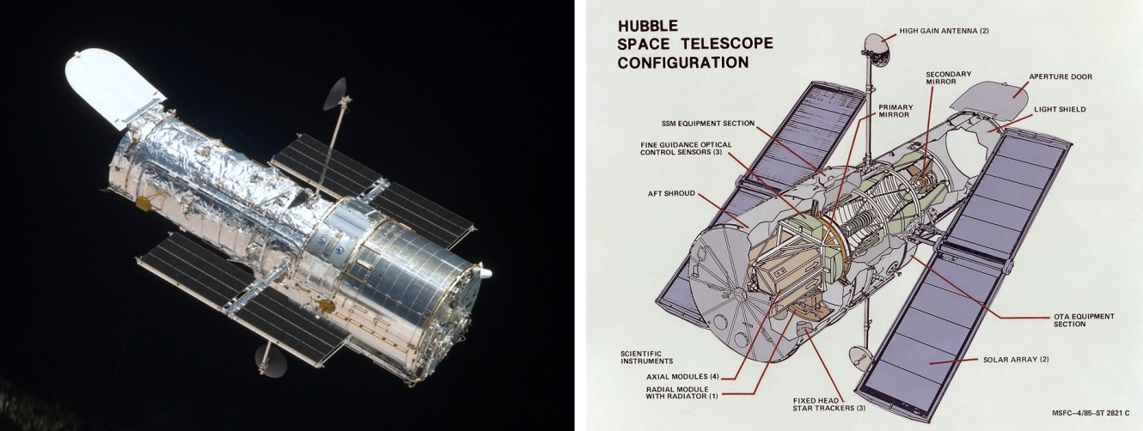
In low-orbit, the spacecraft has to withstand frequent passages from direct sunlight into the Earth's shadow, so a shroud of multi-layer insulation is used to keep the interior temperature stable. The optics being mounted in a graphite-epoxy frame to keep them precisely aligned. The HST's guidance system uses gyroscopes, controlled by three Fine Guidance Sensors, to keep the telescope accurately pointed during an observation. The scientific operation of the HST is under the control of the Space Telescope Science Institute, in Baltimore, who schedule the telescope’s observations and provide support for the astronomers who use the HST (with an European support institute in Germany). Scheduling the observations is a difficult task as the telescope must not be pointed near the Sun, Earth or Moon as scattered light would harm the observations and possibly damage the instruments. Due to its low orbit, effectively in the upper atmosphere, its orbit changes over time as so its position cannot be predicted with accuracy until a few days before a proposed observation.
A Flawed Mirror
During the initial tests of the optical system after the launch of the telescope it became obvious that there was a serious problem with the optical system. Stellar images which should have been ~0.1 arc second across were more than 1 arc second across – no better than ground based images! Image analysis showed that the primary mirror suffered from spherical aberration as the mirror - though the most precisely figured mirror ever made - had been ground to the wrong shape. The result was the image of a star was composed of two parts: a central core 0.1 arc seconds across containing about 15% of the total light (instead of a theoretical ~80%) with the remaining light forming a halo surrounding the core about arc second across. It was still possible to image bright objects and spectroscopy was largely unaffected but faint object imaging (such as of distant galaxies) was virtually impossible. Techniques developed by radio astronomers to produce high quality images from sparse arrays of telescopes (such as MERLIN) came to the rescue to some extent and the HST was able to make productive observations during the three years before the first servicing mission could provide a solution to the problem.
Though the primary mirror was the wrong shape, it precisely followed the wrong shape and this was much better than a badly made mirror of the correct shape! Having found the error in the shape, it was then possible to design and make corrective optics with an identical error but in the opposite sense that were installed during the first HST servicing mission in 1993. [This is rather like the fact that the appropriate concave lenses of my glasses correct for the fact that my retina is too far from the eye lens and so enable me to have essentially perfect vision.]
It turned out that the device (called a null corrector) used by Perkin-Elmer to test the primary mirror had been incorrectly assembled so giving rise to the error in the surface curvature. It appeared that they ignored tests made with two other less precise null correctors both of which indicated that the mirror was suffering from spherical aberration. To incorporate the corrective optics (called COSTAR) into the HST, one instrument had to be initially sacrificed, but upgraded instruments installed in 2002 all incorporated their own corrective optics so, in 2009, COSTAR was replaced with a new spectrograph.
It was known that the four gyroscopes used in the telescope pointing system would have a limited lifespan and so the telescope had always been designed so that it could be regularly serviced, but the first servicing mission in December 1993 assumed great importance as the astronauts had to carry out extensive work over a 10 day period to install the corrective optics. The seven astronauts also replaced the solar arrays and upgraded the on board computers before boosting the telescope into a higher orbit to compensate for the drag and resultant orbital decay experienced over the three years since its launch. Happily the mission was a complete success and in January 1994 NASA published the first perfectly sharp image from the corrected optics.
Further servicing missions were flown in February 1997, December 1999 and March 2002. The fourth mission replaced the solar arrays for the second time. The new arrays, whilst only two-thirds the size of the old arrays, provided 30 percent more power whilst significantly reducing the atmospheric drag so lengthening the time before the HST would need to be boosted back into a higher orbit. This was a critical factor in extending its life. The next scheduled mission was planned for October 2005, when the shuttle crew would have replaced two broken gyroscopes, installed a new CCD camera, WFC3, to replace WFPC2 and installed a new spectrograph to take up the space no longer need by COSTAR. The Columbia disaster in February 2003, delayed all shuttle flights for two years and under a new safety regime (which mandated that all future shuttle flights would have to be able to reach the safety of the International Space Station (ISS) should an in-flight problem occur) any further servicing missions were ruled out as the shuttle was not capable of reaching both the HST and ISS in one mission. This would have meant that the HST would reach the end of its operational life in 2010, well before the launch of the James Webb Space Telescope (JWST), then scheduled for 2014 but now delayed until at least September 2015.
This was a major concern to astronomers given the great scientific impact of HST, and Congress asked NASA to look into ways that it could be saved. Robotic missions were considered and discarded as “not feasible”. In 2005 the new NASA Administrator, Michael D. Griffin, authorized the Goddard Space Flight Center to proceed with preparations for a manned Hubble maintenance flight which was scheduled for October 2008. However a failure of the main data handling unit in the HST in September 2008 meant that this was postponed until May 2009 so that a replacement could be carried to the HST. (The HST had a backup data system which was successfully activated but should this have then failed the HST would then be crippled.)
Two new instruments were installed, one of which, Wide Field Camera 3 (WFC3), increased Hubble’s sensitivity in the ultraviolet and visible parts of the spectrum by up to 35 times. At the same time the astronauts replaced the six battery packs, the three rate sensor units, one of the Fine Guidance sensors and positioning gyroscopes as well as giving the HST a new thermal protective blanket. Hubble resumed operation in September 2009 and it is hoped that it will continue to be fully operational until the end of 2014 and perhaps, hopefully, longer.
Hubble was originally designed to be returned to Earth on board a shuttle. With the retirement of the shuttle fleet this will no longer be possible, so NASA engineers developed a “Soft Capture and Rendezvous System” which was attached to Hubble’s aft bulkhead during its final servicing mission. This will enable the HST to be captured by a future spacecraft (probably robotic) and then safely “deorbited at the end of its long and illustrative life. [The last shuttle flight, with Atlantis, is scheduled for June 28th 2011 – taking supplies and equipment to the International Space Station.]
Hubble Science
In its over 20 year lifetime, the HST has probably been the most productive scientific instrument ever built: it has targeted over 30,000 individual objects, produced over 44 tera-bytes of data from which astronomers have published nearly 9,000 papers. In this section of the transcript it will therefore only be possible to highlight some of the HST’s most exciting results.
Observation of the Supernova SN1987A
In February 1987, a supernova was observed in the Large Magellanic Cloud (LMC) and immediately became the focus of virtually every telescope capable of observing the southern sky. It was continuously monitored by the HST and has enabled a key step in the cosmic distance scale to be determined, that of the distance to the LMC. It appeared that at some time before the star exploded, it has ejected a ring of gas that surrounded the star. This was not initially visible, but as the ultraviolet light from the explosion travelled outwards at the speed of light it reached the ring and caused the gas to glow. Had the ring been at right angles to the line of sight, it would all have lit up simultaneously, but it lies at an angle so the nearest part of the ring was seen to brighten after 75 days and the furthest part after 390 days – this is just due to the light travel time across the ring delaying the brightening of the more distant parts.
From these observations it was deduced that the radius of the ring was 232.5 light days. But also, as the HST had sufficient resolution to image the ring, the ring was measured to be 17.2 arc seconds across. Given both the angular diameter and the distance in light days across the ring (465 light days) the distance of the supernova can be calculated giving a distance of 52 kpc or 170,000 light years to the LMC. This has given a new value for the zero point of the Cephid distance scale, which has greatly improved our knowledge of galactic distances and, as a consequence, the value of Hubble's constant - the scale factor of the universe.
Measurement of the Distance Scale of the Universe, the Hubble Constant and the Age of the Universe
Hubble’s Constant which is a measure of the expansion rate of the universe (and from which one can determine its age) depends on measuring two things about a distant galaxy: its speed of recession and its distance. The former is relatively easy to measure from the redshift seen in its spectral lines. The latter is far harder and it requires the observation of objects of known brightness. The HST’s superb resolution has enabled astronomers to study one such type of object – called Cepheid Variables – out to far greater distances than before. They are pulsating stars about 1,000 times brighter than our Sun whose period is closely related to their absolute brightness. These Cepheid variables are thus called “standard candles”. As the period is easy to measure the brightness can be deduced and hence, using the inverse square law, the distance found.
This, for example, enabled the distance to the galaxy NGC 3021 to be determined to lie at a distance of 92 million light years. In 1995 a type Ia supernova was observed in this galaxy. These have an exceedingly high and well defined brightness. The HST has been able to observe them in very distant galaxies, and so by comparing their observed brightness with that observed in NGC 3012, their distances were able to be determined. Allied to their redshifts this has enabled the error in the value of the Hubble Constant to be reduced to less than 5% - a value of 74.2 +/- 3.6 km/sec/Mpc. This has enabled the precision of other cosmological parameters to be refined as, for example, the age of the universe now known to be 13.75 +/- 0.11 billion years
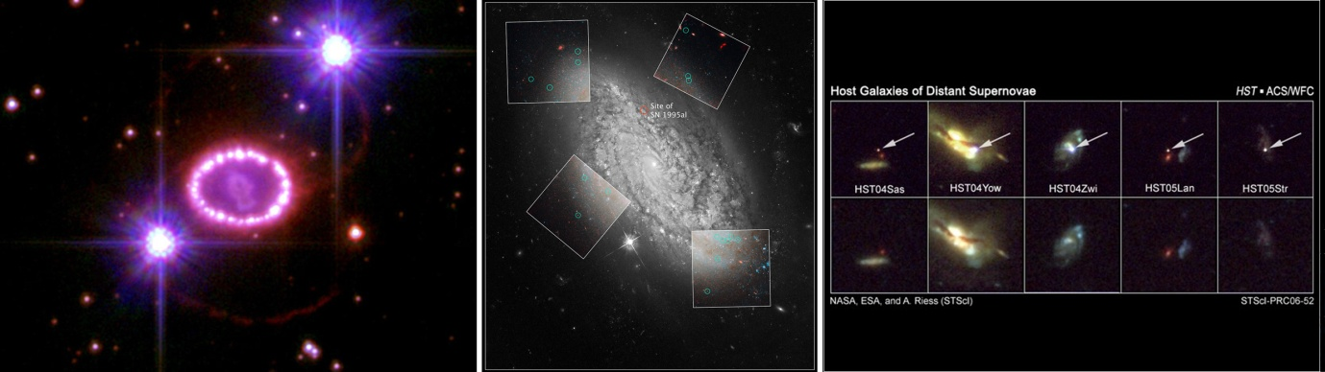
Left: SN1987A in the LMC. Centre: Cepheid Variables in NGC 3012 also showing the site of the 1995 Type 1a Supernova. Right: Type Ia Supernovae in distant galaxies.
Our Solar System and Exoplanets
Shoemaker-Levey 9:
The HST imaged the train of comets that had resulted form the breakup of a comet that had first become captured by Jupiter and then came so close that it came within the “Roche” limit and broke up into ~25 separate pieces. These were predicted to impact onto Jupiter’s surface over a period of a week in 1994. The impact site was beyond the limb, but the HST was able to image the plumes that arose from the impact sites and then the sites themselves as they came into view an hour or so later.
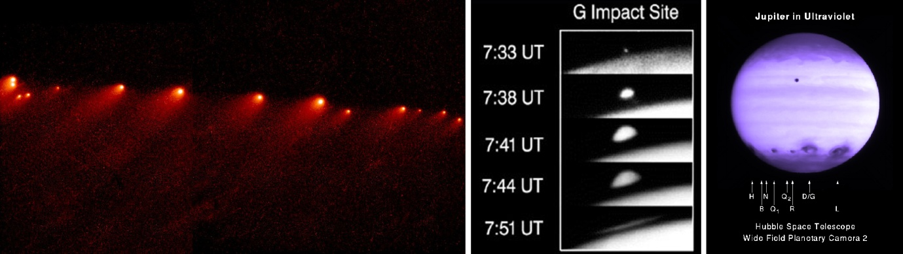
Left: Trail of comets making up Shoemaker-Levey 9. Centre: Plumes rising up from the impact site. Right: Scars seen on the surface.
Pluto and the Kuiper Belt:
In 2005, the HST discovered two new moons of Pluto - Nix and Hydra and was able to show significant changes in the surface markings of the dwarf planet itself. The HST has detected many Kuiper Belt Objects (KBO) and in 2009 detected a body in this region that was under 1km across. This was achieved by observing an occultation of a star by the Fine Guidance System. Its predicted size is ~ 50 times smaller that any KBO’s discovered directly by reflected light and is the first direct evidence of cometary sized bodies existing in the outer solar system. HST observations of the 900 km diameter KBO, Quaoar, have enabled the orbit of its moon, Weymot, to be calculated. This has enabled the mass of Quaoar to be found and hence, given its size, its density. This, surprisingly, appears to be ~4.2 which means that it is a rocky body rather than an icy body as had been expected.
The first, and only, visual image of an exoplanet:
In two images of the star Fomalhaut taken in 2004 and 2006 in which the light form the star was largely eliminated by an occulting disk, a planet was seen orbiting the star at a distance of nearly 120 AU – about 10 times Saturn’s distance from the Sun. It was found orbiting inside a large disk of debris somewhat like our Sun’s Kuiper Belt and is no more that three times Jupiter’ mass.
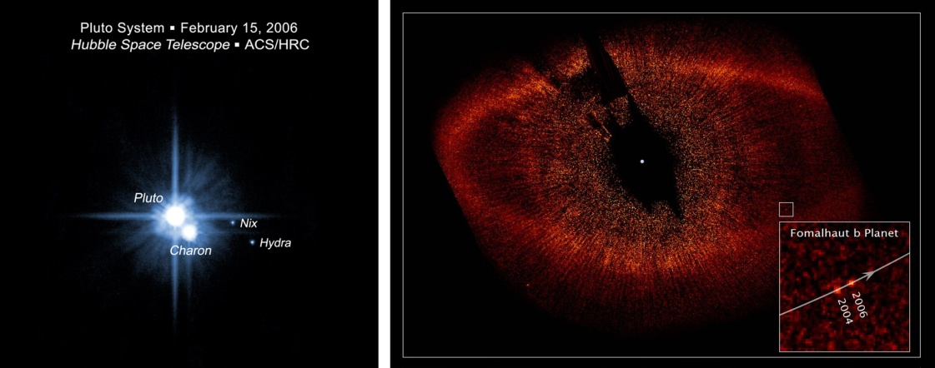
Left: Pluto with Charon, Nix and Hydra. Right: The planet orbiting Formalhaut.
Exoplanets in the Galactic Bulge:
To show whether the locally measured number of planetary systems orbiting stars is representative of the galaxy as a whole, the HST observed 180,000 stars towards the galactic centre. These observations lead to the discovery of 16 candidate planets - a number consistent with the frequency of planets in the solar neighbourhood – indicating that planetary systems are widespread within the galaxy. Five of these planets orbit their sun in less than one Earth day!
Exoplanet atmospheres:
By observing the transit of a planet across the face of a star, the HST has been able to measure the atmospheric composition of two planets. As the planet will block some of the light from the star (typically 1 or 2% in the case of gas giants) the star will dim slightly. However, whilst the planet lies between us and the star, some of the starlight will pass through the planet’s atmosphere. By comparing the spectrum of the starlight before and during the transit it is possible to determine the presence and abundance of chemicals and gasses that exist there. HST observations of a star HD 209458 have shown that its planet’s atmosphere contains sodium, oxygen, carbon and hydrogen whilst, even more exciting, star HD 189733’s planet shows evidence for carbon dioxide, water vapour and methane!
Gamma-ray bursts and Quasars
The HST has imaged the host galaxies of many long duration gamma ray bursts (GRBs). The observations support the theory that this type of GRB is the result of the collapse of a massive star collapsing to form a black hole as they are found in regions where there are many such stars in galaxies with a low abundance of elements beyond helium. (These are called low-metallicity galaxies as all elements beyond helium are called “metals” in astronomy – I do not know why!) It appears that massive stars were far more common in the early universe before the galaxies had enough time to produce a high concentration of “metals” formed by nuclear fusion in the cores of their stars.
By observing the blue star-like objects that are called “quasars” the HST has been able to image the galaxies within which they reside and shown that they are either bright elliptical galaxies or pairs of interacting galaxies.
Studies of Dark Matter and Dark Energy
Dark Matter:
It appears that about 23% (about six times more than normal matter) of the mass in the universe is in the form of dark matter – which does not interact with or emit any light but whose presence can be detected through its gravitational effects. It is thought that they are exotic elementary particles that react very weakly with normal matter but, it is hoped, may be detected soon in highly sensitive experiments carried out deep underground or even created in accelerators such as the large Hadron Collider at CERN.
The presence of dark matter can be detected and its distribution through space can be determined by its distorting effects on the images of distant galaxies due to what is called “weak gravitational lensing”. The light from such galaxies is “warped” as it passes through gravitational influence of intervening galaxy clusters giving rise to stretched and sometimes arced images. Using the HST, astronomers have plotted the three dimensional distribution of dark matter in a slice of the universe out to a distance of 6.5 billion light years. It was found that the dark matter appears to be clumping into more concentrated regions with time.
The HST, in combination with the Chandra X-ray telescope and ground based telescopes, has measured the distribution of dark matter and gas in what is called the “Bullet” cluster which is interacting with a second cluster. The dark matter and gas are seen to have separated during the collision – which is precisely what theorists predict if dark matter is made up of elementary particles that interact very weakly with normal matter.
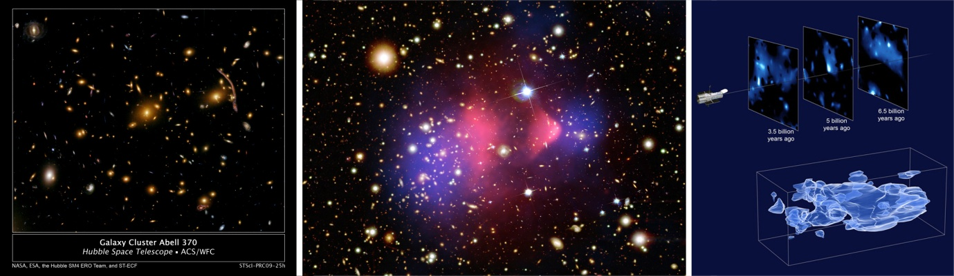
Left: HST image of the Abell Cluster 370 showing weak gravitational lensing of a distant cluster. Centre: The Bullet Cluster showing the separation of dark (blue) and normal matter (red) in a galaxy collision. Right: HST observations showing that dark matter is clumping over time.
Dark Energy:
Up to 1998, astronomers believed that the rate of expansion of the universe was slowing down (decelerating) with time under the attractive pull of gravity – rather as a ball slows when thrown up in the air - but then two independent teams of astronomers presented evidence that, conversely, it appeared that the rate of expansion was increasing (accelerating) with time. The evidence related to the fact that distant supernovae appeared fainter (by about a quarter of a magnitude) than would have been expected if the universe were decelerating under its own gravity. This could be the result of a term in Einstein’s equations of General Relativity called the Lambda (☹) term or “Cosmological Constant”. This would give rise to a force that opposes gravity and Einstein had included it when solving his equations for what he thought to be a “static” universe – one which remained the same size. As gravity would cause the universe to collapse, he was able to cancel out its effects by including this “anti-gravity” term but, when Hubble showed that the universe was expanding he called this the greatest blunder of his life. Perhaps he was not quite so wrong as he thought!
It now appears that dark energy makes up ~73% of the mass/energy of the universe and its true nature is one of the most profound questions relating to the physics of the universe. To try to learn more about its properties we need to trace out the expansion history of the universe. As mentioned above, Type 1a supernova are excellent distance indicators and, due to their great brightness, can be observed more than halfway across the visible universe – so looking back in time some 8-9 billion years. HST observations have shown dark energy appears to be consistent with what quantum mechanics predicts for what is called “vacuum energy” and it effect on the universe increased as the volume of space increased over time. These observations have also shown that its effects were being felt 9 billion years ago, though it was not then dominant and gravity was still reducing the rate of expansion of the universe. They have also shown that the transition from a decelerating universe to one that was accelerating occurred about 5 billion years ago.
Galaxy Formation and Evolution - The Hubble Deep Fields
One of the key aims of the Hubble Space Telescope was to study distant galaxies at far higher resolution than was possible from the ground. This would enable astronomers to study their evolution as the more distant they are, the further back towards the origin of the universe we see them. Early studies once the telescopes optics had been corrected indicated that there were substantial differences between the properties of galaxies “now” (that is, near by ones) and those that are observed as they were several billion years ago.
The observing time of large telescopes is allocated by “time allocation” committees who chose the best observing proposals that have been proposed by astronomers. However a percentage of the telescopes observing time (up to ~10%) is designated as Director's Discretionary Time. The telescope director is then able to allocate time - often to enable observations of transient phenomena, such as supernovae, to be observed. In 1995, once Hubble's corrective optics were shown to be performing well, Robert Williams, the then director of the Space Telescope Science Institute, decided to devote a substantial fraction of his discretionary time to the study of distant galaxies to produce what became known as the Hubble Deep Field (HDF).
An area of the sky was chosen to be at a high galactic latitude (that is well away form the plane of our Milky Way galaxy) to minimise the dust that obscures our view along the galaxy’s plane and also avoid bright foreground stars and known infrared, ultraviolet and X-ray sources. The chosen field was in the constellation Ursa Major – a northern hemisphere region so that follow up observations could be made by optical telescopes such as the two 10m Keck Telescopes on Mauna Kea, Hawaii, and the VLA and MERLIN radio instruments. The field of view was just 5.3 square arc minutes in area just 1/28,000,000 of the sky’s total area. In total over 10 days of observations (when the HST made ~150 orbits of the Earth) were made at four wavelengths in the near-infrared, red, blue and near-ultraviolet of the target field with further observations of the surrounding region to aid follow-up observations by other instruments.
A total of 342 individual images were taken and, when cleaned of cosmic-ray hits, satellite tracks and corrected for scattered light, were combined together to yield four monochrome images one at each wavelength. Three of the images were then combined to give a “false colour” image which would give an approximation to the actual colours of the galaxies in the image. About 3,000 distinct galaxies could be identified including both spiral and irregular galaxies. One of the most significant findings was the discovery of large numbers of galaxies with high redshifts - many corresponding to distances of about 12 billion light-years.
Follow-up observations have been made over a very wide spectral range: infrared emission from 13 of the galaxies visible in the optical images has been observed related to the large quantities of dust associated with star formation, X-ray observations by the Chandra X-ray Observatory revealed six sources in the HDF and radio arrays. The Jodrell Bank MERLIN array detected 16 radio sources in the HDF and greatly helped to determine their precise positions.
In 1998, the HST observed a counterpart region in the southern hemisphere sky. Very similar in appearance, it supported the cosmological principle which states that, at its largest scales the universe is homogeneous. A wider survey, but less sensitive survey, was carried out as part of the Great Observatories Origins Deep Survey; a section of which was then observed for a million seconds (11.3 days) over 400 orbits to create the Hubble Ultra Deep Field, which is the most sensitive optical deep field image to date. Objects as faint as 30th magnitude were detected which corresponds to collecting one photon per minute of observing time! (Nearby galaxies would give millions of photons per minute.) The image shows about 10,000 galaxies one of which, observed by the European Southern Observatory’s VLT 8m telescope in Chile, has a redshift that indicates that it seen at a time when the universe was only 600 million years old - the most distant and oldest galaxy in the universe yet observed. In the 2009 final HST servicing mission it was equipped with a more sensitive CCD camera and so it is likely that at least one further deep field will be produced during the Hubble Telescopes final years of life.
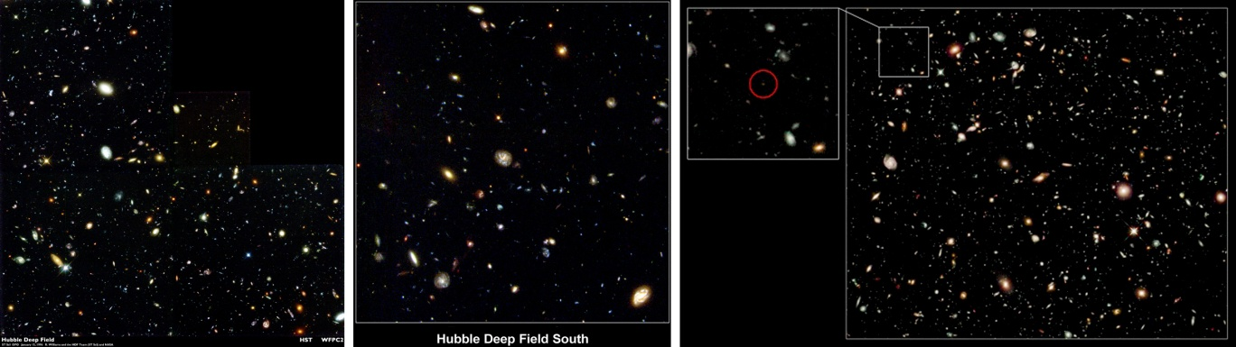
Left: The Hubble Deep Field North (1995). Centre: The Hubble Deep Field South (1998). Right: The Hubble Ultra-deep Field (2009) and the VLT image of the most distant galaxy now known.
What have we learned? Galaxies in the distant past were smaller and more irregular in shape that those we see nearby (and hence more recently). This is consistent with the idea that small galaxies collided and accreted gas to gradually build up the larger galaxies we see today. By analysing the rate of star formation in galaxies at different redshifts (and hence age) astronomers have deduced that star formation reached a peak some 8-10 billion years ago and has since declined to about 1/10th its maximum value. The earliest galaxies were formed when there were only small amounts of heavier elements (beyond the hydrogen and helium created in the big bang) so there was almost no dust present. The HST has shown that these galaxies are very blue – just as one might expect. Another important result related to the understanding of dark matter. It was thought that a substantial part might be in the form of red dwarfs and planetary bodies in the galactic halo called Massive Astrophysical Compact Halo Objects (MACHOs), but the HDF showed that there were not significant numbers of red dwarfs visible (only ~20 foreground stars were observed in the field). HST observations of galaxy centres have revealed that the masses of the super-massive black holes that reside there are tightly correlated with the masses of the stellar bulges at the centre of galaxies. This implies that evolutions of galaxies are intimately connected to the black holes within them.
Hubble’s Heritage Images
There is one further aspect of the HST that will have left a legacy to us all. The Hubble Heritage Imaging team have used a small part of the observing time to make some of the most wonderful astronomical images that have ever been seen. These are now used in virtually all astronomy books and, not least, in my powerpoint presentations to show us some of the beauty of the universe in which we live.
©Professor Ian Morison, Gresham College 2011

About the Speaker
Professor Ian Morison
Ian Morison began his love of astronomy when, at the age of 12, he made a telescope out of lenses given to him by his optician. He attended Chichester High School and then went on to study Physics, Mathematics and Astronomy at Hertford College, Oxford. In September 1965, he became a research student at the University of Manchester's Jodrell Bank Observatory. In 1970 he was appointed to the staff of the Observatory and teaches astronomy at the University of Manchester.
In 1990 he helped found the Macclesfield Astronomy Society which meets at the Observatory and later became president of the Society for Popular Astronomy, the UK's largest astronomical society. He remains on the Society's Council and holds the post of instrument advisor helping members with their choice and use of Telescopes.
He lectures widely on astronomy, has co-authored books for amateur astronomers and writes regularly for the UK astronomy magazines Astronomy Now and Sky at Night. He also writes a monthly sky guide for the Observatory's web site and produces an audio version as part of the Jodrell Bank Podcast. He has contributed to many television programmes and is a regular astronomy commentator on local and national radio. Another activity he greatly enjoys is to take amateur astronomers on observing trips such as those to Lapland to see the Aurora Borealis and, last year, to Turkey to observe a total eclipse of the Sun.
Ian is excited about the prospect of his time as Gresham Professor of Astronomy. He regards it as real challenge and expects it to play a major role in his life for the next three years. He will to give a wide variety of illustrated lectures ranging from how our understanding of the Universe has grown over the centuries to a gentle introduction to Einstein's theory of Gravity - now being tested to extreme accuracy by astronomers at Jodrell Bank.

