

24 September 2014

Are we Alone? The Search for Life beyond the Earth

Professor Ian Morison

We have three possibilities, firstly to find evidence of present or past life on other planets or satellites of our own solar system, secondly to find evidence of life in nearby solar systems and thirdly to detect a signal from another advance civilisation in what is called SETI – the Search for Extra-terrestrial Intelligence. Let’s work our way outwards into the galaxy.

A Civilisation on Mars?

Mars was first seen through a telescope by Galileo in 1609, but his small telescope showed no surface details. When Mars was at its closet to Earth in 1877, an Italian astronomer, Giovanni Schiaparelli, used a 22-cm telescope to chart its surface and produce the first detailed maps. They contained linear features which Schiaparelli called canali, the Italian for channel. However this was translated into English as “canal”− which implies a man made water course − and the feeling arose that Mars might be inhabited by an intelligent race. It should be pointed that a waterway could not be detected from Earth, but it was thought that these would have been used for irrigation and so would have irrigated crops growing adjacent to them which could be seen from Earth.

Influenced by Schiaparelli’s observations, Percival Lowell founded an observatory at Flagstaff Arizonia (later famous for the discovery of Pluto) where he made detailed observations of Mars which showed an intricate grid of canals. However as telescopes became larger, fewer canali were seen though the surface showed distinct features. They appear to have been an optical illusion but the myth of advanced life on Mars was not finally dispelled until NASA’s Mariner spacecraft reached Mars in the 1960’s. (An intriguing image of a huge rock formation, called the “face on Mars”, was obtained by the Viking 1 space craft in 1961 leading some to suspect that this was a giant representation of a past civilisation. However, a detailed photograph taken by Mars Global Surveyor in 2001 showed it to be a “mesa” − a broad flat topped rock outcrop with steep sides.)

The detailed images taken by the Mariner spacecraft showed giant canyons and vast volcanoes. One of these, Olympus Mons, is the largest known volcano in the Solar System with a caldera of 85 km in width surmounting the volcanic cone whose base is 550km in diameter. The caldera is nearly 27 km above the Martian surface, three times higher than Everest! It was realised that when these giant volcanoes were active, some three thousand million yeas ago, they would have given Mars a far thicker atmosphere than now and the effects of greenhouse gasses in the atmosphere would have allowed the surface temperature to be sufficiently high for water to exist on the surface. Other visible surface features gave ample evidence of water flow over the surface leading to speculation that simple life forms might then have existed on Mars.

This possibility lead to the sending of two Viking Landers to Mars in 1976. As well as imaging the surface and collecting scientific data, their objective was to search for any evidence of life. They conducted three experiments which, though discovering unexpected chemical activity in the Martian soil, provided no clear evidence for the presence of any living organisms. As Mars has a very thin atmosphere (and no ozone layer), far more ultraviolet light reaches the surface than on Earth. This would prevent the existence of life above ground. If life had once arisen on Mars, one could now only expect to find evidence for it beneath the surface.

It was nearly 30 years before the next probe to specifically search for evidence of life was sent to Mars. This was the, UK designed and built, Beagle II craft that was due to land on Christmas day 2003. It had left its mother ship, Mars Express, on a perfect trajectory a few weeks before, but appeared to have crash landed on its arrival at the surface – a sad moment for me as I had been charged with receiving its first signals from the surface using the 76-metre Lovell Telescope at Jodrell Bank.

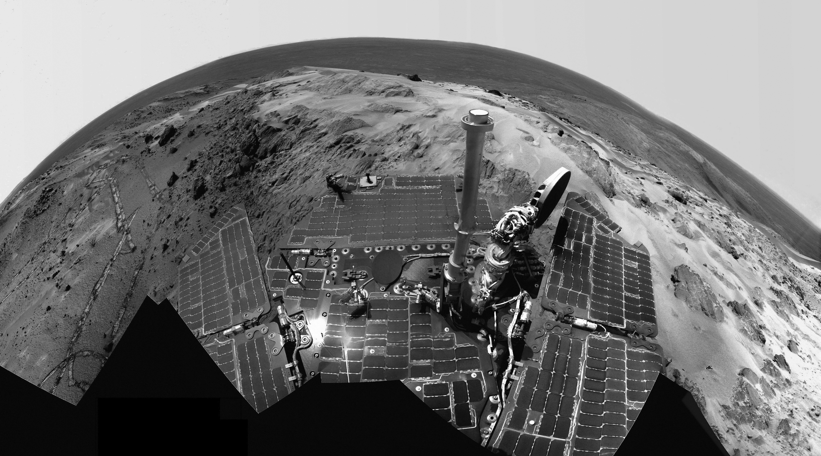

A Martian panorama imaged by the Spirit Rover at Gusev Crater. Image: Mars Exploration Rover Mission, Cornell, JPL, NASA.

Orbiters, Rovers and the Phoenix lander

Following a period when many Mars probes seemed doomed to failure, recent successes have greatly increased our understanding of its surface, either when viewed with high resolution cameras orbiting the planet such as those on Mars Reconnaissance Orbiter which began surveying Mars in November 2006, or with the rovers “Spirit and “Opportunity” which landed in 2004. One of these, Opportunity, was still operational at the beginning of 2014.

The rovers primary scientific mission was to investigate a wide range of rocks and soils that might hold clues to past water activity on Mars. They were targeted to sites on opposite sides of Mars that appear to have been affected by liquid water in the past: Gusev Crater was a possible former lake in a giant impact crater, and Meridiani Planum, where mineral deposits suggested that Mars had a wet past. They have been highly successful, having together traversed over 20 kilometres on the surface of Mars. In 2004, scientists showed pictures revealing a stratified pattern and cross bedding in the rocks inside a crater in Meridiani Planum suggesting that water once flowed there, whilst an irregular distribution of chlorine and bromine suggested that it was once the shoreline of a, now evaporated, salty sea. To confirm the “wet past” hypothesis, Opportunity has found hematite, in the form of small spheres nicknamed “blueberries” which could only have been formed inside rock deposits soaked with groundwater.

Also in 2004, NASA announced that Spirit had found hints of evidence of past water in a rock dubbed "Humphrey” which appeared to contain crystallized minerals lodged in small crevices. These minerals been most likely dissolved in water and carried inside the rock before crystallization. When, in December 2007, one of Spirit’s wheels was not turning properly, it scraped off the upper layer of the Martian soil and uncovered a patch of ground similar to areas on Earth where water or steam from hot springs had come into contact with volcanic rocks. Here, on Earth, such locations are often teeming with bacteria as hot water provides an environment in which microbial life can thrive.

The rovers had never been expected to survive so long as it was thought that dust would soon cover their solar panels to such as extent that they could no longer survive. But scientists had not realized that dust devils − mini tornadoes that can sweep across the Martian surface − could sweep the panels clean. By March 2005, Spirit’s panels had dropped to 60% of their full capacity, but suddenly this increased to 93%! The following day Spirit was able to film a dust devil as it sped across the Martian surface. Sometimes major dust storms can fill the Martian atmosphere and, when the orbiter Mariner 9 reached Mars in November 1971, the surface was totally shrouded by dust. As the storm gradually subsided, the first feature to be seen was the caldera of Nix Olympia rising high above the surface. Towards the end of June 2007, a series of dust storms blocked 99% of the direct sunlight to the rovers and they were facing the real possibility of system failure due to lack of power. They were both placed into hibernation to wait out the storms and happily survived to face another Martian year.

Further evidence of water locked up beneath the surface in a permafrost came when the Phoenix lander used its scoop to dig out a trough in the soil. This exposed sub-surface ice which, as would be expected due to the thin atmosphere, began to vapourise over the following days. This confirms the observations made by the Mars Odyssey and Mars Reconnaissance Orbiter that there is ice beneath the surface of nearly all the northern half of Mars. But until one can drill down into the surface we will not know the depth, and hence the amount, of water ice lying beneath the surface.

The moons of Jupiter

The two innermost Moons, Io and Europa are of great interest. Io is the fourth largest moon in the Solar System with a diameter of 3,642 km. When high resolution images of Io were received on Earth from the Voyager spacecraft in 1979, astronomers were amazed to find that Io was pockmarked with over 400 volcanoes. It was soon realised that giant tidal forces due to the close proximity of Jupiter would pummel the interior, generating heat and so give Io a molten interior. As a result, in contrast with most of the other moons in the outer Solar System which have an icy surface, Io has a rocky silicate crust overlying a molten iron or iron sulphide core. A large part of Io's surface is formed of planes covered by red and orange sulphur compounds and brilliant white sulphur dioxide frost. Above the planes, are seen over 100 mountains, some higher than Mt Everest − a strange world indeed.

In contrast, Europa, the sixth largest moon in the Solar System with a diameter of just over 3,000 km, has an icy crust above an interior of silicate rock overlying a probable iron core. The icy surface is one of the smoothest in the Solar System. Close up images show breaks in the ice as though parts of the surface are breaking apart and then being filled with fresh ice. This implies that the crust is floating above a liquid ocean, warmed by the tidal heating from its proximity with Jupiter. This could thus conceivably be an abode for life and some ambitious proposals have been made for a space craft to land and burrow beneath the ice to investigate whether any life forms are present!

In December 2013, NASA reported that images taken by the Hubble Space Telescope indicate the presence of hydrogen and oxygen above the moon’s southern hemisphere. The observations are consistent with 200-km-high plumes of water vapour. If this can be proved, then it might be possible to detect organic molecules or even evidence of life without having to drill down through the ice. The ESA “Juice” mission, due to be launched in 2022, will make two close flybys in the 2030s and might even be able to fly though any plumes that might exist near the moon’s equator. NASA has made some preliminary plans for an extended mission to Europa called “Europa Clipper” which would spend a year or more in the vicinity of the enigmatic moon.

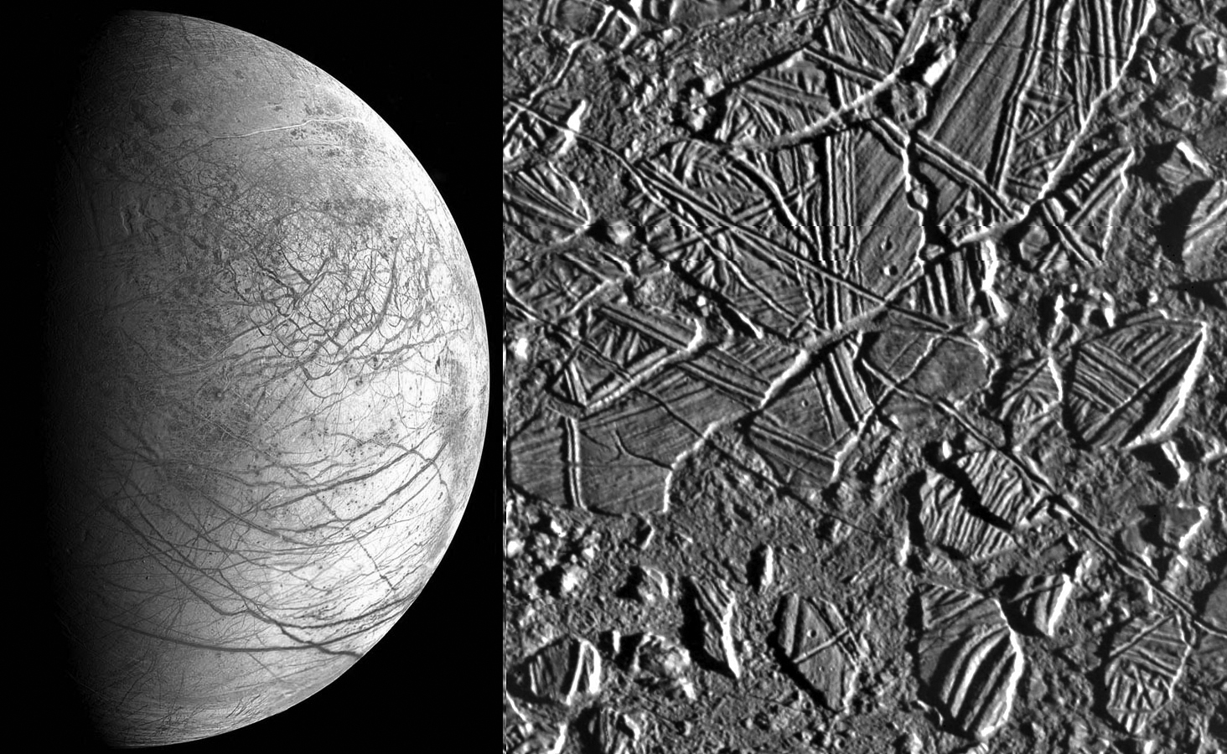

The surface of Europa showing cracks caused by tidal flexure and “icebergs”. Images: NASA, ESA, JPL.

More recently, the Hubble Space Telescope has found evidence of water flumes rising above the surface, presumably associated with the cracking of the surface causes by tidal stresses. This raises the interesting prospect of a spacecraft passing through such a flume and perhaps finding evidence of organic molecules or even simple lifeforms.

Searching for life in nearby Solar Systems.

Let us put ourselves in the place of an advanced civilisation not too far distant in the galaxy. Could we tell if life existed on Earth? The answer is, in fact, yes: they could, and the detection would be based on the taking of an infra-red spectrum of the atmosphere of our planet. If they took spectra of Mars or Venus they would find a flat spectrum with a single deep absorption band due to the presence of carbon dioxide in their atmospheres. But that of our Earth would look very different. The presence of water vapour in our atmosphere would lower the outlying parts of the spectrum and there would be three absorption bands, not one. Along with that due to carbon dioxide, they would find a band due to methane which would be a marker either for life (think cows) or volcanic activity. But, more significantly, they would find a band due to ozone. Ozone can only exist in an atmosphere if there is free oxygen and, as oxygen is highly reactive, unless it is being replenished by some means any will soon disappear. The means by which oxygen is being replenished in our atmosphere is by the action of photosynthesis – a feature of plant life on Earth.

In the same way, should we find evidence of water vapour and ozone in the atmosphere of an exo-planet we could be pretty sure that some form of life might exist there.

I am often asked why we tend to restrict our search for other life forms to locations which are similar to the conditions on Earth. Why should we impose the facts on our own existence on other life forms? My justification for this is twofold. You will have seen that in the stars, somewhat more massive than or Sun, nitrogen is created as they fuse hydrogen into helium and, in the latter stages in the life of stars like our Sun, first carbon and then oxygen are created. Thus the life forms on our planet are very largely composed of what are the most common elements in the Universe. Further, it is generally recognised that carbon has the most complex chemistry of any element and has a complete subject, organic chemistry, devoted to it. So, our life forms are based on the most common elements linked by the chemistry of carbon. Is it not likely that the vast majority of other life forms will use a similar chemistry?

SETI

SETI, the Search for Extra-terrestrial Intelligence, has now been actively pursued for close on 50 years without success. However this does not imply that we are alone in the Milky Way galaxy for, although most astronomers now agree that intelligent civilisations are far less common than once thought, we cannot say that there are none. But it does mean that they are likely to be at greater distances from us and, as yet, we have only seriously searched a tiny region of our galaxy. It will not be until the mid 2020’s that an instrument, now on the drawing board, will give us the capability to detect radio signals of realistic power from across the whole galaxy. It is also possible that light, rather than radio, might be the communication carrier chosen by an alien race, but optical-SETI searches seeking out pulsed laser signals have only just begun.

The Story so Far

The subject may well have been inspired by the building of the 76-metre Mk1 radio telescope at Jodrell Bank in 1957. In 1959 two American astronomers, Giuseppe Guccione and Philip Morrison, submitted a paper to the journal Nature in which they pointed out that, given two radio telescopes of comparable size to the Mk 1, it would be possible to communicate across interstellar distances by radio. They suggested a number of possible nearby, sun-like, stars that could be observed to see if any signals might be detected. This list included Tau Ceti and Epsilon Eridani, both about 10-12 light years distant. They also pointed out that the radio spectral lines of H and OH, whose frequencies would be known to all civilisations capable of communicating with us, lie in a very quiet part the radio spectrum and could act as markers at either end of a band of frequencies that might be used for interstellar communication. This band of frequencies has become known as the “water hole” (as H+OH = H₂0).

The following year Frank Drake, the father of SETI, using a 25m telescope at Green Bank, West Virginia, spent 6 hours every day for 2 months observing Tau Ceti and Epsilon Eridani in what was called Project Ozma − after L. Frank Baum's imaginary land of Oz. They did detect two brief signals in what should be a protected band for radio astronomy but it is believed that these were transmitted by the, then, top secret, U2 spy-plane!

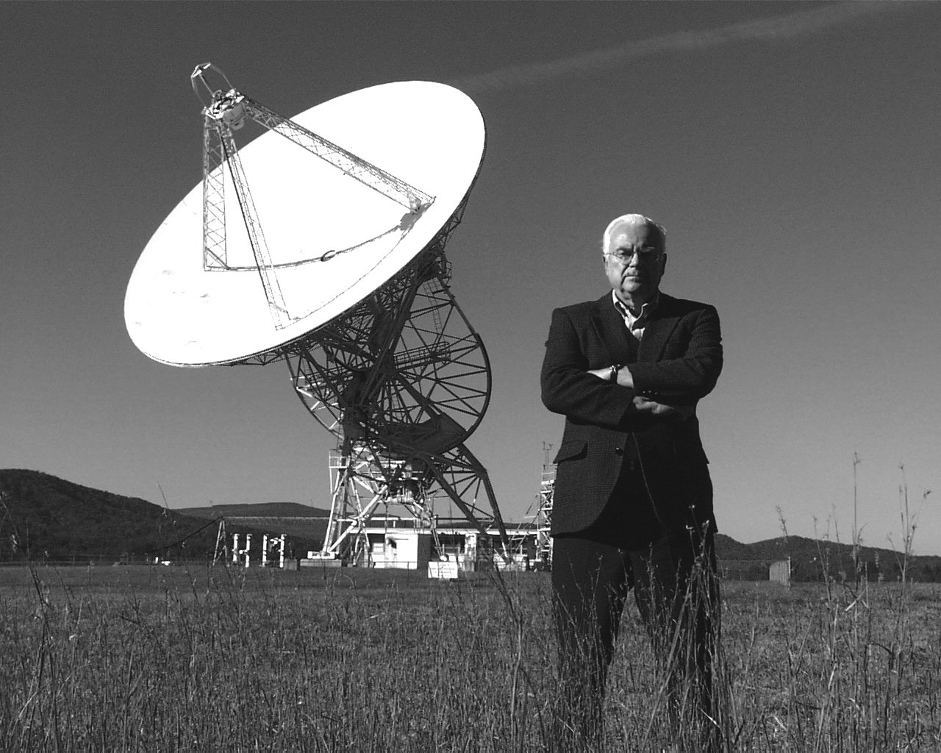

Frank Drake with the 25-metre telescope at Green Bank where he carried out Project Ozma. Image SETI Institute.

The "WOW!" Signal

Since then there have been nearly 100 serious SETI searches. In 1977 a telescope called “Big Ear” operated by Ohio State University which had been carrying out an all-sky SETI survey since 1974, picked up a signal that appeared to have all the right characteristics. It is called the “Wow” signal as the astronomer analysing the data wrote the word in the margin of the computer printout. Sadly, in follow-up observations, no signal has ever been picked up from the same region of sky.

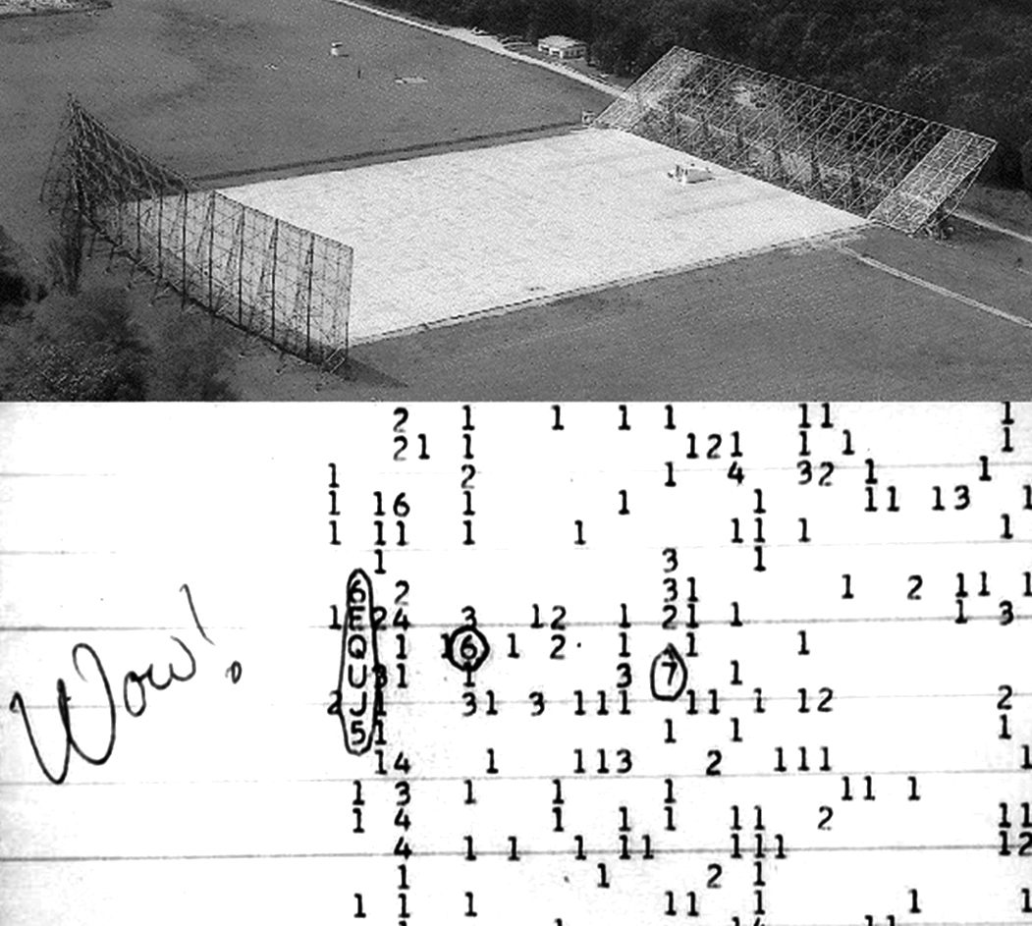

The Big-Ear Telescope and the "WOW!" signal received in 1977. Images: The Ohio State University Radio Observatory and the North American AstroPhysical Observatory (NAAPO). Wikimedia Commons.

To make a radio message as easy as possible to detect over interstellar distances it would almost certainly be in the form of a very slow “morse-code” type signal with a band width of one Hz or less − in contrast to an audio transmission requiring a bandwidth of several KHz. To detect such signals requires highly specialised receivers with millions of channels covering the band of frequencies being searched. Paul Horowitz at Harvard, a leader in this field, developed receivers to simultaneously analyze 80 million channels each with a bandwidth of 0.5 Hz. These were used to search the whole of the “water hole” using the 25m Harvard–Smithsonian telescope at Oak Ridge in projects META and BETA.

Projects SERENDIP and Phoenix

Two significant searches have used the 305m Arecibo Telescope in Puerto Rico. The first of these, Project SERENDIP, still continues whilst the second, Project Phoenix, terminated in 2003. SERENDIP, under the auspices of the University of California, Berkeley, is using the Arecibo dish in “piggy-back” mode with a dedicated feed system observing the sky close to wherever other astronomers are pointing the telescope. Though the SETI observers have no control over what part of the sky is being observed, over a few years most of the sky accessible to the telescope will be observed, much of it several times over. SERENDIP is thus looking for signals that are seen on more than one occasion from the same location in the sky. A small part of this data, relating to a narrow band of radio frequencies close the 1,400 MHz Hydrogen Line, has been analysed by home computers across the world in what is known as SETI@home. After a few years a number of signals with appropriate characteristics had been detected several times and a special observing session was set up to observe these in detail. However no signals appeared in the data to confirm a real detection.

This does highlight a real problem; a signal from ET might be transitory and one really needs to make an immediate confirmation that any signal has an extra-terrestrial origin. This was the premise of Project Phoenix that arose out of the NASA SETI project when the American Congress cut funding. This had been managed for NASA by the SETI Institute who then raised private funds to continue the targeted search part of the NASA programme and observe around 800 nearby sun-like stars. In project Phoenix, two telescopes were used to make simultaneous observations so that any signals originating within our solar system could be eliminated and there would be an immediate confirmation of any extra-terrestrial signal. Initially pairs of telescopes in Australia and the USA were used, but NASA had helped pay for a major upgrade to worlds largest radio-telescope at Arecibo in Puerto Rico and had ~30 weeks of observing time allocated to use it to carry out SETI observations in Project Phoenix. By chance, at a conference on large radio-telescopes in 1996, I happened to sitting next to their project scientist who told me about the proposed use of Arecibo and that they would need a very large radio telescope to operate in tandem with it. I immediately suggested that they use the 76 Lovell telescope at my own observatory, Jodrell Bank − still then the forth largest radio telescope in the world. This came to pass and the receiver system was installed on the telescope in the summer of 1998 with observations beginning that autumn.

Due to their separation across the Atlantic any local interference at either telescope could be immediately discounted. In addition, as a result of the rotation of the Earth and the change in received frequency introduced by the Doppler effect, a signal from beyond our solar system would be received at Jodrell Bank at a precisely calculable frequency which is approximately 2 KHz lower in frequency than that received at Arecibo. Thus, when Arecibo detected a possible alien signal, the receiver at Jodrell, offset in frequency by the required amount, attempted to confirm the signal. This enabled the elimination of any signals received from Earth itself or satellites orbiting nearby in the Solar System. The system was proven each day by observing the very weak signal from the Pioneer 10 spacecraft, then more than 10 million km from Earth and far beyond Pluto. In the 5 years of observations (with ~six weeks of observations per year) 820 sun-like star systems were observed – some of which we now know have planetary systems. It hardly need saying that no positive signals were detected.

The future of radio-SETI

It has been a long term dream of SETI astronomers to have a large dedicated telescope of their own. This dream is has been realised, in part, with the partial construction of the Allen Telescope Array (ATA) at Hat Creek in California. The ATA was conceived as a combined project of the SETI Institute and the Radio Astronomy Laboratory at the University of California, Berkeley to construct a Radio Telescope that will search for extra-terrestrial intelligence and simultaneously carry out astronomical research. (The Berkley collaboration ended in April, 2012, and the project is now managed by SRI International, an independent, non-profit research institute.) This is, as one might suspect, not a telescope “as we know it” and is exploiting the great advances in computing technology to build a highly flexible instrument where, as Jill Tarter of the SETI Institute points out, “steel is being replaced by silicon”.

The cost of building a large single dish antenna tends to rise as the cube of the diameter. The equivalent area could, in principle, be made up of an array of smaller antennas, in which case the cost only rises as the square of the diameter. However the task of combining the signals from the individual elements must also be taken into account. With the reducing cost of electronics; from the receivers on each antenna, their fibre-optic links to the central processing system and the correlators that combine the data − this small D/large N approach has become both feasible and cost effective. But, in addition, there is a far more fundamental reason why this approach is particularly appropriate for SETI purposes. A large single antenna is only sensitive to signals received from a very small area of the sky defined by its “beamwidth”. For a 120-metre antenna observing in the region of the “water-hole” this would be of order 7-8 arc minutes. (The use of multi-beam receiver system can increase this by a small factor.) Let is suppose that, as in the ATA, the same effective area is made up by combining the signals from 350, 7×6 metre antennas. These small antennas will have a beam width of ~120/7 times greater (beamwidth scales directly with diameter) giving ~146×125 arc minutes − over 2 degrees! At the heart of the array, the signals from all antennas are combined together to form a beam of comparable size to the single 120-metre antenna and having the same sensitivity. So nothing is lost. But there is much to gain. If, in additional electronics, the signals from each antenna are combined in a slightly different way then a second narrow beam can be formed anywhere within the overall beam of the small antennas . But if one can form a second beam, then with further electronics one can form a third, a fourth and so on. So the ATA will have multiple beams and could thus observe many stars simultaneously whilst the Berkley group could be observing pulsars or other astronomical objects in the same area of sky.

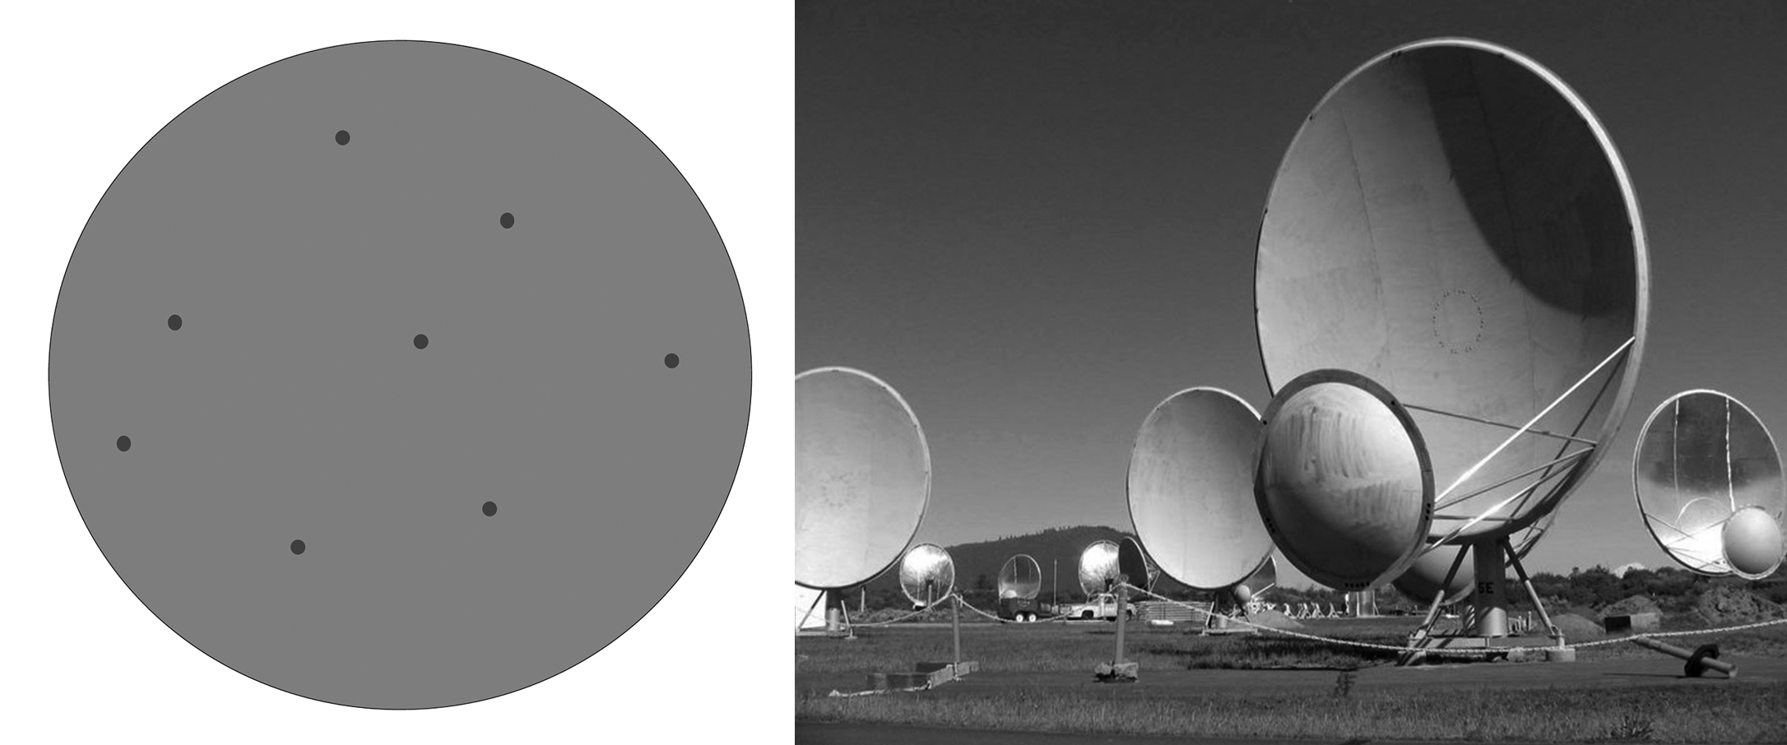

The multiple beams formed with the Allen Telescope Array (left). Allen Telescope Array antennas (right). Image (right): SETI Institute.

The first phase comprising 42 antennas was commissioned in the autumn of 2007 and began its SETI observations with a survey of the galactic centre. However, in April 2011 due to funding shortfalls, the ATA was placed in operational hibernation but then, having found some short-term funding, operation of the ATA was resumed in December that year.

The Square Kilometre Array

In the longer term we have the prospect of a vastly more sensitive radio telescope to give us a realistic chance of detecting radio signals from across a large part of the Galaxy. The Square Kilometer Array will be made up of a thousand or more small ~15 m radio telescopes to be sited in the Northern Cape of South Africa. Linked together by fibre optic cables a giant computing system will combine their signals to give the effect of a radio telescope 1 km across! Like the ATA it will be capable of producing multiple beams so greatly increasing the chance of making a detection.

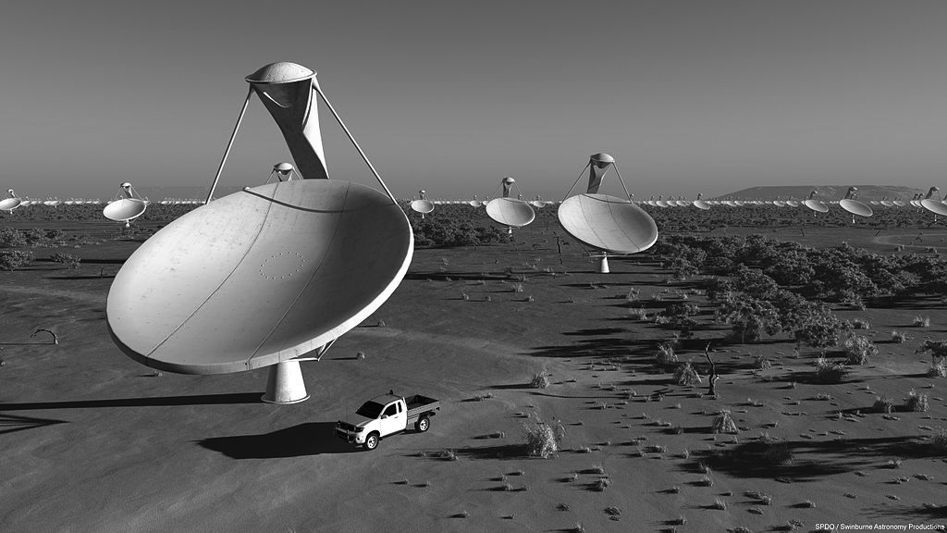

An artist’s impression of the central core of the Square Kilometer Array.

The Drake Equation

The lack of success prompts one to ask what the likelihood is that other advanced civilisations exist in the galaxy who would be attempting to contact us. If we do not expect there to be any other civilisations then there would not be a lot of point in searching. This problem was first addressed by an eminent group of scientists at a meeting organised by Frank Drake at Green Bank in 1961. As an agenda for the meeting he came up with an equation which attempts to estimate the number of civilisations within our galaxy who might be attempting to communicate with us. Known as the “Drake Equation”, it has two parts. The first part attempts to calculate how often intelligent civilisations arise in the galaxy and the second is simply the period of time that such a civilisation might attempt to communicate with us once it has arisen.

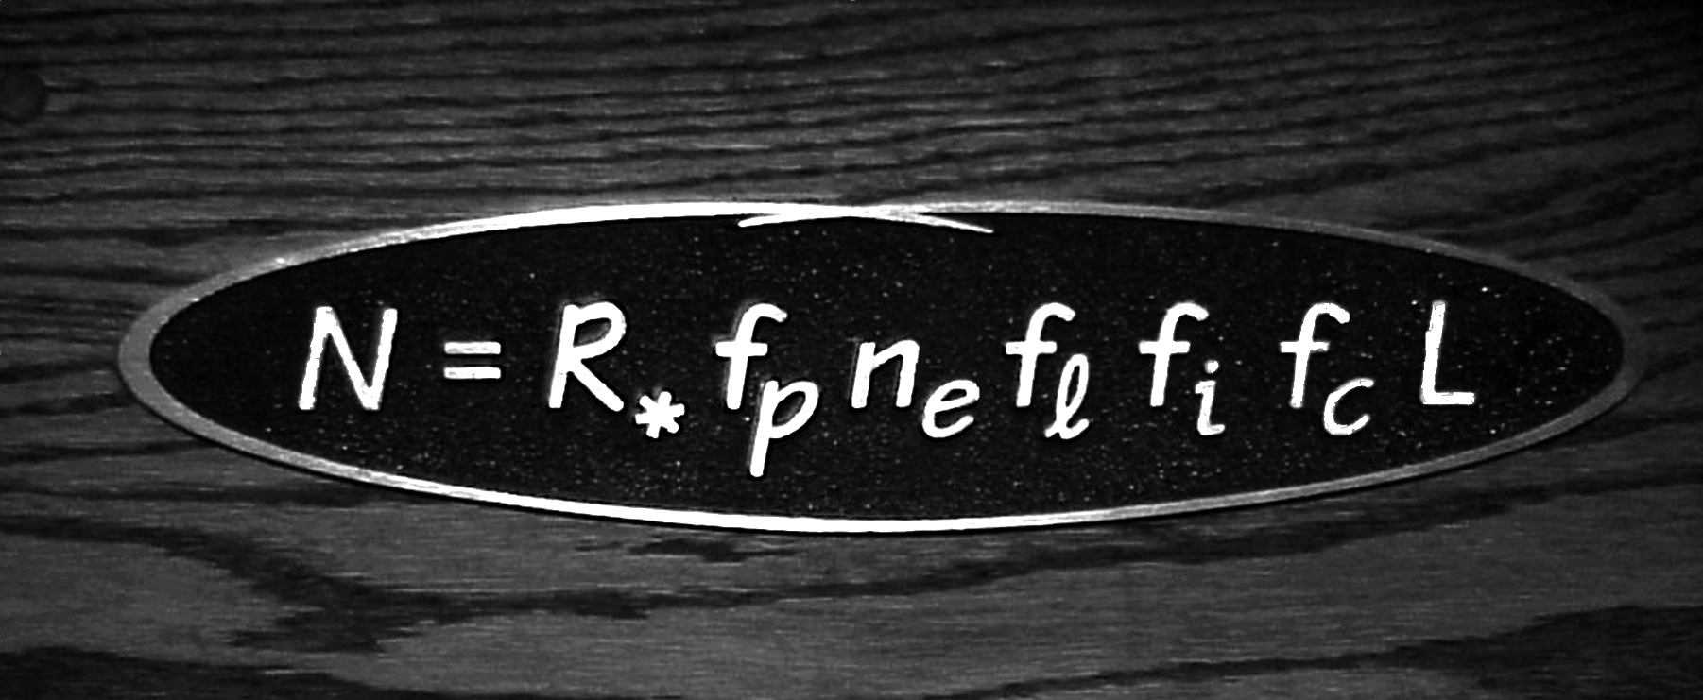

A plaque at Green Bank Observatory commemorating the Drake Equation. Image: Ian Morison.

Some of the factors in the equation are reasonably well known; such as the number of stars born each year in the galaxy, the percentage of these stars (like our Sun) that are hot enough, but also live long enough, to allow intelligent life to arise and the percentage of these that have solar systems. But others are far harder to estimate. For example, given a planet with a suitable environment it seems likely that simple life will arise − it happened here on Earth virtually as soon as the Earth could sustain life. But it then took several billion years for multi-cellular life to arise and finally evolve into an intelligent species. So it appears that a planet must retain an equable climate for a very long period of time. The conditions that allow this to happen on a planet may not occur very often. Our Earth has a large Moon which stabilises its rotation axis, its surface is recycled due to plate tectonics and this releases Carbon Dioxide, bound up into carbonates, back into the atmosphere. This recycling has helped keep the Earth warm enough for liquid water to remain on the surface and hence allow life to flourish. Jupiter’s presence in our Solar system has reduced the number of comets hitting the Earth; such impacts have given the Earth much of its water but too high an impact rate might well impede the evolution of an intelligent species. It could well be, as some have written, a “rare Earth”. How many might there be amongst the stars?

It was widely assumed that once multi-cellular life had formed, evolution would drive life towards intelligence, but this tenant had been challenged in recent years − a very well adapted, but not intelligent, species could perhaps remain dominant for considerable periods of time preventing the emergence of an intelligent species.

The final factor in this part of the equation is the percentage of those civilisations capable of communicating with us who would actually choose to do so. Our civilisation could, but currently does not, attempt to communicate. Indeed there are some who think that it would be unwise to make others aware that here on Earth we have a nice piece of interstellar real estate! Any attempts at communication are very long term with the round travel time for a two way conversations stretching into hundreds or thousands of years. It would be hard at present to obtain funding for such a programme. Estimates of 10% to 20% are often cited for this factor. This may well be optimistic.

The topic of “leakage” radiation from, for example, radars and TV transmitters is often mentioned as a way of detecting advanced civilisations which do not choose to communicate with us. But this is, in my view, unlikely. Any signals that could be unintentionally detected over interstellar distances are, by definition, wasteful of energy. Already, on Earth, high power analogue TV transmitters are being replaced with low power digital transmissions, satellites transmissions are very low power and fibre networks do not radiate at all. The “leakage” phase is probably a very short time in the life of a civilisation and one that we would be unlikely to catch. It could be that airport radars and even very high power radars for monitoring (their) “near-Earth” asteroids might exist long term and give us some chance of detecting their presence but we should not count on it.

When all these factors are evaluated and combined the average time between the emergence of advanced civilisations in our galaxy is derived. If we find it hard to estimate to estimate how often intelligent civilisations arise it is equally hard to estimate the length of time, on average, such civilisations might attempt to communicate with us. In principle, given a stable population and power from nuclear fusion, an advanced civilisation could survive for a time measured in millions of years. Often a period of 1,000 years is chosen for want of anything better. This length of time is critical in trying to estimate how many other civilisations might be currently present in our galaxy. If, for example, a civilisation arose once every 100,000 years − a not unreasonable estimate − but typically, civilisations only attempt to communicate for 1000 years it is unlikely that more than one will be present at any given time. If, however, on average, they remain in a communicating phase for 1 million years then we might expect that 9 other civilisations would be present in our galaxy now.
In what has been the most sensitive search yet undertaken, Project Phoenix, each star was only observed for 1.5 hours so for us to have had any chance of detecting a signal it would have to be effectively continuous. This would require considerable effort on the part of any other civilisation. If they were nearby in the Galaxy, they might know from analysis of the Earth’s infra-red spectrum that some form of life existed here, but unless intelligent life is very common they are likely to be too remote to be able to highlight our own solar system as a possible target.

When the Drake Equation was first evaluated, the estimates of other civilisations were quite high; numbers in the 100,000’s or even 1 million were quoted. Nowadays astronomers who try to evaluate the Drake Equation are far less optimistic. Many estimates are in the ten’s to hundreds and there are a minority of astronomers who suspect that, at this moment in time, we might be the only advanced civilisation in our galaxy. I have to say that I am amongst that number. One reason is that new research indicates that the transition from single to multi cellular life is a very unlikely, so though I am happy to believe that simple life with be quite common across the galaxy, intelligent life may well be very rare and I suspect that we are the only intelligent civilisation in our galaxy at the present time.

The truth is we just do not know. It was once said with great insight that “the Drake Equation is a wonderful way of encapsulating a lot of ignorance in a small space”. Absolutely true, but an obvious consequence is that we cannot say that we are alone in the galaxy. SETI is our only hope of finding out if other intelligent civilisations exist.

Could we find evidence of other civilisations in our immediate locality?

As light and radio waves travel at the fastest speed possible through space other possible means of contact have tended to be ignored. But if speed is not important, then the sending of spacecraft across the galaxy as a one way communication medium might be a sensible way of making contact − perhaps to give us the benefit of the knowledge of a highly advanced civilisation. Indeed four spacecraft, Pioneer 10 and 11 and Voyagers 1 and 2, which are now coasting through space beyond our solar system, carry messages from our civilisation which would tell any one who recovered them a little about ourselves, the star system that we inhabit and even (very cleverly) the time that the spacecraft left our Earth.

Much like Arthur C. Clarke’s lunar monolith in 2001: A Space Odyssey, it is just possible that an alien craft might have landed on the Moon (where it would not suffer the consequences of the erosion we have on Earth) waiting for us to discover it. Or perhaps an alien space craft might be discovered in solar orbit. Fanciful, but not impossible. It is also possible that evidence of a past extraterrestrial civilisation might be found without there being any intent on their part. We are now producing quite significant amounts of space debris. Particles less than about one micro-metre in size, perhaps of exotic alloys, will be ejected from our solar system by radiation pressure and could, far into the future, land on the surface of an airless moon. When our Sun reaches the end of its life, intense solar winds could even eject larger particles into the interstellar medium. Might we find such material from another civilisation within the dust making up the lunar regolith?

For these possibilities to be at all likely, many civilisations must have reached high technical competence in the distant past. If one such civilisation came into existence every 100,000 years then, in the period since have been sufficient heavier elements within the interstellar medium to allow planets to form and the intelligent life to have evolved − perhaps 4 billion years, 40,000 advanced civilisation might have come and gone. Could one of them have left any evidence of their existence?

A final thought

Should we be disheartened that no signals have as yet been detected? Not really, for as Peter Backus of the SETI Institute has made clear, of the ~100 searches that have taken place since 1960, only SERENDIP and Phoenix (because of their use of the giant Arecibo Telescope) have had the sensitivity to detect signals from beyond our immediate locality in space. The use of the SKA will extend the search further and so have a realistic chance of detection if, as many astronomers now believe, intelligent life is thinly spread around the galaxy.

There can be no better way to end this chapter than by quoting from Cuccioni and Morrison’s 1959 paper; “the probability of success (in our search for extraterrestrial life) is difficult to estimate, but if we never search, the chance of success is zero.”

© Professor Ian Morison 24 September 2014

