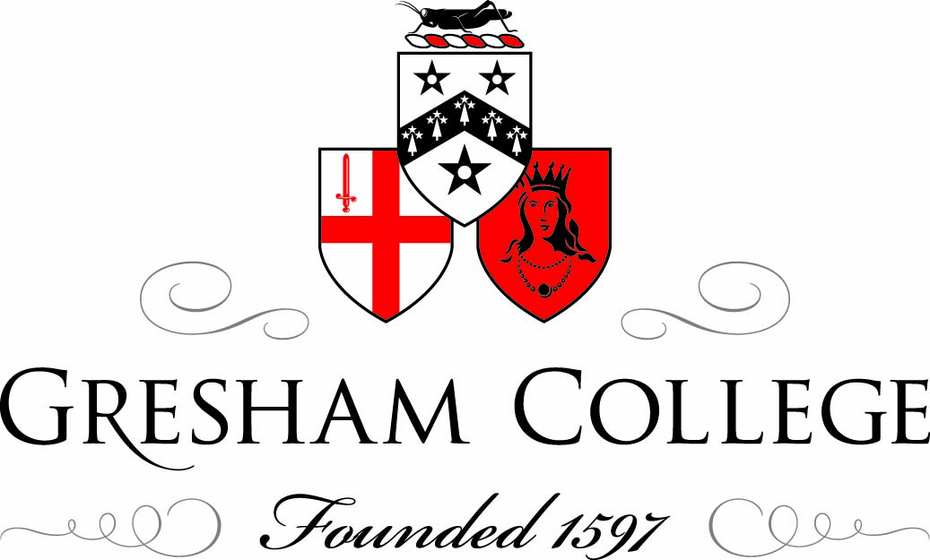
29 November 2011
Introduction to a Lecture by Matthew Hancock
Professor Ken Costa

It is my very great pleasure tonight to be able to introduce Matthew Hancock MP.

Matthew has many achievements of which he may be justly proud. He has a degree in Politics, Philosophy and Economics from Oxford University and a masters in Economics from Cambridge. He has worked as an economist for the Bank of England and then as a senior economic adviser and Chief of Staff to George Osborne. Last year he was elected as MP for West Suffolk, following which he was elected to the Public Accounts Committee and also the Committee on Standards and Privileges that adjudicates on MPs’ conduct. His is rightly tipped as a rising star of the Conservative Party.

However, possibly more important than any of these is the fact that Matthew holds the record for playing the most northerly recorded game of cricket in history, somewhere within the Arctic Circle I believe. Now, cricket is one of those Marmite sports – you either love it or hate it. Matthew is clearly in the ‘love it’ group, as he not only holds this record but is also joint-secretary of the Lords and Commons Cricket group. But cricket is more than just a sport. It’s an idea – an idea that offers me a nice link into the topic under discussion tonight.

If there is one thing people know about cricket, whether they love it or hate it, it is the phrase, “It’s just not cricket.” It is a short phrase that trips off the tongue very easily, but into that short phrase is packed a myriad of ideas and assumptions that are both highly important and much needed.

As everyone knows, the phrase “It’s just not cricket” is shorthand for something like “that kind of behaviour is just wrong: it’s dishonourable, it’s dishonest, it lacks integrity, it lacks decency.” Cricket, like most sports, has many laws but the phrase “It’s just not cricket” is not a legal one. It is a much softer, subtler, cultural phenomenon. No-one should imagine that this makes it less important. Quite the contrary, in fact: it is precisely those subtler, cultural phenomena that make the game what it is.

Well, the spot fixing scandal this year reminds us – as if we needed reminding – that cricket is not cricket any more. But, if cricket is not cricket any more, then neither is finance and that – dare I say it – is a much more serious problem.

Now, I need to be very clear here. I am not suggesting that finance was ever a spotlessly honourable profession. Nor am I suggesting that we need to return to the City of the Edwardian period, in which ‘my word was my bond’ was all you ever needed – largely because most people came from a tiny slice of society – Oxbridge and the great public schools.

What I am suggesting is that we cannot hope to run a secure, efficient, or sustainable finance sector if we fail to realise that we need unwritten laws of conduct – basic human values – just as much as we need written ones, in the form of regulation and legislation. We need the softer, subtler, cultural values – of honour, honesty, integrity, and decency – at least as much as we do effective legislation. We cannot possibly hope to develop a safe, growing and sustainable economy without properly understanding that humans are moral beings just as much as they are financial ones. Put another way, we are liable to repeat history unless we seek to understand human nature.

I have been working on the St Paul’s Initiative to try to connect finance and ethics. There is an important dialogue to be had connecting not only those camped outside St Paul’s Cathedral but also the many people working within the market economy who are as concerned by the need to connect the market economy with its underlying moral roots. People ask why we need regulation rather than trying to bring about a change of heart through individual conscience. I am reminded of Martin Luther King. He said “I admit that laws will not change hearts but they will prevent people from being heartless”.

All of which this leads me to Matthew and to his important new book, Masters of Nothing. Because what Masters of Nothing argues is that economic behaviour is underpinned and shaped by human behaviour. It argues that human behaviour is not as rational and logical as we like to imagine. And it insists that unless we understand human nature and behaviour as it really is – and not as we like to imagine it to be – we are liable to repeat the severe financial crash of recent years again and again.

“Businesses do not act in a moral vacuum”, Matthew writes in his introduction. “Whether legal or not, immoral actions within businesses should not be ignored just because there’s a logo on the door.” Given that my overarching theme in my role as Gresham Professor of Commerce, and indeed in other lectures I have given recently, is that we badly need to reconnect the ethical with the financial, you will not be surprised to hear that I would add a hearty ‘Amen’! to that. The question, of course, is what we can do about it.

I know Matthew has some intriguing and important answers to that question and, for me, the really exciting thing about them is that they are grounded not only in the desire to understand human nature, but in the recognition that we need a realistic understand, and not one that is satisfied by the myth that we are all narrowly, rational automatons. I look forward greatly to hearing what Matthew has to say…

©Ken Costa, Gresham College 2011

