

29 November 2012

Parochial Registration and the
Bills of Mortality

Gill Newton

When John Graunt prepared and published his Observations on the London Bills of Mortality, death must have been much on his mind for personal reasons as much as his intellectual interests. The parish burial register of St Michael Cornhill, the small, wealthy central London parish in which he was living at the time, reveals that in the preceding year he had lost both his parents and a daughter. On March 24 1661/2 his father, Henry Graunt, was buried, dying of old age. A few months later in May 1662 his mother Mary Graunt died, also of old age, and in September the same year he and his wife lost their daughter Frances to “consumption”. The dedicatory epistle Graunt wrote to preface his book is dated January 1652/3, four months after the last of this unhappy trio of losses. As the eldest son he most likely arranged his parents’ funerals, which would have taken place within a couple of days of their deaths. The arrangements would have involved ‘bespeaking’ a grave from the parish sexton, and Graunt may well have been in the house when the two parish Searchers came to view the bodies to ascertain cause of death to report to the parish clerk for inclusion in the Bills of Mortality. When Graunt describes the system of compiling Bills of Mortality from information gathered in the deceased’s parish of residence, we can therefore be sure he was speaking from practical experience as much as any hypothetical description of the process.
Graunt was a well-informed Londoner with a working knowledge of living and trading in the city and strong connections to the civic authority of the guilds (he was a freeman and later liveryman of the Drapers’ company and held several civic offices). This meant that as well as being able to negotiate ready access to the Parish Clerk’s Company Hall to view the Bills of Mortality, he was well-placed to comment on the context of the information contained within them. Indeed, his combination of empirical rigour in analysing their content and a good general grasp of conditions in his city were perhaps the ideal combination for a first consideration of the demographic significance of the London Bills. As well as the statistical contributions for which he is well-known, Graunt furnishes us with many details of how to interpret the information given in the Bills, and descriptions of how the system for creating the Bills of Mortality worked. He expounds at some length on the probable meaning and significance of cause of death descriptors, attempting to divide them between those afflicting young children, who he knew were at greatest risk of dying, and those afflicting adults. Where he speculates, he tells us so, and usually explains by what reasoning he arrives at his conclusion. His reasoning yields important clues as to the likely relationship between certain causes of death and age groups. Though he had no medical training, there was in fact little medical involvement, or even interest in, the causes of deaths reported in the Bills of Mortality in Graunt’s day. The Searchers who determined the causes of death that were collated and reported in the Bills had no medical training either, being old women of the parish who presumably learned by long experience. Graunt’s remarks were similarly drawn from general experience as a longstanding Londoner, and personal experience of deaths in his own family and among his acquaintances. His is probably as close as we may now get to an eye-witness account of how causes of death were identified by lay-persons, forming the basis for the categories given in the Bills of Mortality.
Graunt devotes two of the twelve sections of his work wholly to the “casualties”, or causes of death, in the Bills of Mortality, and one further section and part of another on plague in particular as chief among these causes, as well as making many remarks elsewhere on particular diseases. He ponders on the identity of these causes of death, and on the likelihood of the Searchers consistently reporting them. Some causes of death he considers to be clearly identifiable and not liable to be confused with other conditions. In this category he includes smallpox and rickets. Others he tells us are more ambiguous, and perhaps conjoined with or caused by other conditions. In this group he includes “teeth” and old age. Lacking age reporting cross-tabulated by cause of death, he makes assumptions about the age groups affected by these and other diseases. With evidence from London parish registers, and from registers elsewhere, it is possible to test some of the assumptions Graunt made about the age structure of disease. In later sections of this paper we shall look in particular at three case studies: “teeth”, rickets and old age.

The relationship between Bills of Mortality and Parish Registers
The system for compiling the Bills of Mortality that Graunt describes is illustrated in Figure 1. As should be immediately evident, it was not independent from the parochial system of baptism, burial and marriage registration first instituted by the state in 1538 and administered by ecclesiastical authorities, but complementary to it. The raw data from which the Bills were compiled came from the parish clerk supported by other parochial officers (the boxes representing these parish officials are coloured purple in Figure 1). However, the age and separately tabulated cause of death information that is consistently present in the annual Bills of Mortality after 1629 was not usually recorded in the parish burial register. Graunt’s home parish of St Michael Cornhill was for a brief period an exception, recording causes of death (but not ages) for most of the 264 burials between October 1653 and March 1663. Most parish clerks viewed their responsibility to prepare a report of burials, ages and causes of death each week as separate from keeping parish registers. Although sexton’s accounts record this information in some parishes (in London notably for the large Westminster parish of St Martin in the Fields), they often do not survive.

Figure 1: The process of compiling Bills of Mortality, based on Graunt’s description
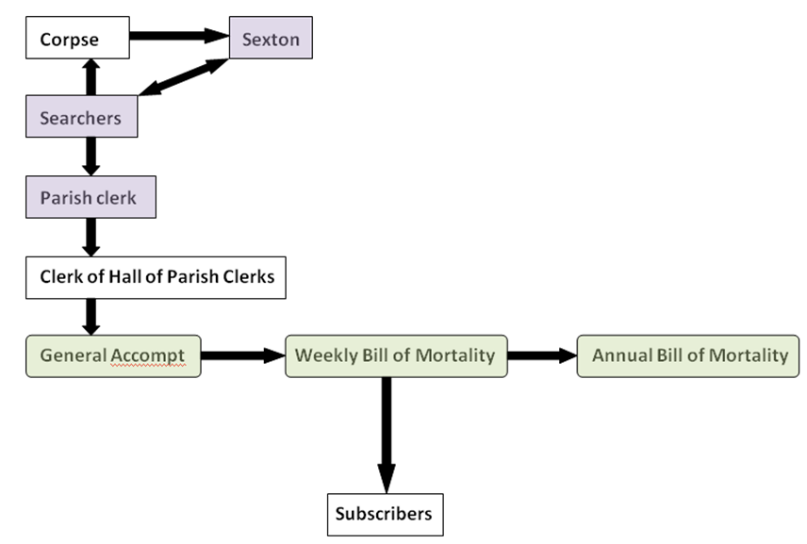
As noted above, Graunt’s remarks on the causes of disease used in the Bills of Mortality frequently speculate on the ages of individuals likely to found within that category, but as the Bills did not cross-tabulate the age and cause of death information they reported, no direct evidence was available to him. Even if he had negotiated access to the burial register in his home parish of St Michael Cornhill with its unusual run of cause of death information, no ages were given there either. However, among the many London parishes there are a few exceptional cases where for a time the parish accounts or registers did state causes of death and ages for each burial, and from these we are now able to reconstruct age-specific causes of death. Later sections of this paper will concern such information based primarily on the eastern suburbs of London, a strongly manufacturing-orientated and relatively poor part of the metropolis. The location of the three London parishes providing the evidence and their close geographical relationship are shown in Figure 2. We will compare these to similar information from the parishes of or adjacent to the major towns of Liverpool, Leeds, York and a parish adjacent to Manchester.

Figure 2: Part of Rocque’s 1746 map of London, with London parishes sampled for cause of death and age information outlined.
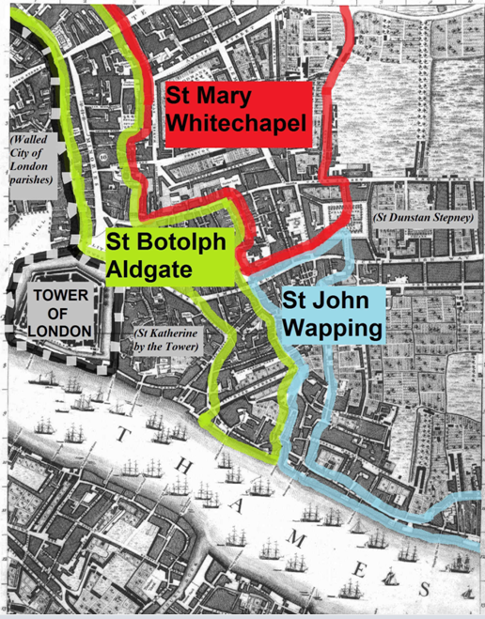
Source: Parish boundaries taken from Richard Blome’s London ward and parish plans created c. 1690, published in John Stow (1755) A Survey of the Cities of London and Westminster. Underlying map from Rocque’s 1746 map of London.

Background to the case studies
However, to take a step back from causes of death for the time being, it is helpful to consider first the point at which our present investigations of these parish registers began. Our original rationale for seeking out cause of death and age information from burial registers was to gain a better understanding of the drivers of short-term fluctuations in mortality, in connection with a pilot project funded by the Wellcome Trust currently underway at the Cambridge Group for the History of Population and Social Structure, involving Richard Smith, Peter Kitson and the author. Initially, we considered the general issue of the long-term change in burial volatility between the sixteenth and eighteenth century in different communities, including London. Graunt himself observed fluctuations of the annual and seasonal numbers of burials in the Bills of Mortality, although he had much shorter runs of information available to him than subsequent research has provided, and less sophisticated methods.

Writing from the perspective of plague-ridden mid-seventeenth century London, in noting the annual variability in the burial total, Graunt finds it useful to distinguish between three types of year. Plague years he takes to be those with at least 200 burials where the cause of death is ascribed to plague. “Sickly” years are those non-plague years in which the total of burials was higher than the preceding and following years, and “healthfull” years are the remaining ones. Graunt’s observations are necessarily largely confined to a 60 year period post 1603, for which Bills of Mortality were most readily and continuously available. However, by using parish burial registers we can now observe continuous annual burial totals in London for a much longer period, extending back into the sixteenth century, and further forwards too into the seventeenth and eighteenth centuries. This makes it easier to consider changes in the long term and to distinguish them from cyclical variations.

The annual counts of burials from two large suburban London parishes, each by the mid seventeenth century already as populous as major towns elsewhere in England, are graphed in Figure 3. The counts are detrended to remove the effect of population growth, and presented relative to an index where zero indicates an annual burial count equal to the expected number of burials for that year, as predicted by other values in the series. Thus, to borrow Graunt’s terminology, “healthful” years approximate those where the point is below an index value of 0; plague years are represented as prominent spikes with index values well above zero (to give some indication of the relative shift in the number of deaths this represents, the crisis mortality ratio in these years was typically between 5 and 7, meaning that the number of burials was between five and seven times higher than in the surrounding years), and sickly years are the less prominent spikes above an index value of zero. Over the long term, a diminution in volatility is apparent in both parishes, but is most obvious in the north-western suburb of Clerkenwell where the information has been gathered for a longer period. Once plague disappears from London after 1665, a mortality regime with periodic large upswings and downswings transitions to one in which the degree of variation between one year and the next was reduced. However, from family reconstitution studies we know that infant and child mortality, responsible for the bulk of deaths, remained high until at least 1750.

Figure 3: Annual burial volatility between 1560 and 1800 in two large London suburbs, detrended to remove the effect of population growth and indexed
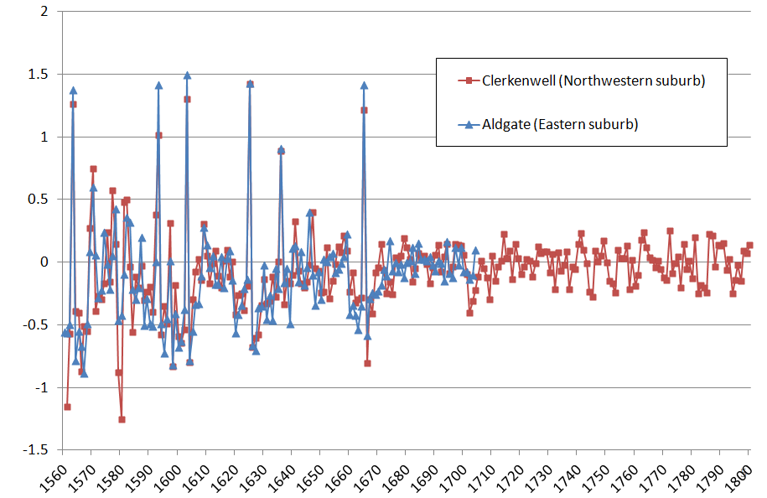

Source: Parish registers of St James and St John Clerkenwell and St Botolph Aldgate. Burials in Clerkenwell post 1753 abstracted by Amanda Copley.

A useful feature of parish register burials data is that children dying while in the same household as their parents were usually identified as such, by the relationship ‘son’ or ‘daughter’. This permits us to consider the contribution to burial totals of individuals aged under 18 years or so separately from the adults. Since mortality is heavily concentrated in the youngest age groups, we know that most of the persons described in the burial register as ‘son’ or ‘daughter’ will be young children. Further refinements are possible where the burial register states the age of the deceased.

Our investigations to date of short term fluctuations in mortality make it clear that adult and child mortality did not necessarily rise and fall in the same years: they operated at least quasi-independently. This decoupling of adult and child mortality becomes more pronounced during the eighteenth century, when parts of Britain were undergoing urbanisation and very rapid population growth Furthermore, there are diseases that afflict infants and young children especially, and which rarely or never affect adults. Graunt tries to surmise which these are, but cannot know for sure. The existence of parish registers that give both causes and age allows more direct scrutiny of the ranges of ages represented under each cause of death. As Figure 4 below illustrates for Leeds parishes, some causes of death do indeed apply primarily to children, and others to adults. The causes of death in the key are listed in order of where the line representing that series meets the y-axis, so causes primarily ascribed to infants appear first, then diseases of older children, and finally diseases of adults. The ages are plotted on a log scale, so it is not possible to show deaths under 1 year here.

Figure 4: Cumulative distributions of selected causes of death by age in Leeds, 1778 – 1799

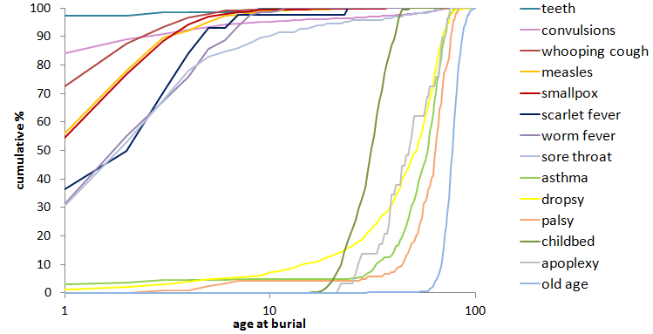

Source: Parish registers of Leeds St John, St Paul and St Peter together with the surrounding parishes of Beeston, Bramley, Chapel Allerton, Farnley and Headingley.

Returning to London to compare causes of death among those aged under 1 year, Table 1 below lists the causes accounting for at least 95% of all deaths aged under 1 year in sampled parish registers. Stillbirths (where given) are listed separately at the bottom of the table. In sixteenth century Aldgate, “chrisom”, meaning a child buried soon after baptism (see below), accounted for a very high proportion of infant burials. Many of the neonate chrisoms were subsumed under the new descriptor of convulsions by the mid eighteenth century, so that Whitechapel reports no chrisoms between 17474 and 1747, but almost half of its infants died of convulsions.

Table 1: Causes of death accounting for >95% of infant burials in sampled London parishes
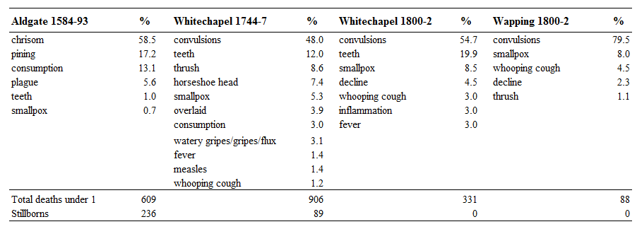
Source: Parish registers of St Botolph Aldgate, St Mary Whitechapel and St John Wapping.

In Graunt’s day convulsions had only recently begun to be used as a cause of death, rising rapidly in incidence in the Bills of Mortality from mere tens of deaths in 1629-31 to thousands of deaths per year by the 1660s, at which level it stayed until the nineteenth century. The author of a pamphlet published in 1701 entitled ‘History of Cradle Convulsions’ observes:
“[...] such a strange distemper as that we call convulsions [...] was not known in Civil Societies 200 Years ago; nor heard of in England, 'till after the Rise of the Bills of Mortality 1603 nor yet had any Established Name in the said Bills, 'till Anno 1629 [...]”

The mid seventeenth century origins of convulsions as a replacement cause of death for chrisom is corroborated by the mixture of the two causes found in the registers of St Michael Cornhill between 1653-63, where 6 children died as chrisoms and 18 of convulsions. Convulsions continued to be the major death category for infants in the early nineteenth century in both Whitechapel and Wapping. However, the convulsions category did not refer exclusively to infants, although in London it primarily indicated this age group. In Whitechapel about 1 in 7 of the deaths attributed to convulsions occurred in older individuals aged anywhere between 1 and 60. In Leeds more than 1 in 3 of deaths attributed to convulsions occurred in adults.

More generally, it is quite clear from Table 1 that parishes did not use the same descriptors to distinguish the major causes of infant death. Sometimes this reflected genuine change over time in the incidence of the disease, as with plague and smallpox, the two most unmistakable infectious diseases listed. It is worth bearing in mind that the Bills of Mortality existed to provide a warning of epidemic outbreaks in London, so there is good reason to suppose that epidemic diseases were recorded most faithfully, provided that the Searchers’ visual inspection of the corpse and questioning of family members could easily identify the disease. However, many deaths in each age group tend to be piled to a greater or lesser extent into one or two major categories, which are often vague, catch-all descriptors that encompass a wide range of conditions – a phenomenon that Graunt suspects in his consideration of “consumption”. This is true for older age groups as much as for infants, and consumption and/or decline are indeed usually the most prevalent catch-all category. But some parishes heaped a smaller proportion of deaths into these categories. Eighteenth century Whitechapel used a much wider range of descriptors than other sampled parishes and time periods, and even in the early nineteenth century when it too was using a smaller range of descriptors, it still recorded more distinct causes of death than neighbouring Wapping. This disparity between cause of death descriptors used in different parishes has important implications for the composition of the totals present in the Bills of Mortality, especially the annual Bills. Apparent increases or decreases in some diseases may have been a consequence in changes in descriptors used in some parishes but not others, perhaps when Searchers died and had to be replaced. Given the huge disparity in population between London parishes, a shift in the descriptors used by just a handful of large suburban parishes could certainly have swayed the overall figures.

The catch-all major cause of death categories conflate too many diseases for it to be profitable to use them to gain further appreciation of the degree of consonance or difference between London and other urban parishes. Since we expect that major infectious diseases such as smallpox, measles, whooping cough and so forth genuinely did exhibit different age specificity at different times and in different places, it would not be appropriate to use these either. What are needed are causes of death that appear to be referring to relatively specific conditions, but which might apply across different places and time periods. For this purpose three causes that attracted Graunt’s attentions were chosen: rickets, teeth and old age.

Three case studies of cause of death recording: rickets, teeth and old age
Case study 1: Rickets
Comparing parish-level causes of death for London parishes and indeed elsewhere immediately reveals that some causes of death are more popular in some parishes than others, or in some time periods than others, as we began to see above. Disentangling genuinely new or changing phenomena from shifting customary practice in reporting cause of death is not easy. Graunt noted that certain causes of death used in the Bills of Mortality had emerged in recent times, most especially rickets among children. We now know that rickets is caused by Vitamin D deficiency, and that Vitamin D is mostly obtained from exposure to sunlight, although there are also dietary sources. Graunt offers an eye-witness account of local environmental changes that might plausibly explain why the incidence of rickets might have increased by the mid seventeenth century, noting the increase in coal as fuel over the last half-century and build-up of smog in London. Smog can limit the amount of ultraviolet radiation reaching the skin, thus preventing Vitamin D from being synthesised, especially among young children who are likely to be kept indoors and thus spend little time in sunlight. However, examination of the Bills of Mortality subsequent to Graunt’s time reveal that rickets declined markedly as a cause of death in the eighteenth century (see Figure 5 below). By 1800 it had dwindled from causing several hundred deaths per year to less than one per year. This was not a consequence of the individually reported causes of death being aggregated differently, since we can observe a similar decline over time in the number of rickets deaths recorded in London parish registers (also shown in Figure 5 below). Rickets is not found as a cause of death in late sixteenth century Aldgate, but by the middle decade of the seventeenth century in Graunt’s own central London parish of St Michael Cornhill between 1653 and 1663, there were 12 rickets fatalities, 4.5% of the total number of burials, and all were children. Just outside the eastern city boundary in St Mary Whitechapel, by 1744-7 the proportion of deaths due to rickets was only 0.4% of the total, comprising 21 rickets deaths of children aged between 21 months and 4 ½ years. By 1800-2 in the same parish of Whitechapel and also in neighbouring St John Wapping there were no recorded rickets deaths.

Figure 5: The rise and fall of rickets burials in London
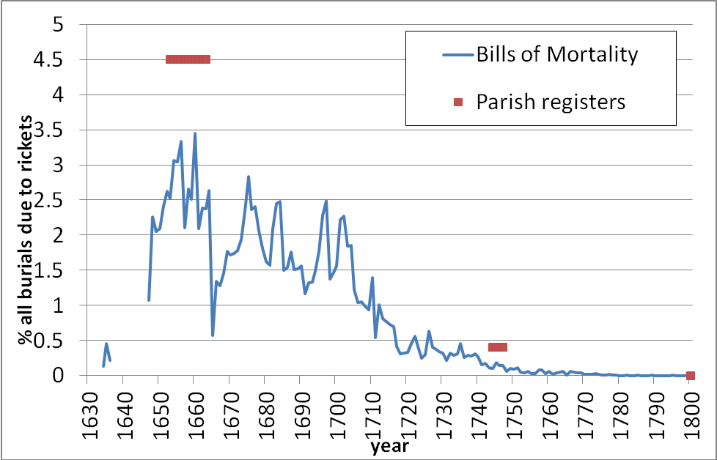

Source: Marshall (1832) and parish registers of St Michael Cornhill, St Mary Whitechapel and St John Wapping.
This apparent decline in rickets mortality does not fit the probable incidence of rickets morbidity given increasing air pollution over this period, as the expansion and industrialisation of the metropolis accelerated. Nor does it accord with the archaeological evidence, where 15-20% of analysed skeletal remains buried in London between the sixteenth and nineteenth centuries have been found to be suffering from rickets. We must assume that rickets simply passed gradually out of common usage as a cause of death descriptor in eighteenth century London, although the reasons for this remain obscure. The proportion of parish register burials attributed to rickets in two London parishes, one wealthy and one poor, appears noticeably higher than that recorded in the Bills of Mortality as a whole. Most likely this is an artefact of the small numbers involved in the parish samples, but it is also possible that rickets deaths were identified unevenly in different parishes, with the Searchers of some parishes using rickets as a cause of death descriptor while others did not, or some parishes abandoning it earlier than others. As discussed above, some parishes do appear to have favoured particular descriptors over others.

In modern studies of rickets in developing countries, the disease has been found to be associated with pneumonia, with thirteen times higher incidence of rickets among Ethiopian children suffering from pneumonia as among other children, and young children with rickets in Jordan commonly hospitalised owing to respiratory infections. It seems likely that those described as dying of rickets in early modern London actually died from respiratory infections too, while displaying sufficiently pronounced outward malformations characteristic of rickets to induce the Searchers to report rickets as the cause of death. Interestingly, the age distribution of rickets deaths in mid-eighteenth century Whitechapel suggests that the descriptor was not used for neonatal rickets where outward deformations would be less apparent, but for slightly older children aged 1 year 9 months and upwards.

The presence of rickets in London from a relatively early date is attested by both Bills of Mortality and parish registers, but it is clear from a closer examination of the evidence that prevailing levels of the disease and changes in its incidence in time cannot reliably be obtained from these sources. The recording of rickets as a cause of death seems to have been largely a London-based phenomenon, although a Bill of Mortality for Chester in 1772 analysed by the physician John Haygarth gave 7 rickets deaths, some 1.8% of the total. Burials registers that give cause of death from the 1760s to 1812 in Leeds and 1770 to 1812 in York record no instances of rickets. Similarly, burial registers that record causes of death from early nineteenth century industrial towns: Toxteth Park in Liverpool and Newton Heath near Manchester, are devoid of rickets deaths.
Case study 2: Teeth
Among the diseases Graunt attributes to infants, “teeth” was the second largest category after chrisom and “infant” in the mid seventeenth century London Bills. All three of these causes are more usefully understood as age categories rather than causes of death, but they are nonetheless useful since they offer the possibility of more precise analysis of mortality in the earliest years of life than the age tabulations given in the Bills from 1728 onwards allow, and furthermore they are available from an earlier date. A chrisom was a child dying close to its date of baptism, and most chrisoms will therefore be neonates aged under one month. “Infant” means burials under 2 years of age when used in a parish register and presumably in the Bills of Mortality as well. As we shall see, “teeth” usually meant children who died while their deciduous or ‘milk’ teeth were erupting, who were generally aged between 6 and 18 months, with a median age of 1 year. However, not all parish Searchers seem to have used chrisom or infant as cause of death (or, indeed, age) descriptors, which means that the totals for these categories reported in the Bills of Mortality will under-report the extent of mortality in these age groups by an unknown factor. Teeth was more widely in use as a cause of death descriptor, at least until the early nineteenth century.

The range of ages covered by the “teeth” descriptor in London parishes and elsewhere is shown in Figure 6. The width of each box is indicative of the number of observations: Whitechapel in 1744-7 is the largest, with 278 instances. As per usual convention, the solid line bisecting each box represents the median, with the lower and upper edges of the box representing the first and third quartiles respectively, and the bars beyond indicating the minimum and maximum values (outliers are not shown). Although the interquartile range (represented by the height of the box) varies, the medians are remarkably consistent across all parishes that use this descriptor, both in London and in other major cities, and in every time period.

Figure 6: Reported ages of those dying of “teeth”
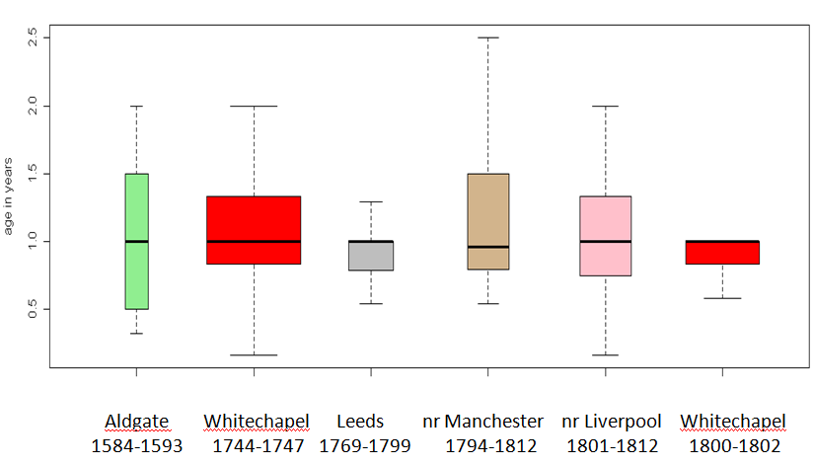
Source: Parish registers of St Botolph Aldgate (London), St Mary Whitechapel (London), Leeds St Peter and Leeds St John, All Saints Newton Heath near Manchester, and Toxteth Park, Liverpool.

Graunt appears to conflate teeth and worms as causes of death among young children, and in Leeds there are almost as many instances of “worms” or “worm fever” as of “teeth”. However, comparing the age structure of these two causes of death reveals that they are unlikely to be different names for the same thing. Nearly half of the worms deaths in Leeds are of children over three years of age, and many are above five years. It appears that older children were assigned this cause of death than is the case with “teeth”. The confusion may have arisen because in Graunt’s day tooth decay was attributed to worms, although the parish registers make it quite clear that eruption or “cutting” of teeth is meant rather than tooth decay. In the sampled London parishes, worms is used as a descriptor only in a handful of cases from sixteenth century Aldgate, but not in Whitechapel or Wapping, nor in Graunt’s own parish of St Michael Cornhill.

The understanding that “teeth” indicates a child dying while teething invites comparison with modern studies of the ages at which deciduous teeth erupt. A study based on 129 living Finns gives deciduous teeth eruption timings of 3-41 months, with most concentrated at 6-36 months, whereas a London study based in part on historical skeletal remains of known age gives 4.5 months to 27 months, depending on the exact definition of eruption (measured precisely as degree of emergence from the jawbone)., These ranges are consistent with nearly all the reported ages for “teeth” shown in Figure 5. In 18th century Whitechapel, for example, 95% of teeth deaths are indeed within the range 6-36 months identified for deciduous tooth eruption by the Finnish study, and more than 97% are in the 4.5 to 27 month period identified by the London study (these proportions include 8 outliers not shown in the figure). The ages for young children are usually given quite precisely in the sampled parish registers, to the last week or month lived, so in this respect it is a reasonably fair comparison. Of course, we cannot know for sure at what age each of these children began teething, and the overall distribution of ages is almost certainly skewed to younger ages than in the living population simply because the risk of dying is higher among the youngest. In fact there is reason to suspect that teething must have been later on average in the living population than the bounds suggested by the Finnish study at least, for we would expect that rickets and other nutritional deficiencies were more prevalent in historical Britain than modern Finland, and delayed eruption of deciduous teeth is recognised as a symptom of rickets.

Teeth as a descriptor is used for a fairly narrowly defined range of ages in early childhood that are consistent with its usage to denote a who died while teething, but this alone is not helpful in suggesting what the true cause of death might have been for these individuals. Graunt again makes some helpful remarks, stating that teeth, convulsions and “scowring” (diarrhoea/vomiting) often went together. Most of the children dying of “teeth” were old enough that it is unlikely they were exclusively breast-fed, and weaning was a particularly hazardous time for infants and young children, because of the risk of infection from contaminated food and water supplies, lack of hygiene in food preparation, and in some cases the unsuitability of foods fed to them. This and Graunt’s remarks make it likely that diarrhoeal disease, and perhaps febrile infections giving rise to convulsions, were the underlying causes of death for those dying of teeth. The seasonality of deaths from “teething” that Landers observed from the Weekly Bills of Mortality in 1670-9 indicates an August peak, the same as that for “griping in the guts”, but in other respects the monthly totals resemble those for convulsions, particularly the low total in September and the rise in incidence in the spring months. This and the lower degree of seasonal variation among teeth deaths overall is probably a consequence of the descriptor conflating diarrhoeal disease otherwise represented as griping in the guts with fevers that gave rise to convulsions.

Case Study 3: Old age
Graunt gives two answers on how old a person has to be for the Searchers to describe them as dying of old age. At first he considers it to be “above sixty years old, or thereabouts”, then a few pages later invokes biblical authority to recast it as 70 years, explaining “which I conceive must be the same, that David calls so, viz. 70”. It may perhaps be significant that Graunt’s own father who had died in March 1661/2 was recorded in the parish register as “aged” at 70 years old (Aubrey’s biographical information provides his date of baptism, allowing his age at death to be calculated, even though it is not stated in the St Michael Cornhill parish register). However, it is apparent from the two differing ages that he gives that Graunt was much less certain of ages in this cause of death category than for diseases that affect infants and children. This was not without reason. Age reporting in parish registers does become less accurate for persons dying of older ages, partly owing to failing memory or desire for exaggeration of the person themselves, and partly owing to the lack of surviving witnesses to corroborate the age of the deceased. We may suspect that in some cases the Searchers simply guessed the age of the deceased from their appearance, and rounded to the nearest 5 years. Age heaping on the decadal years and those ending in ‘5’ is common. For example, in mid-eighteenth century Whitechapel of 205 persons dying of old age whose age was reported as between 63 years and 106, 85 were said to be 70, 75, 80, 85 or 90 years old.

Figure 7 shows the age ranges reported under the old age or aged cause of death category in several locations and time periods. As before, the width of the box represents the number of observations, the largest representing the 1247 Leeds observations between 1761 and 99. Unfortunately old age is not used as a cause of death in sixteenth century Aldgate, London, where most persons over the age of 70 years are assigned to the consumption category. Similarly, in the late eighteenth century registers of Newton Heath near Manchester, most persons over the age of 70 are said to die from decline, consumption or weakness.

Figure 7: Reported ages of persons dying of old age
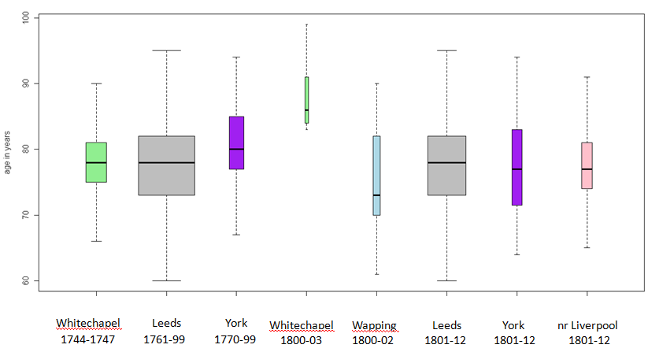
Source: Parish registers of London St Mary Whitechapel; Leeds St John, St Paul and St Peter together with Beeston, Bramley, Chapel Allerton, Farnley and Headingley; York St Mary Castlegate, St Lawrence and St Olave; London St John Wapping; and Liverpool Toxteth Park.

The lack of earlier data from Graunt’s own time or before makes it difficult to tell whether there had been a change in those ages commonly reported as old age, but certainly all the available parish information suggests that by the eighteenth century it was used for individuals over the age of 70 years (or who appeared to be aged over 70 years), and especially those between 75 and 85. Only in Whitechapel, London was there any marked change in age reporting between the eighteenth and early nineteenth century, with nineteenth century old age deaths restricted to an older age group of persons well over 80 years. However, there were few observations from nineteenth century Whitechapel, and data from neighbouring Wapping in the early nineteenth century did not accord with any increase in age. A comparison of nineteenth and eighteenth century data from York also suggests the reverse of the Whitechapel data, with younger persons being reported as dying of old age by 1801-12. Most probably there had been little real change in the ages that were considered eligible for the old age cause of death category, as evident from the larger Leeds dataset. While adult life expectancy may have improved slightly between 1740 and the 1810, perceptions of what constituted old age seem to have remained largely static.

There were some shifts in the proportion of persons deemed to fall into the old age category. In London Whitechapel in 1744-7 nearly 6% of all deaths were attributed to this category, but less than 1% were by 1800-2, although still 4.8% of deaths in neighbouring Wapping were attributed to old age. In the Bills of Mortality the proportion of deaths due to old age had also declined somewhat by 1800. In Leeds 8% of deaths were due to old age in the earlier period, but this fell to 5.8% in the later period. In York, deaths due to old age actually grew in proportion, from 5.6% to 7.4% by 1800-12. Falling proportions of those assigned to the old age category were not accompanied by any greater precision in the causes of death of those over 70. In all locations, decline and consumption were the categories into which the majority of those dying over 70 years but not of old age were placed. Small numbers of deaths in this age group attributed to fevers, dropsy and asthma give some indication of underlying true causes of death that afflicted this age group.

Conclusion
In addition to his pioneering statistical contributions, Graunt made many useful insights into the meaning of causes of death in the Bills of Mortality, based on careful reasoning from his general and personal knowledge as a seventeenth century Londoner. While the Bills of Mortality do not provide causes of death cross-tabulated by age, exceptional parish registers can yield both cause of death and age information. This can help to refine our understanding of both the age structure and the meaning of historical causes of death. The information is available for several urban areas, including Leeds, Liverpool, York and Manchester as well as London, and potentially over a longer period than is possible using the surviving Bills of Mortality, beginning in the sixteenth century, though in practice most parish registers recording cause of death information date from the 1760s or later.
Those London parish registers that do record causes of death are not an independent source from the Bills of Mortality, since the same parish officials gathered the basic information in both cases. From the parish cause of death data it is evident that there were considerable variations in the cause of death descriptors used by the Searchers of different parishes, both over time and between different parishes at the same time, even when those parishes were in the same part of the metropolis and socially homogenous. These idiosyncrasies have important implications for the aggregated totals for specific causes of death represented in the Bills, especially given the huge disparity in population size in different London parishes.

Three case studies of rickets, teething and old age have illustrated further problems of interpretation of causes of death, but also shed some light on the meaning and age-applicability of these descriptors. The disappearance of rickets as a cause of death during a period in which rickets was still prevalent shows that some cause of death descriptors passed into, and out of, fashion, without necessarily entailing any underlying change in the prevalence of the disease. Studies of modern populations in developing countries suggest that acute respiratory infections were the true cause of death of many of those assigned to the rickets category. The “teeth” descriptor is much more consistent over time and place, identifying quite precisely children aged between 6 and 18 months on average, which is consistent with the descriptor signifying that the deceased died while still teething. The seasonality of teeth deaths in conjunction with Graunt’s remarks on the confluence of teeth, convulsions and diarrhoea or vomiting suggests that a combination of diarrhoeal diseases and convulsions probably caused by fevers were the actual causes of death of these children, many of whom would have succumbed to food or water-borne infections following weaning. Deaths assigned to “old age” or “aged” in the eighteenth and early nineteenth centuries tended to identify individuals aged between 75 and 85, somewhat older than Graunt’s seventeenth century supposition of 60 or 70 years. However, there is insufficient evidence to deduce whether the range of ages implied by this descriptor changed over the long term. Little change was evident between the late eighteenth and early nineteenth century, although there was some improvement in adult mortality in this period. The popularity of old age as a descriptor did not affect the precision of causes of death applied to others aged 70, so that parishes using it less tended instead to assign those in this age group to the largest ‘catch-all’ categories of decline or consumption.

Much remains to be done in ascertaining the meaning and universality or otherwise of historical cause of death descriptors, and the task is made easier where ages are also available and comparisons can be made. Initially it may seem disheartening that so many deaths overall are placed in the same, large ‘catch-all’ categories, but analysis of other causes or in different age groups can reveal remarkable consistency in time and place. In London, the Searchers’ role in reporting causes of death has often been lamented because they had no formal training, and their sex has probably not helped in raising the esteem in which they are commonly held. Certainly our task would be much easier if they had all worked to a consistent list of causes of death standardised across every parish! However, what they did have in common was many years of practical experience in a high mortality environment where death and disease was an everyday occurrence. The women who became Searchers had almost certainly been mothers, and perhaps grandmothers, learning from the experience of their own families’ illnesses and deaths. Many would also have nursed children or adults privately or on behalf of the parish, since poorer widows could earn an income, and some social respect as well, by this means. In sixteenth century Aldgate, in the only instance where the Parish Clerk’s Memoranda Book names a Searcher she is referred to as “Goodwyfe” Hunt, the title being a respectful honorific. Graunt was realistic about the capacity of the Searchers to be swayed by bribes from the minority of rich Londoners who did not want their relatives to be recorded as dying from embarrassing or inconveniently monitored diseases, but also careful to note that the Searchers were sworn to their office, and his remarks about them are not overall derogatory in tone. Finally, it is worth remembering that seventeenth and eighteenth century medical diagnoses were often crude and inconsistent, and it would not necessarily have been any better for our modern understanding if medical practitioners had certified the cause of death. The symptoms of many ailments, and perhaps especially the infectious and epidemic diseases that afflicted children, were probably more familiar to the Searchers than to many contemporary doctors.

© Gill Newton 2012

Burial Register of St Martin Cornhill: London Metropolitan Archive MS P69/MIC2/A/003/MS04063.
In seventeenth century England, each year began on 25 March. Hence 25 January 1662 gives the year as Graunt would have understood it, but corrected to years beginning on 1 January, as we are now accustomed, it becomes 25 January 1663.
Sutherland provides a good biographical summary of Graunt’s life in Ian Sutherland (1963) ‘John Graunt: A Tercentenary Tribute’, Journal of the Royal Statistical Society Series A (General), Vol. 126 No. 4, pp. 537-556.
See p. 117; 119: George C Alter and Ann G Carmichael (1999) ‘Classifying the Dead: Toward a History of the Registration of Causes of Death’ Journal of the History of Medicine, Vol. 54, pp. 114-132.
Anonymous (1701) ‘History of Cradle Convulsions’, London, September 1701 (British Library Gale MS Z2000501573).
R Pinhasi, P Shaw, B White and A R Ogden (2006) ‘Morbidity, rickets and long-bone growth in post-medieval Britain – a cross-population analysis’, Annals of Human Biology, Vol. 33, No.3 pp. 372-389. In Broadgate cemetery, East London, of 35 individuals analysed who were buried between 1569 and 1720, 7 or 20% showed evidence of rickets. In more prosperous Spitalfields, 14 of 95 skeletons (15%) buried between 1729 and 1859 showed evidence of rickets (Table 1). See also Theya Molleson and Margaret Cox (1993): The Spitalfields Project Volume 2: the anthropology, the middling sort, Council for British Archaeology Research Report 86, York.
Lulu Muhe, Sileshi Lulseged, Karen E Mason and Eric A F Simoes (1997) ‘Case-control study of the role of nutritional rickets in the risk of developing pneumonia in Ethiopian children’, The Lancet, Vol. 349 No. 9068 pp. 1801-1804; Abdelhamid S Najada, Moen S Habashneh and Maher Khader (2004) ‘ The frequency of nutritional rickets among hospitalized infants and its relation to respiratory diseases’, Journal of Tropical Pediatrics, Vol. 50 No. 6, pp. 364-368.
John Haygarth (1774) ‘Observations on the Bills of Mortality in Chester for the year 1772’, Philosophical Transactions of the Royal Society, Vol. 64, pp. 67-78.
Marjatta Nyström, Leena Peck, Eija Kleemola-Kujala, Marjut Evälahti and Matti Kataja (2000) ‘Age estimation in small children: reference values based on counts of deciduous teeth in Finns’, Forensic Science International, Vol. 110 No. 3, pp.179-188.
S J AlQahtani, M P Hector and H M Liversidge (2010) ‘Brief Communication: The London Atlas of Human Tooth Development and Eruption’, American Journal of Physical Anthropology, Vol. 142 No. 3 pp. 481-90. See Table 10.
Brian Wharton (2003) ‘Rickets’, The Lancet, Vol. 62 No. 9393, pp. 1389-1400.
See John Landers (1993) Death and the Metropolis: studies in the demographic history of London 1670-1830 Cambridge University Press, Cambridge p. 208-9.
John Graunt (1662/3) Natural and Political Observations Made upon the Bills of Mortality, T Rycroft, London p.13 and 18
For a discussion of changes in adult life expectancy in eighteenth and early nineteenth century England see E A Wrigley, R S Davies, J E Oeppen and R S Schofield (1997) English Population History from Family Reconstitution Cambridge University Press, Cambridge, pp. 280-293.
Guildhall Library MS 9234 Vol. 6 fol. 242r.

