City of London Festival 2013
Stravinsky, Britten and the Idea of the Classical Past
Jonathan Cross, University of Oxford
(twitter: @jonathancross)
Gresham College, Tuesday 2 July 2013

Works Discussed

Britten

Young Apollo, Op. 16 (1939, withdrawn 1940, revived at Aldeburgh 1979)
Six Metamorphoses after Ovid, Op. 49 (1951)
Death in Venice, Op. 88 (1973)

Stravinsky

The Rite of Spring (1911–13, premiered 29 May 2013)
Apollon musagète (Apollo) (1927–8)
Orpheus (1947)

References and Further Reading

Bridcut, John, Britten’s Children (London: Faber & Faber, 2006)
Carpenter, Humphrey, Benjamin Britten: A Biography (London: Faber & Faber, 1992)
Cross, Jonathan, Harrison Birtwistle: The Mask of Orpheus (Farnham: Ashgate, 2009)
Griffiths, Paul, Stravinsky (New York: Schirmer, 1993)
Guthrie, W. K. C., Orpheus and the Greek Religion: A Study of the Orphic Movement (Princeton: Princeton University Press, 1952)
Ovid, Metamorphoses, trans. A. D. Melville, with an introduction by E. J. Kenney (Oxford: Oxford University Press, 1986)
Scheijen, Sjeng, Diaghilev: A Life, trans. J. Hedley-Prôle and S. J. Leinbach (London: Profile, 2009)
Stravinsky, Igor, An Autobiography (1903–1934) (New York: Steuer, 1958); originally published in French as Chroniques de ma vie, 2 vols (1935–6)
Stravinsky, Igor and Robert Craft, Dialogues and a Diary, enlarged edn (London: Faber & Faber, 1968)

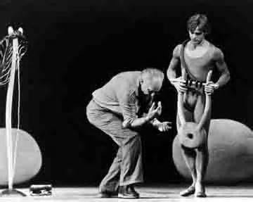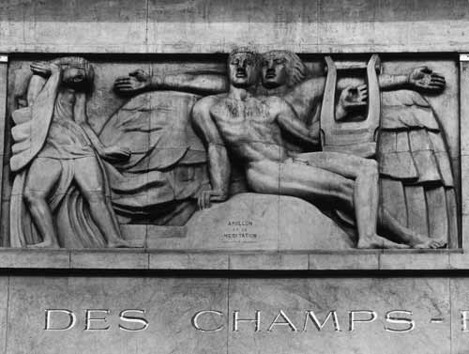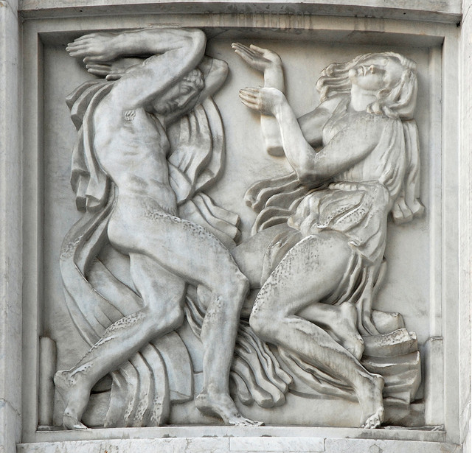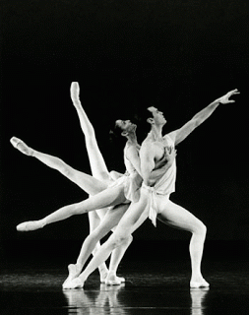
Balanchine rehearsing Orpheus
Bourdelle, Apollon et sa meditation (1912)
Bourdelle, La danse (1912)
Balanchine, Apollo

