30 June 2014

The Science of Singing

Professor David M Howard

Knowledge of voice science has inspired the building of voice synthesis systems since the late 18th century when von Kempelen produced his mechanical ‘speaking machine’ (see fig. 1). The advent of electronics and in more recent decades, local processing opportunities on office and home computers, has enabled both advanced voice synthesis and analysis to be readily available.

The human voice production system consists of three elements [1]: the power source – breathing; the sound source - the vibrating vocal folds in the larynx for pitched sung sounds [YouTube1]; and the sound modifiers - the varying resonant acoustic properties of the tubes of the throat, mouth and nose above the larynx [YouTube2]. For singers, all three elements come under scrutiny in voice lessons; a singer needs to be able to increase stamina to enable long notes and phrases to be sung, increase the pitch range above that used in speech with no audible pitch breaks, and to modify the articulation of vowels to enable a more acoustically efficient output.

Our understanding of the science of singing has increased greatly over the last few decades and voice analysis and synthesis can now be carried out on a standard home computer. Clinicians and speech therapists can analyse voice function live to guide and monitor progress of their therapy and treatment. Knowledge of the acoustics of voice production has lead to new ways of synthesizing voice sounds that are highly intelligible, but rarely if ever are they natural enough to be (mis)taken as emerging from a human vocal tract. We are now looking at modelling the voice production process and manipulating the shape of virtual vocal tract models that are entirely personal to a given speaker or singer, since they make use of magnetic resonance images (MRI) taken across the vocal tract. The opportunity to make 3-D prints of these MRI tracts has been taken up, and this is providing a way of improving our understanding of the detailed nature of the tract itself.

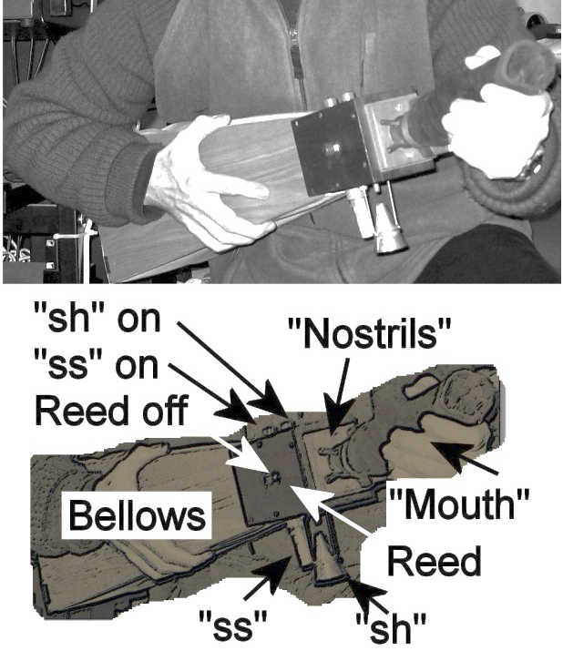 | 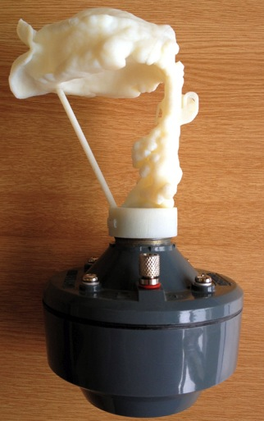
Fig. 1: The author’s replica Von Kempelen machine (top) and labelled version (bottom). | Fig 2: A 3-D print for the vowel “ah” on its loudspeaker drive unit as used in the Vocal Tract Organ.

The author, being an organist, has noted the similarity of these 3-D printed tracts to organ pipes and he has developed a new musical instrument based on this technology, which he terms the Vocal Tract Organ. The author has composed two pieces to demonstrate the Vocal Tract Organ, specifically to enable its output to be compared directly with live singers. In the first, a barbershop-style vocalize called Vocal Vision II, two male singers sing two parts and two other parts are played on the Organ [YouTube1]. In the second, the Vocal Tract Organ accompanies a solo mezzo-soprano singing O mio babbino caro (Puccini), for which he arranged a new chorale-like keyboard accompaniment [YouTube2 from 2m50s].

Vocal acoustics is a subject which is of great interest to today’s singers because the analysis of singing with suitable displays on a computer screen, enables a deeper understanding of how the voice works that is rooted in science. Traditional voice teaching relies on ‘psychological hooks’; descriptions of what is happening that are not always rooted in the reality of the voice production process. Resources are appearing to address this, and the author’s forthcoming book, which describes voice production and performance practice in the context of the choir singer [Howard, 2014] is one of them.

© Professor David M Howard June 2014

References

YouTube1: http://www.youtube.com/watch?v=pUryWk-s9Ig
YouTube2: http://www.youtube.com/watch?v=SX-f1oU0_Kk
Howard, D.M. (2014 – forthcoming). Choral Singing – Acoustics, perception and healthy voice production, Willow Leaf Publishing, (info@willowleafpublishing.com)

