Beauty in the Heavens: Notes

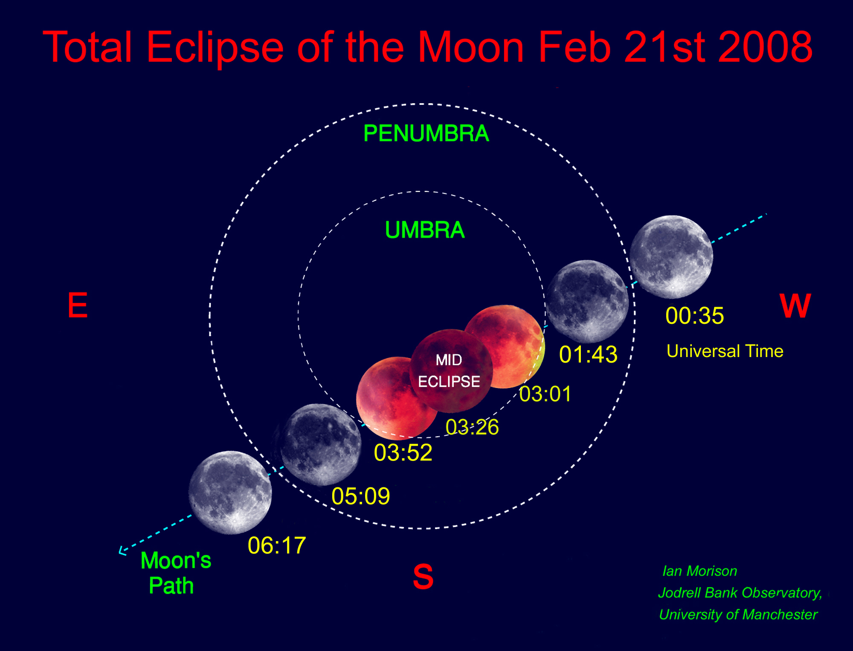
Companies running trips to observe Solar Eclipses:
Ancient World Tours: http://www.ancient.co.uk/
Explorer’s Tours: http://www.explorers.co.uk/astro/default.asp
Responsible Travel: http://www.responsibletravel.com/Trip/Trip101504.htm
On-the-Go Tours: http://www.onthegotours.com/Russia-with-On-the-Go-Tours
IAH holidays: http://www.iah-holidays.co.uk/
Explore: http://www.explore.co.uk
To view the Aurora Borealis - Omega Holidays run 4 types of trip:
1) 3 hour flights from UK airports to Icelandic waters.
2) Day trips to Tromso to observe form the top of a nearby mountain.
3) Weekend trips to Lapland to view from a remote frozen lake and, next day, have a snowmobile or husky trek through the snow!
4) Trips on Norway's Hurtigruten ferries
Omega Holidays: Phone: 0152437500 : http://www.omegaholidays.co.uk/
Comments on Lectures and Subjects you would like me to cover:

