

Gresham Lecture, Tuesday 16 November 2010

Continued Fractions

Professor John D Barrow FRS

Different ways of looking at numbers

There are all sorts of ways of writing numbers. We can use arithmetics with different bases, fractions, decimals, logarithms, powers, or simply words. Each is more convenient for one purpose or another and each will be familiar to anyone who has done some mathematics at school. But, surprisingly, one of the most striking and powerful representations of numbers is completely ignored in the mathematics that is taught in schools and it rarely makes an appearance in university courses, unless you take a special option in number theory. Yet continued fractions are one of the most revealing representations of numbers. Numbers whose decimal expansions look unremarkable and featureless are revealed to have extraordinary symmetries and patterns embedded deep within them when unfolded into a continued fraction. Continued fractions also provide us with a way of constructing rational approximations to irrational numbers and discovering the most irrational numbers.
Every number has a continued fraction expansion but if we restrict our ambition only a little, to the continued fraction expansions of "almost every" number, then we shall find ourselves face to face with a simple chaotic process that nonetheless possesses unexpected statistical patterns. Modern mathematical manipulation programs like Mathematica have continued fraction expansions as built in operations and provide a simple tool for exploring the remarkable properties of these master keys to the secret life of numbers.

The Nicest Way of Looking at Numbers

Introducing continued fractions
Consider the quadratic equation
Dividing by we can rewrite it as
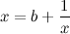
Now substitute the expression for given by the right-hand side of this equation for in the denominator on the right-hand side:
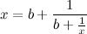
We can continue this incestuous procedure indefinitely, to produce a never-ending staircase of fractions that is a type-setter’s nightmare:
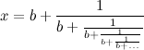
This staircase is an example of a continued fraction. If we return to equation 1 then we can simply solve the quadratic equation to find the positive solution for that is given by the continued fraction expansion of equation 4; it is
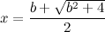
Picking , we have generated the continued fraction expansion of the golden mean,:
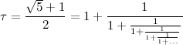
This form inspires us to define a general continued fraction of a number as
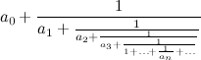
where the are positive integers, called the partial quotients of the continued fraction expansion (cfe). To avoid the cumbersome notation we write an expansion of the form equation 7 as
Continued fractions first appeared in the works of the Indian mathematician Aryabhata in the 6th century. He used them to solve linear equations. They re-emerged in Europe in the 15th and 16th centuries and Fibonacci attempted to define them in a general way. The term "continued fraction" first appeared in 1653 in an edition of the book Arithmetica Infinitorum by the Oxford mathematician, John Wallis. Their properties were also much studied by one of Wallis's English contemporaries, William Brouncker, who along with Wallis, was one of the founders of the Royal Society. At about the same time, the famous Dutch mathematical physicist, Christiaan Huygens made practical use of continued fractions in building scientific instruments. Later, in the eighteenth and early nineteenth centuries, Gauss and Euler explored many of their deep properties.

How long is a continued fraction?
Continued fractions can be finite in length or infinite, as in our example above. Finite cfes are unique so long as we do not allow a quotient of in the final entry in the bracket (equation 8), so for example, we should write 1/2 as rather than as We can always eliminate a from the last entry by adding to the previous entry.
If cfes are finite in length then they can be evaluated level by level (starting at the bottom) and will reduce always to a rational fraction; for example, the cfe . However, cfes can be infinite in length, as in equation 6 above. Infinite cfes produce representations of irrational numbers. If we make some different choices for the constant in equations 4 and 5 then we can generate some other interesting expansions for numbers which are solutions of the quadratic equation. In fact, all roots of quadratic equations with integer coefficients, like equation 5, have cfes which are eventually periodic, like or . Here are the leading terms from a few notable examples of infinite cfes:
These examples reveal a number of possibilities. All of the expansions except that for have simple patterns whilst that for , which was first calculated by John Wallis in 1685, has no obvious pattern at all. There also seems to be a preference for the quotients to be small numbers in these examples. The cfe for was first calculated by
Roger Cotes, the Plumian Professor of Experimental Philosophy at Cambridge, in 1714.
Continued fractions allow us to probe an otherwise hidden order within the realm of numbers. If we had written the number as a decimal () or even in binary () then it looks a pretty nondescript number. Only when it is written as a continued fraction does its unique structure emerge.

Some Useful Applications

Approximating Pi
If we chop off an infinite cfe after a finite number of steps then we will create a rational approximation to the original irrational. For example, in the case of , if we chop off the cfe at we get the familiar rational approximation for of . If we keep two more terms then we have , an even better approximation to .This approximation was known to the early Chinese. The first eight rational approximations are
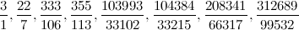
The more terms we retain in the cfe, the better the rational approximation becomes. In fact, the cfe provides the best possible rational approximations to a general irrational number. Notice also that if a large number occurs in the expansion of quotients, then truncating the cfe before that will produce an exceptionally good rational approximation. Later on we shall see that, in some sense, it is probable that most cfe quotients are small numbers ( or ), so the appearance in the cfe of of a number as large as so early in the expansion is rather unusual. It also leads to an extremely good rational approximation to

Pythagorean musical scales
The ancient Pythagoreans discovered that the division of the string of a musical instrument by a ratio determined by small integers resulted in an appealing relationship. For example, a half length gives a frequency ratio of , the musical octave, and a third length gives a ratio of , the musical fifth, a quarter length gives a frequency ratio , the musical fourth, a frequency ratio , the major third. We can now ask how the Pythagorean scale fits together. For example, how many major thirds equal an integral number of octaves; that is, when is
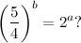
Taking logarithms to the base 2, we are looking for a solution . Since the is irrational there cannot be any exact solutions for integers and . But there are "almost" solutions. To find them we just look at the cfe of . Chopping it after the first fractional term gives the rational approximation , so the approximate solution to our problem is , , and
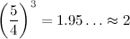
If we used the next cf approximant we would get which is rather awkward to handle.

Gears without tears

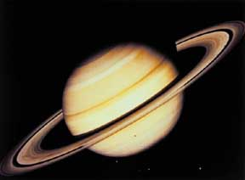
Saturn

Huygens was building a mechanical model of the solar system and wanted to design the gear ratios to produce a proper scaled version of the planetary orbits. So, for example, in Huygens' day it was thought that the time required for the planet Saturn to orbit the Sun is years (it is now known to be years). In order to model this motion correctly to scale, he needed to make two gears, one with teeth, the other with teeth, so that is approximately . Since it is hard to fashion small gears with a huge number of teeth, Huygens looked for relatively small values of and . He calculated the cfe of and read off the first few rational approximations: . Thus, to simulate accurately Saturn's motion with respect to that of the Earth's, Huygens made one gear with teeth and the other with 206 teeth.
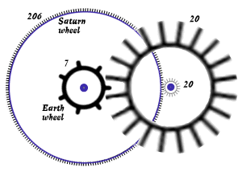
A schematic of Huygens' gear train

One of Ramanujan's tricks revealed
The remarkable Indian mathematician Srinivasa Ramanujan (1887-1920) was famous for his uncanny intuition about numbers and their inter-relationships. Like mathematicians of past centuries he was fond of striking formulae and would delight in revealing (apparently from nowhere) extraordinarily accurate approximations (can you show that ?). Ramanujan was especially fond of cfes and had an intimate knowledge of their properties. Knowing this one can see how he arrived at some of his unusual approximation formulae. He knew that when some irrational number produced a very large quotient in the first few term of its cfe then it could be rationalised to produce an extremely accurate approximation to some irrational. A nice example is provided by Ramanujan’s approximation to the value of ,
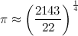
which is good to 3 parts in . How did he arrive at this? Knowing of his fascination with continued fractions we can guess that he knew something interesting about the cfe of . Indeed, there is something interesting to know: quotient number six in the continued fraction expansion of is huge:
By using the rational approximation that comes from truncating the cfe before you get a remarkably accurate approximation to ; now just take its fourth root.
Ramanujan was also interested in other varieties of nested expansion. In 1911 he asked in an article in the Journal of the Indian Mathematical Society what the value was of the following strange formula, an infinite nested continued root:
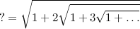
A few months went by and no one could supply an answer. Ramanujan revealed that the answer is simply and proved a beautiful general formula for continued roots:
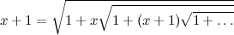
Applied mathematicians have found that by approximating functions by continued function expansions, called Padé approximants, they often obtain far more accurate low-order approximations than by using Taylor series expansions. By truncating them at some finite order, they end up with an approximation that is represented by the ratio of two polynomials.

Rational approximations - how good can they get?

Minding your p's and q's
Continued fractions allow us to probe an otherwise hidden order within the realm of numbers. If we had written the number as a decimal () or even in binary () then it looks a pretty nondescript number. Only when it is written as a continued fraction does its unique status emerge.
The rational fractions which are obtained by chopping off a cfe at order are called the convergents of the cf. We denote them by . As increases, the difference between an irrational and its convergent decreases
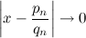
how quickly?
The cfe also allows us to gauge the simplicity of an irrational number, according to how easily it is approximatable by a rational fraction. The number is in this sense the "most irrational" of numbers, converging slowest of all to a rational fraction because all the are equal to , the smallest possible value. In fact, Lagrange showed that for any irrational number there are an infinite number of rational approximations, , satisfying
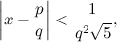
where the statement becomes false if is replaced by a larger number. In the case of the rational approximations to provided by the cfe, they are as and they have the weakest convergent rate allowed by equation 21 with
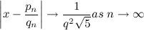
Thus the cfe shows that the golden mean stays farther away from the rational numbers than any other irrational number. Moreover, for any , the denominator to the rational approximation produced by truncating the cfe of any number satisfies
If the cfe is finite then will only extend up to the end of the expansion. In fact, it is possible to pin down the accuracy of the rational approximation in terms of the denominators, , from both directions by
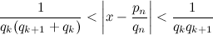
There are many other interesting properties of cfes but one might have thought that there could not be any very strong properties or patterns in the cfes of all numbers because they can behave in any way that you wish. Pick any finite or infinite list of integers that you like any they will form the quotients of one and only one number. Conversely, any real number you care to choose will have a unique cfe into a finite or an infinite list of integers which form the quotients of its cfe. A search for general properties thus seems hopeless. Pick a list (finite or infinite) of integers with any series of properties that you care to name and it will form the cfe of some number. However, while this is true, if we restrict our search to the properties of the cfes of almost any (a.e.) real number – so omitting a set of ’special numbers’ which have a zero probability of being chosen at random from all the real numbers - then there are remarkable general properties shared by all their cfes.

The Patterns Behind Almost Every Number

Gauss's other probability distribution
The general pattern of cfes was first discovered in 1812 by the great German mathematician Carl Friedrich Gauss (1777-1855), but (typically) he didn't publish his findings. Instead, he merely wrote to Pierre Laplace in Paris telling him what he had found, that for typical continued fraction expansions, the probability approaches as . Only in 1928 was Gauss's proof reconstructed and generalised by the Russian mathematician R.O. Kuzmin and (in a different way), also one year later by the French mathematician Paul Lévy (1886-1971).
If we consider the infinite cfe of a.e. real number then, in the limit that grows large, the probability that the quotient is equal to the integer approaches
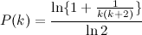
This has some important features. First, check that, because it is a probability distribution, if we take the sum over all values of from to , the answer is . Second, we see that large values of are rare: in fact, evaluating etc shows that about 41% of the quotients are expected to be , and 17% to be 2. As increases the probability of larger values of appearing in the quotients is very small. If we look at our examples in equations 9-12 then we see that is a member of the special set of real numbers not included in the designation "almost every". However, appears to be a member. If we look back at Ramanujan’s approximation for , generated from equation 17, we see that the probability of a quotient as large as 16539 is only about 5 parts in .
If we make large enough to expand the numerator using the binomial theorem (so that behaves as ), then as . This means that if we try to find the average (or arithmetic mean) value of in the cfe of a.e. number we get an infinite answer. The average is the sum from to of which only falls off as as and this sum diverges.

Lévy's constant
Paul Lévy showed that when we confine attention to almost every continued fraction expansion then we can say something equally surprising and general about the rational convergents. We have already seen in equations 21-24 that the rational approximations to real numbers improve as some constant times as increases. It can be shown that, for a.e. number, its cannot grow exponentially fast as increases ( as for some positive ). Lévy isolated the actual growth rate to be determined by a fundamental constant, so that for the denominators of the quotients in the cfe of almost any real number
where the Lévy constant, , is found to be
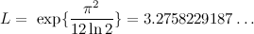

Khinchin's constant
Then the Russian mathematician Aleksandr Khinchin (1894-1959)
proved the third striking result about the quotients of almost any cfe. Although the arithmetic mean, or average, of the does not have a finite value, the geometric mean does. Indeed, it has a finite value that is universal for the cfes of almost all real numbers. He showed that as
where Khinchin’s constant, , is given by a slowly converging infinite product
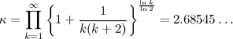
Thus the geometric mean quotient value is about , reflecting the domination by small values that we have seen in the probability distribution. Again, it is interesting to see how closely this value is approached by the quotients of .
If we list the appearance of different values of etc amongst the first terms in the cfe of , then the values and their frequencies in decreasing order of appearance, are as follows:

We see that there is already quite good convergence to the predicted values of for the small values of . If we calculate the geometric mean, then we find even better convergence to Khinchin’s constant,
Remarkably, if you calculate the cfe of Khinchin’s constant itself you will find that its terms also have a geometric mean that approaches Khinchin’s constant as their number approaches infinity.

A notable exception
The most important number that is not a member of the club of "almost every number" whose geometric mean value approaches Khinchin’s is . From equation 9, it is easy to work out what happens to the geometric mean as . All the ’s do nothing to the product of the ’s and what remains is just twice the product of successive numbers, which introduces and so we can use a good approximation for it, like Stirling’s, to show that as
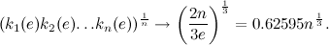

Chaotic Numbers

Numbers as chaotic processes
The operation of generating the infinite list of cfe quotients from a.e. real number is a chaotic process. Suppose the real number we wish to expand is and we split it into the sum of its integer part (denoted ) and its fractional part (denoted ), so
Sometimes we write to denote taking the integer part; for example . Now if we start with a number like , the first quotient is just , and the fractional part is . The next quotient is the integer part of the fractional part, ; the next fractional part is , and so . This simple procedure gives the first few quotients of , that we listed above in equation 12. The fractional parts (by definition) are always real numbers between and . They cannot be equal to or or the number would be a rational fraction and the cfe would be finite. The process of generating successive fractional parts is given by a non-linear difference equation which maps into and then subtracts the integer part:
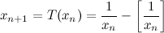
The function is composed of an infinite number of hyperbolic branches.

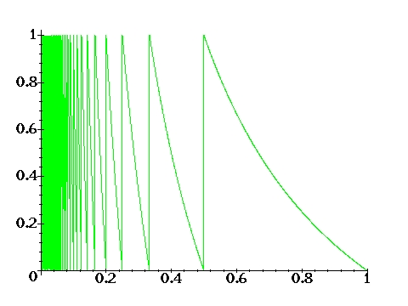
Graph 1: The function T(x).

If we apply this mapping over and over again from almost any starting value given by a real number with an infinite cfe, then the output of values of approaches a particular probability distribution, first found by Gauss:
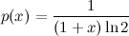
Again, as with any probability distribution, we can check that
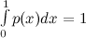.

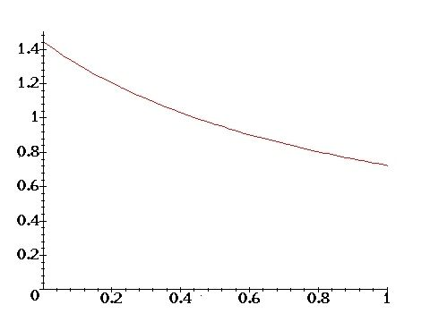
Graph 2: The probability distribution p(x).

What is chaos?
In order for a mapping like to be chaotic it must amplify small differences in values of when the mapping is applied over and over again. This requires the magnitude of its derivative to be everywhere greater than 1. Since and this is clearly true. But this amplification sensitivity clearly depends on the value that is generated – the closer the value is to so the greater is . A small uncertainty will be amplified to by the action of the map . Chaotic sensitivity means that the growth is exponentially rapid, as .
We shall take the mean value of , the exponent of sensitivity, averaged with respect to the probability distribution, equation 34, that governs the output of values from the map . This mean sensitivity, denoted , is sometimes called the Kolmogorov, or metric, entropy of the mapping, and is therefore given by
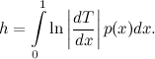
For our mapping , given by equation 33, its value is given by
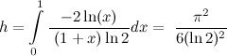
If is non-zero then a mapping is said to be chaotic: small uncertainties in its initial conditions will be exponentially amplified as the mapping is iterated. In the case of a cfe we see that this means that the cfes of two real numbers that are very close will ultimately diverge exponentially with , the number quotients generated.
Continued fractions provide one of the simplest exactly soluble chaotic mappings. Notice how the probability distribution is very smooth and simple, even though the succession of outputs from iterations of the map to generate successive appears purposeless. The mapping is deterministic but any uncertainty in the initial conditions (because the value of is prescribed to only a finite number of decimal places) will be rapidly amplified.
The cfe of a real number can be generalised in a natural way to create what is called the -expansion of a real number (), by writing
where is a monotonically increasing or decreasing positive function. The are non-negative digits that specify the quotients of the -expansion of . The cfe is the particular case of .

Continued Fractions in the Universe

Continued fractions appear in the study of many chaotic systems. If a problem of dynamics reduces to the motion of a point bouncing off the walls of a non-circular enclosure, of which the game of billiards is a classic example, then continued fraction expansions of the numbers fixing the initial conditions will describe many aspects of the dynamics as a sequence of collisions occurs. A striking example of this sort has been discovered in the study of solutions in the general theory of relativity, which describe the behaviour of possible universes as we follow them back to the start of their expansion, or follow the behaviour of matter as it plummets into the central singularity of a black hole. In each of these cases, a chaotic sequence of tidal oscillations occurs, whose statistics are exactly described by the continued fraction expansion of numbers that specify their starting conditions. Even though the individual trajectory of a particle falling into the black hole singularity is chaotically unpredictable, it possesses statistical regularities that are determined by the general properties of cfes. The constants of Khinchin and Lévy turn out to characterise the behaviour of these problems of cosmology and black hole physics.


The Solar System
Continued fractions are also prominent in other chaotic orbit problems. Numbers whose cfes end in an infinite string of s, like the golden mean, are called noble numbers. The golden mean is the "noblest" of all because all of its quotients are s. As we have said earlier, this reflects the fact that it is most poorly approximated by a rational number. Consequently, these numbers characterise the frequencies of undulating motions which are least susceptible to being perturbed into chaotic instability. Typically, a system which can oscillate in two ways, like a star that is orbiting around a galaxy and also wobbling up and down through the plane of the galaxy, will have two frequencies determining those different oscillations. If the ratio of those frequencies is a rational fraction then the motion will ultimately be periodic, but if it is an irrational number then the motion will be non-periodic, exploring all the possibilities compatible with the conservation of its energy and angular momentum. If we perturb a system that has a rational frequency ratio, then it can easily be shifted into a chaotic situation with irrational frequencies. The golden ratio is the most stable because it is farthest away from one of these irrational ratios. In fact, the stability of our solar system over long periods of time is contingent upon certain frequency ratios lying very close to noble numbers.
Continued fractions are a forgotten part of our mathematical education but their properties are vital guides to approximation and important probes of the complexities of dynamical chaos. They appear in a huge variety of physical problems. I hope that this article has given a taste of their unexpected properties.

Further Reading:
- J.D. Barrow, "Chaotic Behaviour in General Relativity", Physics Reports 85, 1 (1982).
- G.H. Hardy and E.M. Wright, An Introduction to the Theory of Numbers, Oxford University Presss, 4th ed. (1968).
- A.Y. Khinchin, Continued Fractions, University of Chicago Press (1961).
- C.D. Olds, Continued Fractions, Random House, NY (1963).
- M. Schroeder, Number Theory in Science and Communication, 2nd edn., Springer (1986).
- D. Shanks and J.W. Wrench, "Khinchin's Constant", American Mathematics Monthly 66, 276 (1959)
- J.J. Tattersall, Elementary Number Theory in Nine Chapters, Cambridge University Press (1999).
- http://www.total.net/~haver/cfpi.html

© John D Barrow, Gresham College 2010

_____

This article was originally published under the title, ‘Chaos in Numberland: The secret life of continued fractions’, by John D. Barrow, in Issue 11 of Plus Magazine



http://plus.maths.org/content/

