Men Woman and Guitars in Romantic England

V
Harmony in the Lowest Home: the Guitar and the Labouring Poor.

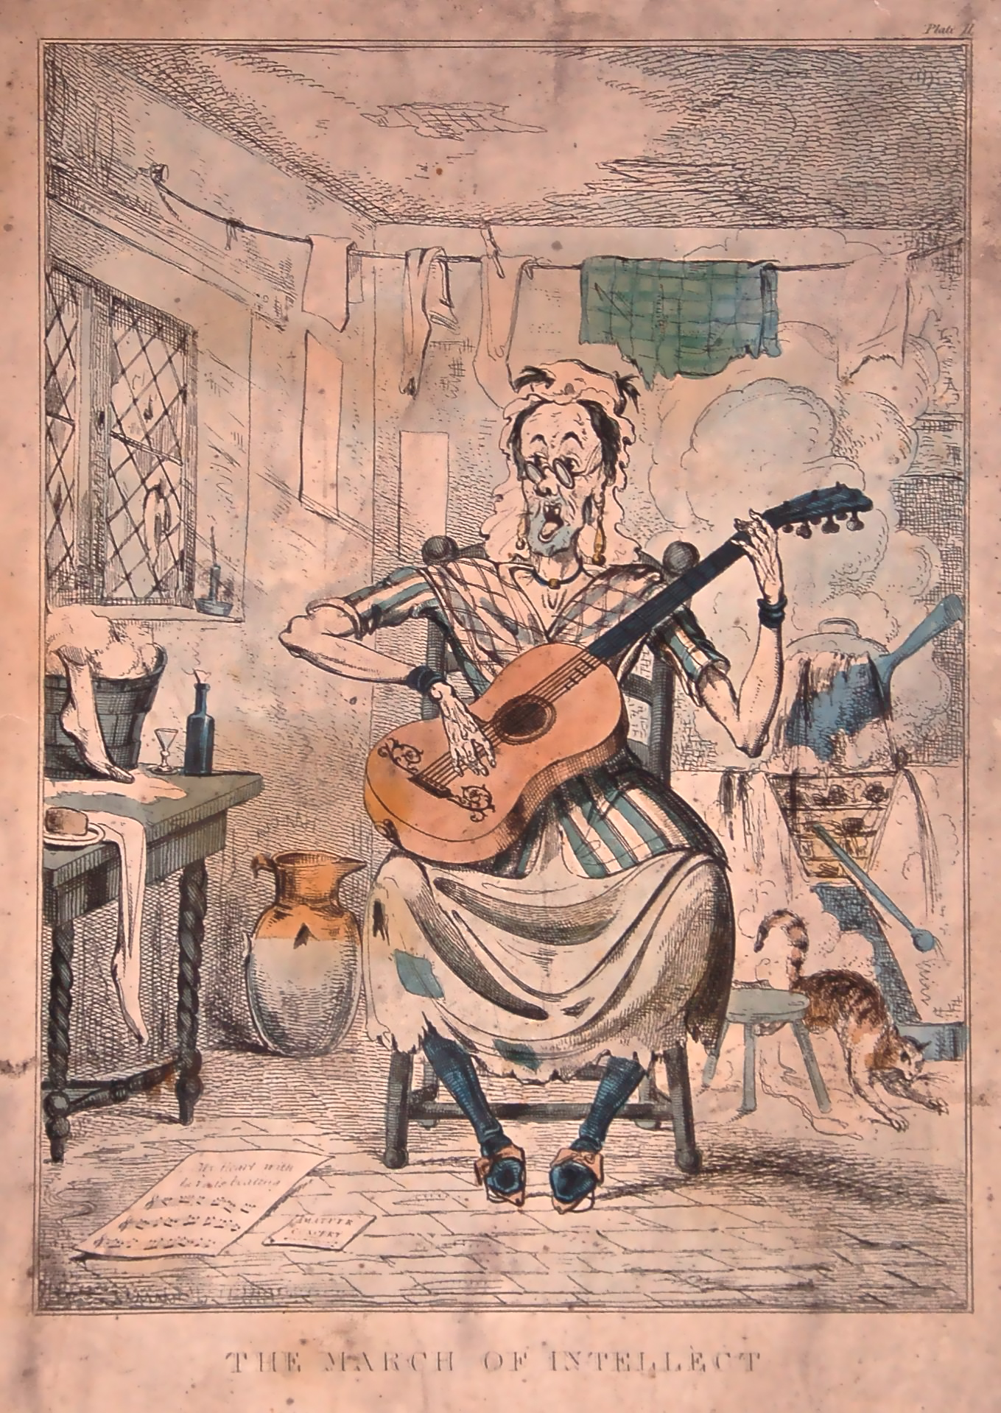

The March of Intellect, caricature of 1831. Private collection

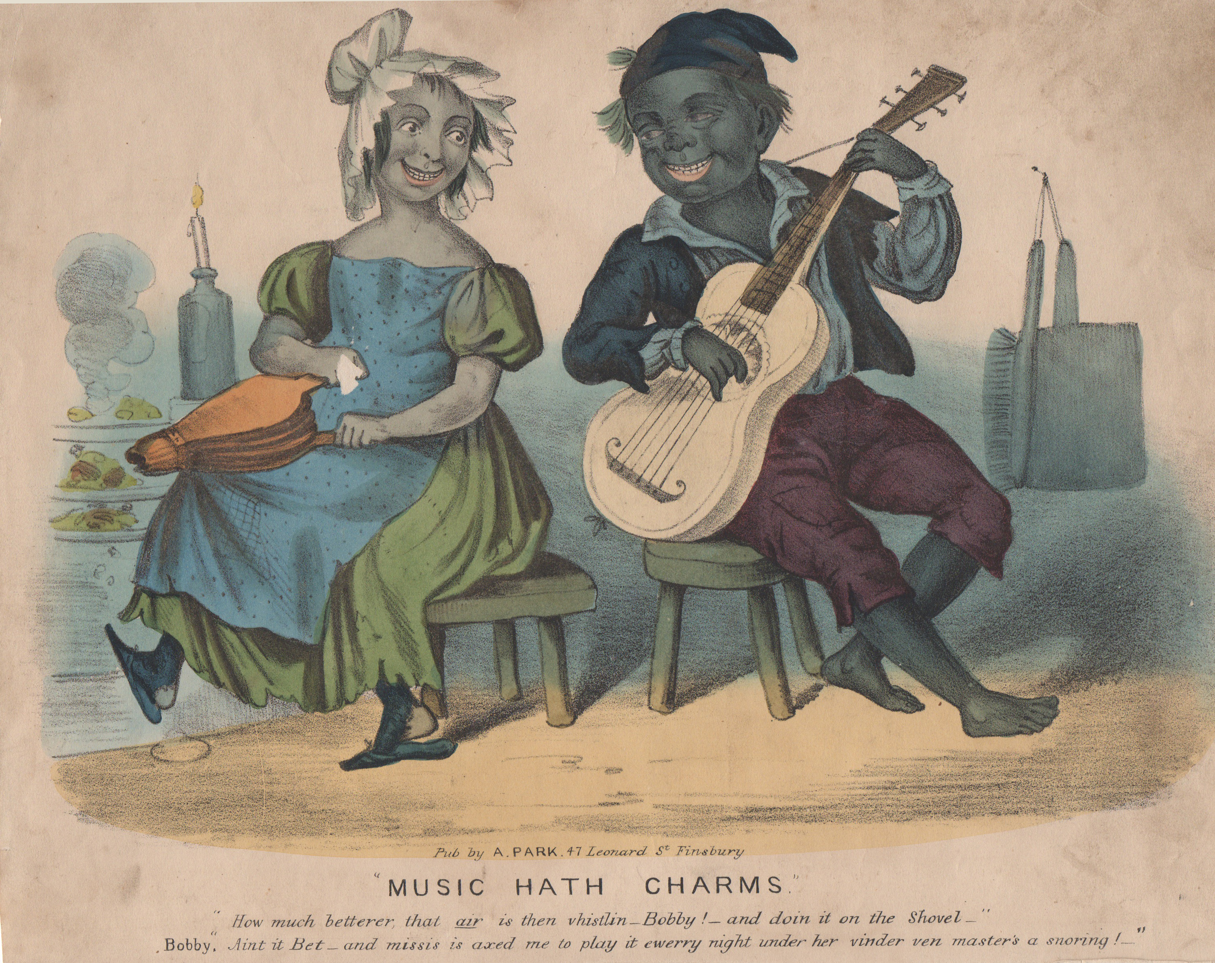

Music hath charms. Lithograph of c1840. Private collection

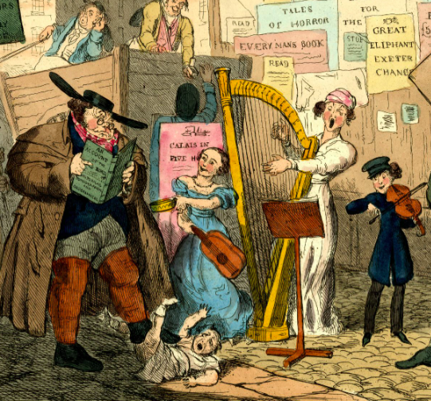

Street musician with a guitar. Detail from a hand-coloured lithograph. Private collection

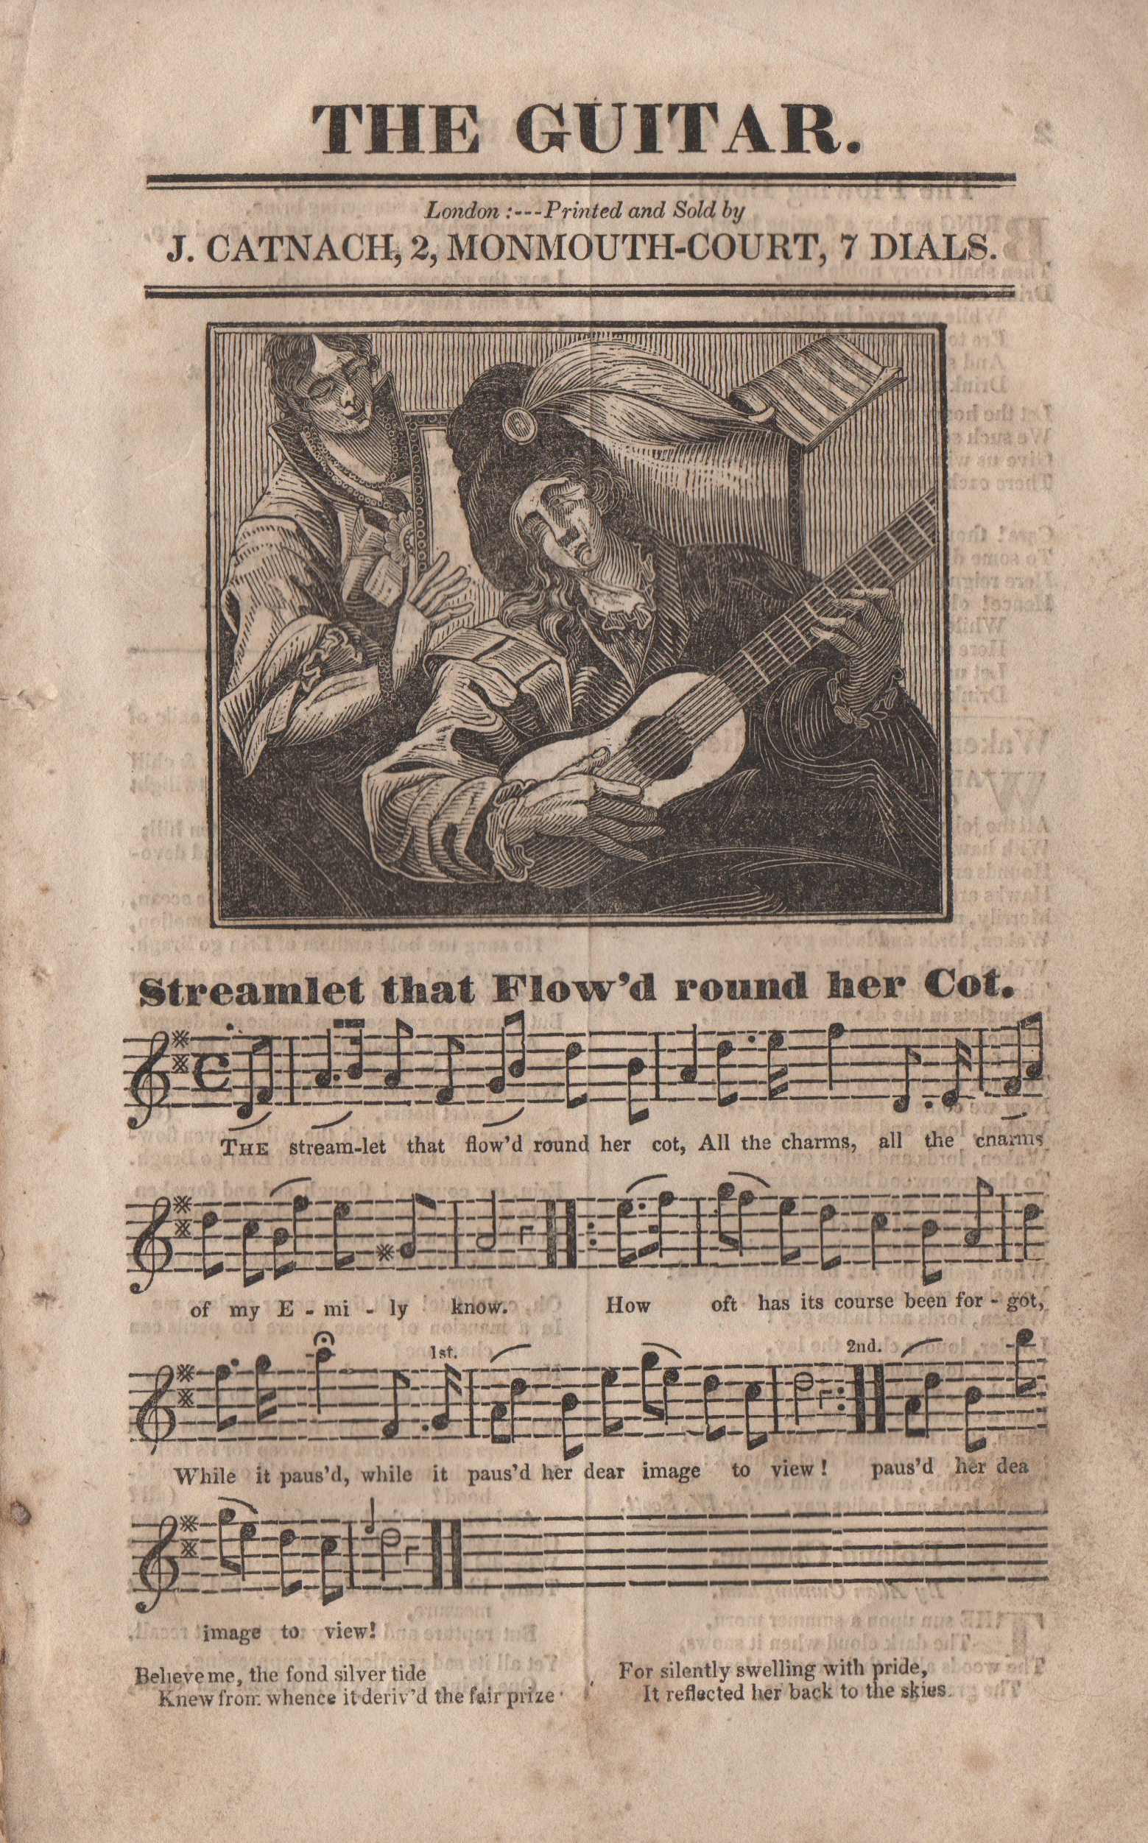

Catnach, The Guitar. Private collection.

